Chapter 1
Windows 95 offers administrators both an infrastructure to support systems management, and tools to monitor and configure networked computers. A centralized repository, the Windows 95 Registry, makes it possible to keep information about each hardware configuration per computer and per each user.
System Management
Windows 95 includes management features that make it easier to configure and manage network access and desktop configurations:
- User profiles define preferences, network settings, and application settings for individuals.
- System policies control what users can and cannot do on the desktop and the network.
- Remote administration allows you to manage network computers from your own computer.
- Backup capabilities allow you to ensure users’ data is backed up and protected.

This chapter describes how to set up and enable user profiles, system policies, remote administration, and network backup functionality. It also describes how to use the Windows 95 system management tools — System Monitor, Net Watcher, System Policy Editor, and Registry Editor.
This chapter includes information about a variety of third-party administration applications and network backup agents that support network administrators in the corporate enterprise.

About System Management 12-2
In This Chapter
System Management with Windows 95 12-2
User Profiles 12-5
System Policies 12-11
Remote Administration 12-45
Network Backup Agents 12-63

About System Management
Not long ago, corporations began downsizing from mainframes to local area networks (LANs). Since then, network administrators have faced the formidable task of managing a growing base of computing assets, spread across the enterprise. This was not a major problem when LANs were small and specialized. But the importance of managing them cost-effectively increased dramatically as organizations moved mission-critical production, decision support, accounting, and other applications to LAN-based computers.
Every computer has three types of resources to be managed:
- Hardware, including the computer’s motherboard, add-in cards, hard disk drive, monitor, CD-ROM, tape drive, mouse, and keyboard. These must be installed, configured, and managed as part of the corporation’s total assets.
- Operating system software, including drivers, system services, and user interface components. These require system software distribution, system and user configuration management, security, and data backup.
- Application software. These must be installed and their use must be licensed and monitored.

In addition, computers must be maintained over time. Network administrators continue to troubleshoot user and network problems, assist users when they have trouble performing computer-related tasks, and monitor the performance of the networked computers.

System Management with Windows 95
Windows 95 was designed with system management in mind and offers several features that support system management:
User profiles. You can enable user profiles so that individual users can configure their own settings and preferences, including Windows 95 settings, network settings and application settings. This is a convenient solution for administrators who provide support without a dedicated computer, because user profiles permit multiple users to share one computer. Additionally, with user profiles “ roving” users can move around the enterprise using multiple computers.
System policies. You can use system policies to fully control and customize network access, security privileges, and computer and user settings (on a per-user and per-configuration basis), from a convenient central location. System policies provide much greater control for administrators over user desktops.
Remote administration. You can use the remote administration capabilities of Windows 95 to better manage all the computers on your network remotely, from your own computer. This reduces the burden of supporting computers in an enterprise, by allowing remote configuration, troubleshooting, and management.
Backup capabilities. You can use the backup capabilities built in to Windows 95 to perform network-based backup to ensure user’s data is fully protected. Windows 95 includes two network backup agents from Arcada and Cheyenne.
Built-in agents. Windows 95 also includes built-in agents, for integrated use with systems management products. Windows 95 can be used with many third-party administration applications, including Microsoft System Management Server, HP® Openview, Intel® LANDesk®, IBM® LAN NetView®, Sun® NetManager, Novell® NMS.
The rest of this chapter describes the system management capabilities and features of Windows 95.

Windows 95 System Management and the Registry
Windows 95 includes both an intelligently designed management infrastructure and a set of system management applications. In Windows 95, the system management infrastructure collects information about the hardware, operating system, and applications. In turn, this information, which is stored in the Windows 95 Registry, is made available to system management applications.
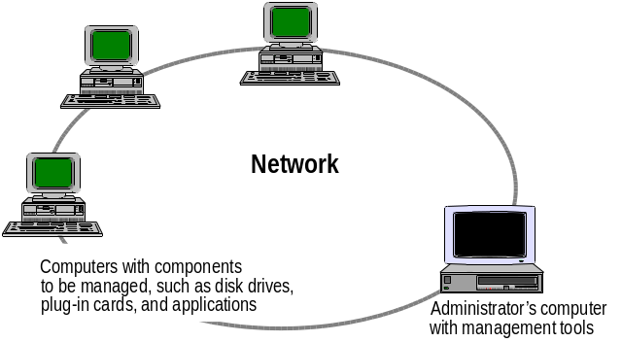
The Windows 95 Registry is a single, structured database where Windows 95 consolidates configuration and status information for most hardware and software components. Because the Windows 95 Registry APIs are can be used remotely via Remote Procedure Calls (RPCs), system administrators can view and modify Registry information from remote computers over the network, using System Policy Editor and the Registry Editor tool. (These tools are described later in this chapter.)
The Registry is logically one data store, but physically it consists of two different files, for maximum network configuration flexibility:
- User-specific information (as reflected in user profiles discussed later) is contained in USER.DAT.
- Hardware- and computer-specific settings (reflected in computer profiles) is contained in SYSTEM.DAT.

In addition to these two Registry files, system policy information (which overrides the previous two and provides user- and/or computer-specific information) is contained in *.POL files and is updated at each login.
Because Registry information is in separate files, Registry components can be located in physically different locations. For example, suppose some users in your organization move from computer to computer on the network. By including SYSTEM.DAT and other Windows 95 system files on the hard disk, and placing a copy of USER.DAT in the user’s logon directory of the network server, a roving user maintains unique network privileges and desktop configurations wherever the user logs on.

A copy of USER.DAT always exists locally. When USER.DAT is placed in the user’s logon directory on a server, a copy of that file is made on the user’s local computer when the user logs on.
Note

Also, by having a centrally located POLICY.POL file, system administrators can manage user privileges and configurations for an entire network from one file and location.
Separate Registry files also make it possible for two or more users to share one computer while maintaining separate user configuration information (such as logon information and desktop preferences) for each user.
Through system policies, separate privileges can be assigned on a per-user and a per-computer basis. You can specify who can and can’t use particular system features for each computer.
For a full discussion of the Registry, see Chapter 25, “Windows 95 Registry.”

User Profiles
User profiles solve the thorny problem of defining individualized configuration settings for multiple users on a particular computer or for users who work on multiple computers. A user profile contains configuration preferences and options for a specific user.

What are user profiles?
Each user can define the way he or she wants to use Windows 95, after an administrator grants user profiles privileges. The user’s preferences are saved to a user profile which Windows 95 uses to configure the desktop each time that user logs on. When a second user logs onto the same computer with a different user name, Windows 95 creates a separate user profile for that user.
Windows 95 also provides support for roving users who don’t necessarily use the same computer every day but who want to use the same desktop configuration on each computer they use on the network. A roving user’s profile is stored on a network server and downloaded to any computer on the network to which the user logs on.

While Windows 95 does offer the ability for roving users to move from one computer running Windows 95 to another, it does not offer the ability to move between a computer running Windows NT and a computer running Windows 95.
Important

User profile settings include everything in the Hkey_Current_User section of the Windows 95 Registry, such as:
- Windows 95 settings. These include settings for desktop layout, background, font selection, colors, shortcuts on the desktop, and so on.
- Network settings. These include settings for persistent network connections.
- Application settings. These include settings for menu and toolbar configurations, fonts, window configuration preferences, and so on.

User profiles work seamlessly when a user logs onto a computer running Windows 95. If they are stored locally, Windows 95 checks for a user profile for the person logging on. If there is a match, that set of configuration information is loaded into the Registry creating a customized desktop. If stored on a network location, Windows 95 searches in the home directory on a Windows NT server or a user’s mail directory on a Novell NetWare® server, to retrieve the appropriate information.

How do user profiles work?

When a user account is created on a NetWare server, a subdirectory of the MAIL directory is automatically created for that user. Since this individualized directory already exists, Windows 95 uses this directory for user profiles for that user.
Note

Enabling User Profiles
You can enable user profiles through customized Setup scripts, or you can enable them after setup. For more information about customized Setup scripts, see Chapter 4, “Network Setup.”

How do I enable user profiles after Setup?
To enable user profiles after Setup
1. From the Passwords Control Panel, click the Profiles tab.
2. Click the Users Can Customize... option, and then click OK.
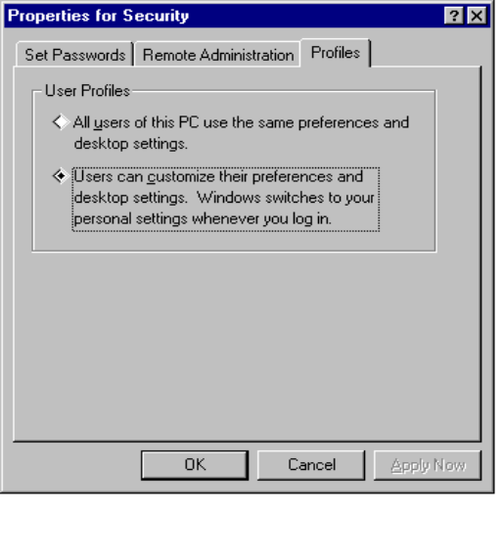

An administrator can also enable user profiles by creating a system policy which can be automatically downloaded when the initial Windows 95 installation is complete. By doing this, administrators avoid having to go to each computer to enable user profiles. For more information, see “System Policies” later in this chapter.
Once user profiles are enabled, logging on as a new user is simple:
1. If Windows 95 is running, from the Start button, click Shut Down.
2. Click Close All Programs and Log On As a Different User.
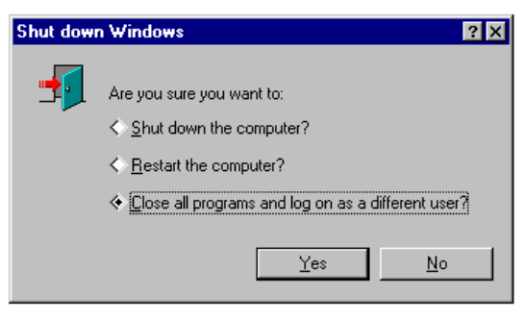
3. When prompted, type your user name and password.
Windows 95 then creates a new user profile for you.

To set up user profiles for a Windows NT network
1. From the Passwords Control Panel, enable user profiles as described above.
2. On the Windows NT server, ensure each user is properly set up and has an assigned home directory on the Windows NT network. (Windows NT administrators can use the User Manager tool to create this directory.)
3. On the user’s computer, from Network Control Panel, ensure Client for Windows Networks is selected.
Windows 95 will now automatically look for a user profile in the following location:
\\Primary Domain Controller\User’s Home Directory\USER.DAT

Windows 95 does not use the PROFILES directory on a Windows NT network; that directory is used only for Windows NT profiles.
Note

To set up user profiles for a Novell NetWare network
1. From the Passwords Control Panel, enable user profiles (as described earlier).
2. Ensure each user on the NetWare network has an established Mail directory.
3. On the user’s computer, from Network Control Panel, ensure Client for NetWare Networks is selected.
Windows 95 will now automatically look for a user profile in the following location:
\\Preferred Server\sys\mail\user’s 8-digit ID\USER.DAT

Using User Profiles with Windows 95
Windows 95 stores user profiles in the Windows 95 Profiles folder of the computer. When the user profiles capability of Windows 95 is enabled (as described in the preceding section), Windows 95 automatically creates a separate user profile for each user who logs onto the computer. Each profile includes three parts — a USER.DAT, a Desktop folder, and a Programs folder —stored within the user’s folder in Windows 95 Profiles, as illustrated here:

How do user profiles work for a standalone computer?
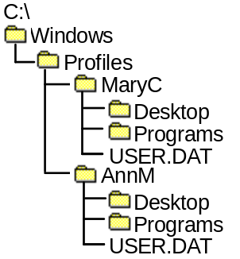

This structure may change in the final product.
Note for this Beta Release

Each time the user logs on, Windows 95 searches the Registry under the following key for a user profile for the person logging on:
Hkey_Local_Machine\Software\Microsoft\Windows\Current Version
\Profile List

If the user profile for that person is found, the user profile information is loaded into the Windows 95 Registry, and the desktop configuration is set according to the preferences listed in the user profile. If no user profile is found for the person currently logging on (and user profiles are enabled), Windows 95 uses the default settings to create a new profile for the user (if user profiles are not enabled, Windows 95 does not create a new profile for the new user logging on).
When the user logs off, Windows 95 saves the user profile for that user. Any changes to the desktop are also saved automatically in the user profile.
Networked computers running Windows 95 also have a Profiles directory on the local computer running Windows 95, with subdirectories for each user who logs on. In addition, copies of user profiles can be maintained on the server. When the user logs on, Windows 95 first checks the user profile on the local computer, and then the user profile on the server. Windows 95 uses the latest version of the two and updates the older version. If no local user profile exists, Windows 95 copies the server version to the local computer. If neither a server user profile nor a local user profile exists, Windows 95 creates a new user profile on the local computer, and then copies it to the server when the user logs off.

How do user profiles work on networked computers?
When the user logs off, Windows 95 saves the local copy of the user profile, as it does for standalone computers, then copies the local profile to the user’s directory on the server. Each time the roving user logs on from a new computer, Windows 95 looks in the specific user’s directory on the server to copy the user’s profile to the local computer. When the user logs off, Windows 95 updates the Desktop and Programs folders, and USER.DAT on the local computer, and then copies the local version to the server. (For a standalone computer, of course, only the local versions are updated and saved.)

How do user profiles work for roving users?
The option to create user profiles on a server is important for supporting roving users. Because the server copy of the user profile is updated each time the user logs off, a roving user can use the same profile no matter which computer on the network he or she uses.

Using User Profiles with Other Networks
When Windows 95 is part of a Windows NT or NetWare network, a copy of the user’s profile is also stored in the user’s home directory on the Windows NT or in the mail directory on the NetWare server (assuming those directories have been properly established). Based on the client setting in the Network Control Panel— for example, a Microsoft Network client or a NetWare client — Windows 95 automatically searches the appropriate server for the user’s home or mail directory for the user profile.

Third-party network vendors also can include support for home directories in their 32-bit network providers for Windows 95. Doing so allows Windows 95 user profiles to work as described earlier with the third-party network.
Note

To recap, there are three ways user profiles can be used on a network:
- Use a default user profile network. This is automatic from the home directory on a Windows NT or a mail directory on a NetWare network (or a home directory on another third-party network that provides support for home directories as a part of their 32-bit network provider).
- Adding a value to the Windows 95 Registry which points to the .INI file on the network.
- Write a .DLL to automatically copy information from the .INI file on the network and add it to the Windows 95 Registry.

Defining Mandatory User Profiles
In Windows 95, you can create a mandatory user profile, called USER.MAN, for all users who log on using a specific home directory on a Windows NT server, or using the user’s mail directory on a Novell NetWare network. When the user logs on, Windows 95 uses this mandatory copy, rather than the local copy, to download the specific configuration. Even if the user makes changes manually to the desktop configuration during the day, these changes are not saved to the master copy in the home (or NetWare mail) directory. This is a helpful feature for network administrators who want to create a standard user profile for each computer and ensure it is implemented at each and every logon.
To create an administrator-defined mandatory user profile that remains constant
1. Enable user profiles. (See “Enabling User Profiles” earlier in this chapter.)
2. From any computer running Windows 95, customize the desktop as you plan to have it for your mandatory user profile.
3. Copy the user profile (USER.DAT, Programs folder, and Desktop folder) to the home directory for Windows NT or mail directory for NetWare. Rename USER.DAT to USER.MAN.

When users log on, Windows 95 will use only the USER.MAN profile, not a local copy of the user profile. Additionally, users will not have write access to this file, so any changes they make during the day manually will not be saved back to USER.MAN when they log off.
Changes will be saved locally in USER.DAT. When the user logs back on, these changes will simply be discarded and the network copy of USER.MAN settings will be applied. The local file is used only if the user is not connected to the network or for some reason cannot access his or her home on a Windows NT network, or mail directory on a Novell NetWare network.

System Policies

It’s best for system administrators to make some decisions about their default set of system policies even before installing Windows 95. For more information, see Chapter 1, “Planning Overview” and Chapter 2, “Implementation Strategy.”
Important

System policies offer a powerful mechanism for network administrators to increase control and manageability of desktop, across the enterprise. By establishing system policies, system administrators can control access to the network, specify desktop configurations, and prevent users from modifying preset applications or desktop configurations. For example, an administrator might preset a user’s environment so that the MS-DOS prompt is unavailable, or so that users can’t add or delete network connections from a predefined list. Administrators can choose from a rich set of system policies offered by Windows 95 or they can create their own custom system policies.

What are system policies?

Creating System Policies
Using system policies, administrators have a great deal of control over users’ desktop, network, and security settings. The settings you define are automatically updated in the Registry:
- The desktop settings you define modify the Local_User portion of the Registry, which in turn defines the contents of USER.DAT. All policy settings affecting USER.DAT are determined by a specific user or by Default User.
- The logon and network access settings you define modify the Local_Machine portion of the Registry, which in turn defines the contents of SYSTEM.DAT. All policy settings affecting SYSTEM.DAT are determined by a specific computer or by Default Computer.

In Windows 95, you set policies with System Policy Editor.

System Policy Editor is a powerful tool, and as such, should be restricted to use only by the Network Administrator. The best way to ensure users do not use this tool is not to install on users’ computers.
Caution

The following illustration shows System Policy Editor listing both specific user settings and specific computer settings, and the default user and default computer settings.
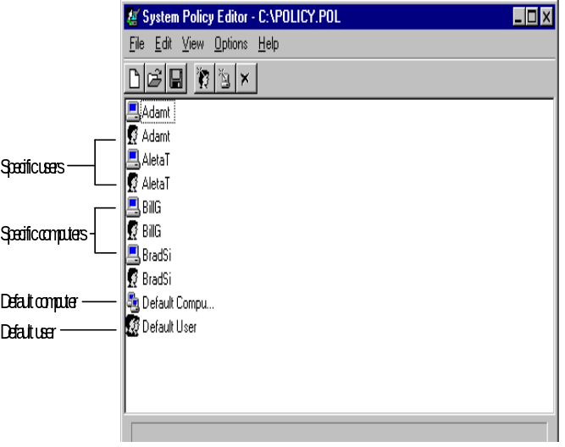
When a user logs on, the system policies for that user are copied to the Registry over default information in the USER.DAT and SYSTEM.DAT files. Although an administrator could potentially have dozens or even hundreds of entries (limited only by how long it takes for users to log on), for both user settings and computer settings, these are all saved a single file called POLICY.POL.

You can rename the file so long as you use the filename extension .POL.
Note

Defining System Policies for Users
The property sheet shown here is accessed through System Policy Editor, as described later, and lists the policies for the default Local User. This illustration shows the policies you can set for an individual user:

What system policies can I set for a user?
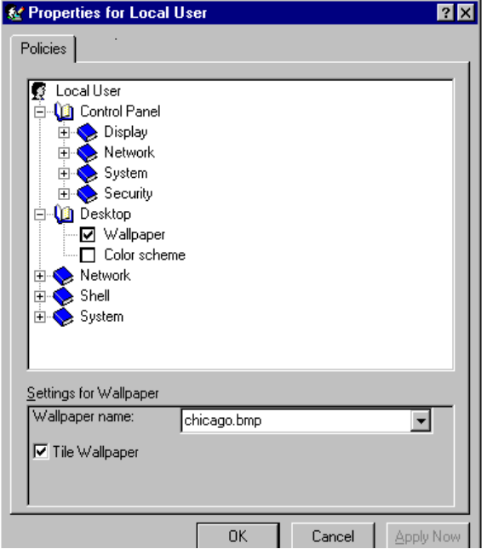
It is often useful to prevent users from changing the behavior and appearance of the system, particularly when many users access the same computer. From the Policies property sheet for a user, you can set options for the following categories to prevent a user form modifying user-specific features of the system:
Control Panel. Within this category of options, you can set policies to prevent the user from accessing Control Panel features.
Desktop. Policies can prevent users from modifying features for the desktop.
Network. The network policies provide restrictions to file and printer sharing.
Shell. You can use shell (that is, user interface) policies to customize folders on the desktop and to restrict changes to the user interface.
System. These system policies restrict the use of Registry editing tools, applications, and MS-DOS-based applications.
Specific settings for each of these categories are described in the following sections.

Restricting Access to Control Panels
Within this category of options, you can restrict access for the following:
- Display Control Panel settings
- Network Control Panel settings
- Printers Control Panel settings
- System Control Panel settings
- Passwords Control Panel settings

The following tables describe the system policies you can apply to the Display, Network, Printers, System, and Passwords Control Panels.
Display Control Panel Settings
Option | Comment
Disable Display Control Panel | Prevents access to the Display Control Panel, displaying an explanation in a dialog box. When you check this box, the following system policy options are displayed.
Hide Background Page | Hides the Background properties sheet of the Display Control Panel.
Hide Screen Saver Page | Hides the Screen Saver properties sheet of the Display Control Panel.
Hide Appearance Page | Hides the Appearance properties sheet of the Display Control Panel.
Hide Settings Page | Hides the Settings properties sheet of the Display Control Panel.

Network Control Panel Settings
Option | Comment
Disable Network Control Panel | Prevents access to the Network Control Panel, displaying an explanation in a dialog box. When you check this box, the following system policy options are displayed.
Hide Configuration Page | Hides the Configuration properties sheet of the Network Control Panel.
Hide Identification Page | Hides the Identification properties sheet of the Network Control Panel.
Hide Security Page | Hides the Security properties sheet of the Network Control Panel.

Printers Control Panel Settings
Option | Comment
Hide General and Details Pages | Hides the General and Details properties sheets for Printer.
Disable Removal of Printers | Prevents removal of current installed printers.
Disable Addition of Printers | Prevents installation of new printers.

System Control Panel Settings
Option | Comment
Hide Device Manager Page | Hides the Device Manager properties sheet from the System Control Panel.
Hide Configuration Page | Hides the Configuration properties sheet from the System Control Panel.
Hide Advanced Button | Hides the Virtual Memory button from the System Control Panel.

Passwords Control Panel Settings
Option | Comment
Disable Passwords Control Panel | Prevents access to the Passwords Control Panel, displaying an explanation in a dialog box. When you check this box, the following system policy options are displayed.
Hide Set Passwords Page | Hides the Set Passwords properties sheet of the Passwords Control Panel.
Hide Remote Administration Page | Hides the Remote Administration properties sheet of the Passwords Control Panel.
Hide Profiles Page | Hides the Profiles properties sheet of the Passwords Control Panel.

Restricting Access to Desktop Settings
Within this category of options, you can restrict users from defining wallpaper and color scheme settings, as listed in the following table:
Wallpaper and Color Scheme Settings
Option | Comment
Wallpaper Name | When checked, the user cannot set the path and filename of a .BMP file to be displayed in the background of the desktop.
Tile | When checked, the wallpaper file will be tiled in the background of the desktop.
Color Scheme | When checked, the user cannot set the name of a color scheme used on the desktop.

Restricting Access to Network Settings
Within this category of options, you can restrict the user’s ability to share files and/or printers.
Option | Comment
Disable File Sharing Controls | When set, removes the Sharing property sheet from the file system.
Disable Print Sharing Controls | When set, removes the Sharing property sheet from the Printer.

Restricting Access to Shell Settings
The following tables describe the system policies you can apply to folders and user interface options.
Custom Folders Settings
The following tables contain settings for customizing the user interface.
Option | Comment
Custom Programs Folder | Used to customize the contents of the Program folder. You must also type a path for the directory containing complete files or .LNK files which define the Programs folder items.
Custom Desktop Shortcuts | Used to customize desktop shortcuts. You must also type a path for the directory containing complete files or .LNK files which define the Desktop shortcuts.
Custom Startup Folder | Used to customize the contents of the Startup folder. You must also type a path for the directory containing complete files or .LNK files which define the Startup folder items.
Custom Network Neighborhood | Used to customize the contents of Network Neighborhood. You must also type a path for the directory containing complete files or .LNK files which define the Network Neighborhood items.
Custom Start Menu | Used to customize what is listed on the Start menu. You must also type a path for the directory containing complete files or .LNK files which define the Start menu items.

Restriction Settings
Option | Comment
Remove Run From Start Menu | Prevents access to the Run command from the Start menu; displays an explanation in a dialog box.
Remove folders From Settings On Start Menu | Prevents access to any item listed under Settings on the Start menu; displays explanation in a dialog box.
Remove Taskbar From Settings on Start Menu | Prevents access to the Task Bar item listed under the Settings on the Start menu; displays explanation in a dialog box.
Remove Find From Start Menu | Prevents access to any of the item listed under Find on the Start menu; displays explanation in a dialog box.
Hide Drives in My Computer | Prevents access to My Computer.
Hide Network Neighborhood | Prevents access to Network Neighborhood.
No Entire Network in Network Neighborhood | Prevents access to Entire Network icon in Network Neighborhood.
Hide All Items on Desktop | Prevents access to all items on the desktop.
Disable Shut Down Command | Prevents access to the Shut Down command on the Start menu; displays explanation in a dialog box.
Don’t Save Settings At Exit | Prevents settings from being written to the file system.

Restricting Access to System Settings
The system policies in this category restrict the use of Registry editing tools, applications, and MS-DOS-based applications. The following tables describe the system policies you can set within this category.
Restriction Settings
Option | Comment
Disable Registry Editing Tools | Prevents access to REGEDIT.EXE and other system management tools; displays an explanation in a dialog box.
Only Run Allowed Applications | Prevents users from running any applications except what is listed.
Disable MS-DOS Prompt | Prevents access to the MS-DOS command prompt.

Defining System Policies for Computers

What system policies can I set for a computer?
The property sheet shown here is accessed through System Policy Editor, as described later, and lists the policies for the default Local Workstation. This illustration shows the policies you can set for an individual computer:
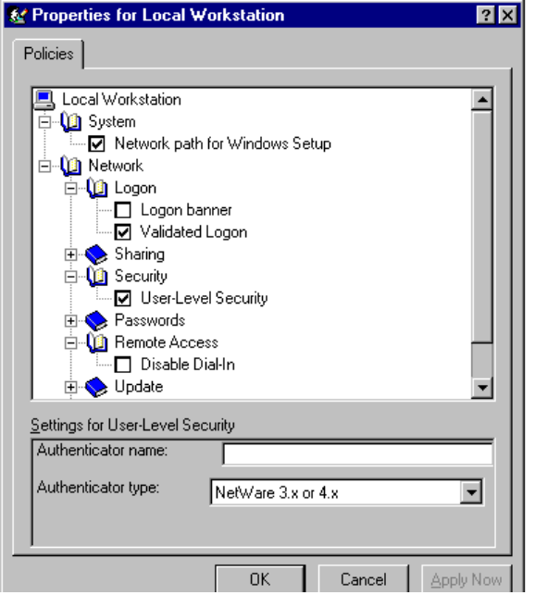
Computer settings prevent users from modifying the system, ensuring it starts up in a predictable way. From the Policies property sheet for a computer, you can set options to restrict access to the computer-specific system and network features.

Restricting Access to Computer-Specific System Settings
This category of options includes system policy settings for the network path for setup and the user profiles. The following tables describe the system policies you can set within this category.
System Settings
Option | Comment
Network Path for Windows Setup | Used to define the network location of the Windows 95 setup program and files. You must also type a unified naming convention (UNC) path for the setup directory.
Enable User Profiles | When checked, this setting activates the user profiles stored on the server.

Restricting Access to Computer-Specific Network Settings
This category of options includes system policy settings for the following:
- Logon dialog box settings
- Sharing settings
- Access control settings for user-level security
- Password settings
- Remote access settings
- Remote Registry settings
- Update settings
- Microsoft Client for Windows Networks settings
- Microsoft Client for NetWare Networks settings
- Simple Network Management Protocol (SNMP) settings

The following tables describe the system policies you can set within this category.
Logon Settings
Option | Comment
Logon Banner | When you check this option, you can type values for a caption and other text to be displayed in the Logon dialog box.
Validated Logon | When checked, you can also specify whether you want to enable validated logon and/or require validated logon. By enabling validated logon, each logon will be validated by a server. By requiring validated logon, each logon must be validated by a server before access is allowed.

Sharing Settings
Option | Comment
Disable File Sharing | Prevents sharing files over a network.
Disable Print Sharing | Prevents sharing printers over a network.

Access Control Settings
Option | Comment
User-level Access Control | When checked, you can use pass-through logon validation by specifying the Windows NT or NetWare server that will act as authenticator. Type the server name and type. You can also specify values for the authenticator name and select the type from the list.

Passwords Settings
Option | Comment
Hide Share Passwords With Asterisks | Uses asterisks to replace passwords that users type when accessing a shared resource
Disable Password Caching | Prevents saving passwords
Require Alphanumeric Login Password | Requires that every password contain letters and numbers.
Minimum Login Password Length | Requires that each logon password has at least the specified number of characters

Remote Access Settings
Option | Comment
Disable Dial-in | Prevents dial-in connections to the computer.

Remote Registry Settings
Option | Comment
Enable Remote Registry Service | Allows the computer’s Registry to be accessed remotely

Update Settings
Option | Comment
Remote Update | Used to define how system policies will be updated. When checked, the following options display.
Update Mode | Determines if system policies are downloaded automatically (the default) or manually..
Path for Manual Update | The UNC path for manual download of system policies.
Display Error Message | When a user logs on, if the system policy for that user is not available, this displays an error message.
Load Balance | For Windows NT networks, allows any server in the public domain to download system policies.

Microsoft Client for Windows Networks Settings
Option | Comment
Logon Domain | If checked, this computer can participate in a Windows NT domain. Type the name of the domain.
Workgroup | If checked, this computer can participate in a workgroup. Type the name of the workgroup.

Microsoft Client for NetWare Networks Settings
Option | Comment
Preferred Server | When checked, you can specify the name of the NetWare network server used by this computer.
Support Long Filenames | When checked, supports long filenames.

SNMP Settings
Option | Comment
Communities | To be provided
Permitted Managers | To be provided
Traps for public community | To be provided

How System Policies Work
When the user logs on, the logon process checks the user’s configuration information for the location of the policy file that applies to the computer and/or user (for Windows NT, Windows 95 checks for the domain; for NetWare, it checks for the preferred server). Logon then downloads the policy, Windows 95 copies the information into the Registry, and tailors the user’s desktop environment accordingly. Logon uses the following process:

How do system policies work?
1. Logon checks for a computer policy to match the computer name. If one exists, logon applies these computer-specific policies to the user’s desktop environment. If a policy for that computer name doesn’t exist, logon applies the default workstation policies. This data will be copied into the SYSTEM.DAT portion of the Registry.
2. Logon checks for a user policy to match the user name. If one exists, logon applies the user-specific policies to the desktop environment. If not, logon applies the default user policies. This data will be copied into the USER.DAT portion of the Registry.

By default, Windows 95 automatically attempts to download computer and user policies from the NETLOGON directory on a Windows NT or the PUBLIC directory on a NetWare server. If no server is present, Windows 95 uses the default settings currently on the computer. (The following procedures provide more information about how to set up system policies for use on a Windows NT or Novell NetWare network.)
To set up for automatic downloading on Windows NT networks (if not already set up during installation)
1. From System Policy Editor, choose to view the local Registry. (This is the default view; if the local Registry is not what is shown, from the File menu, click Open Registry.)
2. Double-click Local Computer to see the following property sheet.
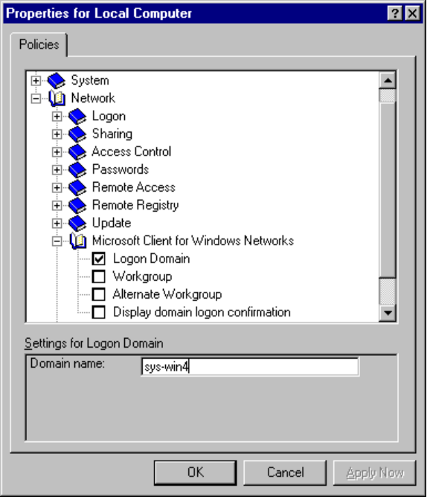
3. Click Network, then click Microsoft Client for Windows Networks, and then click Logon Domain.
4. In the Domain Name box (below), type the name of the Windows NT domain.
5. In the same Network section, click Logon. Check Validated Logon, and then check Enable Validated Logon(below).
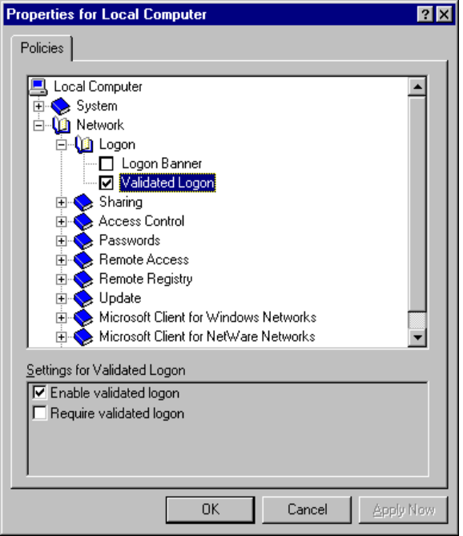
When logging on the first time, the user is required to type the name of the domain, which is maintained by the system after the first time it is specified. (If you are upgrading from a Windows for Workgroups network, this information is automatically preserved by Windows 95 and displayed to the user at logon.)
6. Now that you’ve set the computer for automatic downloading, create a policy file to be downloaded and save it in the Netlogon folder of the primary domain controller for the domain (specified in step #4), using the following form:
\\primary domain controller\Netlogon\POLICY.POL

Windows 95 then uses this path to search for a policy file.

To set up for automatic downloading on NetWare networks
1. From System Policy Editor, choose to view the local Registry. (This is the default view; if the local Registry is not what is shown, from the File menu, click Open Registry.)
2. Double-click Local Computer to see the following property sheet.
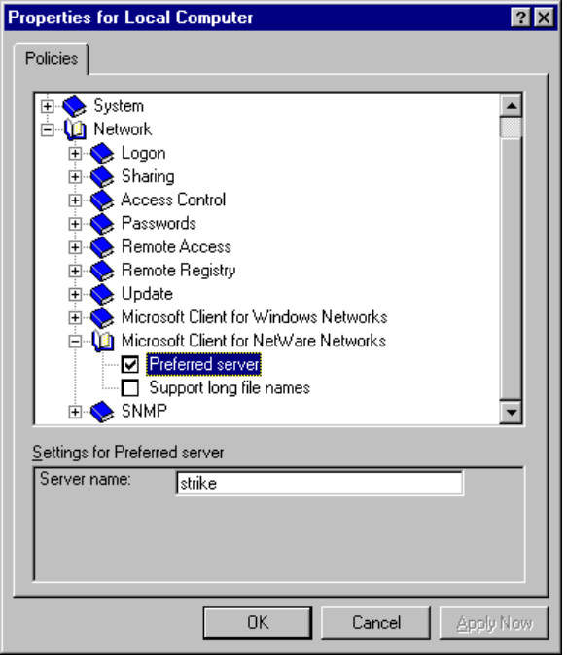
3. Click Network, then click Microsoft Client for NetWare Networks, then click Preferred Server.
4. Type the name of the Novell NetWare Preferred Server.
When logging on the first time, the user is required to type the name of the preferred server. This name is maintained by the system after the first time it is specified.
5. Create a policy file to be downloaded and save it in the following location:
\\Preferred Server\sys\public\POLICY.POL

Windows 95 then uses this path to look for a policy file.

As an alternative to using either of these automatic downloading procedures, when you use the Remote Update policy, you can manually download policy files (even when they are stored locally) by indicating a separate network or local computer location. Manual downloading overrides automatic downloading and gives network administrators the flexibility to determine where a user’s policies will be stored. For more information about manually downloading policies, see “Downloading System Policies” later in this chapter.
Windows 95 also provides support for a master system policy, called CONFIG.POL. If Windows 95 finds this file in the policy directory on a Windows NT or NetWare server, it automatically downloads this file to override any settings on the local computer. This gives administrators the opportunity to create one master system policy file for all users accessing a particular server. For more information about using a master system policy, see “Master System Policy” later in this chapter.
System administrators can choose to define default computer and default user entries, or specific user and specific computer combinations.

To reduce the management load, minimize the number of specific user and specific computer entries for your system policy file.
Tip

It’s best to create a policy file containing both user and computer entries to reside in the NETLOGON directory of a Windows NT server or the PUBLIC directory of a NetWare server. As applicable for your work environment, you can also choose to create a master system policy that overrides all local settings for all users automatically. This also ensures users cannot make permanent changes, because each time they boot their system, a master system policy file is downloaded.

About System Policy Editor
The System Policy Editor is a tool included with Windows 95 that exposes Registry entries that are commonly used in system policies. You can use these entries to set a user-specific and computer-specific policy, as specified in “System Policies for Users” and “System Policies for Computers” earlier in this chapter.
As shown in the following illustration, the system policy entries you set through System Policy Editor are reflected in the policy file (shown here as POLICY.POL), which, in turn, updates the Registry when the user logs on. (A system policy file can be named anything, except for CONFIG.POL, which is the name reserved for a master system policy file).
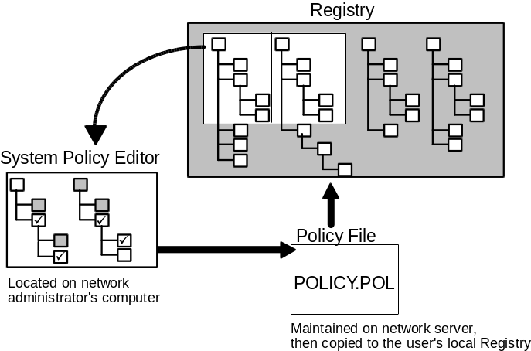

Using System Policy Editor to Create System Policies
System administrators can use System Policy Editor to create and modify system policies.

How do I set system policies?
To run System Policy Editor
- From the Start menu, choose Programs, then Accessories, and then System Tools. Click Admin Configuration Tool.

When you start System Policy Editor, you are looking at the contents of the Windows 95 Registry through a front-end tool.
Important
Any changes made to Local User are immediately implemented in USER.DAT and any changes made to Local Workstation are immediately implemented in SYSTEM.DAT. (For more information about editing the Windows 95 Registry with System Policy Editor, see the “Remote Administration” section later in this chapter.)

With System Policy Editor you can:
- Set the default computer and user policy entries (through the Default Computer and Default User icons).
- Create entries for individual users and computers (through the Edit menu, by clicking Add New User or Add Computer). By default, these will include the policy entries you defined for Default User and Default Computer .
- Define master system policies in a CONFIG.POL file. Administrators can create a file called CONFIG.POL to automatically override any local user’s Registry settings. This allows network administrators to put standardized policies for all users in place and maintain full control over them.
- Specify whether and how you want policies downloaded from a centralized server or whether you want to have policies downloaded from other specific locations for all or certain types of users.

Two System Policy Editor Modes
System Policy Editor is a tool you can use for two main tasks:
- In Registry mode, you can edit the Registry of the local computer or a remote computer. (For more information about editing the Registry for a remote computer, see “Remote Administration” later in this chapter.) Using this mode, you directly edit the contents of the Registry and changes are reflected immediately.
- In Policy File mode, you can create and modify system policies for implementation on other computers. When you use this mode, the Registry is edited indirectly. Changes are reflected only once the policy is implemented.

When you start System Policy Editor, you can use Registry mode, as shown in the following example, by selecting Open Registry from the File menu. Notice that the title bar displays “Local Registry”.
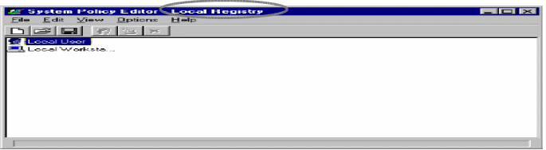

System Policy Editor in Registry mode
When you open a policy file (with File New or File Open), you use the System Policy File mode. The title bar shows either “Untitled” (if you haven’t yet saved a new policy) or the policy filename as shown in the following example:
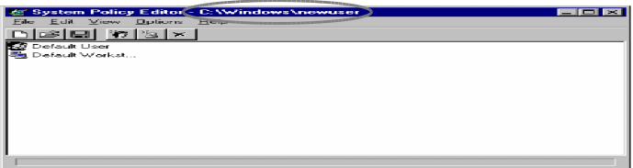

System Policy Editor in Policy File mode

Modifying System Policy Files
Typically, when you use System Policy Editor in Registry mode, you make changes by checking and clearing Registry options. These changes are made in real time, meaning that they are made immediately and not saved to update the Registry later on (as in the case of Policy File mode).
When using System Policy Editor in Policy File mode, to work with system policy files (.POL files), the process is slightly different. With .POL files, changes to the Registry aren’t made until the next time the user logs on. Instead of being able to check or clear the Registry Options, you now have three options for each option:
- Checked means the policy file will be implemented, thus changing the state of the user’s computer to conform to the policy. If the option was checked already from the last time the user logged on, Windows 95 makes no changes.

- Cleared means the policy will not be implemented. If it was implemented before, the state of the computer changes so that the policy is no longer enforced.

- Grayed means the policy is unchanged from the last time the user logged on. Windows 95 will make no modifications.


Allowing three states for policies provides ease of use to the network administrator and logon speed to the user. When a user logs on and Windows 95 implements a policy file, only the checked and cleared boxes are considered. Grayed boxes are ignored by Windows 95. Not only does this provide an easy way for administrators to choose the policies that are important to them, but it also allows Windows 95 to make the appropriate modifications to the Registry very quickly. As more and more corporate administrators and software vendors develop custom policy files (.ADM files) with extensive policy listings, Windows 95 can continue to ensure quick processing because it does not need to process each entry each time a user logs on.

How to View or Edit Default System Policies
To view or edit default system policies
1. In System Policy Editor, click New from the File menu to open a new policy file. Notice that a new file will be listed as “Untitled” in the title bar, as shown here:
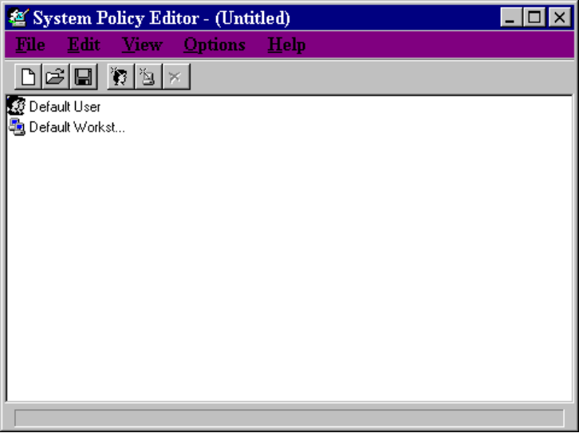
2. Double-click either the Default User icon or the Default Computer icon.
- Default user defines the default settings for user-specific policies.
- Default computer defines the default settings for computer-specific policies.

Policies for Individual Users or Computers
To create system policies for a new user or computer
1. In System Policy Editor, click Add User or Add Workstation from the Edit menu.

There is no limit to the number of individual users or workstations you can add, although you will reach a point to where you may want to have users copying policy files from more than one server to better balance network traffic. Given how quickly the logon process works, you will probably not reach that point until you have added approximately 1,000 users.
Note

2. Click the policies you want to put in place. Clicking the policy places a check mark next to it. Clicking it again clears the check mark.
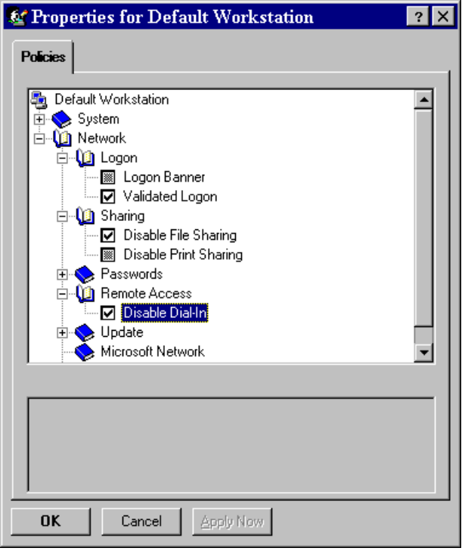

To edit existing system policies
1. From System Policy Editor, click the icon of the user or computer whose policies you want to edit.
2. Check or clear policies by clicking the policy name.

Master System Policy
As described earlier, a master system policy is the mechanism by which an administrator can exercise the most control over end user’s security privileges, network access, and desktop configuration. A master policy file, whose name is always CONFIG.POL, will override all local settings for all users.

A master policy file must be named CONFIG.POL. If you change this filename, Windows 95 will not recognize it as a master policy file.
Important

To create a master system policy
1. Create a customized system policy (.POL) file as described above.
2. Save this file as CONFIG.POL in the NETLOGON directory on a Windows NT server, or in the PUBLIC directory on a NetWare server.
Whenever any user logs on to this domain or preferred server, Windows 95 automatically copies this master policy to the local computer, thus overriding all local computer settings.

Downloading System Policies
System policies can be downloaded from the network in two ways — automatically or manually.
To automatically download user policies when users log on
- Save the policy file in the NETLOGON directory on a Windows NT server or the PUBLIC directory on a NetWare server
- If the server is unavailable, no error occurs, the system starts up with the default configuration.

To manually download user policies when users log on
1. From System Policy Editor, click the Local Workstation icon.
2. Click Network, then click Update, then check Remote Update.
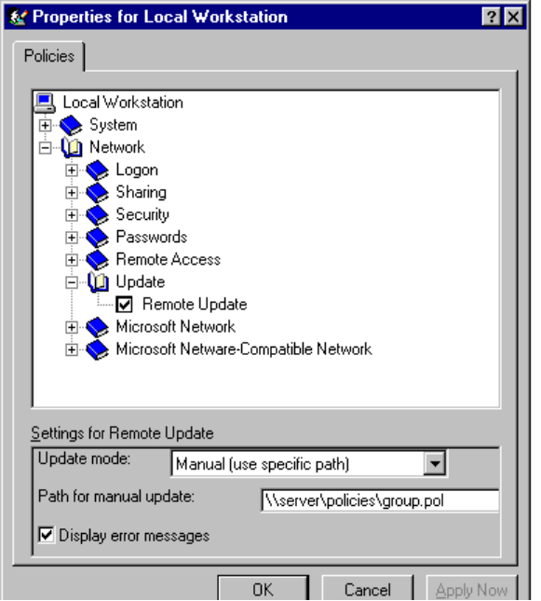
3. New fields for Settings for Remote Update are displayed at the bottom of the dialog box. In the Update Mode field, select Manual.

Manual downloading will work only after the first time system policies are automatically downloaded following Setup. The first downloading is always automatic and provides the user-specific policy information which lists the location to be used for manual downloading.
Note
It’s possible to set up each computer for manual downloading individually, but this is a time-consuming alternative. It’s better to set up each computer for automatic downloading, and then use the remote update option to point specific computers to other servers as appropriate for your environment and users.

4. Type the UNC path for the system policies file you want to download. Be sure this file exists in the location you specify. (If it doesn’t, an error will result.) Click OK.

Using Load Balancing to Download System Policies for Windows NT Networks
As mentioned earlier, Windows 95 automatically downloads system policies from the NETLOGON directory of a Windows NT server or the PUBLIC directory of a NetWare server. On large networks, when thousands of users log on at the same time, all accessing the same policy file, you could potentially experience slow network performance.
To avoid a bottleneck, Windows 95 offers load balancing on Windows NT networks. With load balancing enabled, policies will be taken from the logon server (which can be a domain controller or a backup domain controller) rather than the primary domain controller. This spreads the load over a number of servers but does require that an administrator replicate the policy file on each server.
To enable load balancing
- From System Policy Editor, check the Remote Update option, as shown in the following example. Also check the Load Balance option in the area below.
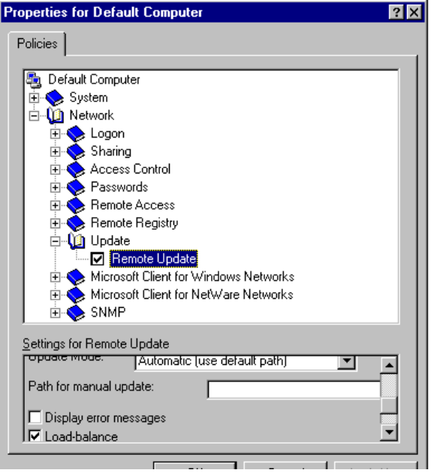

To use load balancing, make sure it is enabled on each client computer. Also, make sure you have a policy file on each server that will potentially participate in load balancing (including all Windows NT domain controllers and servers).
Note
One convenient way to implement is to designate a single default server from which policy files are copied by client computers not yet participating in load balancing. When one of these computers copies this policy file from the server, the policy file will enable load balancing on the client computer.

System Policy Examples
This section provides some examples for how you might use specific policies in your organization.
To assist network administrators begin implementing system policies in their environments, we have created a few examples of recommended configurations. These policy files are .POL files and will be included with the Windows 95 Resource Kit utilities in the final version. You will be able to use these policy files “as is” or with further customization.

Recommended Standard Desktop Configuration
The following system policy example allows administrators to implement a recommended level of control over the end user’s desktop functionality while allowing specific corporate customization. This system policy file is called STANDARD.POL.
STANDARD.POL includes following recommended restrictions and additions:

Restrictions:
- Restrict the Settings page of the Display Control Panel. This allows users to customize their environment but keeps them away from the more serious display control settings.
- Restrict the entire Network Control Panel.
- Restrict the entire Printer Control Panel.
- Restrict the entire System Control Panel.
- Restrict the entire Passwords Control Panel.
Restricting these four Control Panels completely is highly recommended; average users should have no need to modify these settings.
- Disable File and Print Sharing.
- Disable Registry editing tools.
- Disable Remote Dial-in.
Disabling the preceding three features is a standard safety precaution for most corporate environments.

Additions:
- Add Custom Programs Folder.
- Add Custom Startup Folder.
- Add Custom Network Neighborhood.
- Add Custom Start Menu.
This preceding four options provide an opportunity for corporate customization. With these options, an administrator can define a specific program group with a specific vertical or corporate application, an application which is run each time the computer is started, a specific set of computers available in the Network Neighborhood, and a specific Start menu that can have a smaller or custom set of choices that users can use on a regular basis.
- Enable User Profiles. This allows users to change their background colors, fonts, and so forth.
- Enable User-level Security.
- Add Logon Banner.
- Require Validated Logon.
- Require Minimum Password Length. This is a standard corporate security measure.
- Determine Logon Domain and Workgroup for Microsoft Network Client.
– Or –
Determine Preferred Server for NetWare Client. Choose either of these to make the appropriate network settings.
- Enable Remote Registry Service. This allows computers to be remotely administered.

To create the STANDARD.POL system policy

This file will be available with the Windows 95 Resource Kit utilities in the final version. These steps are provided so you can better understand how this policy file was created.
Note

1. In System Policy Editor, choose New File from the File menu.
2. Double-click Default Computer to open policies for the workstation.
3. Click System, then check Enable User Profile.
4. Click Network, then click Logon.
5. Check Logon Banner and type the text for a banner in the text box. Your system policy file should look like this:
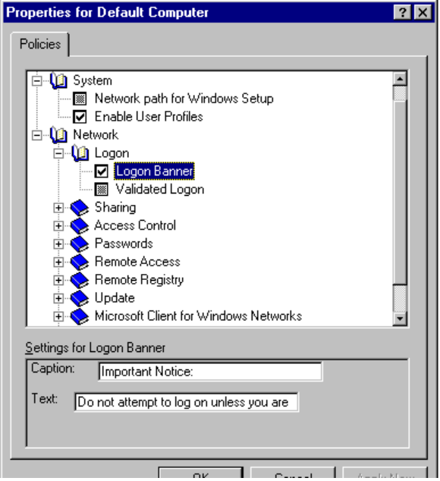
6. Check Validated Logon, and then check Require Validated Logon.
7. Click Access Control and check User-Level Access Control. Then type the Authenticator Name and Authenticator Type in the text box. For example, suppose you are using a Windows NT domain and an authenticator called “SYS-WIN4”. Your policy will look like this:
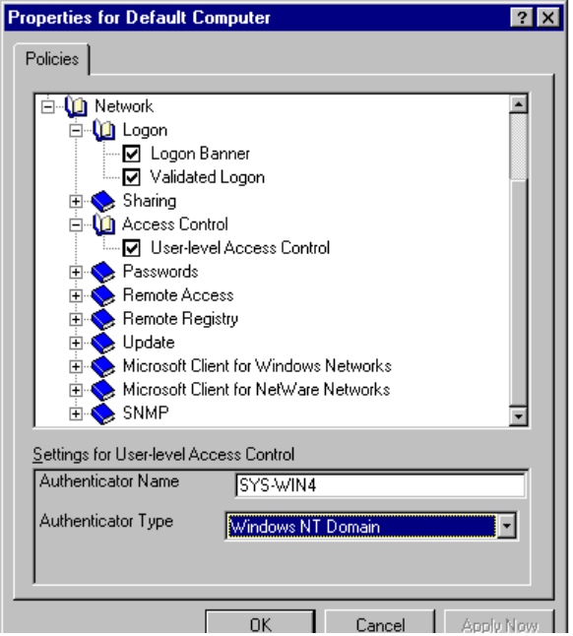
8. Click Passwords, then check Minimum Password Length and specify the minimum number of characters.
9. Click Remote Access and check Disable Dial-in.
10. Click Remote Registry and check Enable Remote Registry Service. Make sure you have also installed the Remote Registry Service files through the Network Control Panel. For more information, see Chapter 4, “Network Setup.”
11. Click Microsoft Client for Windows Networks and check Logon Domain. Type the Logon Domain name in the text box.
12. Check Workgroup and type the Workgroup name in the text box. Click OK.
13. Double-click the Default User icon.
14. Click Control Panel, then click Display. Check Restrict Display Control Panel and check Hide Settings Page, as shown here:
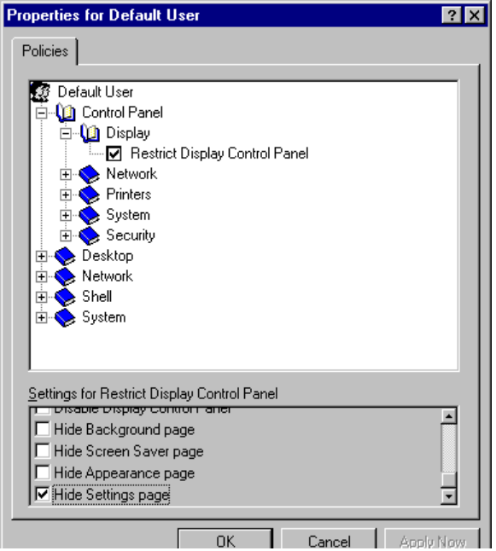
15. Click Network and check Restrict Network Control Panel, then check Disable Network Control Panel.
16. Click Printers and check Restrict Printers Settings, then check Hide General and Detail Pages, Disable Removal of Printers and the Disable Addition of Printers.
17. Click System and check Restrict System Control Panel box, then check Hide Device Manager Page, Hide Configuration Page and Hide Advanced Button.
18. Click Security and check Restrict Passwords Control Panel box, then check Disable Passwords Control Panel.
19. Click Network, click Sharing, and check Disable File Sharing Controls and Disable Print Sharing Controls.
20. Click Shell, click Custom Folders. Then check the following options and type the corresponding UNC path addresses:
- Custom Programs Folder | - Custom Startup Folder
- Custom Network Neighborhood | - Custom Start Menu
Make sure you have placed customized Programs and Startup folders, customized Network Neighborhood and Start Menus in this secure network location. (That is, simply customize a desktop accordingly and save the applicable groups from the Windows Explorer to the secure network location.)
21. Click OK and save this policy file to appropriate server location(s).

Now when users log on, these customized will take effect on the users’ desktops.

How STANDARD.POL Affects Users
The following are illustrations showing the impact of implementing the standard desktop controls defined in STANDARD.POL, the standard system policy described above:
- When a user tries to access a disabled Control Panel, a message from the administrator such as the following will display to indicate that the Passwords Control Panel has been disabled:
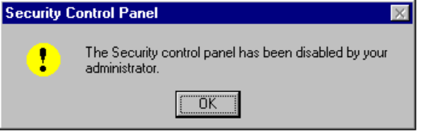
- When a user tries to access disabled file sharing controls, a set of property sheets, such as the following, is displayed. Notice that before sharing controls are turned off, an extra Sharing tab is available to the user.
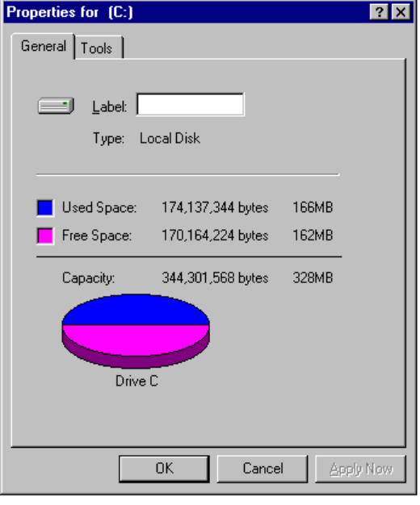

Recommended Maximum Information Systems Control Sample Policy File
If you have an environment where you need to have as much control as possible over the users’ computing environment, the following sample policy file will assist you in establishing the highest possible level of control.

The file created by the following procedure is called MAXIMUM.POL and will be included with the Windows 95 Resource Kit utilities in the final version. Again, the following procedure is included so you can better understand how this policy file was created.
Note

To implement maximum control over the desktop
1. From System Policy Editor, open the STANDARD.POL file (described above).
2. Double-click Default User, and then click Shell. Click Restrictions and check the following:
- Remove Run from Start Menu. This prohibits users from running any application from the command line.
- Remove folders from Settings on Start Menu.
- Remove Taskbar from Settings on Start Menu.
- Remove Find from Start Menu. This prohibits users from changing settings or searching for files.
- Hide all items on the Desktop. This completely hides anything on the desktop and gives access only to the Start button, to which you can add your key applications.
- Disable Shut Down command. This prevents users from closing down Windows 95.
3. Click OK and save this file as MAXIMUM.POL in the appropriate network location.

System Policy Templates
When you start System Policy Editor, Windows 95 opens the default policy template, containing existing policies that the administrator can enable or modify. A template is simply a listing of the possible policies an administrator can use for their environment. By default, this template file is named ADMINCFG.ADM in the Windows INF directory. You can alternately create and use other files as templates.
Creating your own template is helpful when you want to define a specific set of Registry settings, including settings not definable by default through System Policy Editor, in your system policies. As illustrated below, the template defines the policies you can set through System Policy Editor. Changes you make there are reflected in the policy file (shown here as POLICY.POL), which in turn updates the Registry when the user logs on.
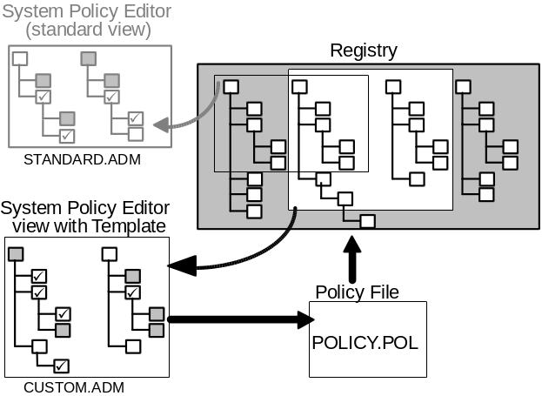
To use a template different from the default template
1. In System Policy Editor, make sure all policy files are closed.
2. Click Template from the Options menu.
3. Click Open Template and select a new .ADM file to act as your template for setting System Policies. Click Open.
4. Click Close to return to System Policy Editor.
5. Edit the policy, as needed, with your new template (.ADM file) loaded.

Remote Administration
Windows 95 includes some powerful tools to help network administrators better manage their computers running Windows 95. The key remote management tools included in Windows 95 are System Policy Editor, Registry Editor, System Monitor, and Net Watcher.

What remote administration tasks can you do with Windows 95?
System Policy Editor. As mentioned already in this chapter, this tool can be used for two main tasks — editing Registry entries in real time for local or remote computers, and creating and editing system policies.
Registry Editor. This is the Registry editing tool for Windows 95 that can be used on local or remote computers (via RPC). With Registry Editor, network administrators can directly read and write values that are contained in the Local User and Local Workstation settings portions of the Windows 95 Registry. Administrators are able to read current settings, make modifications, create new keys, or delete current keys.
System Monitor. This is an enhanced performance monitoring utility that gives network managers the ability to quickly troubleshoot performance problems. System Monitor can provide performance information from any virtual device driver (VxD) including those for the file system and network redirectors. System Monitor works both for local computers, and for remote computers using the RPC protocol.
Net Watcher. This is an interactive utility for creating, controlling, and monitoring remote shared resources. Administrators can use Net Watcher to perform remote network administration functions including:
- Creating, adding, and deleting shares
- Monitoring who is connected to which resource and changing if required

Windows 95 also can be used with both Simple Network Management Protocol (SNMP) and DMI-based systems management products such as HP Openview for Windows, Intel LANDesk, IBM LAN NetView, Sun NetManager, Novell NMS and Microsoft System Management Server. Windows 95 includes built-in SNMP and DMI (not in first release) agents, requiring only that network administrators install a third-party product to manage client computers. No modifications to the client computers are needed.

What support does Windows 95 offer for third-party system management tools?

DMI support will not be in the first release of Windows 95.
Note

Setting Up Computers for Remote Administration
The cost of supporting personal computers is estimated to be approximately 80% of the total cost over the lifetime of the computer. Sending out network administrators or Help Desk technicians to fix users’ problems is expensive and time-consuming. Windows 95 helps to reduce this support burden by including several tools that allow remote administration of networked computers running Windows 95.

It’s best to enable remote administration when you run Setup to install Windows 95. However, you can also enable remote administration after Setup.
Note

Enabling remote administration is a two-step process.
1. Enable remote administration and grant the administrator remote administration privilege to the remote computer. This gives the network administrator the ability to use Net Watcher and to remotely manage remote computer resources, including the file system and shared resources.

Granting remote administration privilege gives the person full access to all shared resources on the system (including the ability to add and remove other remote administrators). Granting or removing remote administrator access from a user does not take effect until the user next connects to the Windows 95 system.
Note

2. Add a service to remotely manage the Registry. With this service enabled, the administrator can access the remote computer using System Policy Editor or Registry Editor and to make real-time changes to the remote computer’s Registry.

In the process of enabling remote administration on a computer, two special resources are created.
- ADMIN$ gives administrators access to the file system on the remote computer.
- IPC$ provides an interprocess communication (IPC) channel between the two computers.
To enable remote administration and grant remote administration privilege

How do I set up computers running Windows 95 to be remotely administered?
1. From the Start menu, choose Settings, then Control Panel.
2. Double-click the Passwords Control Panel icon.
3. Click the Remote Administration tab and click Enable Remote Administration of This Server.
4. For share-level security, type an access password in both the Password and Confirm Password text boxes.
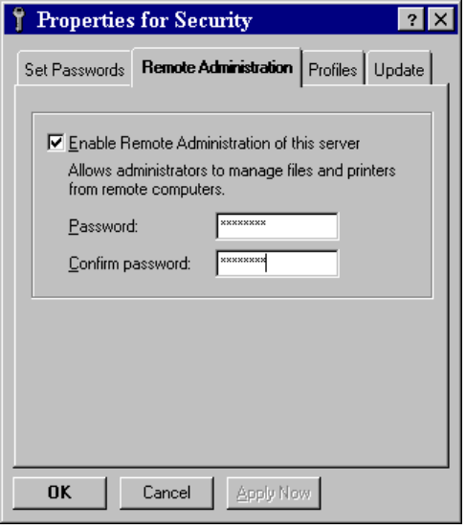
For user-level security, select the specific individuals or groups to be granted Remote Administration privileges.
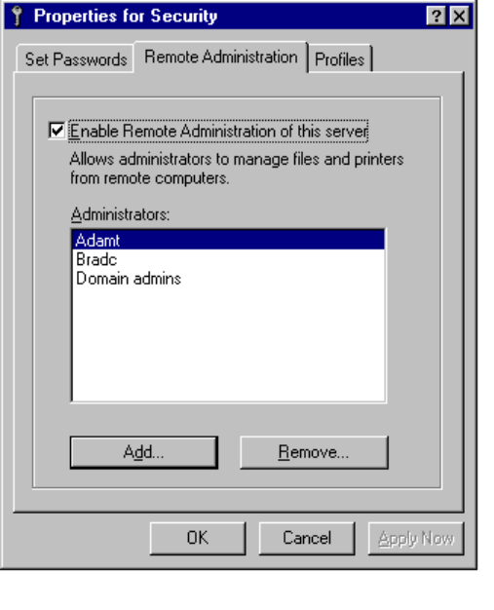

To add a service to remotely manage the Registry
1. From the Control Panel, double-click the Network Control Panel icon.
2. From the Network Control Panel, click Add.
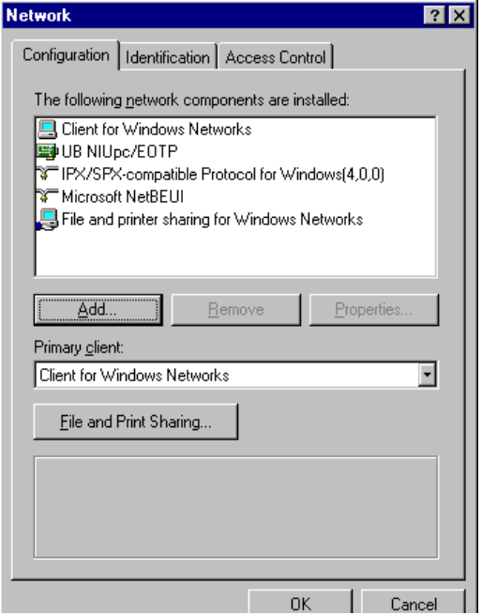
3. From the Select Network Component Type dialog box, select Service, and click Add.
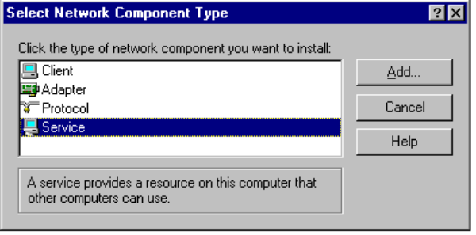
4. From the Select Device dialog box, select Microsoft from the Manufacturers list box, and select Microsoft Remote Registry from the Models list box. Click OK.
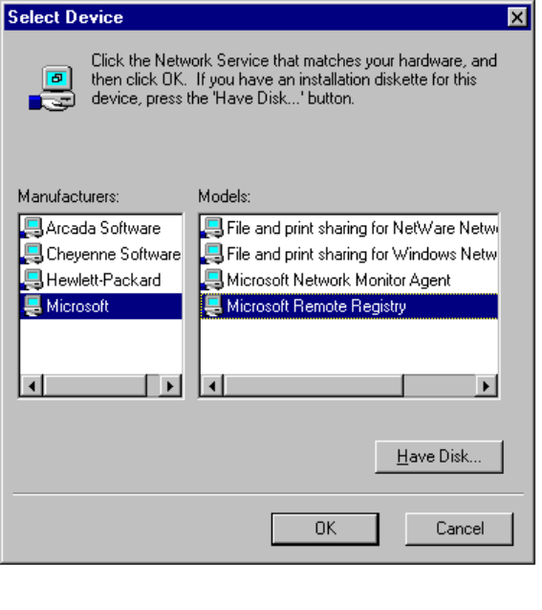

Using Network Neighborhood for Remote Administration
With Windows 95, you can remotely manage a computer by starting System Policy Editor, Registry Editor, Net Watcher, or System Monitor tool, then connecting to that computer. (Each of these tools is discussed later in this chapter.)
You can also right-click the remote computer from within Network Neighborhood as another means to use these tools remotely.
To remotely manage computers in the local workgroup using Network Neighborhood
1. Double-click Network Neighborhood.
2. Right-click the icon of the computer you want to administer. Click Properties.
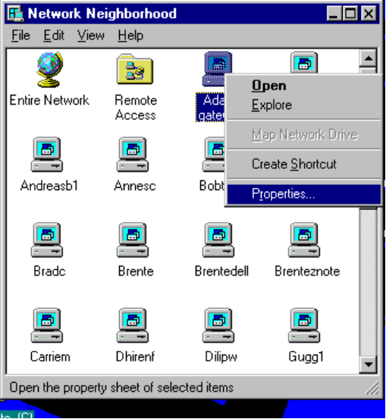
3. Select the Administration Tools tab.
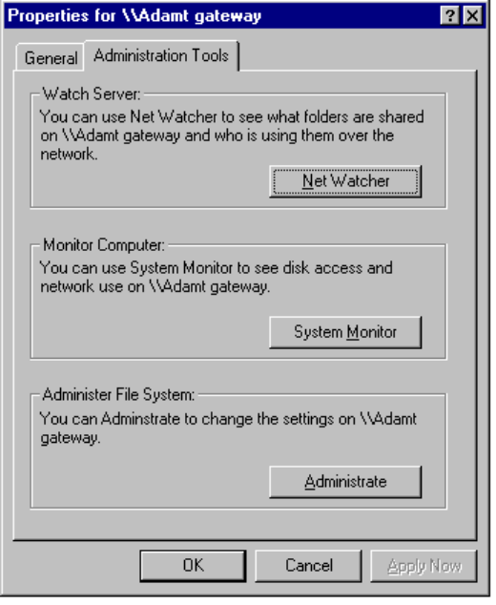
4. Click the button for the system management tool you want to use:
- By selecting Net Watcher, you can launch the Net Watcher tool automatically connected to the specified computer.
- By selecting System Monitor, you can launch the System Monitor tool automatically connected to the specified computer.
- By selecting Administrate, you can open My Computer on your own desktop for the specified computer so you can manage files on that computer.

Making Remote Registry Changes with System Policy Editor
The changes you make with System Policy Editor in Registry mode will change the remote Registry as soon as you save your changes. These policy changes immediately apply to the user or the computer.
To remotely edit the Windows 95 Registry on another computer
1. From the System Policy Editor, choose Connect from the File menu.
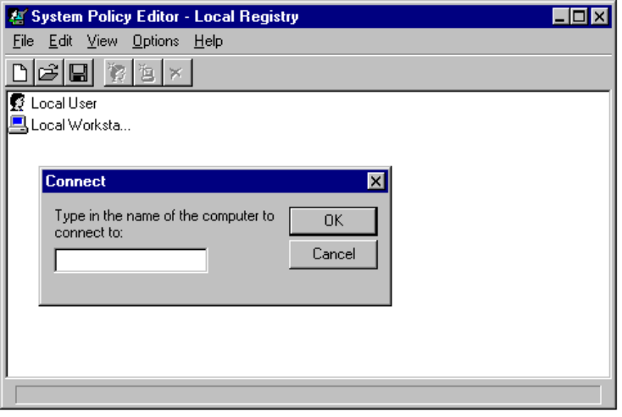
2. Type the name of the computer you want to remotely administer. Use the Computer Name listed in the Network Control Panel. Windows 95 connects to the Registry on the computer you specified (assuming you have appropriate permissions).
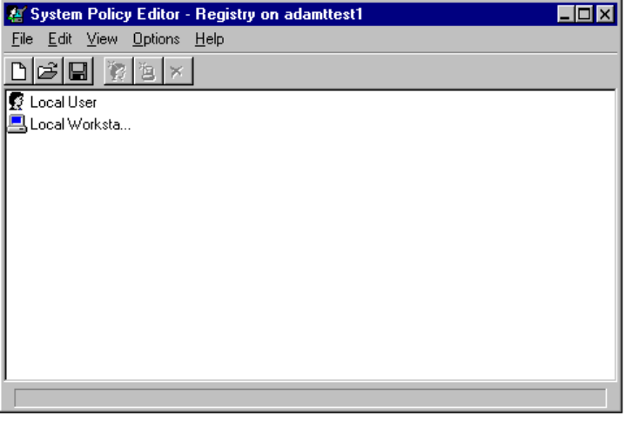

The only way to tell whether you are viewing a local or remote Registry by noticing the computer name shown in the title bar of System Policy Editor.
Note

All changes made to the remote Registry take effect immediately.

Example: Editing a Remote Registry with System Policy Editor
To remove the ability to use the Run command from the Start menu
1. From System Policy Editor, double-click the Local User icon.
2. From the Properties for Local User, click Shell, and then click Restrictions.
3. Check Remove Run from Start Menu.
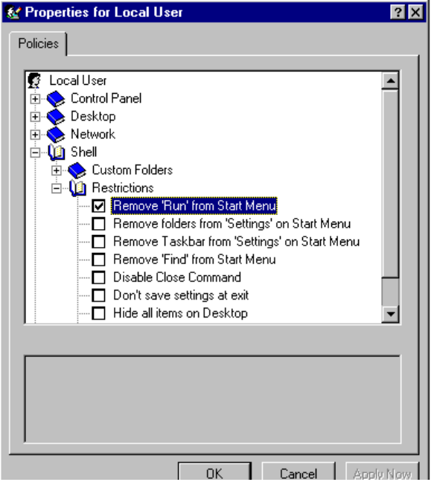
4. Click OK, and then click Save from the File menu.

If the user tries to use the Run command before logging off and then back on, Windows 95 displays a message saying that says the operation is canceled because of restrictions in effect on the computer, and directing the user to contact the system administrator. Once the user logs off, then on again, the Start menu will no longer display the Run command.
Note

Making Remote Registry Changes Using Registry Editor
Network administrators may have occasion to remotely edit the Registry on a computer running Windows 95 to solve a particular user problem. Although many things can be remotely solved by using system policies, you can also use Registry Editor to directly make immediate changes to another system.

Registry Editor is a very powerful tool and should not be used by anyone other than an authorized network administrator. Changes made take immediate effect.
Caution

To place Registry Editor (Regedit) icon on your desktop
1. From the Start menu, click Programs, and then click Windows Explorer.
2. In the left pane of the Windows Explorer, double-click the Windows folder to view its contents.
3. From the right pane, right-drag the Regedit icon to your desktop.
4. Choose Create ShortCut Here from the context menu that appears.

To remotely edit the Windows 95 Registry on another computer
1. Double-click the Registry Editor (Regedit) icon.
2. Click Connect Network Registry from the Registry menu.
3. In the text box, type the name of the computer you want to remotely administer.
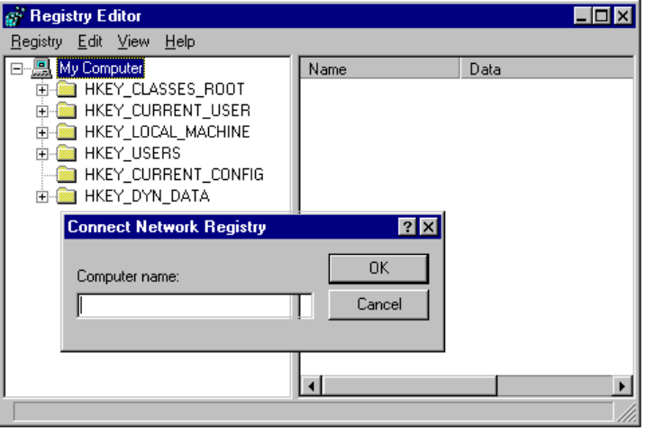
4. Windows 95 changes the contents of the Registry Editor to include the local Registry on top and the remote Registry on the bottom, as shown in the following example:
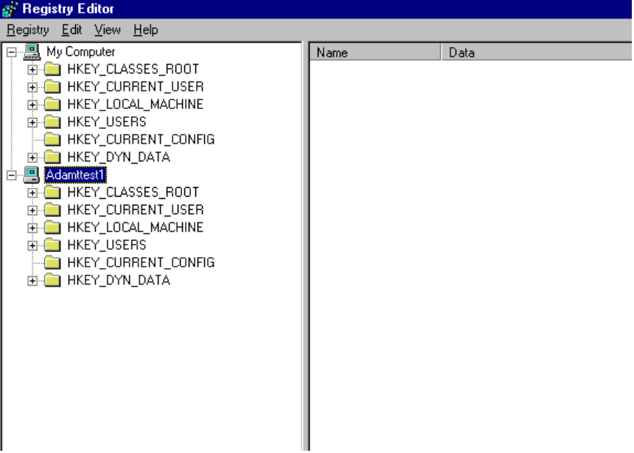

Example: Editing a Remote Registry with Registry Editor
To change a persistent network connection on a remote users computer
1. Connect to the users computer as described in the procedure above
2. Click Hkey_Current_User, click Network, and then click Persistent.
You now see the user has three drives currently associated as persistent network connections, as shown below. In this example, drive F is persistent to the network share \\Pyrex\Psgmktg, but should be persistent to the shared network directory \\Pyrex\User.
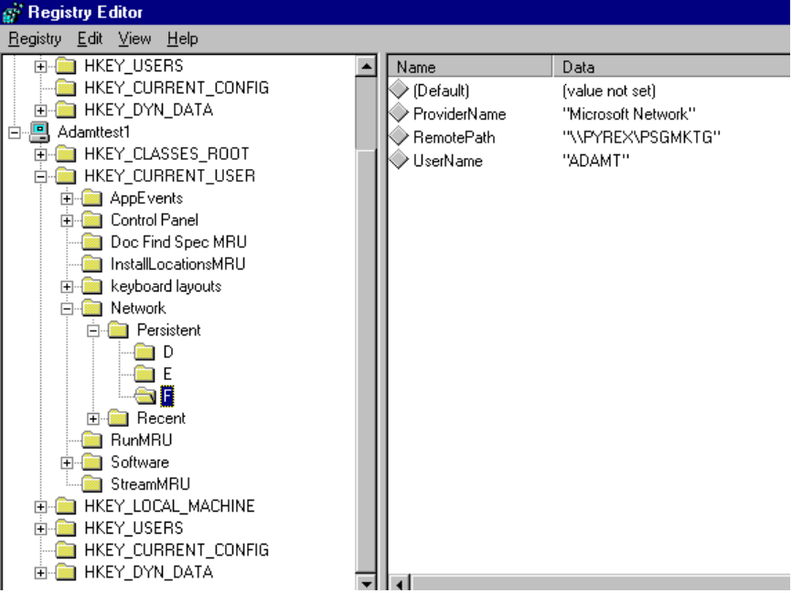
3. Double-click Remote Path to change drive F to point to \\Pyrex\User.
4. When the Edit String dialog box displays, type in the new path of \\Pyrex\User and click OK.
The next time the user logs onto Windows 95, drive F will be a persistent connection to \\Pyrex\User.
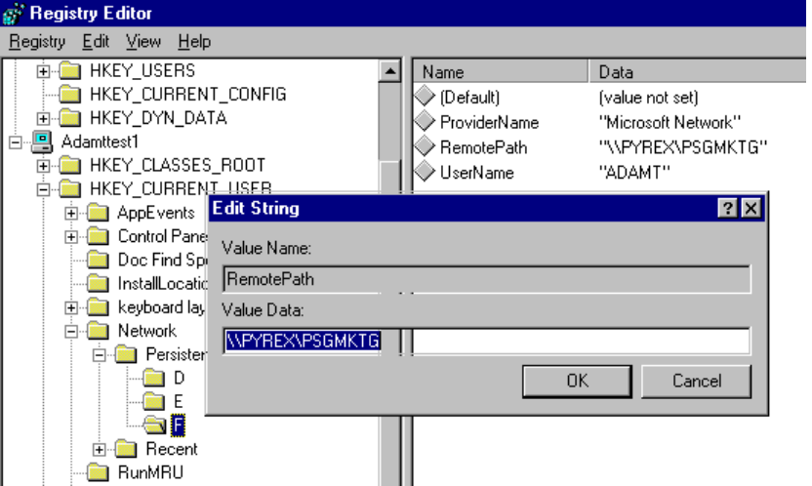

For this example to work when user profiles are enabled, the user whose settings are being edited must be logged on at the time the computer is being administered. If the user is logged off, only the default profile is changed.
Note

For a thorough discussion of the Windows 95 Registry, see Chapter 25, “Windows 95 Registry.”

Using System Monitor
System Monitor is a tracking tool that monitors the real-time performance of various computer components, functions, and behaviors and displays the results in graphs or charts. This information is useful in locating bottlenecks and solving other performance problems.
Collected over time, counter statistics show performance trends. These can help an administrator tune or troubleshoot the computer. For example, monitoring memory and swapping activity can help determine if the computer needs a new hard disk drive or just some more RAM.
The following example shows System Monitor statistics for the number of reads per second and the amount of dirty data processed by the 32-bit file system.
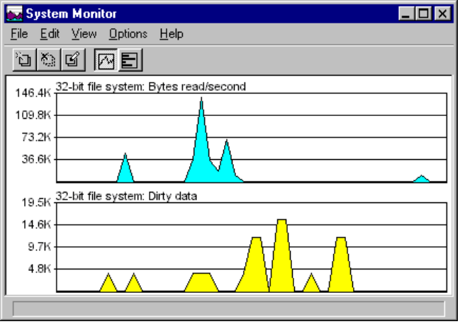

System Monitor Functionality
System Monitor tracks functionality for the following six categories:
- 32-bit file system | - Microsoft Network Server
- IPX/SPX-compatible protocol | - SMB redirector
- Kernel | - Virtual Memory Manager

The following tables describes in detail settings for these categories:
IPX/SPX Compatible Protocol
Setting | Comment
IPX Packets Lost Per Second | The number of IPX packets received from an IPX network that were ignored
IPX Packets Received Per Second | The number of packets received from an IPX network each second
IPX Packets Sent Per Second | The number of packets sent to an IPX network each second
Open Sockets | The number of free sockets
Routing Table Entries | The number of IPX interworking routes known
SAP Table Entries | The number of service advertisements known
SPX Packets Received Per Second | The number of packets received from an SPX network each second
SPX Packets Sent Per Second | The number of packets sent to an SPX network each second

Kernel
Setting | Comment
Processor Usage (%) | The approximate percentage of time the processor is busy
Threads | The current number of threads present in the system
Virtual Machines | The current number of virtual machines present in the system

Microsoft Network Server
Setting | Comment
Buffers | The number of buffers used by the server
Bytes Read | The total number of bytes read from a disk
Bytes Written | The total number of bytes written to a disk
Memory | The total memory used by the server
NBs | Server network buffers
Server Threads | The current number of threads used by the server
Throughput | The total number of bytes read from, and written to a disk

SMB Redirector
Setting | Comment
Bytes Read Per Second | The number of bytes read from the redirector each second
Bytes Write Per Second | The numbers of bytes written to the redirector each second
Transactions Per Second | The number of transactions managed by redirector each second

Virtual Memory Manager (VMM32)
Setting | Comment
Allocated memory | The total amount of allocated memory in bytes.
Discards | The number of pages discarded each second.
Disk Cache Size | The current size of the disk cache in bytes.
Free Memory | The total amount of free memory in bytes.
Instance Faults | The number of instance faults each second.
Locked Memory | The amount of allocated memory that is locked.
Maximum Disk Cache Size | The largest size possible for a disk cache.

Virtual Memory Manager (VMM32) Continued
Setting | Comment
Minimum Disk Cache Size | The smallest size possible for a disk cache.
Other Memory | The amount of allocated memory that is not stored in the swap file; for example, memory mapped files, non-pageable memory, and disk cache pages.
Page Faults | The number of page faults each second.
Page-ins | The number of pages swapped into memory each second.
Page-outs | The number of pages swapped out of memory each second.
Swapfile Defective | The number of bytes in the swap file that are found to be physically defective on the swap medium. Because swap file frames are allocated in 4000-byte blocks, a single damaged sector causes the whole block to be marked as defective.
Swapfile In Use | The number of bytes being used in the current swap file.
Swapfile Size | The size of the current swap file in bytes.
Swappable Memory | The number of bytes allocated from the swap file. Locked pages still count for the purpose of this metric.

32-bit File System
Setting | Comment
Bytes read per second | The number of bytes read from the file system each second.
Bytes written per second | The number of bytes written to the file system each second.
Dirty data | The number of bytes waiting to be written to the disk. Dirty data is stored in cache blocks, so the number reported may be larger than the actual number of bytes waiting.
Reads per second | The number of read operations delivered to the file system each second.
Writes per second | The number of write operations delivered to the file system each second.

By using the System Monitor extensible interface, third-party companies can add their own categories and data items.
Note

To create a picture of a computer’s performance
1. From System Monitor, select the categories and items to be tracked.
2. Click the graph or chart button.

With the appropriate privileges, you can use System Monitor over the network to track the performance of remote computers. To monitor more than one computer simultaneously, simply launch multiple instances of System Monitor and connect to the appropriate computers (or alternatively, browse through Network Neighborhood and select the computers directly).
To remotely view performance data with System Monitor

How do I remotely administer one computer running Windows 95 from another?
1. From the Start menu, choose Programs, then Accessories, then System Tools. Click System Monitor.
2. In System Monitor, click Connect from the File menu.
3. In the Connect dialog box, type the name of computer.
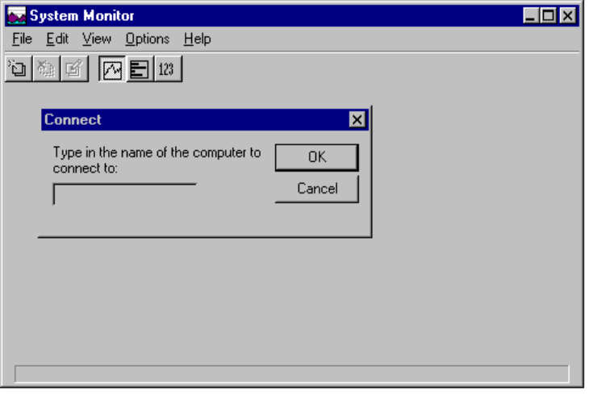
4. Click Add Item from the Edit menu and specify the areas you want to monitor (for example, 32-bit file system). Select the category (for example, 32-bit file system) and then the item (for example, bytes read per second and bytes written per second). Click OK.

You are now ready to monitor the read activity on the remote computer. As the remote computer reads and writes to disk, you are can easily monitor the exact performance from your computer running Windows 95 as shown in the following example:
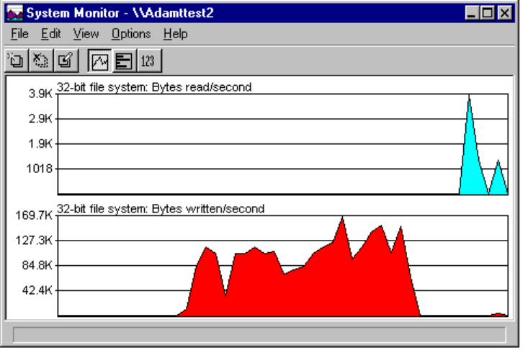

Using Net Watcher
Net Watcher is the Windows 95 tool for creating, controlling, and monitoring remote shared resources. Net Watcher includes a set of icons that make it easy to do the following:
- Add a shared resource | - Show connected users
- Show all shared resources | - Disconnect a user
- Stop sharing a resource | - Show open files
- Close files users have opened

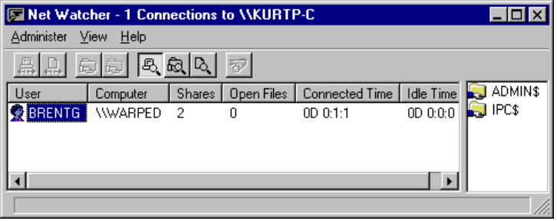

Setting Up a Net Watcher Window for a Remote Computer
You can display a Net Watcher window for a remote computer by doing either of the following:
- Browse Network Neighborhood and choose the target computer on the network.
- Right-click the computer icon, then click Properties. From the property sheet, click Net Watcher. (For more information, see “Using Network Neighborhood for Remote Administration” earlier in this chapter.)

Windows 95 prompts for the appropriate password, if one is needed.

Remotely Creating a Shared Resource with Net Watcher
A local resource is normally shared through its property sheet. An administrator can also share a resource remotely through Net Watcher.
To share a resource remotely
1. From Net Watcher, click the Add Share icon.
2. In the Enter Path dialog box, type the path of the resource that you want to share.
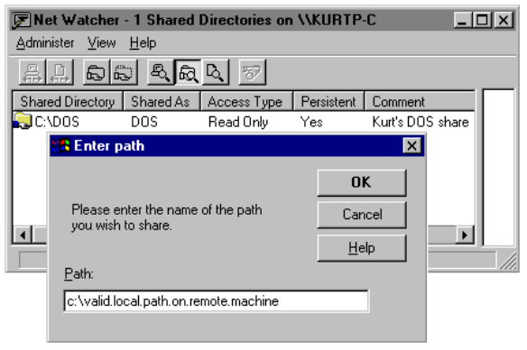

Using Third-Party Administration Tools with Windows 95
To be provided.

How do I remotely administer a computer running Windows 95 using third-party tools?

Monitoring Remote Connections From an SNMP Console
Windows 95 includes a Simple Network Management Protocol (SNMP) agent which conforms to the SNMP version 1 specification. This agent allows you to monitor remote Windows 95 connections from an SNMP console.
The agent is implemented as a Win32-based service and works using Windows Sockets over both TCP/IP and IPX. The extension agents are implemented as Win32 DLLs. (For more information about writing SNMP MIBs under Windows 95, see the SNMP section in the Windows 95 Beta-1 Software Development Kit.)
In this beta release, the agent and its corresponding RFC1156 extension agent are installed automatically when you install the TCP/IP protocol.
To start the SNMP agent on a computer
- From the Start menu, choose Run, then type snmp.exe.

The configuration information for the RFC1156 extension agent is placed in the Windows 95 Registry under the following key:
Hkey_Local_Computer\System\CurrentControlSet\Services\SNMP\Parameters

To be provided -- Details about the following:
- Using Microsoft System Management Server
- Using H-P Openview for Windows
- Using Intel LanDesk
- Using IBM LAN NetView
- Using Sun NetManager
- Using Novell NMS
- Using Microsoft Windows NT

Network Backup Agents
As a part of the system management capability in Windows 95, administrators can remotely back up user data using either of the two network-based backup agents included in Windows 95. These backup agents, from Arcada Software and Cheyenne Software, enable computers to be backed up to a tape drive on a network server.

Please note you must have the corresponding server-based network backup software from either Arcada or Cheyenne. For more information from these vendors, call Arcada at XXX or Cheyenne at XXX.
Note
Phone numbers to be provided.

Setting up Windows 95 Network-based Backup
with the Arcada Agent
To use the Arcada agent, you must have the following components:
- Arcada Backup Exec for NetWare, Enterprise Edition or Single Server Edition
- New versions of Arcada NLMs which have been specifically updated for Windows 95. These include:
- NRLTLI.NLM
- TNRLAPT3.NLM
- TNRLAPT4.NLM
- TNRLTCP.NLM
- TNRLSPX.NLM
To obtain these files, please contact Arcada directly, or dial Arcada’s BBS:
Phone number: | 407-262-8123
Password: | nlm_chicago
File to download: | CHICAGO.ZIP

- Arcada backup agent (included with Windows 95). The agent include BKUPAGNT.EXE, BKUPAGNT.RES, and BKUPNET.DLL.

To back up a computer running Windows 95 with the Arcada agent, you must first enable the Arcada agent. If you didn’t already do this during Setup, you can enable the Arcada agent through the Network Control Panel.
To enable the Arcada agent
1. Double-click the Network Control Panel icon.
2. Click Configuration tab; click Add.
3. Click Service; click Add.
4. Select Arcada Software Backup Exec Agent, as shown in the following example. Click OK.
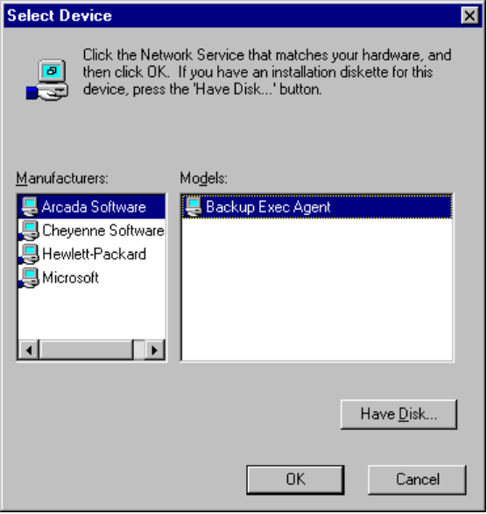

Your computer will now automatically run the backup agent (in the background) when you start Windows 95.
To run the Arcada network-based backup on a computer running Windows 95
1. You must first make a connection to the backup server to allow your computer to be backed up. You do not have to be logged on to that server.
2. Run Arcada Backup Exec (NetWare Enterprise Edition or Single Server Edition). See the Arcada Backup Exec product documentation for further information and instructions.
3. Using the Backup Exec software, the computer will be listed as a backup source. Find the computer in the list of backup sources by looking for the name that was given to the workstation in the Publisher tool.
4. Follow Backup Exec instructions for backing up a Windows workstation.

Setting up Windows 95 Network-based Backup
with the Cheyenne Agent
To use the Cheyenne agent, you must have the following components:
- Cheyenne ARCserve for NetWare (version 5.01).
- New versions of Cheyenne NLMs which have been specifically updated for Windows 95. (Please contact Cheyenne directly.) These include:
- APROCESS.NLM
- ARCOPY.NLM
- WSTAPE.NLM
- Cheyenne backup agent (included with Windows 95). The agent is only one file, ARCSRV32.EXE.

To back up a computer running Windows 95 with the Cheyenne agent, you must first enable the Cheyenne agent This is done through the Network Control Panel (if it was not already done during Setup).
To enable the Cheyenne agent
1. Double-click the Network Control Panel icon.
2. Click the Configuration tab, and then click Add.
3. Click Service, and then click Add.
4. Click Cheyenne Software ARCserve Agent. Click OK.
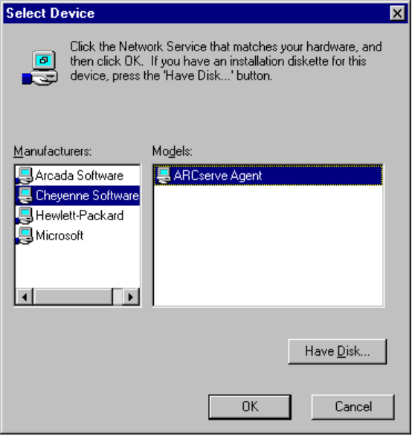

Windows 95 will now automatically run the backup agent (in the background) when you start your computer.
To run the Cheyenne network-based backup on a computer running Windows 95
1. You must first make a connection to the backup server to allow your computer to be backed up. You do not have to be logged on to that server.
2. Run Cheyenne ARCserve for NetWare. The computer is shown in the list of PC clients, as are computers running MS-DOS and Windows 3.1. (See the Cheyenne ARCserve product documentation for further information and instructions.)
3. Find the computer in the list of PC clients by looking for the network address found in the agent log file.
4. Follow ARCserve instructions for backing up a Windows workstation.

