Chapter 1
Devices
This chapter is a draft document. It may contain information that does not accurately represent the final version
Note

This chapter presents an overview of issues related to both Plug and Play and legacy devices. Then it provides specific details for installing and configuring devices, including PCMCIA cards, display adapters, the mouse, and communications devices.

Plug and Play Overview 13-2
In This Chapter
Changing to 32-bit Device Drivers 13-4
Installing New Devices 13-6
Changing Settings with Device Manager 13-9
Enabling PCMCIA Cards 13-14
Managing Alternate Settings for Docking Units 13-18
Configuring the Display 13-18
Configuring the Mouse 13-28
Configuring Communications Ports 13-34
Technical Issues for Devices 13-38
Troubleshooting Devices 13-52

Chapter 24, “Windows 95 Architecture,” for Plug and Play architecture
See Also
Appendix C, “Windows 95 .INF Files,” for information about .INF files used to install software to support hardware devices
PC 95 Hardware Reference Guide by John Gray (Redmond, WA: Microsoft Press, 1994). Part No. 1-55615-642-1; order by calling 1 – 800 – MSPRESS

Plug and Play Overview
Plug and Play is an independent set of computer architecture specifications that hardware manufacturers use to produce computer devices that can be configured with no user intervention. The system determines the optimal configuration, and applications automatically adjust to take full advantage of the new configuration.
The Plug and Play capabilities in Windows 95 have been widely described as key benefits to moving to Windows 95, because of the related reduction in hardware and software support costs. When Windows 95 detects the presence of a Plug and Play device, its device driver can be loaded and configured dynamically, requiring little or no user input. After the device and driver are installed, the driver reacts to system messages when a device is inserted or removed.
Because Windows 95 provides a complete Plug and Play operating system, you can add Plug and Play devices on legacy computers and still gain many of the benefits of automatic detection and configuration. In fact, this path for adding devices is recommended over continuing to add non-Plug and Play devices to legacy computers. To use all Plug and Play features, however, your system must include Plug and Play BIOS (the motherboard), devices (buses), and operating system.
Plug and Play specifications are being created for Personal Computer Memory Card International Association (PCMCIA), SCSI, PCI, EISA, Micro Channel®, VL, and IDE architectures. The following describes Plug and Play requirements and benefits.
For Plug and Play devices, installation consists of plugging in the device and turning on the system. For example, a user can:
- Insert and remove Plug and Play devices such PCMCIA cards with automatic configuration.
- Connect to a docking station or network without restarting the system or changing configuration parameters.
- Print instantly when using a notebook with infrared communications and an infrared printer.
- Add a new monitor by plugging it in and turning it on.

Support automatic installation and configuration of new devices. Plug and Play devices must be able to identify themselves and specify their capabilities and resource requirements. The operating system uses this information to establish a working configuration for all devices and load the appropriate device drivers without user intervention. Installing a new device consists of plugging it in, turning on the computer, and, if necessary, inserting a floppy disk when requested by the system. If the driver is already present on the system, the last step is not required.
Support dynamic configuration changes. Plug and Play allows “hot docking” (that is, docking with the device powered on) and insertion of devices. This means that when a device is inserted, the operating system recognizes the new device, its capabilities, and its requirements, and loads the appropriate driver without requiring the user to restart the system unless the required resources are not available to the new device. Applications are notified about dynamic events, so they can take advantage of the new functionality or stop attempting to use unavailable devices.
Maintain compatibility with existing systems and peripherals. Plug and Play is compatible with the installed base of legacy systems and peripherals that lack device-reporting mechanisms used for Plug and Play. Information about such devices is stored in the system, and devices that cannot be software-configured receive first priority in resource allocation. When unresolvable conflicts occur between devices, the system guides the user through device-configuration options.
Remain independent of operating systems and hardware. The Plug and Play architecture is open and independent of specific operating systems and hardware implementations. The architectural components are based on published interfaces and accommodate different bus and device architectures. Plug and Play supports existing classes of devices and can be extended to new classes of devices that may be developed in the future.
Reduce complexity and increase flexibility of hardware. Plug and Play reduces hardware complexity and increases hardware flexibility by providing hardware manufacturers with specific design guidelines and standard interfaces between system components.

You can obtain the Plug and Play specifications from the PLUGPLAY forum on CompuServe Information Services (CIS).
Note

The following items compare the Plug and Play implementation in the Windows 95 operating system against other implementations:
- Windows 95 drivers operate in protected mode, with dynamic driver loading and initialization and unloading. Most other implementations run in real mode, with DOS-based drivers loaded in CONFIG.SYS.
- Windows 95 supports a wide range of device types (as described in the following section). Most other implementations include only basic PCI-based and ISA-based device configuration.
- Windows 95 provides robust detection for devices, which is critical for Plug and Play on legacy systems. Most other implementations do not provide hardware detection.
- Windows 95 notifies other drivers and applications when a new device is available for use so that, for example, if you plug in a modem, it’s automatically identified and available in Remote Access or other applications. Windows 95 also includes an automatic installation procedure that ensures that the appropriate drivers are installed and loaded. Most other implementations configure device interrupt request (IRQ) settings and so on, but the burden of installation falls on the user.
- Windows 95 provides robust, seamless operation through the interaction and integration of all subsystems and startup process. Other implementations may not be as reliable.
- Windows 95 provides a consistent architecture with a consistent driver and bus interface for all devices. Real-mode implementations do not provide a supporting architecture.

Changing to 32-bit Device Drivers
Microsoft strongly recommends that you change to using 32-bit, protected-mode drivers wherever possible.
Windows 95 unloads real-mode drivers if it has a protected-mode driver to provide the same functionality. For example, the real-mode MSCDEX.EXE driver is unloaded and the protected-mode *VCDFSD driver takes its place. However, the protected-mode device driver should take over only when it guarantees similar functionality to the real-mode driver, not merely because it can drive the hardware.
Real-mode drivers that can be safely replaced are identified in the safe driver list, which identifies drivers and TSRs that Windows 95 can replace with corresponding protected-mode drivers. The safe driver list (IOS.INI in the Windows directory) includes the following information:

How do I know when to use a real-mode driver and when to use a protected-mode driver?
- Name of the driver or TSR, using the same name as used in CONFIG.SYS or AUTOEXEC.BAT
- Driver requirements
- Whether the driver hooks INT 13
- Whether the driver monitors INT 13 (regardless of whether I/O is controlled by a protected-mode driver)
- Whether the driver accesses hardware directly

Windows 95 does not store the version number of the driver or TSR in the list, so the vendor must change the name of the driver if a future version is enhanced so that the driver is safe or unsafe.
By default, the following drivers are considered safe:
- MS-DOS 5.0-compatible real-mode block device drivers
- INT 13 monitors (hooks INT 13 for monitoring I/O but does not access hardware directly or modify the I/O buffer)
- INT 13 hooker (hooks INT 13 for altering I/O but does not access hardware directly)
- INT 13 driver (provides INT 13 functionality and directly accesses hardware)
- ASPI Manager (implements the Advanced SCSI Programming Interface for MS-DOS specification)
- CAM Manager (implements MS-DOS Common Access Method specification)

A real-mode driver is considered unsafe if it implements functionality that is not provided by protected mode drivers. For example, a real-mode IDE or ESDI driver that uses dynamic encryption is an unsafe driver because Windows 95 does not provide encryption. Windows 95 protected mode drivers do not implement the following functions, so if a real-mode driver uses any of the following functions it is considered unsafe and should not be added to the safe driver list:
- Data compression (other than DriveSpace-compatible compression)
- Data encryption
- Disk mirroring
- Bad sector mapping
- Fault tolerance (maintaining ECC correction on a separate disk)
- IOCTLS defined or extended by the vendor

If Windows 95 provides an appropriate protected-mode driver, you should only use the real-mode driver in these cases:
- If the real-mode driver is used for a boot device.
- If a Single MS-DOS Mode application uses the driver’s device, in which case the protected-mode driver must be unloaded in order to load the real-mode driver.

Tip for Using Real-Mode versus Safe Protected-Mode Drivers
If a real-mode driver provides better performance or provides some functions not present in the Windows 95 protected-mode driver, you should remove the real-mode driver from the safe driver list, so that Windows 95 uses real mode to access the driver. Similarly, if a real-mode driver can be safely taken over by protected-mode drivers, add the real-mode driver to the safe driver list.

Installing New Devices
Windows 95 handles the installation and configuration of Plug and Play devices automatically, and for many legacy devices, it can also provide appropriate defaults and easy steps for configuration. Microsoft recommends that, whenever possible, you choose new Plug and Play devices, even for a legacy computer with a non-Plug and Play BIOS.
Windows 95 uses a large number of subsystems to control various classes of devices that identify logical device types such as the display, keyboard, and network. Each subsystem uses a different driver architecture, and different user options and compatibility constraints, so different installation mechanisms are required for each class. The following table lists the default classes and shows where you can find the installation tools for changing the device driver.
For many devices, you must use Device Manager in System Control Panel for configuration if you must make manual changes, as described in the following section.
Class | Device types | Driver configuration
Disk | Disk drives and adapters | Properties sheet for specific devices displayed under related disk controllers in Device Manager.
Display | Video display adapters | Display Adapter properties sheet in Device Manager.
Keyboard | Keyboard | Keyboard Control Panel. (See the Keyboard topics in Help.)
Modem | Data and fax modems | Modem Control Panel. (See Chapter 18, “Modems and Communications Tools.”)
Mouse | Mouse | Mouse Control Panel. (See the Mouse topics in Help.)
Class | Device types | Driver configuration
Multimedia | Multimedia devices | Multimedia Control Panel. (See the related media devices in Device Manager for game ports; see also Chapter 14, “Multimedia.”)
Network | Network adapters | Properties sheet for selected network adapter under Network Control Panel. (See Chapter 7, “Network Technical Issues.”)
PCMCIA | PC Card sockets | Specific device’s properties sheet in Device Manager.
Ports | Ports | Ports properties sheet in Device Manager.
Printer | Printers | Print Manager (no class installer). (See Chapter 17, “Printing.”)
System | System devices | Installation handled by the system. Configure using the specific device’s properties sheet under System in Device Manager.
Unknown | Detected devices with no driver for Windows 95 | Add New Hardware icon in Control Panel.

How Windows 95 Installs a New Device
Windows 95 Setup performs an inventory of all devices on the computer and records the information about those devices in the Registry. Windows 95 gets configuration information from device information (.INF) files. To maintain compatibility, Windows 95 also checks entries in WINI.INI and SYSTEM.INI files.
When a new device is installed, Windows 95 uses the device’s device ID to search .INF files for an entry for that device. Windows 95 uses this information or a default driver to create an entry for the device under the Hkey_Local_Machine branch in the Registry, and it copies the drivers needed. Then the Registry entries are copied from the .INF file to the driver’s Registry entry, including the DevLoader=, PortDriver=, and DeviceDesc= values for the Driver entry and the DriverName= and ConfigFlag= values for the Enum entry.

When you need to install a new device, you should first rely on Windows 95 to detect and configure the device.
To install a new Plug and Play device
1. Insert the device.
Whether you need to turn off the power before inserting the device depends on the type of device. Check the documentation for your new device.
2. Windows 95 notifies you that it has identified a new card. If there is no driver already provided on the system, it asks you to insert a disk that contains a driver.
3. For PCMCIA cards, after Windows 95 identifies and loads the appropriate driver, the computer beeps when the new device is configured.
You can begin working with the device immediately. Windows 95 notifies other drivers and applications that the device is available.

For legacy devices, if Windows 95 does not recognize the new device, you can use the Hardware Installation wizard. If your computer uses PCMCIA cards or other Plug and Play cards and if a driver is not available for the new device, Windows 95 will ask you for a driver file to begin the new device installation procedure.
To install a new device that Windows 95 does not recognize
- If Windows 95 detects the presence of a new device but does not have a driver, it automatically asks for a disk that can be used to install and configure a driver.
– Or –
1. In Control Panel, double-click the Add New Hardware icon.

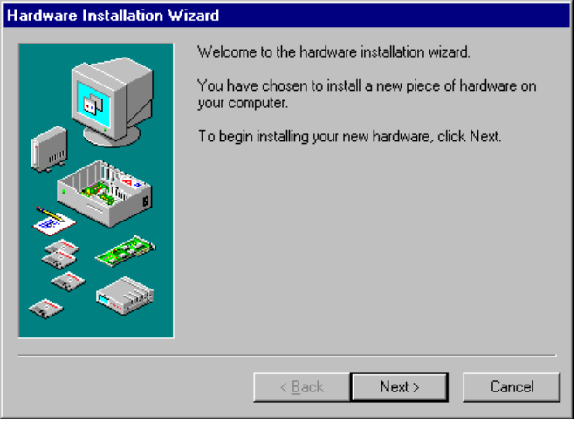
2. When the Hardware Installation wizard appears, follow the instructions on screen to provide a disk with drivers and to select configuration options for the device driver.
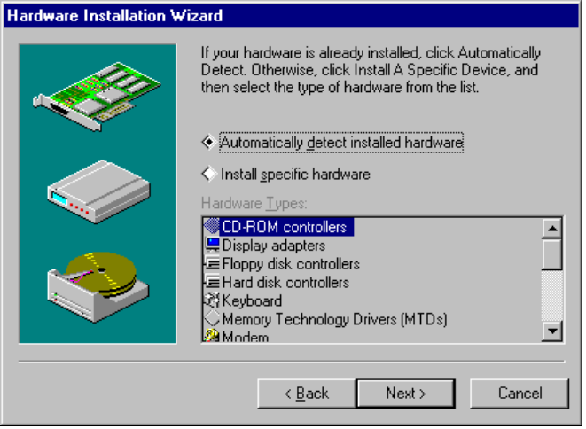

Changing Settings with Device Manager
With Plug and Play, there are no true default settings. Instead, Windows 95 evaluates the devices and their resource requests, and then arbitrates settings among the devices. If no other device requests the same resources, the settings should not change from manual settings. If another device requests the resources, the settings may change to accommodate the request.
Usually, the system performs all configuration operations, but certain circumstances may require user intervention. For example, the system may be unable to configure one device without creating conflicts with another device. In such a case, a message usually appears to explain what is happening and what you can do about the problem — turn off a device to make room for the new device, disable the new device, or reconfigure a legacy card to make room for the new device.
Your first and best resource for changing device settings is the Hardware Conflict Troubleshooter in Windows 95 Help.
To use the Hardware Conflict Troubleshooter
1. In the Help Topics window, click the Contents tab.
– Or –
In any Help window, click the Contents button.
2. Click Troubleshooting, and click the option named If You Have A Hardware Conflict. Then follow the instructions on-screen.

Sometimes problems may require that you manually configure certain devices. When you must manually change the system configuration, you can use Device Manager in System Control Panel to examine and change the configuration of devices on the computer. Using Device Manager will help you to avoid the errors that can occur if you attempt to edit Registry entries directly.

Changing default settings using either Device Manager or Registry Editor can cause conflicts that make one or more devices unavailable on the system.
Caution
Device Manager is provided as a configuration tool for the advanced user who understands configuration parameters and the ramifications of changing settings.

To use Device Manager
1. In Control Panel, double-click the System icon.

2. On the System properties sheet, click the Device Manager tab.
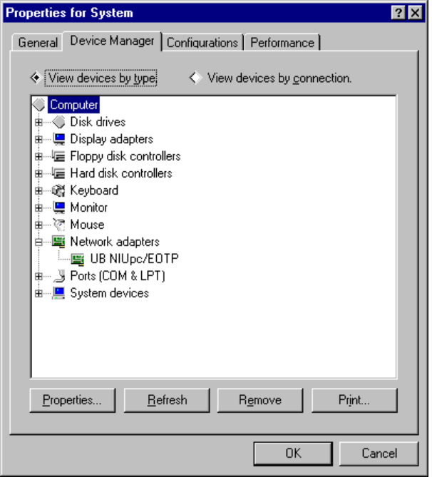
3. Double-click the device type in the list to display the specific devices of that type on your computer.
4. Select the device you want to configure, and then click the Properties button to view or change its settings.

To change the device driver using Device Manager
1. In System Control Panel, click the Device Manager tab. Then double-click the related device type.
2. Double-click your current device to display the properties sheet.
3. Click the Driver tab.
The Driver sheet for the device shows the driver files available for the selected device.
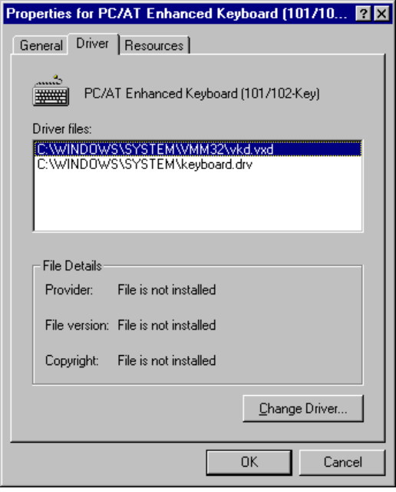
4. Click the Change Driver button.
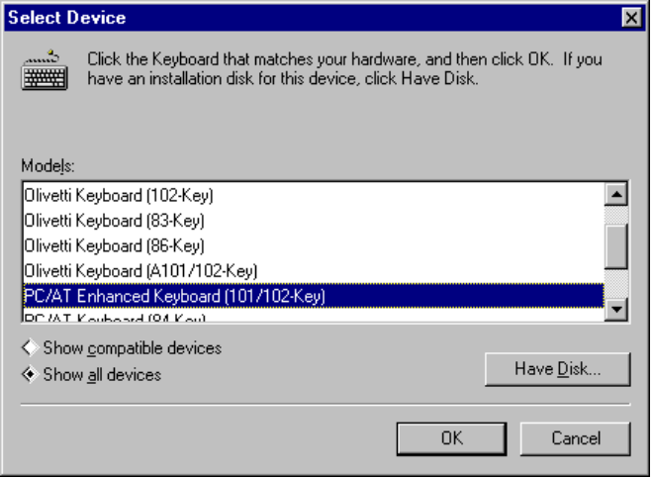
5. In the Select Device dialog box, click the Show Compatible Devices option to see a list of drivers that Windows 95 has identified as compatible for your device.
– Or –
Click Show All Devices to see a list of all the drivers available in Windows 95.
You should select a driver from the Show All Devices list only when you know that you are selecting a driver that is compatible with the device.

Important
You can safely select any driver in the Show Compatible Devices list.
6. In the Models list, select the driver you want to use, and then click OK.

7. If requested, follow the instructions on screen to provide a disk or a path to a directory that contains the display driver.

The following sections describe system configuration tasks using Device Manager and other configuration tools.

Enabling PCMCIA Cards
Windows 95 automatically installs Plug and Play PCMCIA support on computers with compatible PCMCIA sockets. In some cases, Windows 95 disables Plug and Play PCMCIA support if there is a risk of incompatibility.
Windows 95 supports many PCMCIA cards including modems, network cards, SCSI cards, and others. If Windows 95 includes supporting drivers for the PCMCIA card and for the socket, then installation and configuration should be automatic. This section provides some guidelines for enabling Windows 95 enhanced PCMCIA support when automatic detection and configuration aren’t available for your card.
First, if your PCMCIA card is not listed on the Hardware Compatibility List, you should contact the vendor and request a Windows 95-compatible installation disk before enabling the Windows 95 enhanced PCMCIA support.

Important
Your PCMCIA socket driver and network driver both must be Plug and Play drivers (that is, developed for Windows 95 and NDIS 3.1-compliant) or both must be real-mode drivers. If these drivers are of mixed types, the computer may stall or the network may not work.

Windows 95 Setup automatically detects the presence of a PCMCIA socket. If Windows 95 has not detected a PCMCIA socket, your socket controller may not be supported by Windows 95.
See Help Topic
“Setting Up Other Hardware” if you added a PCMCIA socket after setting up Windows 95
To verify that Windows 95 has properly detected your PCMCIA socket
1. In the System Control Panel, click the Device Manager tab.
2. Look for a PCMCIA Socket listing.
Example to be provided.
If your PCMCIA socket was not detected, you should find out whether that PCMCIA socket is supported.
To find out if a PCMCIA socket is supported
1. In Control Panel, double-click the Add New Hardware icon.
2. On the first screen in the Hardware Installation Wizard, click the Next button, and then select the Install Specific Hardware option.
3. In the Hardware Types list, select PCMCIA Socket, and then click the Next button.
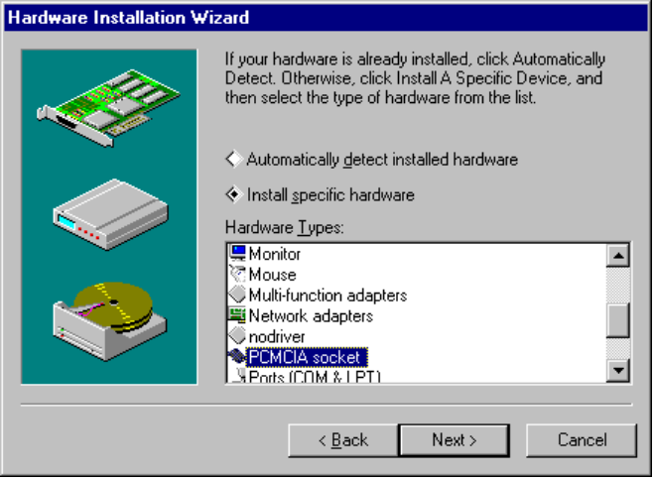
4. Select the manufacturer for your device, and examine the Models list.
If your card does not appear in the list, you should contact the manufacturer to see if new drivers are available.

If your PCMCIA socket is supported and was detected, but you still have problems, it may be that Windows 95 did not activate enhanced PCMCIA support.
To find out if Windows 95 has activated enhanced PCMCIA support
1. In System Control Panel, click the Device Manager tab. Then select your PCMCIA controller, and click the Properties button.
2. Click the General tab.
If the Use Device option is selected, then enhanced PCMCIA support is activated.
- If the Use Device option is selected, then you probably need to change the memory settings, as described in the following procedure.
- If the Do Not Use Device option is selected, then Windows 95 probably detected old drivers for this device. To remove these drivers, see the procedure “To disable the enhanced PCMCIA support.”

If you have the correct drivers and enhanced PCMCIA support is activated, but the device is still not available, your system is probably using the wrong memory window for the device. Windows 95 selects a default set of commonly supported settings. Your socket may not support certain interrupt settings, so you might be able to get a PCMCIA socket to work by changing the selected memory window.
To change the interrupt for a PCMCIA device
1. In System Control Panel, click the Device Manager tab. Then select your PCMCIA socket, and click the Properties button.
2. Click the Global Settings tab on the PCMCIA controller properties sheet.
3. Make sure that the Automatic Selection check box is not checked.
4. Change the Start address based on information from your hardware system manual.
Typically, selecting a Start value higher than 100000 will work.
5. Restart Windows 95.

If Windows 95 still doesn’t detect your PCMCIA cards, you should disable the Windows 95 enhanced PCMCIA support.
To disable the enhanced PCMCIA support
1. In System Control Panel, click the Device Manager tab. Then select your PCMCIA controller, and click the Properties button.
2. Click the General tab, and then click the Do Not Use Device option.

Windows 95 automatically disables enhanced PCMCIA support if it detects the presence of previous PCMCIA drivers, because it cannot automatically remove these drivers. Enabling PCMCIA support requires ensuring that the specific PCMCIA cards on your computer are supported by Windows 95 and then removing the old PCMCIA drivers from CONFIG.SYS and other configuration files.
If you must use old drivers, Windows 95 should work well with your previous PCMCIA drivers, although some Plug and Play capabilities such as automatic installation and friendly device names will not be available.
Before enabling the enhanced PCMCIA support in Windows 95, you need to remove any previous PCMCIA drivers. Windows 95 provides similar functionality and may conflict with your previous drivers, which are typically listed in CONFIG.SYS.
To remove previous PCMCIA drivers
1. Start a text editor such as WordPad and, for CONFIG.SYS, WIN.INI, and SYSTEM.INI, add the word rem before each of the relevant lines.
For example your CONFIG.SYS file may look like this after using rem to remove PCMCIA drivers:
rem device=c:\ss365sl.exe
rem device=c:\cs.exe
rem device=c:\ralloc.exe
rem device=c:\cic.exe
rem device=c:\windows\cendis.exe

2. Restart Windows 95.

Note
Check the documentation for your previous drivers to determine the names of the drivers to be removed from specific configuration files.

3. On the General sheet of the PCMCIA controller’s property sheet, click the Use Device option to enable the enhanced support for the PCMCIA socket.

Managing Alternate Settings for Docking Units
To be provided.

Configuring the Display
Windows 95 consolidates display properties in the Display Control Panel, so you can easily customize display adapter settings. Using the Display Control Panel in Windows 95, you can:
- Change the display type or driver.
- Change video resolution and color palette without restarting the computer when using display drivers and display adapters that support this functionality.
- Change color schemes and text styles in all screen elements, including changing fonts used in dialog boxes, menus, and title bars.
- View changes in colors, text, and other elements of display appearance before the changes are applied.

To set display options quickly, right-click the desktop background, and then click Properties. Click the Help icon to get context-sensitive Help for setting display properties.
Tip

Display Driver Overview
Windows 95 provides enhanced functionality and easy configuration for display drivers, in addition to resolving many problems inherent in Windows 3.1 display drivers. By using a mini-driver architecture for display adapter drivers, Windows 95 provides better support for a wide range of video hardware and provides more stable and reliable drivers. Benefits of the new display driver support in Windows 95 include:
- Support for changing video resolution without restarting Windows 95.
- Consistent, unified setup and configuration of display drivers and display properties such as colors, wallpaper patterns, and screen savers using tools in Control Panel.
- Image color matching (ICM) support for mapping colors displayed on-screen with colors generated on output devices for consistent output. Microsoft worked with Eastman Kodak Company to offer this device-independent color support.
- Support for new hardware and device functionality such as Energy Star Monitors conforming to the VESA DPMS specification, and detection of monitor properties such as maximum resolution supported for Plug and Play monitors.

Windows 95 provides a universal driver to support device-dependent code in a display mini driver and to support the device-independent code and functionality usually handled by a monolithic video display driver. The mini-driver uses the graphics device-independent bitmap (DIB) engine in Windows 95, providing a better mechanism for manipulating memory bitmaps. The new 32-bit DIB engine is optimized to provide fast, robust drawing for high resolution and frame buffer-based display adapters.
To ensure broad support for display adapter devices in Windows 95, Microsoft developed many of the display drivers in cooperation with the major display-controller hardware manufacturers. The Microsoft development team also worked closely with hardware manufacturers to write additional display drivers and assisted in optimizing drivers to enhance display speed for improved graphic performance. The video drivers provided with Windows 95 were stringently tested to ensure reliability and stability.
Windows 95 also includes mechanisms to ensure that incompatible display drivers cannot prevent a user from accessing the system. If a display driver fails to load or initialize when Windows 95 is started, Windows 95 automatically uses the generic VGA display driver. This ensures that you can start Windows 95 to fix a display-related problem.
Windows 95 Setup automatically detects the video display adapter in the computer and installs the correct display driver, upgrading to a new VDD if a new version is available. Windows 95 Setup also removes all standard-mode grabber, because Windows 95 does not use standard mode.
Although Windows 95 supports Windows 3.1 display device drivers, you should take advantage of the Windows 95-specific display drivers that provide new features and functionality. For example, many display adapters and drivers support Plug and Play detection and on-the-fly resolution changes.
The Plug and Play requirements for display adapters include:
- To be provided.

Plug and Play does not currently allow for “hot” attachment of display adapters. This is because the display VxDs are static and too many conflicts exist for memory and I/O port addresses among different display adapters. However, changing display monitors does not cause conflict issues, so monitors can be changed dynamically.
Display features not included in Windows 95 are dynamic-color-depth, generic 16-color (planar) drivers, Super VGA mini-drivers, and DIB-engine drivers. Displays that are no longer supported under Windows 95 include the following:
- To be provided.

For problem-solving tips, see “Troubleshooting Video Display Problems” later in this chapter.

Changing the Display Type and Driver
You can select or install another display driver using the Display Control Panel or Device Manager.

Some monitors can be physically damaged by incorrect video settings. Carefully check the manual for your monitor before choosing a new setting.
Caution

To change the display driver using Device Manager
1. In System Control Panel, click the Device Manager tab. Then double-click Display.
2. Double-click your current display adapter.
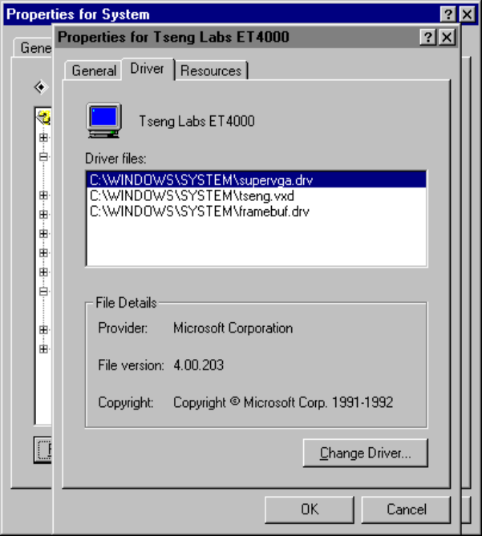
3. Click the Driver tab, and click the Change Driver button.
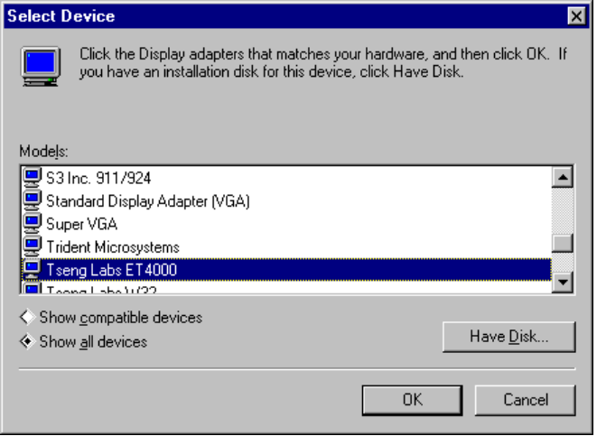
4. In the Select Device dialog box, click the Show Compatible Devices option to see a list of drivers that Windows 95 has identified as compatible with your display adapter.
– Or –
Click Show All Devices to see a list of all the display drivers available in Windows 95.
Select the Show All Devices option only if you know that you need to select a driver from the Models list that also supports your display. You must be careful to select a driver that you know to be compatible with your display adapter.

Important
You can safely select any driver in the Show Compatible Devices list.
5. In the Models list, select the driver you want to use, and then click OK.

If requested, follow the instructions on-screen to provide a disk or path to a directory that contains the display driver.

To change the display driver using the Display Control Panel
1. In Control Panel, double-click the Display icon.

– Or –
Right-click the desktop, and then select Properties from the context menu.
2. On the Display properties sheet, click the Settings tab.
3. On the Display Settings sheet, click the Change Display Type button.
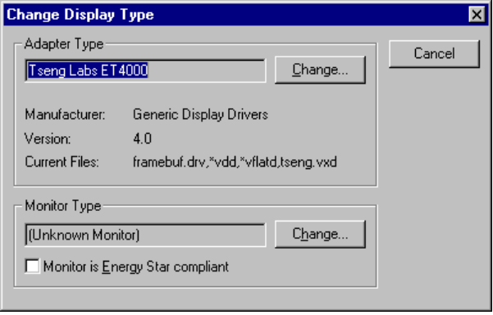
4. Click the Change button, and then follow steps 4 and 5 in the previous procedure.

For display drivers that do not appear in the Select Device dialog box (that is, those that are not provided with Windows 95), the Windows Driver Library (WDL) provides support for additional third-party drivers. For information about the WDL, see Appendix G, “Windows 95 Resource Directory.”
You can also install Windows 3.x display drivers if required. However, Microsoft strongly recommends that you upgrade to Windows 95 display drivers.
To install Windows 3.1 display drivers
1. In Display Control Panel, click the Settings tab. Then click Change Display Type
2. Click the Change button next to Adapter Type, and then click the Have Disk button.
3. Specify the path to the disk or directory containing the Windows 3.1 drivers you want to use.
4. Select the correct driver to use from the list that appears, and click OK to install.
Old drivers appear in the Select Device dialog under the manufacturer type Windows 3.x Drivers, when Show All Devices is selected in the Select Device dialog box.

Notice that some Windows 3.1 drivers require the screen resolution to be specified in the [boot.description] section of SYSTEM.INI. For example:
display.drv=Acme Inc. 640x480 256 colors

Configuring Display Resolution and Color Palette
You can configure the display resolution and color palette choices for your video display or customize the font size used using Display Control Panel.
After making these kinds of changes, you must shut down and restart the computer unless you are using a Plug and Play display adapter and driver that support on-the-fly changes.
To configure your display resolution
1. In Display Control Panel, click the Settings tab.
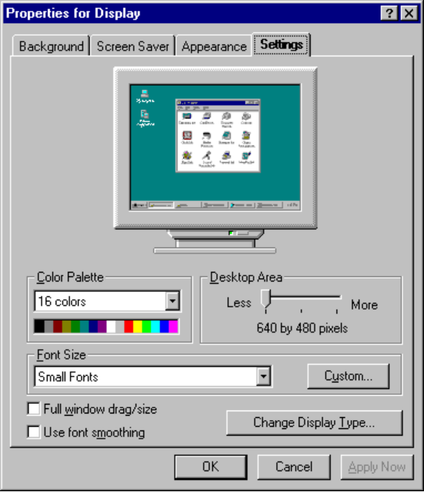
2. On the Display properties sheet, use the options described in the following table to change your display settings.
Option | Description
Color Palette | Select from this list the number of colors you want for your display adapter. The larger the number, the greater the number of colors.
Desktop Area | Drag the scroll bar to change the visible screen area used by the display. The larger the desktop area, the smaller everything looks on your screen.
Option | Description
Font Size | Select from this list one of the font sizes for your display type. Typically, the selections will be Small Fonts and Large Fonts. To set the font used in dialog boxes, see “Configuring Display Appearance” later in this chapter.
Custom | Changes the size of the text that Windows 95 displays, as described in the following procedure.
Change Display Type | Displays a dialog box for selecting another adapter type or monitor type. For information, see “Changing the Display Type and Driver” earlier in this section.

Sometimes a larger number of colors requires you to have a smaller desktop area, and vice versa. This is due to a limitation of the display adapter.
Note
Extra large sizes may adversely affect the display in some applications.

To customize fonts
1. On the Display properties sheet, click the Custom button.
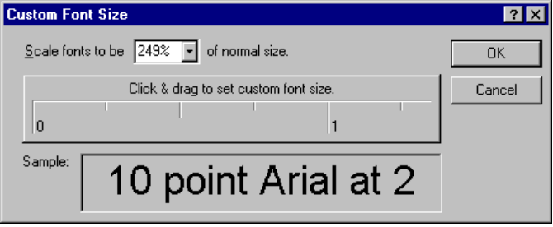
2. Drag the controls until the sample shows the size that you want, and then choose OK.
For non-Plug and Play devices, you must shut down and restart Windows 95 for the changes to take effect.

Configuring Display Appearance
You can use the Display Control Panel to set the screen saver and the background pattern used on the desktop. (These options replace Desktop options in the Windows 3.x Control Panel.)
You can also use settings on the Screen Saver property sheet to take advantage of Energy Star Monitor support in Windows 95 if your hardware supports this feature. Energy Star is an effort inspired by the U.S. Environmental Protection Agency (EPA) to develop computer hardware and peripherals that conserve power in idle states. This is similar to the standby mode commonly used in laptop computers to save power.
The video display monitor is typically one of the most “power-hungry” components of a computer. Manufacturers of newer display monitors have incorporated energy-saving features into their monitors based on the VESA Display Power Management Signaling (DPMS) specification. Through signals from the video display adapter, a software control can place the monitor in standby mode or even turn it off completely, thus reducing the power the monitor uses when inactive. To do this, Windows 95 extends the screen saver capabilities to provide a time-delay setting that allows the user to put the display monitor in a low-power standby mode, and a delay setting to turn the monitor off completely.
To configure the background pattern and wallpaper
1. In the Display Control Panel, click the Background tab.
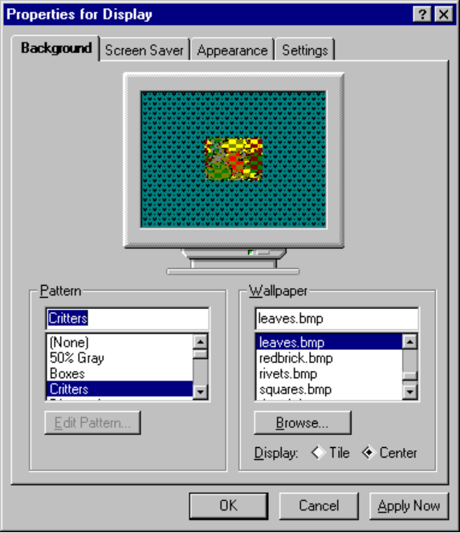
2. From the Pattern list, select the pattern to use on the desktop background.
3. From the Wallpaper list, select the wallpaper you want to use, and then click Tile or Center to specify how you want the wallpaper to be displayed.
The Wallpaper list shows all the bitmap (.BMP) files on the system. Use the Browse button to find bitmap files that use other filename extensions.
4. The selected options appear immediately on the sample display in the box. Choose the Apply Now button to apply the current settings.

To configure a screen saver
1. In the Display Control Panel, click the Screen Saver tab.
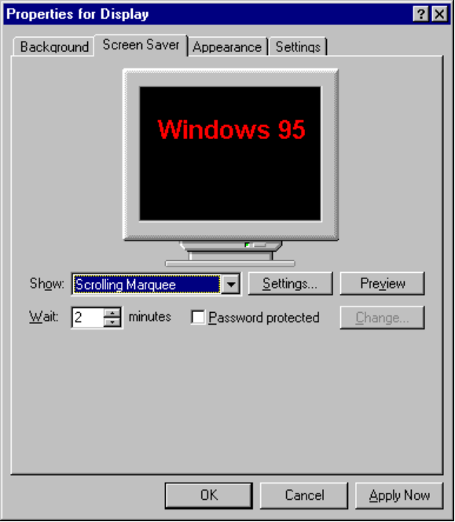
2. In the Show list, select the screen saver you want to use.
3. If the screen saver requires it (for example, for the scrolling marquee screen saver), click the Settings button and complete the options for configuring that type of screen saver.
4. In the Wait list, specify the interval of inactivity before the screen saver appears.
5. If you want to protect access to the computer by using a password with the screen saver, make sure the Password Protected box is checked. Then click the Change button to specify the password.
6. Click the Preview button to test the screen saver, and click Apply Now to begin using the selected screen saver when all options are configured as you want them.

If your system can use Energy Star power consumption features, additional options appear in the Screen Saver property sheet. To take advantage of these features, both the display adapter and monitor must meet the Energy Star specifications. Also, the display driver must support the extensions needed to control the monitor device. Several hardware providers currently manufacture monitors designed to support the Energy Star goals.
To use Energy Star power consumption features
- On the Screen Saver sheet in the Display properties, specify the time intervals for when to use lower-power standby and when to shut off power.
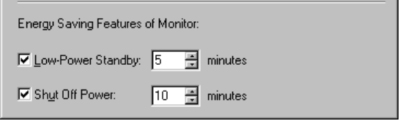
For example, you may want to set these options:
- Display a specific screen saver after 5 minutes of inactivity
- Set the computer to standby after the screen saver has displayed for 10 minutes
- Turn off the monitor after 15 minutes of standby

To configure the appearance of display colors and type styles
1. In the Display Control Panel, click the Appearance tab.
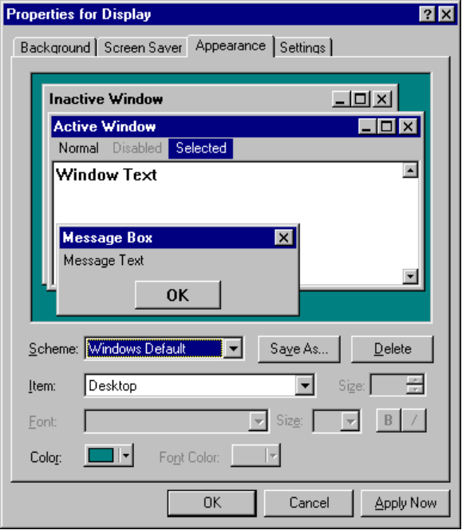
2. In the Scheme list, select the color and text configuration you want.
– Or –
Click an element in the sample window, and use the controls to specify the color and font styles you want. Use the context-sensitive help for guidelines in specifying settings for each of the options. You can click the Save As button to save a scheme.
3. Click the Apply Now button to use the selected scheme.

Configuring the Mouse
Mouse drivers based on the Windows 95 minidriver architecture are protected-mode drivers that provide better support for MS-DOS–based applications in the Windows 95 environment. Windows 95 also makes mouse configuration and customization easier by providing a single Control Panel option for mouse settings.
Windows 95 Setup detects Microsoft and Microsoft-compatible mouse device drivers, and then replaces these with new VxDs and removes any related TSRs from the system configuration files.

Mouse and Pointing Device Driver Overview
Windows 95 provides the following improvements in mouse and pointing device support:
- Plug and Play support for easy installation of pointing devices. For example, the VxD VMOUSE driver interface supports Plug and Play.
- Smooth, reliable input when using the new protected-mode drivers.
- More drivers available for more devices.
- No need to use MS-DOS–based mouse drivers.
Windows 3.1 provided support for using the system mouse in an MS-DOS–based application when running the application in a window. However, support for using a mouse in full-screen mode required loading an MS-DOS–based mouse driver before starting Windows.

The protected-mode Windows 95 VxD mouse driver provides mouse support for Windows-based applications, MS-DOS–based applications running in a window, and MS-DOS–based applications running in full-screen mode. These improvements result in zero use of conventional memory for mouse support in the Windows 95 environment. (However, most legacy real-mode drivers will run in Windows 95.)
In addition to better mouse services, Windows 95 allows the use of serial ports COM1 through COM4 for connecting a mouse or other pointing device.
To see the improvements in mouse driver support
1. Be sure the real-mode mouse driver from such entries as MOUSE.COM or MOUSE.SYS has been removed from your CONFIG.SYS or AUTOEXEC.BAT file.
2. Restart the computer and run an MS-DOS–based application that supports the use of a mouse.
For example, use an application such as Edit and try the MS-DOS–based application both in a window and full-screen.
Notice that the mouse is available in both modes, and use the mem /c command at the command prompt to verify that the mouse driver is not loaded in real mode.

Windows 95 does not include VESA video cursor interface support. Also, you will not receive notification for a missing mouse, and there is no mouse-change message support for applications.

Changing Mouse Drivers
The Mouse Control Panel provides customization options, including setting the behavior of the mouse buttons and the mouse pointer. You can use either the Mouse option or Device Manager to change drivers for a pointing device.
For problem-solving tips, see “Troubleshooting Mouse Problems” later in this chapter.
To change the mouse driver using Device Manager
1. In System Control Panel, click the Device Manager tab. Then double-click Mouse.
2. Select your current pointing device, and click the Properties button.
3. Click the Driver tab, and then click the Change Driver button.
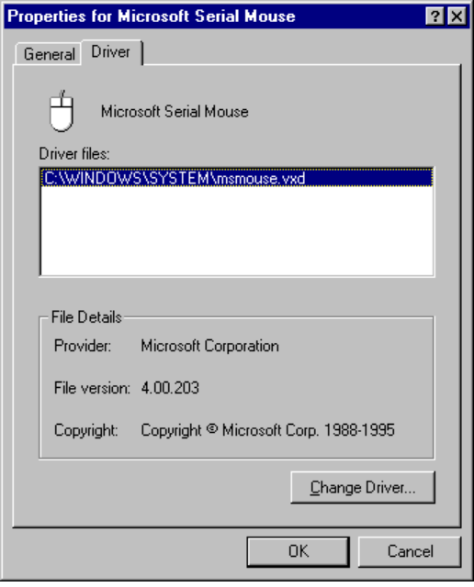
4. Select the new driver to be used, as described earlier in “Changing Settings with Device Manager.”
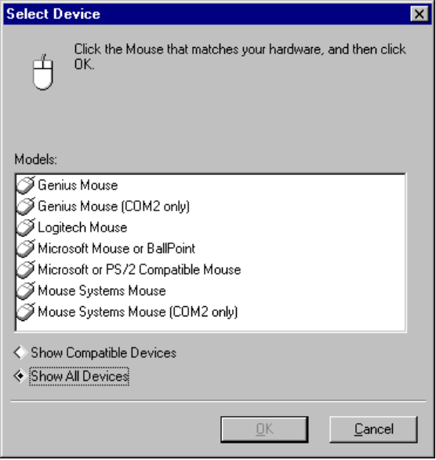
To change the driver using the Mouse Control Panel
1. In Control Panel, double-click the Mouse icon.

2. On the Mouse properties sheet, click the General tab.
3. Click the Change button.
4. In the Select Device dialog box, select the new driver to be used, as described earlier in “Changing Settings with Device Manager.”

For pointing device drivers that do not appear in the Select Device dialog box (that is, those that are not provided with Windows 95), the Windows Driver Library (WDL) provides support for additional third-party drivers. For information about the WDL, see Appendix G, “Windows 95 Resource Directory.”

Configuring Mouse Behavior
The Mouse Control Panel provides options for configuring button action, customizing mouse cursor appearance, setting mouse speed, and other actions. This section briefly describes these options. Different options may be available, depending on the pointing device used on your system.
To specify mouse behavior
1. In the Mouse Control Panel, click the tab for the behavior you want to set:
- Click the Buttons tab to specify the primary button and the speed for double-clicks.
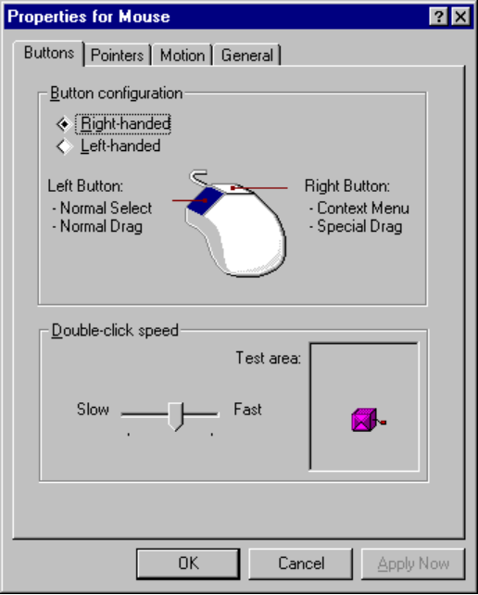
- Click the Pointers tab to customize the pointers that appear in relation to specific actions.
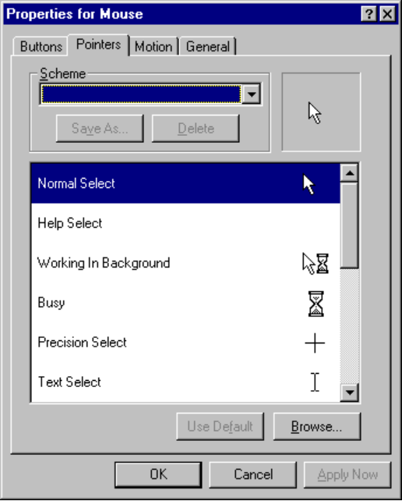
- Click the Motion tab to specify whether you want to use pointer trails and to specify pointer speed, which defines how fast the pointer moves as you drag.
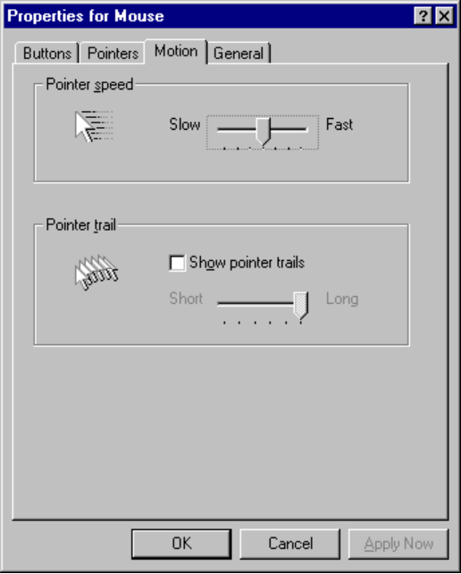
2. When the settings are as you want them to be, click the Apply Now button.

Configuring Communications Ports
A communications resource is a physical or logical device that provides a single asynchronous data stream. Serial ports, parallel ports, FAX machines, and modes are examples of communications resources. In Windows 95, VCOMM is the communications VxD that manages all access to communications devices. Port drivers use VCOMM to register themselves and manage access to communications devices.
Windows 95 provides improved communications device and hardware support. A few areas of improvement include the following.
- 16550A UART FIFO support
Windows 95 provides greater robustness and performance at high baud rates for MS-DOS – based and Windows-based communications applications using local serial ports with 16550A compatible UARTs. The 16550A UART contains a 16-byte FIFO buffer to prevent character overflow due to interrupt latency and to reduce interrupt overhead. (Windows 3.1 communications driver did not fully support the use of the 16550A UART, requiring some third-party communications vendors to replace the Windows 3.1-provided communications driver.)
- Support for more ports
The enhanced communication APIs in Windows 95 support 128 serial ports and 128 parallel ports, the same number of logical ports as MS-DOS. This removes the limit imposed in Windows 3.1 and makes possible the use of multiport serial devices in Windows 95. The actual limit to the number of usable ports is still based on the physical number of ports available to the system.
- ECP support for future parallel modems
Windows 95 provides support for Enhanced Capabilities Ports (ECP) to facilitate higher speed communications than possible over a serial device. This support allows the use of future parallel port modems. ECP can support Plug and Play devices that use the parallel port.

Plug and Play serial ports — also known as COM ports or RS-232 ports — must support baud rates up to 115.2K. Typically, Plug and Play serial ports use the 16550A buffered UART, which has a 16-byte FIFO that gives the CPU more time to serve other processes and that can serve multiple characters in a single interrupt routine.
If a particular computer is not a complete Plug and Play system, you may have to change resource settings for its communications ports. You can easily change communications port settings by using Device Manager. For problem-solving tips, see “Troubleshooting Communications Ports” later in this chapter.
To configure a communications port
1. In System Control Panel, click the Device Manager tab. Then double-click Ports.
The tree expands to show the types of ports available on the computer.
2. Double-click the port you want to configure to display the properties sheet.
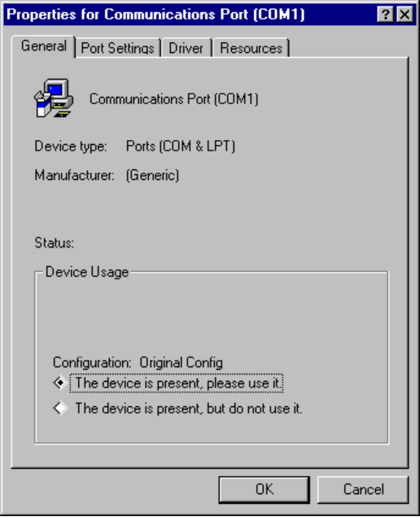
3. On the Communications Port property sheet, click the Resources tab.
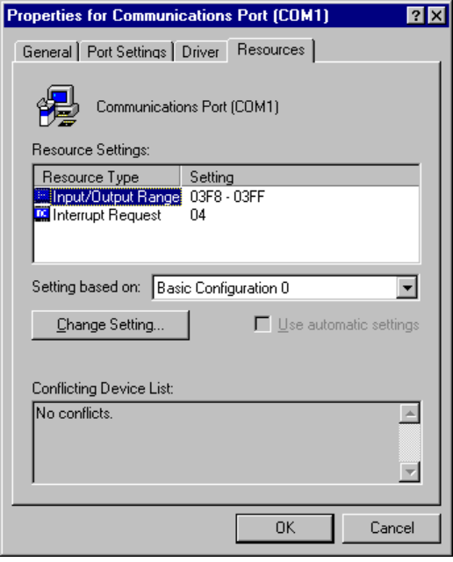
Information about Settings Based On list to be provided.
Notice also that the Conflicting Devices List shows any conflicting values for resources used by other devices.
4. In the Resource Type list, select the setting you want to change, and then click the Change Setting button.
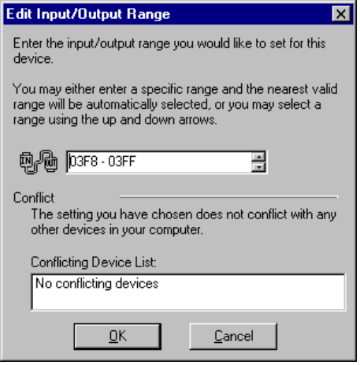
These configurations are the various settings that the device supports. Notice that, in the Input/Output Range box, any interrupt marked with an asterisk (*) will conflict with an existing device.
5. Enter a setting that does not conflict with any other devices, and then click OK.
6. Shut down and restart Windows 95. Then verify that the settings are correct for the communications port.

You may want to record for future reference the settings that appear on the Resources sheet for each communications port.
Tip

Technical Issues for Devices
This section presents the following technical topics:
- Plug and Play device types
- Windows 95 hardware tree
- Improved device support in Windows 95
- Disk device driver overview

Plug and Play Device Types
A variety of devices are compatible with Plug and Play, but the amount of compliance varies by type of device. The following sections describe the types of devices and provide details for Plug and Play versus legacy devices.
For information about Plug and Play support for networking devices, see Chapter 7, “Network Technical Issues.”

ISA Overview
Industry Standard Architecture (ISA) bus design is the architecture specified for the IBM® PC/AT®.
Plug and Play ISA devices can run on existing computers, because the specification does not require any change to ISA buses. For automatic configuration of Plug and Play ISA devices, the system performs the following steps:
1. Identify and configure the devices using I/O ports, which enables the Plug and Play logic on the card.
2. Isolate each card and assign a unique device ID and serial number.
3. Read the resource requirements and capabilities stored on each card.
4. Allocate resources to each card, which reserves these resources so that other Plug and Play cards in the computer cannot be assigned these resources.
5. Activate the Plug and Play ISA cards.

For legacy devices, standard ISA cards can coexist with Plug and Play ISA cards on the same computer. Windows 95 determines the type of hardware and its configuration during setup, either by polling the hardware or asking the user to supply values. This configuration information is stored as static values in the Registry, and cannot be changed dynamically, but it is used to determine resource assignments for Plug and Play devices.

EISA Overview
Enhanced Industry Standard Architecture (EISA) a bus design for x86-based computers specified by an industry consortium. EISA devices use cards that are upwardly compatible from ISA. EISA devices use standard software mechanisms for identification and configuration. As such, they meet most of the Plug and Play requirements. Windows 95 includes a bus enumerator that makes configuration information from these devices accessible to the operating system.

SCSI Overview
Small Computer Standard Interface (SCSI) is a multiple-device chained interface used in many devices such as hard disks and CD-ROM drives. Plug and Play SCSI devices support dynamic changes to the adapter and automatic configuration of device ID and termination.
Configuration of a SCSI system can be separated into two distinct processes:
- Configuring the SCSI bus itself, such as terminating both ends of the SCSI bus and setting device IDs.
- Configuring the SCSI host adapter, such as assigning an IRQ channel, DMA channel, and so on.

Configuring a SCSI bus that is not Plug and Play-compliant is difficult for most users. The list of issues related to configuring a SCSI bus is long, including:
- SCSI device ID assignment
- Termination
- SCSI parity
- Command sets
- Disk geometry and software

For example, the SCSI-2 specification does not define an automated ID assignment mechanism, so the user is responsible for making sure that no two SCSI devices on the same SCSI bus share the same SCSI ID. As another example, you can replace a SCSI host adapter with one from a different company and find it doesn’t work due to differences in disk geometries or the way devices are mapped to INT 13H parameters.
For more information about SCSI devices and drivers, see “Disk Device Driver Overview” later in this chapter. For some troubleshooting tips for non-Plug and Play SCSI devices, see “Troubleshooting SCSI Devices” later in this chapter.

PCMCIA Overview
Personal Computer Memory Card International Association (PCMCIA) created the standard for the credit card-sized interface cards in portables and other small computers.
PCMCIA provides all Plug and Play functionality. Windows 95 provides automatic installation and drivers for Intel-compatible and Databook-compatible PCMCIA sockets. Windows 95 also supports third-party real-mode and protected-mode PCMCIA system software drivers (card services), but some of the Plug and Play capabilities will not be available, such as hot swapping of network adapter cards and automatic installation.
Windows 95 supports hot or warm docking for a PCMCIA device. The device’s configuration information is saved under a unique identifier in the hardware tree (as described later in this section) so it can be used for dynamic configuration.
Depending on how the hardware manufacturer uses the Plug and Play standard, a PCMCIA device driver might be combined with an ISA or an EISA driver for the card, or the system’s generic driver can be used.
To take advantage of Plug and Play, a card must contain information that Windows 95 can use to create a unique device ID for the card. Device drivers can be implemented under three possible schemes, depending on how complete the Card Information Structure (CIS) is on the card, whether the driver requires memory services, and whether the drive is bus-sensitive:
- A standard Plug and Play device driver for PCMCIA (the preferred driver) can handle dynamic configuration and removal, and receive configuration information from the operating system without knowledge of the card in the PCMCIA bus. NDIS 3.x drivers for network adapter cards and Windows NT miniport drivers for SCSI cards, which do not require PCMCIA-specific services such as memory buffers, are recommended.
- Generic Windows 95 device drivers are supported automatically by Windows 95 for devices such as modems and disk drives. If the card contains complete configuration information, the operating system initializes the device and passes configuration information to the driver.
- Manufacturer-supplied drivers are required for device classes such as network or SCSI adapters that require specific PCMCIA functions, such as memory-mapped I/O or memory window operations. Windows 95 supports these operations through the standard card services API.

For information about configuring PCMCIA devices, see “Enabling PCMCIA Cards” earlier in this chapter. For problem-solving tips, see “Troubleshooting PCMCIA” later in this chapter.

VL and PCI Overview
The Video Electronic Standards Association (VESA) Local (VL) bus is a bus standard that allows high-speed connections to peripherals. VL bus devices are not totally Plug and Play-compliant. Because a VL bus device is an ISA child bus, VL devices can work similarly to ISA devices. The same modifications are required as for ISA; otherwise, the VL device will be treated as a legacy device in Windows 95. The VL bus is used especially to support high-performance video cards.
The Peripheral Component Interconnect (PCI) local bus is a standard used in most Pentium™ computers and in the Apple® PowerPC™ Macintosh® and is likely to be the successor to VL.
The PCI bus architecture meets most Plug and Play requirements, and PCI devices use standard mechanisms for identifying themselves and declaring resource requirements.

PCI is usually a secondary bus. If its primary bus is not Plug and Play-compliant, the PCI bus cannot use Plug and Play functions.
Note

Other Device Types Overview
Other device types can take advantage of Plug and Play if they provide mechanisms for identification and configuration. These include IDE controllers, Extended Capabilities Ports (ECP), and communications ports.
Parallel ports, also known as LPT ports, can also take advantage of Plug and Play. The most common parallel port type is the Centronics® interface. Plug and Play parallel ports meet Compatibility and Nibble mode protocols defined in IEEE P1284. Compatibility mode provides a byte-wide channel from the computer to the peripheral. Nibble mode provides a channel from the peripheral to the host through which data is sent as 4-bit nibbles using the port’s status lines. These modes provide two-way communication between the host and the peripheral. Nibble mode is also used to read the device ID from the peripheral for device enumeration.

Windows 95 Hardware Tree
The Windows 95 hardware tree is a record created in RAM at system startup of the current system configuration, based on the configuration information for all devices in the hardware branch of the Registry. The hardware tree is created each time the system is started or whenever a dynamic change occurs to the system configuration.
Each branch in the tree defines a device node with the following requirements for configuration:
- A unique identification code, or device ID
- Required resources, including the resource type (such as IRQ and memory range) and constraints on specific resources (such as a COM port that requires IRQ3)
- Allocated resources
- Whether the device node is a bus (each bus device has additional device nodes under it in the tree)

The configuration process in Windows 95 uses the device nodes to identify the devices and resource requirements for establishing the working system configuration. Several new system components work together in Windows 95 to configure the system:
Configuration Manager. The central component of a Plug and Play system that drives the process of locating devices, setting up their nodes in the hardware tree, and running the resource allocation process. The three phases of configuration management — boot time (BIOS), real mode, and protected mode — each has its own configuration manager. The Configuration Manager determines a working resource allocation that meets the requirements of the enumerated devices, and then notifies device drivers of their assigned configuration. When the Configuration Manager cannot generate a non-conflicting configuration for a device, it explains the problem and asks the user for resolution: turn off another device, disable the new device, or reconfigure a non-Plug and Play card.
Bus enumerators. A new type of driver required for each specific bus type, responsible for building (“enumerating”) the hardware tree on a Plug and Play system.
Resource Arbitrator. Allocates specific types of resource to devices and resolves conflicts between devices requesting identical resources. The Resource Arbitrator contains information about how a resource is structured and algorithms for determining feasible resource configurations for a set of requirements and constraints. The Resource Arbitrator interacts with the Configuration Manager to assign resources during system startup and for dynamic configuration changes.
The hardware tree contains information only about those devices currently detected and running in the system, but the Registry contains a complete list of all hardware ever installed on the particular computer.
For more information about each of these elements, see Chapter 24, “Windows 95 Architecture.”

Improved Device Support in Windows 95
Windows 95 provides improved support for hardware devices and peripherals including disk devices, video display adapters, pointing devices, modems and other communication devices, and printers.
Windows 95 extends the minidriver architecture for printer drivers used in Windows 3.1 to the architecture for drivers of other system components, resulting in increased driver stability. Windows 95 uses the layered minidriver and miniport model for components throughout the operating system.
Although it is still possible to write and use monolithic drivers in Windows 95, Microsoft recommends that hardware manufacturers use the minidriver model because of the advantages it provides:
- Leverage hardware and operating system knowledge
The minidriver model allows hardware manufacturers to easily take advantage of their knowledge of the I/O mechanisms that the hardware supports and the commands the hardware device responds to when implementing the device-dependent portion of the driver used to interact with the hardware device.
The Microsoft development team used their understanding of the operating system mechanisms to develop the universal driver, which interact with the device-dependent code. A universal driver is the layer of code between the API layer of device interaction and the device-dependent code that controls the device.
- Increase system stability and reliability
Because Windows 95 components communicate with a device through a universal driver, this component received a high level of testing. The universal driver also reduces the complexity of the code that hardware manufacturers must write, resulting in simplified drivers that are more reliable than traditional monolithic drivers.
- Increase forward compatibility and support for hardware innovation
The minidriver model simplifies extending and changing the driver a hardware manufacturer must provide when new functionality is developed for the hardware device. The minidriver model provides mechanisms for hardware manufacturers to add special device functionality beyond the base set of required functionality.

Disk Device Driver Overview
Windows 95 uses layered block device drivers to manage input and output to block devices such as disks and CD-ROM devices. A block device is a device such as a disk drive that moves information in groups of bytes (blocks) rather than one byte at a time. Layered block device drivers are 32-bit, flat-model device drivers that run in protected mode. These drivers support partitioned and non-partitioned removable media and conventional, SCSI, and floptical floppy disk drives. Windows 95 also uses layered block device drivers to manage Windows 3.x FastDisk drivers, MS-DOS – based real-mode device drivers, and Windows NT miniport drivers.
Each layered block device driver can be loaded dynamically, so the appropriate driver can be loaded or unloaded as needed, without restarting the computer. Although the drivers are virtual device drivers (VxDs), they do not use the standard virtual device services and APIs. Instead, the I/O Supervisor provides the services and functions the device drivers need to complete their tasks.
Specifically, the block I/O subsystem in Windows 95 provides the following:
- Architecture to support all Plug and Play features
- Support for miniport drivers that are compatible with Windows NT
- Compatibility support for Windows 3.1 FastDisk drivers and MS-DOS real-mode disk device drivers
- Protected-mode drivers that take over real-mode MS-DOS device drivers when it is safe to do so

The following sections briefly describe how some of the I/O subsystems work. Remember, however, that the system takes care of all configuration, so you will not directly see these system elements in action.

I/O Supervisor and Driver Loading
The I/O Supervisor is a required system VxD that carries out all control and management tasks for the protected-mode file system and block device drivers in Windows 95. The I/O Supervisor loads and initializes protected-mode device drivers and provides services needed for I/O operations.
The I/O Supervisor receives requests from VFAT and CDFS file systems and loads the drivers for accessing local disk devices and drives, including SCSI and IDE. It supports WD1003-compatible drivers, takes control of real-mode drivers, and provides a mapper for real-mode drivers.
The real-mode mapper in the I/O Supervisor provides compatibility with real-mode MS-DOS device drivers for which protected-mode counterparts do not exist. For example, the real-mode mapper goes to work when real-mode disk compression software is running and a protected-mode disk compression driver is not available. This component ensures binary compatibility with existing MS-DOS–based disk device drivers in Windows 95.
The I/O Supervisor was first implemented in Windows 3.x as *BLOCKDEV, and in Windows 95 it also provides *BLOCKDEV services for older 32-bit disk access drivers. New responsibilities for the I/O Supervisor include:
- Registering drivers
- Routing and queuing I/O requests, and sending asynchronous notifications to drivers as needed
- Providing services that drivers can use to allocate memory and complete I/O requests

Windows 95 loads and initializes the I/O Supervisor as specified in a device= entry in SYSTEM.INI. The I/O Supervisor has a low value for its initialization order, so it is initialized before clients and virtual device drivers, such as PAGEFILE, PAGESWAP, and *INT13, so clients and virtual device drivers can call services in the I/O Supervisor to register and carry out tasks.
To load and initialize port drivers, miniport drivers, and value-added drivers, the I/O Supervisor requires the files for these drivers to be stored in the SYSTEM\IOSUBSYS directory with the following filename extensions.
Filename extension | Description
PDR | Port drivers, such as SCSIPORT, ESDI_506, and NEC
MPD | Miniport drivers
386 or VXD | Value-added drivers, such as the volume tracker and vendor-supplied drivers

The SYSTEM\IOSUBSYS directory is reserved for device drivers specifically designed to be used with the I/O Supervisor. Other clients or virtual device drivers should be stored in other directories and explicitly loaded using device= entries in SYSTEM.INI.
The I/O Supervisor initializes device drivers (as described in the following sections) from the bottom layer upwards, so port drivers are initialized before vendor-supplied drivers, vendor-supplied drivers before type-specific drivers, and so on. Value-added drivers are initialized in groups, layer by layer, with all drivers in one layer initialized before drivers in the next layer. The initialization order within a layer is not defined, so you cannot depend on the drivers in a group being initialized in a specific order or even that the order remains between startup operations.
For Plug and Play detection, the I/O Supervisor loads a specific port or miniport driver only if the Configuration Manager requests that driver after hardware detection locates an adapter. The Configuration Manager can detect the IDE and AHA154x SCSI adapters only. To support other adapters, the configuration manager forces the I/O Supervisor to load all remaining miniport drivers. However, such drivers remain loaded only if they locate an adapter they support.

Type-Specific and Vendor-Supplied Drivers
Type-specific drivers are generic drivers that work with all devices of a specific type. Windows 95 includes two type-specific drivers, for disks and CD-ROM. The type-specific driver validates incoming I/O requests, converts logical requests to physical requests so the adapter driver understands it, and notifies the requester upon completion. The type-specific driver can also initiate logical error recovery as needed for certain types of devices, principally disk devices.
A vendor-supplied driver intercepts and processes I/O requests for a specific block device. Such drivers can be used to incorporate enhancements for an existing layered block device driver or to extend driver capabilities to similar new hardware. A vendor-supplied driver usually works with a specific port driver or set of port drivers, and so is retained in memory only if the adapter that the port driver supports is present in the system.

Disk Device Support
Windows 95 provides better disk device support than is available under Windows 3.1, but also ensures compatibility with existing MS-DOS – based and Windows-based disk device drivers. Windows 95 features a new block I/O subsystem that provides broader 32-bit disk device support and improved disk I/O performance. In addition, the disk device drivers in Windows 95 are compatible with Windows NT miniport drivers.
Windows 95 also provides enhanced support for large media using logical block addressing, including hard drives with more than 1024 cylinders. Extensions to the INT 13H disk controller support are provided in the protected-mode disk handler drivers for this support. (Windows 3.1 did not provide this support in its 32-bit disk access drivers.)
Windows 95 supports the following hard disk drives and controllers:

ESDI
Hardcards
IDE
IDE LBA
MFM
PCI
PCMCIA
RLL
SCSI
SCSI 2

IDE Drives and Controllers
Any IDE device that includes mechanisms for identification and declaration of resource requirements can take advantage of Plug and Play. IDE controllers provide support for multiple disk drives.
Windows 95 provides improved support for IDE drive configurations, including the following:
- Support for large IDE disk drives
IDE drives are currently available that support a logical block addressing (LBA) scheme, allowing them to exceed the 0.5 gigabyte (GB) (528 MB) size limitation. Windows 95 provides protected-mode support for IDE disk drives as large as 137 GB.
- Support for alternate IDE controllers
Windows 95 provides protected-mode support for the use of two IDE controllers in a computer, or the combination of an IDE controller in a laptop and an alternate controller in a docking station (available, for example, in some COMPAQ laptop/docking station combination products).
- Support for IDE–based CD-ROM drives
Currently, most disk devices in personal computers use an IDE-based hard disk controller. Adding a CD-ROM drive typically requires adding an additional controller card to provide either SCSI or a proprietary interface for connecting to the CD-ROM drive. Windows 95 supports new, inexpensive CD-ROM drives that connect to IDE-compatible disk controllers.

SCSI Devices and Drivers
Windows 95 provides support for SCSI disk devices, which was not available in Windows 3.1. SCSI support in Windows 95 includes SCSI’izer drivers, the SCSI Port Manager, and SCSI miniport drivers.
Disk SCSI translator (SCSI’izer) drivers. Responsible for constructing SCSI Command Descriptor Blocks for a specific device class and carrying out device-level error recovery and logging. There are two of these drivers (one for each class): one for SCSI hard disk devices and one for CD-ROM devices.
SCSI Manager. Manages the interaction between the SCSI’izer and a SCSI miniport driver, initializes the miniport driver, converts the I/O request format, and provides other services for the miniport driver.
SCSI miniport drivers. For a specific set of SCSI adapters, the related miniport driver detects and initializes the adapter, handles interrupts, transmits I/O requests to the device, and carries out adapter-level error recovery and logging.
The best choice is a driver that complies with Plug and Play, although Windows 95 can use Windows NT miniport drivers. Windows 95 provides several .MPD files with Plug and Play capabilities, including the ability to transition from protected mode to real mode (to support Single MS-DOS Application Mode) and to accept configuration information from the SCSI Manager for dynamically loading and unloading drivers.
Support in Windows 95 for SCSI devices includes:
- Broad support for popular SCSI controllers
Windows 95 includes 32-bit disk device drivers for popular SCSI controllers from manufacturers such as Adaptec™, Future Domain, Trantor, and UltraStor.
- ASPI/CAM compatibility for MS-DOS–based applications and drivers, and 16-bit and 32-bit ASPI for Windows-based clients and applications
Support for the Advanced SCSI Programming Interface (ASPI) and Common Access Method (CAM) allows application and driver developers to submit I/O requests to SCSI devices. This allows existing MS-DOS–based applications and drivers that use the ASPI or CAM specification to work properly under Windows 95. Windows 95 also includes 16-bit and 32-bit drivers to support Windows-based ASPI clients and applications.
- Compatibility with Windows NT miniport drivers
Windows 95 supports the use of Windows NT miniport SCSI drivers without modification or recompiling. Compatibility with Windows NT-based miniport drivers ensures broad device support for disk devices under Windows 95, while simplifying the driver development efforts for hardware manufacturers.
However, most Windows NT miniport drivers ignore configuration information from the SCSI Manager and check I/O ports to identify hardware. Miniport drivers in Windows 95 must honor configuration information without scanning for other adapters if the configuration information is not the default configuration. This is because many adapters supported under Windows 95 have port ranges that conflict with other adapters and are adversely affected by scanning. For example, Artisoft LANtastic network adapters occupy a range of port addresses used by Adaptec 154X adapters, and accessing these ports will cause the system to lock up.

ESDI Controllers
Windows 95 also provides 32-bit disk driver support for ESDI controllers in addition to supporting IDE and SCSI disk devices.

Non-SCSI Port Drivers
A non-SCSI port driver usually works with a specific adapter, so the driver is retained in memory only if the related adapter is present in the system. Windows 95 includes, for example, port drivers for IDE or ESDI and NEC floppy disks and for WD1003-compatible drives.
A port driver provides the same functionality as the SCSI Manager and mini port driver, but these drivers are monolithic and are not portable to Windows NT. A port driver manages and controls the adapter for a given block device. The port driver detects and initializes the adapter, handles interrupts, transmits I/O requests to the device, and carries out adapter-level error recovery and logging.

Do not use a device= entry in SYSTEM.INI to load a port driver. The I/O Supervisor loads appropriate drivers from the Windows SYSTEM\IOSUBSYS subdirectory.
Important

High-Speed Floppy Disk Driver
Windows 95 provides protected-mode support for communicating with floppy disk controllers. Windows 95 provides INT 13H hard disk controller support as 32-bit device drivers, which results in improved performance, stability, and system robustness. Windows 95 provides floppy disk controller support as a 32-bit device driver, and offers improved performance for file I/O to floppy disk drives, plus improved reliability of the system.
You can now format a disk or copy files to and from a disk while performing other tasks.

Removable Media and Docking Devices
Windows 95 provides protected-mode support for the following removable media devices with MS-DOS – compatible partitions, among others:
- Floppy disk drives and controllers
- Floptical disk drives and controllers
- Bernoulli drive
- Syquest®
- CD-ROM

Windows 95 allows the system to lock or unlock the device to prevent the media from being removed prematurely.
Windows 95 also supports an eject mechanism for devices that support it, so that users can use software control to eject media from a device (for example, new floppy drives that support software-based media ejection).
Docking refers to the insertion or removal of a device in the system. Devices that can be docked include almost anything, depending on the hardware — monitors, network access, removable hard drives, or any removable resource. A docking station is a base unit into which you can insert the portable hardware and which includes drive bays, expansion slots, and additional ports. Port replicators can also be used as docking station substitutes that provide extra functionality not available in the portable docking device.
If a docking change occurs in the computer configuration during operation, such as the insertion of a PCMCIA card, the system is notified so that the new device can be configured and applications notified of the change.
There are three types of docking supported by Windows 95:
- Cold docking, where the device must be powered off or restarted before the device can be docked or undocked. This is how legacy laptops work.
- Warm docking, where the device can be docked or undocked when it is in a reduced-power mode (for example, standby or “sleep”).
- Hot docking, where the device can be docked or undocked while running at full power.

In addition, some devices require certain preliminary steps before they can be docked or undocked. For example, if you have a file open and decide to remove the hard disk, the file must be closed. To handle these situations, Windows 95 supports different undocking systems, depending on the type of hardware:
- Auto-ejection, which is a software interface that operates a VCR-type ejection mechanism, which allows Windows 95 to request user action to resolve any open resources. The user can save files and so on before the system ejects the dockable resource.
- Manual ejection, where the user undocks the resource without a software interface. Because the system cannot be notified when this occurs, any closing of files or other actions must be performed by the user to prevent loss of data.

Troubleshooting Devices
To be provided: basic steps for troubleshooting devices.
This section provides troubleshooting information on the following topics:
- Using Hardware Conflict Troubleshooter
- Disk driver problems
- PCMCIA problems
- SCSI devices
- Mouse problems
- Communications ports
- Video display configuration

For information about using Device Manager, Registry Editor, and MSD for troubleshooting, see Chapter 6, “Troubleshooting Setup and System Startup.”

Using Hardware Conflict Troubleshooter
The Hardware Conflict Troubleshooter that is part of Windows 95 Help provides step-by-step guidance for resolving memory and device settings that conflict.
To be provided.

Troubleshooting Disk Driver Problems
To be provided.

Troubleshooting Device Installation

Windows 95 doesn’t recognize a device.
- Check SETUPLOG.TXT
- Check DETLOG.TXT
- Check the Registry

1. In System Control Panel, click the + sign next to the device.
2. Click the specific device, and click on the Properties button.
3. Verify that the drivers are loaded and hardware resources do not conflict.

Troubleshooting PCMCIA Problems
To be provided.

Troubleshooting SCSI Devices
To be provided.

Troubleshooting Mouse Problems
To be provided.

The mouse doesn’t move after installation.
- Check the mouse driver.
- Check the port used for the mouse.

For the PS/2® mouse:
- Try dos=high,umb

For the LogiTech™ mouse:
- The driver for the LogiTech mouse may not work with your LogiTech mouse. To get a driver update for the LogiTech driver, you can download the file VMOUSE.VXD from the Windows 95 forum or the Microsoft Download Service (MSDL).

Troubleshooting Communications Ports
To be provided.

Troubleshooting Video Display Problems

Tip for Solving Display Drive Problems
If you have problems that might be in a Windows 95 version display driver, add the line SafeMode=1 to the [windows] section of WIN.INI, and restart Windows 95. This disables all non-essential hardware acceleration, if any. If the problem still occurs, try SafeMode=2, which disables all hardware acceleration, and note the effect of either of these switches.

Check Video Resolutions
Check the resolution support by trying a lower resolution using the same (current) video driver.
To check video resolution
1. In Display Control Panel, click the Settings tab.
2. In the Color Palette box, click the box that displays available resolutions.
3. If the selection is other than 16-color, then Select 16 color (4 bit).
4. Click the Apply Now button. Then shut down and restart the computer.

Check Video Drivers
To check the video drivers
1. In System Control Panel, click the Device Manager tab.
2. Click the + sign next to Display Adapter.
3. Select the specific display adapter shown (for example, Cirrus Logic).
4. Click the Properties button.
5. Click the Driver tab.
6. Click each file shown in the Driver Files box. The File Version will be displayed below in the File Details box (if available — some vendor’s video drivers may not contain version information).
7. Check displayed file versions for compatibility. Windows 95 video driver files have version numbers starting at 4.00 or higher.
8. If you have an incompatible driver, you can reinstall the original driver from the Windows 95 disks, or get new drivers from the Microsoft Download Services (MSDL).
If the display adapter is not supported using Microsoft drivers, you need to contact the display adapter vendor for updated drivers.

Check Where the Driver Is Loading From
Check the SYSTEM.INI file, [boot] section for the entry:
display.drv=display.drv

If this entry is present, the video entries in the SYSTEM.INI are ignored, and the video drivers are loaded from the Windows 95 Registry.
If the entry specifies any driver, the video drivers are loaded from the entries in the SYSTEM.INI file.

Check Basic VGA
Use Fail-Safe Startup by pressing F5 to load the basic VGA drivers. Notice that this driver is a 640x480x16 color driver.

