Chapter 1
With Windows 95, you can run Win32-based, Win16-based, and MS-DOS–based applications. Most MS-DOS–based applications can even run in a Windows 95 window as other applications do. This chapter describes some restrictions and offers some tips for making your applications run well under Windows 95.
Application Support
This chapter also describes how Win32-based, Win16-based, and MS-DOS–based applications can share and exchange data and can create compound documents containing multiple data types using OLE.

How Applications Work Under Windows 95 16-2
In This Chapter
How Applications Share Data Using OLE 16-4
Installing Applications 16-8
Modifying the Desktop for Easy Application Startup 16-9
Configuring Win16-based and MS-DOS–based Applications 16-10
Running Applications from the Network 16-17
Issues for Running MS-DOS-based Applications 16-17
Applications That Won’t Run Well in Windows 95 16-18
Troubleshooting Application Startup Problems 16-19

How Applications Work Under Windows 95
In addition to applications written specifically for Windows 95, you can run many applications written for Windows NT, Windows version 3.1, and MS-DOS in Windows 95.
Applications for MS-DOS and Windows 3.1 were written as 16-bit applications and known as MS-DOS–based applications and Win16-based applications, respectively.
Windows NT and Windows 95 are both 32-bit operating systems for which developers can write Win32-based applications.
See also Chapter 24, “Windows 95 Architecture.”
The following sections describe how Win32-based, Win16-based, and
MS-DOS–based applications run under Windows 95.

Win32-based Applications
Win32-based applications can take advantage of all the Windows 95 performance optimization features.
Each Win32-based application runs in its own address space, with its own input and message queues. Each runs unaware of and uninhibited by other applications that may also be running on the system. Windows 95 allocates multiple threads to run Win32 processes, and Win32-based applications can each use multiple threads (unlike Win16-based applications).
To make the most of Windows 95, the applications you develop or run should:
- Be Win32-based applications
- Be OLE-compliant to allow for data sharing with other applications
- Use Remote Procedure Call (RPC) for networked NetBIOS applications
- Use Windows Sockets for networked non-NetBIOS applications

Win32-based Applications for Windows NT
Win32-based applications that run under Windows NT will run well under Windows 95 so long as these two conditions apply:

How do existing Windows NT applications work with Windows 95?
- The application uses only the Windows 95 subset of the Win32 APIs.
- The application does not have an initial load address below 4M in memory and lacks any sort of relocation information.

Win16-based Applications
You can run your old 16-bit Windows 3.1 applications in Windows 95. Because a 16-bit application cannot directly call 32-bit API routines (and vice versa), Windows 95 uses a process called thunking to support 16-bit applications. Thunking is a method of transitioning between 16-bit code and 32-bit code, in either direction. This allows 16-bit applications to communicate with Windows 95, a 32-bit operating system, and vice versa.

How do existing 16-bit applications work with Windows 95?
Windows 95 provides the same system resources to both Win32-based and Win16-based applications. While Win32-based applications are preemptively multitasked, Win16-based applications are not. Win16-based applications share memory, a common input queue, and a common message queue, and their processes are scheduled cooperatively. A well-designed Win16-based application will yield access to these shared system resources regularly so that other processes can also use them. Ill-behaved applications, however, can cause delays to other applications and processes. Because all Win16-based applications run in the same virtual machine, an ill-behaved application could cause other Win16-based applications to fail as well, but shouldn’t adversely affect 32-bit applications.
If a Win16-based application crashes and you press ctrl+alt+del to end it, Windows 95 displays a list of all running processes and asks you to specify which you want to end.

How does Windows 95 provide crash protection for Win16-based applications?
For more information, see “Configuring Win16-based and MS-DOS–based Applications” later in this chapter.

MS-DOS–based Applications
Most often, you can run MS-DOS–based applications in a Windows 95 window. Some MS-DOS–based applications, however, are written so that they can run only at the MS-DOS command prompt and not in a window. These applications are unable to share system resources with other Windows-based applications. Although there is no way to exit Windows 95 to MS-DOS, you can still run applications similar to these by using a special mode called MS-DOS Mode. Applications running in this mode have exclusive access to system resources; no other processes can use them while the application runs in MS-DOS Mode. When the application is closed, system resources are again available for other processes to use.
For more information, see “Configuring Win16-based and MS-DOS–based Applications” later in this chapter.

How Applications Share Data Using OLE
OLE is the object-oriented programming model that describes how objects should interact and provides a set of services that facilitate the communication between objects. An object, as defined by OLE, is a unit of data and functions to manipulate OLE data. These are also known as Windows objects.

What is OLE?
OLE defines a structured storage model for saving and retrieving data. This model also describes how a file with more than one type of data is handled. Such files are called compound files. In Windows 95, STORAGE.DLL manages compound files.
The compound document technology provides a way of communicating between a container application and object applications. A container application maintains compound documents, and object applications provide various data objects (such as text, bitmaps, spreadsheets, spreadsheet cells, or sound clips) to be included in the compound document. The container application does not need to know anything about the server application or its specific data type to communicate with it.

Embedding and Linking Objects
The two ways to associate a container application and an object application are linking and embedding. The difference between these two depends on how and where the server object data is actually stored. When an object is linked, the object data is stored where it was originally created. Only a reference to the object, called a link, is stored in the compound document. When an object is embedded, a copy of the object data and all information needed to manage the object are stored inside the container’s compound document. In this case, the embedded object becomes part of the compound document and is no longer part of the server application’s document.

What’s the difference between linking and embedding?
The following table describes some differences between linking and embedding:
Linking | Embedding
Source data resides wherever it was initially created. A link to the data is stored in the compound document. | A copy of the original data and all information needed to manage the object reside in the compound document.
Object data is not maintained as part of the compound document. | Object data is physically part of the compound document.
The size of the compound document is kept relatively small. | The size of the compound document can increase.
The object always reflects any changes made to the original data. | Changes made to the object’s original data are not reflected in the embedded object data.
The object cannot be visually edited in the context of the compound document. | The object can be visually edited.
If the original document is deleted, the data is lost from the compound document. | If the original document is deleted, the data is still retained in the compound document.

Visually Editing Embedded Objects
Embedded objects can be visually edited, meaning that users can activate objects and edit, play, or otherwise manipulate them in the same window in which they are contained. For example, if a mail message includes an embedded sound clip, the sound clip object includes the information needed to play it. The user doesn’t have to open an separate audio application to play the sound clip.
To enable visual editing, both the container application and the object application must be OLE-compliant and both must support the OLE visual editing interface. If the container application or object application meets only OLE 1.0 specification, then the object application will be launched in its own window for editing. For example, Corel® Draw 4.0 implements some features of OLE which do not include the visual editing interface, so when a Corel Draw 4.0 object is opened for editing, the Corel Draw 4.0 application will start in its own window.

If an embedded object has a filename extension that is not associated with any application, you may not be able to successfully activate it.
Note

Application interface controls like View Zoom are available, depending upon the application. For example, in Microsoft Word 6.0, you cannot change the Zoom ratio while an object is being visually edited, nor can the object be scaled or cropped while activated. Conversely, Microsoft Publisher 2.0 will perform scaling of the container window during visual editing. The container application also determines whether to visually edit a particular object class. Word document objects cannot be visually edited in Word; they will open in a separate document window.

Activating Embedded and Linked Objects
When an object is activated in place, the object applications’ menus and interface controls are added to the container application’s windows and remain there as long as the object remains active. What you are able to do by activating an object in place depends on whether it’s embedded or linked:
- Embedded objects can be edited, played, displayed, and recorded in place.
- Linked objects can be activated in place for operations such as playback, but can’t be visually edited.

Using Clipboard to Embed Objects
Each time you cut or copy data from a document, it is copied to the Windows 95 Clipboard. You can paste that data elsewhere in the same document or even in a different document. And with Clipboard Viewer, you can share OLE objects for use in documents across the network.
With OLE-compatible applications, you can also use the Paste Special option to embed the data in another document. When you copy or cut data from an OLE-compliant application, the data includes information about its data type. When you choose Paste Special from the Edit menu, you can choose which data type you want to use for the object you are pasting by selecting from a list in the Paste Special dialog box. The dialog box also explains the pros and cons of each data type option.
For example, when you copy a part of a picture from Paintbrush, then choose Paste Special in Microsoft Word 6.0, you’ll see the following data type choices and explanations:
Data type | Explanation
Paintbrush Picture Object | Inserts the contents of the Clipboard into your document so that you can edit the contents using Paintbrush Picture.
Picture | Inserts the contents of the Clipboard as a picture. This format is better than Bitmap for printing to high-quality printers. Also the Picture format takes less space, and Word can redraw faster.
Bitmap | Inserts the contents of the Clipboard as a bitmap format. This format can take up a lot of memory and disk space, but is exactly what you see on the screen.

In other cases, you can insert an object as an icon. If you do this, it is possible to later display the contents of the object instead of the icon. To display the contents, right-click the object icon, then choose Convert. Then clear the Display as Icon check box.
Hint

Dragging and Dropping Objects and Text
Dragging and dropping an embedded or linked object moves the object from one container to another.
For OLE-compliant applications, when text is dragged between documents, the dragged text automatically becomes an embedded object in the destination document, unless both the source and destination applications understand the data type. In that case, the text is simply pasted into the destination document.

Maintaining Accurate Links
For a linked object, the container object includes a link to data in the source document. OLE maintains accurate links even when source and container documents are moved. For example, suppose that PAINTERS.DOC contains a link to an object in the spreadsheet application file ARTWORK.XLS. Both files reside under the ONLOAN directory. Then suppose that the contents of the ONLOAN directory are moved to a new directory named COLLECTN. The link in PAINTERS.DOC is updated automatically and now points to \COLLECTN\ARTWORK.XLS.

To check the path of a link
1. After the files have been moved, open the container document.
2. Choose the option that allows you to view field codes. Usually, this is an option on the View, Options, or Tools menu of your application.
3. Select the Link field and press F9.

Hints for OLE in Word for Windows 6.0
- To create a Word 6.0 object based on a template other than NORMAL.DOT, change OLEDOT=template_name in WINWORD6.INI. This tells Word to use a template other than NORMAL.DOT when a new Word 6.0 object is created.
- If you are linking a certain portion of a source file into Word through the Clipboard, the object application inserts a bookmark-like structure into the source document to define the linked information. This action turns on the “dirty” flag in the source document and the object application will prompt you to save. You must choose Yes so that the link is properly defined; otherwise it will be lost.
- By default, Word 6.0 updates all links in a file when it is opened. To turn off this option for all links, choose Options from the Tools menu. Then click the General tab, and make sure Update Automatic Links at Open is not checked. To turn off object link updating for a particular link, choose Links from the Edit menu, and then disable this option in the dialog box that appears.

Sharing OLE Objects Over the Network
To be provided.

OLE Registry Entries
For each OLE object, the Registry contains an entry that includes a unique identification tag for the object and a program identifier. The program identifier is also used as a class name when OLE objects are placed in OLE 1.0 containers. For example, “Word.Document.6” is the program identifier for a Word 6.0 document.

OLE 1.0 and OLE Interoperability
Because OLE is an improvement to the OLE 1.0 standard, OLE 1.0 applications can use OLE objects and OLE applications can use OLE 1.0 objects. However, in each case, functionality is limited to OLE 1.0. For example, OLE 1.0 does not include in-place interaction. When you double-click an object within an OLE 1.0 application, the source application starts and the object opens in that application’s window. If the source application is not available on the local computer, the object cannot be opened.

Installing Applications
For applications specifically designed to run with Windows 95, use the application’s setup program to install each application.
Applications you used under Windows 3.1 are automatically ported to Windows 95 when you upgrade by installing Windows 95 in the same directory you used for Windows 3.1.
If you install Windows 95 in a separate directory, use the Windows 95 Application Installation Wizard to reinstall your applications. (Simply copying their files to the Windows 95 directory is probably not sufficient.)

Windows 95 has no PIF Manager. All application configuration formerly done through PIF Manager is now done through the application’s property sheets (described in the following sections).
Note

Using the Application Installation Wizard
To be provided.

To install your Windows 3.1 and MS-DOS–based applications on Windows 95

1. Insert the installation disk or compact disc for your application in the appropriate drive.
2. From the Start button, choose Settings, and then click Control Panel.
3. Double-click the Add/Remove Programs icon.
This wizard leads you through the steps to install the application on your computer.

When you install MS-DOS–based applications, the wizard lets you choose an icon for the application. It copies information about the application from the APPS.INF file to the application’s .PIF file. In Windows 95, .PIF files work in the same way as link (.LNK) files under Windows 3.1. Therefore, when you copy an MS-DOS–based application, you really copy the .PIF file, not an .LNK file.

Uninstalling an Application
To be provided.

Modifying the Desktop for Easy Application Startup
To be provided.

To bring a running application to the foreground, either click its button on the task bar, or press alt+tab to display the icons for the active tasks then choose your application’s icon from those displayed and press enter.
Tip

Revising the Start Menu
To be provided.
To add an application’s icon to the Start or other menu
1. Right-click the task bar. From the context menu, click Properties.
2. Click Add.
3. Specify the filename of the application you want to add to a menu. Click Next.
4. Click the appropriate folder icon to specify where on the menu structure you want to add the application’s icon. (For example, to add it to the Start menu, click the Start folder icon.) Click Next.
– Or –
Click the appropriate folder icon under which you want to add a new menu, then click New Folder. (For example, if you want to add a new menu under the Programs menu, click the Programs icon, and then click New Folder.) Type the new folder’s name next to its icon. Click Next.
5. Type the name that will appear on the menu (and if prompted, choose an icon). Click Finish. Your application’s icon will be added to the menu structure, as illustrated in the following, where the Paint program was added to the Start menu:

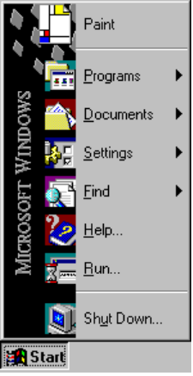

Creating A Shortcut
To be provided.
To create a shortcut
1. From My Computer, click the icon for the hard disk, and then click the icon for the directory in which your application resides.
2. Right-click the icon for your application. From the context menu, click Create Shortcut.
3. Drag the shortcut icon to the desktop or other folder window of your choice.
– Or –
1. Right-drag the icon for your application to the desktop or other folder window.
2. When you release the icon, a context menu appears. Click Create Shortcut(s) Here.

Configuring Win16-based and MS-DOS–based Applications
Application properties are maintained in the Registry.
To view or change properties for a Windows 3.1 application
1. Right-click the application’s icon. This displays the property sheet for the application.

How do I set Win16-based application properties?
For example, the following shows the property sheet for the Windows for Workgroups Calculator tool.
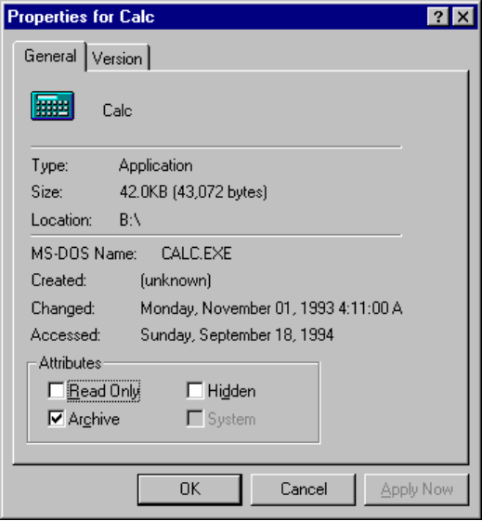
2. Change the attribute settings as appropriate. The Read Only, Archive, Hidden, and System attributes have the same meanings that they did with Windows 3.1.

To view or change properties for an MS-DOS–based application
1. Right-click the application’s icon. This displays the property sheet for the application.

How do I set properties for an
MS-DOS–based application?
2. Click the tab you want to use and change the options as appropriate. (See the following section for information on all of these options.)
3. Do the same for all other options and tabs, and then click OK.

Setting Properties for MS-DOS–based Applications
To view or modify the property settings for an MS-DOS–based program
- Right-click the icon for the program. (If the program’s icon is not on the Windows 95 desktop, use Windows Explorer to find the program, then right-click the icon in Windows Explorer.) This displays the property sheets for the program.

MS-DOS–based programs have six property sheets — General, Program, Font, Memory, Screen, and Misc.
Use the General property sheet to see information about the type, size, and location of the MS-DOS–based application. From this property sheet, you can turn on and off the Read Only, Archive, Hidden, and System attributes, which have the same meaning as with MS-DOS.

Do not change file attributes unless you are sure of what you are doing.
Caution

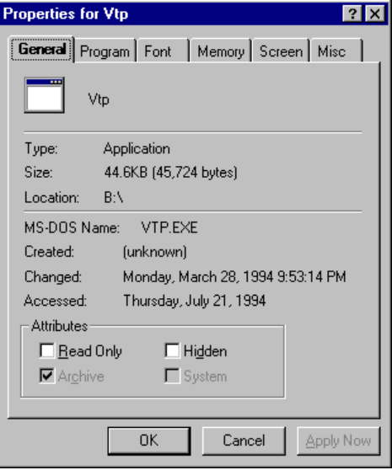
Use the Program property sheet to identify details about how the program will be run.
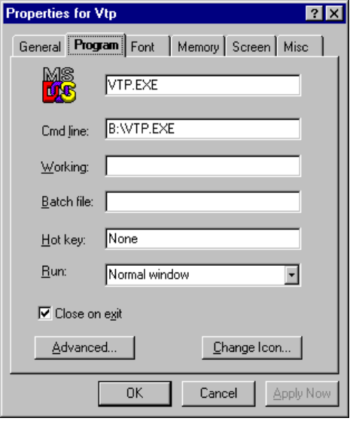
Field | Comments
(Filename) | Include the filename for the application.
Command Line | Type the full command line, including the correct drive, path name, and options, to run this application.
Working | Specify the working directory.
Batch File | Type the name of a batch file you want to run before the program starts.
Hot Key | Specify the key combination (if any) that you want to use to quickly switch to this application.
Run | Choose whether to run the program in a normal-sized window, a maximized window, or a minimized window.
Close on Exit | Check this box if you want the window to close once the  MS-DOS–based program has ended.

Use the Advanced command button to specify information about the mode in which your program will run.
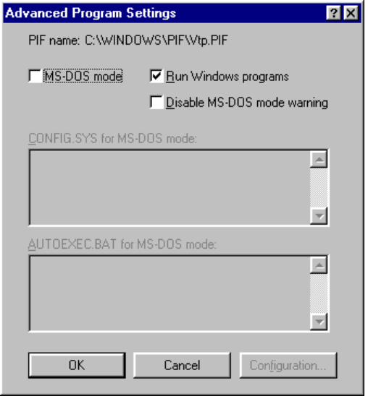
Field | Comments
MS-DOS Mode | Check this box to run this program in exclusive MS-DOS mode. No other processes are allowed to run simultaneously if you use this option. (When you choose this option, Run Windows Programs is unavailable.)
Run Windows Programs | Check this box to allow other applications to run concurrently with this MS-DOS–based application. (When you choose this option, other options are unavailable.)
Disable MS-DOS Mode Warning | To be provided.
CONFIG.SYS | Type any lines you want to add to CONFIG.SYS to allow this application to run properly. This version of CONFIG.SYS is used only for the MS-DOS Mode session in which this application runs.
AUTOEXEC.BAT | Type any lines you want to add to AUTOEXEC.BAT for this application. This version of AUTOEXEC.BAT is used only for the MS-DOS Mode session in which this application runs.

From the Font property sheet, you can specify the font size and type to be used as the MS-DOS–based program runs. From this property sheet, you can also preview how the program window and the font will appear.
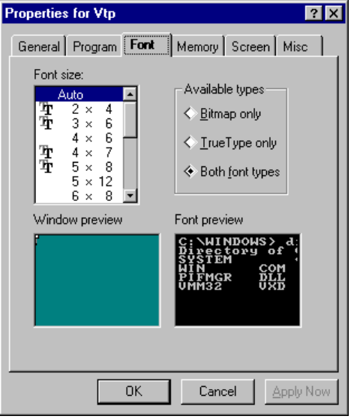
From the Memory property sheet, you can define memory allocation options for:
- Conventional memory, which consists of the first 640K of memory available on your computer.
- Extended memory, which is essentially a seamless upward extension of the original 1 megabyte (MB) address space available in the memory of 80286 and 80386 computers. Extended memory always starts at exactly 1024K, where the upper memory area ends.
- Expanded memory, which can be installed as an expanded memory card or emulated by an expanded memory manager (EMM). EMM software maps pages of expanded memory onto the system’s upper memory area.

Using Upper Memory Blocks (UMBs) and High Memory Area (HMA) are two ways to free conventional memory for use by MS-DOS–based applications, and thus improve performance. In conventional memory, UMBs are the unused part of upper memory from 640K to 1 MB, where information can be mapped to free memory below 640K. HMA is the first 64K of extended memory, where drivers can be loaded to free conventional memory.

How can I maximize the memory available to my MS-DOS–based applications?
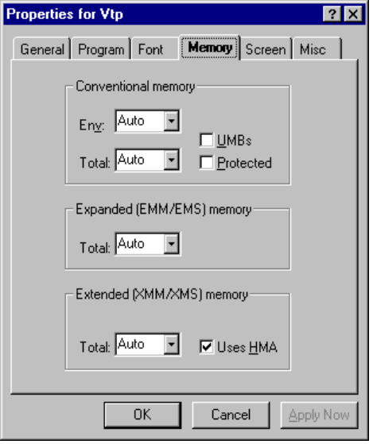
From the Screen property sheet, you can specify options for how the application will be displayed on the screen.
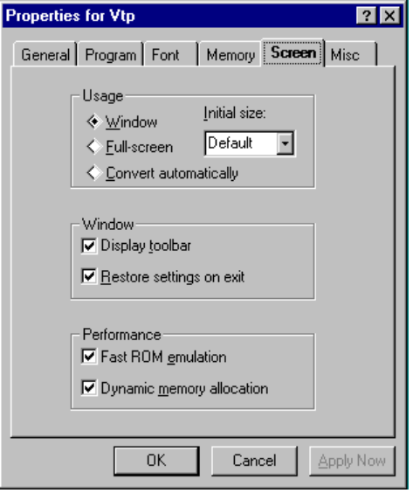

Field | Comments
Usage | Specify whether the application will run in a window with an initial size you can specify, a full-screen, or a window with a size automatically determined by the graphic mode it uses.
Windows | Choose whether to display a toolbar or to preserve the previously set Windows 95 windows settings.
Performance | Choose Dynamic Memory Allocation to use the Windows 95 video ROM-handling capabilities.

From the Misc property sheet, you can specify details about running your program in the foreground and in the background. You can specify whether your program must have exclusive access to the system when it is in the foreground and whether running a screen saver is allowed when the program is active. You can also specify whether the program must be suspended when it is in the background.
In addition, you can specify preferences for mouse, idle sensitivity, Windows hot keys, and other options.
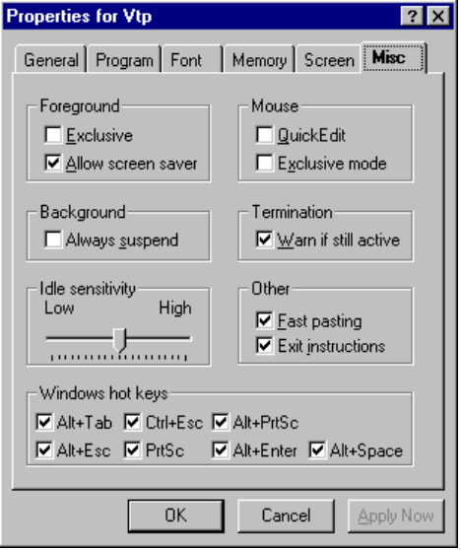

Running Applications from the Network
To be provided.

Issues for Running MS-DOS-based Applications
To be provided.

Applications That Won’t Run Well in Windows 95
Some Windows-based and MS-DOS–based applications may not run well under Windows 95 because they were written to take advantage of characteristics of older operating systems not found in Windows 95. For example, certain applications use a portion of the title bar to include items other than the title, such as a Quick Help button. Because Windows 95 title bars are not formatted in the same way as Windows 3.x title bars, some information may be overwritten when you run these old applications.

Which applications don’t work well under Windows 95?
In addition, some applications use interrupts that are not automatically supported by Windows 95. Others do not handle long filenames well or check for the operating system version number incorrectly. The following sections describe how Windows 95 works with these applications, to try to accommodate them.

While many programming tools that are not specifically designed to run under Windows 95 may run satisfactorily under Windows 95, the corresponding debugging tools usually will not. Be sure that both the programming and debugging tools you use are specifically written to run under Windows 95.
Note

Some Win16-based and MS-DOS–based disk utilities must be run with special care. In addition, some disk utilities do not perform correctly with long filenames. For more information about using Win16-based and MS-DOS–based disk utilities with Windows 95, see Chapter 15, “Disks and File Systems.”

Running Terminate-and-Stay-Resident Programs
Some older terminate-and-stay-resident programs (TSRs) rely on DOS interrupts to monitor everything that happens on the system. However, because of its protected-mode file system, Windows 95 doesn’t use DOS interrupts. If Windows 95 detects that a TSR is trying to monitor these interrupts, it will readjust itself to accommodate the application and will send all system information through DOS interrupts. This way, the TSR can monitor system events successfully. However, doing this will cause the performance of the operating system to slow significantly.
If Windows 95 finds the application listed in IOS.INI, it will not send system events through the DOS interrupts, thus avoiding decreased performance.

Fixing Version-Checking Errors
Some applications do not check the version of Windows 95 correctly. Incorrect version-checking techniques swapped the two bytes that record the version number, thus, version 3.10 would be reported as 10.3. Windows 95 tries to accommodate this possible version-checking error by reporting 3.95 as the version. This way, if an application looks for a version greater than 3.10 or its inverse, 10.3, the new Windows 95 version will prove to be greater.
If the application looks for an exact match for the version number, such as Windows version 3.10, it may not run on Windows 95. To fix this situation, you must edit the [Compatibility] section of WIN.INI to include the following line:
compiled_module_name=0x00200000

The compiled module name is the one contained in the DOS header. For example, the following entry is for cc:Mail™:
[Compatibility]
CCMAIL=0x00200000

Running Games
Notes
- The Windows 95 WIN.INI file includes fixes for many applications known to have this problem.
- Do not add a permanent entry for a program called SETUP. Install your application first, and then edit WIN.INI for the application module name.

In most cases, your games will run with no special adjustments under Windows 95. Most popular games have listings in the Windows 95 APPS.INF file.
Although some settings in their Windows 3.1 .PIF files are not necessary, the extra settings will not impede performance on Windows 95, except for minor delays due to the added overhead of reading the extra entries.

To run an MS-DOS–based game
1. Click the game icon.
2. If the game won’t run well, try setting the EMS option to 400 MB.
3. If the first two steps don’t work, run the game in MS-DOS Mode.

Troubleshooting Application Startup Problems

My application should have loaded during startup, but didn’t.
Try starting your computer, and pressing F8 during the restart process. This begins the “Fail-Safe Start” process. For a detailed description of this process, see Chapter 6, “Troubleshooting Setup and System Startup.” Next, check BOOTLOG for a record of anything that went wrong from the time you powered on your computer to the time the Windows 95 shell was loaded when you last started your computer. If your application loaded successfully, you should see two entries in BOOTLOG — one saying Windows 95 is about to load the VxD and one saying it was successfully loaded.

I installed Windows 95 in a directory other than the one used for Windows 3.1, but still want to use my Windows 3.1 applications. How do I reinstall?
If an application was installed under Windows 3.1, and Windows 95 was installed into a clean directory, the application will need to be installed under Windows 95. Use the App Install Wizard in the Control Panel to reinstall your application.

I upgraded from Windows 3.1 using the same directory. Are my applications ready to use?
If the application was installed under Windows 3.1 and that installation was upgraded to Windows 95, the .GRP file should have been converted and the application should run. If it does not, use the App Install Wizard to reinstall the application into the same directory. This will ensure that the Registry settings are correct for the application.

I installed a Windows 3.1 application, but something seems to be wrong when I try to run it.
Windows-based applications are sometimes written to overwrite system .DLL files and core components. If your application doesn’t run, or Windows 95 is not running properly after you install an application, check the size and dates of the files, and also check for any new VxDs that may have been added. Try using the FPARSE utility before and after installations of new software. This shows which new files were added to the Windows 95 directories and lets you easily compare size and dates of the Windows 95 files.

