Chapter 1
This chapter provides a brief review of the Windows 95 architecture to assist you in understanding how the various key operating system components operate.
Windows 95 Architecture
Windows 95 provides a complete, integrated, operating system, that offers modern 32-bit operating system technology, and includes built-in connectivity support. It also provides high performance, robustness, and complete backward compatibility.
With Windows 95, you can run Windows 16-bit and MS-DOS – based applications in addition to Windows 32-bit applications. (Windows 32-bit applications are also called Win32-based applications; Windows 16-bit applications are called Win16-based applications.)

Improvements over Windows 3.1 24-2
In This Chapter
Windows 95 Architecture Components 24-3
The Registry 24-4
Device Drivers 24-6
Configuration Manager 24-8
Core System Components 24-10
Installable File Systems 24-17
Virtual Machine Manager 24-24
Application Support 24-27
User Interface 24-34

Improvements over Windows 3.1
While the architectural design of Windows 95 is based on Windows version 3.1, Windows 95 includes several improvements over the earlier operating system, including:
- Fully integrated 32-bit, protected-mode operating system, eliminating the need for a separate copy of MS-DOS
- Preemptive multitasking, and multithreading support — improving system responsiveness and smooth background processing
- 32-bit installable file systems including VFAT, CDFS, and network redirectors supporting better performance, use of long filenames, and an open architecture to support future growth
- 32-bit device drivers available throughout the system, delivering improved performance and intelligent memory use
- Complete 32-bit kernel, including memory management and process scheduling and management
- Improved system-wide robustness and cleanup after an application ends or fails, delivering a more stable and reliable operating environment
- More dynamic environment configuration reducing the need for users to adjust their systems
- Improved system capacity, allowing multiple applications and system tasks to run well concurrently

Windows 95 Architecture Components
Windows 95 offers several architectural improvements over earlier Windows products. It includes a new device driver model, a new file system, new 32-bit graphics engine, and new 32-bit print, communications, and multimedia subsystems.
These new features are supported by the modular design shown in the following diagram.
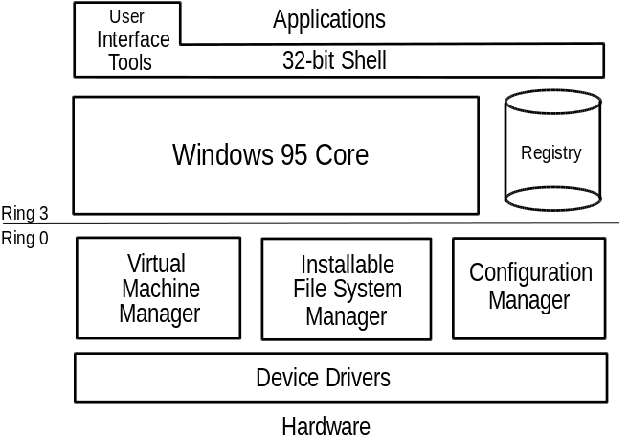
This chapter describes the key components that make up the Windows 95 architecture and explains how these provide improved performance and reliability to the user.

The Registry
The central information database for Windows 95 is called the Registry. This hierarchical database both simplifies the operating system and makes it more adaptable. The Registry simplifies the operating system by eliminating the need for AUTOEXEC.BAT, CONFIG.SYS, and .INI files (except when legacy applications require them). It makes the operating system more adaptable by storing per-user and per-configuration information so you can share one computer among multiple users and you can have more than one configuration (such as in the office and on-the-road configurations) for each computer.
The Registry is structured as a hierarchical database of keys, where each key can contain a value, or can even contain other keys (subkeys), as shown in the following example:
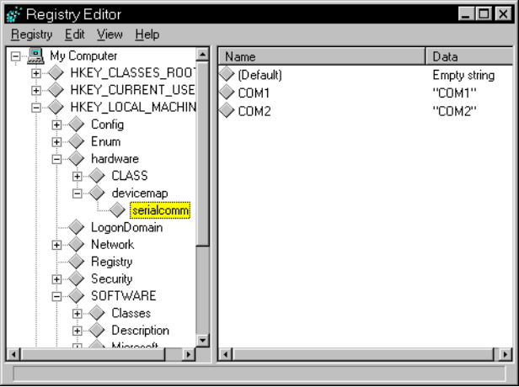
The Registry stores both binary and text values and supports keys that can have more than one value and can also support data of different types.
Logically, the Registry is a single information store. Physically it is made up of two .DAT files — SYSTEM.DAT contains computer-specific information and USER.DAT contains user-specific information. By storing user information in a separate file, an administrator can maintain a master copy of this information on a centralized server so that it can be downloaded to whatever computer on the network the user happens to use for logon. (For more information about user profiles, see Chapter 12, “System Management.”)
Windows 3.1 used initialization (.INI) files to store system-specific or application-specific information on the state or configuration of the system. For example, the WIN.INI file stored state information about the appearance or customization of the Windows environment, the SYSTEM.INI file stored system-specific information on the hardware and device driver configuration of the system, and various .INI files (for example, POWERPNT.INI, MSMAIL.INI, and WINWORD6.INI) stored application-specific information about the default state of an application.

Why replace .INI files with a centralized Registry?
In addition to the problems of managing multiple files, .INI files caused other limitations:
- .INI files are text-based, and are limited to 64K in total size, and APIs only allow for get/write operations.
- Information stored in .INI files is non-hierarchical and supports only two levels of information (specifically, section headings with a list of key names under each).
- Many .INI files contain a myriad of switches and entries that are complicated to configure or are used only by operating system components.
- .INI files provide no mechanism for storing user-specific information, thus making it difficult for multiple users to share a single computer.
- Configuration information in .INI files is local to each system, and no API mechanisms are available for remotely managing configuration, thus making it difficult to manage multiple systems.

The Registry addresses these issues by centralizing user, application, and computer-specific information, and by making this information easier to manage through either local or remote access.

When you upgrade from Windows 3.1 to Windows 95, system-specific information such as the static reference to loading virtual device drivers is moved, as appropriate, from the SYSTEM.INI file to the Registry.
Notes
Because many Win16-based applications still need them, WIN.INI, SYSTEM.INI, application-specific .INI files, CONFIG.SYS, and AUTOEXEC.BAT are not eliminated. For example, .INI files used by Win16-based applications to add entries or load unique device drivers are not deleted by Windows 95. In addition, Windows 95 will continue to examine the [386Enh] section of SYSTEM.INI at startup to check for virtual device drivers.

Plug and Play and the Registry
One of the primary roles of the Registry in Windows 95 is to serve as a central repository for hardware-specific information for use by the Plug and Play system components. Windows 95 maintains information about hardware components and devices that have been identified through an enumeration process in the hierarchical structure of the Registry. When new devices are installed, the system checks the existing configuration in the Registry to determine the hardware resources (for example, interrupts, I/O addresses, DMA channels, and so on) that are not being used, so the new device can be properly configured without conflicting with a device already installed in the system.

Remote Access to Registry Information
Another advantage of the Registry for Win32-based applications is that many of the Win32-based Registry APIs can be used remotely through the the remote procedure call (RPC) mechanism in Windows 95 to provide access to Registry information across a network. This means that network administrators can use system management tools to access the contents of the Registry for any computer on the network. (Of course, the remote computer must be configured to allow remote administration. For more information, see Chapter 12, “System Management.”) With the Windows 95 remote administration mechanism, industry management mechanisms such as Simple Network Management Protocol (SNMP) can easily be integrated into Windows 95, simplifying the management and support burden of the network administrator.

Device Drivers
Windows 95 features improved support for hardware devices and peripherals including disk devices, video display adapters, mice, modems, and printers. In Windows 3.1, device drivers were, for the most part, monolithic and complex to develop. Use of a universal driver/mini-driver architecture makes it easier for hardware vendors to provide device-specific code for their hardware.
For most types of hardware, such as printers, modems, and display adapters, Microsoft provides a universal driver. This driver provides the interface to the appropriate Windows 95 components, such as the print or communications subsystems, and works to run common devices in that category. (For example, the Unimodem driver works with all modems supporting IBM® PC/AT commands.) Hardware vendors can write specific mini-drivers for their devices which do not run with Microsoft’s universal drivers.

Virtual Device Drivers
A virtual device driver (VxD) is a 32-bit, protected-mode driver that manages a system resource, such as a hardware device or installed software, so that more than one application can use the resource at the same time. VxD refers to a general virtual device driver—the x represents the type of device driver. For example, a virtual device driver for a display device is known as a VDD, a virtual device driver for a timer device is a VTD, a virtual device driver for a printer device is a VPD, and so forth.
With Windows 3.1, VxDs were statically loaded and took up a lot of memory space. Windows 95 dynamically loads VxDs — only those which are needed at any given time are loaded into memory.
VxDs support all hardware devices for a typical computer, including disk controller, serial and parallel ports, parallel ports, keyboard and display device, and so on. If the state of the hardware device can be disrupted by switching between multiple applications, the device must have a corresponding virtual device and VxD. The virtual device keeps track of the state of the device for each application and ensures that the device is in the correct state whenever an application continues.
Although most virtual devices manage hardware, some manage only installed software, such as an MS-DOS device driver or a terminate-and-stay-resident (TSR) program. Such virtual devices contain code to emulate the software or ensure that the software uses data that applies only to the currently running application. Also, VxDs are often used to improve software performance.

Windows 95 virtual device driver files have a filename extension of .VXD; Windows 3.1 drivers use an extension of .386.

Configuration Manager
Today’s personal computers consist of many bus and device architectures coexisting on a single system. A bus is the mechanism that allows information to be transferred between the computer and the device.
More than one device type might use the same bus architecture. For example, both a mouse and a keyboard can use the same keyboard controller bus; both a CD-ROM drive and a hard disk drive can use the same SCSI bus. Each device type has a separate set of configuration requirements.
To support Plug and Play functionality, the Windows 95 architecture includes a new component called the Configuration Manager which orchestrates the configuration process. This component works with other system components to identify each bus and each device on the system, and to identify the configuration settings for each device. Configuration Manager ensures that each device on the computer can use an IRQ number, I/O port addresses, and other resources without conflict with other devices.
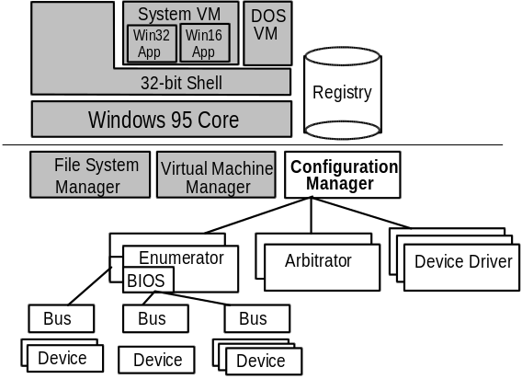
The Configuration Manager also helps monitor the computer for changes in the number and type of devices present and manages the reconfiguration of the devices, as needed, when changes take place. As these events occur, the Configuration Manager communicates the information to applications.
To perform its role, Configuration Manager (implemented as part of VMM32) calls on the bus enumerators to identify all the devices on their specific buses and their respective resource requirements.
Bus enumerators are new drivers which are responsible for creating the hardware tree on a Plug and Play system. A hardware tree is the hierarchical representation of all the buses and devices on a system. Each bus and each device is represented as a node. The following is a graphical representation of a hardware tree.
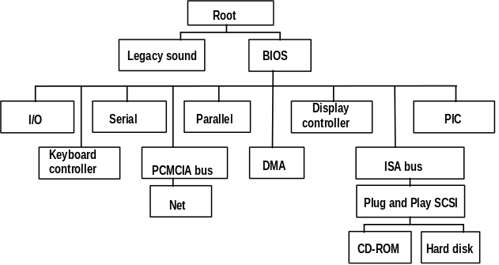
During the device enumeration process, the bus enumerator locates and gathers information from either the device drivers or BIOS services for that particular device type. For example, the SCSI enumeration is done by calling the SCSI driver. (Some bus enumerators may instead check the hardware directly.) Similarly, the PCMCIA enumerator may be built in to Card Services or Socket Services.
For each device, a driver is loaded, and is instructed by Configuration Manager to await assignment of specific resources (such as IRQ numbers).
Configuration Manager calls on resource arbitrators to allocate resources for each device. Resource arbitrators also resolves conflicts among devices that request identical resource assignments. Windows 95 provides arbitrators for the standard I/O, memory, hardware interrupt, and DMA channel resources. The arbitrators are separate components, rather than a part of Configuration Manager, to ensure future extensibility to new types of resources, such as power allocation or automatic SCSI IDs, for example.
To complete the configuration process, Configuration Manager informs the device drivers about the device configuration. This process is repeated when the BIOS or one of the other bus enumerators informs Configuration Manager about an event that requires a change to the system configuration, such as the removal or insertion of a Plug and Play-compliant PCMCIA card.

Core System Components
Like Windows version 3.1 and Windows for Workgroups version 3.1, Windows 95 includes a core composed of three components — User, Kernel, and GDI.
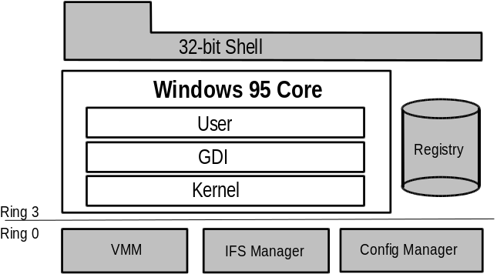
Each of these components includes a pair of DLLs — one 32-bit and one
16-bit — which provide services for the applications you run. The following sections describe the services provided by these core components.
32-Bit Versus 16-Bit Components
Windows 95 is a 32-bit preemptive multitasking operating system that implements some 16-bit code to provide compatibility with existing applications. Windows 95 is designed to use 32-bit code wherever it significantly improves performance without sacrificing application compatibility. Windows 95 retains existing 16-bit code where it is required to maintain compatibility or where 32-bit code would increase memory requirements without significantly improving performance. All of the Windows 95 I/O subsystems (such as networking and file systems) and device drivers are fully 32-bit, as are all the memory management and scheduling components, including the Kernel and Virtual Memory Manager.
As shown here, the lowest-level services provided by the Windows 95 Kernel are provided as 32-bit code to ensure a high-performance core. Most of the remaining 16-bit code consists of hand-tuned assembly language, delivering performance that rivals some 32-bit code used by other operating systems available on the market today.
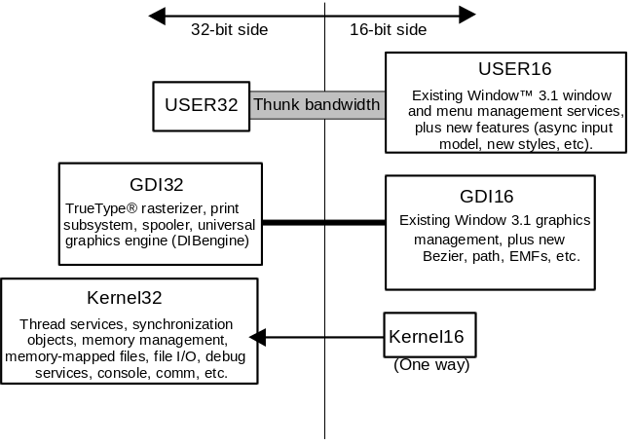
Many functions provided by the GDI — which are mostly complex, CPU-intensive functions — are now rewritten as 32-bit code to improve performance. Much of the window management code in the User components— which are small, fast functions — remains 16-bit, thus retaining application compatibility.
Windows 95 also improves on the MS-DOS and Windows 3.1 environment by implementing many device drivers as 32-bit, protected-mode code. Virtual device drivers (VxDs) in Windows 95 assume the functionality provided by many real-mode, MS-DOS–based device drivers, eliminating the need to load them in MS-DOS. This results in a minimal conventional memory footprint, improved performance, and improved reliability and stability of the system over MS-DOS – based device drivers.

User
The User component manages input from the keyboard, mouse, and other input devices and output to the user interface (windows, icons, list boxes, menus, and so on). It also manages interaction with the sound driver, timer, and communication ports.
Windows 95 uses an asynchronous input model for all input to the system and applications. As the various input devices generate interrupts, the interrupt handler converts these interrupts to messages and sends the messages to a raw input thread area, which in turn passes each message to the appropriate message queue. (While each Win32-based application has its own message queue, all Win16-based applications share a common message queue.)

Kernel
The Kernel provides base operating system functionality including file I/O services, memory management, and task scheduling. When a user wants to start an application, the Kernel loads the .EXE and .DLL files for the application.
The Kernel provides services to both 16-bit and 32-bit applications by using a translation process called thunking to map between 16-bit and 32-bit formats. Thunking converts a 16-bit value to its 32-bit equivalent, as illustrated in the following:
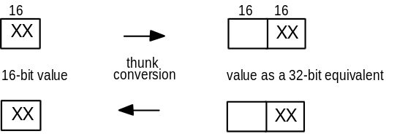
Exception handling is another service of the Kernel. Exceptions are events that occur as a program runs and that require software outside of the normal flow of control to be run. For example, if an application generates an exception, the Kernel is able to communicate that to the application to perform the necessary functions to resolve the problem.
The Kernel also allocates virtual memory, resolves import references, and supports demand paging for the application. As the application runs, the Kernel schedules and runs threads of each process owned by an application.

32-Bit Address Space
To support a 16-bit operating environment including Windows 3.1 and MS-DOS, the Intel® processor architecture uses a mechanism called asegment. Segments reference memory by using a 16-bit segment address, and a 16-bit offset address within the segment. A segment is 64K in size, and both applications and the operating system suffer a performance penalty for accessing information across segments.
Windows 95 addresses this issue by using the 32-bit capabilities of the Intel 80386 (and above) processor architecture to support a flat, linear memory model for 32-bit operating system functionality and Win32-based applications. A linear addressing model simplifies the development process for application vendors, and removes the performance penalties imposed by the segmented memory architecture.
With this addressing model, Windows 95 allows full use of the 4 gigabytes (GB) — 4 billion bytes of memory — of addressable memory space for all 32-bit operating system components and applications. Each 32-bit application can access up to 2 GB of addressable memory space, which is large enough to support even the largest desktop application.

Virtual Memory Management
Virtual memory refers to the fact that the operating system can actually allocate more memory than the computer physically contains . Each process is allocated a unique virtual address space, which is a set of addresses available for the process’s threads to use. This virtual address space appears to be 4 GB in size — 2 GB reserved for program storage and 2 GB reserved for system storage.
The following diagram illustrates where Windows 95 system components and applications reside in virtual memory.
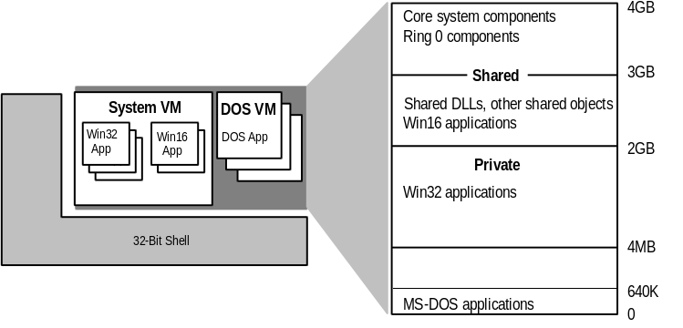
From top to bottom, here’s where system and application components reside in virtual memory:
- The Windows 95 core components and all Ring 0 components reside in the address space above 3 GB.
- Win32-based applications reside between 4 megabytes (MB) and 2 GB. Each Win32-based application has its own address space, which means that other programs cannot corrupt or otherwise hinder the application, or vice versa.
- Shared dynamic-link libraries (DLLs) reside in the shared address space between 2 GB and 3 GB. This makes them available to all applications.

Swap File Improvements
Windows 95 improves on the virtual memory swap file implementation provided in Windows 3.1, to address the problems and limitations imposed in Windows 3.1.
Under Windows 3.1, users were faced with a myriad of choices and configuration options when it came to setting up a swap file to support virtual memory. They had to decide whether to use a temporary swap file or a permanent swap file, how much memory to allocate to the swap file, and whether to use 32-bit disk access to access the swap file or not. Users benefited from a temporary swap file in that the swap file did not need to be contiguous, and Windows allocated space on the hard disk when Windows was started, and freed up the space when the user exited Windows. A permanent swap file provided the best performance; however, it required a contiguous block of space, had to be set up on a physical hard disk, and was statically specified by the user, so that it did not free up space when the user exited Windows.
The swap file implementation in Windows 95 simplifies the configuration task for the user and combines the best of a temporary swap file and a permanent swap file, due to improved virtual memory algorithms and access methods. The swap file in Windows 95 is now dynamic, and can shrink or grow, based on the operations that are performed on the system. The swap file can also occupy a fragmented region of the hard disk, with no substantial performance penalty hit. (The swap file can also reside on a compressed volume.)
The user can still adjust the parameters used for defining the swap file in Windows 95; however, the need to do this is reduced by intelligent use of system defaults. The following illustration shows the new, simplified swap file configuration options, allowing the user to specify the minimum and maximum swap file size to use.
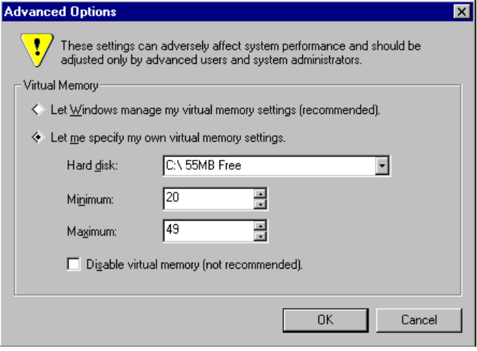

Graphics Design Interface
The Graphics Design Interface (GDI) is the graphical system that manages what is displayed to the screen. It also provides graphics support for printers and other output devices. It draws graphic primitives, manipulates bitmaps, and interacts with device-independent graphics drivers, including those for display and printer output device drivers.

Graphics Subsystem
The graphics subsystem is a significant improvement over Windows 3.1 and provides graphics support for input and output devices. The Windows 95 graphics subsystem includes:
- A new graphics engine for quicker screen redrawing
- A new display driver model for wider device support
- Image Color Matching for better color-matching between display and color output devices

To gain reliability and better performance, Microsoft developed a new 32-bit graphics engine (also known as the Device Independent Bitmaps (DIB) engine). This engine directly controls graphics output to the screen, which results in more reliable system performance. It also provides a set of optimized generic drawing functions for monochrome, 16-color, 256-color, 16-bit high colors, and 24-bit true color graphic devices, and supports Biezier curves and paths.
As with other parts of the operating system, the Windows 95 graphics subsystem includes a universal driver/mini-driver model. As illustrated in the following, display drivers for Windows 3.1 included hardware specific instructions, in addition to general instructions for the operating system. Now, all instructions about drawing to the screen or output device, and so on, are included in the universal display driver. Mini-drivers for Windows 95 define only hardware-specific instructions. Mini-drivers are available for most leading Super VGA adapters and graphics accelerators, including S3, ATI, Tseng, Paradise, and Cirrus Logic.
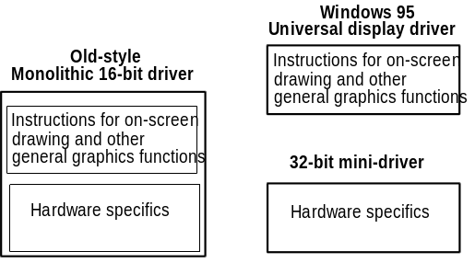
With Image Color Matching in Windows 95, users can see a better match between the colors displayed on the screen and the colors printed on a color printing device. Image Color Matching is implemented as a service within Windows 95. Applications can use the corresponding APIs and DLL to take advantage of Image Color Matching features.

Print Subsystem
The 32-bit Windows 95 print subsystem improves performance through smoother background printing and faster return-to-application time.
In Windows 3.1, Print Manager passed a fixed amount of information to the printer, whether the printer was ready to receive it or not. If the printer wasn’t ready to receive more data, processing at the computer was suspended until the printer was ready. Unlike Print Manager, the Windows 95 spooler passes data to the printer only when the printer is ready to receive more information, by using background thread processing. This helps to reduce what often seemed like “jerkiness,” when printing documents with Windows 3.1 Print Manager.
Windows 95 spools enhanced metafiles (EMF), rather than raw printer data, to ensure quick return-to-application time (as much as two times faster than with Windows 3.1). Once spooled, the EMF information is interpreted in the background, and output is then sent to the printer.
When users browse the network to choose the printers they want to use, Windows 95 automatically installs the appropriate printer driver from the Windows 95 or Windows NT server.
The print subsystem supports Point and Print. A user simply drags a document’s icon to the desired printer and the document prints. The user does not have to install a device driver for the printer; Windows 95 does that automatically without user intervention.
Another feature of the Windows 95 print subsystem is deferred printing. If no printing device is available where a user is working (for example, on an airplane), the user can still “print” the job. Windows 95 generates the print job, then saves it for output to the print device when one is available.Then, when the user docks the portable computer after a road trip, the print job that was “printed” on the airplane begins generating pages at the print device.
The print subsystem also provides system-level support of bidirectional communication protocols for printers adhering to the Extended Communication Port (ECP) printer communication standard, developed by Microsoft and Hewlett-Packard. This capability allows printers to send unsolicited messages to Windows 95 and to applications. For example, the printer might send an “out of paper” or “printer offline” message. Bidirectional communication enables much more detailed status reporting on a wider variety of information, such as toner-low, detailed paper jam information, maintenance needs, and so on.

Installable File Systems
Windows 95 features a layered file system architecture that supports multiple file systems, including:
- VFAT, the 32-bit FAT file system
- CDFS, the 32-bit CD-ROM file system

The new file system architecture makes the system easier to use and improves file and disk I/O performance. Features of the new file system architecture include:
- Long filename support
- Dynamic system cache for file and network I/O
- Open architecture for future system support
- Disk device driver compatibility with Windows NT

Long filename support improves ease of use because users no longer need to reference files by the MS-DOS 8.3 filename structure. Instead, users can specify up to 255 characters to identify their documents. In addition, filenames seem less cryptic and thus easier to read because Windows 95 hides the filename extensions from users.
Windows 95 I/O performance is dramatically improved over Windows 3.1. This is because Windows 95 features 32-bit protected-mode code for reading information from and writing information to the file system, and for reading information from and writing information to the disk device. It also includes intelligent, 32-bit caching mechanisms, and a full, 32-bit code path is available from the file system to the disk device.
The following figure shows the file system architecture used by Windows 95.
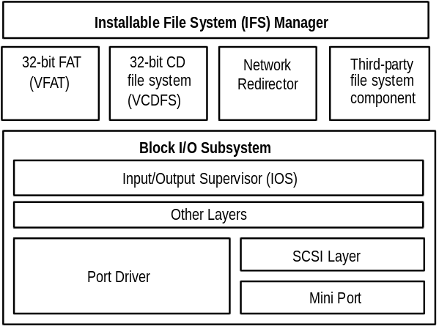
The Windows 95 file system architecture is made up of the following components:
- Installable File System (IFS) Manager. The IFS Manager is responsible for arbitrating access to different file system components.
- File system drivers. The file system drivers layer includes access to file allocation table (FAT)-based disk devices, CD-ROM file systems, and redirected network device support.
- Block I/O subsystem. The block I/O subsystem is responsible for interacting with the physical disk device.

The following sections describe these components.

Installable File System Manager
Under MS-DOS and Windows 3.1, the MS-DOS Int 21h interrupt function is responsible for providing access to the file system to manipulate file information on a disk device. To support redirected disk devices (for example, a network drive, or a CD-ROM drive), other system components such as the network redirector would hook the Int 21h function so that it could examine the file system request to determine whether it should handle the file I/O request, or let the base file system handle it. While this mechanism provided the ability to add on more device drivers, some add-on components were ill-behaved and interfered with other installed drivers.
Another problem with the MS-DOS – based file system was the difficulty in loading multiple network redirectors to provide concurrent access to different network types. Windows for Workgroups provided support for running the Microsoft Windows Network redirector at the same time as an additional network redirector such as Novell® NetWare®, Banyan® VINES®, or Sun® PC-NFS®; however, support for running more than two network redirectors at the same time was not supported.
The key to friendly access to disk and redirected devices in Windows 95 is the Installable File System (IFS) Manager. The IFS Manager arbitrates access to file system devices, and other file system device components.

File System Drivers
With Windows 3.1, file system drivers were supported by MS-DOS. With Windows 95, file system drivers Ring 0 components of the operating system. Windows 95 includes support for all of the following file systems (others can be added by third-party vendors):
- 32-bit FAT driver (VFAT)
- 32-bit CD-ROM file system driver (CDFS)
- 32-bit network redirector for connectivity to Microsoft Network servers like Windows NT Advanced Server, along with a 32-bit network redirector to connect to Novell NetWare servers

VFAT File System
The 32-bit VFAT driver provides a 32-bit, protected-mode code path for manipulating the file system stored on a disk. Because it is reentrant and multithreaded, it provides smoother multitasking performance. The 32-bit file access driver is improved over that provided originally with Windows for Workgroups 3.11, and is compatible with more MS-DOS device drivers and hard disk controllers.
Benefits of the 32-bit file access driver over MS-DOS – based driver solutions include:
- Dramatically improved performance and real-mode disk caching software
- No conventional memory used (real-mode SmartDrive has been replaced)
- Better multitasking when accessing information on disk (no blocking)
- Dynamic cache support

Under MS-DOS and Windows 3.1, manipulation of the file allocation table (FAT) and writing information or reading information from the disk is handled by the Int 21h MS-DOS function and is 16-bit real-mode code. Being able to manipulate the disk file system from protected-mode removes or reduces the need to switch to real-mode to write information to the disk through MS-DOS, thus resulting in a performance gain for file I/O access.
The 32-bit VFAT driver interacts with the block I/O subsystem to provide 32-bit disk access to more device types than are supported by Windows 3.1. Windows 95 also supports mapping to any real-mode disk drivers that a user may have installed. The combination of 32-bit file access and 32-bit disk access drivers results in significantly improved disk and file I/O performance.

VCACHE
The 32-bit, VFAT works in conjunction with a 32-bit, protected-mode cache driver (VCACHE). This driver replaces the 16-bit, real-mode SmartDrive disk cache software provided with MS-DOS and Windows 3.1. The VCACHE driver features more intelligent caching algorithms than SmartDrive, to cache information read from or written to a disk drive. The VCACHE driver also manages the cache pool for the CD-ROM File System (CDFS) and the 32-bit network redirectors that are provided with Windows 95.
Another big improvement in VCACHE over SmartDrive is that the memory pool used for the cache is dynamic and is based on the amount of available free system memory. Users no longer need to statically allocate a block of memory to set aside as a disk cache. The system automatically allocates or deallocates memory used for the cache based on system use.
For example, as you perform a large number of activities on the network, Windows 95 increases the size of the network cache. As network activity decreases and more applications are started, Windows 95 decreases the network cache size to make room in memory for the applications.

CD-ROM File System
The 32-bit protected-mode CD-ROM File System (CDFS) implemented in Windows 95 provides improved CD-ROM access and performance over the real-mode MSCDEX driver in Windows 3.1. (CDFS conforms to the ISO 9660 standard.) The CDFS driver cache is dynamic and shares the cache memory pool with the 32-bit VFAT driver, requiring no configuration or static allocation on the part of the user.
Benefits of the new 32-bit CDFS driver include:
- No conventional memory used — real-mode MSCDEX has been replaced
- Improved performance over MS-DOS – based MSCDEX and real-mode cache
- Better multitasking when accessing CD-ROM information — no blocking
- Dynamic cache support to provide a better balance between providing memory to run applications versus providing memory to serve as a disk cache

If MSCDEX is specified in the user’s AUTOEXEC.BAT, the 32-bit CDFS driver automatically takes over the role played by the MSCDEX driver and communicate with the CD-ROM device. Use of MSCDEX is no longer necessary under Windows 95.

Block I/O Subsystem
The block I/O subsystem in Windows 95 improves upon the 32-bit disk access “FastDisk” device architecture used in Windows 3.1 to enhance performance for the entire file system and provides a broader array of device support.
As shown in the following diagram, the block I/O subsystem includes these components:
- High-level Input/Output Supervisor (IOS) layer, which provides the interface to the block I/O subsystem and the higher-layer components
- Port driver, which represents a monolithic disk device driver
- SCSI layer, which provides a standard interface and driver layer to provide device-independent control code for SCSI devices
- SCSI mini port driver, which contains the device-dependent control code responsible for interacting with individual SCSI controllers

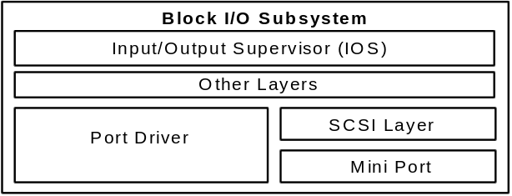
The following sections examine the block I/O subsystem components.

I/O Supervisor
The I/O Supervisor (IOS) provides services to file systems and drivers. The IOS is responsible for the queuing of file service requests and for routing the requests to the appropriate file system driver. The IOS also provides asynchronous notification of file system events to drivers that are installed.

Port Driver
The port driver is a monolithic, 32-bit, protected-mode driver that communicates with a specific disk device such as a hard disk controller. This driver is Windows 95-specific and resembles the 32-bit disk access (FastDisk) driver used in Windows 3.1 (for example, WDCTRL for Western Digital™ compatible hard disk controllers). In Windows 95, the driver that communicates with IDE/ESDI hard disk controllers and floppy disk controllers is implemented as a port driver. A port driver provides the same functionality as the combination of the SCSI manager and the mini port driver.

SCSI Layer
The SCSI layer applies a 32-bit protected-mode universal driver model architecture for communicating with SCSI devices. The SCSI layer provides all the high-level functionality that is common to SCSI-like devices, and then uses a mini port driver to handle device-specific I/O calls. The SCSI Manager is also part of this system and provides the compatibility support for using Windows NT mini port drivers.

Mini Port Driver
The Windows 95 mini port driver model makes it easier for a hardware disk device vendor to write a device driver. Because the SCSI stub provides the high-level functionality for communicating with SCSI devices, the hardware disk device vendor only needs to create a mini port driver that is tailored to the vendor’s own disk device. The Windows 95 mini port driver is 32-bit protected-mode code, and is binary-compatible with Windows NT mini port drivers. Binary compatibility with Windows NT results in a more stable and reliable device driver, because the hardware vendor needs to only maintain one code base for device support, and Windows 95 users can benefit from the fact that many mini port drivers are already available for Windows NT.

Some mini port drivers written for Windows NT do not include Plug and Play information and, therefore, will not perform as well as others on Windows 95.
Note

Real-Mode Mapping Layer
To provide compatibility with real-mode, MS-DOS – based device drivers for which a protected-mode counterpart does not exist, the block I/O subsystem provides a mapping layer to allow the protected-mode file system to communicate with a real-mode driver as if it were a protected-mode component. The layers above and the real-mode mapper are protected-mode code, and the real-mode mapper translates file I/O requests from protected mode to real-mode, such that the MS-DOS – based device driver can perform the appropriate operation to write or read information to or from the disk device. An example scenario where the real-mode mapper would come into play is when real-mode disk compression software is running and a protected-mode disk compression driver is not available. The net effect of this component is to ensure binary compatibility with existing MS-DOS – based disk device drivers in Windows 95.

Using MS-DOS – based device drivers can be a potential bottleneck because all I/O must be serialized. Also, because all of these VxDs must be page-locked, this will increase the working set used by the operating system.
Note

Virtual Machine Manager
The Windows 95 Virtual Machine Manager is responsible for creating and maintaining the virtual machine environments in which applications and system processes run.
A virtual machine is an environment in memory that, from the application’s perspective, looks like a separate computer, complete with all of the resources available on the physical computer that an application needs to run. The Virtual Machine Manager provides each application with the system resources it needs.
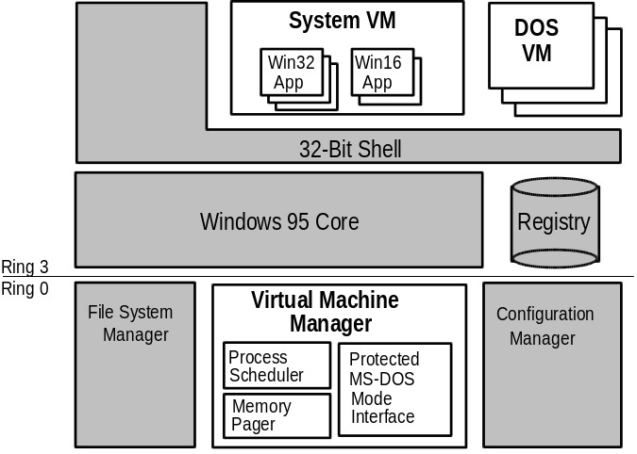
Windows 95 has a single virtual machine called System, in which all system processes run. In addition, all Win32 and Win16-based applications run in this virtual machine. Each MS-DOS – based application runs in its own DOS virtual machine.
The Virtual Machine Manager is responsible for three key areas of services:
- Process scheduling
- Memory paging
- MS-DOS Mode support for MS-DOS – based applications that require exclusive access to system resources

Virtual Machine Manager replaces WIN386.EXE in Windows 3.1.
The following sections discuss process scheduling and memory paging. MS-DOS Mode is described later in this chapter.

Process Scheduling and Multitasking
The process scheduler is the component responsible for providing system resources to the applications and other process you run, and for scheduling processes to allow multiple applications to run concurrently.
With Windows 3.1, applications ran concurrently through a method known as cooperative multitasking. This means that the operating system required an application to check the message queue periodically and to relinquish control of the system to other running applications. Applications that did not check the message queue frequently would effectively “hog” CPU time and prevent the user from switching to another application.

What’s the difference between cooperative and preemptive multitasking?
Windows 95 uses preemptive multitasking for Win32-based applications. This means that the operating system will take control away from or gives control to another running task, depending on the needs of the system.
Unlike Win16-based applications which are cooperatively multitasked in Windows 95 for compatibility reasons, Win32-based applications do not need to yield to other running tasks to multitask properly. Win32-based applications can take advantage of multithreading, a mechanism that Windows 95 provides to facilitate the ability to run applications concurrently. A Win32-based application running in the system is called a process in terms of the operating system. Each process consists of at least a single thread of execution that identifies the code path flow as it is run by the operating system. A thread is a unit of code that can get a time slice from the operating system to run concurrently with other units of code, and must be associated with a process. However, a Win32-based application can initiate multiple threads for a given process to enhance the application for the user by improving throughput, enhancing responsiveness, and aiding background processing. Because of the preemptive multitasking nature of Windows 95, threads of execution allow code to be smoothly processed in the background.
For example, a word processing application (process) can implement multiple threads to enhance operation and simplify interaction with the user. The application can have a separate thread that responds to keys typed on the keyboard by the user to place characters in a document, while another thread performs background operations such as spell-checking or paginating, and while a third thread spools a document to the printer in the background.

Some Windows 3.1 applications may provide functionality similar to this; however, because Windows 3.1 does not provide a mechanism for supporting multithreaded applications, it is up to application vendors to implement their own threading schemes. The use of threads in Windows 95 makes it easy for application vendors to add asynchronous processing of information to their applications.
Note

Memory Paging
Windows 95, like Windows NT, uses a demand-paged virtual memory system. This system is based on a flat, linear address space accessed using 32-bit addresses.
Each process is allocated a unique virtual address space of 4 GB. This virtual address space is divided into equal blocks, or pages.
Demand paging refers to a method by which data is moved in pages from physical memory to a temporary paging file on disk. As the data is needed by a process, it is paged back into physical memory.
The Memory Pager maps virtual addresses in the process’s address space to physical pages in the computer’s memory. In doing so, it hides the physical organization of memory from the process’s threads. This ensures that the thread can access its process’s memory as needed, but not the memory of other processes. Therefore, as shown in the following, a thread’s view of its process’s virtual memory is much simpler than the real arrangement of pages in physical memory.
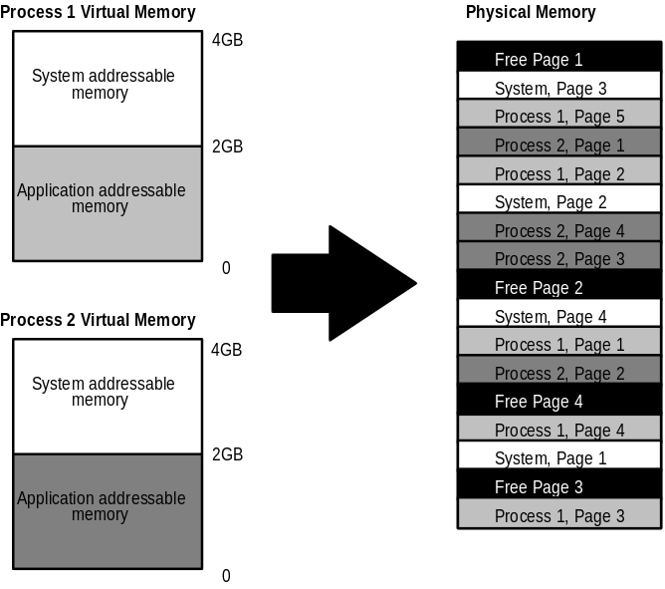

Application Support
Windows 95 supports Win32-based, Win16-based, and MS-DOS – based applications.
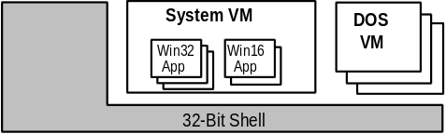
As illustrated here, Win32-based and Win16-based applications run in the System virtual machine (VM). Win32-based applications each run in a separate address space, while Win16-based applications run together in a shared address space. Each MS-DOS application runs in its own virtual machine. For more information about virtual machines, see “Virtual Machine Manager” earlier in this chapter.

Support for Win32-based Applications
Windows 95 is designed to optimize 32-bit applications. Therefore, Win32 can take full advantage of all of the performance enhancement features of this operating system’s design. Win32 applications feature several benefits over Win16-based applications, including preemptive multitasking, Win32 APIs, long filename support, separate message queues, flat address space, and memory protection. In addition, each Win32-based application runs in its own fully-protected, private address space, preventing it from causing the operating system or other applications to fail.
Windows 95 preemptively multitasks Win32-based applications. The operating system Kernel schedules the time allotted for running applications in the system. Its support for preemptive multitasking results in smoother concurrent processing and prevents any one application from using all system resources without permitting other tasks to run.
Win32-based applications can optionally implement threads to improve the granularity at which they multitask within the system. The use of threads by an application improves the interaction with the user and results in smoother multitasking operation.
Under Windows 3.1, the system uses the point when an application checks the system message queue as the mechanism to pass control to another task, allowing that task to be scheduled cooperatively. If an application doesn’t check the message queue on a regular basis, or the application stops and thus prevents other applications from checking the message queue, the system keeps the other tasks in the system suspended until the errant application is ended.
As illustrated in the following, each Win32-based application has its own message queue and thus is not affected by how other tasks access message queues.
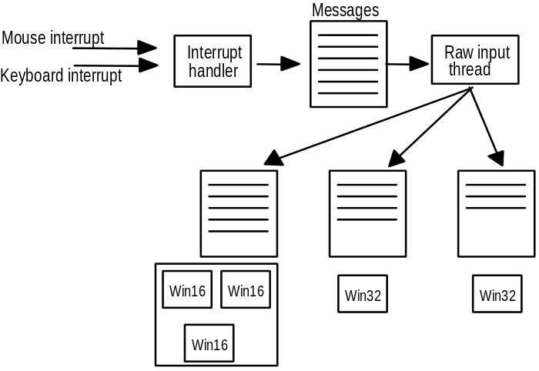
Resources allocated for each Win32-based application tracked on a per-thread basis are automatically freed when the application ends. If an application hangs, users can perform a local reboot by pressing ctrl+alt+del to end the stopped application without affecting other running tasks. If a Win16-based application stops, or if another Win32-based application fails, it does not adversely affect a Win32-based application that is also running. The Win32-based application continues to run preemptively and continues to receive incoming messages or event notifications in its message queue.

Support for Win16-based Applications
Win16-based applications written for Windows 3.1 run in Windows 95 without modification.
In Windows 95, Win16-based applications run together within a unified address space, rather than in separate address spaces, as Win32-based applications do. Windows 95 cooperatively multitasks Win16-based applications. Win16-based applications benefit from the preemptive multitasking of other system components including the 32-bit print and communications subsystems, and the improvements made in system robustness and protection from the Windows 95 system kernel.
Windows 95 ensures that any Win16-based application will run as well or better on a 4-MB or 8-MB computer (or greater) than with Windows 3.1. In addition, the performance of a Win16-based application is improved because it can use operating system services that are provided by the 32-bit system components of Windows 95, including 32-bit device driver components and 32-bit subsystems.
The improvements made to overall system-wide robustness significantly increase the system’s ability to recover from an errant application, and lessens the likelihood of application errors, due to improved cleanup of the system. General protection faults (GPFs) under Windows 3.1 were typically caused by an application that wrote over its own memory segments, rather than another application’s memory. Windows 3.1 did not recover gracefully when a Windows-based application failed or stopped. When an application was halted by a GPF, the system commonly left allocated resources in memory, causing the system to degenerate. Windows 95 tracks resources allocated by Win16-based applications and uses the information to clean up the system after an application exits or ends abnormally, thus freeing up unused resources for use by the rest of the system.
Win16-based applications use a common message queue that is separate from those used by Win32-based applications. Because of this, Windows 95 can provide better system recovery and can ensure that the system will not halt if a Win16-based application hangs.

Support for MS-DOS – based Applications
Windows 95 includes many improvements over Windows 3.1 for running MS-DOS–based applications. In fact, Windows 95 offers better compatibility for running MS-DOS–based applications than Windows 3.1 does, including the ability to run hardware-intensive applications such as games.
As with Windows 3.1, each MS-DOS – based application runs in its own virtual machine. A DOS virtual machine takes advantage of the Intel 80386 (and higher) architecture, allowing multiple 8086-compatible sessions to run on the CPU, allowing existing MS-DOS applications to run preemptively with the rest of the system.
Virtual machines are protected from one another, and from other applications running on the system. This prevents errant MS-DOS – based applications from being able to overwrite memory occupied or used by system components or other applications. If an MS-DOS – based application attempts to access memory outside of its address space, the system notifies the user and the MS-DOS – based application is ended.
As with Windows 3.1, the use of virtual device drivers provides common regulated access to hardware resources, thereby making each application running in a virtual machine think it’s running on its own individual computer; this allows applications not designed to multitask to run concurrently with other applications.
Windows 95 provides a flexible environment for running MS-DOS – based applications, even those applications that must have exclusive access to system resources. MS-DOS – based application compatibility is improved in Windows 95 so almost all MS-DOS – based applications should run under Windows 95. For those that cannot run in a DOS virtual machine, Windows 95 offers two other options:
- With Exclusive Mode, you can allocate more resources for the MS-DOS – based application running in the foreground than for other applications running in the background.
- With MS-DOS Mode, you can run MS-DOS – based applications that cannot be run in a normal DOS virtual machine or in exclusive mode because they need sole access to computer resources. With MS-DOS Mode, Windows 95 starts an MS-DOS session for the application and runs versions of CONFIG.SYS and AUTOEXEC.BAT files which are customized for that application. For more information about this mode, see the following section.

One of the major difficulties MS-DOS applications had in the virtual machines created in previous versions of Windows was insufficient conventional memory space. By the time MS-DOS – based device drivers, MS-DOS–based terminate-and-stay-resident (TSR) programs, MS-DOS – based networking components, and Windows were loaded, there simply wasn’t enough conventional memory left to allow the MS-DOS application to load or run. Windows 95 provides 32-bit, protected-mode driver components that replace many of the 16-bit, real-mode device driver and TSR counterparts, providing the same functionality while improving overall system performance and using no conventional memory.
The resulting memory savings for using 32-bit, protected-mode components can be significant. As an example, a computer configured with the real-mode NetWare 3.1 client software, a SCSI CD-ROM drive, and the MS-DOS support files for SmartDrive and Mouse would have a conventional memory savings with Windows 95 of over 225K.
Some other improvements made to the system provide the following benefits for running MS-DOS applications in the Windows 95 environment:
- Improved robustness for MS-DOS – based applications, including better virtualization for computer resources, such as timers and sound device support.
- Improved support for highly graphical MS-DOS applications. This allows you to run video-mode style programs in a window rather than in a full screen.
- Improved memory protection. Windows 95 includes a global memory-protection attribute on the property sheet that allows the MS-DOS system area to be protected from errant MS-DOS applications.
- User-scaleable window, which supports TrueType® fonts in a windowed
MS-DOS virtual machine.
- Local virtual machine environmental settings. Windows 95 allows a batch file to be specified in the property sheet to customize the virtual machine environment.

MS-DOS Mode
Some MS-DOS applications are designed to run only under MS-DOS and require 100 percent access or control of the system components and resources. Windows 95 provides support for these applications by including a mechanism that is the equivalent of running an MS-DOS – based application from real-mode MS-DOS. The mechanism is called MS-DOS Mode.

You can use the Program property sheet for an MS-DOS program to use
MS-DOS Mode for the application.
Tip

When an MS-DOS – based application uses MS-DOS Mode, as soon as the application starts, Windows 95 removes itself from memory, except for a small stub, and provides the MS-DOS application with full access to all the resources in the computer. Before a user runs an MS-DOS application in this mode, Windows 95 prompts the user as to whether running tasks can be ended. Upon user’s approval, Windows 95 ends all running tasks, loads a real-mode copy of
MS-DOS, and launches the specified application. The process is similar to exiting Windows 3.1, then running the specified MS-DOS application under MS-DOS. After the user exits the MS-DOS application, Windows 95 restarts and returns the user to the Windows 95 shell.

The version of MS-DOS reported will be 7.0. This is true regardless of the mode in which the MS-DOS application is run. Thus, applications that are version specific will produce an error.
Note

Improved System Resource Capacity
Windows 95 provides better system capacity than Windows 3.1 for running Win16 and MS-DOS – based applications, so that system resources are not quickly depleted.
Many users have probably seen “Out of Memory” error messages when running multiple Windows-based applications under Windows 3.1, even though the system still reports several megabytes of available free memory. What users typically encountered was a condition where the system was not able to allocate an internal memory resource in a Windows API function call, due to insufficient space available in a region of memory called a heap.
Windows 3.1 maintained 64K heaps for GDI and USER system components. These heaps stored GDI or memory object information allocated when an application called a Windows API function. The amount of space available in the combination of these two heaps is identified as a percentage of system resources that are free and is shown in the Help About box (in Program Manager and other Windows applications). When the calculated amount of free space dropped to a low number, the system often reported that it was out of memory even though the amount of free memory shown in the About box was still quite high. This was often due to low memory in either the GDI or the USER heap, or both.
To help reduce the system resource limitation, many data structures formerly stored in the 16-bit GDI and USER heaps are now stored in 32-bit heaps. (Some remain in the 16-bit heap for compatibility reasons.) This provides more room for the remaining data elements to be created.
The net result for users is that they can count on more system resources to be available for running applications, creating windows, using fonts, and so on.

User Interface
Windows 95 features a 32-bit user interface shell, provided by the CAB32.EXE file. This shell contains several desktop tools, including the Network Neighborhood. As shown in the following figure, these tools run at the same level as other Win32-based, Win16-based, and MS-DOS – based applications.
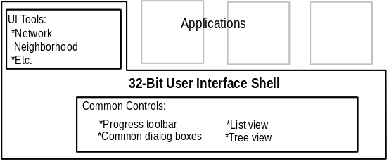
All applications and tools can take advantage of the common controls offered by the shell, such as common dialog boxes, tree views, and list views.

