Chapter 1
This chapter describes technical issues related to using Windows 95 within any networking environment, including descriptions of how the networking components in Windows 95 work together.
Network Technical Issues
This chapter also includes troubleshooting information for networking components, with specific information for troubleshooting network protocols.

Windows 95 Networking Overview 7-2
In This Chapter
Windows 95 Network Architecture 7-7
Multiple Network Support 7-12
NDIS Protocol Overview 7-21
Network Adapter Cards and Windows 95 7-23
Choosing the Protocols to Use 7-35
IPX/SPX-Compatible Protocol 7-40
TCP/IP Protocol 7-47
NetBEUI Protocol 7-71
IPC and Windows 95 7-74
Troubleshooting Network Problems 7-82

Chapter 3, “Introduction to Windows 95 Setup,” for a description of how to install networking support for Windows 95
See Also
Chapter 8, “Windows 95 on Microsoft Networks,” Chapter 9, “Windows 95 on NetWare Networks,” and Chapter 10, “Windows 95 on Other Networks,” for details related to particular networks
Chapter 15, “Disks and File Systems,” for information about long-filename compatibility on various networks

Windows 95 Networking Overview
Windows 95 networking includes these specific improvements over earlier versions of Windows:
32-bit, protected-mode, client and peer resource-sharing software for Windows and NetWare networks. This also includes new 32-bit virtual device drivers for network protocols and adapter cards, plus a new implementation of TCP/IP. For information about adapter drivers, see “Network Adapter Cards and Windows 95” later in this chapter. For information about new protocols, see the topics for each protocol later in this chapter.
Support for the Win32 WinNet interface. This is an application programming interface (API) that allows developers to create applications that run unmodified on different networks. The Win32 WinNet interface in Windows 95 supports 16-bit and 32-bit applications (as opposed to the WinNet interface in Windows 3.x, which supports only 16-bit applications). For information, see “Win32 WinNet Interface for Applications” later in this chapter.
Support for simultaneous connection to multiple networks on a single computer. Windows 3.x supports connection to only one network. Windows for Workgroups 3.11 allows simultaneous connection to only two networks. For more information, see “Multiple Network Support” later in this chapter.
Plug and Play networking support. This enhancement is described in “Plug and Play Networking Overview” later in this section.
Devices and buses are grouped as classes in Windows 95 architecture. These class types are reflected in the key under which settings for networking software information are stored in the Registry. The networking classes are shown in the following list.
Class | Meaning
Net | Network adapter card (or media access control layer, MAC) drivers
NetTrans | Protocols (transports)
NetRedir | Redirectors (network clients)
NetService | Network services such as sockets or RPC Runtime

The network device installer (NETDI.DLL) handles installation of network adapter and protocol drivers, client software, and other network services based on information in related .INF files, as described in Appendix C, “Windows 95 .INF Files.”

Network Configuration Overview
All networking options for Windows 95 can be installed and configured by choices made during Windows 95 Setup or by using Network Control Panel. You can configure any network component installed on a Windows 95 computer by double-clicking the Network icon in Control Panel and then changing settings on the property sheets for network components. From these property sheets, you can set properties for the following:
- Configuration of network clients, adapter cards, protocols, and services
- Identification of the computer on the network
- Access control, to specify how other users can access this computer

In the procedures presented here, it is assumed that Windows 95 and the appropriate networking hardware have already been installed on your computer.

To quickly display Network Control Panel, right-click the Network Neighborhood icon, and then click Properties on the context menu.
Tip

To install network components in Windows 95
1. Double-click the Network Control Panel icon, and click the Configuration tab.
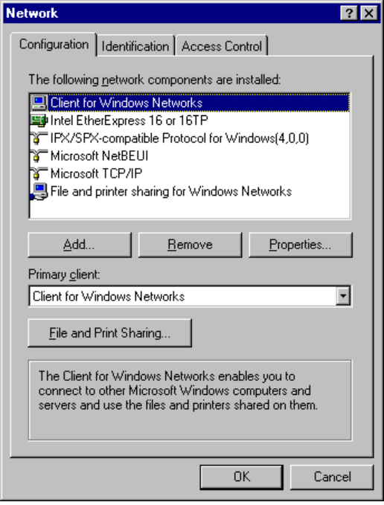
2. Click the Add button.
3. In the Select Network Component Type dialog box, select the kind of component to be installed, and then click the Add button.
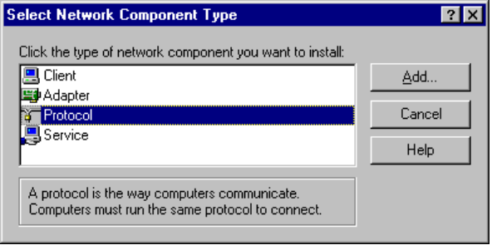
Component | Description
Client | Select to install client software for the various types of networks to which the computer is connected. You can use either a 32-bit network client, which needs no real-mode components, or older real-mode networking clients. There is no limit to the number of 32-bit network clients you can install, but you can have only one real-mode network client installed at a time. Some networks are supported only as primary networks. For more information, see “Multiple Network Support” later in this chapter.
Adapter | Select to install drivers for the network adapter cards in the computer. You can select the type of driver to use (enhanced-mode NDIS, real-mode NDIS, or ODI), specify the resources the cards you are using (such as I/O, IRQ, and transceiver type), and define other options for the card. For more information, see “NetWare Adapter Cards and Windows 95” later in this chapter.
Protocol | Select to install network protocols and set related options. For more information, see the topics for the related protocols later in this chapter.
Service | Select to specify the types of peer file and printer sharing services you want to run and to install other types of network services, such as backup agents, additional print services, Remote Registry, and Network Monitor.

4. In the Select dialog box, select the name of the component manufacturer in the Manufacturers list, and then select the specific component in the Models list. Then click OK.

Some components are static and require that you shut down and restart the computer after installing that component. For details, see the procedures for configuring that component in related sections of this chapter. Windows 95 requires that you define a workgroup and computer name for each networked computer, independent of the type of networking software you use. This information is required if you install networking software during Windows 95 Setup. You can also change the computer name or workgroup after Setup is complete.
To specify the computer name, workgroup, and description for a computer
1. In Network Control Panel, click the Identification tab.
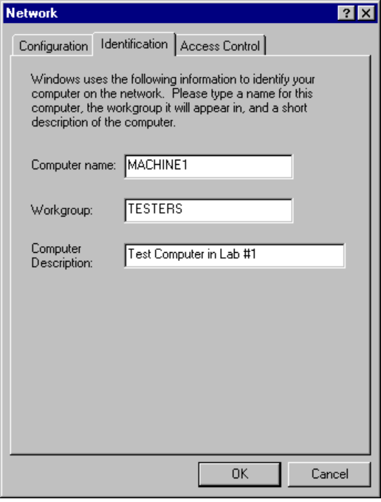
2. Type values for the computer identification settings as follows:
Computer Name | The name must be unique on the network. It can be up to 15 characters long, with no blank spaces. The computer name can contain only alphanumeric characters, plus the following special characters:  ! @ # $ % ^ & ( ) - _ ' { } . ~
Workgroup name | The name does not need to be unique, but it uses the same naming conventions as the computer name. For information about using WKGRP.INI to set administrative guidelines for specifying the workgroup to select, see Chapter 4, “Network Setup.”
Description | Information entered in this box is displayed as a comment next to the computer name, when users are browsing the network.

You only need to configure security if you are running Client for NetWare Networks, Client for Windows Networks, remote access, or the Remote Registry service. For information about settings on the Security tab, see Chapter 11, “Security.”

Plug and Play Networking Overview
Windows 95 supports dynamic loading and unloading of Plug and Play-compliant network adapter cards and drivers. For example, a PCMCIA network adapter card can be removed while the computer is running. In this case, the network adapter driver is unloaded if there are no other adapters of the same type in use, and other parts of the system receive a warning when they try to access the removed adapter. The user gets a message after the configuration has changed. Remote files will not be available, and cached information and connections to client-server applications will be lost. For information about using and configuring PCMCIA cards, see Chapter 13, “Devices.”
To be provided: details about Plug and Play for networking components.

The NDIS 3.1 specification for protocol drivers also supports adding and removing network adapters dynamically while the system is running. However, NDIS 3.1 does not support network adapter drivers changing their resource usage while the system is running, nor does it allow drivers to choose resources at startup time. The NDIS 3.1 specification also does not address how the network client, for example, deals with adding and removing adapters dynamically. For more information, see “NDIS Protocol Overview” later in this chapter.
Note

Windows 95 Network Architecture
Windows 95 provides multiple, simultaneous connections to a variety of networks (Windows NT, Novell® NetWare®, and others) and a variety of resources (files, programs, printers, host systems, mail systems) over most popular media (Ethernet, Token Ring, X.25, ISDN) from most any location (office, home, hotel).
Windows 95 networking capabilities are implemented using a high-performance, reliable, and open architecture based on the Windows Open Services Architecture (WOSA) specification. This approach provides users with a consistent interface to different services on the front end, while giving system administrators the flexibility to mix and match multiple services on the back end.

OSI Reference Model and Windows 95 Architecture
The modular networking architecture of Windows 95 is based on two industry standard models for a layered networking architecture, namely the International Standards Organization (ISO) model for computer networking, called the Open Systems Interconnect (OSI) model and the Institute of Electrical and Electronic Engineers (IEEE) 802 model. Windows NT and Windows for Workgroups are likewise designed according to these standard models. The ISO and IEEE 802 models define a modular approach to networking, with each layer responsible for some discrete aspect of the networking process.
The OSI Reference Model describes the flow of data in a network, from lowest layer (the physical connections) up to the user’s applications. Data going to and from the network is passed layer to layer. Each layer is able to communicate with the next highest and next lowest layers. This way, each layer is written as an efficient, streamlined software component. When a layer receives a packet of information, it simply checks the destination address, and if its own address is not there, passes the packet to the next layer.
When two computers communicate on a network, the software at each layer on one computer assumes it is communicating with the same layer on the other computer. For example, the Transport Layer of one computer communicates with the Transport layer on the other computer. The Transport Layer on the first computer has no regard for how the communication actually passes through the lower layers of the first computer, across the physical media, and then up through the lower layers of the second computer.
The OSI Reference Model includes seven layers, as shown in the following figure.

7  Application Layer | — Represents the level at which user applications access network services. This layer represents the services that directly support the user applications such as software for file transfers, database access, and electronic mail.
6  Presentation Layer | — Translates data from the Application Layer into an intermediary format. This layer also manages security issues by providing services such as data encryption, and compresses data so that fewer bits need to be transferred on the network.
5  Session Layer | — Allows two applications on different computers to establish, use, and end a session. This layer establishes dialog control between the two computers in a session, regulating which side transmits, plus when and how long it transmits.
4  Transport Layer | — Handles error recognition and recovery. It also repackages long messages when necessary into small packets for transmission and, at the receiving end, rebuilds packets into the original message. The receiving Transport Layer also sends receipt acknowledgments.
3  Network Layer | — Addresses messages and translates logical addresses and names into physical addresses. It also determines the route from the source to the destination computer and manages traffic problems, such as switching, routing, and controlling the congestion of data packets.
2  Data Link Layer | — Packages raw bits from the Physical Layer into frames (logical, structured packets for data). This layer is responsible for transferring frames from one computer to another, without errors. After sending a frame, it waits for an acknowledgment from the receiving computer.
1  Physical Layer | — Transmits bits from one computer to another and regulates the transmission of a stream of bits over a physical medium. This layer defines how the cable is attached to the network adapter card and what transmission technique is used to send data over the cable.

The following diagram shows the layered components that make up the Windows 95 networking model.
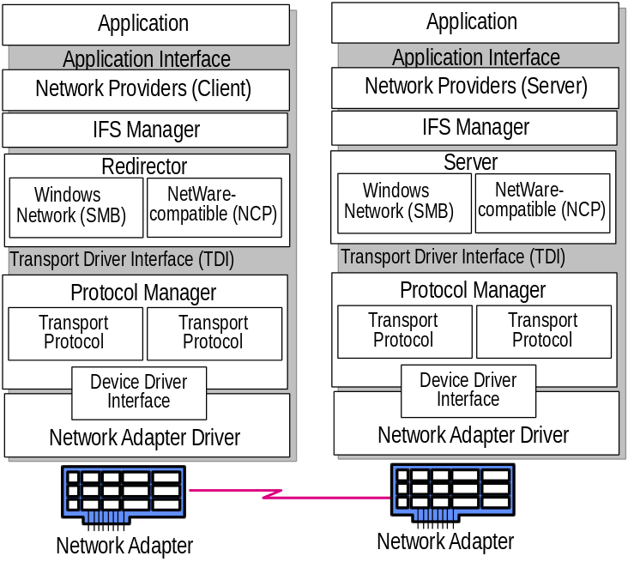
Layers in the Windows 95 networking model
The following sections describe these elements of the Windows 95 network architecture:
- Redirectors and Installable File System Manager
- Transport Driver Interface (TDI) and Protocol Manager

The architecture in Windows 95 for other layers in the networking model is discussed in the following sections later in this chapter:
See Also:
other networking architecture discussions later in this chapter
- The Application layer and network providers in Windows 95 are described in “Multiple Network Support” later in this chapter.
- The architecture for each network protocol is described in the section for that protocol later in this chapter.
- The device driver interface and network adapter drivers are described in “Network Adapter Cards and Windows 95” later in this chapter.

Redirectors and Installable File System Manager
A network redirector provides mechanisms to locate, open, read, write, and delete files and submit print jobs, and makes available application services such as named pipes and mail slots. When an application needs to send or receive data from a remote device, it begins by sending a call to the redirector. The redirector provides the functionality of the application and presentation layers of the OSI model. The redirector maps local names into network devices and decides whether the application needs access to a local or remote device.
The redirectors are included in the Windows 95 network client software as the following file system drivers:
- In Microsoft Client for Windows Networks (VREDIR.VXD), the redirector supports all Microsoft networking products, which use the Server Message Block (SMB) file-sharing protocol.
- In Microsoft Client for NetWare Networks (NWREDIR.VXD), the redirector supports NetWare networking products, which use the NetWare Core Protocol (NCP) file-sharing protocol.

Windows 95 also supports network redirectors from other network vendors.
Because each redirector is implemented in Windows 95 as a file system driver, the redirector is managed by the Installable File System (IFS) Manager. The IFS Manager controls file I/O transfers for all the installable file systems in Windows 95.
The Windows 95 redirector formats an application’s request into data packet SMBs and submits the packet to the Transport Driver Interface. The NetWare redirector formats requests into NCP packets. The data packet is passed by the protocol to the Protocol Manager.
The Windows 95 server side at this layer of the networking model supports peer resource sharing. Windows 95 provides two server services for peer networking:
- File and Printer Sharing for Windows Networks (the Windows 95 SMB-based server, VSERVER.VXD), which supports resource sharing among all computers on the network that use the SMB file sharing protocol.
- File and Printer Sharing for NetWare Networks (the Windows 95 NCP-based server, NWSERVER.VXD), which supports resource sharing among all computers on the network that use the NCP file sharing protocol.

TDI and Protocol Manager
To communicate with a network device, the redirector makes a call using the Transport Driver Interface to the protocol by passing a data packet to the Protocol Manager. The protocol and the network adapter driver add the equivalent of headers and footers to the packet, and the network adapter driver places the packet on the network itself. This interface provides a uniform set of commands for requesting the lower-level network services. It provides interaction with the network in the same way that the BIOS provides for interaction to local hardware.
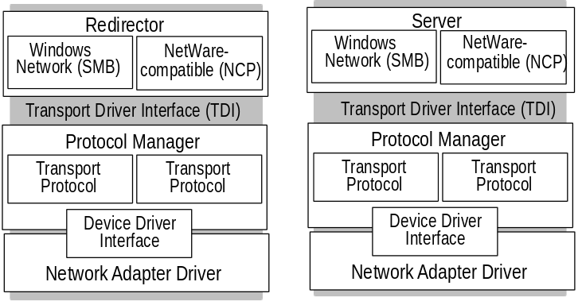

Transport Driver Interface
For communication between the Session and Transport layers of the OSI Reference Model, Microsoft developed and supports the Transport Driver Interface (TDI). On a computer running Windows 95, the server and redirector processes communicate with protocols through the TDI. Like NDIS (as described later in this chapter), TDI makes networking on Windows 95 more versatile by making it possible for different protocols and upper-level networking components to communicate using a common interface. Different protocols that conform to TDI can work with different upper-level components that also support TDI. When a redirector or server makes a call to a protocol, it uses the TDI for the call and thus does not have to know anything about the protocols being used.
The TDI support in Windows 95 means that alternate protocols or even alternate redirectors or servers written by other network vendors that conform to TDI, will work with Windows 95. Using TDI enables Windows 95 to overcome limitations of LAN Manager 2.x. For example, TDI imposes no limit on the number of workstations that can connect to a server, although LAN Manager 2.x was limited to 254 workstation connections for each of the server’s network adapter cards.
The Transport Driver Interface supports interprocess communications (IPC) mechanisms used in distributed computing, as described in “IPC and Windows 95” later in this chapter.

Protocol Manager
The Protocol Manager is responsible for sending information to the appropriate protocol. The protocol, in turn, manages both the quality of service and the accuracy of information. It provides a network message standard used to translate messages into information that the system recognizes.
Windows 95 can accommodate multiple protocols on a single computer and is designed to be protocol-independent, so it works the same, regardless of the protocol being used. For information about using NetBEUI, IPX/SPX, and TCP/IP with Windows 95, see “Choosing the Protocols to Use” and the related sections for each protocol later in this chapter.

Multiple Network Support
Enterprise networks are often a conglomeration of many different types of networks and are becoming more interconnected all the time. Companies are linking their Windows-based computers to multiple PC-based network servers, mainframes and mini-computer host systems, UNIX® computers, and even a variety of services such as the Internet. The desktop operating system must meet this challenge and provide support for the disparate connectivity needs on the network.
The Windows 95 modular Network Provider Interface, as described later in this section, supports concurrent communication with several different networks. For example, a user’s computer can have connections to computers running Windows 95 peer resource-sharing services, to servers for Windows NT and NetWare networks, and to the Internet, all at the same time.
In addition to the Windows 95 network client and peer sharing components, Windows 95 supports the following network clients from other vendors:
- Artisoft LANtastic version 5.0 and greater
- Banyan® VINES® version 5.52 and greater
- Beame and Whiteside BW-NFS 3.0c and greater
- DEC Pathworks version 4.1 and greater (installed as a protocol)
- DEC Pathworks version 5.0 and greater (installed as a protocol)
- Novell NetWare version 3.11 and greater
- SunSelect PC-NFS® version 5.0 and greater
- TCS 10-Net

Most network clients can be installed along with any Microsoft networking component. Windows 95 does not include the supporting files for these networks; you must obtain them from the network vendor. For information about using these network clients and the required supporting files, see Chapter 10, “Windows 95 On Other Networks.”
Windows 95 does include the support necessary to work with networking components from other network vendors. The network software should be installed and running before installing Windows 95, so that Windows 95 Setup can detect the network and install support for it by default. You can check this on the Network Options page during Custom Setup.
Multiple network support in Windows 95 consists of these components, as described in the following sections:
- Win32 WinNet API
- Multiple provider router
- Service provider interface
- Network providers (including the WinNet16 interface)

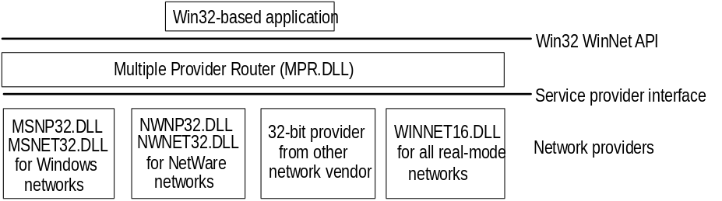
Components of multiple network support in Windows 95

Win32 WinNet Interface for Applications
The Win32 WinNet interface in Windows 95 provides an application programming interface (API), that software developers can use to create single versions of applications that run unmodified on different networks. The Win32 WinNet interface is the successor to the WinNet16 interface introduced in Windows 3.0 and enhanced in Windows 3.1.
The WinNet interface is set of network-independent APIs implemented by a driver supplied by the network vendor. In Windows 95, the expanded WinNet API set includes the following:
- Support for the Win32 WinNet APIs as defined in Windows NT. This set of functions and the other Win32 APIs provide all the commonly used capabilities required by applications.
- An interface that allows browsing of network resources (network directories, printers, and other network resources). This includes consistent handling of authentication requirements across multiple networks and support for the NetWare server security model.
- Backward compatibility with Windows for Workgroups 3.11 and support for networking using the Windows 3.1-based architecture (that is, a network that uses a WinNet16 network driver).

Multiple Provider Router
The Multiple Provider Router in Windows 95 exports the Win32 WinNet APIs to applications. It provides seamless access to network services and resources, and it supports a way to access a single WinNet16 network driver. It routes incoming network requests to the appropriate network provider, using the same interface whether one or more network providers are installed.
Features common to all networks are implemented once in the Multiple Provider Router, which reduces the code base for each network provider and ensures common behavior between networks. For example, network providers do not implement persistent connections — this feature is implemented in the Multiple Provider Router and is entirely transparent to a network provider.

Service Provider Interface
Windows 95 uses an open, modular service provider interface (SPI) to allow multiple 32-bit network providers to be installed in Windows 95 simultaneously. The service provider interface is a single, well defined set of APIs used by Windows 95 to request network services to browse servers, connect to and disconnect from servers, send a print job, and so on. The service provider interface is below the Win32 WinNet API in the networking model, and provides the needed network services to honor a Windows 95 request for network-specific services. This model is similar to the Windows 95 design for various device driver interfaces: a well-defined set of interfaces used by the operating system, with services provided by a device driver (often written by a third party) to honor requests. These requests are then passed to the network providers.
The service provider interface enables Microsoft or any other network provider to integrate varied network services seamlessly into Windows 95. The service provider interface ensures that all supported networks are identically accessed and managed through the Windows 95 Network Neighborhood and other user interface components.
The service provider interface consists of two parts, the service provider API and the network providers, as described in the following section.

Network Providers
Windows 95 uses an open, modular network provider interface (NPI) to allow multiple network support simultaneously in Windows 95. Key benefits of the network provider interface architecture are the following:
- An open interface allows any network vendor to supply tightly integrated support for its network servers for Windows 95.
- Identical access and management through the Windows 95 user interface components, including Network Neighborhood and Network Control Panel.

The network provider interface consists of two parts—the network provider API and the network providers. The network provider API calls are used by applications to request network services. When Windows 95 receives a network provider call, it passes the call to the appropriate network provider, which then supplies the requested network service.
The network provider is a network-specific device driver that implements the service provider interface call from the Multiple Provider Router. The functions provided include authenticating users when they access a network server, managing passwords, adding or removing connections to a server, and browsing network resources.
Windows 95 includes the following network providers:
- MSNW32.DLL and MSNET32.DLL, for Microsoft networks
- NWNP32.DLL and NWNET32.DLL, for NetWare networks
- A network provider to support at most one WinNet16 driver (WINNET16.DLL)

Windows 95 also supports any number of other 32-bit network providers and a single 16-bit network provider that uses WinNet16 driver. Such network providers must be supplied by other network vendors.
The Windows 95 system logon is an example of a network service provided by the network provider interface. Each network provider can provide a unique logon dialog box to suit the needs of its network server security model. Once the logon is validated by the requested server, this is passed back to Windows 95. Windows 95 can then use this password as the master key password to unlock any system or network resource linked to the master key password validation. In this way, Windows 95 can accommodate the various ways that network servers provide their services, yet still offer a consistent user interface.
The following summarizes the internal processes when, for example, a user double-clicks the Entire Network icon in Network Neighborhood:
1. The Windows 95 user interface generates a Win32-based network API call to enumerate the network.
2. The Multiple Provider Router receives the API call and submits a service provider interface call to all the available network providers.
3. Each network provider browses its individual networks and returns the list to the Windows 95 shell, which displays all the networks and their hierarchies in the Entire Network window.

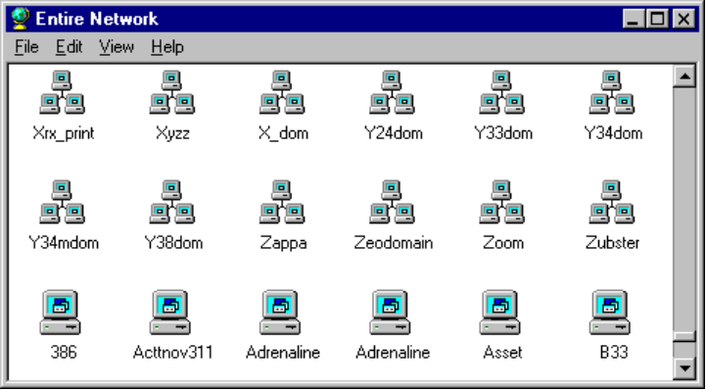
This is an example of the list of workgroups and computers available in Network Neighborhood.
Because of network provider support in Windows 95, users can specify server name strings in a drive connection dialog box using the syntax to which they are accustomed. A network provider knows how to correctly interpret the syntax of its own server name strings. The server name string is the syntax used by a particular network operating system to specify a shared disk resource. Microsoft network-compatible networks use the Uniform Naming Convention (UNC), which appears as the following:
\\server_name\share_name

However, NetWare servers are usually specified as follows on NetWare networks:
server_name/volume_name:directory_name

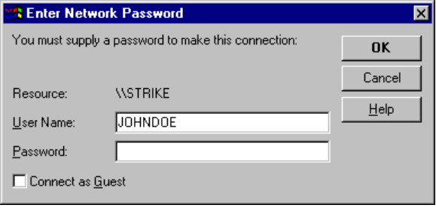
This example shows the dialog box for logging onto a Novell NetWare 3.x server, including an option to log on as Guest.
Because the network provider knows how to interpret server name strings, users who are accustomed to using the NetWare server syntax can type such server names wherever required in Windows 95 to access NetWare server resources. The Windows 95 user interface and the net command also support UNC names for connecting to NetWare resources.

Network Provider for NetWare Networks
The network provider that supports NetWare networks (NWNP32.DLL and its support library, NWNET32.DLL) provides access to NCP-based NetWare network resources using, for example, Windows Explorer, Network Neighborhood, Control Panel, and other Win32-based applications.
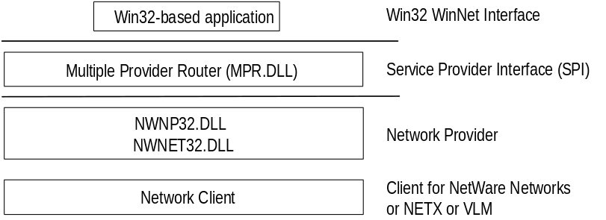
Basic architecture for network provider for the NetWare networks
The network provider supports these functions on NetWare networks:
- Browsing of NetWare networks
Bindery-based NetWare networks (versions 2.15 and above, 3.x, and 4.x with bindery emulation) use a Server-Volume-Directory hierarchy.
- Logging on to and off a NetWare network, providing dialog boxes for network login, and performing attachments to bindery-based servers.
- Adding and removing connections, allowing remote drive and printer connections using the NetWare format (server/volume:) and the UNC connections to NCP-based network resources (mapped drive or printer port, and UNC \\server\share).

Network Provider for Microsoft Networks
The network provider that supports Microsoft networks (MSNP32.DLL) provides access to SMB-based Microsoft network resources using the Windows 95 user interface (such as Windows Explorer, Network Neighborhood, and Control Panel) and other 32-bit Windows applications.
MSNET32.DLL is the Microsoft 32-bit network API support library for MSNP32.DLL. Together MSNP32.DLL and MSNET32.DLL provide the Microsoft network-specific dialog boxes (such as the Windows NT domain logon dialog box) and code to resolve a service provider interface call from the Multiple Provider Router to a call to VREDIR (Client for Windows Networks).
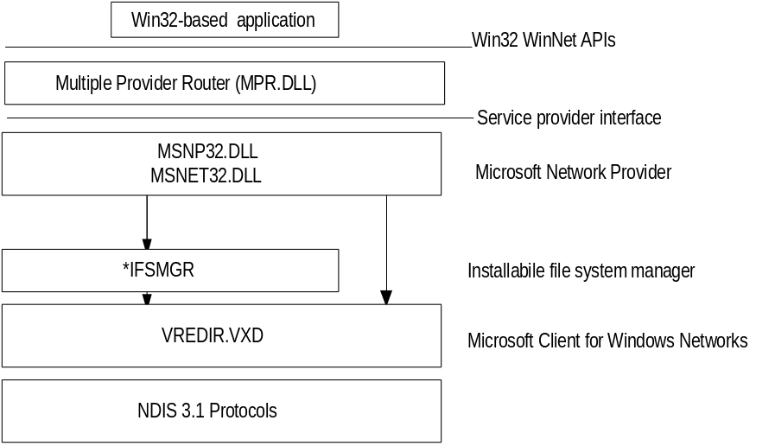
Windows 95 architecture for the network provider for Windows networks
Notice that there are two arrows, one going through IFS Manager and one going directly to Client for Windows Networks (VREDIR.VXD).
- When a network request is for file I/O or printer output, the call is submitted to the IFS Interface.
- When a network request is not based on file I/O or printer output (browsing functions, connection functions, or server logons), the call is sent to VREDIR.VXD.

The network provider supports these functions in Windows networks:
- Browsing Microsoft networks
Microsoft networks use either a Workgroup-Computer-Share hierarchy when dealing with Windows for Workgroups or Windows 95 networks, or a Domain-Computer-Share hierarchy when dealing with LAN Manager or Windows NT Server networks.
- Logging onto and off a Windows NT domain
The Microsoft network provider provides authentication services for validation by a Windows NT domain controller, plus the ability to change the domain password.
- Adding or removing connections
The Microsoft network provider allows remote drive and printer connections and UNC connections to SMB-based network resources.

WinNet16 Interface
The WinNet16 interface (WINNET16.DLL) is the earlier set of network-independent APIs introduced with Windows 3.0 and enhanced in Windows 3.1. WinNet16 provides simple functionality such as connecting to a drive letter or redirecting a printer port to a network printer. Windows 95 provides support for using a single WinNet16 driver.
If a network vendor provides a WinNet16 network driver developed for Windows 3.1 and has not written a 32-bit network provider and file system driver for Windows 95, using the WinNet16 interface and WINNET16.DLL is the only way to support that network in Windows 95. The WinNet16 driver that currently works with Windows 3.1 can be used without modification under Windows 95, using the WINNET16.DLL.
If Windows 95 Setup detects a Windows 3.x installation that uses a WinNet16 network driver and there is no 32-bit network provider available, Windows 95 Setup keeps the 16-bit network driver in place and provides network functionality with the 16-bit network driver installed as the primary network. For example, if Artisoft LANtastic 5.x is detected, then Windows 95 Setup installs the existing LANTASTI.DRV and LANTASTI.386 drivers.
The following diagram shows an example of a Windows-based LANtastic network utility using the WinNet16 interface. For specific details for various types of other networks in a similar configuration, see Chapter 10, “Windows 95 on Other Networks.”
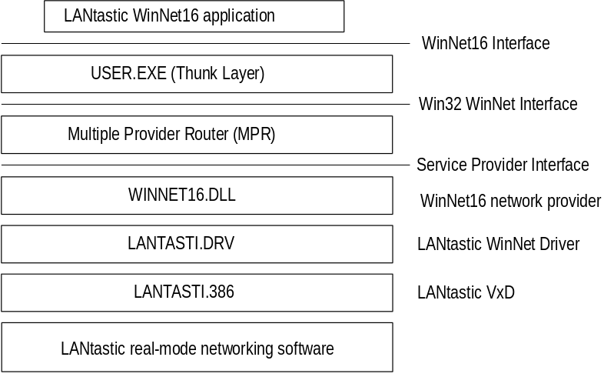
This example shows a Windows-based network utility from another network vendor using the WinNet16 interface.

Multiple Network Example
In the following example, the user has installed two Windows 95 network clients (Client for Windows Networks and Client for NetWare Networks) and also has installed Banyan VINES support using a WinNet16 driver.
Banyan VINES uses the StreetTalk™ syntax to specify server names, as follows:
file service@group@organization

In trying to resolve the request to connect to Docs@Marketing@Corp from a network drive connection dialog box in Windows 95, the Multiple Provider Router submits the request to all installed network providers. WINNET16.DLL receives the call and passes it on to VINES.DRV, which submits the drive connection request to the Banyan real-mode networking software through VVINESD.386.
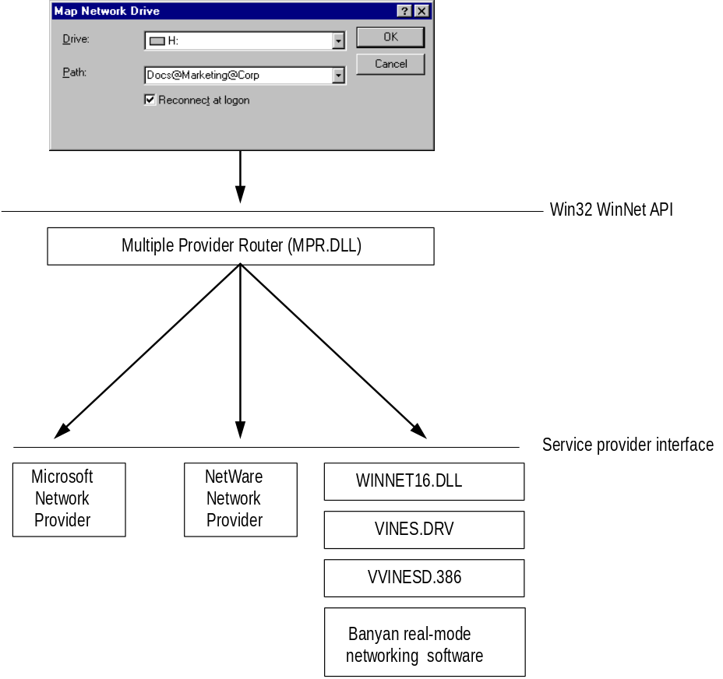
This example shows a network drive connection request with multiple networks installed.

NDIS Protocol Overview
Windows 95 supports the Network Device Interface Specification (NDIS) 2.x and NDIS 3.1 protocol drivers. This section provides some technical background information about NDIS support in Windows 95.
Windows 95 does not support NDIS 3.0 protocol drivers. The earlier NDIS 3.0 protocol expects to read its configuration during device initialization, but at that point Windows 95 will not necessarily know which network adapters are available and may not have completed resource arbitration for Plug and Play devices. This is why Windows 95 cannot support NDIS 3.0.
Notice, however, that Windows 95 includes an NDIS 3.1 replacement for every 3.0 driver.

NDIS 2.x Protocol Drivers
Windows 95 supports NDIS 2.x protocols. An NDIS 2.x protocol driver must use an NDIS 2.x network adapter card driver. Both protocol drivers and network adapter card drivers must load and bind in real mode before launching Windows 95.
When you run the real-mode network (for example, when using Fail-Safe Startup), the system uses NDIS 2 versions of NetBEUI and IPX/SPX. These protocols are not intended for everyday use since Windows 95 supplies faster protected-mode versions of these protocols. NDIS 2 NetBEUI and real-mode, IPX/SPX-compatible protocols are provided for client computers that start from a floppy disk and run a shared copy of Windows 95 from a server.
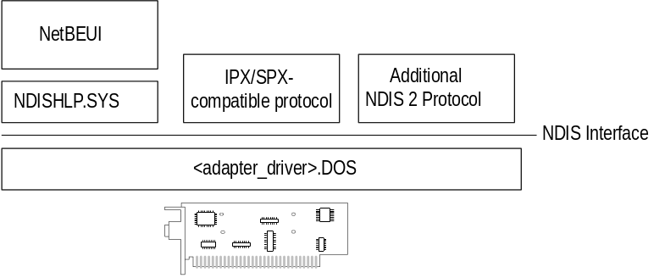
Windows 95 architecture for NDIS 2 protocols

NDIS 3.1 Protocol Drivers
Windows 95 supports a wide range of network media including Ethernet, Token Ring, and ArcNet through the NDIS 3.1 specification. The NDIS 3.1 specification accommodates Plug and Play features, so that network adapters can be added and removed dynamically while the system is running. NDIS 3.1 has enhancements for Windows 95 in two key areas: Plug and Play and a new NDIS mini-driver model.
Plug and Play enhancements to the Protocol Manager and Media Access Control (MAC) layer. These enhancements ensure that the network protocol and network adapter card drivers can be dynamically loaded and unloaded. If a Plug and Play event occurs, such as undocking a laptop computer, the NDIS 3.1 protocols and network adapter card drivers remove themselves from memory automatically. For events such as docking a laptop computer, the NDIS 3.1 protocols and network adapter card drivers are automatically loaded and initialized without user intervention.
With the NDIS 3.1 support for dynamic unloading of network protocols, the system determines which adapters the protocol should bind to. Changes to the NDIS 3.1 interface affect only the protocol drivers, not the network adapter drivers. Although Plug and Play allows device drivers to choose and change their resource usage (such as IRQs and I/O addresses) dynamically, NDIS 3.1 does not support this ability nor does it allow drivers to choose resources at startup time.
New NDIS mini-driver model. The Windows 95 mini-drivers are binary-compatible with Windows NT 3.5 mini-drivers. This means that the driver files from Windows NT 3.5 can be used by Windows 95 without recompiling, as described in Chapter 13, “Devices.”
The mini-driver divides the existing NDIS MAC layer into two halves and implements only the half specific to the network adapter card. These include specific details such establishing communications with the card, turning on and off electrical isolation for Plug and Play, providing media detection, and enabling any value-added features the card may contain. The NDIS wrapper implements the other half of the MAC functionality that remains common to all NDIS drivers. In earlier releases of NDIS, each adapter driver carried all this redundant code, so mini-drivers are faster and are roughly 40 percent smaller than existing NDIS 3.x network adapter card drivers.
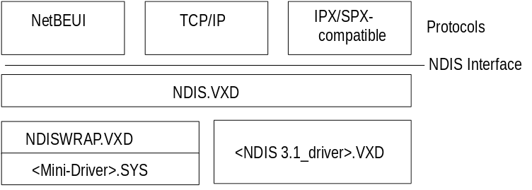
Windows 95 architecture for NDIS 3.1 protocols

Network Adapter Cards and Windows 95
This section provides technical details for the following topics:
- Choosing drivers for network adapter cards
- Configuring network adapter cards
- Setting LAN adapter numbers
- Technical notes on network adapters

Choosing Drivers for Network Adapter Cards
When setting up Windows 95 for networking, you must choose which types of network adapter card drivers and protocols to use. Because Windows 95 has an open architecture, you have a lot of flexibility in this decision. Windows 95 supports both the Network Driver Interface Specification (NDIS) and Transport Driver Interface (TDI) standards. These standards allow Windows 95 to communicate with many other networking products and make it possible for you to choose from a variety of network adapter cards and protocols for the network.
A network adapter card (sometimes called a network interface card, or NIC) is a hardware card that is installed in a computer so it can function
on a network. The network adapter card provides one or more ports for the network cable to physically connect to, and the card physically transmits data from the computer onto the network cable and vice versa.
Every network computer must have a network adapter card driver, a software driver that controls the network card. Each network adapter card driver is specifically configured to run with a certain type of network card.
In addition to the network card and network card driver, a network computer
must also have a protocol driver (sometimes called a transport protocol or just a protocol). The protocol driver works between the upper-level network software—such as the workstation and server — and the network adapter card. The protocol packages data that is to be sent on the network in a way that the computer on the receiving end can understand. The process of associating a protocol driver with the network adapter card and establishing a communication channel between the two is called binding.
For two computers to communicate on a network, they must use identical protocols. Sometimes, a computer is configured to use multiple protocols. In this case, two computers need only have one protocol in common to communicate. For example, a server using both NetBEUI and TCP/IP can communicate both with computers using only NetBEUI and with computers using only TCP/IP.
With some networks, each computer’s network adapter card driver and protocol are separate pieces of software. With other networks, a single piece of software called a monolithic protocol stack performs the functions of both the network adapter card driver and the protocol. Microsoft recommends that you choose separate 32-bit protected-mode protocols and drivers rather than monolithic stacks, which can run only in real mode.
Windows 95 includes mapping technology for users who continue to use real-mode NDIS 2.x or ODI network adapter card drivers.

Choosing NDIS Drivers
Windows 95 supports NDIS versions 2.x and 3.1 (as described earlier in this chapter), which lets you use separate protocols and network adapter card drivers. All network adapter card drivers and protocols shipped with Windows 95 conform to NDIS. You can use any combination of one or more protocol drivers that conforms to NDIS along with any network adapter card driver that conforms to NDIS.
It is probable that the computers on your network have different types of network adapter cards and thus require different network adapter card drivers. Because of NDIS, you can use exactly the same protocol driver with each of these workstations and are not required to have a different version of the protocol for each type of network adapter card, as would be required if you were using monolithic protocol stacks.
Also, NDIS allows multiple protocols to use a single network card. Usually, when you use a monolithic protocol with a network adapter card, the protocol monopolizes the network card, preventing you from using other protocols with that card.

Choosing ODI Adapters
The Open Datalink Interface (ODI) specification was defined by Novell and Apple Computer to provide a protocol and a consistent API for communicating with a network adapter driver, and to support the use of multiple protocols by a network adapter driver.
To ensure the most flexibility in Windows 95 for other protocol support along with NetWare integration, Microsoft recommends that you use ODI drivers when running Windows 95 on NetWare networks. Novell also recommends using ODI-based client software rather than monolithic IPX drivers. For information about ODI drivers, see Chapter 9, “Windows 95 on NetWare Networks.”

Configuring Network Adapter Cards
Windows 95 supports up to four network adapter cards in a single computer. (Network adapter cards are also called network interface cards, or NICs.) Windows 95 Setup automatically detects most network adapter cards, installs the appropriate driver for the card, and provides appropriate default settings to configure the card.
With Windows 95, when you install a network adapter card in a computer, installation of the appropriate driver is simple. You use either the Windows 95 Setup program or Network Control Panel, and choose the name of the network adapter card from the list. The network card driver is automatically bound to all NDIS protocols currently running on the computer, and if any protocols are added later, they will also be bound automatically to the network card driver.
If you choose to add a network adapter card manually, Windows 95 displays a list of supported network adapter cards.
To manually add a driver for a network adapter card
1. In Network Control Panel, click the Configuration tab, and then click the Add button. Select Adapter and click the Add button.
2. In the Manufacturers list in the Select Device dialog box, select a network adapter card manufacturer.
3. In the Models list, select the appropriate model, and then click OK.
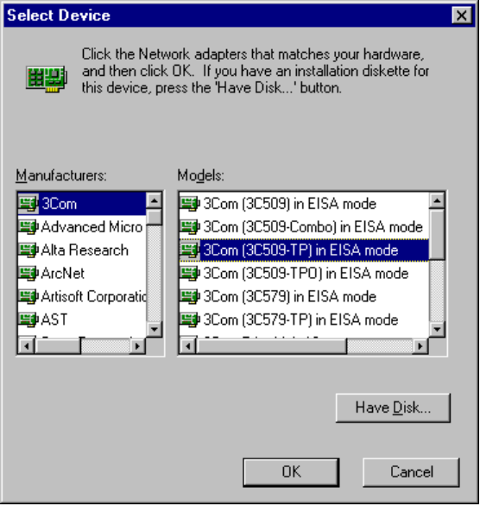
The following procedures show how to configure various properties of a network adapter card driver.
To configure properties for network adapter card drivers
- In Network Control Panel, click the Configuration tab. Then select the driver in the list and click the Properties button.

To specify the network adapter card driver type
1. On the Properties sheet for the selected network adapter card, click the Driver Type tab.
2. Click one of three options (if available for the specific card), as described in the following table.
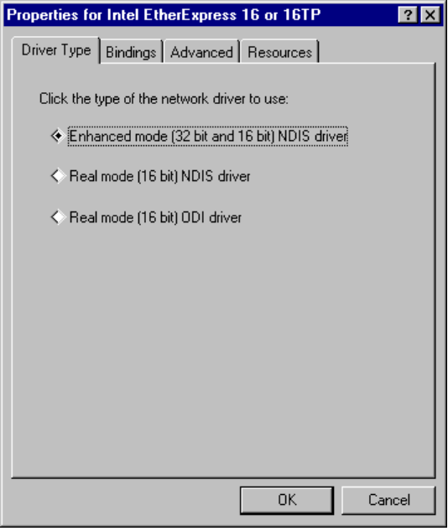
Network card driver type | Description
Enhanced mode (32-bit and 16-bit) NDIS driver | Installs an NDIS 3.1-compliant driver.
Real-mode NDIS driver | Installs an NDIS 2.x-compliant driver.
Real-mode (16-bit) ODI driver | Installs a real-mode driver created to support ODI for Windows 3.1.

For a protocol to communicate with each network adapter card on your computer, the network adapter card driver must be bound to the protocol. The bindings define the relationships between networking software components. Windows 95 automatically binds the appropriate protocols to the network adapter card. You can change the bindings if, for example, you do not want to use a specific protocol with a particular network adapter card.
To configure bindings for protocols
1. On the Properties sheet for the selected network adapter card, click the Bindings tab.
The protocols that are bound to the selected adapter are checked in the list. If a particular protocol does not appear in the list, check that it is correctly installed by returning to the Configuration property sheet and reinstalling it.
2. In the list of protocols, click a protocol so that it is not checked, if you do not want this network adapter card to be bound to the selected protocol.

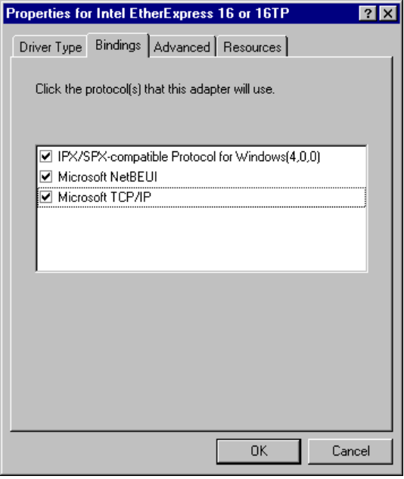
In this example, the IPX/SPX compatible and NetBEUI protocols are bound to the driver for the Intel EtherExpress 16 or 16TP card.
To be provided: introduction to advanced settings for network adapter cards--
what they are, how they can be used, why they should be changed.

The options available on the Advanced property sheet vary, depending on the type of network adapter card.
Note

To specify additional settings for the network adapter card
1. On the Properties sheet for the selected network adapter card, click the Advanced tab.
2. To change these values, select an item in the Property list, and then select the value in the Value box.
3. To accept the new settings (and update the Registry), click the Accept button.
To cancel new settings and return to the original values, click the Reject button.

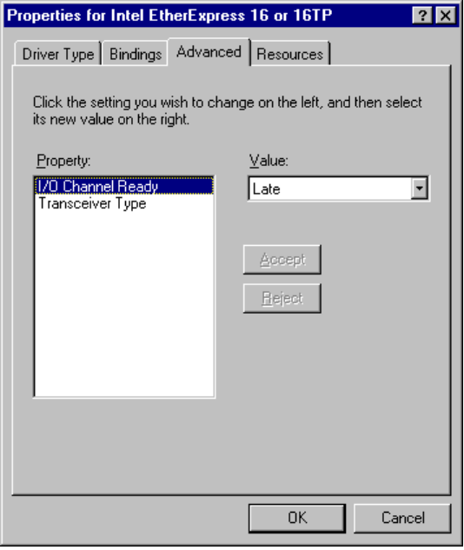
This example shows the advanced options for the Intel® EtherExpress™ 16 or 16TP network card.
The following table explains some typical settings for general types of network adapter cards. For an explanation of the specific settings for your network adapter cards, see the documentation provided by your card manufacturer.
Sample Advanced Settings for Network Adapter Cards
Setting Type | Description
Settings for Token Ring cards: | To be provided.
Settings for Ethernet cards:
Transceiver Type | The transceiver is the device that connects a computer to the network. This value specifies whether it is twisted-pair, thin-net, or thick-net.
I/O Channel Ready | Options: Later, Never, Early.  To be provided.

Windows 95 can determine hardware settings for most network adapter cards. When you install a network adapter card, you should accept the proposed settings unless you are absolutely sure they are incorrect.
Devices cannot share interrupt request (IRQ) settings, memory buffer addresses, or ROM addresses. Where possible, Windows 95 identifies and resolves conflicts. However, if one of the supported devices does not seem to work, the problem may be the particular hardware configuration. Make sure there are no conflicts among network adapters or other peripherals, or between the system board and adapters. Sometimes these settings are set with software, sometimes with jumpers or switches on the hardware (refer to your hardware documentation for specific details). If settings for a network card can be configured through software, you can configure settings using Network Control Panel.
To configure the hardware settings for the network card
1. On the Properties sheet for the selected network adapter card, click the Resources tab.
2. If you are installing a new card and are unsure about the actual settings for this hardware, click the option titled Configure Hardware Settings Later.
– Or –
Click the option titled Use These Hardware Settings, and confirm values for the listed settings.
3. To see and select from the available values for a setting, click the arrow beside the setting’s current value.
- If the displayed value is the current setting, it is preceded by a hash (#) character.
- If the value is preceded by an asterisk (*) character, there is a conflict with another device in the system. You should reconfigure one of the devices.
The possible settings displayed depend on the type of network adapter card. The following table describes typical settings.
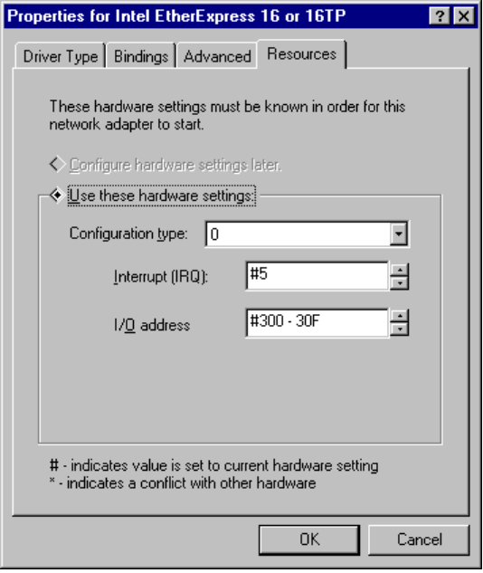
Sample Hardware Settings for Network Adapter Cards
Setting type | Description
Configuration Type | To be provided.
I/O Address Range | The memory address range reserved for the network adapter card to use for temporary storage of input and output data.
Interrupt (IRQ) | Specifies the hardware line over which the device can send interrupts (requests for service) to the computer’s microprocessor.

Setting LAN Adapter Numbers
Each combination of a NetBIOS network protocol and a network adapter forms a logical network over which computers can communicate with each other. For example, a computer can have a token ring adapter and an Ethernet adapter, and might use NetBEUI on the token-ring network and both NetBEUI and TCP/IP on the Ethernet network. In this case, the computer is connected to three logical networks, each of which is assigned a NetBIOS LAN adapter (LANA) number that Windows 95 uses to communicate with them.
When a computer uses multiple protocols, the computer transmits data first using one protocol, then again using the next protocol, and so on. When you install multiple protocols on a computer, you designate the order in which the computer will use them. The first protocol in this series is sometimes called the primary protocol.
On a computer running Windows 95, each binding of a protocol to a network adapter card has a LAN adapter number assigned to it. (For example, one protocol bound to two network cards requires two LAN adapter numbers; two protocols each bound to two cards requires four LAN adapter numbers.) When you install Windows 95 on a computer and when you install additional protocols or network adapter cards, Windows 95 automatically assigns LAN adapter numbers to protocol/network adapter card bindings. You need to change these LAN adapter numbers only if you have a NetBIOS application that specifies that it must use a certain LAN adapter number.
In Windows 95, LANA numbers are assigned dynamically, beginning with 7 and working downward. This accommodates dynamic Plug and Play events such as removing a network adapter while the computer is running. If you are running Windows 95 in such a dynamic environment, Windows 95 cannot guarantee that a given protocol will receive the same LANA number each time the system is started, although, if the computer’s network hardware never changes, the LANA numbers may not change at each startup. Also, the default protocol is always LANA 0.
A protocol can be used simultaneously on more than one network adapter. LANA numbers are assigned in sequence of binding order for the protocols. Some NetBIOS applications require a network protocol to be available on LANA 0.
To select a default protocol for LANA settings
1. In Network Control Panel, click the Configuration tab.
2. Select the protocol you want to be the default, and click the Properties button.
3. Click the Advanced tab.
4. Click the option named Set This Protocol To Be The Default Protocol so that the check box is checked.
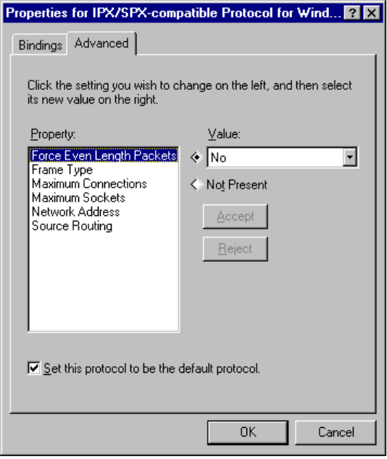
5. Click OK, and then click OK on the Network properties sheet. Then restart the computer.

Some applications may need to know the LANA number. For example, Lotus® Notes® requires that you enter the LANA number that Lotus Notes will use. To configure Windows 95 to use Lotus Notes, set the NetBIOS-based protocol on which you want to run Lotus Notes as the default protocol. This could be NetBEUI, IPX/SPX-compatible, or TCP/IP with NetBIOS support.
Note

Technical Notes on Network Adapter Cards
This section provides some technical notes for specific network adapter cards and briefly describes changes to network adapter card driver support from support under Windows for Workgroups 3.11.

Using Windows 3.x .INF Files for Network Card Drivers
As described earlier in “NDIS Protocol Overview,” NDIS 3.0 network card drivers that worked with Windows for Workgroups 3.11 do not work under Windows 95 without changes. You must use an NDIS 2.x real-mode driver, an ODI driver, or an updated NDIS 3.1 protected-mode driver for your network card, plus a Windows 95 .INF file. There are many real-mode drivers, updated protected-mode drivers, and supporting .INF files included with Windows 95.
If you have an .INF file created for an earlier version of Windows to describe a network adapter card driver, you can use that .INF file by clicking the Have Disk button in the Add dialog box for installing network adapter card drivers.
The major reason that the .INF file format has changed for all types of Windows 95 network card drivers is that .INF files are now used to add information to the Windows 95 Registry. The .INF files created for earlier versions of Windows do not contain this kind of information. For information about .INF files for network adapter card drivers, see Appendix C, “Windows 95 .INF Files.”

Configuring the IBM 4/16 Token Ring Adapter
To set the I/O address of IBM® 4/16 Token Ring adapter card, select either primary or secondary in the Advanced property page for the adapter. The I/O settings on the Resource page are ignored.

Changing 3Com Etherlink III Settings
Changing 3Com® Etherlink III® (3c509) settings in Network Control Panel does not change adapter settings. The Network Control Panel does not reprogram the Etherlink III adapter.
To change 3Com Etherlink III adapter settings
1. Use the 3Com configuration disk that came with your adapter to reprogram it.
2. Write down the settings made so that you can refer to them in the following step.
3. In Network Control Panel, change the settings to the ones you noted.
4. Restart the computer.

Configuring DEC Network Adapters
Users of DEC network adapters should verify the detected configuration in the Network Options box in Windows 95 Setup by clicking the Advanced tab in Network Control Panel. If the detected IRQ or I/O ports are not correct, set them manually in Network Control Panel.

Setting Transceiver Settings
The transceiver setting specifies whether the network media is twisted-pair, thin-net, or thick-net. You should only have to change such settings if you change the network adapter card connection, for example, from twisted-pair to thin-net.
To set the transceiver setting for those network adapters that support it
1. In Network Control Panel, click the Configuration tab, and then double-click the network adapter entry to display its properties sheets.
2. Click the Advanced tab.
3. In the Properties list, select the transceiver setting, and in the Value box, select the proper setting for your transceiver.
4. Click OK on this property sheet, and click OK in Network Control Panel.
5. Restart the computer.

Choosing the Protocols to Use
Windows 95 is based on the NDIS architecture and can support multiple network protocols simultaneously as described earlier in “NDIS Protocol Overview.” Protocol software can be shared among the network providers that are installed. The protected-mode protocols included with Windows 95 are the Microsoft implementation of the IPX/SPX-compatible protocol, Microsoft TCP/IP, and NetBEUI, which are all separate virtual device drivers (VxDs). The real-mode protocols included with Windows 95 are IPX/SPX-compatible and NetBEUI. Technical details about each of the three protocols are provided in the following sections.
The protocols provided with Windows 95 (sometimes called protocol stacks) can be shared among the installed networks. For example, a single implementation of the IPX/SPX-compatible protocol can serve the needs of both the Client for Windows Networks and Client for NetWare Networks.
All protected-mode protocols provided with Windows 95 are Plug and Play-compliant. This means that if the network is unavailable, either due to an undocking procedure or the removal of a PCMCIA network card, the operating system continues to run. The protocol software can unload itself after having notified any dependent applications that the protocol will be unloaded. Conversely, docking or adding a PCMCIA network card will cause the system to dynamically load the protocols.
The following sections discuss uses, advantages, and disadvantages of each protocol provided with Windows 95.

Choosing IPX/SPX-Compatible Protocol
Microsoft provides an NDIS-compliant version of the Internetwork Packet Exchange (IPX/SPX) protocol that is used on Novell NetWare networks. This protocol is compatible with the Novell NetWare IPX/SPX protocol, and it provides 32-bit, protected-mode support for Microsoft Client for NetWare Networks. This protocol appears as IPX/SPX-Compatible Protocol For Windows in the Network Control Panel.
The IPX/SPX-compatible protocol is compatible with TDI, and NetBIOS and Windows Sockets. For information, see ‘IPC and Windows 95” later in this chapter.
IPX/SPX-Compatible Protocol Advantages and Disadvantages
Advantages | Disadvantages
Provides compatibility with Novell NetWare  Allows a single protocol in mixed NetWare and Windows NT network environments  Routable protocol | Not as fast as NetBEUI on small LANs  More overhead than NetBEUI  Does not support the same level of routability control that TCP/IP does
Recommendations:
- Use on Ethernet if the servers use IPX or NetBIOS over IPX/SPX. For NetBIOS, make sure your routers will forward NetBIOS broadcasts.
- Use on token ring only if the environment requires IPX/SPX to connect to other systems.

Choosing TCP/IP
TCP/IP stands for Transmission Control Protocol/Internet Protocol. It was developed in the late 1970s, resulting from a Defense Advanced Research Projects Agency (DARPA) research project on network interconnection. The major advantages of TCP/IP are that it is a standard, routable protocol, and it is the most complete and accepted protocol available. It provides communication across interconnected networks with different operating systems and hardware architectures, such as UNIX, mainframes, and Microsoft networks.
TCP/IP also provides compatibility with the Internet, the collection of networks and gateways linking together many worldwide universities, corporations, government offices, and military installations. In addition, TCP/IP is required for use of SNMP network management. You can use SNMP to monitor any computer running Windows 95 with Microsoft TCP/IP as either its primary or secondary protocol.
Microsoft TCP/IP supports the Windows Sockets 1.1 interface, a cross-platform client-server framework that is ideal for developing client-server applications that can run with Windows Sockets-compliant stacks from other vendors
Microsoft TCP/IP uses the NetBIOS interface commonly known as NetBIOS over TCP/IP. Microsoft also includes several TCP/IP utilities for use with Microsoft TCP/IP.
TCP/IP Advantages and Disadvantages
Advantages | Disadvantages
Most widely accepted protocol  Provides connectivity across operating systems and hardware platforms  Provides Internet connectivity  Routable protocol  Windows Sockets 1.1 support  SNMP support | Not as fast as NetBEUI on small LANs  Requires careful planning and management of the IP address space unless DHCP servers are in place on the network
Recommendations:
- Use on Ethernet if:
- The servers use NetBIOS over TCP/IP. Make sure your routers will forward NetBIOS broadcasts.
- UNIX connectivity is needed in the environment.
- Use on token ring only if the environment requires TCP/IP to connect to other systems.

Choosing NetBEUI
NetBIOS extended user interface (NetBEUI) was first introduced by IBM in 1985. It is a small, efficient, and fast protocol.
When NetBEUI was developed in 1985, it was assumed that LANs would be segmented into workgroups of 20 to 200 computers and that gateways would be used to connect one LAN segment to other LAN segments or to a mainframe. NetBEUI is optimized for very high performance when used in departmental LANs or LAN segments. For traffic within a LAN segment, NetBEUI is the fastest of the protocols shipped with Windows 95.
The version of NetBEUI shipping with Windows 95 is NetBEUI 3.0, which includes the following enhancements:
- Eliminates the previous limitation of 254 sessions to a server on one network adapter card.
- Is completely self-tuning.
- Provides much better performance over slow links than did previous versions of NetBEUI.

Strictly speaking, NetBEUI 3.0 is not truly NetBEUI. Instead, it is a NetBIOS Frame (NBF) format protocol. NetBEUI uses the NetBIOS interface as its upper-level interface, but NBF conforms to TDI instead. NBF is completely compatible and interoperable with the NetBEUI shipped with earlier Microsoft networking products, however, and is referred to as NetBEUI in Windows 95.
Because NetBEUI is very fast for small LAN communications but provides poorer performance for wide-area network (WAN) communications, one recommended method for setting up a network is to use both NetBEUI and another protocol, such as TCP/IP, on each computer that may need to access computers across a router or on a WAN.
When you install both protocols on each computer and set NetBEUI as the first protocol to be used, Windows 95 uses NetBEUI for the communication between computers within each LAN segment, and uses TCP/IP for communication across routers and to other parts of your WAN.
NetBEUI Advantages and Disadvantages
Advantages | Disadvantages
Tuned for small LAN communication,  and, therefore, is very fast in that situation  Good error protection  Small memory usage | Not routable  Performance across WANs is poor
Recommendations:
- Use on Ethernet if:
- All computers are in a single subnetwork (all computers connected to a single backbone; no bridges, no routers). No more than 100 computers.
- The networking services are based on LAN Manager or Windows NT. No support for Novell NetWare, LAN Manager for UNIX, or DEC Pathworks.
- Use on token ring if:
- All computers are in a single ring.
- If multiple rings, all rings are connected using “source router” routers.
- The networking services are based on LAN Manager or Windows NT. No support for Novell NetWare, LAN Manager for UNIX, or DEC Pathworks.

Adding a Protocol
The following procedure shows how to add one of the protocols provided by Microsoft. This procedure assumes that Windows 95 has already been installed with networking support, and that you need to add an additional protocol or want to change the protocol used on a particular computer.
For information about choosing and configuring a protocol during Windows 95 Setup, see Chapter 3, “Introduction to Windows 95 Setup.”
To add a network protocol provided by Microsoft
1. In Network Control Panel, click the Configuration tab, and then click the Add button.
2. In the Select Network Component Type dialog box, select Protocol, and then click the Add button.
3. In the Select Device dialog box, select Microsoft in the Manufacturers list. From the Models list, select the protocol you want. Then click OK.
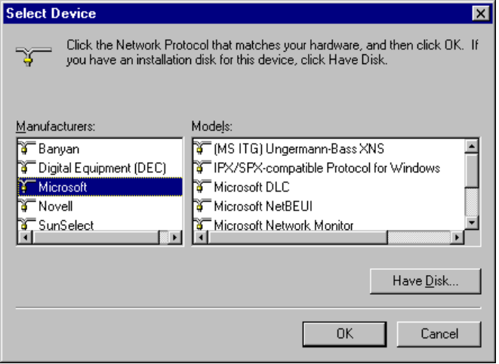

IPX/SPX-Compatible Protocol
Internet Packet Exchange/Sequential Packet Exchange (IPX/SPX) is a small, fast protocol that is routable and best suited for small to medium-sized LANs. IPX/SPX is not well suited for large enterprise networks due to the high number of broadcasts.
The IPX/SPX-compatible protocol for Windows (NWLINK.VXD) is compatible with Novell NetWare IPX/SPX. This protocol is routable and can take advantage of IPX routers.
Microsoft IPX/SPX-compatible protocol supports the 32-bit Windows Sockets programming interface, so that any Win32-based Windows Socket application can run on IPX/SPX with Windows 95. (There are no 16-bit Windows Sockets applications using IPX/SPX, so backward compatibility for 16-bit sockets for IPX/SPX is not an issue.)
IPX/SPX-compatible protocol can be used by Client for NetWare Networks to communicate with NetWare 2.x, 3.x, or 4.x server or a computer running File and Printer Sharing for NetWare Networks. IPX/SPX can also be used by Client for Windows Networks to communicate with computers running Windows for Workgroups 3.11 or Windows NT with IPX/SPX-compatible protocol.
The Microsoft IPX/SPX-compatible protocol uses the NWNBLINK.VXD module to support computers that use NetBIOS over IPX and to support the NetBIOS programming interface.
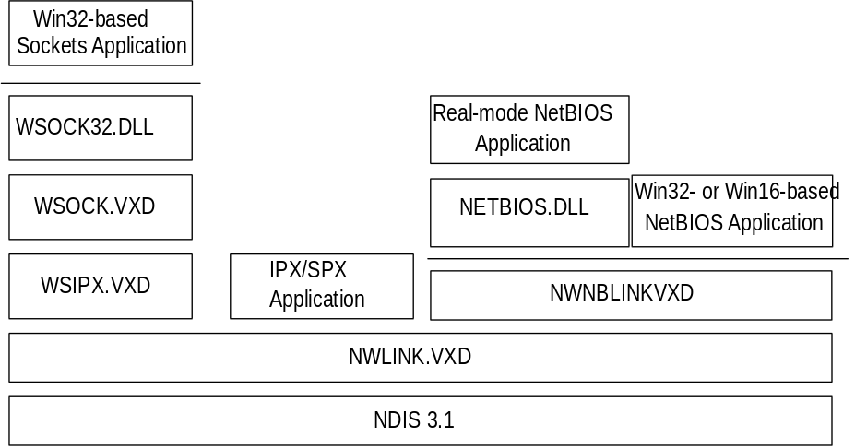
Windows 95 architecture for IPX/SPX-compatible protocol
The Microsoft IPX/SPX-compatible protocol is NDIS 3.1-compliant, allowing computers running Windows 95 to communicate over a routable IPX-compatible protocol. This protocol can use Novell NetWare servers configured as routers (and other IPX routers) to transfer its packets across LANs to access resources on other computers running Windows 95.
The IPX/SPX-compatible protocol is a 32-bit, protected-mode protocol that is Plug and Play-compliant. With the IPX/SPX-compatible protocol, it is not necessary to load the Novell VIPX.386 driver.

Configuring IPX/SPX-Compatible Protocol
The Microsoft IPX/SPX-compatible protocol is installed if you also install Client for NetWare Networks during Windows 95 Setup. You can also install this protocol to support other network clients, including Microsoft Client for Windows Networks.
To configure the IPX/SPX-compatible protocol
1. On the Configuration sheet in Network Control Panel, select IPX/SPX Compatible Protocol for Windows, and then click the Properties button.
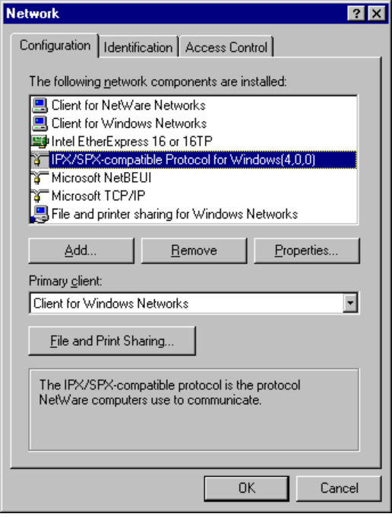

If your computer has multiple network adapter cards, there will be an instance of the IPX/SPX-compatible protocol for each network adapter card. You must configure each card with its own settings.
Note

2. Click the Advanced tab.
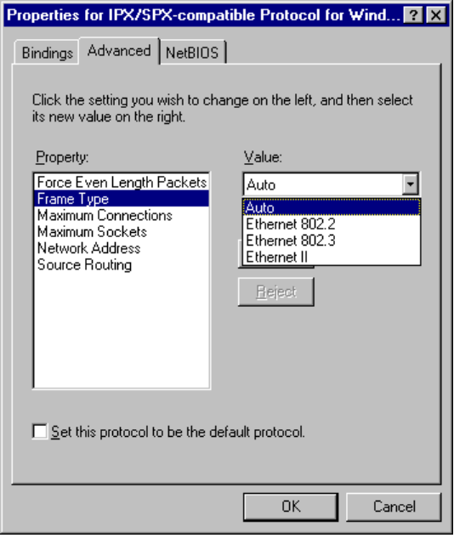
3. Most values have correct defaults in typical installations. If you need to change a value for a particular purpose, select the item in the Property list, and specify a value in the Value list, based on the settings in the following table.

Property | Value
Force even-length IPX packets | Enabled only for Ethernet 802.3 on monolithic implementations that cannot handle odd-length packets.
Frame type | Specifies the frame type based on detection.¹ This value is used for network adapter cards that support multiple frame types. The possible values are:  - Auto-detect (recommended)  - ArcNet  - Ethernet 802.2 (default for NetWare 3.12 and later)  - Ethernet 802.3  - Ethernet_II  - SNAP  Token ring networks do not use this parameter.

Property | Value
Maximum connections | Specifies the maximum number of connections that IPX will allow. Configured dynamically.
Maximum sockets | Specifies the maximum number of IPX sockets that IPX assigns. Configured dynamically.
Network address | Specifies the IPX network address as a four-byte value. Configured dynamically.
Source routing cache size | Specifies the cache size to use when using source routing. This parameter is used only on token ring networks, where it is used to turn on source routing.
¹ Each time you start the computer, Windows 95 detects the frame type by sending a general RIP request in each frame format. Based on the responses received from routers, Windows 95 determines the most prevalent frame type used and sets that as the default frame type for the IPX/SPX-compatible protocol.

You should not need to change binding in most circumstances. However, if your computer is connected to multiple networks and you don’t want to use the server on one network, you can disable the bindings, mostly for security purposes. For example, if the computer is on a local LAN and also connected to the enterprise internetwork, you may not want your peer resource sharing services on the internetwork.
To change bindings for the IPX/SPX-compatible protocol
1. On the properties sheet for IPX/SPX-Compatible Protocol For Windows, click the Bindings tab.
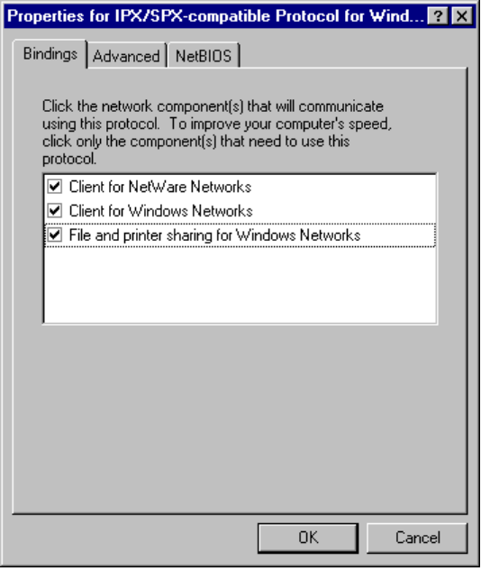
2. Click any network component to change its bindings.
If the option is checked, it is bound to the protocol. If it is not checked, that network component is not using the IPX/SPX-compatible protocol.

Microsoft Client for NetWare Networks is always bound only to the IPX/SPX-Compatible Protocol for Windows. This network client cannot use another protocol.
Note

Using NetBIOS Over IPX
NetBIOS is a high-level interface used by applications to communicate with other NetBIOS-compliant protocols. The NetBIOS interface is responsible for the following:
- Establishing logical names on the network
- Establishing connections (called sessions) between two logical names on the network

Windows 95 provides a 32-bit, protected-mode NetBIOS driver to support NetBIOS services over IPX (NWNBLINK.VDX, which complements NWBLINK). NWNBLink is compatible with the Novell NetBIOS support driver and provides improved performance when using NetBIOS with IPX. Performance enhancements include acknowledgment of previous frames in response frames (called PiggyBackAck), plus a “sliding window” acknowledgment mechanism. These NetBIOS enhancements are used only when communicating with other computers using NWNBLink, such as other computers running Windows 95, Windows NT, or NetWare servers running Lotus Notes.
Novell provides a TSR NetBIOS driver named NETBIOS.EXE, which is a Level 1 NetBIOS provider that consumes about 40K of conventional memory. The Novell NetBIOS driver acknowledges each frame received, thus increasing the amount of traffic generated when NetBIOS is used. With NWNBLink loaded, the real-mode NETBIOS.EXE TSR can be removed from the system.
The following table shows when the IPX/SPX-compatible protocol and when the IPX/SPX-compatible protocol with NetBIOS should be installed.
Feature needed | IPX/SPX-compatible protocol | IPX over NetBIOS
NetBIOS support | — | •
Connectivity to Windows NT 3.5 | • | •
Connectivity to Windows 95 | • | • (for Network DDE)
Network DDE over IPX | — | •

NWNBLink is not necessary for computers running Windows 95 to communicate with each other. The redirector and server networking components in Windows 95 communicate with the IPX protocol directly without NetBIOS. (This is sometimes called direct hosting over IPX.)
NWNBLink is commonly required in these cases:
- When using any NetBIOS applications on a NetWare (or IPX) server, such as Lotus Notes.

The Windows NT 3.5 server service (not the Windows NT Server) supports IPX without NetBIOS. The Windows NT 3.5 workstation service (not the Windows NT Workstation) does not support IPX without NetBIOS. A network client on a computer running Windows 95 that uses IPX without NetBIOS can connect to a Windows NT 3.5 server that uses IPX without NetBIOS. However, the Windows NT 3.5 workstation service cannot connect to a computer running Windows 95 that uses IPX without NetBIOS, while running File and Printer Sharing for Windows Networks.
Note

To use the IPX/SPX-compatible protocol with NetBIOS on a computer
1. In Network Control Panel, click the Add button, select Protocol, and then click the Add button.
2. In the Manufacturers list in the Select dialog box, select Microsoft, and in the Models list, select NetBIOS Support for IPX/SPX-compatible Protocol. Then click OK.
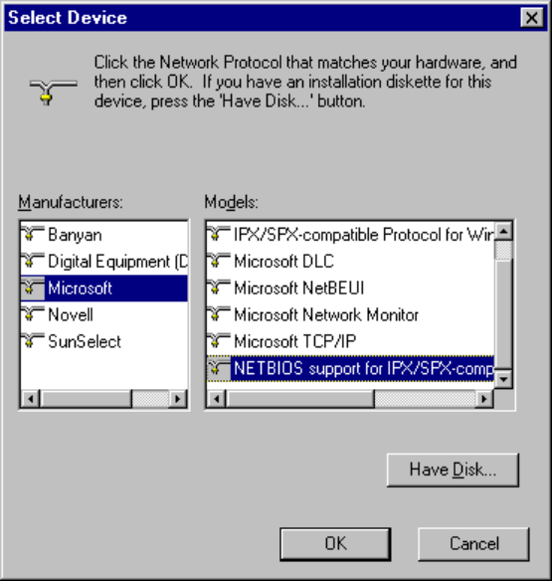

IPX/SPX Technical Issues on NetWare Networks
- There is no need to enable Source Routing on Token Ring networks if the communication is on the same ring, even if one computer has it enabled.
- SPX-II is a protocol definition for windowing and transmitting large packets over SPX. SPX-II is supported under Windows 95 when using a Novell-supplied DLL. An application must call and use this DLL. There is no SPX-II support in the IPX/SPX-compatible protocol.
- The IPX/SPX-compatible protocol in Windows 95 uses NET.CFG parameters for NetBIOS over IPX, if specified in the Registry. However, configuring these parameters should not be necessary because most parameters are dynamic and self-adjusting. If you upgrade to Client for NetWare Networks, the NET.CFG parameters are moved to the Registry. If you upgrade from other implementations of IPX/SPX, the values in NET.CFG and SHELL.CFG are moved to the Registry.
- To determine the network ID (which is the network address in IPX packets), Windows 95 checks the wire for RIP packets and keeps a count of the 10 most-used IPX network IDs and chooses the most likely ID. The network ID is dynamic and will change when a new network ID becomes more prevalent.
- All Transport Layer Interface (TLI) libraries can run on the IPX/SPX-compatible protocol in Windows 95. TLI is similar to TDI in Microsoft networking as a layer between the protocol and network adapter driver; this implementation is similar to STREAMS and provides a STREAMS environment for NetWare, but Windows 95 uses the Windows Sockets specification instead.

TCP/IP Protocol
Transmission Control Protocol/Internet Protocol (TCP/IP) is a networking protocol that provides communication across interconnected networks made up of computers with diverse hardware architectures and various operating systems. TCP/IP can be used to communicate with computers running Windows 95, with devices using other Microsoft networking products, or with non-Microsoft systems, such as UNIX®.
The TCP/IP protocol family is a standard set of networking protocols. TCP/IP is used to connect the Internet. These same protocols can be used in private internetworks that connect several local area networks.
The Microsoft implementation of TCP/IP in Windows 95 enables enterprise networking and connectivity on computers running the TCP/IP protocol. Adding TCP/IP to a computer running Windows 95 offers the following advantages:
- A standard, routable enterprise networking protocol that is the most complete and accepted protocol available. All modern operating systems offer TCP/IP support, and most large networks rely on TCP/IP for much of their network traffic.
- A technology for connecting dissimilar systems. Many standard connectivity utilities are available to access and transfer data between dissimilar systems, including File Transfer Protocol (FTP) and Terminal Emulation Protocol (TELNET).
With TCP/IP as a connectivity protocol, computers running Windows 95 can communicate with many non-Microsoft systems, including Internet hosts, Apple® Macintosh® systems, IBM® mainframes, UNIX systems, and Open VMS® systems.
- A robust, scaleable, cross-platform client-server framework. TCP/IP in Windows 95 supports the Windows Sockets 1.1 interface, which is ideal for developing client-server applications that can run Windows Sockets-compliant stacks from other vendors. Many public-domain Internet tools also use the Windows Sockets standard.
- Client for Dynamic Host Configuration Protocol (DHCP), for dynamic resolution of IP addresses to host names on networks that have DHCP servers.
- Client for Windows Internet Name Resolution (WINS), for dynamic resolution of IP addresses to computers names on networks that have WINS servers.
- Point-to-Point protocol for asynchronous communication, as described in Chapter 22, “Remote Access.”

Microsoft TCP/IP provides all the following elements necessary to implement these protocols for networking:
- Core TCP/IP protocols, including the Transmission Control Protocol (TCP), Internet Protocol (IP), User Datagram Protocol (UDP), Address Resolution Protocol (ARP), and Internet Control Message Protocol (ICMP). This suite of Internet protocols provides a set of standards for how computers communicate and how networks are interconnected.
- Support for application interfaces, including Windows Sockets for network programming and NetBIOS for establishing logical names and sessions on the network.
- Basic TCP/IP connectivity applications, including ftp and telnet. With these utilities, users can interact with and use resources on non-Microsoft hosts, such as UNIX workstations.
- TCP/IP diagnostic tools, including arp, ipconfig, nbtstat, netstat, ping, route, and tracert. These utilities can be used to detect and resolve TCP/IP networking problems.

For a summary of the command-line options for TCP/IP utilities, see Appendix A, “Summary of Command-Line Commands.”
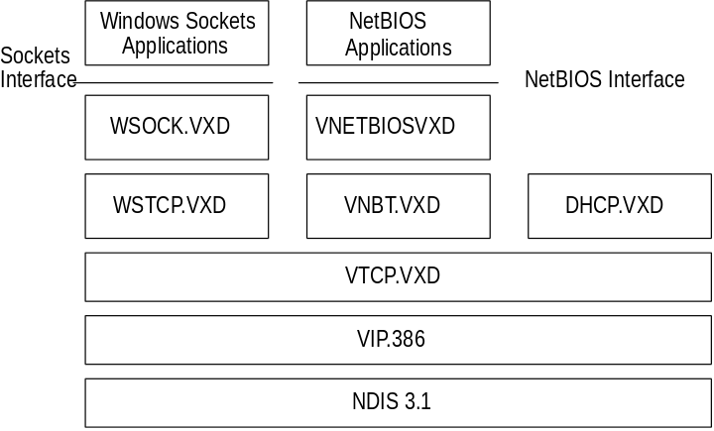
Windows 95 architecture for Microsoft TCP/IP

Configuring TCP/IP with DHCP
In an effort to make the implementation of the TCP/IP protocol more manageable, Microsoft, working with other industry leaders have created a mechanism called Dynamic Host Configuration Protocol (DHCP) for the automatic allocation of IP addresses. DHCP is not a Microsoft standard, but a public Request for Comments (RFC) that Microsoft has implemented.
DHCP allows a network management utility to centrally establish a range of IP addresses per subnet. An individual IP address from the range is assigned to any Microsoft TCP/IP client requesting an address. DHCP also allows the network management utility to centrally establish a lease time or how long the allocated IP address is to remain valid.
A DHCP server runs as a process on a Windows NT 3.5 Server. Using DHCP company-wide, it is possible to move from subnet to subnet and always have a valid IP address. Microsoft TCP/IP includes a utility, IPCONFIG, that allows a user or administrator to quickly examine the current IP address allocated to the computer, the IP address lease time and other useful data about the DHCP allocation for troubleshooting purposes.
DHCP support can be specified during installation, or enabled using Network Control Panel. If you want, a manually entered IP address can be used, and DHCP support can be disabled.
To use DHCP for automatic configuration of TCP/IP settings
1. On the Network properties sheet, click the Configuration tab.
2. Select Microsoft TCP/IP, and then click the Properties button.

If your computer has multiple network adapter cards, there will be an entry for TCP/IP for each network adapter card. You must configure each card with its own TCP/IP settings.
Note

3. On the Microsoft TCP/IP properties sheet, click the IP Address tab.
4. Click the option named Obtain An IP Address From A DHCP Server, and then click OK.
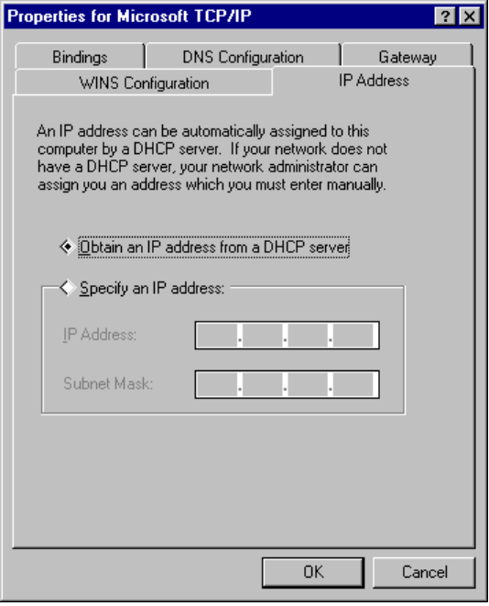

When the IP address for your computer is configured dynamically using DHCP, you can use the ipconfig command at the MS-DOS Prompt to see the currently assigned IP address.
Tip

If Microsoft TCP/IP is configured to obtain an IP address from a DHCP server when a DHCP server is not available on the network, the next time Windows 95 starts, the following error message appears:
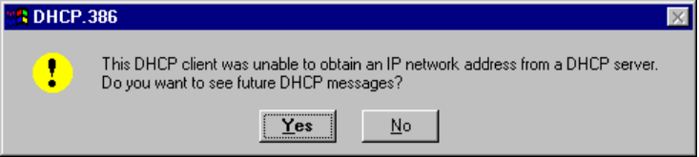
To solve this problem, use the procedure described in the following section to configure TCP/IP manually.

A computer running Windows 95 cannot be a DHCP server. A computer running Microsoft Windows NT 3.5 Server can act as both a DHCP and WINS server.
Note

Configuring TCP/IP Settings Manually
If you cannot use DHCP for automatic configuration, the network administrator must provide these values so that individual users can configure TCP/IP manually:
- The IP address and subnet mask for each network adapter card installed on the computer. For more information, see “IP Address Overview for TCP/IP Networks” later in this chapter.
- The IP address for the default gateways (IP routers).
- Whether the computer will use Domain Name System (DNS) and, if so, the IP addresses of the DNS servers on the internetwork.
- WINS server addresses, if WINS servers are available on your network.

The following procedure describes the basic configuration options for TCP/IP. If you want to configure the computer to use WINS or DNS for name resolution, see the procedures in “Using WINS for Name Resolution” and “Using DNS for Name Resolution” later in this chapter.
To configure the TCP/IP protocol manually
1. In Network Control Panel, click the Configuration tab.
2. Select Microsoft TCP/IP, and then click the Properties button.

If your computer has multiple network adapter cards, there will be an instance of TCP/IP for each network adapter card. You must configure each card with its own TCP/IP settings.
Note

3. On the Microsoft TCP/IP properties sheet, click the IP Address tab.
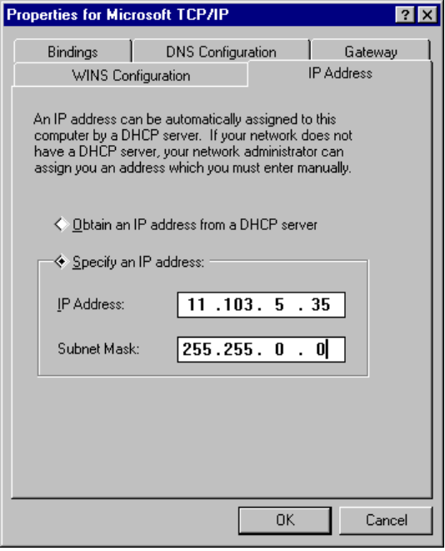
4. Type an IP address and subnet mask in the respective boxes.
The network administrator must provide these values for individual users, based on the network ID and the host ID plan for your site.
- The value in the IP Address box identifies the IP address for the local computer or, if more than one network card is installed in the computer, for the network adapter card selected in the Adapter box.
- The value in the Subnet Mask box identifies the network membership for the selected network adapter and its host ID. This allows the computer to separate the IP address into host and network IDs. The subnet mask defaults to an appropriate value, as shown in the following list:
Address class | Range of first octet  in IP address | Subnet mask
Class A | 1–126 | 255.0.0.0
Class B | 128–191 | 255.255.0.0
Class C | 192–223 | 255.255.255.0

5. To view or specify which network clients (redirectors) are bound to the TCP/IP protocol, click the Bindings tab.
- To keep a network client from using the TCP/IP protocol, click the client to remove the selection.
- If the network client for which you want to use TCP/IP does not appear in this list, that client is not bound to the TCP/IP protocol.
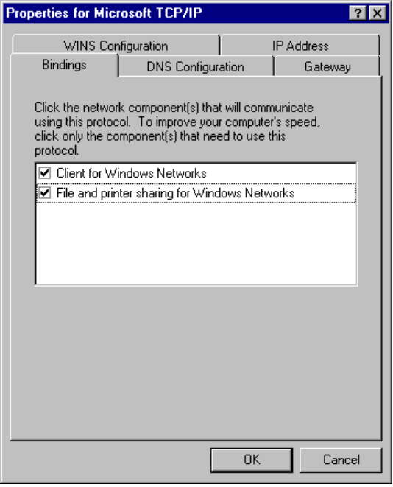

The only network client provided with Windows 95 that can use Microsoft TCP/IP is the Client for Windows Networks. Client for NetWare Networks does not use Microsoft TCP/IP.
Note
NetWare/IP from Novell allows the NCP request to be sent over an IP header. Windows 95 supports NetWare/IP, through the Novell-provided, real-mode client.

6. Click the Gateway tab, and then type at least one IP address for the default gateway (IP router) on the network.
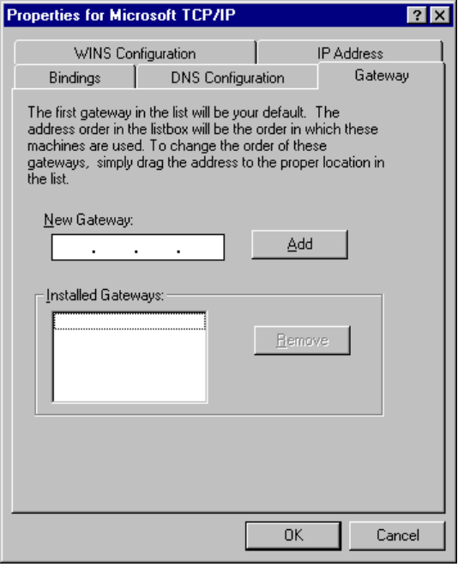
7. To specify an IP address for an additional gateway, type the IP address in the New Gateway box, and then click on the Add button.
Up to 7 additional gateways can be specified to facilitate a connection to a computer that is not reachable through the default gateway. Windows 95 will attempt to connect to a remote computer using the default gateway, and then each additional gateway specified. Additional gateways also provide fault management in case the default gateway becomes inoperable.
The first gateway in the list is the default gateway. Gateway addresses can be prioritized by dragging the IP address in the list of Installed Gateways.
8. Click OK, and then restart the computer for changes to take effect.

Name Resolution for Windows Networking
For TCP/IP and the Internet, the computer name is the globally known system name plus a DNS domain name. On the local network, the computer name is the NetBIOS name that was defined during Windows 95 Setup.
Computers use IP addresses to identify each other, but users usually find it easier to work with computer names. A mechanism must be available on a TCP/IP network to resolve names to IP addresses. To ensure that both name and address are unique, the computer using Microsoft TCP/IP registers its name and IP address on the network during system startup. Computers running Microsoft TCP/IP on the network can use one or more of the following methods to ensure accurate name resolution in TCP/IP internetworks:

Windows Internet Name Service
Computers running Microsoft TCP/IP can use WINS if one or more Windows NT Server computers configured as WINS servers are available that contain a dynamic database mapping computer names to IP addresses. WINS can be used in conjunction with broadcast name resolution for an internetwork, where other name resolution methods are inadequate. WINS is a NetBIOS-over-TCP/IP mode of operation defined in RFC 1001/1002 as p-node. Notice that WINS replaces the functionality of the LMHOSTS file (described later in this chapter).

Broadcast name resolution
Computers running Microsoft TCP/IP can also use broadcast name resolution, which is a NetBIOS-over-TCP/IP mode of operation defined in RFC 1001/1002 as b-node. This method relies on a computer making IP-level broadcasts to register its name by announcing it on the network. Each computer in the broadcast area is responsible for challenging attempts to register a duplicate name and for responding to name queries for its registered name.

DNS name resolution
The Domain Name System (DNS) provides a way to look up name mappings when connecting a computer to foreign hosts using NetBIOS over TCP/IP or Windows Sockets applications such as FTP. DNS is a distributed database designed to relieve the traffic problems that arose with the exploding growth of the Internet in the early 1980s. A DNS name server must be configured and available on the network. Notice that DNS replaces the functionality of the HOSTS file (also described later in this chapter) by providing a dynamic mapping of IP addresses to host names used by TCP/IP applications and utilities.

LMHOSTS or HOSTS files
An LMHOSTS file specifies the NetBIOS computer name and IP address mappings; a HOSTS file specifies the DNS name and IP address. On a local computer, the HOSTS file (used by Windows Sockets applications to find TCP/IP host names) and LMHOSTS file (used by NetBIOS over TCP/IP to find Microsoft networking computer names) can be used to list known IP addresses mapped with corresponding computer names. LMHOSTS is still used for name resolution in Windows 95 for small-scale networks or remote subnets where WINS is not available.
Windows 95 provides support for multiple DNS servers and up to two WINS servers. Support for either service can be configured in Windows 95 Setup or added later using Network Control Panel. For more information, see “Using WINS for Name Resolution” and “Using DNS for Name Resolution” later in this chapter.
The following sections provide some background information about the modes of NetBIOS over TCP/IP that can be used in Microsoft networks.

NetBIOS over TCP/IP and Name Resolution Overview
NetBIOS over TCP/IP is the session-layer network service that performs name-to-IP address mapping for name resolution. This section describes the modes of NetBIOS over TCP/IP, as defined in RFCs 1001 and 1002 to specify how NetBIOS should be implemented over TCP/IP.
The modes of NetBIOS over TCP/IP define how network resources are identified and accessed. The two most important aspects of the related naming activities are registration and resolution. Registration is the process used to acquire a unique name for each node (computer system) on the network. A computer typically registers itself when it starts. Resolution is the process used to determine the specific address for a computer name.
The NetBIOS over TCP/IP modes include the following:
- b-node, which uses broadcasts to resolve names
- p-node, which uses point-to-point communications with a name server to resolve names
- m-node, which uses b-node first (broadcasts), then p-node (name queries) if the broadcast fails to resolve a name
- h-node, which uses p-node first for name queries, then b-node if the name service is unavailable or if the name is not registered in the WINS database

For DHCP users on a Windows NT network (including computers running Windows 95), the node type is assigned by the DHCP server. When WINS servers are in place on the network, NetBIOS over TCP/IP resolves names on a client computer by communicating with the WINS server. When WINS servers are not in place, NetBIOS over TCP/IP uses b-node broadcasts to resolve names. NetBIOS over TCP/IP in Microsoft networks can also use LMHOSTS files and DNS for name resolution, depending on how TCP/IP is configured on a particular computer.
Windows 95 supports all of the NetBIOS over TCP/IP modes described in the following sections. NetBIOS over TCP/IP is also used with the LAN Manager 2.x Server message protocol.

B-Node
The b-node mode uses broadcasts for name registration and resolution. That is, if the computer named PC1 wants to communicate with PC2, it will broadcast to all computers that it is looking for PC2 and then wait a specified time for PC2 to respond.
B-node has two major problems:
- In a large environment, it loads the network with broadcasts.
- Routers do not forward broadcasts, so computers that are on opposite sides of a router will never hear the requests.

P-Node
The p-node mode addresses the issues that b-node does not solve. In a p-node environment, computers neither create nor respond to broadcasts. All computers register themselves with the WINS server, which is a NetBIOS Name Server (NBNS) with enhancements. The WINS server is responsible for knowing computer names and addresses and for ensuring no duplicate names exist on the network. All computers must be configured to know the address of the WINS server.
In this environment, when PC1 wants to communicate with PC2, it queries the WINS server for the address of PC2. When PC1 gets the appropriate address from the WINS server, it goes directly to PC2 without broadcasting. Because the name queries go directly to the WINS server, p-node avoids loading the network with broadcasts. Because broadcasts are not used and because the address is received directly, computers can span routers.
The most significant problems with p-node are the following:
- All computers must be configured to know the address of the WINS server (although this is typically configured using DHCP).
- If, for any reason, the WINS server is down, computers that rely on the WINS server to resolve addresses cannot get to any other systems on the network, even if they are on the local network.

M-Node
The m-node mode was created primarily to solve the problems associated with b-node and p-node. This mode uses a combination of b-node and p-node. In an m-node environment, a computer first attempts registration and resolution using b-node. If that is successful, it then switches to the p-node. Because this uses b-node first, it does not solve the problem of generating broadcast traffic on the network. However, m-node can cross routers. Also, because b-node is always tried first, computers on the same side of a router continue to operate as usual if the WINS server is down.
M-node uses broadcasts for performance optimization, because, in most environments, local resources are used more frequently than remote resources. Also, in a Microsoft network, m-node can cause problems with NetLogon in routed environments.

H-Node
The h-node mode, which is currently in RFC draft form, is also a combination of b-node and p-node that uses broadcasts as a last effort. Because p-node is used first, no broadcasts are generated if the WINS server is running, and computers can span routers. If the WINS server is down, b-node is used, so computers on the same side of a router continue to operate as usual.
The h-node mode does more than change the order for using b-node and p-node. If the WINS server is down so that local broadcasts (b-node) must be used, the computer will continue to poll the WINS server. As soon as the WINS server can be reached again, the system switches back to p-node. Also, optionally on a Windows network, h-node can be configured to use LMHOSTS after broadcast name resolution fails.
The h-node mode solves the most significant problems associated with broadcasts and operating in a routed environment. For Microsoft TCP/IP users who configure TCP/IP manually, h-node is used by default, unless the user does not specify addresses for WINS servers when configuring TCP/IP.

B-Node with LMHOSTS and Combinations
Another variation is also used in Microsoft networks to span routers without a WINS server and p-node mode. In this mode, b-node uses a list of computers and addresses stored in an LMHOSTS file. If a b-node attempt fails, the system looks in LMHOSTS to find a name and then uses the associated address to cross the router. However, each computer must have this list, which creates an administrative burden in maintaining and distributing the list. Both Windows for Workgroups 3.11 and LAN Manager 2.x used such a modified b-node system. Windows 95 uses this method if WINS servers are not used on the network. In Windows 95, some extensions have been added to this file to make it easier to manage as described later in this chapter, but modified b-node is not an ideal solution.
Some networks may need to use both b-node and p-node modes at the same site. Although this configuration can work, administrators must exercise extreme caution in doing so, using it only for transition situations. Because p-node hosts disregard broadcasts and b-node hosts rely on broadcasts for name resolution, the two hosts can potentially be configured with the same NetBIOS name, leading to unpredictable results. Notice that if a computer configured to use b-node has a static mapping in the WINS database, a computer configured to use p-node cannot use the same computer name.

Using WINS for Name Resolution
WINS provides a distributed database for registering and querying dynamic computer name-to-IP address mappings in a routed network environment. If you are administering a routed network, WINS is your best choice for name resolution, because it is designed to solve the problems that occur with name resolution in more complex internetworks.
WINS reduces the use of local broadcasts for name resolution and allows users to easily locate systems on remote networks. Furthermore, when dynamic addressing through DHCP results in new IP addresses for computers that move between subnetworks, the changes are automatically updated in the WINS database. Neither the user nor the network administrator needs to make manual accommodations for name resolution in such a case.
The WINS protocol is based on and is compatible with the protocol defined for WINS server in Requests for Comments (RFCs) 1001 and 1002, so it is interoperable with any other implementations of these RFCs. A WINS server is a Windows NT Server 3.5 computer with WINS server software installed. When Microsoft TCP/IP is installed, WINS client software is installed automatically.
This section provides an overview of how WINS and name query broadcasts perform name resolution on Windows networks.
WINS consists of two components: the WINS server, which handles name queries and registrations, and the client software (NetBIOS over TCP/IP), which queries for computer name resolution.
Windows networking clients that are WINS-enabled (computers running Windows NT 3.5 or Windows 95) can use WINS directly. Non-WINS computers on the internetwork that are b-node-compatible, as described in RFCs 1001 and 1002, can access WINS through proxies, which are network WINS-enabled computers that listen to name query broadcasts and then respond for names that are not on the local subnet or are p-nodes.
On a Windows network, users can browse transparently across routers. To allow browsing without WINS, the network administrator must ensure that the users’ primary domain has Windows NT Server computers on both sides of the router to act as master browsers. These computers need correctly configured LMHOSTS files with entries for the domain controllers across the subnet.
With WINS, such strategies are not necessary because the WINS servers and proxies transparently provide the support necessary for browsing Windows NT domains across routers.
For a technical discussion of how WINS works and how it can be set up on the network, see Windows NT Server 3.5 TCP/IP in the Windows NT Server 3.5 documentation set.
If there are WINS servers installed on your network, you can use WINS in combination with broadcast name queries to resolve NetBIOS computer names to IP addresses. If you do not use this option, Windows 95 uses name query broadcasts (b-node mode of NetBIOS over TCP/IP) plus the local LMHOSTS file to resolve computer names to IP addresses. Broadcast resolution is limited to the local network, as described earlier in this chapter.
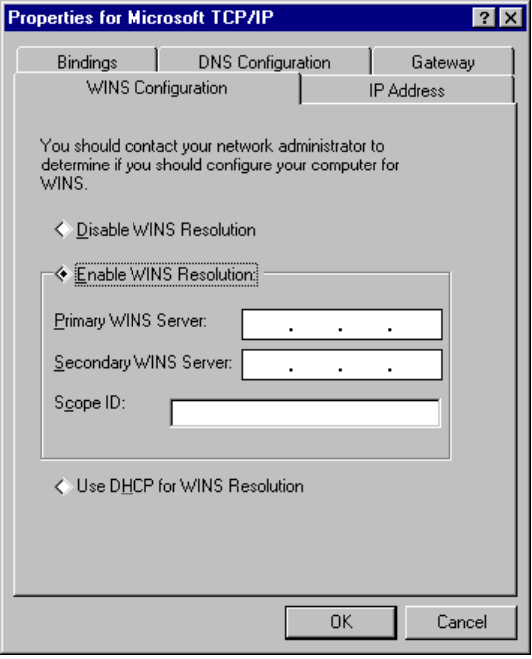
To configure a computer to use WINS for name resolution
1. In Network Control Panel, select Microsoft TCP/IP, and then click the Properties button.
2. Click the WINS Configuration tab.
3. If a WINS server is not available, select Disable WINS Resolution.
– Or –
If a WINS server is available (or a secondary WINS server), select Enable WINS Resolution and enter the IP addresses of the Primary and Secondary WINS servers. These values should be provided by the network administrator, based on the IP addresses assigned to these Windows NT Server computers.
4. If WINS is enabled, in the Scope ID box, type the computer’s scope identifier, if required on an internetwork that uses NetBIOS over TCP/IP.
Usually this value is left blank. Scope IDs are used only for communication based on NetBIOS over TCP/IP. In such a case, all computers on a TCP/IP internetwork must have the same scope ID. A scope ID may be assigned to a group of computers that will communicate only with each other and no other systems. Such computers can find each other if their scope IDs are identical.
5. If a DHCP server is available that is configured to provide information on available WINS servers, select Use DHCP for WINS Resolution.

If DHCP is used for automatic configuration, these parameters can be provided by the DHCP server.

Using DNS for Name Resolution
The Domain Name System (DNS) is a distributed database, providing a hierarchical naming system for identifying hosts on the Internet. The specifications for DNS are defined in RFCs 1034 and 1035.
Although DNS may seem similar to WINS, there is one major difference: DNS requires static configuration of IP addresses for name-to-address mapping. WINS can provide name-to-address mapping dynamically and requires far less administration.
The DNS database is a tree structure called the domain name space, where each node or domain is named and can contain subdomains. The domain name identifies the domain’s position in the database in relation to its parent domain, with a period (.) separating each part of the names for the network nodes of the DNS domain.
The root of the DNS database is managed by the Internet Network Information Center. The top-level domains were assigned organizationally and by country. These domain names follow the International Standard (ISO) 3166. Two-letter and three-letter abbreviations are used for countries, and various abbreviations are reserved for use by organizations, as shown in the following example.
DNS domain name | Type of organization
com | Commercial (for example, microsoft.com)
edu | Educational (for example, mit.edu for Massachusetts Institute of Technology)
gov | Government (for example, nsf.gov for the National Science Foundation)
org | Noncommercial organizations (for example, fidonet.org for FidoNet)
net | Networking organizations (for example, nsf.net for NSFNET)

DNS uses a client-server model, where the DNS servers contain information about a portion of the DNS database and make this information available to clients, called resolvers, that query the name server across the network. DNS name servers are programs that store information about parts of the domain namespace called zones. The administrator for a domain sets up name servers that contain the database files with all the resource records describing all hosts in their zones. DNS resolvers are clients that are trying to use name servers to gain information about the domain namespace.
Microsoft TCP/IP includes the DNS resolver functionality used by NetBIOS over TCP/IP and Windows Sockets connectivity applications such as ftp and telnet to query the name server and interpret the responses.
The key task for DNS is to present friendly names for users and then resolve those names to IP addresses, as required by the internetwork. Name resolution is provided through DNS by the name servers, which interpret the information in an FQDN to find its specific address. If a local name server doesn’t contain the data requested in a query, it sends back names and addresses of other name servers that could contain the information. The resolver then queries the other name servers until it finds the specific name and address it needs. This process is made faster because name servers continuously cache the information learned about the domain namespace as the result of queries.
All the resolver software necessary for using DNS on the Internet is installed with Microsoft TCP/IP.
Although TCP/IP uses IP addresses to identify and reach computers, users typically prefer to use host names. Domain Name System (DNS) is a naming service generally used in the UNIX networking community to provide standard naming conventions for IP workstations. TCP/IP utilities, such as ftp and telnet, can also use DNS, in addition to the HOSTS file, to find systems when connecting to foreign hosts or systems on your network.
The network administrator must determine whether users should configure their computers to use DNS. Usually you will use DNS if you are using TCP/IP to communicate over the Internet or if your private internetwork uses DNS to distribute host information.
Microsoft TCP/IP provides a DNS client for resolving Internet or UNIX system names. Microsoft Windows networking provides dynamic name resolution for NetBIOS computer names using WINS servers and NetBIOS over TCP/IP, as described in the previous section.
If you choose to use DNS, you must configure how the computer will use DNS and the HOSTS file. TCP/IP must be installed to manually set up the DNS connectivity options. DNS configuration is global for all network adapters installed on a computer.
If DHCP is used for automatic configuration, these parameters can be provided by the DHCP server.
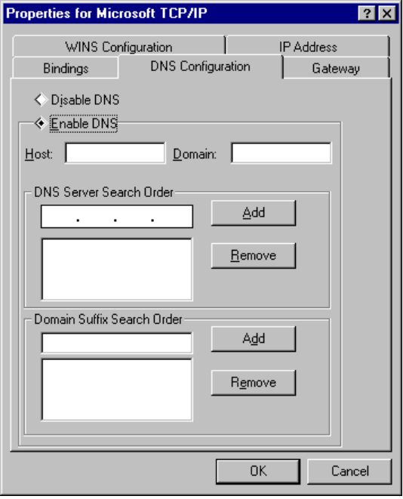
To configure a computer to use DNS for name resolution
1. In Network Control Panel, select Microsoft TCP/IP, and then click the Properties button.
2. Click the DNS Configuration tab.
3. If a DNS server is not available, click Disable DNS.
– Or –
If a DNS server is available, click Enable DNS. Then specify a host name and complete the other configuration information, as described in the following procedure.

The host name is used to identify the local computer by name for authentication by some utilities. Other TCP/IP-based utilities can use this value to learn the name of the local computer. Host names are stored on DNS servers in a table that maps names to IP addresses for use by DNS.
To set the host name for DNS
- Type a name in the Host Name box.
The name can be any combination of the letters A–Z, the numerals 0–9, and the hyphen (-), plus the period (.) character used as a separator. By default, this value is the Microsoft networking computer name, but the network administrator can assign another host name without affecting the computer name.

Some characters that can be used in computer names, especially the underscore, cannot be used in host names.
Note

The TCP Domain Name is used with the host name to create a fully qualified domain name (FQDN) for the computer. The FQDN is the host name followed by a period (.), followed by the domain name. For example, this could be johndoe.microsoft.com, where johndoe is the host name and microsoft.com is the domain name.
During DNS queries, the local domain name is appended to short names. A short name consists of just a host name, like janedoe. When querying the DNS server for the IP address of janedoe, the domain name is appended to the short name and the DNS server is actually asked to resolve the FQDN of janedoe.microsoft.com. Notice that the FQDN of Jane Doe at Microsoft (janedoe.microsoft.com) is not the same as her Internet electronic mail address of janedoe@microsoft.com.
To set the domain name
- Optionally, type a name in the Domain Name box.
This is usually an organization name followed by a period and an extension that indicates the type of organization, such as microsoft.com. The name can be any combination of the letters A–Z, the numerals 0–9, and the hyphen (-), plus the period (.) character used as a separator.

A DNS domain is not the same as a Windows NT or LAN Manager domain. A DNS domain is a hierarchical structure for organizing TCP/IP hosts and provides a naming scheme used in UNIX environments. A Windows NT or LAN Manager domain is a grouping of computers for security and administrative purposes.
Note

You can add up to three IP addresses for DNS servers. For a given DNS query, Windows 95 will attempt to get DNS information from the first IP address in the list. If no response is sent, Windows 95 will go to the second server in the list, and so on. To change the order of the IP addresses, you must remove them and enter them in the order that you want the servers to be searched.
To set the DNS server search order
1. In the Domain Name System (DNS) Search Order box, type the IP address of a DNS server that will provide name resolution. Then click the Add button to add the IP address to the list.
The network administrator should provide the correct values for this parameter, based on the IP address assigned to the DNS server used at your site.
2. To remove an IP address from the list, select it and click the Remove button.

The Domain Suffix Search Order specifies the DNS domain suffixes to be appended to host names during name resolution. You can add up to 5 domain suffixes. Domain suffixes are placed in the list in alphabetic order.
To set the domain suffix search order
1. In the Domain Suffix Search Order box, type the domain suffixes to add to your domain suffix search list, and then click the Add button.
2. To remove a domain name from the list, select it and click the Remove button.

When attempting to resolve a Fully Qualified Domain Name (FQDN) from a short name, Windows 95 will first append the local Domain name. If not successful, then Windows 95 will use the Domain Suffix list to create additional FQDNs and query DNS servers in the order listed.

Using Host Files for Name Resolution with TCP/IP
For computers located on subnetworks where WINS is not used, the HOSTS and LMHOSTS files provide mappings for names to IP addresses. These are the name resolution method used on internetworks before DNS and WINS were developed.
- The HOSTS file is used as a local DNS equivalent to resolve host names to IP addresses.
- The LMHOSTS file is used as a local WINS equivalent to resolve NetBIOS computer names to IP addresses.

Each of these files is also known as a host table. Sample versions of LMHOSTS (called LMHOSTS.SAM) and HOSTS files are added to the Windows directory when you install Windows 95 with TCP/IP support. These files can be edited using any ASCII editor, such as WordPad or Edit.
For information about setting up and using HOSTS and LMHOSTS files, see Appendix H, “HOSTS and LMHOSTS Files for Windows 95.”

IP Address Overview for TCP/IP Networks
A host is any device attached to the network that uses TCP/IP. To receive and deliver packets successfully between hosts, TCP/IP relies on three pieces of information: IP address, subnet mask, and default gateway. The network administrator provides this information for configuring TCP/IP on a computer. This section provides details about IP addresses and subnet masks.
Every host interface, or node, on a TCP/IP network is identified by a unique IP address. This address is used to identify a host on a network; it also specifies routing information in an internetwork. The IP address identifies a computer as a 32-bit address that is unique across a TCP/IP network. An address is usually represented in dotted decimal notation, which depicts each octet (eight bits, or one byte) of an IP address as its decimal value and separates each octet with a period. An IP address looks like this:
102.54.94.97

Because IP addresses identify nodes on an interconnected network, each host on the internetwork must be assigned a unique IP address, valid for its particular network.
Important

Network ID and Host ID
Although an IP address is a single value, it contains two pieces of information: the network ID and the host (or system) ID for your computer.
- The network ID identifies a group of computers and other devices that are all located on the same logical network, which are separated or interconnected by routers. In internetworks (networks formed by a collection of local area networks), there is a unique network ID for each network.
- The host ID identifies your computer within a particular network ID. (A host is any device that is attached to the network and uses TCP/IP.)

Networks that connect to the public Internet must obtain an official network ID from the InterNIC to guarantee IP network ID uniqueness. The InterNIC can be contacted by electronic mail at info@internic.net (for the United States, 1–800–444–4345 or, for Canada and overseas, 619–455–4600). Internet registration requests can be sent to hostmaster@internic.net. You can also use FTP to connect to is.internic.net, then log on as anonymous, and change to the /INFOSOURCE/FAQ directory.
After receiving a network ID, the local network administrator must assign unique host IDs for computers within the local network. Although private networks not connected to the Internet can choose to use their own network identifiers, obtaining a valid network ID from InterNIC allows a private network to connect to the Internet in the future without reassigning addresses.
The Internet community has defined address classes to accommodate networks of varying sizes. Each network class can be discerned from the first octet of its IP address. The following table summarizes the relationship between the first octet of a given address and its network ID and host ID fields. It also identifies the total number of network IDs and host IDs for each address class that participates in the Internet addressing scheme. This sample uses w.x.y.z to designate the bytes of the IP address.
IP Address Classes
Class | w values1,2 | Network ID | Host ID | Available networks | Available hosts per net
A | 1–126 | w | x.y.z | 126 | 16,777,214
B | 128–191 | w.x | y.z | 16,384 | 65,534
C | 192–223 | w.x.y | z | 2,097,151 | 254
1 Inclusive range for the first octet in the IP address.
2 The address 127 is reserved for loopback testing and interprocess communication on the local computer; it is not a valid network address. Addresses 224 and above are reserved for special protocols (IGMP multicast and others), and cannot be used as host addresses.

A network host uses the network ID and host ID to determine which packets it should receive or ignore and to determine the scope of its transmissions (only nodes with the same network ID accept each other’s IP-level broadcasts).
Because the sender’s IP address is included in every outgoing IP packet, it is useful for the receiving computer system to derive the originating network ID and host ID from the IP address field. This is done by using subnet masks, as described in the following section.

Subnet Masks
Subnet masks are 32-bit values that allow the recipient of IP packets to distinguish the network ID portion of the IP address from the host ID. Like an IP address, the value of a subnet mask is frequently represented in dotted decimal notation. Subnet masks are determined by assigning 1s to bits that belong to the network ID and 0s to bits that belong to the host ID. Once the bits are in place, the 32-bit value is converted to dotted decimal notation, as shown in the following table.
Default Subnet Masks for Standard IP Address Classes
Address class | Bits for subnet mask | Subnet mask
Class-A | 11111111 00000000 00000000 00000000 | 255.0.0.0
Class-B | 11111111 11111111 00000000 00000000 | 255.255.0.0
Class-C | 11111111 11111111 11111111 00000000 | 255.255.255.0

The result allows TCP/IP to determine the host and network IDs of the local computer. For example, when the IP address is 102.54.94.97 and the subnet mask is 255.255.0.0, the network ID is 102.54 and the host ID is 94.97.
Although configuring a host with a subnet mask might seem redundant after examining the previous tables (since the class of a host is easily determined), subnet masks are also used to further segment an assigned network ID among several local networks.
For example, suppose not a network is assigned the Class-B network address 144.100. This is one of over 16,000 Class-B addresses capable of serving more than 65,000 nodes. However, the worldwide corporate network to which this ID is assigned is composed of 12 international LANs with 75 to 100 nodes each. Instead of applying for 11 more network IDs, it is better to use subnetting to make more effective use of the assigned ID 144.100. The third octet of the IP address can be used as a subnet ID, to define the subnet mask 255.255.255.0. This splits the Class-B address into 254 subnets: 144.100.1 through 144.100.254, each of which can have 254 nodes. (Host IDs 0 and 255 should not be assigned to a computer; they are used as broadcast addresses, which are typically recognized by all computers.) Any 12 of these network addresses could be assigned to the international LANs in this example. Within each LAN, each computer is assigned a unique host ID, and they all have the subnet mask 255.255.255.0.
The preceding example demonstrates a simple (and common) subnet scheme for Class-B addresses. Sometimes it is necessary to segment only portions of an octet, using only a few bits to specify subnet IDs (such as when subnets exceed 256 nodes). Each user should check with the local network administrator to determine the network’s subnet policy and the correct subnet mask. For all systems on the local network, the subnet mask must be the same for that network ID.

All computers on a logical network must use the same subnet mask and network ID; otherwise, addressing and routing problems can occur.
Important

Supported RFCs for TCP/IP on Windows 95
TCP/IP standards are defined in Requests for Comments (RFCs), which are published by the Internet Engineering Task Force (IETF) and other working groups. The relevant RFCs supported in this version of Microsoft TCP/IP are described in the following table. All RFCs can be found on the Internet using ds.internic.net.
Requests for Comments (RFCs) Supported by Microsoft TCP/IP
RFC | Title
768 | User Datagram Protocol (UDP)
791 | Internet Protocol (IP)
792 | Internet Control Message Protocol (ICMP)
793 | Transmission Control Protocol (TCP)
826 | Address Resolution Protocol (ARP)
854 | Telnet Protocol (TELNET)
894 | IP over Ethernet
919, 922 | IP Broadcast Datagrams (broadcasting with subnetworks)
959 | File Transfer Protocol (FTP)
1001, 1002 | NetBIOS Service Protocols
1034, 1035 | Domain Name System (DOMAIN)
1042 | IP over Token Ring
1055 | Transmission of IP over Serial Lines (IP-SLIP)
1112 | Internet Gateway Multicast Protocol (IGMP)
1122, 1123 | Host Requirements (communications and applications)
1134 | Point-to-Point Protocol (PPP)
Requests for Comments (RFCs) Supported by Microsoft TCP/IP (continued)

RFC | Title
1188 | IP over FDDI
1191 | Path MTU Discovery
1201 | IP over ArcNet
1332 | PPP Internet Protocol Control Protocol (IPCP)
1334 | PPP Authentication Protocols
1533 | DHCP Options and BOOTP Vendor Extensions
1534 | Interoperation Between DHCP and BOOTP
1541 | Dynamic Host Configuration Protocol (DHCP)
1542 | Clarifications and Extensions for the Bootstrap Protocol
1547 | Requirements for PPP
1548 | Point-to-Point Protocol (PPP)
1549 | PPP in High-level Data Link Control (HDLC) Framing
1552 | PPP Internetwork Packet Exchange Control Protocol (IPXCP)

In this version, Microsoft TCP/IP does not include a complete suite of TCP/IP connectivity utilities, Network File System (NFS) support, or some TCP/IP server services (daemons) such as routed and telnetd. Many such applications and utilities are available in the public domain or from other vendors and will work with Microsoft TCP/IP through Windows Sockets.

NetBEUI Protocol
Windows 95 provides the NetBIOS extended user interface (NetBEUI) protocol for compatibility with existing networks that use NetBEUI, including Windows for Workgroups, Windows NT, LAN Manager, Microsoft Workgroup Add-On for MS-DOS®, and other networks. NetBEUI is a small, efficient protocol designed for small networks of 20 to 200 computers, and is non-routable. It is ideal for large I/O requirements such as copying files from network servers or launching applications from network servers. For enterprise-wide networks that require a routable protocol, TCP/IP or the IPX/SPX-compatible protocol should be used.
NetBEUI in Windows 95 supports a NetBIOS programming interface, conforms to the IBM NetBEUI specifications, and includes performance enhancements related to NetBIOS 3.0.
The NetBEUI protocol is implemented as both a real-mode and protected-mode protocol. The NetBEUI module, NETBEUI.VXD, is accessible through the NetBIOS interface.
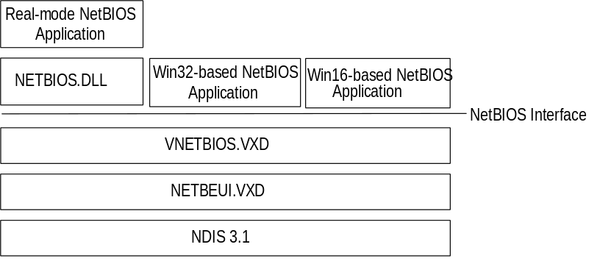
Windows 95 architecture for NetBEUI protocol
To manually configure NetBEUI
1. In Network Control Panel, click the Configuration tab. Then select Microsoft NetBEUI and click the Properties button.
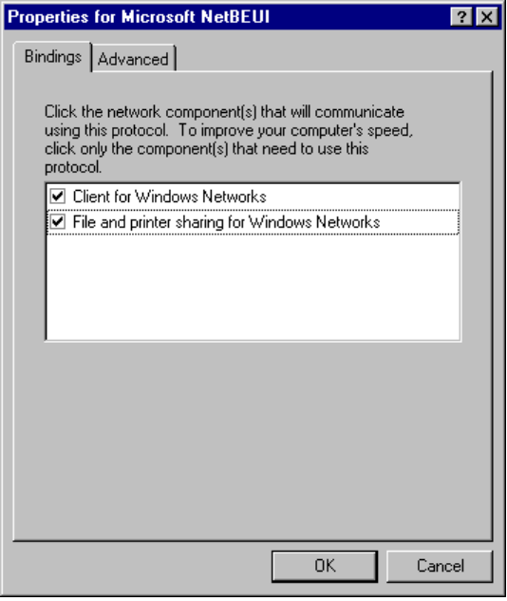

If your computer has multiple network adapter cards, there will be an instance of NetBEUI for each network adapter card. You must configure each card with its own settings.
Note

2. The Bindings tab shows which clients and services are currently using the NetBEUI protocol.
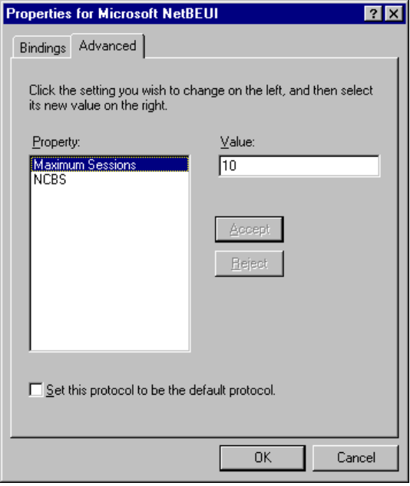
3. The Advanced tab is for modifying Maximum Sessions and NCBs for the real-mode NetBEUI. (The real-mode network runs, for example, when you use Fail Safe Startup.)
Option | Description
Maximum Sessions | Used to identify the maximum number of connections to remote computers that can be supported from the redirector. Equivalent to the sessions= parameter formerly specified in PROTOCOL.INI.
NCBS (network control blocks) | Used to identify the maximum number of NetBIOS commands that can be used. Equivalent to the ncbs= parameter formerly specified in PROTOCOL.INI,

Protected-mode NetBEUI dynamically sets Maximum Sessions and NCBs, and therefore does not use these settings.
4. Click OK to accept and confirm changes, and then restart the computer.

IPC and Windows 95
The goal in distributed computing is to divide the computing task into two parts. The first part runs on the client computer. This may not take a great deal of computing power but may require a lot of network bandwidth (operations such as screen graphics, mouse movements, and keyboard actions). The other part of the process requires large amounts of data, number crunching, or specialized hardware (operations such as database lookups and updates, or mainframe data access).
In some cases, distributed computing may provide the distribution of a complex task. One computer can work on a complex math problem that would take a month to complete. But with distributed computing, 50 computers could work on the math problem simultaneously so it could be completed in a less than a day.
Central-to-distributed computing is a connection between the client and the server at a process-to-process level that allows data to flow in both directions. Such interprocess communication is direct communication between processes on two different stations without using the file system.
The following interprocess communication (IPC) mechanisms are provided by Windows 95.
NetBIOS. Provides backward compatibility with existing NetBIOS applications. NetBIOS provides a protocol-independent way of creating sessions, datagrams, and name resolution and management over multiple protocols. NetBIOS is supported by all three protocols in Windows 95.
Windows Sockets. A Windows implementation of the widely used Berkeley sockets programming interface. Windows Sockets was originally designed as a vendor independent way of accessing datagram and session services over TCP/IP and has been extended in Windows 95 to support TCP/IP and IPX/SPX.
Named pipes. Provides backward compatibility with existing LAN Manager installations and applications.
Mailslots. Provides backward compatibility with existing LAN Manager installations and applications.
Remote Procedure Calls (RPCs). Compatible with the Open Software Foundation (OSF) Data Communication Exchange (DCE) specification for remote procedure calls.
The following sections provide details about these IPC implementations in Windows 95.

NetBIOS
Although TDI is the interface in Windows 95 for communication between protocols and upper-level software such as the redirector and server service, NetBIOS is also supported. NetBIOS is provided as an additional driver and DLL, and enables Windows 95 to be compatible with NetBIOS applications and to run software that specifically requires NetBIOS. The NetBIOS software is used only for these situations.
NetBIOS defines the interface between the redirector and the protocol layers. SMBs are passed to components at the OSI Transport Layer using the NetBIOS interface. The NetBIOS interface is a set of function calls that allow an application (such as the redirector in the Windows 95 protected-mode network client) to use the services of a Transport-layer service provider. The NetBEUI protocol driver is an example of such a service provider. The protocol driver contains the actual program code that implements the service requested by the NetBIOS “command” or API call. The NetBIOS specification also defines a protocol that can be implemented by a protocol driver to provide the services requested by applications using the NetBIOS interface (the interface between the Windows 95 redirector and one or more protocol drivers).
Many network applications use NetBIOS to send commands to the protocol driver. As long as a protocol driver recognizes NetBIOS commands issued by an application, that protocol driver can be used with any NetBIOS application. The NetBIOS interface in Windows 95 is supported by all three protocols shipped with Windows 95.
- VNETBIOS.386 implements the NetBIOS interface for 32-bit and 16-bit Windows-based applications so that computers running Windows 95 can concurrently run network-aware Windows-based and MS-DOS – based applications that use NetBIOS to communicate.
- NETBIOS.DLL provides support for backward compatibility with real-mode NetBIOS applications that call INT 5Ch.

The architecture for NetBIOS over the various protocols is described with the respective protocols earlier in this chapter.

Windows Sockets
Windows Sockets is a Windows implementation of the widely used UC Berkeley Sockets API, the de facto standard for TCP/IP networking. Non-NetBIOS applications must be written to the sockets interface to access Microsoft TCP/IP protocols. Applications written to the sockets interface include FTP, SNMP, and the NetBIOS name service.
Windows Sockets in Windows 95 is a protocol-independent networking API tailored for use by programmers using the Windows family of products. Windows Sockets is a public specification that aims to do the following:
- Provide a familiar networking API to programmers using Windows or UNIX
- Offer binary compatibility between heterogeneous Windows-based TCP/IP stack and utility vendors
- Support both connection-oriented and connectionless protocols

Sockets have these benefits over a NetBIOS protocol:
- Less overhead. Non-NetBIOS native protocols like TCP/IP and IPX/SPX require a NetBIOS interface and mapping layer. This extra NetBIOS software adds more processing time and also adds a header to the data frame sent on the wire. A good example is NetBIOS over TCP/IP. When the NetBIOS interface is used, a NetBIOS header is added to the frame before the TCP and IP headers. Stations running just native TCP/IP cannot see this frame. When sockets are used, the frame is sent using native TCP/IP without the addition of a NetBIOS header.
- Portability. A sockets-based network application on one system can communicate with any other computer that supports sockets.

In TCP/IP, the Internetwork Address is the IP address of the station and the software process address is the port number. Source and destination IP address and port numbers are fields in the TCP/IP packet structure. In IPX/SPX, the Internetwork Address is the combination of the IPX Network ID and the media access control (MAC) address of the network adapter card, and the software process address is the IPX Socket number. Source network, destination network, node, and socket numbers are fields in the IPX/SPX packet structure.

IPX Sockets are not the same as Windows Sockets. Novell uses the term “socket” to identify the individual software process address.
Note

For a bidirectional path, a Windows Sockets application specifies the following, depending on the protocol.
Protocol | Source socket | Destination socket
TCP/IP bi-directional path | IP address and port number of the source | IP address and port number of the destination
IPX/SPX bi-directional path | Network ID, MAC address of the network adapter card, IPX socket number | Network ID, MAC address of the network adapter card, IPX socket number

The following table describes the supporting files for 16-bit and 32-bit Windows Sockets over TCP/IP and 32-bit Windows Sockets over IPX/SPX.
Windows Sockets Supporting Files
File | Description | Comment
WINSOCK.DLL | 16-bit Windows Sockets | Provides backward compatibility with existing 16-bit TCP/IP Windows Sockets applications such as PING
WSOCK.VXD | Virtualized Windows Sockets | Supports 16-bit Windows Sockets and 32-bit TCP/IP and IPX/SPX Windows Sockets
WSTCP.VXD | Windows Sockets over TCP/IP¹ | Supports 16-bit Windows Sockets and 32-bit TCP/IP Windows Sockets
WSOCK32.DLL | 32-bit Windows Socket | Supports 32-bit TCP/IP Windows Socket applications such as TELNET and 32-bit IPX/SPX Windows Socket applications
WSIPX.VXD | Windows Sockets over IPX/SPX² | Supports 32-bit IPX/SPX Windows Sockets
¹ TCP/IP sockets are STREAMS-based over TCP and datagram-based over UDP.
² IPX/SPX sockets are STREAMS-based over SPX and datagram-based over IPX.

Most users will use programs that comply with Windows Sockets, such as FTP or TELNET. If you are interested in developing a Windows Sockets 1.1 application, specifications for Windows Sockets are available on the Internet from ftp.microsoft.com, on CompuServe® in the MSL library, and in the Microsoft Win32® Software Developers Kit.
To get a copy of the Windows Sockets specification using anonymous FTP
1. Make sure you have write permission in your current working directory.
2. Start ftp and connect to ftp.microsoft.com (or 198.105.232.1).
3. Log on as anonymous.
4. Type your electronic mail address for the password.
5. Type cd \advsys\winsock\spec11 and press ENTER.
6. Use the dir command to see the list of available file types. If you want binary data such as in the Microsoft Word version, type bin and press ENTER.
7. Determine the file with the format you want [for example, ASCII (.TXT), PostScript® (.PS), or Microsoft Word (.DOC)], and then type get winsock.ext where ext is the format that you want, such as winsock.doc for the Microsoft Word version.

To get a copy of the Windows Sockets specification from CompuServe
1. Type go msl and press ENTER.
2. Browse using the keywords windows sockets.
3. Choose the file with the format you want [ASCII (.TXT), PostScript (.PS), or Microsoft Word for Windows (.DOC)], and then type get winsock.ext.

There is also an electronic mailing list designed for discussion of Windows Sockets programming.
To subscribe to the Windows Sockets mailing list
- Send electronic mail to listserv@sunsite.unc.edu with a message body that contains subscribe winsock user’s-email-address.
You can use the same procedure to subscribe to two mailing lists called winsock-hackers and winsock-users.

Client-Side Named Pipes
As with Windows for Workgroups 3.11, Windows 95 supports client-side named pipes for other networks such as NetWare and VINES. Server-side named pipes are not supported.
VREDIR in Client for Windows Networks makes the Named Pipes API available for applications that use named pipes for IPC. However, VREDIR does not provide named pipes support for other networks such as Novell NetWare and Banyan VINES. A user who needs Novell NetWare or Banyan VINES named-pipes support must use the real-mode TSRs and network components provided by Novell or Banyan.
Named pipes provide an easy-to-access conduit for a one-to-one, reliable, connection-oriented data transfer between two processes. These two processes are normally differentiated as a client process and a server process. The term “server” as applied to the server process in a named-pipe application does not refer to the “server service” that is a component of the network operating system, although the server service may be (but is not necessarily) involved in making the pipe available to other stations.
- The named-pipe server process creates the pipe and manages access to it. The resources that make up the pipe are owned by the server process and physically exist on the station where the server process is running.
- The named-pipe client process uses the services of the underlying network protocols to access the remote pipe resources.

Although named pipes are usually used bidirectionally, the pipe can be configured to allow communication in only one direction, such as from server to client.
A common use for named pipes is in client-server applications based on SQL. The SQL client application can be run on the computer running Windows 95 with Microsoft Client for Windows Networks. The SQL server application, however, must be set up on a LAN Manager, Windows NT, or other named-pipes server computer.

Mailslots
Mailslot APIs in Windows 95 and Windows NT are a subset of the APIs in Microsoft OS/2 LAN Manager. VREDIR in Client for Windows Networks makes the Mailslots API available for applications that use mailslots for interprocess communication.
A mailslot is similar to a named pipe except that named pipes can only be used for one-to-one communication. Mailslots can be used for one-to-one, one-to-many, many-to-one, or many-to-many communication. A mailslot can be created on any network station. When a message is sent to a mailslot, the sending application specifies in the mailslot message structure whether the message is to be sent using first-class or second-class delivery.
First class delivery is a session-oriented, guaranteed data transfer for one-to-one or one-to-many communication. Messages designated as first-class delivery can only be sent to a mailslot that was created on a server.
Second class delivery is a datagram, non-guaranteed data transfer for one-to-one, many-to-one, one-to-many, and many-to-many communication. Messages designated as second-class delivery can be sent to a mailslot that was created on any station, or even on multiple stations, if the message size is 400 bytes or less.
Windows 95 and Windows NT implement only second-class mailslots, which are most useful for identifying other computers or services on a network and for wide-scale identification of a service. Windows 95 uses second-class mailslots for WinPopup messages and browsing.

Remote Procedure Calls
Much of the original design work for an RPC facility was started by Sun Microsystems®. This work was continued by the Open Software Foundation (OSF) as part of the overall Data Communication Exchange (DCE) standard. The Microsoft RPC facility is compatible (but not compliant) with the OSF/DCE-standard RPC. (Compliance in this case means starting with the OSF source code and building on it.) The Microsoft RPC facility is completely interoperable with other DCE-based RPC systems such as those for HP and IBM AIX® systems.
The RPC mechanism is unique because it uses other IPC mechanisms to establish communications between the client and the server. RPC can use named pipes, NetBIOS, or Windows Sockets to communicate with remote systems.
RPC is based on the concepts used for creating structured programs, which can be viewed as having a “backbone” to which a series of “ribs” can be attached. The backbone is the mainstream logic of the program, which should rarely change. The ribs are the procedures that the backbone calls on to do work or perform functions.
In traditional programs, these ribs are statically linked. By using DLLs, structured programs can dynamically link the ribs. With DLLs, the procedure code and the backbone code are in different modules. The DLL can thus be modified or updated without changes to the backbone. RPC means that the backbone and the ribs can exist on different computers, a feature which is important for distributed applications.
As shown in the following, Windows 95 provides RPC client support over the NetBIOS, named pipes, and Windows Sockets interfaces.
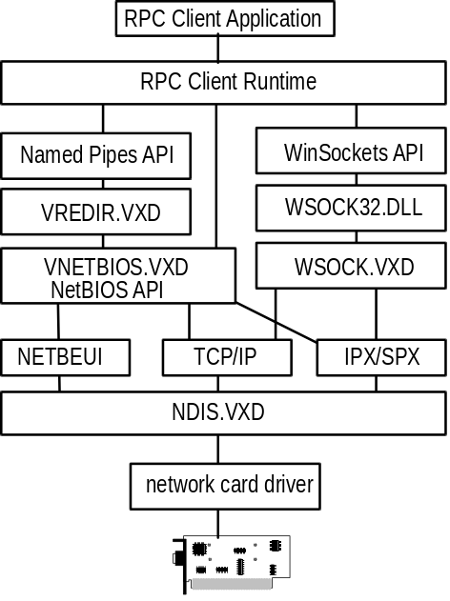
RPC client support in Windows 95
The following diagram shows how Windows 95 provides RPC server support over NetBIOS and Windows Sockets. There is no server support for RPC over named pipes. With a named-pipes RPC application, the named-pipes client can be run on the computer running Windows 95 but the named-pipes server must be set up on a LAN Manager server or Windows NT computer.
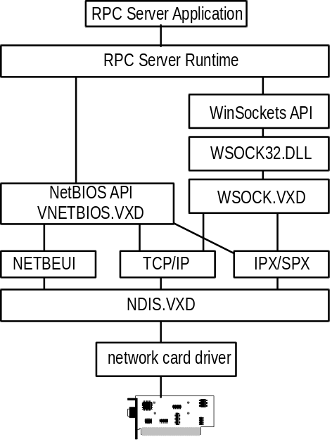
RPC server support in Windows 95

Troubleshooting Network Problems
This section provides troubleshooting tips organized under these general topics:
- Troubleshooting overview for network
- Troubleshooting for upgrading protocols from earlier versions
- Troubleshooting NetBEUI
- Troubleshooting the IPX/SPX-compatible protocol
- Troubleshooting TCP/IP

Troubleshooting Overview for Networks
This section provides basic troubleshooting steps to follow if the network doesn’t work or if you cannot see network resources.

Network doesn’t work upon Windows 95 system startup.
1. Did the network work before installing Windows 95?
No: Reinstall network software, verify that it is working on your system, and reinstall Windows 95.
2. Has any network cable been moved or added?
- Check the cable. Temporarily replace the network cable and retest. For Ethernet, connect only one other computer, terminate both ends, and retest.
- Check that the network connections are live (a malfunctioning network connection will prevent network operations). To check if the network jacks are live, look at the status lights on the back of the network card. If the status lights show activity, the network connection is live. If there is no activity on the status lights, disconnect and reconnect the network cable, and check again for activity such as blinking lights.
- Check terminators.
3. Have any protocols been added or removed?
- Check protocol settings and bindings in Network Control Panel. If the protocol isn’t bound to the adapter, networking functionality is not available.
- Check compatibility of the protocol with the network.
4. Are network adapter card settings appropriate for the card?
You can view the settings for the adapter in Network Control Panel. Check these against the documentation from your adapter manufacturer.
5. Was the other network previously installed and working?
6. How does the system work when you use Fail-Safe Startup with networking (F6)?
- Restart the computer and press F6 when the Starting Windows message appears. When Windows 95 finishes loading, check network functionality.
- Establish a diagnostic server to check basic networking functionality, as described in “Diagnosing Network Hardware Problems” later in this section.
- Check whether the real-mode network client works.
- If the network operates correctly in real mode, try reinstalling the protected-mode drivers by selecting all components in Network Control Panel and clicking the Remove button. Then click the Add button, and reinstall all components.

The following shows procedures for these troubleshooting steps.
To check whether the real-mode network client works
1. Restart the computer, and use F8 — Interactive Start .
2. Do not run WIN.COM
3. At the real-mode command-line prompt, type:
net start full

To use the real-mode network client to test protocol functionality
1. Set up a diagnostic server by running net diag on another computer and selecting the Diagnostic Server option. For more information, see “Diagnosing Network Hardware Problems” later in this seciton.
2. On the problem computer, load the real-mode client by typing the following:
net start full

3. Run net diag to identify the installed protocols.
Use net diag /? to see a list of the command-line switches.
4. Select the protocol you want to test

Other real-mode network operations for troubleshooting are summarized in the following list.
Command | Comment
net /status | Displays network information
net /name | Requires NetBIOS
net stop /y | Stops network, but retains real-mode drivers. Run Windows to verify it runs with real-mode network drivers.
net view | Displays connections.

Cannot see any computers after configuring network components.
The network transceiver or connector may be set incorrectly. Check your network hardware documentation, and ensure that the physical connection is correct.
Make sure the network card is configured correctly. If there is nothing connected to the port that Windows 95 is using, the computer thinks the network just isn’t very active.

Cannot connect to other network resources
1. If domains, workgroups, and workstations do not appear in the Network Neighborhood, try connecting to the server or workstation.
2. If you cannot connect to the server or workstation, check the following:
- Check error message details if available.
- Verify that you can connect to any server or workstation.
- Verify that you can connect to the server or workstation from other systems. If you cannot connect to the server or workstation from other systems, it probably indicates a problem with the server or workstation or the cabling or routing to it.
3. If you cannot connect to any server or workstation, check the following:+
- Check workgroup assignment.
- Check domain assignment.
- Check domain rights.
- Check basic network operations.

Others cannot connect to my network resources.
Check that sharing is enabled in Network Control Panel by selecting the File and Printer Sharing service, and clicking the Properties button. Verify that there are check marks in the boxes for the following options:
- I want to be able to give others access to my files.
- I want to be able to allow others to print to my printer(s).

If a check mark is missing, Windows 95 will not allow sharing of that resource.

Diagnosing Network Hardware Problems
Network hardware problems are commonly caused by improperly terminated network adapter cards, incorrect or non functional cabling, improper settings for the network adapter card, or faulty network adapter cards.

If you are upgrading from a previous version of Windows 3.x or Windows for Workgroups with a properly functioning network card, it is unlikely that you will find the network card itself to be faulty.
Note

Generally, it’s best to first rule out the possibility that you have hardware problems by running a network diagnostic tool to ensure that the computer can see the network and can be seen by other computers on the network.
To run Microsoft Network Diagnostics
1. From within an MS-DOS session (or from outside Windows 95 if you are testing the real-mode network), type net diag at the command prompt.
– Or –
To establish a diagnostic server with Fail-Safe Startup, restart the system. When the Starting Windows message appears, press Shift+F6. At the command-line prompt, type net diags
The Microsoft Network Diagnostics identifies the types of protocols that are currently installed. If you have both an IPX and a NetBIOS provider, you can choose which protocol to use. Select the protocol that is common to all computers to be involved in the diagnostics.
Microsoft Network Diagnostics then tries to detect a diagnostic server on the network. If you have not already started a diagnostic server, you can specify the local computer as the diagnostic server with which other computers can try to communicate.

If you already started a diagnostic server and this server is not detected, you may have a hardware problem.
Note

The first computer on which you run Microsoft Network Diagnostics becomes the diagnostic server with which the other computers on your network will attempt to communicate.
2. Run Microsoft Network Diagnostics on another workstation.
This workstation will exchange information with the diagnostic server and will display messages about any problems on its screen.

Troubleshooting Network Software Problems
To troubleshoot software-related problems
1. Check Network Control Panel to make sure the correct components are installed. This includes the client, network drivers, and protocols.
2. If the installed components appear to be correct, check the properties for each of the installed components. Items to check include logical network IDs, frame types, transceiver settings, and so on.
3. If all the settings appear to be correct and you know you do not have a hardware problem, see if there is another computer with the same configuration that can access the network properly. Check to see if any settings for that computer are different from those for the problem computer.

Troubleshooting Specific Networking Problems
To be provided: Overview and additional specific issues.

Changing network settings in SYSTEM.INI does not affect configuration.
The settings in the [network] and [network drivers] sections of SYSTEM.INI are not used in Windows 95. However, Windows 95 Setup does not delete these settings. Changing these settings does not affect the configuration of Windows 95. Use the Network Control Panel to change values.

A Sony proprietary CD-ROM that worked with Windows for Workgroups doesn’t work with the same settings under Windows 95.
The Sony CD-ROM can only use INT 5. The default interrupt Windows for Workgroups Setup would pick was 5 for many cards. But, the driver was real mode, so the CD-ROM and the network card were able to share the interrupt (but there are other tradeoffs when this is done).
Under Windows 95, this won’t work any longer. This is due to the new network driver that runs in protected mode and the underlying interrupt architecture changes. Microsoft cautions against sharing interrupts under Windows 95.

Troubleshooting for Upgrading Protocols from Earlier Versions
This section provides some specific troubleshooting tips related to updating networking components from earlier versions of Windows networking.

The error Net0111 occurs after upgrading from Windows for Workgroups with TCP/IP
The network still functions, but Windows 95 Network Control Panel does not remove the old version of TCP/IP.
To remove the old version of TCP/IP
- Remove the following lines from AUTOEXEC.BAT:
tcptsr
tinyrfc
nmtsr.exe
emsbrf.exe
sockets.exe
USER=C:\machine
INIT=C:\machine

Windows 95 Setup does not preserve the default protocol when migrating from Windows for Workgroups.
Windows 95 Setup sets the IPX/SPX-compatible protocol to be the default protocol.
To change the default protocol
1. In Network Control Panel, click the Configuration tab.
2. Select the protocol you want to be the default, and click the Properties button.
3. Click the Advanced tab, then click the option named Set This Protocol To Be The Default Protocol, so that the check box is checked.
4. Click OK, and then click OK on the Network properties sheet. Then restart the computer.

Troubleshooting NetBEUI
To be provided.
- Check bindings
- Going across a router
- Timeout errors

Troubleshooting IPX/SPX-Compatible Protocol
To be provided.

Troubleshooting TCP/IP
The following diagnostic utilities included with Microsoft TCP/IP can be used to find solutions to TCP/IP networking problems.
Utility | Usage
arp | View the Address Resolution Protocol (ARP) table on the local computer to detect invalid entries.
ipconfig | Display current TCP/IP network configuration values and update or release TCP/IP network configuration values.
nbtstat | Check the state of current NetBIOS over TCP/IP connections, update the LMHOSTS cache, and determine the registered name and scope ID.
netstat | Display protocol statistics and the state of current TCP/IP connections.
ping | Verify that TCP/IP is configured correctly and that a remote TCP/IP system is available.
tracert | Check the route to a remote system.

For information about the utilities included with Microsoft TCP/IP, including the syntax and description of the TCP/IP commands, see Appendix A, “Summary of Command-Line Commands.”

Troubleshooting IP Connections
You can use the PING utility to isolate network hardware problems and incompatible configurations, by verifying a physical connection to a remote computer. Use the PING utility to test both the host name and the IP address of the host.
To test TCP/IP using PING
1. If the computer was configured using DHCP, use ipconfig to find the IP address.
2. Check the loopback address by typing ping 127.0.0.1 and pressing ENTER at the command prompt. The computer should respond immediately.
3. To determine whether you configured IP properly, use ping with the IP address of your computer, your default gateway, and a remote host.

If you cannot use ping successfully at any point, verify the following:
- The computer was restarted after TCP/IP was installed and configured.
- The local computer’s IP address is valid and appears correctly in the TCP/IP Configuration dialog box.
- The IP address of the default gateway and remote host are correct.
- IP routing is enabled on the router and the link between routers is operational.

If you can use ping to connect to other computers running Microsoft TCP/IP on a different subnet but cannot connect through Network Neighborhood or with net use \\server\share, verify the following:
- The correct computer name was used.
- The target host uses NetBIOS. If not, you must use FTP or Telnet to make a connection; in this case, the target host must be configured with the FTP server daemon or Telnet daemon, and you must have correct permissions on the target host.
- The scope ID on the target host is the same as the local computer.
- A router path exists between your computer and the target computer.
- LMHOSTS contains correct entries, so that the computer name can be resolved. For more information, see “Troubleshooting Name Resolution Problems” later in this section.
- The computer is configured to use WINS, the WINS server addresses are correct, and WINS servers are functioning.

Troubleshooting Name Resolution Problems
If the IP address responds but the host name does not respond when you use ping, you have a name resolution problem. In this case, use the following lists of common problems in name resolution to find solutions.
For information about the name resolution files, see Appendix H, “HOSTS and LMHOSTS Files for Windows 95.”

Finding Name Resolution Problems in HOSTS
These problems can occur because of errors related to the HOSTS file:
- The HOSTS file or DNS do not contain the particular host name.
- The host name in the HOSTS file or in the command is misspelled or uses different capitalization. (Host names are case-sensitive.)
- An invalid IP address is entered for the host name in the HOSTS file.
- The HOSTS file contains multiple entries for the same host on separate lines.
- A mapping for a computer name-to-IP address was mistakenly added to the HOSTS file (rather than LMHOSTS).

Finding Name Resolution Problems in LMHOSTS
These problems can occur because of errors related to the LMHOSTS file:
- The LMHOSTS file does not contain an entry for the remote server.
- The computer name in LMHOSTS is misspelled. (LMHOSTS names are converted to uppercase.)
- The IP address for a computer name in LMHOSTS is not valid.

Troubleshooting Other TCP/IP Problems
In addition to ping, the other diagnostic utilities such as netstat and nbtstat can be used to find and resolve problems. Although this is not a complete list, these examples show how you might use these utilities to track down problems on the network.

Unable to connect to a server.
1. Unable to connect to server is returned if name resolution fails for a particular computer name. If the computer is on the local subnet, confirm that the target server name is spelled correctly and that the target server is also running TCP/IP. If the computer is not on the local subnet, be sure that its name and IP address mapping are available in the LMHOSTS file or the WINS database.
2. If all TCP/IP elements appear to be installed properly, use ping with the remote computer to be sure that its TCP/IP software is working.

Long connect times after adding to LMHOSTS.
- Because this behavior can occur with a large LMHOSTS file having an entry at the end of the file, mark the entry in LMHOSTS as a preloaded entry by following the mapping with the #PRE tag. Then use the nbtstat -R command to update the local name cache immediately.
– Or –
Place the mapping higher in the LMHOSTS file.
As discussed earlier in this chapter, the LMHOSTS file is parsed sequentially to locate entries without the #PRE keyword. Therefore, you should place frequently used entries near the top of the file and place the #PRE entries near the bottom.

Connection problems when specifying a name for a server.
- Use the nbtstat -n command to determine the name that the server registered on the network.
The output of this command lists several names that the computer has registered. A name resembling the computer’s computer name should be present. If not, try one of the other unique names displayed by nbtstat.
The nbtstat command can also display the cached entries for remote computers from either #PRE entries in LMHOSTS or recently resolved names. If the name the remote computers are using for the server is the same, and the other computers are on a remote subnet, be sure that they have the computer’s mapping in their LMHOSTS files.

Only IP addresses work for connections to foreign systems but not host names.
1. Make sure that the appropriate HOSTS file and DNS setup have been configured for the computer by checking the host name resolution configuration using Network Control Panel and then clicking the DNS button in the TCP/IP Configuration dialog box.
2. If you are using a HOSTS file, make sure that the name of the remote computer is the same in the file and from the application using it, checking both spelling and capitalization.
3. If you are using DNS, be sure that the IP addresses of the DNS servers are correct and in the proper order. Use ping with the remote computer by typing both the host name and IP address to determine whether the host name is being resolved properly.

A TCP/IP connection to a remote computer is not working properly.
- Use the netstat -a command to show the status of all activity on TCP and UDP ports on the local computer.
The state of a good TCP connection is usually established with 0 bytes in the send and receive queues. If data is blocked in either queue or if the state is irregular, there is probably a problem with the connection. If not, you are probably experiencing network or application delay.

Troubleshooting Telnet

The banner displayed with Telnet identifies a different computer, even when specifying the correct IP address.
- Make sure the DNS name and hosts table are up to date.
- Make sure that two computers on the same network are not mistakenly configured with the same IP address.
The Ethernet and IP address mapping is done by the address resolution protocol (ARP) module, which accepts the first response it receives. So the “impostor” computer’s reply sometimes comes back before the intended computer’s reply.
These problems are difficult to isolate and track down. Use the command arp -g to display the mappings in the ARP cache. If you know the Ethernet address for the intended remote computer, you can easily determine whether the two match. If not, use arp -d to delete the entry, then use ping with the same address (forcing an ARP), and check the Ethernet address in the cache again by using arp -g.
It is likely that if both computers are on the same network, you will eventually get a different response. If not, you may have to filter the traffic from the impostor host to determine the owner or location of the system.

Troubleshooting TCP/IP Database Files
The following UNIX-style database files are stored in the Windows directory when you install Windows 95.
Filename | Use
HOSTS | Provides host name-to-IP address resolution for Windows Sockets applications
LMHOSTS.SAM | Provides NetBIOS name-to-IP address resolution for Windows networking
NETWORKS | Provides network name-to-network ID resolution for TCP/IP management
SERVICES | Provides service name-to-port ID resolution for Windows Sockets applications

To troubleshoot any of these files on a local computer
- Make sure the format of entries in each file matches the format defined in the sample file originally installed with Microsoft TCP/IP.
- Check for spelling or capitalization errors.
- Check for invalid IP addresses and identifiers.

Troubleshooting TCP/IP Interconnectivity Problems
To be provided: troubleshooting for interconnectivity configuration issues:
- Invalid subnet mask
- Invalid gateway (router) address
- Invalid scope ID
- Problems with DCHP, WINS, and DNS servers
- Access to UNIX resources

