Chapter 1
This chapter describes technical issues related to using Windows 95 in a network environment, including descriptions of how to configure networking component, with specific information about network adapter cards and protocols.
Network Technical Issues
This chapter also includes troubleshooting information for networking components, with specific information for troubleshooting network protocols.

Windows 95 Networking Overview 11-2
In This Chapter
NDIS Protocol Overview 11-7
Network Adapter Cards and Windows 95 11-9
Choosing the Protocols to Use 11-20
IPX/SPX-Compatible Protocol 11-25
TCP/IP Protocol 11-31
NetBEUI Protocol 11-40
Troubleshooting Network Problems 11-43

Chapter 3, “Introduction to Windows 95 Setup,” for a description of how to install networking support for Windows 95
See Also
Chapter 8, “Windows 95 on NetWare Networks,” for information about configuring Windows 95 with ODI drivers
Chapter 17, “Disks and File Systems,” for information about long-filename compatibility on various networks
Chapter 27, “Windows 95 Network Architecture,” for a description of how networking components work together in the Windows 95 architecture

Windows 95 Networking Overview
Windows 95 networking includes these specific improvements over earlier versions of Windows:
32-bit, protected-mode, client and peer resource-sharing software for Windows and NetWare networks. This also includes new 32-bit virtual device drivers for network protocols and adapter cards, plus a new implementation of TCP/IP. For information about adapter drivers, see “Network Adapter Cards and Windows 95” later in this chapter. For information about new protocols, see the topics for each protocol later in this chapter.
Support for the Win32 WinNet interface. This is an application programming interface (API) that allows developers to create applications that run unmodified on different networks. The Win32 WinNet interface in Windows 95 supports 16-bit and 32-bit applications (as opposed to the WinNet interface in Windows 3.x, which supports only 16-bit applications). For information, see Chapter 12, “”Windows 95 on Other Networks.”
Support for simultaneous connection to multiple networks on a single computer. Windows 3.x supports connection to only one network. Windows for Workgroups 3.11 allows simultaneous connection to only two networks. For more information, see Chapter 27, “Windows 95 Network Architecture.”
Plug and Play networking support. This enhancement is described in “Plug and Play Networking Overview” later in this section.
Devices and buses are grouped as classes in Windows 95 architecture. These class types are reflected in the key under which settings for networking software information are stored in the Registry. The networking classes are shown in the following list.
Class | Meaning
Net | Network adapter card (or media access control layer, MAC) drivers
NetTrans | Protocols (transports)
NetRedir | Redirectors (network clients)
NetService | Network services such as sockets or RPC Runtime

The network device installer (NETDI.DLL) handles installation of network adapter and protocol drivers, client software, and other network services based on information in related .INF files, as described in Appendix C, “Windows 95 .INF Files.”

Network Configuration Overview
All networking options for Windows 95 can be installed and configured by choices made during Windows 95 Setup or by using Network Control Panel. You can configure any network component installed on a Windows 95 computer by double-clicking the Network icon in Control Panel and then changing settings on the property sheets for network components. From these property sheets, you can set properties for the following:
- Configuration of network clients, adapter cards, protocols, and services
- Identification of the computer on the network
- Access control, to specify how other users can access this computer

In the procedures presented here, it is assumed that Windows 95 and the appropriate networking hardware have already been installed on your computer.

To quickly display Network Control Panel, right-click the Network Neighborhood icon, and then click Properties on the context menu.
Tip

To install network components in Windows 95
1. Double-click the Network Control Panel icon, and click the Configuration tab.
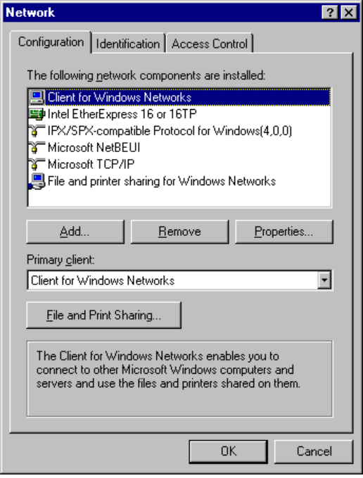
2. Click the Add button.
3. In the Select Network Component Type dialog box, select the kind of component to be installed, and then click the Add button.
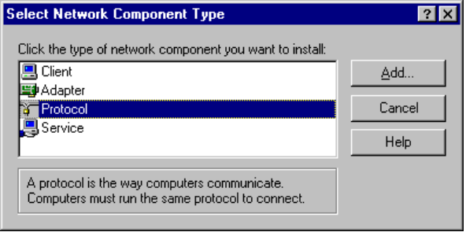
Component | Description
Client | Select to install client software for the various types of networks to which the computer is connected. You can use either a 32-bit network client, which needs no real-mode components, or older real-mode networking clients. There is no limit to the number of 32-bit network clients you can install, but you can have only one real-mode network client installed at a time. Some networks are supported only as primary networks. For more information, see Chapter 12, “”Windows 95 on Other Networks.”
Adapter | Select to install drivers for the network adapter cards in the computer. You can select the type of driver to use (enhanced-mode NDIS, real-mode NDIS, or ODI), specify the resources the cards you are using (such as I/O, IRQ, and transceiver type), and define other options for the card. For more information, see “Network Adapter Cards and Windows 95” later in this chapter.
Protocol | Select to install network protocols and set related options. For more information, see the topics for the related protocols later in this chapter.
Service | Select to specify the types of peer file and printer sharing services you want to run and to install other types of network services, such as backup agents, additional print services, Remote Registry, and Network Monitor.

4. In the Select dialog box, select the name of the component manufacturer in the Manufacturers list, and then select the specific component in the Models list. Then click OK.

Some components are static and require that you shut down and restart the computer after installing that component. For details, see the procedures for configuring that component in related sections of this chapter. Windows 95 requires that you define a workgroup and computer name for each networked computer, independent of the type of networking software you use. This information is required if you install networking software during Windows 95 Setup. You can also change the computer name or workgroup after Setup is complete.
To specify the computer name, workgroup, and description for a computer
1. In Network Control Panel, click the Identification tab.
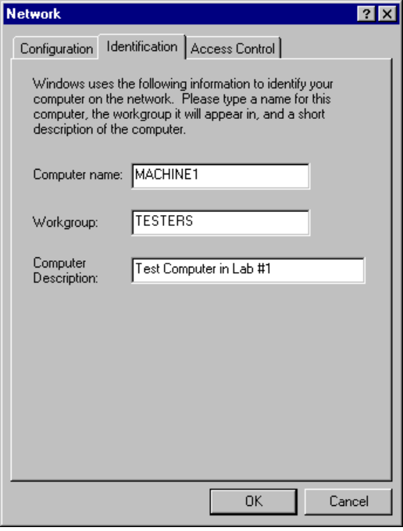
2. Type values for the computer identification settings as follows:
Computer Name | The name must be unique on the network. It can be up to 15 characters long, with no blank spaces. The computer name can contain only alphanumeric characters, plus the following special characters:  ! @ # $ % ^ & ( ) - _ ' { } . ~
Workgroup name | The name does not need to be unique, but it uses the same naming conventions as the computer name. For information about using WKGRP.INI to set administrative guidelines for specifying the workgroup to select, see Chapter 5, “Windows 95 Custom and Push Installations.”
Description | Information entered in this box is displayed as a comment next to the computer name, when users are browsing the network.

You only need to configure security if you are running Client for NetWare Networks, Client for Windows Networks, remote access, or the Remote Registry service. For information about settings on the Access Control tab, see Chapter 13, “Security.”

Plug and Play Networking Overview
Windows 95 supports dynamic loading and unloading of Plug and Play-compliant network adapter cards and drivers. For example, a PCMCIA network adapter card can be removed while the computer is running. In this case, the network adapter driver is unloaded if there are no other adapters of the same type in use, and other parts of the system receive a warning when they try to access the removed adapter. The user gets a message after the configuration has changed. Remote files will not be available, and cached information and connections to client-server applications will be lost. For information about using and configuring PCMCIA cards, see Chapter 15, “Devices.”
To be provided: details about Plug and Play for networking components.

The NDIS 3.1 specification for protocol drivers also supports adding and removing network adapters dynamically while the system is running. However, NDIS 3.1 does not support network adapter drivers changing their resource usage while the system is running, nor does it allow drivers to choose resources at startup time. The NDIS 3.1 specification also does not address how the network client, for example, deals with adding and removing adapters dynamically. For more information, see “NDIS Protocol Overview” later in this chapter.
Note

NDIS Protocol Overview
Windows 95 supports the Network Device Interface Specification (NDIS) 2.x and NDIS 3.1 protocol drivers. This section provides some technical background information about NDIS support in Windows 95.
Windows 95 does not support NDIS 3.0 protocol drivers. The earlier NDIS 3.0 protocol expects to read its configuration during device initialization, but at that point Windows 95 will not necessarily know which network adapters are available and may not have completed resource arbitration for Plug and Play devices. This is why Windows 95 cannot support NDIS 3.0.
Notice, however, that Windows 95 includes an NDIS 3.1 replacement for every 3.0 driver.

NDIS 2.x Protocol Drivers
Windows 95 supports NDIS 2.x protocols. An NDIS 2.x protocol driver must use an NDIS 2.x network adapter card driver. Both protocol drivers and network adapter card drivers must load and bind in real mode before launching Windows 95.
When you run the real-mode network (for example, when using Fail-Safe Startup), the system uses NDIS 2 versions of NetBEUI and IPX/SPX. These protocols are not intended for everyday use since Windows 95 supplies faster protected-mode versions of these protocols. NDIS 2 NetBEUI and real-mode, IPX/SPX-compatible protocols are provided for client computers that start from a floppy disk and run a shared copy of Windows 95 from a server.
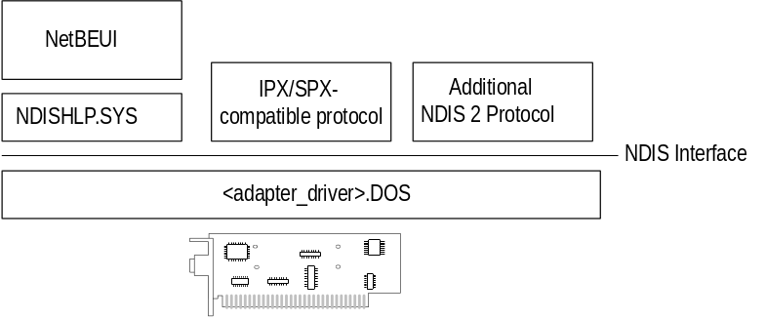
Windows 95 architecture for NDIS 2 protocols

NDIS 3.1 Protocol Drivers
Windows 95 supports a wide range of network media including Ethernet, Token Ring, and ArcNet through the NDIS 3.1 specification. The NDIS 3.1 specification accommodates Plug and Play features, so that network adapters can be added and removed dynamically while the system is running. NDIS 3.1 has enhancements for Windows 95 in two key areas: Plug and Play and a new NDIS mini-driver model.
Plug and Play enhancements to the Protocol Manager and Media Access Control (MAC) layer. These enhancements ensure that the network protocol and network adapter card drivers can be dynamically loaded and unloaded. If a Plug and Play event occurs, such as undocking a laptop computer, the NDIS 3.1 protocols and network adapter card drivers remove themselves from memory automatically. For events such as docking a laptop computer, the NDIS 3.1 protocols and network adapter card drivers are automatically loaded and initialized without user intervention.
With the NDIS 3.1 support for dynamic unloading of network protocols, the system determines which adapters the protocol should bind to. Changes to the NDIS 3.1 interface affect only the protocol drivers, not the network adapter drivers. Although Plug and Play allows device drivers to choose and change their resource usage (such as IRQs and I/O addresses) dynamically, NDIS 3.1 does not support this ability nor does it allow drivers to choose resources at startup time.
New NDIS mini-driver model. The Windows 95 mini-drivers are binary-compatible with Windows NT 3.5 mini-drivers. This means that the driver files from Windows NT 3.5 can be used by Windows 95 without recompiling, as described in Chapter 15, “Devices.”
The mini-driver divides the existing NDIS MAC layer into two halves and implements only the half specific to the network adapter card. These include specific details such establishing communications with the card, turning on and off electrical isolation for Plug and Play, providing media detection, and enabling any value-added features the card may contain. The NDIS wrapper implements the other half of the MAC functionality that remains common to all NDIS drivers. In earlier releases of NDIS, each adapter driver carried all this redundant code, so mini-drivers are faster and are roughly 40 percent smaller than existing NDIS 3.x network adapter card drivers.
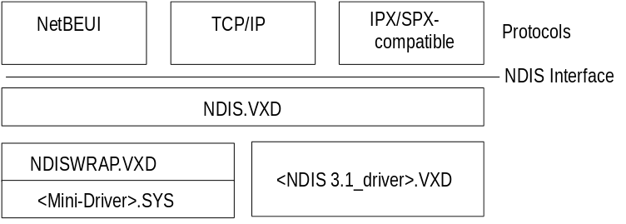
Windows 95 architecture for NDIS 3.1 protocols

Network Adapter Cards and Windows 95
This section provides technical details for the following topics:
- Choosing drivers for network adapter cards
- Configuring network adapter cards
- Setting LAN adapter numbers
- Technical notes on network adapters

For information about configuring Windows 95 with ODI drivers, see Chapter 8, “Windows 95 on NetWare Networks.”

Choosing Drivers for Network Adapter Cards
When setting up Windows 95 for networking, you must choose which types of network adapter card drivers and protocols to use. Because Windows 95 has an open architecture, you have a lot of flexibility in this decision. Windows 95 supports both the Network Driver Interface Specification (NDIS) and Transport Driver Interface (TDI) standards. These standards allow Windows 95 to communicate with many other networking products and make it possible for you to choose from a variety of network adapter cards and protocols for the network.
A network adapter card (sometimes called a network interface card, or NIC) is a hardware card that is installed in a computer so it can function on a network. The network adapter card provides one or more ports for the network cable to physically connect to, and the card physically transmits data from the computer onto the network cable and vice versa.
Every network computer must have a network adapter card driver, a software driver that controls the network card. Each network adapter card driver is specifically configured to run with a certain type of network card.
In addition to the network card and network card driver, a network computer
must also have a protocol driver (sometimes called a transport protocol or just a protocol). The protocol driver works between the upper-level network software — such as the workstation and server — and the network adapter card. The protocol packages data that is to be sent on the network in a way that the computer on the receiving end can understand. The process of associating a protocol driver with the network adapter card and establishing a communication channel between the two is called binding.
For two computers to communicate on a network, they must use identical protocols. Sometimes, a computer is configured to use multiple protocols. In this case, two computers need only have one protocol in common to communicate. For example, a server using both NetBEUI and TCP/IP can communicate both with computers using only NetBEUI and with computers using only TCP/IP.
With some networks, each computer’s network adapter card driver and protocol are separate pieces of software. With other networks, a single piece of software called a monolithic protocol stack performs the functions of both the network adapter card driver and the protocol. Microsoft recommends that you choose separate 32-bit protected-mode protocols and drivers rather than monolithic stacks, which can run only in real mode.
Windows 95 includes mapping technology for users who continue to use real-mode NDIS 2.x or ODI network adapter card drivers.

Choosing NDIS Drivers
Windows 95 supports NDIS versions 2.x and 3.1 (as described earlier in this chapter), which lets you use separate protocols and network adapter card drivers. All network adapter card drivers and protocols shipped with Windows 95 conform to NDIS. You can use any combination of one or more protocol drivers that conforms to NDIS along with any network adapter card driver that conforms to NDIS.
It is probable that the computers on your network have different types of network adapter cards and thus require different network adapter card drivers. Because of NDIS, you can use exactly the same protocol driver with each of these workstations and are not required to have a different version of the protocol for each type of network adapter card, as would be required if you were using monolithic protocol stacks.
Also, NDIS allows multiple protocols to use a single network card. Usually, when you use a monolithic protocol with a network adapter card, the protocol monopolizes the network card, preventing you from using other protocols with that card.

Choosing ODI Adapters
The Open Datalink Interface (ODI) specification was defined by Novell and Apple Computer to provide a protocol and a consistent API for communicating with a network adapter driver, and to support the use of multiple protocols by a network adapter driver.
To ensure the most flexibility in Windows 95 for other protocol support along with NetWare integration, Microsoft recommends that you use ODI drivers when running Windows 95 on NetWare networks. Novell also recommends using ODI-based client software rather than monolithic IPX drivers. For information about ODI drivers, see Chapter 8, “Windows 95 on NetWare Networks.”

Configuring Network Adapter Cards
Windows 95 supports up to four network adapter cards in a single computer. (Network adapter cards are also called network interface cards, or NICs.) Windows 95 Setup automatically detects most network adapter cards, installs the appropriate driver for the card, and provides appropriate default settings to configure the card.
With Windows 95, when you install a network adapter card in a computer, installation of the appropriate driver is simple. You use either the Windows 95 Setup program or Network Control Panel, and choose the name of the network adapter card from the list. The network card driver is automatically bound to all NDIS protocols currently running on the computer, and if any protocols are added later, they will also be bound automatically to the network card driver.
If you choose to add a network adapter card manually, Windows 95 displays a list of supported network adapter cards.
To manually add a driver for a network adapter card
1. In Network Control Panel, click the Configuration tab, and then click the Add button. Select Adapter and click the Add button.
2. In the Manufacturers list in the Select Device dialog box, select a network adapter card manufacturer.
3. In the Models list, select the appropriate model, and then click OK.
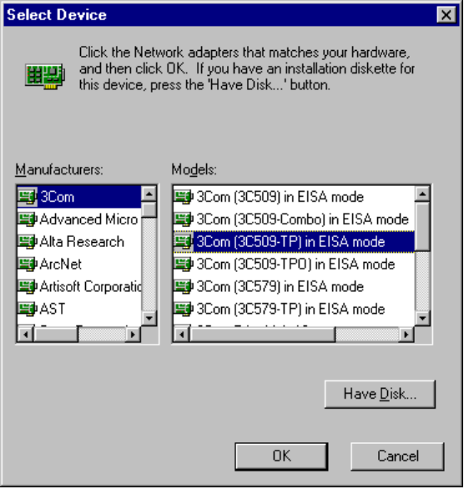
The following procedures show how to configure various properties of a network adapter card driver.
To configure properties for network adapter card drivers
- In Network Control Panel, click the Configuration tab. Then select the driver in the list and click the Properties button.

To specify the network adapter card driver type
1. On the Properties sheet for the selected network adapter card, click the Driver Type tab.
2. Click one of three options (if available for the specific card), as described in the following table.
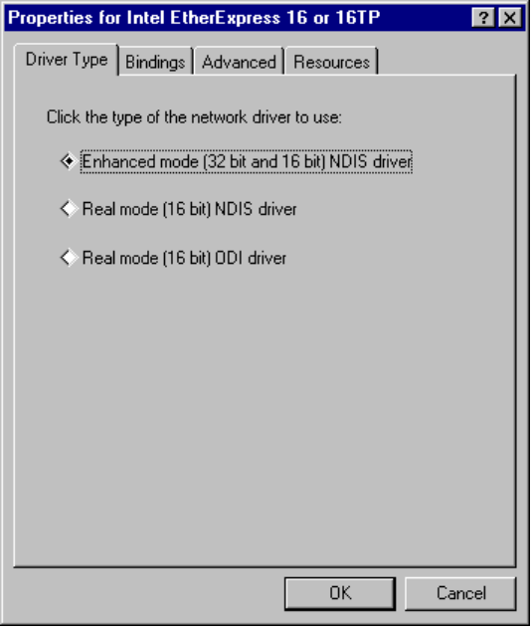
Network card driver type | Description
Enhanced mode (32-bit and 16-bit) NDIS driver | Installs an NDIS 3.1-compliant driver.
Real-mode NDIS driver | Installs an NDIS 2.x-compliant driver.
Real-mode (16-bit) ODI driver | Installs a real-mode driver created to support ODI for Windows 3.1.

For a protocol to communicate with each network adapter card on your computer, the network adapter card driver must be bound to the protocol. The bindings define the relationships between networking software components. Windows 95 automatically binds the appropriate protocols to the network adapter card. You can change the bindings if, for example, you do not want to use a specific protocol with a particular network adapter card.
To configure bindings for protocols
1. On the Properties sheet for the selected network adapter card, click the Bindings tab.
The protocols that are bound to the selected adapter are checked in the list. If a particular protocol does not appear in the list, check that it is correctly installed by returning to the Configuration property sheet and reinstalling it.
2. In the list of protocols, click a protocol so that it is not checked, if you do not want this network adapter card to be bound to the selected protocol.

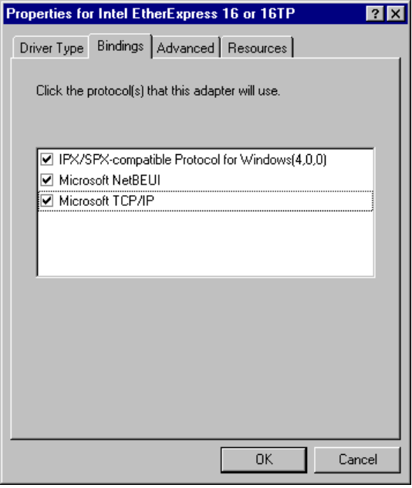
In this example, the IPX/SPX compatible and NetBEUI protocols are bound to the driver for the Intel EtherExpress 16 or 16TP card.
To be provided: introduction to advanced settings for network adapter cards--
what they are, how they can be used, why they should be changed.

The options available on the Advanced property sheet vary, depending on the type of network adapter card.
Note

To specify additional settings for the network adapter card
1. On the Properties sheet for the selected network adapter card, click the Advanced tab.
2. To change these values, select an item in the Property list, and then select the value in the Value box.
3. To accept the new settings (and update the Registry), click the Accept button.
To cancel new settings and return to the original values, click the Reject button.

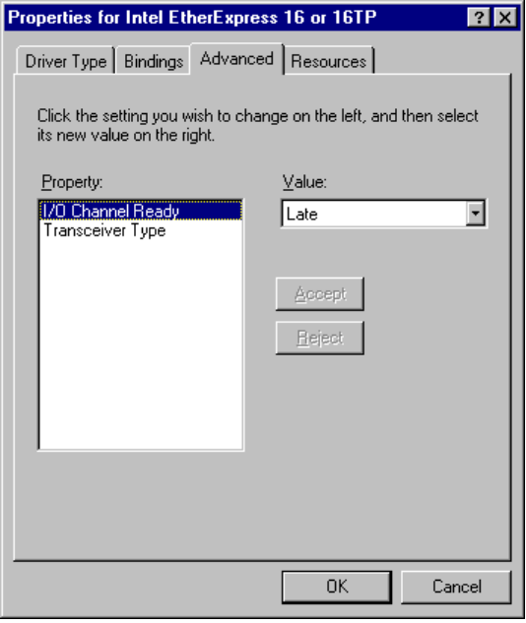
This example shows the advanced options for the Intel® EtherExpress™ 16 or 16TP network card.
The following table explains some typical settings for general types of network adapter cards. For an explanation of the specific settings for your network adapter cards, see the documentation provided by your card manufacturer.
Sample Advanced Settings for Network Adapter Cards
Setting Type | Description
Settings for Token Ring cards: | To be provided.
Settings for Ethernet cards:
Transceiver Type | The transceiver is the device that connects a computer to the network. This value specifies whether it is twisted-pair, thin-net, or thick-net.
I/O Channel Ready | Options: Later, Never, Early.  To be provided.

Windows 95 can determine hardware settings for most network adapter cards. When you install a network adapter card, you should accept the proposed settings unless you are absolutely sure they are incorrect.
Devices cannot share interrupt request (IRQ) settings, memory buffer addresses, or ROM addresses. Where possible, Windows 95 identifies and resolves conflicts. However, if one of the supported devices does not seem to work, the problem may be the particular hardware configuration. Make sure there are no conflicts among network adapters or other peripherals, or between the system board and adapters. Sometimes these settings are set with software, sometimes with jumpers or switches on the hardware (refer to your hardware documentation for specific details). If settings for a network card can be configured through software, you can configure settings using Network Control Panel.
To configure the hardware settings for the network card
1. On the Properties sheet for the selected network adapter card, click the Resources tab.
2. If you are installing a new card and are unsure about the actual settings for this hardware, click the option titled Configure Hardware Settings Later.
– Or –
Click the option titled Use These Hardware Settings, and confirm values for the listed settings.
3. To see and select from the available values for a setting, click the arrow beside the setting’s current value.
- If the displayed value is the current setting, it is preceded by a hash (#) character.
- If the value is preceded by an asterisk (*) character, there is a conflict with another device in the system. You should reconfigure one of the devices.
The possible settings displayed depend on the type of network adapter card. The following table describes typical settings.
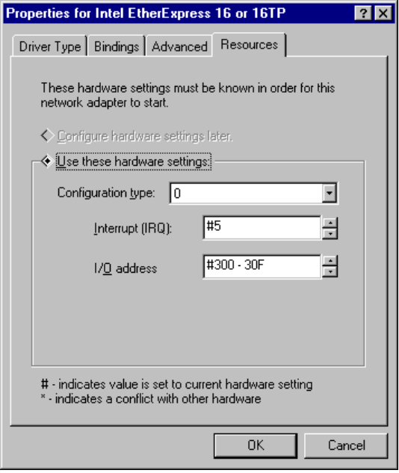
Sample Hardware Settings for Network Adapter Cards
Setting type | Description
Configuration Type | To be provided.
I/O Address Range | The memory address range reserved for the network adapter card to use for temporary storage of input and output data.
Interrupt (IRQ) | Specifies the hardware line over which the device can send interrupts (requests for service) to the computer’s microprocessor.

Setting LAN Adapter Numbers
Each combination of a NetBIOS network protocol and a network adapter forms a logical network over which computers can communicate with each other. For example, a computer can have a token ring adapter and an Ethernet adapter, and might use NetBEUI on the token-ring network and both NetBEUI and TCP/IP on the Ethernet network. In this case, the computer is connected to three logical networks, each of which is assigned a NetBIOS LAN adapter (LANA) number that Windows 95 uses to communicate with them.
When a computer uses multiple protocols, the computer transmits data first using one protocol, then again using the next protocol, and so on. When you install multiple protocols on a computer, you designate the order in which the computer will use them. The first protocol in this series is sometimes called the primary protocol.
On a computer running Windows 95, each binding of a protocol to a network adapter card has a LAN adapter number assigned to it. (For example, one protocol bound to two network cards requires two LAN adapter numbers; two protocols each bound to two cards requires four LAN adapter numbers.) When you install Windows 95 on a computer and when you install additional protocols or network adapter cards, Windows 95 automatically assigns LAN adapter numbers to protocol/network adapter card bindings. You need to change these LAN adapter numbers only if you have a NetBIOS application that specifies that it must use a certain LAN adapter number.
In Windows 95, LANA numbers are assigned dynamically, beginning with 7 and working downward. This accommodates dynamic Plug and Play events such as removing a network adapter while the computer is running. If you are running Windows 95 in such a dynamic environment, Windows 95 cannot guarantee that a given protocol will receive the same LANA number each time the system is started, although, if the computer’s network hardware never changes, the LANA numbers may not change at each startup. Also, the default protocol is always LANA 0.
A protocol can be used simultaneously on more than one network adapter. LANA numbers are assigned in sequence of binding order for the protocols. Some NetBIOS applications require a network protocol to be available on LANA 0.
To select a default protocol for LANA settings
1. In Network Control Panel, click the Configuration tab.
2. Select the protocol you want to be the default, and click the Properties button.
3. Click the Advanced tab.
4. Click the option named Set This Protocol To Be The Default Protocol so that the check box is checked.
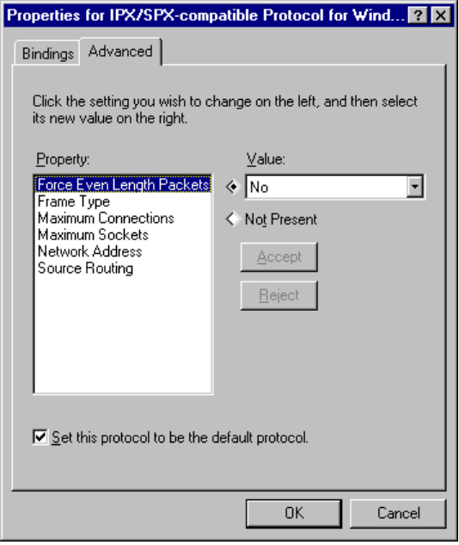
5. Click OK, and then click OK on the Network properties sheet. Then restart the computer.

Some applications may need to know the LANA number. For example, Lotus Notes® requires that you enter the LANA number that Lotus Notes will use. To configure Windows 95 to use Lotus Notes, set the NetBIOS-based protocol on which you want to run Lotus Notes as the default protocol. This could be NetBEUI, IPX/SPX-compatible, or TCP/IP with NetBIOS support.
Note

Technical Notes on Network Adapter Cards
This section provides some technical notes for specific network adapter cards and briefly describes changes to network adapter card driver support from support under Windows for Workgroups 3.11.

Using Windows 3.x .INF Files for Network Card Drivers
As described earlier in “NDIS Protocol Overview,” NDIS 3.0 network card drivers that worked with Windows for Workgroups 3.11 do not work under Windows 95 without changes. You must use an NDIS 2.x real-mode driver, an ODI driver, or an updated NDIS 3.1 protected-mode driver for your network card, plus a Windows 95 .INF file. There are many real-mode drivers, updated protected-mode drivers, and supporting .INF files included with Windows 95.
If you have an .INF file created for an earlier version of Windows to describe a network adapter card driver, you can use that .INF file by clicking the Have Disk button in the Add dialog box for installing network adapter card drivers.
The major reason that the .INF file format has changed for all types of Windows 95 network card drivers is that .INF files are now used to add information to the Windows 95 Registry. The .INF files created for earlier versions of Windows do not contain this kind of information. For information about .INF files for network adapter card drivers, see Appendix C, “Windows 95 .INF Files.”

Configuring the IBM 4/16 Token Ring Adapter
To set the I/O address of IBM® 4/16 Token Ring adapter card, select either primary or secondary in the Advanced property page for the adapter. The I/O settings on the Resource page are ignored.

Changing 3Com Etherlink III Settings
Changing 3Com® Etherlink III® (3c509) settings in Network Control Panel does not change adapter settings. The Network Control Panel does not reprogram the Etherlink III adapter.
To change 3Com Etherlink III adapter settings
1. Use the 3Com configuration disk that came with your adapter to reprogram it.
2. Write down the settings made so that you can refer to them in the following step.
3. In Network Control Panel, change the settings to the ones you noted.
4. Restart the computer.

Configuring DEC Network Adapters
Users of DEC network adapters should verify the detected configuration in the Network Options box in Windows 95 Setup by clicking the Advanced tab in Network Control Panel. If the detected IRQ or I/O ports are not correct, set them manually in Network Control Panel.

Setting Transceiver Settings
The transceiver setting specifies whether the network media is twisted-pair, thin-net, or thick-net. You should only have to change such settings if you change the network adapter card connection, for example, from twisted-pair to thin-net.
To set the transceiver setting for those network adapters that support it
1. In Network Control Panel, click the Configuration tab, and then double-click the network adapter entry to display its properties sheets.
2. Click the Advanced tab.
3. In the Properties list, select the transceiver setting, and in the Value box, select the proper setting for your transceiver.
4. Click OK on this property sheet, and click OK in Network Control Panel.
5. Restart the computer.

Choosing the Protocols to Use
Windows 95 is based on the NDIS architecture and can support multiple network protocols simultaneously as described earlier in “NDIS Protocol Overview.” Protocol software can be shared among the network providers that are installed. The protected-mode protocols included with Windows 95 are the Microsoft implementation of the IPX/SPX-compatible protocol, Microsoft TCP/IP, and NetBEUI, which are all separate virtual device drivers (VxDs). The real-mode protocols included with Windows 95 are IPX/SPX-compatible and NetBEUI. Technical details about each of the three protocols are provided in the following sections.
The protocols provided with Windows 95 (sometimes called protocol stacks) can be shared among the installed networks. For example, a single implementation of the IPX/SPX-compatible protocol can serve the needs of both the Client for Windows Networks and Client for NetWare Networks.
All protected-mode protocols provided with Windows 95 are Plug and Play-compliant. This means that if the network is unavailable, either due to an undocking procedure or the removal of a PCMCIA network card, the operating system continues to run. The protocol software can unload itself after having notified any dependent applications that the protocol will be unloaded. Conversely, docking or adding a PCMCIA network card will cause the system to dynamically load the protocols.
The following sections discuss uses, advantages, and disadvantages of each protocol provided with Windows 95.

Choosing IPX/SPX-Compatible Protocol
Microsoft provides an NDIS-compliant version of the Internetwork Packet Exchange (IPX/SPX) protocol that is used on Novell NetWare networks. This protocol is compatible with the Novell NetWare IPX/SPX protocol, and it provides 32-bit, protected-mode support for Microsoft Client for NetWare Networks. This protocol appears as IPX/SPX-Compatible Protocol For Windows in the Network Control Panel.
The IPX/SPX-compatible protocol is compatible with TDI, and NetBIOS and Windows Sockets. For information, see Chapter 27, “Windows 95 Network Architecture.”
IPX/SPX-Compatible Protocol Advantages and Disadvantages
Advantages | Disadvantages
Provides compatibility with Novell NetWare  Allows a single protocol in mixed NetWare and Windows NT network environments  Routable protocol | Not as fast as NetBEUI on small LANs  More overhead than NetBEUI  Does not support the same level of routability control that TCP/IP does
Recommendations:
- Use on Ethernet if the servers use IPX or NetBIOS over IPX/SPX. For NetBIOS, make sure your routers will forward NetBIOS broadcasts.
- Use on token ring only if the environment requires IPX/SPX to connect to other systems.

Choosing TCP/IP
TCP/IP stands for Transmission Control Protocol/Internet Protocol. It was developed in the late 1970s, resulting from a Defense Advanced Research Projects Agency (DARPA) research project on network interconnection. The major advantages of TCP/IP are that it is a standard, routable protocol, and it is the most complete and accepted protocol available. It provides communication across interconnected networks with different operating systems and hardware architectures, such as UNIX, mainframes, and Microsoft networks.
TCP/IP also provides compatibility with the Internet, the collection of networks and gateways linking together many worldwide universities, corporations, government offices, and military installations. In addition, TCP/IP is required for use of SNMP network management. You can use SNMP to monitor any computer running Windows 95 with Microsoft TCP/IP as either its primary or secondary protocol.
Microsoft TCP/IP supports the Windows Sockets 1.1 interface, a cross-platform client-server framework that is ideal for developing client-server applications that can run with Windows Sockets-compliant stacks from other vendors.
Microsoft TCP/IP uses the NetBIOS interface commonly known as NetBIOS over TCP/IP. Microsoft also includes several TCP/IP utilities for use with Microsoft TCP/IP.
TCP/IP Advantages and Disadvantages
Advantages | Disadvantages
Most widely accepted protocol  Provides connectivity across operating systems and hardware platforms  Provides Internet connectivity  Routable protocol  Windows Sockets 1.1 support  SNMP support | Not as fast as NetBEUI on small LANs  Requires careful planning and management of the IP address space unless DHCP servers are in place on the network
Recommendations:
- Use on Ethernet if:
- The servers use NetBIOS over TCP/IP. Make sure your routers will forward NetBIOS broadcasts.
- UNIX connectivity is needed in the environment.
- Use on token ring only if the environment requires TCP/IP to connect to other systems.

Choosing NetBEUI
NetBIOS extended user interface (NetBEUI) was first introduced by IBM in 1985. It is a small, efficient, and fast protocol.
When NetBEUI was developed in 1985, it was assumed that LANs would be segmented into workgroups of 20 to 200 computers and that gateways would be used to connect one LAN segment to other LAN segments or to a mainframe. NetBEUI is optimized for very high performance when used in departmental LANs or LAN segments. For traffic within a LAN segment, NetBEUI is the fastest of the protocols shipped with Windows 95.
The version of NetBEUI shipping with Windows 95 is NetBEUI 3.0, which includes the following enhancements:
- Eliminates the previous limitation of 254 sessions to a server on one network adapter card.
- Is completely self-tuning.
- Provides much better performance over slow links than did previous versions of NetBEUI.

Strictly speaking, NetBEUI 3.0 is not truly NetBEUI. Instead, it is a NetBIOS Frame (NBF) format protocol. NetBEUI uses the NetBIOS interface as its upper-level interface, but NBF conforms to TDI instead. NBF is completely compatible and interoperable with the NetBEUI shipped with earlier Microsoft networking products, however, and is referred to as NetBEUI in Windows 95.
Because NetBEUI is very fast for small LAN communications but provides poorer performance for wide-area network (WAN) communications, one recommended method for setting up a network is to use both NetBEUI and another protocol, such as TCP/IP, on each computer that may need to access computers across a router or on a WAN.
When you install both protocols on each computer and set NetBEUI as the first protocol to be used, Windows 95 uses NetBEUI for the communication between computers within each LAN segment, and uses TCP/IP for communication across routers and to other parts of your WAN.
NetBEUI Advantages and Disadvantages
Advantages | Disadvantages
Tuned for small LAN communication,  and, therefore, is very fast in that situation  Good error protection  Small memory usage | Not routable  Performance across WANs is poor
Recommendations:
- Use on Ethernet if:
- All computers are in a single subnetwork (all computers connected to a single backbone; no bridges, no routers). No more than 100 computers.
- The networking services are based on LAN Manager or Windows NT. No support for Novell NetWare, LAN Manager for UNIX, or DEC Pathworks.
- Use on token ring if:
- All computers are in a single ring.
- If multiple rings, all rings are connected using “source router” routers.
- The networking services are based on LAN Manager or Windows NT. No support for Novell NetWare, LAN Manager for UNIX, or DEC Pathworks.

Adding a Protocol
The following procedure shows how to add one of the protocols provided by Microsoft. This procedure assumes that Windows 95 has already been installed with networking support, and that you need to add an additional protocol or want to change the protocol used on a particular computer.
For information about choosing and configuring a protocol during Windows 95 Setup, see Chapter 3, “Introduction to Windows 95 Setup.”
To add a network protocol provided by Microsoft
1. In Network Control Panel, click the Configuration tab, and then click the Add button.
2. In the Select Network Component Type dialog box, select Protocol, and then click the Add button.
3. In the Select Device dialog box, select Microsoft in the Manufacturers list. From the Models list, select the protocol you want. Then click OK.
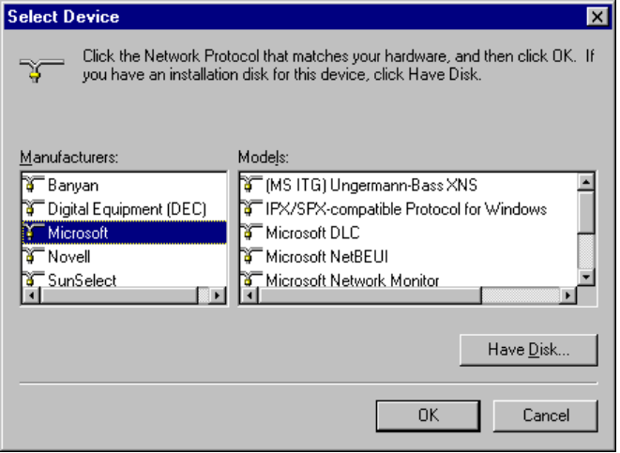

IPX/SPX-Compatible Protocol
Internet Packet Exchange/Sequential Packet Exchange (IPX/SPX) is a small, fast protocol that is routable and best suited for small to medium-sized LANs. IPX/SPX is not well suited for large enterprise networks due to the high number of broadcasts.
The IPX/SPX-compatible protocol for Windows (NWLINK.VXD) is compatible with Novell NetWare IPX/SPX. This protocol is routable and can take advantage of IPX routers.
Microsoft IPX/SPX-compatible protocol supports the 32-bit Windows Sockets programming interface, so that any Win32-based Windows Socket application can run on IPX/SPX with Windows 95. (There are no 16-bit Windows Sockets applications using IPX/SPX, so backward compatibility for 16-bit sockets for IPX/SPX is not an issue.)
IPX/SPX-compatible protocol can be used by Client for NetWare Networks to communicate with NetWare 2.x, 3.x, or 4.x server or a computer running File and Printer Sharing for NetWare Networks. IPX/SPX can also be used by Client for Windows Networks to communicate with computers running Windows for Workgroups 3.11 or Windows NT with IPX/SPX-compatible protocol.

Configuring IPX/SPX-Compatible Protocol
The Microsoft IPX/SPX-compatible protocol is installed if you also install Client for NetWare Networks during Windows 95 Setup. You can also install this protocol to support other network clients, including Microsoft Client for Windows Networks.
To configure the IPX/SPX-compatible protocol
1. On the Configuration sheet in Network Control Panel, select IPX/SPX Compatible Protocol for Windows, and then click the Properties button.
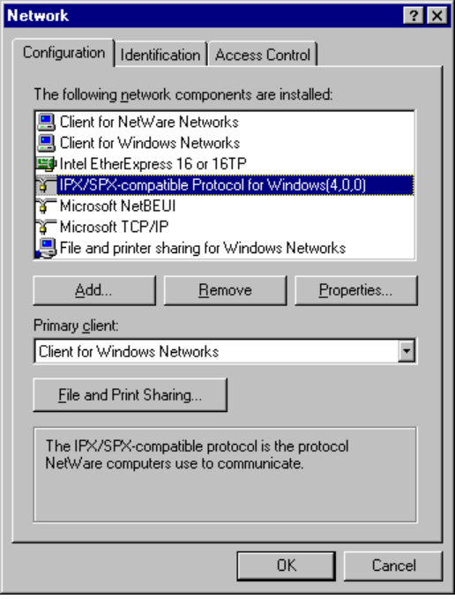

If your computer has multiple network adapter cards, there will be an instance of the IPX/SPX-compatible protocol for each network adapter card. You must configure each card with its own settings.
Note

2. Click the Advanced tab.
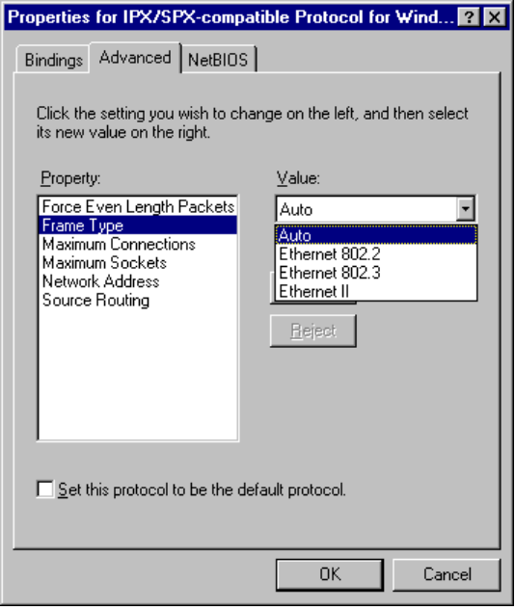
3. Most values have correct defaults in typical installations. If you need to change a value for a particular purpose, select the item in the Property list, and specify a value in the Value list, based on the settings in the following table.

Property | Value
Force even-length IPX packets | Enabled only for Ethernet 802.3 on monolithic implementations that cannot handle odd-length packets.
Frame type | Specifies the frame type based on detection.¹ This value is used for network adapter cards that support multiple frame types. The possible values are:  - Auto-detect (recommended)  - ArcNet  - Ethernet 802.2 (default for NetWare 3.12 and later)  - Ethernet 802.3  - Ethernet_II  - SNAP  Token ring networks do not use this parameter.

Property | Value
Maximum connections | Specifies the maximum number of connections that IPX will allow. Configured dynamically.
Maximum sockets | Specifies the maximum number of IPX sockets that IPX assigns. Configured dynamically.
Network address | Specifies the IPX network address as a four-byte value. Configured dynamically.
Source routing cache size | Specifies the cache size to use when using source routing. This parameter is used only on token ring networks, where it is used to turn on source routing.
¹ Each time you start the computer, Windows 95 detects the frame type by sending a general RIP request in each frame format. Based on the responses received from routers, Windows 95 determines the most prevalent frame type used and sets that as the default frame type for the IPX/SPX-compatible protocol.

You should not need to change binding in most circumstances. However, if your computer is connected to multiple networks and you don’t want to use the server on one network, you can disable the bindings, mostly for security purposes. For example, if the computer is on a local LAN and also connected to the enterprise internetwork, you may not want your peer resource sharing services on the internetwork.
To change bindings for the IPX/SPX-compatible protocol
1. On the properties sheet for IPX/SPX-Compatible Protocol For Windows, click the Bindings tab.
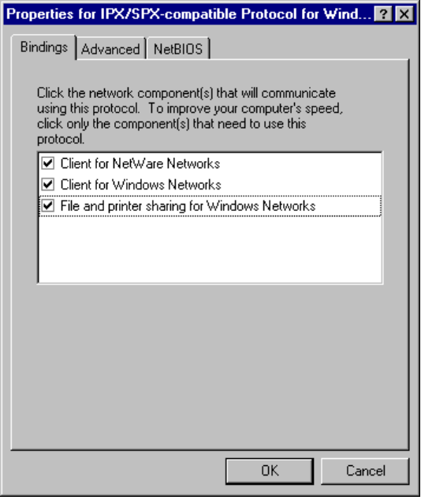
2. Click any network component to change its bindings.
If the option is checked, it is bound to the protocol. If it is not checked, that network component is not using the IPX/SPX-compatible protocol.

Microsoft Client for NetWare Networks is always bound only to the IPX/SPX-Compatible Protocol for Windows. This network client cannot use another protocol.
Note

Using NetBIOS Over IPX
NetBIOS is a high-level interface used by applications to communicate with other NetBIOS-compliant protocols. The NetBIOS interface is responsible for the following:
- Establishing logical names on the network
- Establishing connections (called sessions) between two logical names on the network

Windows 95 provides a 32-bit, protected-mode NetBIOS driver to support NetBIOS services over IPX (NWNBLINK.VDX, which complements NWBLINK). NWNBLink is compatible with the Novell NetBIOS support driver and provides improved performance when using NetBIOS with IPX. Performance enhancements include acknowledgment of previous frames in response frames (called PiggyBackAck), plus a “sliding window” acknowledgment mechanism. These NetBIOS enhancements are used only when communicating with other computers using NWNBLink, such as other computers running Windows 95, Windows NT, or NetWare servers running Lotus Notes.
Novell provides a TSR NetBIOS driver named NETBIOS.EXE, which is a Level 1 NetBIOS provider that consumes about 40K of conventional memory. The Novell NetBIOS driver acknowledges each frame received, thus increasing the amount of traffic generated when NetBIOS is used. With NWNBLink loaded, the real-mode NETBIOS.EXE TSR can be removed from the system.
The following table shows when the IPX/SPX-compatible protocol and when the IPX/SPX-compatible protocol with NetBIOS should be installed.
Feature needed | IPX/SPX-compatible protocol | IPX over NetBIOS
NetBIOS support | — | •
Connectivity to Windows NT 3.5 | • | •
Connectivity to Windows 95 | • | • (for Network DDE)
Network DDE over IPX | — | •

NWNBLink is not necessary for computers running Windows 95 to communicate with each other. The redirector and server networking components in Windows 95 communicate with the IPX protocol directly without NetBIOS. (This is sometimes called direct hosting over IPX.)
NWNBLink is commonly required in these cases:
- When using any NetBIOS applications on a NetWare (or IPX) server, such as Lotus Notes.

The Windows NT 3.5 server service (not the Windows NT Server) supports IPX without NetBIOS. The Windows NT 3.5 workstation service (not the Windows NT Workstation) does not support IPX without NetBIOS. A network client on a computer running Windows 95 that uses IPX without NetBIOS can connect to a Windows NT 3.5 server that uses IPX without NetBIOS. However, the Windows NT 3.5 workstation service cannot connect to a computer running Windows 95 that uses IPX without NetBIOS, while running File and Printer Sharing for Windows Networks.
Note

To use the IPX/SPX-compatible protocol with NetBIOS on a computer
1. In Network Control Panel, click the Add button, select Protocol, and then click the Add button.
2. In the Manufacturers list in the Select dialog box, select Microsoft, and in the Models list, select NetBIOS Support for IPX/SPX-compatible Protocol. Then click OK.
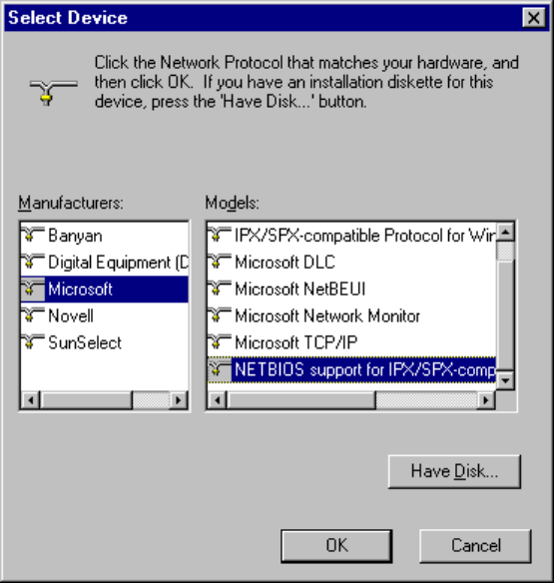

IPX/SPX Technical Issues on NetWare Networks
- There is no need to enable Source Routing on Token Ring networks if the communication is on the same ring, even if one computer has it enabled.
- SPX-II is a protocol definition for windowing and transmitting large packets over SPX. SPX-II is supported under Windows 95 when using a Novell-supplied DLL. An application must call and use this DLL. There is no SPX-II support in the IPX/SPX-compatible protocol.
- The IPX/SPX-compatible protocol in Windows 95 uses NET.CFG parameters for NetBIOS over IPX, if specified in the Registry. However, configuring these parameters should not be necessary because most parameters are dynamic and self-adjusting. If you upgrade to Client for NetWare Networks, the NET.CFG parameters are moved to the Registry. If you upgrade from other implementations of IPX/SPX, the values in NET.CFG and SHELL.CFG are moved to the Registry.
- To determine the network ID (which is the network address in IPX packets), Windows 95 checks the wire for RIP packets and keeps a count of the 10 most-used IPX network IDs and chooses the most likely ID. The network ID is dynamic and will change when a new network ID becomes more prevalent.
- All Transport Layer Interface (TLI) libraries can run on the IPX/SPX-compatible protocol in Windows 95. TLI is similar to TDI in Microsoft networking as a layer between the protocol and network adapter driver; this implementation is similar to STREAMS and provides a STREAMS environment for NetWare, but Windows 95 uses the Windows Sockets specification instead.

TCP/IP Protocol
Transmission Control Protocol/Internet Protocol (TCP/IP) is a networking protocol that provides communication across interconnected networks made up of computers with diverse hardware architectures and various operating systems. TCP/IP can be used to communicate with computers running Windows 95, with devices using other Microsoft networking products, or with non-Microsoft systems, such as UNIX.
The TCP/IP protocol family is a standard set of networking protocols. TCP/IP is used to connect the Internet. These same protocols can be used in private internetworks that connect several local area networks.
The Microsoft implementation of TCP/IP in Windows 95 enables enterprise networking and connectivity on computers running the TCP/IP protocol. Adding TCP/IP to a computer running Windows 95 offers the following advantages:
- A standard, routable enterprise networking protocol that is the most complete and accepted protocol available. All modern operating systems offer TCP/IP support, and most large networks rely on TCP/IP for much of their network traffic.
- A technology for connecting dissimilar systems. Many standard connectivity utilities are available to access and transfer data between dissimilar systems, including File Transfer Protocol (FTP) and Terminal Emulation Protocol (TELNET).
With TCP/IP as a connectivity protocol, computers running Windows 95 can communicate with many non-Microsoft systems, including Internet hosts, Apple® Macintosh® systems, IBM® mainframes, UNIX systems, and Open VMS® systems.
- A robust, scaleable, cross-platform client-server framework. TCP/IP in Windows 95 supports the Windows Sockets 1.1 interface, which is ideal for developing client-server applications that can run Windows Sockets-compliant stacks from other vendors. Many public-domain Internet tools also use the Windows Sockets standard.
- Client for Dynamic Host Configuration Protocol (DHCP), for dynamic resolution of IP addresses to host names on networks that have DHCP servers, which are Windows NT Server computers that maintain the DHCP database.
- Client for Windows Internet Name Resolution (WINS), for dynamic resolution of IP addresses to computers names on networks that have WINS servers, which are Windows NT Server computers that maintain the WINS database.
- Point-to-Point protocol for asynchronous communication, as described in Chapter 24, “Remote Access.”

Microsoft TCP/IP provides all the following elements necessary to implement these protocols for networking:
- Core TCP/IP protocols, including the Transmission Control Protocol (TCP), Internet Protocol (IP), User Datagram Protocol (UDP), Address Resolution Protocol (ARP), and Internet Control Message Protocol (ICMP). This suite of Internet protocols provides a set of standards for how computers communicate and how networks are interconnected.
- Support for application interfaces, including Windows Sockets for network programming and NetBIOS for establishing logical names and sessions on the network.
- Basic TCP/IP connectivity applications, including ftp and telnet. With these utilities, users can interact with and use resources on non-Microsoft hosts, such as UNIX workstations.
- TCP/IP diagnostic tools, including arp, ipconfig, nbtstat, netstat, ping, route, and tracert. These utilities can be used to detect and resolve TCP/IP networking problems.

For a summary of the command-line options for TCP/IP utilities, see Appendix A, “Command-Line Commands Summary.”

You cannot use Microsoft TCP/IP on a computer where a NetWare network client is the only installed client. You must install an additional client such as Microsoft Client for Windows Networks if you want to use Microsoft TCP/IP.
Note

Configuring TCP/IP Settings Manually
If you cannot use DHCP for automatic configuration, the network administrator must provide these values so that individual users can configure TCP/IP manually:
- The IP address and subnet mask for each network adapter card installed on the computer. For more information, see “IP Address Overview for TCP/IP Networks” later in this chapter.
- The IP address for the default gateways (IP routers).
- Whether the computer will use Domain Name System (DNS) and, if so, the IP addresses of the DNS servers on the internetwork.
- WINS server addresses, if WINS servers are available on your network.

The following procedure describes the basic configuration options for TCP/IP.
To configure the TCP/IP protocol manually
1. In Network Control Panel, click the Configuration tab.
2. Select Microsoft TCP/IP, and then click the Properties button.

If your computer has multiple network adapter cards, there will be an instance of TCP/IP for each network adapter card. You must configure each card with its own TCP/IP settings.
Note

3. On the Microsoft TCP/IP properties sheet, click the IP Address tab.
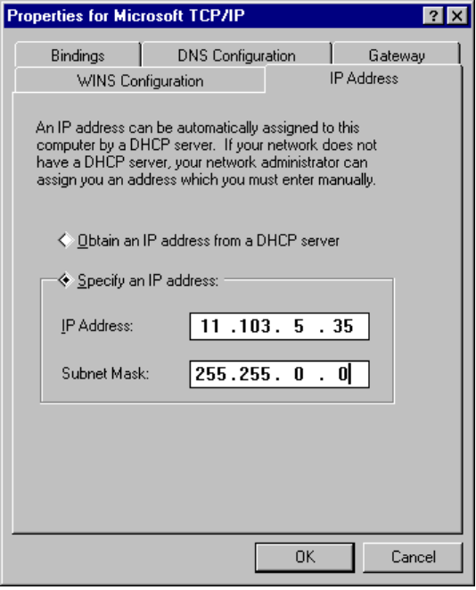
4. Type an IP address and subnet mask in the respective boxes.
The network administrator must provide these values for individual users, based on the network ID and the host ID plan for your site.
- The value in the IP Address box identifies the IP address for the local computer or, if more than one network card is installed in the computer, for the network adapter card selected in the Adapter box.
- The value in the Subnet Mask box identifies the network membership for the selected network adapter and its host ID. This allows the computer to separate the IP address into host and network IDs. The subnet mask defaults to an appropriate value, as shown in the following list:
Address class | Range of first octet  in IP address | Subnet mask
Class A | 1–126 | 255.0.0.0
Class B | 128–191 | 255.255.0.0
Class C | 192–223 | 255.255.255.0

5. To view or specify which network clients (redirectors) are bound to the TCP/IP protocol, click the Bindings tab.
- To keep a network client from using the TCP/IP protocol, click the client to remove the selection.
- If the network client for which you want to use TCP/IP does not appear in this list, that client is not bound to the TCP/IP protocol.
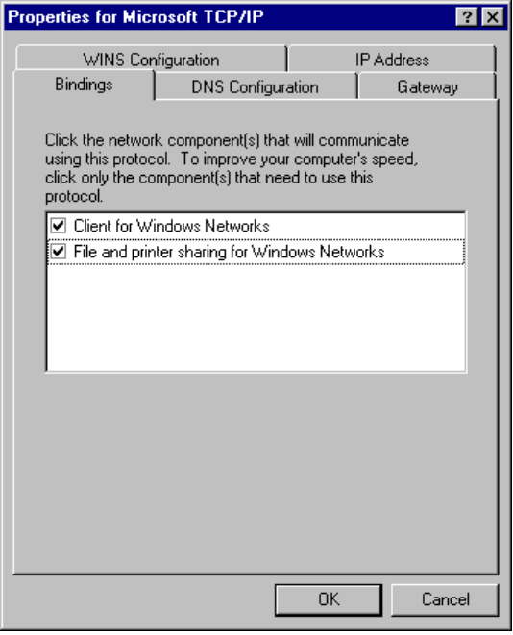

The only network client provided with Windows 95 that can use Microsoft TCP/IP is the Client for Windows Networks. Client for NetWare Networks does not use Microsoft TCP/IP.
Note
NetWare/IP from Novell allows the NCP request to be sent over an IP header. Windows 95 supports NetWare/IP, through the Novell-provided, real-mode client.

6. Click the Gateway tab, and then type at least one IP address for the default gateway (IP router) on the network.
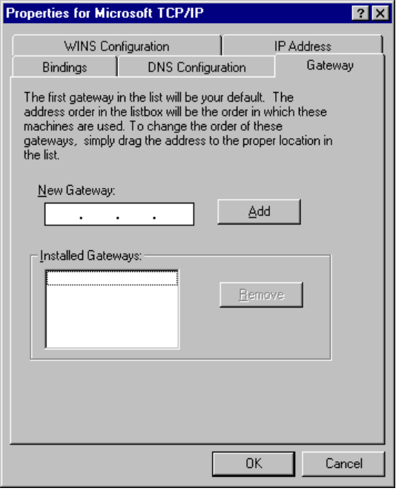
7. To specify an IP address for an additional gateway, type the IP address in the New Gateway box, and then click on the Add button.
Up to 7 additional gateways can be specified to facilitate a connection to a computer that is not reachable through the default gateway. Windows 95 will attempt to connect to a remote computer using the default gateway, and then each additional gateway specified. Additional gateways also provide fault management in case the default gateway becomes inoperable.
The first gateway in the list is the default gateway. Gateway addresses can be prioritized by dragging the IP address in the list of Installed Gateways.
8. Click OK, and then restart the computer for changes to take effect.

Using Host Files for Name Resolution with TCP/IP
For computers located on subnetworks where WINS is not used, the HOSTS and LMHOSTS files provide mappings for names to IP addresses. These are the name resolution method used on internetworks before DNS and WINS were developed.
- The HOSTS file is used as a local DNS equivalent to resolve host names to IP addresses.
- The LMHOSTS file is used as a local WINS equivalent to resolve NetBIOS computer names to IP addresses.

Each of these files is also known as a host table. Sample versions of LMHOSTS (called LMHOSTS.SAM) and HOSTS files are added to the Windows directory when you install Windows 95 with TCP/IP support. These files can be edited using any ASCII editor, such as WordPad or Edit.

IP Address Overview for TCP/IP Networks
A host is any device attached to the network that uses TCP/IP. To receive and deliver packets successfully between hosts, TCP/IP relies on three pieces of information: IP address, subnet mask, and default gateway. The network administrator provides this information for configuring TCP/IP on a computer. This section provides details about IP addresses and subnet masks.
Every host interface, or node, on a TCP/IP network is identified by a unique IP address. This address is used to identify a host on a network; it also specifies routing information in an internetwork. The IP address identifies a computer as a 32-bit address that is unique across a TCP/IP network. An address is usually represented in dotted decimal notation, which depicts each octet (eight bits, or one byte) of an IP address as its decimal value and separates each octet with a period. An IP address looks like this:
102.54.94.97

Because IP addresses identify nodes on an interconnected network, each host on the internetwork must be assigned a unique IP address, valid for its particular network.
Important

Network ID and Host ID
Although an IP address is a single value, it contains two pieces of information: the network ID and the host (or system) ID for your computer.
- The network ID identifies a group of computers and other devices that are all located on the same logical network, which are separated or interconnected by routers. In internetworks (networks formed by a collection of local area networks), there is a unique network ID for each network.
- The host ID identifies your computer within a particular network ID. (A host is any device that is attached to the network and uses TCP/IP.)

Networks that connect to the public Internet must obtain an official network ID from the InterNIC to guarantee IP network ID uniqueness. The InterNIC can be contacted by electronic mail at info@internic.net (for the United States, 1–800–444–4345 or, for Canada and overseas, 619–455–4600). Internet registration requests can be sent to hostmaster@internic.net. You can also use FTP to connect to is.internic.net, then log on as anonymous, and change to the /INFOSOURCE/FAQ directory.
After receiving a network ID, the local network administrator must assign unique host IDs for computers within the local network. Although private networks not connected to the Internet can choose to use their own network identifiers, obtaining a valid network ID from InterNIC allows a private network to connect to the Internet in the future without reassigning addresses.
The Internet community has defined address classes to accommodate networks of varying sizes. Each network class can be discerned from the first octet of its IP address. The following table summarizes the relationship between the first octet of a given address and its network ID and host ID fields. It also identifies the total number of network IDs and host IDs for each address class that participates in the Internet addressing scheme. This sample uses w.x.y.z to designate the bytes of the IP address.
IP Address Classes
Class | w values1,2 | Network ID | Host ID | Available networks | Available hosts per net
A | 1–126 | w | x.y.z | 126 | 16,777,214
B | 128–191 | w.x | y.z | 16,384 | 65,534
C | 192–223 | w.x.y | z | 2,097,151 | 254
1 Inclusive range for the first octet in the IP address.
2 The address 127 is reserved for loopback testing and interprocess communication on the local computer; it is not a valid network address. Addresses 224 and above are reserved for special protocols (IGMP multicast and others), and cannot be used as host addresses.

A network host uses the network ID and host ID to determine which packets it should receive or ignore and to determine the scope of its transmissions (only nodes with the same network ID accept each other’s IP-level broadcasts).
Because the sender’s IP address is included in every outgoing IP packet, it is useful for the receiving computer system to derive the originating network ID and host ID from the IP address field. This is done by using subnet masks, as described in the following section.

Subnet Masks
Subnet masks are 32-bit values that allow the recipient of IP packets to distinguish the network ID portion of the IP address from the host ID. Like an IP address, the value of a subnet mask is frequently represented in dotted decimal notation. Subnet masks are determined by assigning 1s to bits that belong to the network ID and 0s to bits that belong to the host ID. Once the bits are in place, the 32-bit value is converted to dotted decimal notation, as shown in the following table.
Default Subnet Masks for Standard IP Address Classes
Address class | Bits for subnet mask | Subnet mask
Class A | 11111111 00000000 00000000 00000000 | 255.0.0.0
Class B | 11111111 11111111 00000000 00000000 | 255.255.0.0
Class C | 11111111 11111111 11111111 00000000 | 255.255.255.0

The result allows TCP/IP to determine the host and network IDs of the local computer. For example, when the IP address is 102.54.94.97 and the subnet mask is 255.255.0.0, the network ID is 102.54 and the host ID is 94.97.
Although configuring a host with a subnet mask might seem redundant after examining the previous tables (since the class of a host is easily determined), subnet masks are also used to further segment an assigned network ID among several local networks.
For example, suppose that a network is assigned the Class-B network address 144.100. This is one of over 16,000 Class-B addresses capable of serving more than 65,000 nodes. However, the worldwide corporate network to which this ID is assigned is composed of 12 international LANs with 75 to 100 nodes each. Instead of applying for 11 more network IDs, it is better to use subnetting to make more effective use of the assigned ID 144.100. The third octet of the IP address can be used as a subnet ID, to define the subnet mask 255.255.255.0. This splits the Class-B address into 254 subnets: 144.100.1 through 144.100.254, each of which can have 254 nodes. (Host IDs 0 and 255 should not be assigned to a computer; they are used as broadcast addresses, which are typically recognized by all computers.) Any 12 of these network addresses could be assigned to the international LANs in this example. Within each LAN, each computer is assigned a unique host ID, and they all have the subnet mask 255.255.255.0.
The preceding example demonstrates a simple (and common) subnet scheme for Class-B addresses. Sometimes it is necessary to segment only portions of an octet, using only a few bits to specify subnet IDs (such as when subnets exceed 256 nodes). Each user should check with the local network administrator to determine the network’s subnet policy and the correct subnet mask. For all systems on the local network, the subnet mask must be the same for that network ID.

All computers on a logical network must use the same subnet mask and network ID; otherwise, addressing and routing problems can occur.
Important

NetBEUI Protocol
Windows 95 provides the NetBIOS extended user interface (NetBEUI) protocol for compatibility with existing networks that use NetBEUI, including Windows for Workgroups, Windows NT, LAN Manager, Microsoft Workgroup Add-On for MS-DOS®, and other networks. NetBEUI is a small, efficient protocol designed for small networks of 20 to 200 computers, and is non-routable. It is ideal for large I/O requirements such as copying files from network servers or launching applications from network servers. For enterprise-wide networks that require a routable protocol, TCP/IP or the IPX/SPX-compatible protocol should be used.
NetBEUI in Windows 95 supports a NetBIOS programming interface, conforms to the IBM NetBEUI specifications, and includes performance enhancements related to NetBIOS 3.0.
To manually configure NetBEUI
1. In Network Control Panel, click the Configuration tab. Then select Microsoft NetBEUI and click the Properties button.
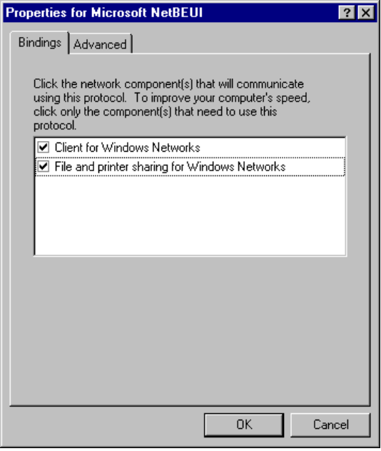

If your computer has multiple network adapter cards, there will be an instance of NetBEUI for each network adapter card. You must configure each card with its own settings.
Note

2. The Bindings tab shows which clients and services are currently using the NetBEUI protocol.
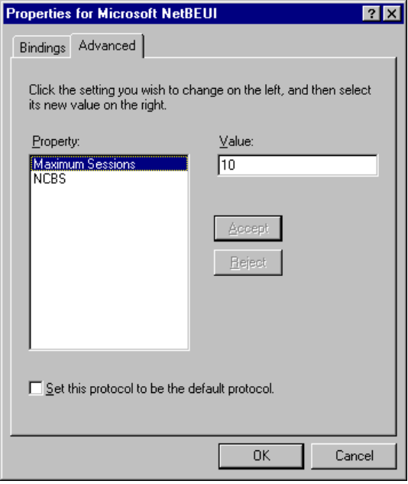
3. The Advanced tab is for modifying Maximum Sessions and NCBs for the real-mode NetBEUI. (The real-mode network runs, for example, when you use Fail Safe Startup.)
Option | Description
Maximum Sessions | Used to identify the maximum number of connections to remote computers that can be supported from the redirector. Equivalent to the sessions= parameter formerly specified in PROTOCOL.INI.
NCBS (network control blocks) | Used to identify the maximum number of NetBIOS commands that can be used. Equivalent to the ncbs= parameter formerly specified in PROTOCOL.INI,

Protected-mode NetBEUI dynamically sets Maximum Sessions and NCBs, and therefore does not use these settings.
4. Click OK to accept and confirm changes, and then restart the computer.

Troubleshooting Network Problems
This section provides troubleshooting tips organized under these general topics:
- Troubleshooting overview for network
- Troubleshooting for upgrading protocols from earlier versions
- Troubleshooting NetBEUI
- Troubleshooting the IPX/SPX-compatible protocol
- Troubleshooting TCP/IP

Troubleshooting Overview for Networks
This section provides basic troubleshooting steps to follow if the network doesn’t work or if you cannot see network resources.

Network doesn’t work upon Windows 95 system startup.
1. Did the network work before installing Windows 95?
No: Reinstall network software, verify that it is working on your system, and reinstall Windows 95.
2. Has any network cable been moved or added?
- Check the cable. Temporarily replace the network cable and retest. For Ethernet, connect only one other computer, terminate both ends, and retest.
- Check that the network connections are live (a malfunctioning network connection will prevent network operations). To check if the network jacks are live, look at the status lights on the back of the network card. If the status lights show activity, the network connection is live. If there is no activity on the status lights, disconnect and reconnect the network cable, and check again for activity such as blinking lights.
- Check terminators.
3. Have any protocols been added or removed?
- Check protocol settings and bindings in Network Control Panel. If the protocol isn’t bound to the adapter, networking functionality is not available.
- Check compatibility of the protocol with the network.
4. Are network adapter card settings appropriate for the card?
You can view the settings for the adapter in Network Control Panel. Check these against the documentation from your adapter manufacturer.
5. Was the other network previously installed and working?
6. How does the system work when you use Fail-Safe Startup with networking (F6)?
- Restart the computer and press F6 when the Starting Windows message appears. When Windows 95 finishes loading, check network functionality.
- Establish a diagnostic server to check basic networking functionality, as described in “Diagnosing Network Hardware Problems” later in this section.
- Check whether the real-mode network client works.
- If the network operates correctly in real mode, try reinstalling the protected-mode drivers by selecting all components in Network Control Panel and clicking the Remove button. Then click the Add button, and reinstall all components.

The following shows procedures for these troubleshooting steps.
To check whether the real-mode network client works
1. Restart the computer, and use F8 — Interactive Start .
2. Do not run WIN.COM
3. At the real-mode command-line prompt, type:
net start full

To use the real-mode network client to test protocol functionality
1. Set up a diagnostic server by running net diag on another computer and selecting the Diagnostic Server option. For more information, see “Diagnosing Network Hardware Problems” later in this seciton.
2. On the problem computer, load the real-mode client by typing the following:
net start full

3. Run net diag to identify the installed protocols.
Use net diag /? to see a list of the command-line switches.
4. Select the protocol you want to test

Other real-mode network operations for troubleshooting are summarized in the following list.
Command | Comment
net /status | Displays network information
net /name | Requires NetBIOS
net stop /y | Stops network, but retains real-mode drivers. Run Windows to verify it runs with real-mode network drivers.
net view | Displays connections.

Cannot see any computers after configuring network components.
The network transceiver or connector may be set incorrectly. Check your network hardware documentation, and ensure that the physical connection is correct.
Make sure the network card is configured correctly. If there is nothing connected to the port that Windows 95 is using, the computer thinks the network just isn’t very active.

Cannot connect to other network resources
1. If domains, workgroups, and workstations do not appear in the Network Neighborhood, try connecting to the server or workstation.
2. If you cannot connect to the server or workstation, check the following:
- Check error message details if available.
- Verify that you can connect to any server or workstation.
- Verify that you can connect to the server or workstation from other systems. If you cannot connect to the server or workstation from other systems, it probably indicates a problem with the server or workstation or the cabling or routing to it.
3. If you cannot connect to any server or workstation, check the following:
- Check workgroup assignment.
- Check domain assignment.
- Check domain rights.
- Check basic network operations.

Others cannot connect to my network resources.
Check that sharing is enabled in Network Control Panel by selecting the File and Printer Sharing service, and clicking the Properties button. Verify that there are check marks in the boxes for the following options:
- I want to be able to give others access to my files.
- I want to be able to allow others to print to my printers.

If a check mark is missing, Windows 95 will not allow sharing of that resource.

Diagnosing Network Hardware Problems
Network hardware problems are commonly caused by improperly terminated network adapter cards, incorrect or non functional cabling, improper settings for the network adapter card, or faulty network adapter cards.

If you are upgrading from a previous version of Windows 3.x or Windows for Workgroups with a properly functioning network card, it is unlikely that you will find the network card itself to be faulty.
Note

Generally, it’s best to first rule out the possibility that you have hardware problems by running a network diagnostic tool to ensure that the computer can see the network and can be seen by other computers on the network.
To run Microsoft Network Diagnostics
1. From within an MS-DOS session (or from outside Windows 95 if you are testing the real-mode network), type net diag at the command prompt.
– Or –
To establish a diagnostic server with Fail-Safe Startup, restart the system. When the Starting Windows message appears, press Shift+F6. At the command-line prompt, type net diags
The Microsoft Network Diagnostics identifies the types of protocols that are currently installed. If you have both an IPX and a NetBIOS provider, you can choose which protocol to use. Select the protocol that is common to all computers to be involved in the diagnostics.
Microsoft Network Diagnostics then tries to detect a diagnostic server on the network. If you have not already started a diagnostic server, you can specify the local computer as the diagnostic server with which other computers can try to communicate.

If you already started a diagnostic server and this server is not detected, you may have a hardware problem.
Note

The first computer on which you run Microsoft Network Diagnostics becomes the diagnostic server with which the other computers on your network will attempt to communicate.
2. Run Microsoft Network Diagnostics on another workstation.
This workstation will exchange information with the diagnostic server and will display messages about any problems on its screen.

Troubleshooting Network Software Problems
To troubleshoot software-related problems
1. Check Network Control Panel to make sure the correct components are installed. This includes the client, network drivers, and protocols.
2. If the installed components appear to be correct, check the properties for each of the installed components. Items to check include logical network IDs, frame types, transceiver settings, and so on.
3. If all the settings appear to be correct and you know you do not have a hardware problem, see if there is another computer with the same configuration that can access the network properly. Check to see if any settings for that computer are different from those for the problem computer.

Troubleshooting Specific Networking Problems
To be provided: Overview and additional specific issues.

Changing network settings in SYSTEM.INI does not affect configuration.
The settings in the [network] and [network drivers] sections of SYSTEM.INI are not used in Windows 95. However, Windows 95 Setup does not delete these settings. Changing these settings does not affect the configuration of Windows 95. Use the Network Control Panel to change values.

A Sony proprietary CD-ROM that worked with Windows for Workgroups doesn’t work with the same settings under Windows 95.
The Sony CD-ROM can only use INT 5. The default interrupt Windows for Workgroups Setup would pick was 5 for many cards. But, the driver was real mode, so the CD-ROM and the network card were able to share the interrupt (but there are other tradeoffs when this is done).
Under Windows 95, this won’t work any longer. This is due to the new network driver that runs in protected mode and the underlying interrupt architecture changes. Microsoft cautions against sharing interrupts under Windows 95.

Troubleshooting for Upgrading Protocols from Earlier Versions
This section provides some specific troubleshooting tips related to updating networking components from earlier versions of Windows networking.

The error Net0111 occurs after upgrading from Windows for Workgroups with TCP/IP
The network still functions, but Windows 95 Network Control Panel does not remove the old version of TCP/IP.
To remove the old version of TCP/IP
- Remove the following lines from AUTOEXEC.BAT:
tcptsr
tinyrfc
nmtsr.exe
emsbrf.exe
sockets.exe
USER=C:\machine
INIT=C:\machine

Windows 95 Setup does not preserve the default protocol when migrating from Windows for Workgroups.
Windows 95 Setup sets the IPX/SPX-compatible protocol to be the default protocol.
To change the default protocol
1. In Network Control Panel, click the Configuration tab.
2. Select the protocol you want to be the default, and click the Properties button.
3. Click the Advanced tab, then click the option named Set This Protocol To Be The Default Protocol, so that the check box is checked.
4. Click OK, and then click OK on the Network properties sheet. Then restart the computer.

Troubleshooting NetBEUI
To be provided.
- Check bindings
- Going across a router
- Timeout errors

Troubleshooting IPX/SPX-Compatible Protocol
To be provided.

Troubleshooting TCP/IP
The following diagnostic utilities included with Microsoft TCP/IP can be used to find solutions to TCP/IP networking problems.
Utility | Usage
arp | View the Address Resolution Protocol (ARP) table on the local computer to detect invalid entries.
ipconfig | Display current TCP/IP network configuration values and update or release TCP/IP network configuration values.
nbtstat | Check the state of current NetBIOS over TCP/IP connections, update the LMHOSTS cache, and determine the registered name and scope ID.
netstat | Display protocol statistics and the state of current TCP/IP connections.
ping | Verify that TCP/IP is configured correctly and that a remote TCP/IP system is available.
tracert | Check the route to a remote system.

For information about the utilities included with Microsoft TCP/IP, including the syntax and description of the TCP/IP commands, see Appendix A, “Command-Line Commands Summary.”

Troubleshooting IP Connections
You can use the PING utility to isolate network hardware problems and incompatible configurations, by verifying a physical connection to a remote computer. Use the PING utility to test both the host name and the IP address of the host.
To test TCP/IP using PING
1. If the computer was configured using DHCP, use ipconfig to find the IP address.
2. Check the loopback address by typing ping 127.0.0.1 and pressing ENTER at the command prompt. The computer should respond immediately.
3. To determine whether you configured IP properly, use ping with the IP address of your computer, your default gateway, and a remote host.

If you cannot use ping successfully at any point, verify the following:
- The computer was restarted after TCP/IP was installed and configured.
- The local computer’s IP address is valid and appears correctly in the TCP/IP Configuration dialog box.
- The IP address of the default gateway and remote host are correct.
- IP routing is enabled on the router and the link between routers is operational.

If you can use ping to connect to other computers running Microsoft TCP/IP on a different subnet but cannot connect through Network Neighborhood or with net use \\server\share, verify the following:
- The correct computer name was used.
- The target host uses NetBIOS. If not, you must use FTP or Telnet to make a connection; in this case, the target host must be configured with the FTP server daemon or Telnet daemon, and you must have correct permissions on the target host.
- The scope ID on the target host is the same as the local computer.
- A router path exists between your computer and the target computer.
- The computer is configured to use WINS, the WINS server addresses are correct, and WINS servers are functioning.

Troubleshooting TCP/IP Database Files
The following UNIX-style database files are stored in the Windows directory when you install Windows 95.
Filename | Use
HOSTS | Provides host name-to-IP address resolution for Windows Sockets applications
LMHOSTS.SAM | Provides NetBIOS name-to-IP address resolution for Windows networking
NETWORKS | Provides network name-to-network ID resolution for TCP/IP management
SERVICES | Provides service name-to-port ID resolution for Windows Sockets applications

To troubleshoot any of these files on a local computer
- Make sure the format of entries in each file matches the format defined in the sample file originally installed with Microsoft TCP/IP.
- Check for spelling or capitalization errors.
- Check for invalid IP addresses and identifiers.

Troubleshooting TCP/IP Interconnectivity Problems
To be provided: troubleshooting for interconnectivity configuration issues:
- Invalid subnet mask
- Invalid gateway (router) address
- Invalid scope ID
- Problems with DCHP, WINS, and DNS servers
- Access to UNIX resources

