Chapter 1
Windows 95 features a new, 32-bit communications subsystem that provides higher throughput, better reliability, and greater device independence for communications operations than Windows 3.1. The new communications subsystem serves as the underlying architecture on which Windows 95 provides communication services for supporting remote network access, Microsoft At Work fax services, access to on-line information services, and remote access to mail.
Modems and Communication Tools
This chapter describes the features in Windows 95 that offer improved communications capabilities over Windows 3.1. It also describes how to install and use modems with Windows 95, and how you can use HyperTerminal and Phone Dialer tools for online communication.

Improved Communications in Windows 95 18-3
In This Chapter
Communications Architecture 18-4
Setting Up a Modem 18-8
Defining Your Location 18-9
Modem Registry Keys 18-13
Using HyperTerminal 18-14
Using Phone Dialer 18-16
Using Dial Helper 18-18
Troubleshooting Modem and Dial-out Problems 18-26

Chapter 21, “Microsoft Exchange and Mail,” for information about using the Microsoft Exchange application to send and receive electronic mail and faxes, and to access information services
See Also
Chapter 22, “At Work Fax” e
Chapter 23, “Internet Access” for information about using Windows 95 to access the Internet
Chapter 24, “Remote Access” for information about Windows 95 features that allow you to access the network from a remote location

Improved Communications in Windows 95
Windows 95 improves on the Windows 3.1 architecture for supporting communications applications and supports high-speed communications. Windows 95 also replaces the monolithic communications driver architecture with a modular driver model to allow third parties and communications device manufacturers to easily plug in new communications device drivers.
Changes made in the kernel and communications architecture in Windows 95 provide improvements and benefits to the Windows 3.1 user including:
High-speed reliability. Windows 95 supports reliable high-speed communications by keeping up with data coming in from the communications port, thus resulting in no lost characters due to interrupt latency. In addition, the use of a 32-bit protected mode file system and network architecture results in less impact on the communications system by reducing required mode transitions and interrupt latency.
Higher data throughput. The 32-bit communications subsystem leverages the preemptive multitasking architecture of Windows 95 to provide better responsiveness to communications applications, thus supporting higher data throughput. Communications transfers in 32-bit applications are not as affected by other tasks running in the system as Win16–based applications under Windows 3.1.
Support for time-critical protocols. The Windows 95 communications architecture provides support for time-critical protocols and allows for real-time serial device control.
Plug and Play support for communications devices. Plug and Play support simplifies installation and configuration. Windows 95 also provides support for existing hardware by including mechanisms for detecting legacy modems. The new communications architecture supports more robust communications devices beyond base RS-232 devices (for example, ISDN).
Device sharing among communications applications. Through the use of the Telephony API (TAPI), Windows 95 provides consistent device-independent access to control communication devices for operations such as dialing and answering incoming calls. Arbitration for sharing communication ports and devices is also handled through TAPI. For example, while Windows 95 remote access services is waiting for an incoming call, a TAPI-aware fax communications application can send an outgoing fax without having to first terminate the already running communications application.

Communications Architecture
Windows 95 supports higher sustained communications throughput through improvements to the operating system kernel. The amount of code in the kernel that can only be used by one process at a time (critical sections) was reduced, thus reducing interrupt latency in the core system. In addition, 32-bit protected-mode components in the file system and network subsystem also improve system responsiveness. Windows 95 is limited in baud rate only by the hardware characteristics of the computer, such as the processor speed and type of communications port.
The communications subsystem manages communications resources. A communications resource is a physical or logical device that provides a single asynchronous data stream. Serial ports, parallel ports, fax machines, and modems are examples of communications resources.
The central communications component in Windows 95 is the virtual communications driver, VCOMM. This driver manages all access to communications resources. VCOMM provides protected-mode services that enable Windows-based applications and device drivers to use ports and modems. To conserve system resources, communications device drivers are loaded into memory only when in use by applications. Also, VCOMM uses the new Windows 95 Plug and Play services to assist with configuration and installation of communications devices.
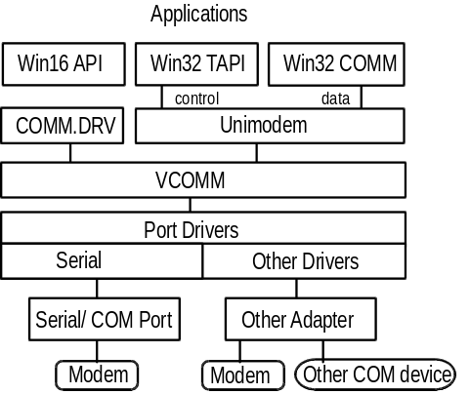

Windows Telephony

Another key component called Windows Telephony API (TAPI) provides a programmatic interface for applications and service providers that manage phone systems. Telephony is a technology that integrates computers with the telephone network. With Windows Telephony, the implementation of TAPI in Windows 95, people can use the capabilities of their computers to take advantage of a wide range of sophisticated communications features over a telephone line, such as conference calls, call waiting, and voice mail. Windows Telephony supports both speech and data transmission, and allows for a variety of devices.
Windows Telephony includes two interfaces — an application programming interface (API) and a service provider interface (SPI), as illustrated here.
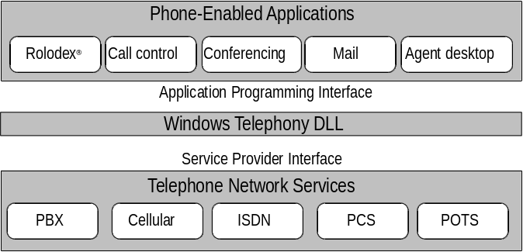
The Windows Telephony API provides a standard way for communication applications to control telephony functions for data, fax, and voice calls. This includes such basic functions as establishing, answering, and ending a call. It also includes supplementary functions, such as hold, transfer, conference and call-park found in PBXs and other phone systems. The API also provides access to features that are specific to certain service providers, with built-in extensibility to accommodate future telephony features and networks as they become available.
Through the use of the TAPI services, applications that support communication services have a device-independent means for interacting with communications devices. TAPI also provides a common access mechanism for requesting the use of communication ports and communication devices, thus providing a means for communications-based applications to share a single modem (voice, fax, or data) in the computer.
Windows 95 includes TAPI support in the base operating system, thus allowing application developers to leverage this functionality in their Windows 95-aware applications. In addition, all communication components included as part of Windows 95 are TAPI clients.
Through the TAPI interface, communications applications can ask for access to the modem or telephone device, allowing the Windows 95 communications subsystem to arbitrate device contention and allowing applications to share a communications device in a cooperative manner.
Win32–based applications can use TAPI functionality so that applications can make outgoing calls, while others are waiting for inbound calls. For example, while a remote network access service configured for auto-answer mode is waiting for an incoming call, a Win32–based communications application can call the TAPI services to request the use of the modem and initiate an outgoing call. Of course, only one call can be performed at a time, but users no longer have to end other applications that are using a communications port in order to run a different communication. The TAPI services arbitrate requests to share communication ports and devices.

Communications Drivers
Windows 3.1 uses a monolithic communications driver, COMM.DRV, that provides an API for Windows–based applications to interact with communications devices and the code that serves as the communications port driver. The monolithic approach made it necessary to completely replace the Windows communication driver if new functionality was required by a hardware device.
Windows 95 has a modular device driver model which includes a universal modem driver called Unimodem and mini-drivers. Unimodem communicates with the other Windows 95 architectural components and the mini-driver. It includes instructions used by all modem drivers. The mini-driver contains only those instructions needed for the specific device.
Unimodem is both a VCOMM device driver and a TAPI service provider. This driver supports data transmission by modem and implements several basic telephony functions to work with IBM® PC/AT®-command modems. Other service providers (for example, those supporting other devices, such as an ISDN card, a telephone on a PBX system, or a non-IBM PC/AT-command modem) can also be used with TAPI. It translates TAPI function calls into AT commands to configure, dial, and answer modems.
For each Unimodem session, Windows 95 creates a MODEMLOG.TXT file. This file describes the progress of the session and can be used as a troubleshooting tool.

File Transfer Protocols and Terminal Emulation Types
Windows 95 supports six file transfer protocols. The following table explains the main differences between each protocol.
Protocol | Description
Xmodem | The most common error-correcting data communications protocol. Most communications packages support (and some only support) XMODEM. This protocol is also supported by most online services. Xmodem is slower than other protocols (for example, Zmodem).
1K Xmodem | A variant of traditional Xmodem, which sends data in 1K (1024 byte) blocks instead of 128 byte blocks. On some bulletin boards, this protocol is sometimes called Ymodem.
Ymodem | A faster version of Xmodem, transferring data in 1K blocks.
Ymodem-G | A variant of Ymodem designed for use with modems that support hardware error control. If you cannot transfer files using Ymodem-G, your modem may not support error control. Use Ymodem instead.
Zmodem | The fastest data transfer protocol, and the primary choice of most bulletin board users. Zmodem dynamically changes its block size based on line conditions, and is extremely reliable.
Kermit | An extremely flexible protocol, found most often on DEC VAX computers, IBM mainframes, and other minicomputers. However, Kermit is quite slow, and should not be used if faster options are available on the other computer.

Windows 95 supports the following terminal emulation types:
- ANSI | - Viewdata (for the United Kingdom)
- Minitel (for France) | - VT 100™
- TTY | - VT 52

Setting Up a Modem
After you install Windows 95, you can install a new modem in one of two ways:
- By using the Modems Control Panel.
- By using a communications program such as Phone Dialer or HyperTerminal before you install a modem. Windows 95 will prompt you automatically to install a modem at that time.

To install a new modem through the Modems Control Panel
1. From the Start button, choose Settings, then click Control Panel.
2. From the Control Panel, double-click the Modems icon.
If no modem is currently installed on your computer, the Modem Wizard starts automatically to lead you through the steps to install your modem. Follow the online instructions.
– Or –
- If you are installing a second modem, click Add to start the Modem Wizard.

In most cases, it’s best to let the Modem Wizard try to detect your modem for you. If the manufacturer and model cannot be detected exactly, the Modem Wizard tries to pick the best generic type (for example, “14400 bps modem”).
To select a better match for your modem than one proposed by the Modem Wizard, or if no match is found, follow these guidelines:
- A comparable model name by the same manufacturer will usually work; for example, a Practical PM9600FX modem will probably work properly, even if specified as a Practical PM9600HC II.
- OEM modems supplied by PC manufacturers are often compatible with Hayes®, Microcom®, or US Robotics modems. The manual for your modem may indicate compatible models.
- Try one of the Hayes-compatible types listed for the Hayes manufacturer.
- Try one of the basic types listed for the “Generic” manufacturer.

Defining Your Location
The first time you set up a modem, you’ll be prompted for information about your location. Applications and tools that use the modem to dial out, such as HyperTerminal and Phone Dialer, will use this information when you dial out.
In the Location Information dialog box, specify your country, area code, and number you dial for an outside line. Also specify whether you are using a pulse or tone telephone.
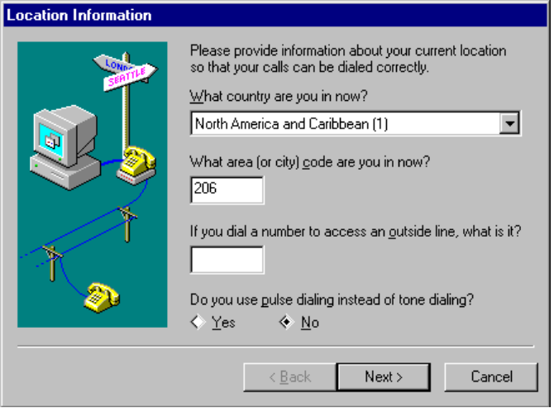

Setting Modem Properties
You can use the Modems Control Panel to change default modem settings globally for all Windows 95 communication tools and applications. For example, if you do not want to listen to the modem speaker no matter which tool or application you use with the modem, turn off the feature using Modems Control Panel.
To view current properties for a modem
1. From the Modems Control Panel, click the modem you want to configure.
2. Click Properties to see its current configuration settings.

General Property Settings
Use the General property sheet to specify the port, speaker volume, and maximum baud rate.
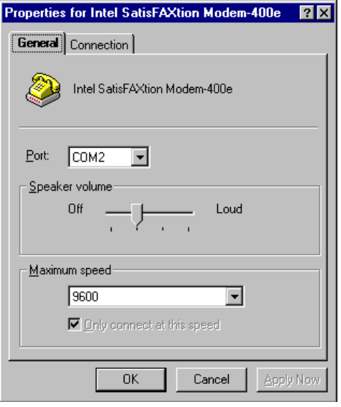
Field | Comments
Port | This field cannot be changed if you are using a PCMCIA modem using a Windows 95 Sockets driver.
Maximum Speed | This is the baud rate at which Windows 95 communicates with the modem. Windows 95 picks a conservative default speed, so that slower computers don’t lose data during transfers. Users with 80486 or better computers may be able to raise the speed for better performance. For example, 57600 may work better than the Windows 95 default setting of 38400 for v.32bis (14400 bps) modems on fast computers. If applications report transmission errors, then stepping down the modem’s maximum speed (for example, from 38400 to 19200 for v.32bis modems) might work better.  Set this speed higher for faster performance. Set it lower if your computer is too slow and if the faster rate causes data errors.

Connection Property Settings
You can use the Connection property sheet to specify settings for data bits, parity, and stop bits. You can also define calling preferences from this property sheet.
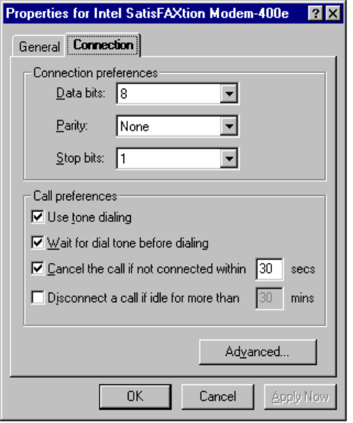
Field | Comments
Connection Preferences | Usually it’s best not to change connection settings using the Modems Control Panel. Rather, it’s often better to use a specific tool or application, such as HyperTerminal, to change these settings on a connection by connection basis. Connection settings must correspond to what the computer on the other end is using.
Use Tone Dialing | Clear this field if you are using a local phone line or system that doesn’t support touch tone.
Wait for Dial... | Clear this if you are making transcontinental calls, and your modem interprets a foreign dial tone as no dial tone.
Cancel the Call... | Change the number of seconds listed in this field if, for some reason, connections are taking a long time to make; for example, when you are calling transcontinentally and there are long delays before the call is connected.

Click the Advanced button to display a dialog box from which you can set error control, flow control, and modulation, and audit the modem operations.
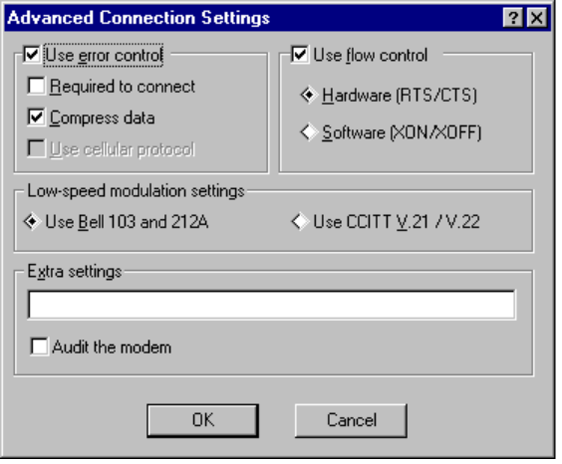

The Extra Settings field is intended only for debugging purposes, and should only be used by experienced modem users.
Caution

Field | Comments
Use Error Control  Compress Data | These two features, available on most modems, boost transmission speeds by eliminating errors caused by noise on the telephone line and by compressing data between the modems. When these features are enabled, modems sometimes have trouble connecting. If this is true for your situation, clear these two check boxes.
Required To Connect | Using modem compression can sometimes reduce performance if data being sent is already compressed by the application.  If you don’t ever want your modem to connect with another modem unless there is error control enabled on a call, check Required To Connect.
Use Cellular Protocol | Check this when you want your modem to use special protocols designed to reduce errors over cellular connections. Clear this if you are making a call on a normal non-cellular telephone line.

Field | Comments
Use Flow Control | 9600 baud and higher modems should use flow control for faster performance. Whether to use hardware or software flow control depends on your modem cable. If your modem cable has RTS/CTS wires connected, you can use hardware flow control.
Low-speed Modulation Settings | In the U.S., 300 and 1200 baud connections are usually made using Bell modulations 103 and 212A. In Europe, CCITT V.21 / V.22 is usually used. If you are having problems to a 300 or 1200 baud modem when making an intercontinental call, try setting CCITT instead of Bell.
Extra Settings | Use this field to type modem commands that Windows 95 will include in its INIT string and send to the modem before dialing. Do not include the “AT” prefix in this box .
Audit the Modem | When checked, a MODEMLOG.TXT file is created in your Windows directory. This can help debug problems connecting your modem.

Modem Registry Keys
There are two registry keys for each modem installed in the Modems Control Panel — a hardware key and a software key.
The hardware key is created by the modem’s bus enumerator. Non-Plug and Play modems are enumerated by the Modems Control Panel. Plug and Play modems are enumerated by the appropriate bus enumerator, for example, ISA, PCMCIA, PCI, or COM.
The root of a modem’s hardware key is:
Hkey_Local_Machine\Enum\Enumerator\Device ID\Instance ID

The hardware key for a modem will always have the following subkeys:
Class = Modem
FriendlyName = friendly name
Driver=Modem\driver instance

The software key is created by the Modems Control Panel when the modem is installed. The root of a modem’s software key is:
Hkey_Local_Machine\System\CurrentControlSet\Services\Class
\Modem\Driver Instance

Using HyperTerminal
HyperTerminal is a Windows 95 tool that you can use with your modem to dial up remote computers. You can also use HyperTerminal to connect your computer to another terminal, for example, a debugging terminal. This tool is similar to the Windows Terminal tool, but also includes auto-detection of data bits, stop bits, and parity.

How do I configure and use HyperTerminal?
To define a new HyperTerminal connection
1. From the Start button, choose Programs, then Accessories, then click HyperTerminal Connections.
2. Double-click HyperTerminal Connection. The Connection Description dialog box displays.
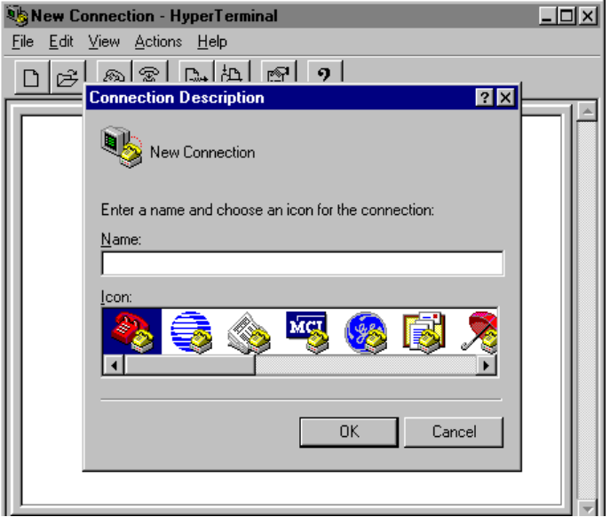
3. Type the name of the connection and select an icon to associate with it. Click OK.
4. The Phone Number dialog box displays next. Specify the area code, phone number, and modem for this connection.
When you start HyperTerminal, if you haven’t previously installed a modem, you will be prompted to do so. (For more information, see “Setting Up a Modem” earlier in this chapter.)
Click OK.
5. When the Dial dialog box displays, click Dial to begin a session.
6. When you close the session (or click Cancel from this dialog box, then end HyperTerminal), you’ll be prompted to save your session definition. Click Yes and you’ll see an icon for your session in the Hyper Terminal window.

To dial up a remote computer using HyperTerminal
1. From the Start button, click Programs, then Accessories, then HyperTerminal Connections. Then double-click the icon of the session you want to use.
2. Click Dial.
When the connection is made, the computer you are dialing will display its own access screen or prompt.
3. When you are done using the connection, from the Action menu, click Hang Up.

To edit HyperTerminal properties for the current session
1. From HyperTerminal, click the File menu, then click Properties.
2. Use the Phone Number property sheet to correct country code, area code, phone number, or modem information. Use the Configure button to update modem settings.
3. Use the Settings property sheet to specify preferences for keyboard functions, emulation, and backscroll buffer.
4. Click OK.

To transfer binary files to another computer using HyperTerminal
1. When the other computer indicates that it is ready to receive the file, click the Actions menu, then click Send File.
2. Specify the filename to send, or click Browse to find the file.
3. Select the protocol to use in transferring the file. Both computers must be using the same protocol. (See the earlier section called “File Transfer Protocols and Terminal Emulation Types” for details about supported protocols.)
4. Click Send to begin the file transfer.

To receive binary files from another computer using HyperTerminal
1. When the other computer indicates that it is ready to send the file, click the Actions menu, then click Receive File.
2. Specify the destination directory for the file, or click Browse to find the appropriate directory.
3. From Use Receiving Protocol, select the protocol to use in transferring the file. Both computers must be using the same protocol. (See the earlier section called “File Transfer Protocols and Terminal Emulation Types” for details about supported protocols.)
4. Click OK to begin the file transfer.

Using Phone Dialer
Through Windows Telephony, Windows 95 combines your computer with one of the most basic business tools — the telephone. Intel Corporation and Microsoft Corporation, in cooperation with many major telecommunications, PC and software companies, have created the Windows Telephony standard for the integration of telephones and personal computers running Microsoft Windows.
By connecting your telephone to your modem’s phone jack and your computer to the modem’s input jack, you can connect your telephone and modem. Then, you can take advantage of the Windows Telephony capabilities in Windows 95.
Phone Dialer is the tool you can use to dial phone numbers for voice telephone calls.
With Phone Dialer, you can dial phone numbers in a number of different ways:
- By clicking a speed-dial phone number
- By typing the number to dial, and then clicking Dial (or pressing Enter or alt+d)
- By clicking the digits on Phone Dialer’s numeric keypad to indicate the phone number you want to dial, and then clicking Dial
- By selecting from a drop-down list of most recently-used numbers

To start Phone Dialer

How do I configure and use Phone Dialer?
- From the Start button, choose Programs, then Accessories, then click Phone Dialer.
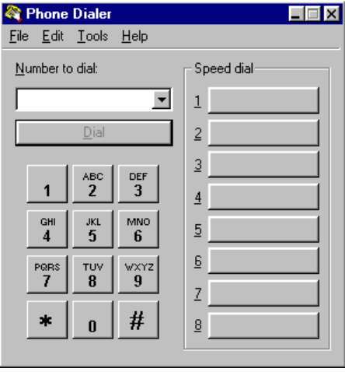

Storing Phone Numbers
When you type a phone number either from your keyboard or using Phone Dialer’s numeric keypad, that number is automatically stored in a list of your most-recently used telephone number. You can also store phone numbers as speed-dial numbers.
You can store local, domestic long distance, or international telephone numbers. Simply type all the digits you need to dial in the Number To Dial text box.

There is no limitation on the number of digits you can type in the Number To Dial text box. Therefore, you can type a local, domestic long distance, or international long distance phone number in this text box. The same is true when you create speed dial numbers.
Important

If you type the area code and local telephone number, Phone Dialer automatically precedes the dialed number with a “1”.
If you type non-numeric characters (such as a hyphen or a parenthesis) in a phone number, Phone Dialer will ignore the non-numeric character. An exception is when you type a plus sign (+) at the beginning of your number, which is international format. If you type a number in international format, you must put parentheses around the area code.
To create a speed-dial phone number
1. Click the button you want to configure as a speed-dial button.
2. Type the name that will appear on the button and the phone number, then click Save.

Dialing Long Distance Without a “1” Prefix
According to the North America Dialing Plan, you must dial a “1”, followed by a three-digit area code, followed by a seven-digit local phone number to make a long distance call. There are a few cases where local phone companies have not followed this rule by allowing you to omit dialing the initial “1”. Thus, the number you dial is 10 digits, not 11.
1. From the Tools menu, click Dial Helper. (For more information about this tool, see the following section.)
2. Verify the area code listed here is correct for your location. (Correct it if necessary.) Click OK.
3. Using any method you prefer for storing phone numbers (see the preceding section), type the phone number as a 10-digit number, omitting the “1” prefix.
The Windows Telephony number translation function will see the local area code in both the location and in the destination number, and assume it should only dial the local number. For example, suppose you are dialing from area code 905 and can dial phone numbers with area code 416 without the “1” prefix. You would store those numbers as “+1 (905) 416xxxxxxx”.

Using Dial Helper
Dial Helper is a utility used with Phone Dialer, HyperTerminal, the Remote Access Wizard, and other Windows 95 tools.
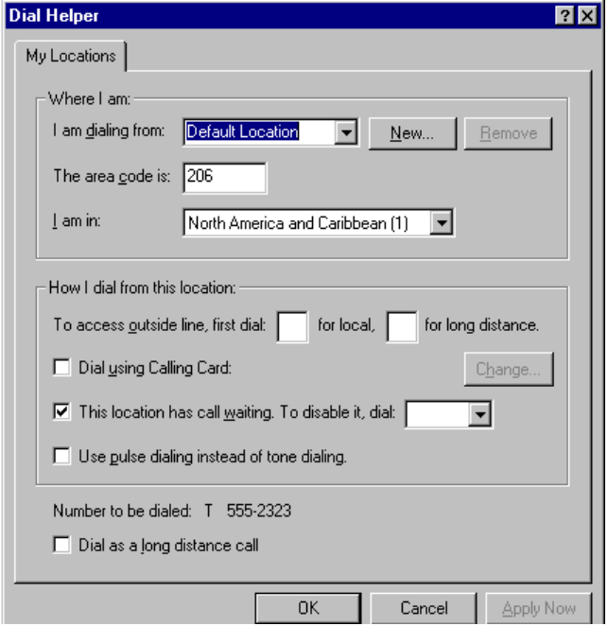
The options you set with Dial Helper are stored in the TELEPHON.INI file (instead of the System Registry) to ensure backward compatibility with older 16-bit Windows TAPI-enabled applications. For information about the content and structure of TELEPHON.INI, see the section called “About TELEPHON.INI” later in this chapter.
With this tool, you can
- Specify the location from which you are calling, or define a new location
- Specify the area code and the country code
- Specify in-house dialing rules
- Define calling card rules

Defining Calling Card Rules
Dial Helper includes several built-in calling card definitions including AT&T®, Sprint, MCI, British Telecom, France Telecom Mercury, Telecom New Zealand, and others.
To specify that you are using a calling card
1. From the Tools menu, click Dial Helper.
2. Check the Dial Using Calling Card check box. The Change Calling Card dialog box appears.
3. Select your calling card type from the list, then type your calling card number.

Dial Helper accepts an area code of more than three digits. This is convenient when countries convert to longer area codes in the near future. For example, the United Kingdom is scheduled to convert to a five-digit area code in the coming year.
Note

You can also customize dialing rules by clicking the Advanced button from the Change Calling Card dialog box. The following two examples illustrate how you might use dialing rules.

Calling Card Example: Redefining the Numbers that Automatically Precede the Phone Number
Suppose you are making a calling-card phone call from outside the United States and do not want Dial Helper to automatically add a “0” prefix to the number you are calling. Instead you want to precede the phone number with another numeric code (such as “144” in the following example).
1. From the Tools menu, click Dial Helper.
2. Check the Dial Using Calling Card check box. The Change Calling Card dialog box appears.
3. Click the New button, then type the name of the calling card. Click OK.
4. Type the card number and click Advanced. The Dialing Rules dialog box displays.
5. Complete the dialing rule fields. Insert a comma to include a fixed two-second pause; use multiple commas to increase the time. Use the following codes as appropriate:
E | Country code | W | Wait for a second dial tone
F | Area code | @ | Wait for a ringing tone followed by five seconds of silence
G | Destination local number | $ | Wait for a calling card prompt tone (if your modem supports it)
H | Calling card number | ? | Display an on-screen prompt to the user to continue dialing

For example, if you are using a British Telecom card and need to precede the number you dial with “144”, complete the fields as follows:
Field | Type
Calls Within the Same Area | 144,H,G
Long Distance Calls | 144,H,0FG
International Calls | 144,H,010EFG

6. Click OK, then click OK again to display the My Locations property sheet.
7. Remove the leading zero from your area code (for example, “71” or “81” in London). Click OK.
8. Using Phone Dialer or HyperTerminal (or other tool), store your destination number with only the country code (44), area code (without the leading 0), and local number.
When you choose the Dial option from Phone Dialer or HyperTerminal, the tool you are using automatically expands this number to include “144” and the card number, plus the pause codes.

Calling Card Example: Omitting the “1” Prefix with a PBX System
Suppose your organization uses a PBX system and you need to omit the “1” prefix before the area code. Create a calling card as follows:
1. From the Tools menu, click Dial Helper.
2. Check the Dial Using Calling Card check box. The Change Calling Card dialog box appears.
3. Select your calling card type from the list, then type your calling card number.
4. Click Advanced. The Dialing Rules dialog box appears.
5. Complete the text boxes as follows:
Field | Type
Calls Within the Same Area | G
Long Distance Calls | FG
International Calls | 011EFG

6. Click OK.

About TELEPHON.INI
TELEPHON.INI is a file maintained in the Windows directory. This file includes the following sections:
- [Providers]
- [ProviderX]
- [HandoffPriorities]
- [Locations]
- [Cards]
- [Countries]

These areas of TELEPHON.INI are described in the following sections.

Providers Section
This section specifies the permanent provider IDs and filenames of installed Telephony service providers. This information is used so that TAPI.DLL can identify and load each provider.
NumProviders=count
Indicates how many service providers are installed.
NextProviderID=nextPPID
Indicates the Permanent Provider ID (PPID) that will be assigned to the next provider to be installed.
ProviderIDx=PPID
One per provider. Assigns a permanent PPID to each Telephony service provider. This ID is used to link parameters in other sections and files to the provider information. These entries may be renumbered as providers are deleted, but the permanent provider IDs are not changed.
ProviderFilenamex=filename
One per provider. Identifies the filename (in \WINDOWS\SYSTEM) of the service provider DLL.

ProviderX Section
For each telephony service provider defined in the [Providers] section, there must be a [ProviderX] section. (X is the PPID for the provider.) In addition to the entries listed below, the service provider can include any other entries in its section which are necessary to fulfill the responsibilities of the provider. This section includes
NumLines=count
The number of lines supported by that provider
NumPhones=count
The number of phones supported by that provider

HandoffPriorities Section
This section specifies the priority of applications to handle incoming calls and call hand-offs of particular media types and for Assisted Telephony requests. This section should not be modified by anyone other than the telephonic application’s developer. Users can set certain application-specific settings shown in this section from within the application (for example, by using the Preferences setting within the application). The following shows the structure of this section:
[HandoffPriorities]
RequestMakeCall=[appname[,appname]...]
RequestMediaCall=[appname[,appname]...]
unknown=[appname[,appname]...]
interactivevoice=[appname[,appname]...]
automatedvoice=[appname[,appname]...]
g3fax=[appname[,appname]...]
g4fax=[appname[,appname]...]
datamodem=[appname[,appname]...]
teletex=[appname[,appname]...]
videotex=[appname[,appname]...]
telex=[appname[,appname]...]
mixed=[appname[,appname]...]
tdd=[appname[,appname]...]
adsi=[appname[,appname]...]
digitaldata=[appname[,appname]...]
NumExtends=count
extendindex=extid0,extid1,extid2,extid3,bit,"friendlyname
[,appname[,appname]...]

Locations Section
This section specifies the locations that are defined by the user via the Location dialog box (seen, for example, when you configure your first modem).
Locations=count, nextID
Indicates how many locations are defined with the count parameter, and the next permanent location ID to be assigned with the nextID parameter.
LocationX=id, "friendlyname", "localprefix", "LDprefix", "areacode", countrycode, preferredcardid, hint, insertareacode, "tollprefixes"
Identifies a location, where X is the PPID for the location. The following variables are included in this entry:
id The location’s permanent ID. Once a permanent ID is assigned to a location, it is never changed.
friendlyname The user-assigned name for the location. It must be enclosed in quotation marks, and must not contain quotation marks.
localprefix The string to be dialed before all local calls (same country, same area code, not in the toll list).
Ldprefix The string to be dialed before all long-distance calls (different country, different area code, or in the toll list).
areacode The area or city code associated with current location.
countrycode The country code associated with the current location. This is linked to an entry in the [Countries] section.
preferredcardid The preferred dialing method which will be preselected when the user requests a dialing operation. This must match an entry in the [Cards] section, if not, it is presumed to be 0 (Direct).
hint The number of the CardX entry which matched preferredcardid at the time this LocationX was last modified.
insertareacode A value of either 0 or 1. 0 indicates that toll calls should not include the area code before the local number; 1 indicates that toll calls should have the area code before the local number. Applicable only when the countrycode is 1 (North America), the country code and area code being dialed are the same as for the current location, and the prefix of the local number appears in tollprefixes.
tollprefixes A list of three digit prefixes, separated by commas, for calls which receive special treatment. If the number being dialed has a prefix which appears in this list and insertareacode=1, then the area code will be dialed before dialing the local number.
CurrentLocation=id, hint
Gives the ID of the location at which the user is presently located. This value should match an id in an existing LocationX entry; if it does not, the current location is assumed to be the default location. The hint parameter indicates the number of the LocationX entry which matched id at the time CurrentLocation was last set.

Cards Section
This section specifies information related to a method of dialing telephone calls. This method, may, or may not, include an associated telephone calling card number (the dialing methods are referred to generically as “calling cards” because use of a calling card is the most frequent reason for using an alternative dialing procedure). The calling card numbers are scrambled to provide security against non-determined, casual observation (for example, someone looking at the TELEPHON.INI file with a text editor); greater security will depend on system-level file or system access security (such as in case a notebook computer is stolen).
Cards=count, nextID
Indicates how many dialing options are defined with the count parameter, and the next permanent card ID to be assigned with the nextID parameter. The values of these parameters are controlled by the Telephony control panel.
CardX=id, “friendlyname”, “scrambledcardnum”, “samearea”, “longdistance”, “international”, hidden
Identifies a card where X is an arbitrary number assigned to the card. These entries may be renumbered as cards are deleted. Card0 cannot be removed or modified by a user; it is a placeholder used to indicate that the direct dialing rules for the country specified in CurrentLocation should be used for dialing. The following variables are included in this entry:
id The permanent ID associated with this card, assigned by the control panel.
friendlyname The user-assigned name of the card. It must be enclosed in quotation marks and cannot contain quotation marks.
scrambledcardnum The card number associate with this entry (if any; it must be for a CardX which actually specifies alternative direct dial rules). The contents are scrambled in order to provide security from accidental viewing.
samearea, longdistance, international Dialing-string templates for the three classes of calls (same are code, different area code but same country, and different country code, respectively). The contents of these strings should be selected from the following list (spaces, hyphens, periods, and parentheses can be included for formatting purposes):
Value | Meaning | Value | Meaning
0-9, A-D | Digits that can be dialed | @ | Wait for quiet answer
# | Dial DTMF “#” | $ | Wait for “bong” tone
* | Dial DTMF “*” | ? | Prompt user before proceeding
T | DTMF dial subsequent digits | E | Insert country code
P | Pulse dial subsequent digits | F | Insert area code
! | Hook flash | G | Insert subscriber number
, | Pause during dialing | H | Insert calling card number
W | Wait for second dial tone | I | Insert area code (area codes are optional; used in country entries only)

hidden
Determines whether or not this entry should be displayed in lists of available dialing methods displayed to the user by applications. Values are as follows:
Value | Meaning
0 | Not hidden. The value can be set by the user.
1 | Not hidden. The value can only be set by an application (it cannot be deleted).
2 | Hidden. The value can be set by the user.
3 | Hidden. The value can only be set by the application (it cannot be deleted).

Countries Section
This section specifies the well-known direct dialing procedures for calls placed within specific countries. The contents in this section should not be edited by the user. The following shows the structure of this section:
[Countries]
Countryindex=countrycode, nextcountry, "name", "samearea", "longdistance", "international"

Troubleshooting Modem and Dial-out Problems

Modem Wizard did not detect my external modem.
1. Check the connections to your computer.
2. Turn the modem off and on again to reset it.
3. Restart Modem Wizard to detect the manufacturer and model.
4. If this fails, ensure that the modem’s port is configured correctly. Use the Device Manager in the System Control Panel to set the address and IRQ for the port.
5. If you are unsure about the correct values for these settings, run the New Device Wizard to let Windows 95 detect and configure the port.

My modem isn’t listed in Modem Wizard.
Try the following to find a compatible model:
1. Specify a comparable model name by the same manufacturer. For example, a Practical PM9600FX modem may work properly when specified as a Practical PM9600HC II.
2. Check the manual for your modem to find a listing of compatible modems, then specify that modem. For example, a modem may be compatible with Hayes, Microcom, or U.S. Robotics modems.
3. Try one of the Hayes-compatible types listed for the Hayes manufacturer.
4. Try one of the basic types listed for the “Generic” manufacturer.

The COM port I want to use doesn’t seem to work.
1. Check that the port is installed in the Device Manager in the System Control Panel. If it is not, install it using the New Device Control Panel.
2. Check that the port’s Input-Output Range and Interrupt Request line are specified correctly in its Resources properties sheet.

I can’t dial out with Phone Dialer.
1. From Phone Dialer, click the Tools menu, then click Dial Helper.
2. Make sure your area code and country code are correct.
3. For each access number you want to use for calling out, specify, at a minimum, the country code, area code, and telephone number.

I can’t dial out with HyperTerminal
If your modem is not set up correctly, TAPI and communications features may not function properly. Try reconfiguring your modem:
1. From the Control Panel, double-click the Modem icon.
2. Verify that the manufacturer and model for your modem is correct. If not, select the appropriate modem from the list and click OK.
If your modem does not appear in the list of installed modems, click Add, then select the appropriate modem. You may want to remove any other modem entries in the list to eliminate any conflicts.
3. If the manufacturer and model are not correct and are not available from the list, try one of these options.
- Hayes-compatible at the maximum baud rate in which their modem should function.
- Generic Modem with the maximum baud rate at which their modem should function.
4. Click OK.
5. From Control Panel, double-click the System icon, then click the Device Manager tab.
6. Select your modem from the list and click Properties. Ensure that the option labeled The Device Is Present, Please Use It is checked.
From the Modem General property sheet, ensure that the port listed is correct. If not, type the correct port. Click OK.
7. Select the port from the list and click Properties. From the Resources property sheet, ensure that the Interrupt Request setting listed is correct. Click Change Setting to update it; otherwise, click OK.

I can’t send or receive binary files using HyperTerminal
1. Make sure that both computers are using the same file transfer protocol (that is, Xmodem, 1K Xmodem, Ymodem, Ymodem-G, Zmodem, or Kermit).
2. If you are using the Ymodem-G file transfer protocol, ensure that your modem supports hardware error control. If it doesn’t, try using Ymodem instead.
3. Most communications packages, bulletin-boards, and online services support Xmodem. If you are trying to use an alternative protocol (such as Zmodem), try Xmodem instead.

