Chapter 1
This chapter introduces basic concepts and requirements for installing Windows 95, and provides a step-by-step guide to using Custom Setup options to install Windows 95 on the local hard disk of a standalone computer.
Introduction to Windows 95 Setup

Guide to Windows 95 Setup Information 3-2
In This Chapter
Windows 95 Setup Overview 3-3
Types of Windows 95 Installations 3-6
Installation Requirements 3-12
Before Installing Windows 95 3-16
Starting Windows 95 Setup 3-17
Windows 95 Setup for Standalone Computers 3-22

Chapter 4, “Server-Based Setup for Windows 95,” for information about setting up network workstations to run a shared copy of Windows 95, and for information about customizing Windows 95 and automating Setup
See Also
Chapter 6, “Setup Technical Issues,” for details about the actions performed by Setup, Smart Recovery, and system startup, and for information about Setup and system files
Chapter 7, “Troubleshooting Setup and System Startup,” for specific tips on troubleshooting problems with Windows 95 Setup
Guide to Windows 95 Setup Information
Sections in this chapter and several other chapters in Part 2, “Installation and Networking,” provide technical details and procedures for customizing and automating Windows 95 Setup for multiple computers, as shown in the following list.
“Installation Requirements” in this chapter
Hardware, operating system, and disk partition requirements for installing Windows 95.
“Types of Windows 95 Installations” in this chapter
Overview of installation types.
“Windows 95 Setup for Standalone Computers” in this chapter
Installing Windows 95 to run on the local hard disk of a single computer.
Chapter 4, “Server-Based Setup for Windows 95”
Preparing for network setup, and installing a shared copy of Windows 95.
Chapter 5, “Windows 95 Custom and Push Installations”
Preparing for automating and customizing Windows 95 Setup.
Chapter 6, “Setup Technical Issues”
Using fail-safe features in Setup, removing Windows 95 from a computer, plus descriptions of Windows 95 Setup and system startup processes and key files.
Chapter 7, “Troubleshooting Setup and System Startup”
Troubleshooting Windows 95 Setup and Windows 95 system startup, plus general troubleshooting guidelines.
Chapter 8, “Windows 95 on NetWare Networks”
Installing Windows 95 on a NetWare network.
Chapter 11, “Network Technical Issues”
Configuring network components for Windows 95.
Chapter 12, “Windows 95 on Other Networks”
Installing Windows 95 on a network from another vendor or with connectivity software.
Appendix B, “Windows 95 System Files”
Windows 95 directory structure and file descriptions.

Windows 95 Setup Overview
This section provides a brief summary of the installation steps in Windows 95 Setup, plus an overview of the new features in Windows 95 Setup.
This information is designed to provide a fundamental description of Setup for administrators who are responsible for installing Windows 95 on many computers. The information provided here, however, will also help individuals who are installing Windows 95 on standalone computers.

In the Windows 95 Resource Kit for NetWare, “standalone computer” refers to a personal computer with Windows 95 system files installed on the local hard disk; such an installation can also include networking software.
Note
The term “shared installation” is used to refer to a computer that runs a shared copy of Windows 95 from a network server, with few or no Windows 95 files installed on the local workstation.

Quick Start for Windows 95 Setup
These are the basic tasks you perform when installing Windows 95 on a computer for the first time:
1. Check the details in “Before Installing Windows 95,” and then start Windows 95 Setup.
How you start Setup depends on whether you are running Setup from floppy disks, a CD-ROM compact disc, or a shared network directory. For details, see “Starting Windows 95 Setup” later in this chapter.
2. Choose the directory where the Windows 95 system files will be installed on the computer, as described in “Gathering Information” later in this chapter.
3. Choose the type of Setup — Typical, Compact, Portable, or Custom. For most users installing Windows 95 on desktop computers, we recommend Typical Setup, which installs all options with default settings. For information, see “Typical, Portable, Compact, or Custom Setup?” later in this chapter.
4. Provide identification information about your user name, computer name, and other identifiers. For details, see “Providing User Information” and “Specifying Computer Identification” later in this chapter.
5. If you choose Custom Setup, you must specify the options you want to install and make other choices about the system components, including networking. For details, see “Selecting Components in Custom Setup,” “Selecting Network Components in Custom Setup,” “Changing Computer Settings in Custom Setup,” and “Selecting Advanced Options in Custom Setup” later in this chapter.
6. Create a startup disk for emergency recovery, as prompted by Windows 95 Setup. For details, see “Creating a Startup Disk” later in this chapter.
7. Restart the computer after Setup copies the required files. Then, depending on the type of installation, select time zone, and set up the locally installed printer and detected MIDI devices. For details, see “Copying Files and Completing Setup” later in this chapter.

Windows 95 Setup automatically guides you through each of these tasks and provides Help for any step where you need assistance before proceeding.

New Windows 95 Setup Features
Windows 95 Setup ensures easier, fail-safe installation and also offers greater flexibility and better customization options than Windows version 3.1. Windows 95 Setup is also more modular, allowing easy customization of individual installation steps and installation of custom components. The following summarizes these improvements.
A complete Windows-based setup process. Windows 95 Setup provides better visual feedback of configured options and greater flexibility for navigating through the setup process than was available for Windows 3.x. Windows 95 Setup runs entirely from within the Windows environment, even if an earlier version of Windows 3.x is not already on the computer. Windows 95 wizards lead users through the process of choosing all configuration options at the beginning of Windows 95 Setup. Using the wizards, users can return to a previous screen to change options. After all choices have been made, Windows 95 Setup proceeds without further user actions.
Modular architecture for Setup. To make installation modular and, consequently, easier and more flexible, the Windows 95 development team completely rewrote the installation code. Because Windows 95 is a complete, integrated operating system, it is responsible for installing the disk operating system, the graphical user interface elements, and the networking functionality on the computer. Windows 95 also incorporates the use of “smart” defaults and mechanisms for automatically configuring or installing components with minimal user intervention.
Improved hardware device detection and configuration support. Windows 95 Setup detects the hardware devices and components configured on the computer and uses this information to install drivers and set Registry entries. Windows 95 provides more versatile detection and configuration for a wider range of devices than was available for Windows 3.x. For information, see “Safe Detection, Smart Recovery, and Verification” and “Hardware Detection Phase” in Chapter 6, “Setup Technical Issues.”
Improved customization of installation. Windows 95 provides easier, more flexible customization of Setup for system administrators than was available for Windows 3.x, allowing for better control over components installed into an existing environment and for easy tailoring of configuration options for network adapter cards, printers, and other devices. System administrators can add components to be installed during Windows 95 Setup or can run additional procedures during the final phases of Setup. For information, see Chapter 4, “Server-Based Setup for Windows 95.”
Smart Recovery for Setup failures. Windows 95 Setup provides an improved recovery mechanism in the case of setup failure, using a log that is maintained as setup operations are performed and hardware devices are detected. If Setup fails — for example, due to problems during hardware detection — the last entry in the setup log identifies where the process was interrupted. When you rerun Windows 95 Setup, it uses the log to begin from where it left off and bypasses the detection module where the problem occurred. For information, see “Safe Detection, Smart Recovery, and Verification” in Chapter 6, “Setup Technical Issues.”
Built-in verification of installed components. During Setup (and during subsequent maintenance of Windows 95), Windows 95 creates and maintains a log of installed components. For information, see “Safe Detection, Smart Recovery, and Verification” in Chapter 6, “Setup Technical Issues.”
Network installation and configuration integrated with other Windows 95 Setup components. These elements are summarized in “Selecting Network Components in Custom Setup” later in this chapter. For more information, see Chapter 11, “Network Technical Issues.”
Support for automated installation procedures. Windows 95 Setup offers an automated installation option using batch setup scripts. The system administrator can simplify installation for users by defining the settings that Setup needs, and specifying defaults for installing and configuring devices. Batch installation for Windows 95 is more flexible and full-featured than for Windows 3.x, and includes the option for hands-free “push” installation with no user intervention. For information, see Chapter 5, “Windows 95 Custom and Push Installations.”

Types of Windows 95 Installations
As either an individual user or a network administrator, you can choose from a range of options for various types of Windows 95 installation:
- Run Windows 95 Setup from MS-DOS or Windows 3.x
- Upgrade Windows 3.x versus create a new installation that can dual-boot with MS-DOS
- Install a typical, compact, or custom version on a desktop computer, or install Windows 95 for a laptop computer
- Install Windows 95 system files locally or run a shared copy from a server
- Create customized and automated installations
- Use Windows 95 features to maintain or update an installation

These options are described in the following sections.

Run Setup from MS-DOS or Windows?
Windows 95 Setup is a protected-mode, 16-bit, Windows-based application. There are two different scenarios in which Windows 95 Setup can be run:
- From within Windows 3.1 or Windows for Workgroups 3.1x
- From within MS-DOS at the command prompt (not from the MS-DOS Prompt in Windows)

The preferred method for running Windows 95 Setup is from within Windows 3.1 or Windows for Workgroups. Run Windows 95 Setup from MS-DOS when Windows 3.1 or Windows for Workgroups is not installed on the computer, but MS-DOS, OS/2, or Windows 3.0 is installed.
If Windows 3.x is not installed on the computer, Windows 95 Setup first installs a mini-version of Windows on the computer and uses these files to run Setup from the local computer.

Note
For information about installing Windows 95 on computers with other operating systems, see Chapter 6, “Setup Technical Issues.”

Upgrade or New Installation?
By default, Windows 95 is always installed over an existing MS-DOS or Windows installation. When Windows 3.1 or Windows for Workgroups is installed on the computer, Windows 95 Setup detects the earlier installation and offers to install in the same directory and upgrade the existing installation. Or, you can choose to install Windows 95 in a new directory without migrating existing settings for applications or the desktop.
There are advantages and disadvantages to both types of installations, as described in the following lists.
If you upgrade from Windows 3.x to Windows 95:
- Windows 95 Setup migrates the configuration settings stored in SYSTEM.INI, WIN.INI, and PROTOCOL.INI into the Windows 95 Registry (as described in Chapter 28, “Windows 95 Registry”).
- Settings for all of your applications are migrated to the Registry, so all applications will automatically work in the new Windows 95 environment.
- The network client software is automatically upgraded for Microsoft networks. For other networks, the appropriate network support is installed.
- All Windows 3.x Program Manager groups are converted to folders in the Programs folder on the Windows 95 Start button. Windows 95 also automatically creates a Shortcut for each original icon or application you had under the earlier version of Windows.
- You cannot, however, dual-boot with MS-DOS.

If you install Windows 95 in a new directory:
- You must reinstall all of your Windows-based applications before they can function properly in the new environment.
- You must recreate all desktop settings and create Shortcuts to applications.
- You can create a dual-boot installation. This way, if you press f4 when your computer starts up, MS-DOS runs instead of Windows 95. If you upgrade an existing Windows 3.x installation, the dual-boot option is not available.

The following table summarizes the available options, and how you should install Windows 95 to enable them.
Upgrade versus New Installation Options
Feature | Install Windows 95  to a new directory | Upgrade existing Windows 3.x installation with Windows 95
Dual-boot Windows 95 and Windows 3.x | • | —
Migrate existing Windows application settings and files | — | •
Leave previous MS-DOS directory intact | • | —

For details about installing Windows 95 and dual-booting with other operating systems, including changes that Windows 95 Setup makes to existing system files, see “Windows 95 Setup with Other Operating Systems” in Chapter 6, “Setup Technical Issues.”

Typical, Portable, Compact, or Custom Setup?
In Windows 95 Setup, you can choose from several options for the type of installation. These options define the size of the Windows 95 installation on the computer (and, of course, the number of features installed), and specify the amount of control the user has in customizing the installation.
Option | Description
Typical Setup | Performs hardware detection, copies the system and component files for a standard Windows 95 installation, and then completes system configuration, automatically migrating any existing configuration settings to Windows 95. You only confirm the directory where Windows 95 files will be installed, provide user and computer identification information, specify whether to create a startup disk. Typical Setup is the default option and is  recommended for most users with desktop computers.
Portable Setup | Installs the appropriate set of files for a laptop computer.  Additional information to be provided.
Compact Setup | Installs the minimum files required to run Windows 95.  Additional information to be provided.
Custom Setup | Installs the appropriate files based on user selections. You select custom application settings, specify network components to be installed, and confirm the configuration settings for devices. This type of Setup is recommended for experienced users who want to control various elements of Windows 95 Setup.

Standalone or Shared Installation?
Windows 95 can run as the operating system on the local hard disk of a standalone computer or as a shared copy on the server for network workstations.

Windows 95 Setup for Standalone Computers
Windows 95 files are distributed in three forms for installation on computers that already have other operating systems in place:
- Windows 3.1 (or higher) upgrade on CD-ROM
- Windows 3.1 (or higher) upgrade on 3.5-inch high-density disks
- MS-DOS or Windows 3.0 upgrade on 3.5-inch high-density disks

To install Windows 95 on a standalone computer
- Insert the first floppy disk or compact disc into the drive and type setup
For a step-by-step description of the installation process, see “Windows 95 Setup for Standalone Computers” later in this chapter.

Depending on the license agreement at your site, the administrator can also copy the Windows 95 source files to a shared network directory. Users can connect to this directory and run Windows 95 Setup. For information, see Chapter 4, “Server-Based Setup for Windows 95.”

Windows 95 Setup for Shared Installations
You can install Windows 95 system files on a network server (using NETSETUP.EXE), and use that distribution point to install Windows 95 on workstations (using SETUP.EXE) in a number of different configurations:
- Install and run a shared copy of Windows 95 on a computer with a local hard disk, with all system files except the startup files stored on and running from the server.
- Install and run a shared copy of Windows 95 on a computer with only a floppy-disk drive, with all system files except the startup files stored on and running from the server.
- Install and run a shared copy of Windows 95 from a NetWare server to support diskless workstations that remote boot from a Windows 95 boot image on the server.

In these cases, Windows 95 Setup creates a shared installation where most or all of the Windows 95 program files reside on the server instead of the workstation. Windows 95 Setup copies the files that are relevant to the user’s system and desktop preferences to the user’s personal Windows directory. This directory can be on the server (and must be on the server for computers that start from a floppy disk and for remoteboot workstations).
To configure each network workstation, Windows 95 Setup must run on the computer, as described in Chapter 4, “Server-Based Setup for Windows 95.” However, administrators can run a batch setup script from the command line or from a logon script stored on the server for automated installation. Such batch scripts can list all preferences and answers to questions presented during Custom Setup and can include additional custom components defined by the administrator.
When Windows 95 Setup runs from a server, it checks the setup script to see if the system files should be installed on the local hard disk, or if this is a shared server-based installation, or if either is allowed. If the script allows either kind, Windows 95 Setup prompts the user to choose whether a local or shared version of Windows 95 is to be installed.

Customized and Automated Setup?
The system administrator has several options for creating and installing custom versions of Windows 95:
- Create custom setup scripts based on the MSBATCH.INF format. Custom setup scripts contain predefined settings for all Setup options, and can contain instructions for installing additional software.
- Define WKGRP.INI files to control users’ choices for workgroups to join on the network.
- Create user profiles and system policies to restrict users’ abilities to change the system configuration.

The administrator can use setup scripts to create an automated mandatory installation scheme for installing Windows 95 on multiple computers. This is a new feature that can be used for easy installation of Windows 95 throughout the enterprise. To use this method, the administrator sets up the Windows 95 source files on one or more servers, creates setup batch scripts, and then uses one of several options for performing push installations:
- Use a logon script to run Setup from a setup batch script, automatically installing Windows 95 when each user logs on.
- Use Microsoft System Management Service (SMS) to run Windows 95 Setup with a setup batch script as a mandatory job.
- Use network management software from another vendor to automatically install Windows 95 based on custom setup scripts.

For information about these options, see Chapter 5, “Windows 95 Custom and Push Installations.”
MSBATCH.INF
[section_name]
option=value
can be used to customize this option
Tip for Planning Customized Setup Scripts
In this chapter, notations in the margin (similar to the example shown beside this note) indicate the MSBATCH.INF section name and option that you can specify to customize a particular part of Setup in a script.
For specific information about setup script entries, see Appendix D, “MSBATCH.INF and Sample Setup Scripts.”

Maintenance or Repair Setup?
If you run Windows 95 Setup again when problems occur, the Smart Recovery option in Setup automatically skips previous problems so that Setup can be completed. Smart Recovery can also be used to repair damaged or corrupt installations. For more information, see “Beginning Windows 95 Setup and Smart Recovery” later in this chapter, and see also Chapter 6, “Setup Technical Issues.”
Also, you can create an emergency startup disk during Windows 95 Setup, which you can use to start the computer in case of configuration problems.
Windows 95 provides a variety of maintenance applications for adding, removing, and configuring Windows 95 components, as summarized in the following table.
Icon | Application | Description
 | Add/Remove Programs | Install or remove applications; run Windows 95 Setup to add or remove components; create a startup disk. To run this wizard, click the Add/Remove Applications icon in Control Panel.
 | Add New Hardware | Install hardware device drivers. To run this wizard, click the Add New Hardware icon in Control Panel.
 | Display | Install and configure display drivers. To run this option, click the Display icon in Control Panel.
 | Printer | Install and configure printers. To run this wizard, click the New Printer icon in the Printers folder.
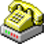 | Modem | Install and configure modems. To run this wizard, click the Modems icon in Control Panel.
 | Network | Install and configure network components. To run this option, click the Network icon in Control Panel.

Installation Requirements
There are requirements for running Windows 95 Setup in addition to the requirements for installing and running Windows 95 on a computer. This section lists the following kinds of requirements:
- Operating system requirements
- Windows 95 Setup memory, disk space, and user information requirements
- Windows 95 hardware, disk space, partition, and other requirements

Operating System Requirements
The retail version of Windows 95 must be installed as an upgrade over an existing operating system. Windows 95 can be installed over a number of different operating systems, including MS-DOS, Windows, and Windows for Workgroups. Windows 95 can also be installed over DR DOS/Novell DOS, PC-DOS, OS/2, and Windows NT.
The minimum operating system software required to install Windows 95 is any one of the following:
- MS-DOS version 3.2 or higher, or an equivalent original equipment manufacturer (OEM) version that supports partitions greater than 32 MB
- Windows 3.x
- Windows for Workgroups 3.1x
- Dual-boot OS/2 (with MS-DOS)
- Dual-boot Windows NT (with MS-DOS)

Tip for MS-DOS Versions and Windows 95 Setup
Windows 95 Setup attempts to install Windows 95 on a computer with an OEM version equivalent to MS-DOS 3.2 only if that version can exceed the 32 MB partition limit (such as COMPAQ version 3.31), because the operational disk space requirements for Windows 95 can exceed the 32 MB partition limitation.
The computer must have MS-DOS version 3.2 or later. Because there are many OEM variations of MS-DOS 3.2, Microsoft recommends you upgrade to Windows 95 from MS-DOS version 5.0 or later.
To check the MS-DOS version on a computer, type ver at the command prompt.

For information about how Windows 95 Setup treats disk partitions created under other operating systems, see “Partition Requirements” later in this chapter. For information about how Windows 95 Setup deals with the boot sector and installs files for dual-boot operation with other operating systems, see Chapter 6, “Setup Technical Issues.”

Requirements for Windows 95 Setup
Usually, you need to supply very little information during Windows 95 Setup for a successful Windows 95 installation. The unique information required for a typical installation consists of only the following:
- User name
- Computer and workgroup names, if the computer is connected to the network

For Windows 95 Setup to run, the computer must have at least 417K of available conventional memory. The amount of disk space required for Windows 95 Setup varies. This may be due to the types of hardware on the computer and the drivers that need to be installed. The numbers in the following table are rough estimates.
Disk Space Requirements for Windows 95
Installation option | Compact¹ | Typical
New installation | 30 MB | 40 MB
Windows 3.1 upgrade | 20 MB | 30 MB
Windows for Workgroups 3.x upgrade | 10 MB | 20 MB
¹ You may not get typical functionality of all Windows 95 features (including networking) with a compact configuration.

Although basic estimates of disk space requirements can be made (and are made in the SETUPC.INF), actual Windows 95 disk space requirements vary with individual system resources that Windows 95 must support, using drivers and other system components.

System Requirements for Windows 95
Windows 95 is an operating system for computers based on the Intel standard, and it cannot be installed on anything other than an x86-based platform. The following table describes the basic hardware requirements for Windows 95 on a standalone computer.
System Hardware Requirements for Windows 95 on a Standalone Computer
Component | Windows 95 requirement
Computer | 386 processor (or higher) with high-density floppy disk and hard disk drive.
Memory | At least 4 MB of RAM; 8 MB recommended.
Video display | VGA (minimum); Super VGA (recommended).
Disk space | 30 MB of free hard-disk space is recommended. The full custom installation requires a minimum of 19 MB. You also need at least 8 MB of free disk space for a swap file, depending on how much RAM your computer has.  If you have disk compression software installed, you must have at least 3 MB of uncompressed disk space on your host drive before installing Windows 95.
Optional | Modem, for remote access.  CD-ROM drive.  Network adapter card.  Sound card.  Other multimedia hardware components.

For information about the requirements for shared installations, see Chapter 4, “Server-Based Setup for Windows 95.”

Partition Requirements
Windows 95 Setup cannot install Windows 95 unless a file allocation table (FAT) partition exists on the hard disk. It cannot install Windows 95 on a computer that has only HPFS or NTFS partitions. Windows 95 Setup reads most partitioning schemes, changes the partition table, and rewrites it if the partition is nonstandard. Windows 95 Setup always writes to the master boot record, except when disk partitioning schemes from other vendors are used.
The following table describes how Windows 95 Setup handles different types of disk partitions.
Partition type | How Windows 95 Setup handles such partitions
MS-DOS (Fdisk) | Windows 95 Setup recognizes and begins installation over existing MS-DOS FAT partitions, provided the partition is large enough to accommodate Windows 95 files (including swap files).
NTFS | Windows 95 cannot be installed on and cannot recognize information on a local NTFS partition.
OS/2 | If you use the first Windows 95 Setup disk to start the computer, as is required for a computer running only OS/2, Windows 95 Setup offers to reformat the hard disk.

Windows 95 and partitions on removable media. Windows 95 supports MS-DOS FDISK partitions on removable media drives such as the Iomega® Bernoulli™ drives.
Windows 95 and third-party disk partitions. Windows 95 recognizes and translates third-party disk partitioning schemes including the following:
- Disk Manager DMDRVR.BIN
- SpeedStor® SSTOR.SYS
- Golden Bow Vfeature

Windows 95 and disk compression. Windows 95 works with disk compression drivers, including those in the following list. For detailed information, see Chapter 17, “Disks and File Systems.”
- Microsoft DriveSpace
- Microsoft DoubleSpace
- Stacker® versions 3.0 and 4.x
- SuperStor™

Before Installing Windows 95
Check the following questions before proceeding with Windows 95 Setup on an individual computer.

Is the hardware on the Hardware Compatibility List?
Check the Hardware Compatibility List and verify that your computer hardware is on the list. If any computer component (model, video, CD-ROM, and so on) is not on the hardware compatibility list, select the model that your hardware can emulate or that is of the closest type.

Do the computer components meet the minimum requirements?
Read “Installation Requirements” earlier in this chapter, and check your computer hardware and software components. Verify that all components meet the minimum requirements.

Are all unnecessary TSRs disabled?
Disable all terminate-and-stay-resident (TSRs) and device drivers loaded in CONFIG.SYS or AUTOEXEC.BAT (or in any batch files called from AUTOEXEC.BAT) that are not required for system operation.

This does not include drivers required for partition or hard disk control, network drivers, or any driver required for operation of a device (such as video, CD-ROM, and so on).
Note

Is the installation drive checked and defragmented?
To optimize the installation process and operation of Windows 95 after installation, you should thoroughly check and defragment the hard disk drive before beginning Setup.
- If you have MS-DOS 6.2x or later, you can use ScanDisk to check the drive integrity. Be sure to choose the option to perform a Surface Scan, as this provides a good indication of the drive’s current integrity. For information on using ScanDisk, type scandisk /? at the MS-DOS prompt.
- If you have MS-DOS 6.x or later, you can use Defrag to defragment the hard disk drive. For information on using Defrag, type defrag /? at the MS-DOS prompt.

Are all key system files backed up?
The files you should back up before installing Windows 95 include the following:
- All initialization (.INI) files in the Windows directory
- All Registry data (.DAT) files in the Windows directory
- All password (.PWL) files in the Windows directory
- All critical real-mode drivers specified in CONFIG.SYS and AUTOEXEC.BAT
- CONFIG.SYS and AUTOEXEC.BAT in the root of the C drive
- Proprietary network configuration files and logon scripts

You may also want to back up personal or business data on the hard disk drive to guarantee data security in the event of unforeseen problems. Although most Windows 95 installations are easy and trouble-free, it is possible that some kind of error could occur (from system stalls because of incompatible hardware, to power loss during writes to disk) that may temporarily or permanently prevent access to data. Any time you upgrade the operating system (not just with Windows 95), backing up critical business or personal data is a prudent precaution.

Does all network software work before starting Windows 95 Setup?
Make sure that the network software is working immediately before installing Windows 95. Windows 95 needs to inherit the settings from the existing configuration to provide support for those settings in Windows 95.

If a multiple-boot configuration is specified in CONFIG.SYS for the previous operating system, only the current configuration is read and used by Windows 95 Setup.
Note

Starting Windows 95 Setup
The Windows 95 Setup program (SETUP.EXE) is found on the Windows 95 installation disks or may be provided on a shared network resource. For information about the installation media, see “Types of Windows 95 Installations” earlier in this chapter.
This section describes methods for starting Windows 95 Setup on computers that will run Windows 95 from the local hard disk after installation. For information about setting up a computer to run a shared copy of Windows 95, see Chapter 4, “Server-Based Setup for Windows 95.”

No TSRs or Windows-based applications should be running when you start Windows 95 Setup. Close any such applications before continuing with Windows 95 Setup.
Caution

To start Windows 95 Setup from Windows 3.1 or Windows for Workgroups 3.x
1. Start your computer in the usual way, and run Windows.
If you are setting up a network computer, you must also be sure any real-mode network software components are running before starting Windows 95 Setup.
2. If you are installing Windows 95 from floppy disks, insert Disk #1 in the drive and make that the active drive in File Manager.
– Or –
If you are installing Windows 95 from CD-ROM, put the compact disc in the drive and make that the active drive.
– Or –
If you are installing Windows 95 from source files on a network server, connect to that server and switch to the shared network directory that contains the Windows 95 source files.
3. Double-click SETUP.EXE in the directory of the Windows 95 installation files.
– Or –
From the File menu, choose Run, and then type setup and press Enter.
Windows 95 Setup begins the initialization process.
4. Follow the instructions on-screen, as described in the following sections of this chapter.

To start Windows 95 Setup from MS-DOS
1. Start your computer in the usual way.
2. If you are installing Windows 95 from floppy disks, insert Disk #1 in the drive and make that the active drive. For example, type cd a: if the disk is in the A drive.
– Or –
If you are installing Windows 95 from CD-ROM, put the compact disc in the drive and make that the active drive.
– Or –
If you are installing Windows 95 from source files on a network server, connect to that server and switch to the shared network directory that contains the Windows 95 source files.
3. At the command prompt, type setup and press Enter.
Windows 95 Setup begins the initialization process.
4. Follow the instructions on-screen, as described in the following sections of this chapter.

To start Windows 95 Setup with a script from a network computer
1. Log onto the network, running the existing network client.
2. Connect to the server that contains the Windows 95 distribution files.
3. At the command line, run Windows 95 Setup by specifying the batch file with the installation settings, using this syntax:
setup msbatch.inf

For example, type setup e:\wfwbatch.inf to run Setup using a setup script named WFWBATCH.INF that is stored on drive E. For more information, see Chapter 5, “Windows 95 Custom and Push Installations.”

The location of the network directory from which Windows 95 was installed is stored in the Registry. If that server is available when you add a device or require additional support files to run Windows 95, Setup automatically attempts to get the files from the server, using the Uniform Naming Convention (UNC) path name stored in the Registry. This eliminates the need to maintain a permanent network connection on the computer and makes it easier to install new drivers when you modify the configuration of a computer in a networked environment.
Note

Using Setup Command-Line Switches
Windows 95 Setup provides options to control the installation process. These options, or switches, are specified on the command line as arguments for the setup command (such as setup /d). Similar to MS-DOS command arguments, the specific option is preceded by a slash (/) character (not the backslash used to specify directory arguments).
Windows 95 Setup can be run using the following command-line switches.
Setup switch | Meaning
setup /? | Provides help for syntax and use of setup command-line switches.
setup /d | Instructs Windows 95 Setup not to use the existing version of Windows to run Windows 95 Setup. (Usually, Windows 95 Setup uses existing Windows DLLs for the initial phase of Windows 95 Setup; this switch specifically prevents that.)
setup /id | Instructs Windows 95 Setup not to check for the minimum disk space required to install Windows 95.
setup /nostart | Instructs Windows 95 Setup to copy a minimal installation of the required Windows 3.x DLLs used by Windows 95 Setup, and then to exit to MS-DOS without installing Windows 95.
setup script file | Instructs Windows 95 Setup to use settings in the specified script to automatically install Windows 95; for example, setup msbatch.inf. For more information, see Chapter 5, “Windows 95 Custom and Push Installations.”

Beginning Windows 95 Setup and Smart Recovery
When Windows 95 Setup begins, the welcome message shows the estimated time that it will take to complete the process, plus the four basic phases of Windows 95 installation.
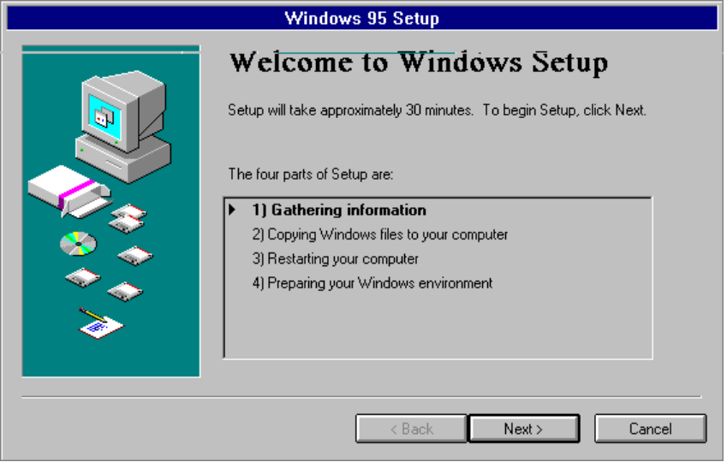
MSBATCH.INF
[setup]
express=1
bypasses this option
To navigate in Windows 95 Setup
- Click the Next or Back buttons on the Setup screens to let Windows 95 Setup guide you through choosing installation options.
Clicking the Next button accepts the choices made on the current screen; clicking the Back button lets you return to a previous screen to change your choice.

If a previous attempt to install Windows 95 has failed, Windows 95 Setup provides an option to use the Smart Recovery feature or to run a full new Setup process. If the Smart Recovery dialog box appears when you start Windows 95 Setup, you should select the Use Smart Recovery option. When you select this option, Windows 95 Setup can use built-in methods to avoid installation problems that occurred previously.
After you start Smart Recovery, the standard Welcome to Windows Setup screen appears. For more information about Smart Recovery, see Chapter 6, “Setup Technical Issues.”
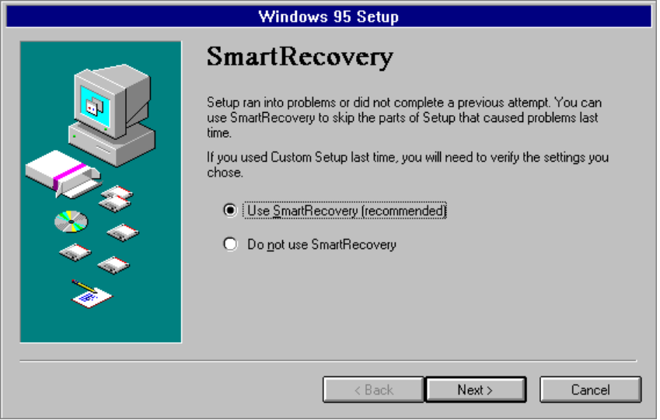
MSBATCH.INF
[setup]
express=1
bypasses this option

You can also use Smart Recovery with Windows 95 Setup whenever you suspect that Windows 95 system files have become corrupt or damaged.
Tip

Windows 95 Setup for Standalone Computers
This section describes the procedures for installing Windows 95 on the hard disk of a computer that is not running a shared copy from a network server. The following topics are presented:
- Gathering information
- Selecting components in Custom Setup
- Providing user information
- Creating a startup disk
- Selecting network components in Custom Setup
- Changing computer settings in Custom Setup
- Specifying computer identification
- Selecting advanced options in Custom Setup
- Copying files and completing Setup

Gathering Information
Most information needed to install Windows 95 is gathered automatically by Windows 95 Setup before you are asked to do anything. The following series of tasks are presented by Windows 95 Setup to guide you through providing the information needed to install and configure the new operating system:
- Selecting the setup type
- Choosing the Windows directory
- Checking disk space for Windows 95

Selecting the Type of Setup
Windows 95 Setup asks you to select the type of setup you want. For a description of these options and the decisions to be made, see “Typical, Portable, Compact, or Custom Setup?” earlier in this chapter. By default, the Typical Setup option is selected.
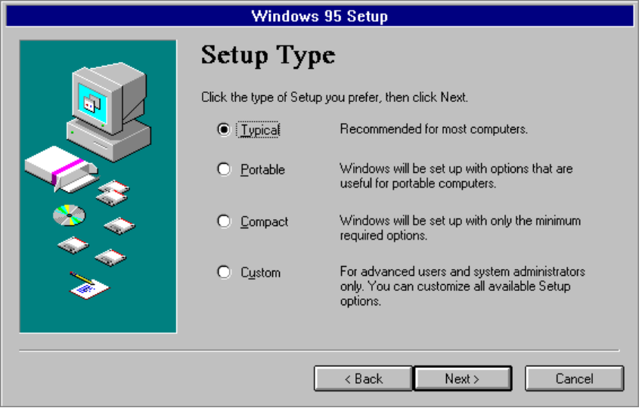
MSBATCH.INF
[setup]
express=0
bypasses this option;
customize=1
selects Custom
To specify Custom Setup
In the Setup Type box, click Custom, and then click the Next button.

In the following sections, the notations in the margins indicate the options that are available if you select Typical Setup and those that are available only for Custom Setup.

Choosing the Windows Directory
If a previous installation of Windows 3.1 or Windows for Workgroups 3.x exists, Windows 95 asks you to confirm the directory where Windows 95 will be installed. The directory containing the existing Windows installation is selected as the default.
This option is presented for Typical and Custom Setup
For information to guide the decision about whether to upgrade or install Windows 95 in a new directory, see “Upgrade or New Installation?” earlier in this chapter.
To install Windows 95 into a new directory
1. Click the Other Directory option, and then click the Next button.
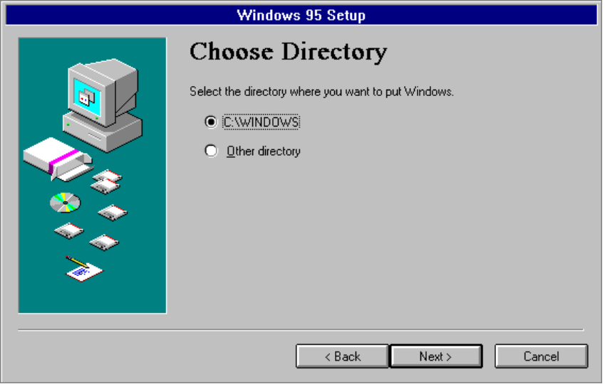
MSBATCH.INF
[setup]
InstallDir=dirname
sets this value and bypasses confirmation
2. If you choose to change the directory where Windows 95 will be installed, the following dialog box appears so that you can specify the drive and directory. Type a new directory name, and then click the Next button.
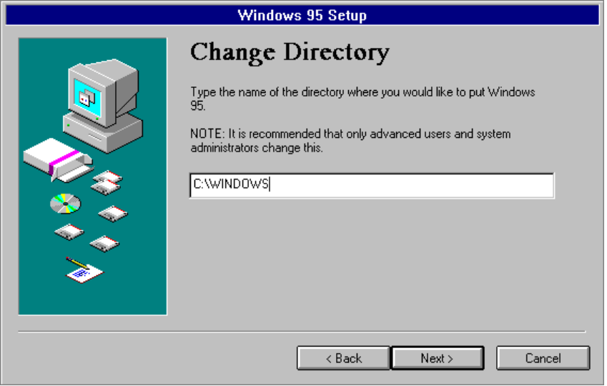
MSBATCH.INF
[setup]
ChangeDir=0
bypasses this option

If you choose to install Windows 95 into a new directory, you will need to reinstall all your Windows-based applications. This is because Windows 95 uses a different method from Windows 3.x for placing entries in configuration and Registry files. Windows 95 Setup cannot transfer this information for applications if you choose another directory.

A common method that administrators used with Windows 3.1 and Windows for Workgroups 3.x — copying all the *.GRP and *.INI files into the new installation directory — does not work with Windows 95, because *.GRP files and .INI entries cannot be used by Windows 95 unless Windows 95 Setup migrates this information to the Registry.
Note
You must run Windows 95 Setup and install Windows 95 into the existing Windows directory to migrate .GRP and .INI information from Windows 3.x.

Checking Disk Space for Windows 95
After you select the directory for Windows 95, Setup checks the available disk space to make certain there is enough free disk space on the destination drive for Windows 95.
If there is insufficient space on the destination drive, Windows 95 Setup warns you about the lack of space, and shows the minimum and complete installation space requirements.
- If Windows 95 Setup detects that there is insufficient disk space for a normal upgrade of an existing version of Windows, you can choose to install a compact configuration of Windows 95.
- If you continue when there is insufficient disk space, the installation may be incomplete.

You can disable the disk-space check by using setup /id to start Windows 95 Setup from the command prompt. You may want to do this if you are testing Setup or if you have a compressed drive, since your disk compression utility may not report an accurate amount of free space.

Windows 95 Setup may fail in the middle of installation if it runs out of disk space.
Caution
If you are installing Windows 95 on a compressed drive, make sure that at least 2.5 times the required space is free on that drive.

Selecting Components in Custom Setup
The Select Components dialog box appears so that you can specify the Windows 95 components to be installed. Notice that to the right of each component is information about the disk space required for that component.
This option is presented only for Custom Setup
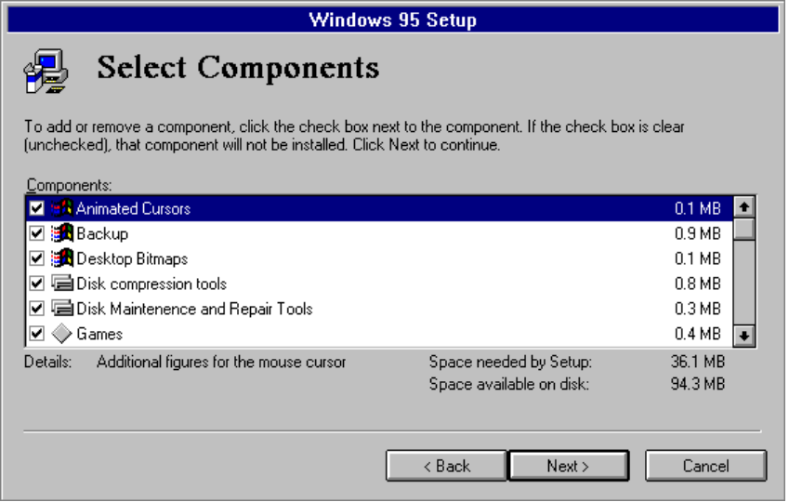
MSBATCH.INF
[OptionalComponents]can define these options
To prevent a component from being installed
- Click the check box next to it, so that the box is unchecked.

To add a component to the list being installed
- Click the check box next to the component you want, making sure that a check mark appears in the box.

When you have selected all the components to be installed, click the Next button.

Network Administration Tools (such as System Policy Editor), Microsoft Exchange and Internet Mail System are not installed by default. You must select these in the list to install then with Windows 95. (You must install Microsoft Exchange to install Internet Mail System.)
Note

Providing User Information
The information requested during this part of Setup is always required, no matter what Setup Type you specified (Typical, Custom, Portable, or Compact).
This option is presented for Typical and Custom Setup
After completing the disk space check, Windows 95 Setup asks you to enter your name and company name. Windows 95 uses your name and company name to identify you for various operations. You must type and verify a response for Setup to continue.
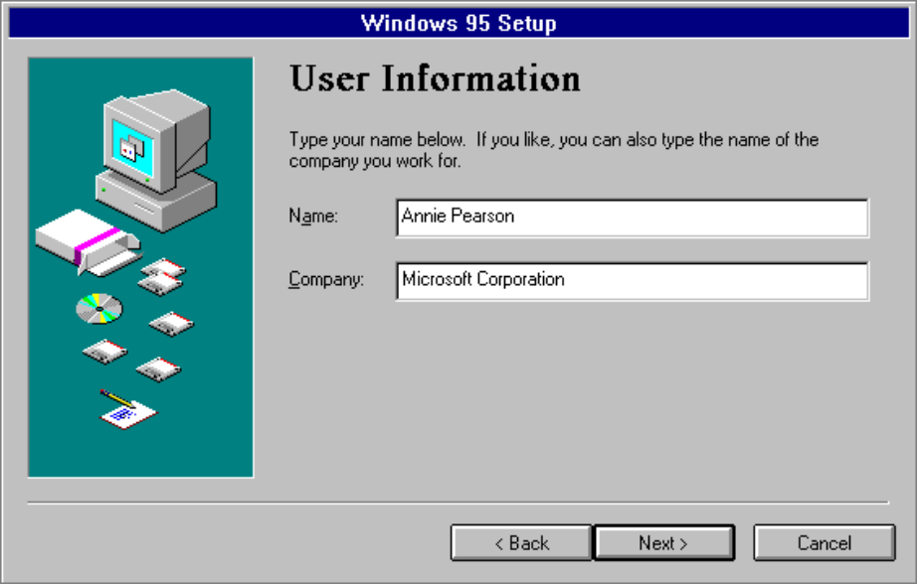
MSBATCH.INF
[NameAndOrg]
name=value
org=company
sets these values;
display=0
bypasses this option
Windows 95 Setup next requests a Product Identification number, which your technical support representative can use to identify your system. You must type and verify a response for Setup to continue. After Setup is complete, you can see this Product ID number by choosing the About command from the Help menu in My Computer. The Product ID dialog box might not appear if you are installing Windows 95 from the network, depending on the requirements at your site.

Analyzing the Computer
After you complete the user information, Windows 95 Setup is ready to begin the hardware detection phase. Setup can automatically search for all basic system components such as disk drives and controllers, display devices, pointing devices, and keyboards.
This option is presented for Typical and Custom Setup
For Typical Setup, you can choose to skip detection for CD-ROM or multimedia devices. If you know that these types of devices are not attached to the computer, skipping detection for these devices will save time during Setup.
For Custom Setup, you can specify whether you want Setup to skip detecting any specific devices attached to your computer. Usually, you should let Windows 95 Setup detect the system hardware unless you know that the computer contains devices that cause problems during the hardware detection phase. For example, you should have Setup skip detection of a particular device if Setup failed previously while detecting that device, and if Smart Recovery does not automatically skip detecting that device when you run Setup again. For information about specific device types, see the Hardware Compatibility List, and see also the Release Notes on the Windows 95 distribution media.
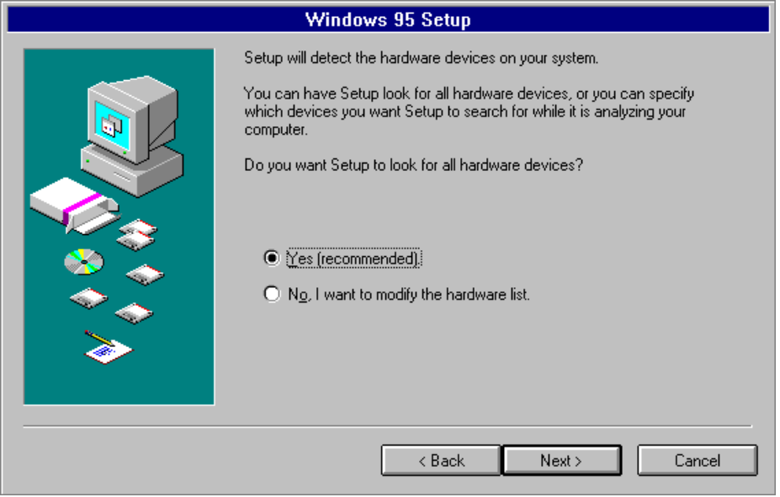
MSBATCH.INF
[setup]
detection=0
bypasses hardware detection
To have Windows 95 Setup attempt to detect all system hardware
- On the first Hardware Detection screen, select the Yes option. Then click the Next button.

To modify the list of hardware that Windows 95 Setup will attempt to detect
1. On the first Hardware Detection screen, select the option named No, I Want To Modify The Hardware List. Then click the Next button.
The Analyzing Your Computer screen appears, with lists of the components that Windows 95 Setup proposes to detect.
2. To instruct Windows 95 Setup not to detect a specific class of hardware, click the check box next to that item in the Hardware Types list to clear the box.
3. To avoid detecting a specific manufacturer and model of hardware device (while detecting other devices in that class), make sure there is a check mark beside the related Hardware Type. Then click the item you want to skip in the Manufacturer And Model list, so that the related check box is cleared.

If the box beside a particular Hardware Type is grayed (filled in), this indicates that you cannot modify how Windows 95 Setup will detect that class of hardware.
Note

4. When the list of hardware types and related manufacturer and model names specifies only the devices that Windows 95 Setup should attempt to detect, click the Next button.
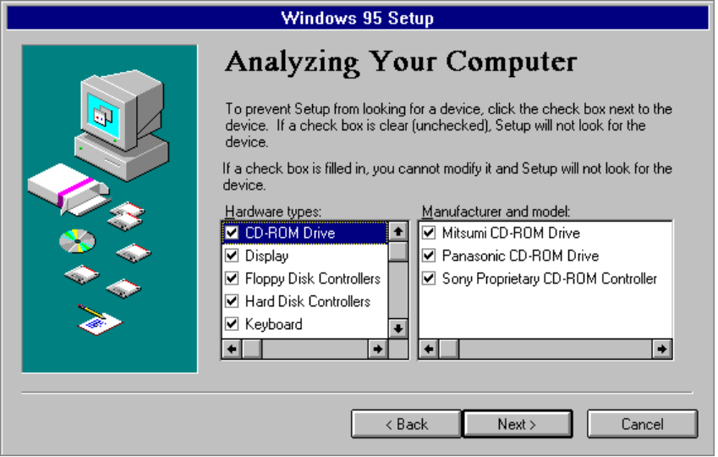

After you click the Next button, Windows 95 Setup begins the hardware detection process. This can take several minutes. The progress indicator shows what portion of hardware detection has been completed.
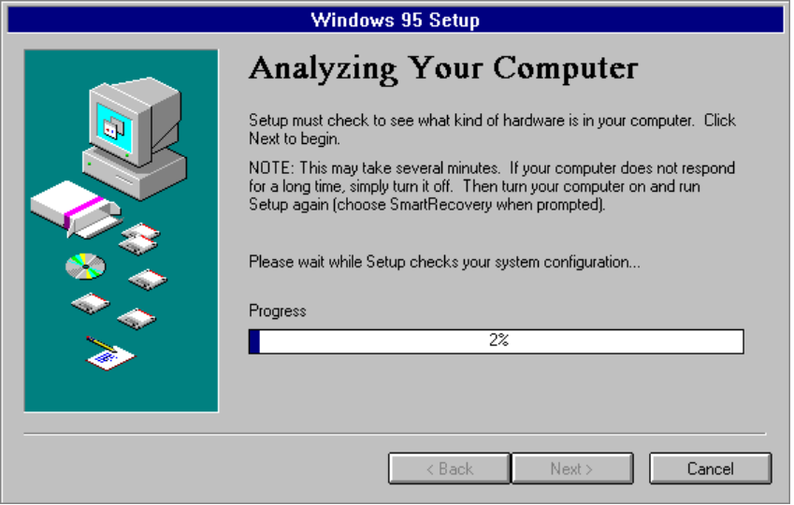
This is also the point at which Windows 95 Setup can stall if hardware detection fails for a particular system component.
To continue with installation if Windows 95 Setup stalls during hardware detection
1. Press F3 or click the Cancel button.
- If the computer responds to the Cancel button, choose No to continue the Setup process.
- If the computer does not respond to the Cancel button, restart the computer. First, restart it by pressing CTRL+ALT+DEL. If that method fails, then turn your computer off and then back on again.
2. Run Setup again.
Setup will ask you whether you want to use Smart Recovery to recover the failed installation. Choose the Smart Recovery option and click the Next button. Repeat your installation choices. Hardware detection runs again, but skips the portion that caused the initial failure. In some computers, you might encounter additional failures during the hardware detection process.
3. If the computer stops again during the hardware detection process, restart Setup again, and repeat the process until the hardware detection portion of Setup completes successfully.

Creating a Startup Disk
Windows 95 Setup offers to create an emergency startup disk that contains basic system files. This disk can be used to start Windows 95 when you cannot start the operating system from the hard disk. Creating the startup disk is the default option, but you can choose to bypass this step.
This option is presented for Typical and Custom Setup

It is strongly recommended that you create a startup disk during Windows 95 Setup.
Important
If you do not create a startup disk, or require a new disk after Windows 95 has been installed, you can use the Add/Remove Programs option in Control Panel to create a new emergency startup disk.

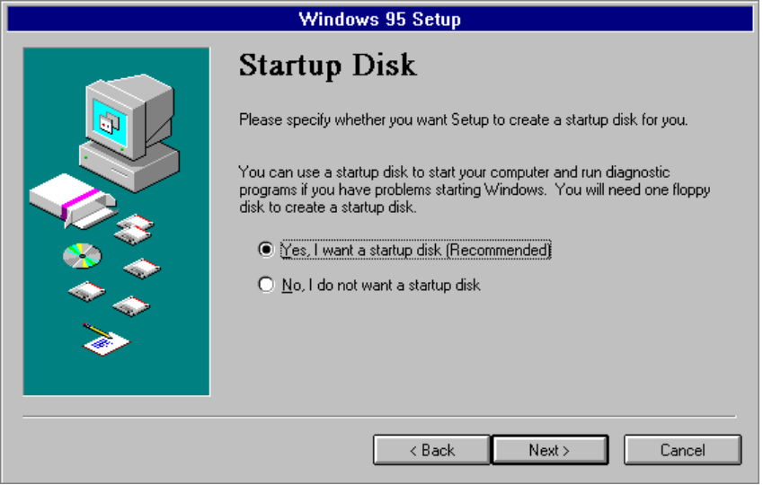
MSBATCH.INF
[setup]
EBD=1
forces creation of a startup disk;
EBD=0
bypasses creating a startup disk
To prevent Windows 95 Setup from creating a startup disk
- Click the option named No, I Do Not Want A Startup Disk. Then click the Next button.

Selecting Network Components in Custom Setup
Windows 95 Setup allows you to specify custom network components and settings. This section summarizes the options for modifying network settings during Windows 95 Setup. For detailed information about installing and configuring network components, see Chapter 11, “Network Technical Issues.”
This option is presented only for Custom Setup

Windows 95 Setup provides appropriate settings based on hardware and software detection for the network components installed in the computer and running when you started Setup. You should accept the default settings unless you know that particular settings need to be changed.
Note

To change network components
1. In the Network Configuration dialog box, select any component you do not want to install, and click the Remove button.
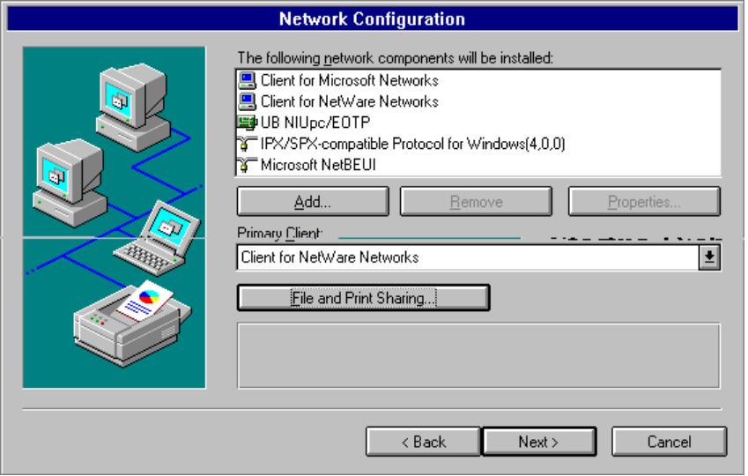
MSBATCH.INF
[setup]
network=0
bypasses this option
2. To add a component, click the Add button in the Network Configuration dialog box. Select the type of component you want to add — Client, Adapter, Protocol, or Service. Then click the Add button in the Select Network Component Type dialog box.
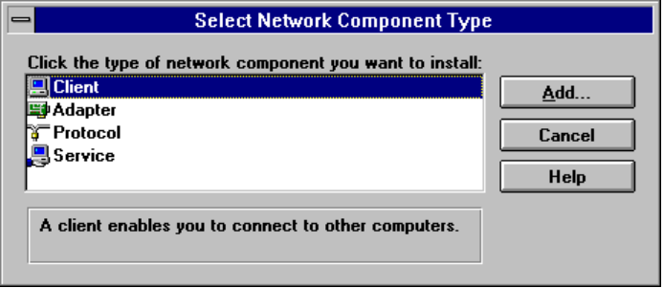
3. In the Select Device dialog box, click the vendor for the component in the Manufacturers list. Then click the appropriate version in the Models list.
4. Click OK. Then select the component in the list and click the Properties button to configure its settings.
Window 95 Setup uses default settings for all components, which you can usually rely on.
5. Repeat the process for each component you want to add.
6. After you have installed and configured all components, click the Next button.

The following sections summarize each type of network option.

Selecting the Network Client
If you choose to add a network client, Windows 95 Setup displays a list of supported networks. Windows 95 supports the following network types:
- Artisoft® LANtastic® version 5.0 and greater
- Banyan® VINES® version 5.52 and greater
- Beame and Whiteside BW-NFS 3.0c and greater
- DEC™ Pathworks™ version 4.1 and greater, or version 5.0 and greater (installed as a protocol)
- Novell® NetWare® version 3.11 and greater
- SunSelect PC-NFS® version 5.0 and greater
- TCS® 10-Net version 4.1 or greater

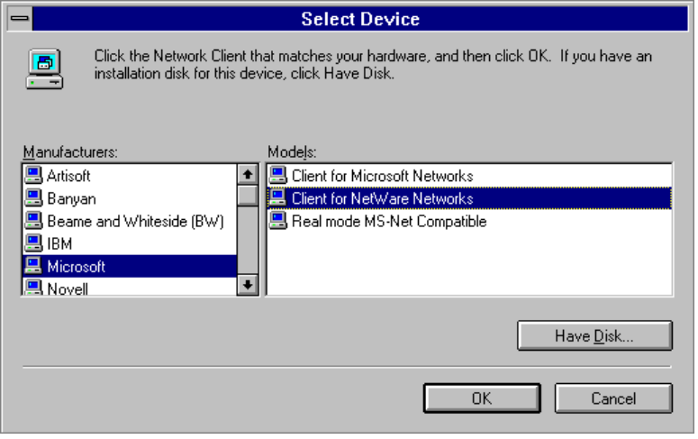
MSBATCH.INF
[network]
clients=value
defines this option, where the value is a Device ID defined in the related .INF file
To use Windows 95 on a NetWare network, you must install client software for NetWare networks. If you install the Microsoft 32-bit, protected-mode Client for NetWare Networks, you can take advantage of complete Plug and Play support, automatic reconnection to servers, and client-side caching for network information, in addition to the improved performance of the protected-mode implementation. For any NetWare-supplied networking client that you install, you can browse NetWare computers using Network Neighborhood and use both NetWare and Microsoft networking commands. For information about this and about installing and configuring network clients for other kinds of networks, see Chapter 8, “Windows 95 on NetWare Networks.”

Selecting and Configuring a Network Adapter
Windows 95 supports multiple network adapter cards (also called network interface cards, or NICs) similar to Windows for Workgroups 3.11 support — that is, up to four network adapter cards can be supported in a single computer.
If you choose to add a network adapter, Windows 95 displays a list of supported network adapter cards. For information on technical issues for network adapter cards, see Chapter 11, “Network Technical Issues.”
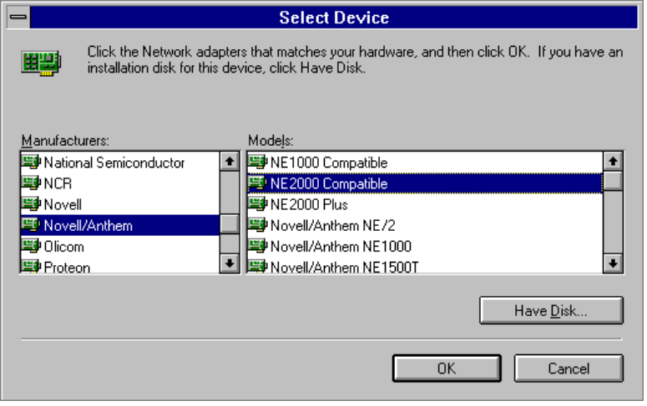
MSBATCH.INF
[network]
netcards=value
defines this option, where the value is a Device ID defined in the related .INF file

Selecting and Configuring the Network Protocols
Windows 95 Setup automatically installs the appropriate protocol for the network client you select. Microsoft provides real-mode and 32-bit, protected-mode versions of these protocols:
- IPX/SPX-compatible protocol for Windows
- Microsoft NetBEUI
- Microsoft TCP/IP

Protocols to support other network clients are also provided. For information about technical issues for network protocols, see Chapter 11, “Network Technical Issues.”
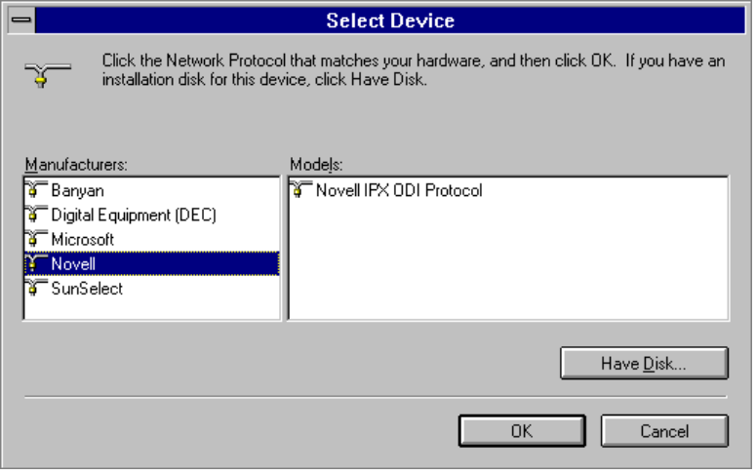
MSBATCH.INF
[network]
protocols=value
defines this option, where the value is a Device ID defined in the related .INF file

Selecting and Configuring a Network Service
Network services provide additional networking support, such as resource-sharing protocols and remote administration capabilities.
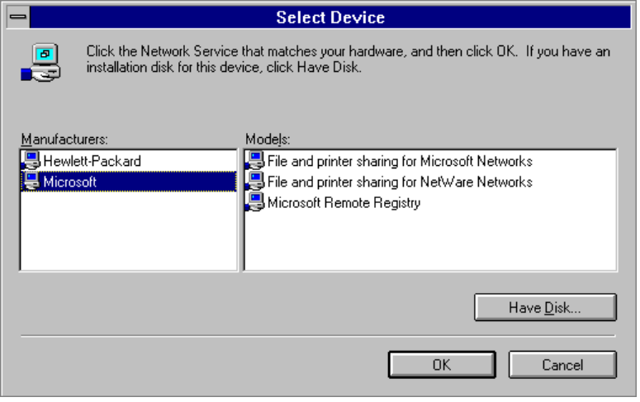
MSBATCH.INF
[network]
services=value
defines this option, where the value is a Device ID defined in the related .INF file
Microsoft provides the following network services for Windows 95:
- File and Printer Sharing for NetWare Networks
This service allows computers running NetWare clients to share file, printer, and CD-ROM resources on this computer. For detailed information about installing, configuring, and using this service, see Chapter 8, “Windows 95 on NetWare Networks.”
- File and Printer Sharing for Windows Networks
This service allows computers running Microsoft network clients to share file, printer, and CD-ROM resources on this computer.
- Microsoft Remote Registry
This service allows administrators to manage this computer remotely using System Policy Editor and other tools. For information, see Chapter 12, “System Management.”

Changing Computer Settings in Custom Setup
Windows 95 Setup detects the hardware in your computer and determines appropriate default values for configuring the hardware. Usually, you should accept the values determined through hardware detection, unless you know that a manual setting must be supplied.
This option is presented only for Custom Setup
To configure system hardware options
1. When the Computer Settings dialog box appears, select the item in the list, and then click the Change button, or double-click the item you want to change.
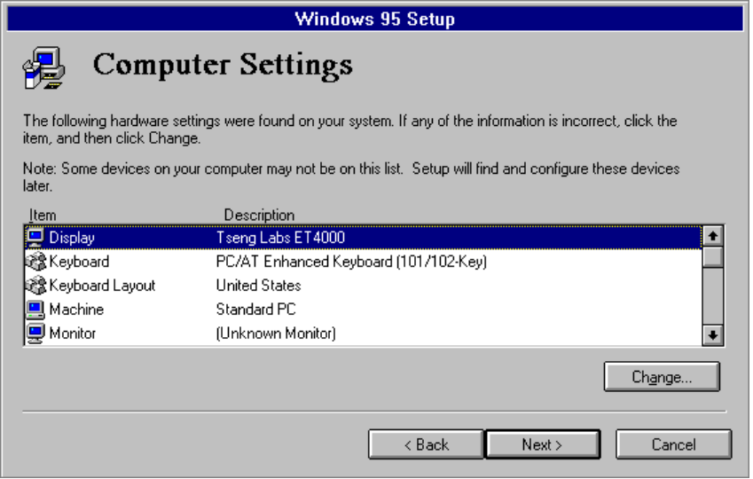
MSBATCH.INF
[system] entries
can define these settings;
display=0
bypasses this option
Windows 95 Setup displays a Select Device dialog box for the item you selected. This list by default shows the models that are identified as compatible for the hardware detected in your computer. You can also choose to display all the possible entries for that particular device type.
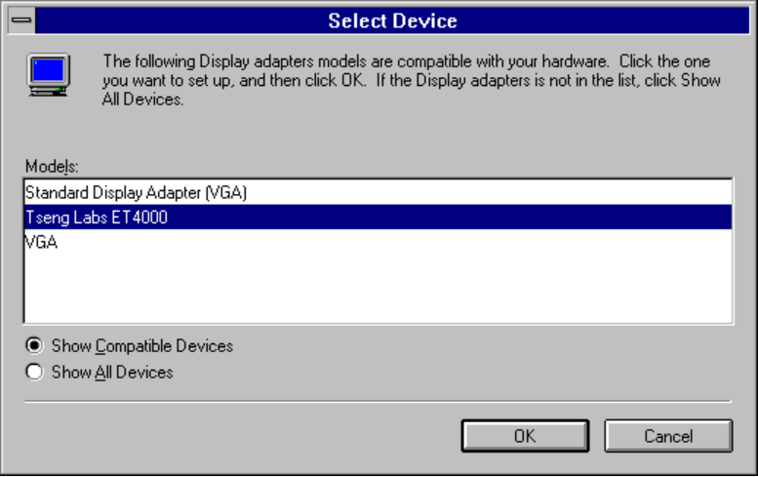
MSBATCH.INF
[system]
display=value
defines this option; the value is a section name in that device’s .INF file
2. In the Select Device dialog box, select the model name that matches your device.
– Or –
If you want to display all possible entries for the selected device class, click the Show All Devices option, and then select the model that matches your device.
3. Click OK, and then use the device’s property sheet to configure settings, as described in Chapter 15, “Devices.”

The following chapters provide information about changing specific computer settings. You use the same procedures during Custom Setup to change settings as are used to change settings after Windows 95 is installed.
To change this device setting | See this chapter
Display, mouse, communication ports | Chapter 15, “Devices”
Network adapter card | Chapter 11, “Network Technical Issues”
Keyboard | To be provided.

The following list presents notes for specific devices:
- If Windows 95 does not have a new driver for your display adapter when upgrading over a previous version of Windows, it reports it as Standard Display Adapter (VGA) in the Computer Settings list, and later display a message that your display driver is invalid. However, you can select your Windows 3.1 driver from the list and continue. Although you can install Windows 3.1 display drivers, as described in Chapter 15, “Devices,” Microsoft recommends that you upgrade to Windows 95 drivers wherever possible for improved performance and reliability.
- Other notes to be provided.

Specifying Computer Identification
The Computer Identification dialog box allows you to specify how the computer appears on the network.
This option is presented for Typical and Custom Setup
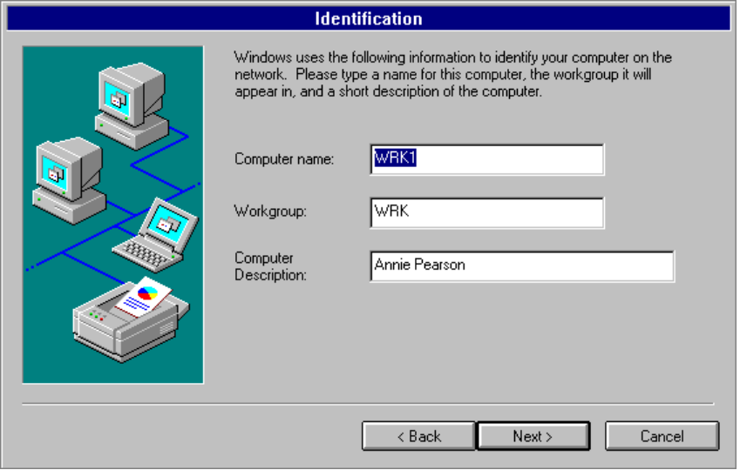
MSBATCH.INF
[network]
display=0
bypasses this option
- The computer name must be unique on the network, and can be up to 15 characters long with no spaces (no blank characters). The name can contain only alphanumeric characters and the following special characters.
MSBATCH.INF
[network]
computername=value
workgroup=value
description=value
define these options
! @ # $ % ^ & ( ) - _ ' { } . ~

- The workgroup name does not need to be unique and uses the same naming conventions as the computer name. The network administrator might provide guidelines for specifying the workgroup to select.
- Information in the Computer Description box appears as a comment next to the computer name when users are browsing the network.

Selecting Advanced Options in Custom Setup
Windows 95 Setup presents an option for advanced users and system administrators to specify how Windows 95 Setup will configure the file system — specifically, whether users can take advantage of long filenames.
This option is presented only for Custom Setup
For information about how Windows 95 manages long filenames and issues related to using long filenames on networks with mixed types of operating systems and file systems, see Chapter 17, “Disks and File Systems.”
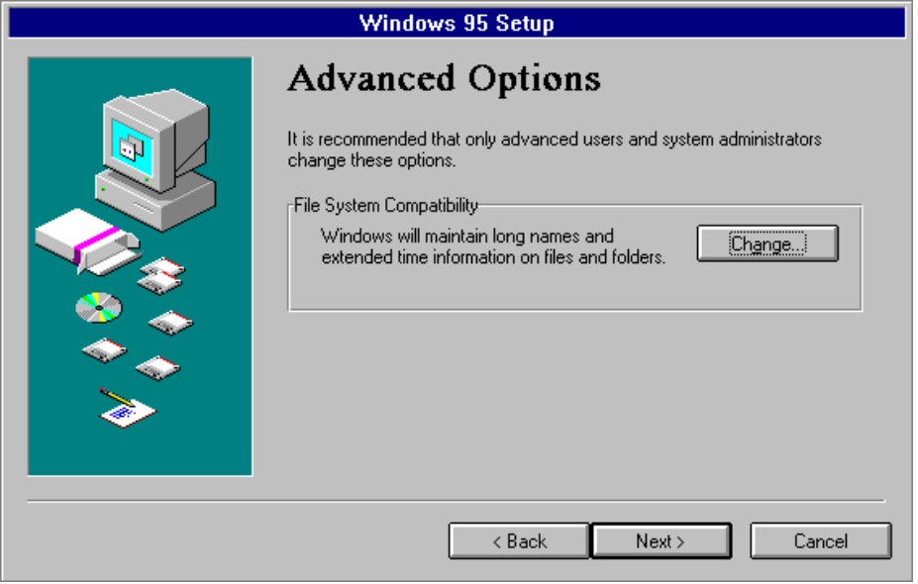
To turn off the long-filename capability in Windows 95
1. In the Advanced Options dialog box, click the Change button.
2. In the File System Compatibility dialog box, click the option named No, I Do Not Want To Use New File System Features. Then click OK.
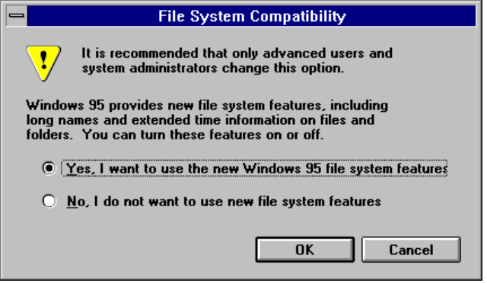

If this option is selected, you can use only the standard 8.3 filenames allowed for the standard FAT file system.

Copying Files and Completing Setup
After hardware detection is complete and Windows 95 Setup has obtained all required information, the next phase of Windows 95 Setup begins, during which the base Windows 95 files and the files for supporting your system are copied to the destination drive and directory.
For more information about this phase, see Chapter 6, “Setup Technical Issues.” For a list of files installed for specific configurations, see Appendix B, “Windows 95 System Files.”
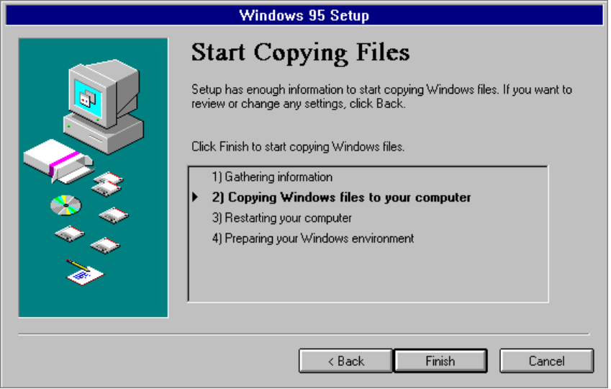
If you chose to have Windows 95 Setup create a startup disk, Setup asks you to insert a floppy disk into drive A. The disk does not need to be either formatted or empty. After you insert the disk, click OK to begin creating the startup disk. Windows 95 Setup will format the disk and copy the appropriate files.
When the basic installation steps are completed, Windows 95 Setup asks you to remove any disks from the floppy disk drive. After you click OK, the computer is restarted, and the final phase of the installation process begins, which includes converting Windows Program Manager groups and migrating various system configuration settings to the Registry.

If the specified network path cannot be found, or becomes unavailable during the file copying process, Windows 95 Setup warns you of the error. You can correct the path by choosing the Details button in the error message.
Note

Near the end of the installation process, Windows 95 Setup asks you to complete several configuration options, as described in the following sections.

Setting the Time Zone
Setup offers you the opportunity to set the time zone for your work site. This is an important step for network computers that need to keep time stamps synchronized.
To configure the time zone
- Click your location on the map.
– Or –
Select your time zone from the list.
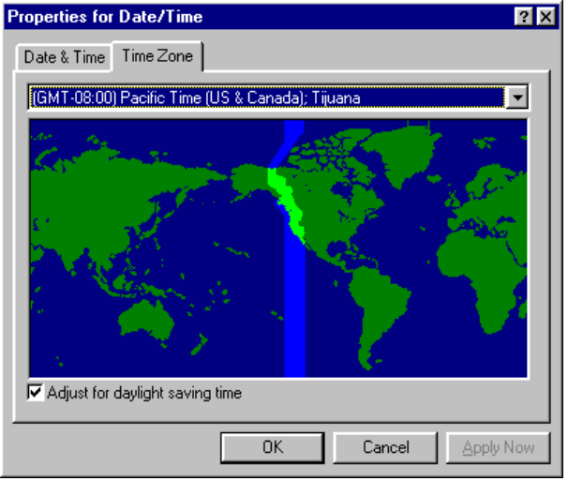

Installing and Configuring a Printer
Windows 95 Setup automatically presents the Printer Installation Wizard the first time that Windows 95 is started after the basic installation is complete.
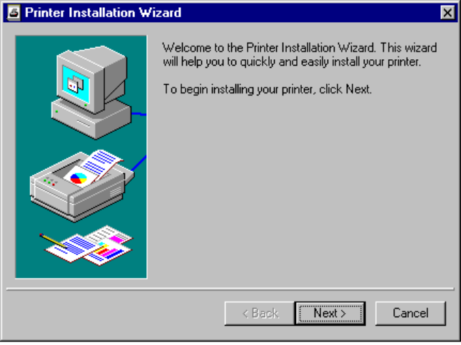
To configure a printer during Windows 95 Setup
- In the Printer Installation Wizard, click the Next button and follow the instructions on-screen.
– Or –
Click Cancel if you do not want to install a printer.

If you want to install or change a printer after Windows 95 is installed, click the Printers folder in Windows Explorer. For information about installing and managing printers in Windows 95, see Chapter 19, “Printing.”

Completing Windows 95 Setup
Windows 95 files are now installed on the system, and the computer is completely configured for running your applications.
For information about the system that is initialized at the completion of Setup and for a detailed description of the system startup process, see Chapter 6, “Setup Technical Issues.”

