Windows 95 System Policies Specification
Version 0.9

Revision History

1.0 Overview
Windows 95 System Policies are a mechanism to propagate registry settings to a large number of machines. Administrators can thus centrally control user and machine configurations. However, we do not want to require the administrator to have detailed knowledge of the registry in order to accomplish this task. There are many settings in the registry, and it is often the case that multiple registry settings need to be manipulated in order to achieve the desired end result. The System Policies feature provides a layer of abstraction to make it easier to control registry settings. It also provides the capability to do this from a central location.

Instead of thinking in terms of individual registry settings, the administrator can think in terms of policies. Each policy has some text that describes its effect. Some examples of policies are:
• Disable file sharing
• Display a custom logon banner
• Remove the “Run” command from the “Start” menu
• Use user-level security
Each policy is actually associated with one or more registry settings. When the administrator chooses to enforce a policy, the System Policies tool does the work of figuring out what registry changes need to be made. It also does the work of getting those changes made in the registries of the users and machines for which this policy applies. (The administrator can specify policies for individual users, user groups, and individual machines. Defaults can also be specified.)

There are two components involved; a policy editor, an application that lets administrators specify registry settings for particular computers, users and user groups, and a policy downloader, a small piece installed on every client that merges the administrator’s settings into the local registry. The policy editor uses a template file, which is a text file that describes interesting registry settings and specifies how the settings should appear in the policy editor UI. The output of the policy editor is a policy file, which is a single file that contains policy settings for a number of computers, users and user groups. The policy file is a registry hive which is created and manipulated using Win32 APIs.

Microsoft will provide a policy editor with Windows 95, the System Policy Editor, and a policy downloader built into MPR (Multiple Provider Router). ISVs may create their own policy editors, which must be able to read template files and be able to read and write policy files. ISVs may also create their own policy downloaders; policy downloaders may be “installed” so that MPR will call the installed component to do the downloading rather than doing so itself. The policy file format allows for extensions so that ISVs may provide additional “value-add” functionality.

The Windows 95 team has identified registry settings that administrators would most want to control and propagate, and has implemented policies for them. System Policies thus controls only a subset of the registry. However, System Policies are extensible. Application ISV’s are encouraged to supply template files and implement policies for registry settings for their products. Their customers may then plug those template files into a policy editor and control policies for that application.

2.0 Architecture
A machine’s configuration is defined in terms of policies. The policies are ultimately stored on the local machine’s registry. Every component that provides a policy is responsible for reading the registry at appropriate times and acting accordingly. Consider, for example, the policy that removes the “Run” item from the “Start” menu. The shell code that displays the “Start” menu must check the right registry setting to see whether or not it is supposed to display the “Run” item. The policies are generic data items; the admin tools and components have no knowledge about them besides their names, their associated data, and where they reside in the registry. The only responsibilities of the admin components are to allow the admin to make policy settings and propagate those settings to the user’s registry.

2.1 Policy primitives
• A policy is a permission or attribute about a particular item, action, or object. It is either enabled or disabled.
• A part is a subcomponent of a policy. A policy may have zero or more parts. Policy parts may have various data types, including boolean values, numeric values and string values. The values of the parts only apply if the policy is enabled.
• A category is a collection of similar policies.
• A user-specific policy is one that can be specified for each user or group. A default set of policies can be specified for users or groups who do not have sets of policies defined for them explicitly. Most policies are user-specific. User-specific policies are always merged into the HKEY_CURRENT_USER branch of the registry.
• A machine-specific policy is a policy that does not make sense to have change depending on the user. A machine-specific policy is global across all users, and will not follow users around as they sit at different computers. Machine-specific policies are always merged into the HKEY_LOCAL_MACHINE branch of the registry.

Some policies do not need any parts. For instance, “Lock Desktop Links” could be a policy, and it is sufficient to say that either this is enabled or disabled; if it is enabled, the user can not modify her desktop links in any way. Alternatively, “Desktop Links” could be a policy, and it could have the following boolean parts: “Create Links”, “Delete Links”, “Modify Links”. As another example, “Password Expiration” is an example of a policy, and “Number of days” would be its part (which would be a numeric value).

Policies and parts are analogous to a group of controls in a dialog box which are all enabled by a single checkbox. The checkbox (whether or not the policy is enabled) “turns on” the controls in the dialog (the policy parts), and data can be entered into the controls. A policy with no parts, e.g. no associated controls, is analogous to a single checkbox.

Any application or component may define a policy. That policy will appear in the administrator UI, and information that the administrator has set about the policy will be migrated to the local machine’s registry. It is up to the application or component to check the registry appropriately to enforce its own policy.

2.4 Data path
Policy information typically follows this path:

• Categories, policies, and parts are described in an template (.ADM) file. The .ADM format is described in Appendix A. An ADMINCFG.ADM file with all the policies that the system supports is shipped with Windows 95. ISVs, other Microsoft groups and others may provide their own template files.
• The admin runs the policy editor which reads one or more policies and lists the available categories and policies. The admin sets up the desired policies and the work is saved to a policy (.POL) file, using registry APIs. The format of policy files is described in Appendix B.
• After the user logs on (and user profiles are reconciled if user profiles are enabled), the policy downloader is invoked. It determines where to find the file on the network, opens the policy file and merges the appropriate computer, user and group policies into the local registry.

2.5 Users, groups, and standalone
There is a standard username called DEFAULT USER and a standard computer name called DEFAULT COMPUTER. When the policy downloader updates machine- and user- specific policies, it will first try to find an entry in the policy file for the local computer name or username, respectively. If it does not find an entry, it will next look for an entry for DEFAULT USER or DEFAULT COMPUTER respectively, and use those entries for the update. If there are no entries for a particular user or computer and default entries do not exist, no update will take place.

The DEFAULT USER and DEFAULT COMPUTER entries are powerful because administrators can set policies for a vast sea of users and computers and then manage the exceptions by creating specific user and computer entries in the .POL file.

2.6 Policy Downloading
Policy downloading can be set in one of the following three states:
• Off
• Automatic
• Manual

If policy downloading is off, then no downloading takes place.

If policy downloading is set to automatic, then MPR asks the primary network provider to find a place to look on the network for the policy file. Microsoft’s Windows and NetWare providers both support this. (For a Windows NT network, MPR will look on the primary domain controller’s NETLOGON directory for a file called CONFIG.POL. For a NetWare 3.x network, MPR will look on the preferred server’s SYS\PUBLIC directory for a file called CONFIG.POL.) Any vendor who provides a 32-bit network provider can support this by implementing the NPGetPolicyPath API. If policy downloading is set to automatic and the primary network provider does not support NPGetPolicyPath, then no downloading will take place.

If policy downloading is set to manual, then a specific path to the policy file must also be supplied. This can either be a UNC path or a path beginning with a drive letter. (In the latter case, the drive letter must be appropriately mapped prior to downloading.)

By default, “out of the box,” policy downloading is set to automatic. Also by default, no error messages are displayed if the policy file cannot be found in the location the network provider suggests. This means that a site can install a number of Windows 95 clients and then decide to deploy policies at a later date. All the admin needs to do is place policy file(s) in the appropriate location(s) on the network, and the clients will immediately begin using them (on next login).

3.0 Policy Editor UI
This section describes the user interface of the policy editor that is shipped with Windows 95. Other vendors may choose to use different UI.

The System Policy Editor always needs a template (.ADM) file describing the available policies in order to run. By default, it will use ADMINCFG.ADM but different template files may be specified (via the Templates menu).

The main window of the policy editor displays the users and computers that have entries in the policy file that is currently open. To create a new policy file, choose File->New. A new policy file contains entries for default user and default computer. To add entries for particular users and/or computers, click on the Add User or Add Computer button. Note that policies for all of the entries shown in the main window will be saved to one policy file. Typically, an administrator will save the policy file to the network location where the policy downloader looks by default.

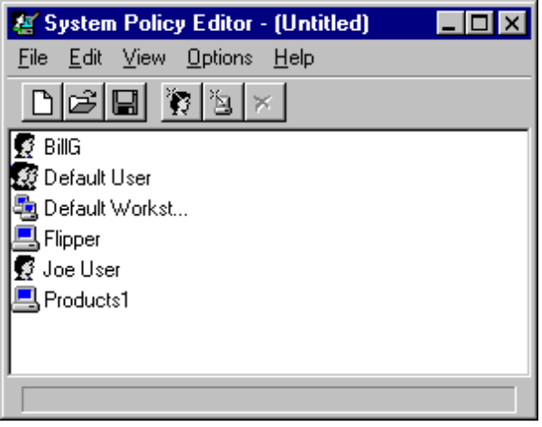

Double-clicking on an entry brings up the property dialog containing the policies for that entry. The policy dialog has an upper section listing the policies, with a lower section showing specific settings for that policy.

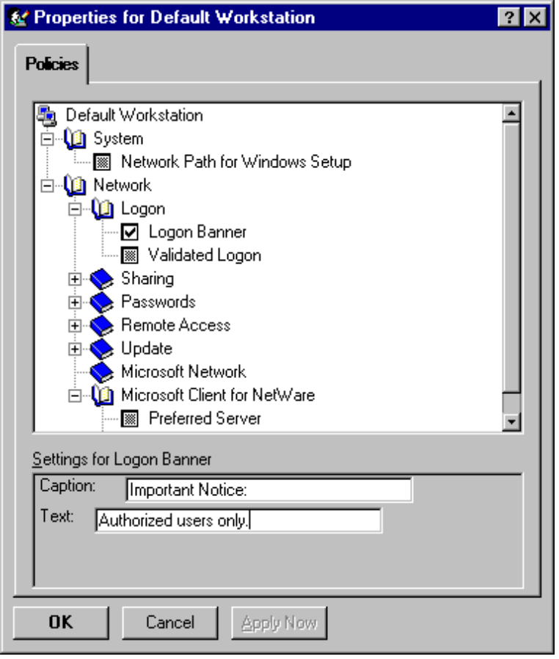

The checkbox has three states. Checked means that this policy will be enforced; the corresponding settings will get added to the registry at policy download time. Unchecking a policy (box is empty) means that those same settings will get deleted from the registry at policy download time. If the checkbox is grey, then the registry settings for that policy will not be changed at all at policy download time. This means that the user has the freedom to choose their own settings, if those settings can be changed from the gui.

A couple of examples should help to clarify. First, look at the user policy Desktop->Wallpaper. By checking that policy, the administrator specifies what wallpaper that user will have. Even if the user changes the wallpaper via the Display control panel, the next time they log in they will get the wallpaper specified by the administrator. If the administrator unchecks this policy, then the wallpaper setting will be deleted; thus when the user logs in, there will be no wallpaper. If the administrator makes this checkbox grey, then nothing is enforced; the user can choose the wallpaper.

As a second example, look at the user policy Shell->Restrictions->Remove Run from Start menu. Checking this policy adds a registry setting that tells the shell not to include the Run item in the Start menu. By unchecking this policy, this registry key is deleted, and so the shell will display the Run item. If the policy is left grey, then this setting will not be changed. If the policy had already been in force, then it will stay that way - the user will continue to not see the Run item. If the policy had not been applied already, then that user will continue to see the Run item. Note that unlike the wallpaper example, the user cannot change this setting via any control panel or other ui.

The policy editor can also operate directly on the local registry rather than on a policy file. This is very useful for troubleshooting problems that may be policy-related, because it shows what policies are currently in place for that user on that computer. There is no policy file involved in this mode. To switch to the local registry view, choose File->Open Registry. Note that the checkboxes will only be two-state, checked and unchecked, since the registry settings for that policy are either present (and thus the policy is on) or not present (policy is off).

Appendix A Template (.ADM) File Format
The .ADM file describes a number of categories. Each category can contain zero or more policies; each policy can contain zero or more parts.

A.1 Category definition statement

A category is specified by the following format:

CATEGORY <name> TYPE <category type>
[KEYNAME <key name>]

[... policy definition statements ...]

END CATEGORY

<name> is the category name as it should appear in the Policy Editor listbox. It may optionally be enclosed by quotes (names with spaces must be enclosed by quotes).
<category type> must be USER or MACHINE. This denotes whether the category is per-user or per-machine.
<key name> is an optional registry key name to use for the category. If there is a key name specified, this will be used by all child categories, policies and parts, unless they specifically provide a key name of their own.

A category definition statement may not appear more than once for the same category name.

A.2 Policy definition statement

A policy is specified by the following format:

POLICY <name>
[KEY <key name>]
[... part definition statements ...]
END POLICY

<name> is the policy name as it should appear in the Policy Editor listbox. It may optionally be enclosed by quotes (names with spaces must be enclosed by quotes).
<key name> is an optional registry key name to use for the policy. If there is a key name specified, this will be used by all child parts of the policy, unless they specifically provide a key name of their own.

A.3 Part definition statement

A policy part is specified as follows:

PART <name> TYPE <part type>
<type-dependent data>
[KEYNAME <key name> ]
VALUENAME <value name>
END PART

<name> is the part name as it should appear in the Policy Editor listbox. It may optionally be enclosed by quotes (names with spaces must be enclosed by quotes).
<part-type> is the policy part type. Part types are discussed in section A.3.1.
<type-dependent data> is information about the part. This is discussed in section A.3.1.
<key name> is optional key name to use. If no key name is specified, then the previous key name in hierarchy is used.
<value name> is the value name to use to set the data for this part.

A.3.1 Policy part types

The following part types are defined:

CHECKBOX - Displays a checkbox. Its value is a REG_DWORD in the registry. The value will be non-zero if checked by the user, and zero if unchecked.
NUMERIC - Displays an edit field with an optional spin (up-down) control that accepts a numeric value. The value is set in the registry with type REG_DWORD.
EDITTEXT - Displays an edit field that accepts alphanumeric text. The text is set in the registry with type REG_SZ.
COMBOBOX - Displays a combo box, which is an edit field plus a drop down list box for suggested values.
TEXT - Displays a line of static (label) text. There is no associated registry value with this part type.

DROPDOWNLIST - Displays a dropdown-list style combo box. The user may only choose from one of the entries supplied. The main advantage of a dropdown-style combo box is that based on the user’s selection, a number of extra arbitrary registry edits to be performed may be specified.

LISTBOX - Displays a listbox with “add” and “remove” buttons. This is the only part type that can be used to manage multiple values under one key.

The type-specific data that each type accepts is:
CHECKBOX:
DEFCHECKED Causes the checkbox to be initially checked.
VALUEON If specified, this will override the default “on” behavior of the checkbox. Example: VALUEON “Foobar” write “Foobar” to
VALUEOFF If specified, overrides the default “off” behavior of the checkbox. See example below.
ACTIONLISTON Optional action list to be taken if checkbox is “on”. See section A.4, “Action lists”.
ACTIONLISTOFF Optional action list to be taken if checkbox is “off”. See section A.4, “Action lists”.
The default behavior of checkboxes is to write the value 1 to the registry if it checked, and 0 if unchecked. This can be overridden, as in the following examples:
VALUEON “Foobar” /* “Foobar” will get written when this checkbox is checked.*/
VALUEOFF NUMERIC 12 /* 12 will get written when this checkbox is unchecked */

NUMERIC:
DEFAULT <value> Specifies initial numeric value for edit field. If this statement is not specified, the edit field is initially empty.
MIN <value> Specifies minimum value for number. Default value is 0.
MAX <value> Specifies maximum value for number. Default value is 9999.
SPIN <value> Specifies increments to use for spin control. Specifying SPIN 0 removes the spin control. SPIN 1 is the default.
REQUIRED If specified, the policy editor won’t allow a policy containing this part to be enabled unless a value has been entered for this part.
TXTCONVERT Writes values as REG_SZ strings (“1”,”2”,”128”) rather than binary values.

EDITTEXT:
DEFAULT <value> Specifies initial string to place in edit field. If this is not specified, field is initially empty.
MAXLEN <value> Maximum length of string. String is limited to this length in edit field.
REQUIRED If specified, the policy editor won’t allow a policy containing this part to be enabled unless a value has been entered for this part.
OEMCONVERT Sets ES_OEMCONVERT style on the edit field so that typed text is mapped from ANSI to OEM and back.

COMBOBOX:
accepts all the keywords that EDITTEXT does, plus:
SUGGESTIONS Begins a list of suggestions to be placed in the drop-down list. Suggestions are separated with spaces and can be enclosed by quotes. The list is terminated with END SUGGESTIONS. For instance:
SUGGESTIONS
Alaska Alabama Mississippi “New York”
END SUGGESTIONS
TEXT:
no type-specific data

DROPDOWNLIST:
REQUIRED If specified, the policy editor won’t allow a policy containing this part to be enabled unless a value has been entered for this part.
ITEMLIST Begins a list of the items in the dropdown list. The end of the list must be terminated by END ITEMLIST. Each item in the list is specified as follows:
NAME <name> VALUE <value>
[ACTIONLIST <actionlist>]
...
<name> is the text to be displayed in the dropdown list for this item. <value> is the value to be written for the part’s value if this item is selected. Values are assumed to be strings, unless they are preceded by the keyword NUMERIC. e.g.
VALUE “Some value”
VALUE NUMERIC 1
If the VALUE keyword is followed by the DELETE keyword (e.g. VALUE DELETE), then this registry value/valuename pair will be deleted.
<actionlist> is an optional actionlist to be used if this value is selected, see section A.4, “Action lists”.

LISTBOX:
The VALUENAME keyword cannot be used with the listbox type, since there is no single value name associated with this type. By default, only one column appears in the listbox, and for each entry a value is created with an identical value name and value data. For instance, an entry “foo” in the listbox would create a value named “foo” whose data was “foo”.
VALUEPREFIX <prefix> The prefix to be used in determining value names. If a prefix is specified, then this prefix plus “1”, “2”, etc. will be used instead of the default value naming scheme listed above. The prefix can be empty (“”), which will cause the value names to be “1”, “2”, etc. A prefix of “SomeName” will generate value names “SomeName1”, “SomeName2”, etc.
EXPLICITVALUE This makes the user specify not only the value data, but the value name as well. The listbox will show two columns for each item, one for the name and one for the data. This keyword cannot be used with the VALUEPREFIX keyword.
ADDITIVE By default, the content of listboxes will “override” whatever values are set in the target registry. (Specifically, a control value is inserted in the policy file which causes existing values to be deleted before the values set in the policy file are merged.) If the ADDITIVE keyword is specified, then existing values are not deleted, and values set in the listbox will be in addition to whatever values exist in the target registry.

A.4 Action lists
An action list is a set of arbitrary registry edits that is performed in response to a control being in a certain state. For instance, if a checkbox is turned on, you may want to install some VxDs and do some other edits.

The syntax for an actionlist is:
ACTIONLIST
[KEYNAME <key name>]
VALUENAME <value name>
VALUE <value>
[KEYNAME <key name>]
VALUENAME <value name]
VALUE <value>
....
END ACTIONLIST

The actionlist specifies a number of key name/value name/value triplets. A key name does not need to be specified for every action, if it is not listed the key name from the previous action will be used (which is useful for writing a number of values to one key). Values are assumed to be strings, unless they are preceded by the keyword NUMERIC. e.g.
VALUE “Some value”
VALUE NUMERIC 1.
If the VALUE keyword is followed by the DELETE keyword (e.g. VALUE DELETE), then this registry value/valuename pair will be deleted.

A.5 Comments

Comments can be added by preceding the line with “//” or “;”.

Appendix B Policy (.POL) File Format
B.1 Overview

A policy file is a registry hive, which is created using the Win32 API RegSaveKey().

The following top-level keys are defined:
• “Users”
• “Computers”
• “Groups”
• “GroupData”
• “Misc”

A policy downloader uses the following steps to download policies:
• Locate the appropriate computer key (if any) under “Computers”. Beneath that key is an image of the registry settings to be merged. It should walk through all the subkeys and values and merge those settings into HKEY_LOCAL_MACHINE, paying attention to control codes as defined in section B.2, “control codes”.
• Locate the appropriate groups key(s) (if any) under “Groups”. Under the group keys is an image of the registry settings to be merged. These must be merged into HKEY_CURRENT_USER.
• Locate the appropriate user key (if any) under “Users”. Under the user key is an image of the registry settings to be merged. These must be merged into HKEY_CURRENT_USER.

B.2 Control Codes

Special control codes are used to signify that special processing must take place. All control codes are prefixes to a value or key name, and take the form “**<code>.<value or key name>“.

The following control codes are presently defined:
Value names:
**del. Specifies that the value name following the control code should be deleted.
**soft. Specifies that this is a soft value. Only propagate the value name following the control code if a value by that name does not exist in the local registry. (e.g. do not overwrite existing settings with soft values.)
**delvals. Delete all values under this key in the local registry before proceeding to propagate values under this key from the policy file. When processing a particular key, a downloader must look for and process this value first. This control code is inserted by a listbox control so that existing values are cleaned out before the new values are added.
Key names:
no codes currently defined

If a policy downloader encounters a control code it does not understand, it must not process the key or value. If the control code is part of a value name, the policy downloader should skip that value in the hive file but continue to process other values under that key and its subkeys. If the control code is part of a key name, then the downloader should ignore the key and not process any values under it or its subkeys. This behavior is important, because it allows ISVs to create new control codes while not breaking existing downloaders.

ISVs may create new control codes in the above format (“**<code>.”). ISVs who do so should notify Microsoft so that Microsoft can document it.

B.3 “Computers” key

Underneath the computers key is a list of computers who have entries in the policy file. The algorithm to use in locating a computer key is:
• first, see if there is a key that is the same as the computer name. If so, merge the registry image beneath it into HKEY_LOCAL_MACHINE.
• If not, see if there is a key called “.default”. This appears in the policy editor UI as “Default Computer”. If so, merge the registry image beneath it.
• Otherwise, do nothing.

B.4 “Groups” and “GroupData” keys

Underneath the groups key is a list of user groups who have entries in the policy file. Since a user may belong to many groups and those groups may have conflicting settings, an order to process groups in must be specified. This order is contained in the GroupData\Priority key, which has values in the form “1”=“<group name>“, “2”=“<group name>“, etc. “1” is highest priority, and priority diminishes as the number in the value name increases. The downloader must read the group priority values, and then process groups from lowest priority to highest; e.g. begin with the highest numbered value and work to the value “1”. For each group in the priority list, the downloader needs to determine if the user is a member of that group. If so, it should try to find a key with that group name under the Group key. If so, then it should merge the registry image under that key into HKEY_CURRENT_USER. It is not an error if a group is specified in the priority list but does not have an entry under the Group key, it is just a no-op. This process is repeated for each group in the priority list. (If a group has an entry under the Group key but does not have an entry in the priority list, it is never processed.)

B.5 “Users” key

Underneath the users key is a list of computers who have entries in the policy file. The algorithm to use in locating a user key is:
• first, see if there is a key that is the same as the user name. If so, merge the registry image beneath it into HKEY_CURRENT_USER.
• If not, see if there is a key called “.default”. This appears in the policy editor UI as “Default User”. If so, merge the registry image beneath it.
• Otherwise, do nothing.

B.6 “Misc” key

This is a key that ISVs can use to store vendor-specific data. The naming convention for this key is as follows:
Misc\<Vendor Name>\<Product Name>\<Version>\<data>

The vendor may store whatever it wants in <data>. A key or value containing version information is highly recommended. As is recommended for the registry, <Version> should be “CurrentVersion” for the most current version of the product.

Appendix C Installable policy downloaders
An installable policy downloader must be a Win32 DLL. It should export a named function of the following format:

VOID FAR PASCAL ProcessPolicies(HWND hwndOwner,LPSTR lpszPolicyFilePath,LPSTR lpszUserName,LPSTR lpszComputerName,DWORD dwFlags);

hwndOwner Specifies the parent window
lpszPolicyFilePath Specifies the full path and file name that MPR would have used to look for the policy file. The downloader may use this or ignore it and use a different path.
lpszUserName The logged-on user name
lpszComputerName The local machine name
dwFlags Can be a combination of the following:
PP_DISPLAYERRORS Display error messages about errors encountered during downloading (including file not found, network resource not found, etc.). Otherwise fail silently if there is an error.

In addition to defining and exporting this function, it is necessary to record this in the registry. Under the registry key HKLM\Network\Logon, add the following entry:
PolicyHandler = "<dll name>,<function name>"
where <dll name> is the name of the DLL containing the function and <function name> is the exported function name.

