C H A P T E R 9

Window Management
When designing software to support user tasks, there are several different techniques that you can use to manage a set of windows. This chapter covers some common techniques.

Single Document Window Interface
In many cases, the interface of an object or application can be expressed using a single, primary window and a number of supplemental secondary windows. The desktop and task bar provide management of primary windows. Opening the window puts it at the top of the Z-order and places an entry in the task bar. When the object represents a document or other type of data file, if a user attempts to open the object again (within the same desktop), elevate the existing window to the top of the Z-order rather than opening another window for that object. This provides a one-to-one relationship between the object and its window.

For more information about the operation of opening a window, see Chapter 6, "Windows."

Some types of objects, such as certain device objects, may not require a primary window and only use a secondary window for viewing and editing its properties. When this occurs, do not include the Open command in the menu for the object; instead, replace it with a Properties command also defined as the default command. It is also possible for an object to not have any windows, but only an icon as its sole presentation. In this rare case, make certain that the object provides an adequate set of commands to allow a user to control its activity.

Multiple Document Interface
For some type of tasks, the task bar may not be sufficient for managing a set of related windows; for example, you may find it more effective to present multiple views of the same data or multiple views of related data in windows that share interface elements. You can use the multiple document interface (MDI) for this kind of situation.

The MDI technique uses a single primary window, called a parent window, to visually contain a set of related document or child windows as shown in Figure 9.1. Each child window is essentially a primary window, but constrained to only appear within the parent window instead of on the desktop. The parent window also provides a visual and operational framework for its child windows. For example, child windows typically share the menu bar of the parent window and may also share other parts of the parent’s interface, such as a toolbar or status bar. These may be changed to reflect the commands and attributes of the active child window

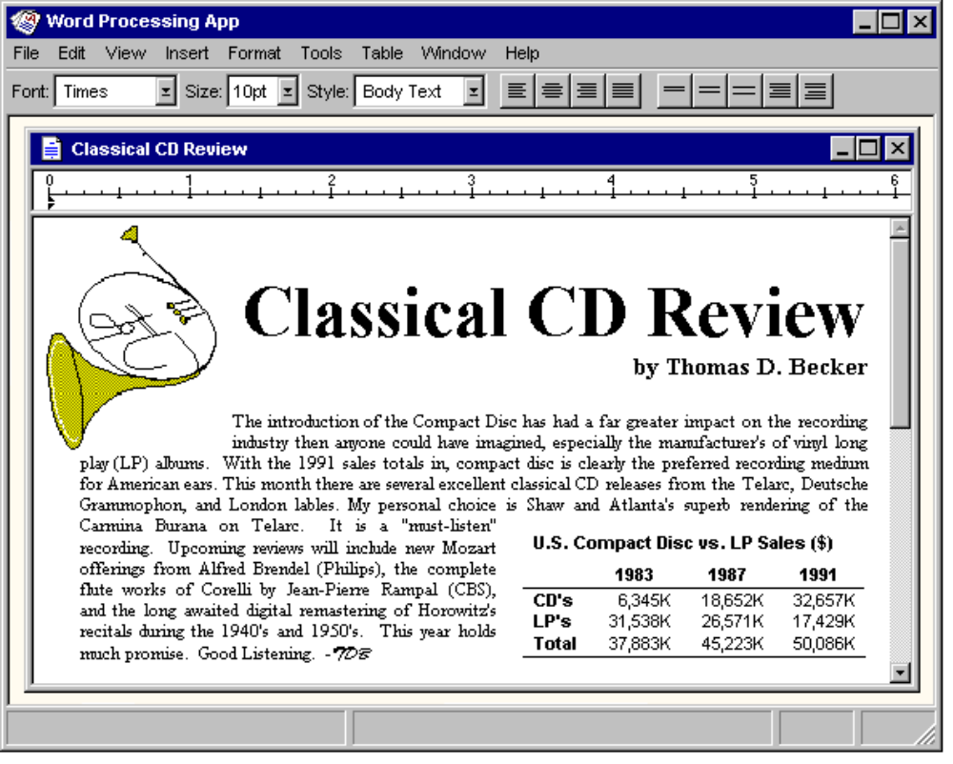

Figure 9.1 An MDI Parent and a Child Window.
Secondary windows — such as dialog boxes, message boxes, or property sheets — displayed as a result of interaction within the MDI parent or child, are typically not contained or clipped by the parent window. These windows should be managed in the same way as secondary windows associated with a primary window are normally handled, even if they apply to individual child windows.

In the title bar of an MDI parent window, include the icon and name of the application or the object that represents the work area displayed in the parent window. In the title bar of a child window, include the icon representing the document or data file type and its filename. In addition, include pop-up menus for the window and title bar icon for both the parent window and any child windows.

Opening and Closing MDI Windows

A user can start an MDI application either by directly opening the application or by opening a document (or datafile) of the type supported by the MDI application. If an MDI document file is directly opened, the MDI parent window opens first, and then a child window for the file is opened within it. To support users opening other document files associated with that application you can include an interface, such as an Open command.

If the user attempts to open an MDI document file from outside the interface of its MDI parent window — for example, by directly opening the file — and the parent window for that application is already open, open another instance of the MDI parent window that a child window for the file rather than opening the file's window in the existing MDI parent window. While opening the child window within the existing parent window may be more efficient, opening the new window may disrupt the task environment already set up in that parent window. For example, if the newly opened file is a macro, opening it in the opened parent window could inadvertently affect other documents open in that window. If the user wishes to open a document as part of that set, commands within that parent window provide for that.

For more information about opening primary windows, see Chapter 6, "Windows."

Because MDI child windows are primary windows, the user can close them using the Close button in the title bar or the Close command on the pop-up menu for the window. Similarly, closing the parent window follows the conventions of any primary window. Closing a child window should not close the parent window, although closing the parent window should close its child windows. Where possible, preserve the state of a child window, such as its size and position within the parent window; restore the state when the file is reopened.

Moving and Sizing MDI Windows
MDI allows users to move or hide the child windows as a set by moving or minimizing the parent window., When the user moves an MDI parent window, the open child windows within it maintain their relative positions within the parent window. Moving a child window constrains it to its parent window so that it may be clipped by the parent window's interior area. Optionally, you may support automatic resizing of the parent window when a child window is moved either toward or away from the edge of the parent window. Similarly, you may optionally support automatic resizing or respositioning of child windows when the user resizes the parent window.

Although an MDI parent window minimizes as an entry on the task bar, MDI child windows minimize within their parent window as shown in Figure 9.2.

The recommended visual appearance of a minimized child window in Microsoft Windows 95 is that of a window that has been sized down to only display part of its title area and its border. This avoids potential confusion between minimized child windows and icons that represent objects.
Note

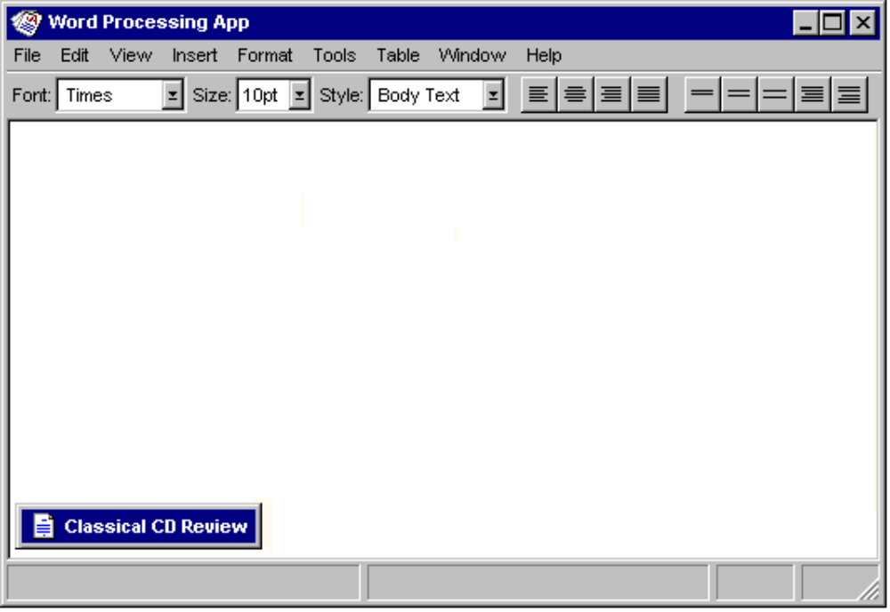
Figure 9.2 A Minimized MDI Child Window.
When the user maximizes an MDI parent window, like any other primary window, enlarge the window to its maximum size. When the user maximizes an MDI child window, you should also expand it to its largest, maximum size. When this size exceeds the interior of its parent window the child window merges with its parent window. The child window's title bar icon and Restore button and Minimize button (if supported) should be placed in the menu bar of the parent window in the same relative position as in the title bar of the child window as shown in Figure 9.3.

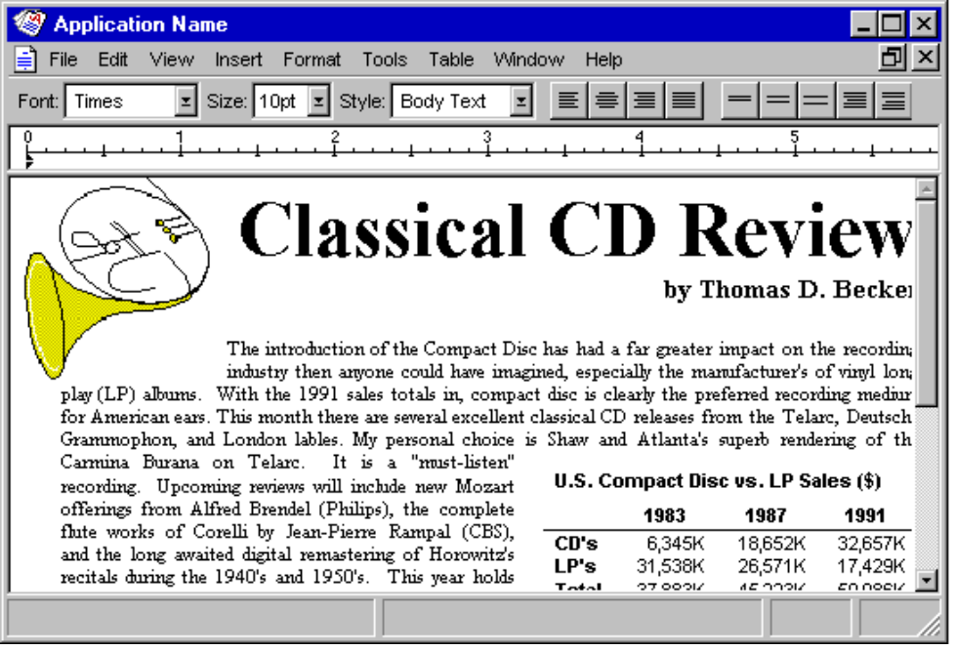

Figure 9.3 A Maximized MDI Child Window.
If the user maximizes one child window and then switches to another, display that window as maximized as well. Similarly, when the user restores one child window from its maximized state, restore all other child windows to their previous sizes.

Switching Between MDI Child Windows
Apply the same common mouse conventions for switching between windows for MDI child windows. ctrl+f6 and ctrl+tab (and shift+ modified combinations to cycle backwards) are the recommended keyboard shortcuts for switching between child windows. In addition, include a Window menu on the menu bar of the parent window. The Window menu should include commands for switching between child windows and commands that allow the user to manage or arrange the windows within the MDI parent window (for example, Tile or Cascade).

When the user switches child windows you can change the interface of the parent window, such as its menu bar, toolbar, or status bar to appropriately reflect the commands that apply to that child window. However, provide as much consistency as possible, keeping any menus that control the application or overall parent window environment, such as the File menu or the Window menu, constant.

MDI Alternatives
MDI does have its limitations. MDI tends to reinforce the visibility of the application as the primary focus for the user, instead of providing a more data-centered interface. The user may start an MDI application by directly opening one of its document or data files. However, if the user wants to work with multiple documents within the same MDI parent window, they must use the application's interface for opening those documents. Even when the user opens multiple files within the same MDI parent window, the storage relationship between the child windows and the objects being viewed in those windows is not consistent. That is, while the child windows are visually contained within the parent window, the files the windows display are not contained within that parent window.

For more information about opening multiple MDI documents, see Chapter 6, "Windows."Similarly, because the MDI parent window does not actually contain the objects opened within it, MDI cannot support an effective design for persistence. When users close the application and then return to it, they are presented with new, blank documents rather than the previous ones with which they were working.

MDI may make some aspects of the OLE interface unintentionally more complex. For example, if the user opens a text document in an MDI application and then opens an embedded worksheet contained in that text document, the task relationship breaks down, because the embedded document's window does not appear in the same MDI parent window.
Finally, the MDI technique of managing windows by confining child windows to the parent window can be inconvenient or inappropriate for some types of tasks, such as window or form layout tools. Similarly, the nested nature of child windows can make it difficult for the user to differentiate between a child window in a parent window versus a primary window that is a peer with the parent window, but positioned on top.

While MDI provides useful conventions for managing a set of related windows, it is not the only means of supporting task management. Some of its window management techniques can be applied in some alternative designs. The following — workspaces, workbooks, and projects, are examples of some of these design alternatives. They present a single window design model, but in such a way that preserves some of the window and task management benefits found in MDI.

The samples also suggest a form of containment. However, you can also apply some of these designs to display multiple views of the same data. Similarly, the designs are flexible as to the types of objects that may be contained. Like any container, you can define your implementation to hold and manage only certain types of objects. For example, an appointment book and an index card file can be both containers that organize a set of information but may differ in the way and type of information they manage. So whether you define a container to hold the same or different types of objects depends on the design and purpose of the container.

The following are examples that illustrate alternatives of data-centered window or task management. They are not exclusive of other possible designs. As a result, specific details may not be included and there are no explicit programming interfaces for these constructs.
Note

Workspaces
A workspace shares many of the characteristics of MDI, including the association and management of a set of related windows within a parent window, and the sharing of the parent window's interface elements, such as menus, toolbars, and status bar. Figure 9.4 shows a workspace.

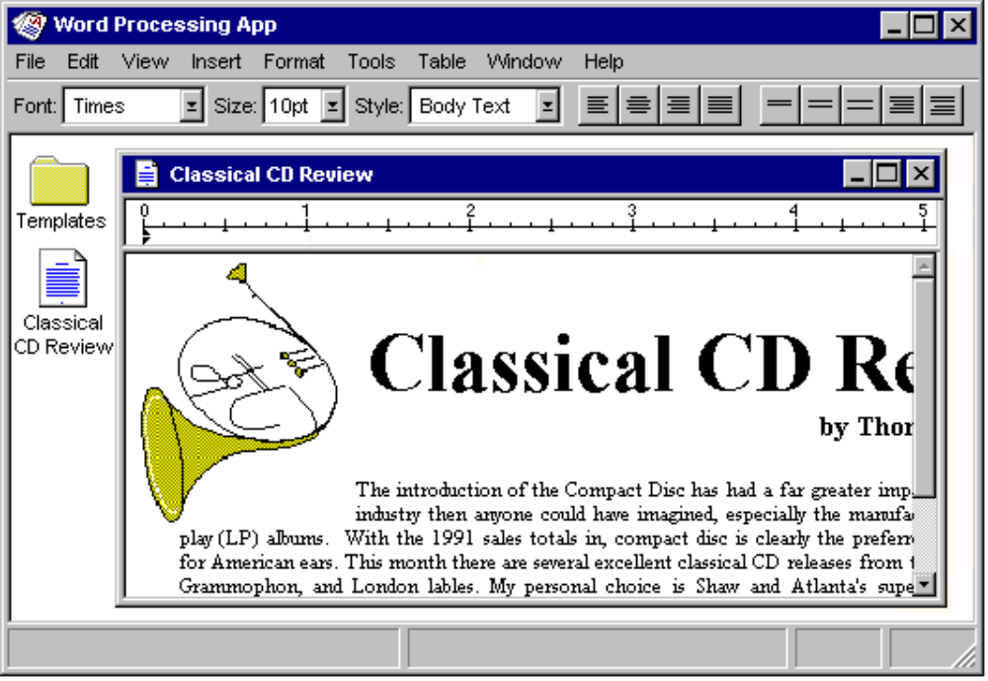
Figure 9.4 A Workspace.

Workspaces as a Container
Based on the metaphor of a work area, like a table, desktop, or office, a workspace differs from MDI by including the concept of containment. That is, objects represented as icons, may be contained or stored in the workspace in the same way they can be contained in folders. However, in a workspace, icons stored within the workspace, open as child windows within the workspace parent window. In this way, a workspace's behavior is similar to that of the desktop, except that a workspace can be displayed as an icon or opened into a window. To have an object's window appear in the workspace, its icon must reside there. This can be supported by allowing the user to move, copy, or link icons into the workspace.

The workspace is an object itself and therefore includes its own commands and properties. It also includes commands for creating new objects within the workspace (using information based on the registry), transfer commands for moving and copying objects into the workspace, and optionally, a Save All command that saves the state all of the objects opened in the workspace.

Workspaces for Task Grouping
Because a workspace visually contains and constrains the icons and windows of the objects placed in it, you can define workspaces to allow the user to organize a set of objects for particular tasks. Like MDI, this makes it easy for users to move or switch to a set of related windows as a set.

Also similar to MDI, the child windows of objects opened in the workspace can share the interface of the parent window. .For example if the workspace includes a menu bar, the windows of any objects contained within the workspace share the menu bar. If the workspace does not have a menu bar, or if you provide an option for the user to hide the menu bar, the menu bar appears within the document's child window. The parent window can also provide a framework for sharing toolbars and status bars.

A workspace provides support for users to move the icons from the workspace and place them in other containers like the desktop and folders. When the user moves an icon out of the workspace and places it on the desktop or a folder, its interface elements are displayed, such as its menu bar, within its own window. It is only when the icon is stored in the workspace that its window shares the workspace menu bar.

Window Management in a Workspace
A workspace manages windows, using the same conventions as MDI. When a workspace closes, all the windows within it close. The state of these windows is retained (for example, their size and position within the workspace), so it can be restored when the user reopens the workspace.

Like most primary windows, when the user minimizes the workspace window, the window is removed from the screen but its entry remains in the task bar. Minimized windows of icons opened within the workspace have the same behavior and appearance as minimized MDI child windows. Similarly, maximizing a window window within a workspace follows the MDI technique: if the window's maximize size exceeds the size of the workspace window, the child window merges with the workspace window. Its title bar icon and window buttons are placed in the menu bar of the workspace window.

A workspace always provides a means of navigating between the child windows within a workspace in addition to simple window activation, such as listing the open child windows on a Window drop-down menu and on the pop-up menu for the parent window.

Workbooks
A workbook is another alternative for managing a set of views. However, instead of a work area, a workbook uses the metaphor of a book or notebook. Within the workbook, you can present views of objects as sections within the workbook's primary window rather than in individual child windows as shown in Figure 9.5.

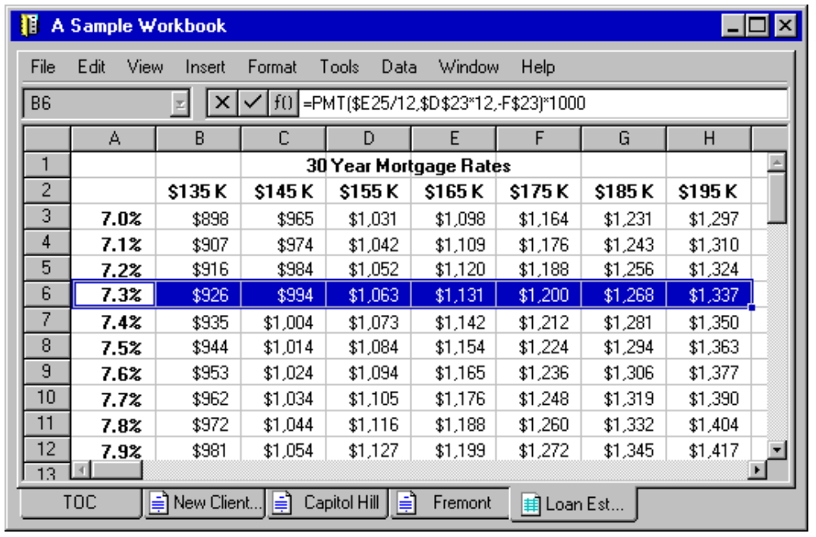
Figure 9.5 A Workbook.
Tabs serve as a navigational interface to move between different sections. Each section represents a view of data, such as an individual document. Unlike a folder or workspace, a workbook is better suited to ordered content; that is, where the order of the sections has significance. In addition, a workbook can optionally include a special section listing the content of the workbook, like a table of contents. This view can be also used as part of the navigational interface for the workbook.

A workbook shares an interface similar to an MDI parent window with all of its child windows maximized. The sections share the parent window's interface elements, such as the menu bar and status bar. When the user switches sections within the workbook, the menu bar changes so that it applies to the current object. When the user closes a workbook, the interface prompts the user to confirm or discard any unsaved edits or unapplied transactions before closing the workbook window.

A workbook should support transfer operations so that the user can move, copy, and link objects into it and an Insert command that allows the user to create new objects, including a new tabbed section in the workbook. You can also include a Save All command, which saves any uncommitted changes and prompts the user to save or discard those changes.

Projects
A project (shown in Figure 9.6) is another window management technique that provides for association of a set of objects and their windows, but without visually containing the windows. A project is similar to a folder in that the icons contained within it can be opened into windows that are peer with the parent window. As a result, each child window also has its own entry in the task bar. However, unlike a folder, a project still provides window management for the windows of its content. For example, when the user opens a document in a folder and then closes the folder, it has no effect on the window of the opened document. However, when the user closes a project window all the child windows of opened objects contained in the project are closed. In addition, when the user opens a project window, the the windows of objects contained within it are restored their previous state.
Similarly, when the user minimizes a project window, the project parent window is hidden and also any windows of the objects it contains. The task bar entries for these windows remain. However, the user can restore a specific child window without restoring the project window or other windows within the project. In addition, the user can independently minimize any child windowwithout affecting the project window.

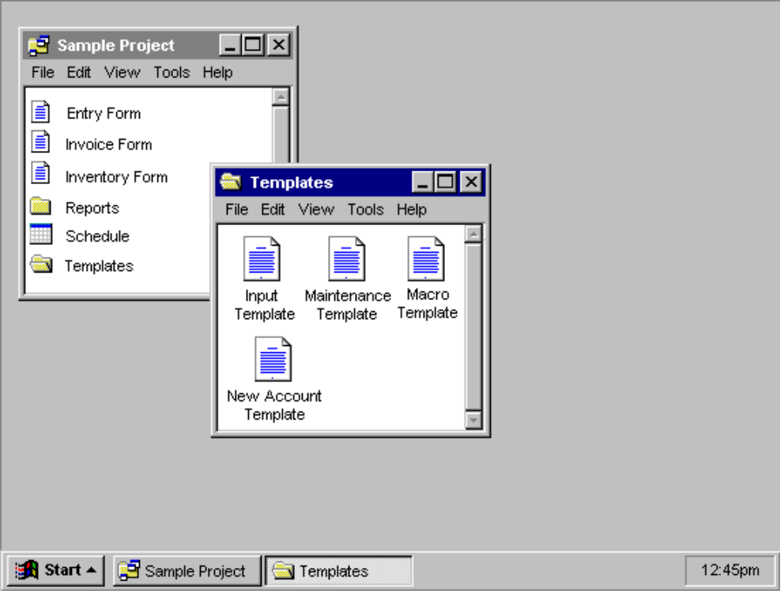

Figure 9.6 A Project.
The windows of objects stored in the project do not share the menu bar or other areas within the project window. Instead, each window has its own interface elements. However, you can provide toolbar palette windows that can be shared among the windows of the objects in the project.

Similar to workspaces and workbooks, a project include should include commands for creating new objects within the project, for transferring existing objects into the project, and for saving any changes for objects stored within the project. In addition, a project includes its own commands and properties.

Combining Alternatives
Workspaces, workbooks, and projects are not necessarily exclusive design techniques. It may be advantageous to combine these techniques. For example, you can design workbooks and projects as objects within a workspace. In similar fashion, a project might contain a workbook as one of its objects.

