C H A P T E R 3

The Windows 95 Environment
This chapter provides a brief overview of some of the basic elements included in the Microsoft Windows 95 operating system (sometimes referred to as the shell).

The Desktop
The desktop is a user's primary work area; it fills the screen and forms the visual background for all operations. However, the desktop is more than just a background. It can also be used as a convenient location to place objects that are stored in the file system. In addition, for a computer connected to a network, the desktop also serves as a private work area through which a user can still browse and access objects remotely located on the network.

The Task Bar
The task bar is a special component of the desktop that can be used to switch between open windows, and to access global commands and other frequently used objects. As a result, it provides a home base — an operational anchor for the interface. Like most application toolbars, the task bar can be configured. It can be undocked from its default location and redocked along another edge of the screen. Figure 3.1 shows the task bar.

Figure 3.1 The Task Bar.
For more information about the task bar, see Chapter 10, "Integrating with the Shell."

Icons
Icons may appear on the desktop and in windows. Icons are pictorial representations of objects. (This is somewhat different from the use of icons in Windows 3.1 which represented minimized windows.) Your software should provide and register icons for the application and any of its associated data or document files.

For more information about the use of icons, see Chapter 10, "Integrating with the Shell." For information about the design of icons, see Chapter 13, "Visual Design."

The Windows 95 environment includes a number of icons that represent basic objects, such as the following:

Table 3.1 Icons
Icon | Type | Function
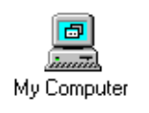 | Computer | Provides access to a user's private storage.
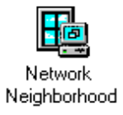 | Network | Provides access to the network.
 | Folder | Provides organization of files and folders.
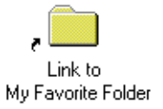 | Link | Provides access to other objects.  (Typically, links are used for providing convenient access to objects that may be stored elsewhere.)
illustration  of the  Find File icon | File Query | Locates files or folders.
illustration  of the  Browser icon | File Browser | Allows browsing the content of a user's computer or the network.
illustration  of the  Control Panel icon | Control Panel | Provides access to properties of installed devices and resources (for example, fonts, displays, and keyboards).

Windows
You can open icons into windows. Windows provide a means of viewing and editing information, and viewing the content and properties of objects. You can also use windows to display parameters to complete commands, palettes of controls, or messages informing a user of a particular situation. Figure 3.2 demonstrates some of the different uses for windows.

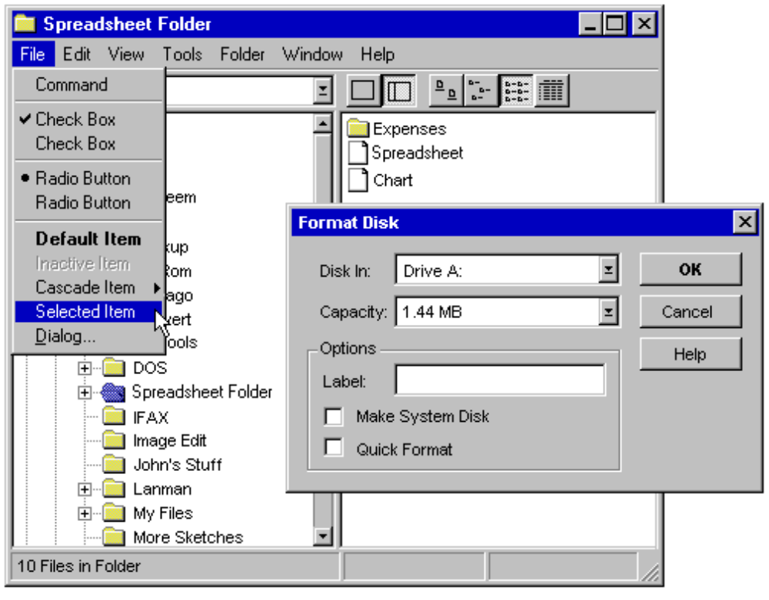

Figure 3.2 Example of Different Windows.
For more information about windows, see Chapter 6, "Windows" and Chapter 8, "Secondary Windows."

