Assignment 5.2 – Projections
Name: Jonathan Cantu
Date: July 4, 2026

Login
Jonathans-MacBook-Pro-M5:week-5 jonathan$ mongosh "mongodb+srv://bellevueuniversity.uzidtds.mongodb.net/" --apiVersion 1 --username web335_user
Enter password: ******
Current Mongosh Log ID: 6a4a9160ee529b6ee35250a8
Connecting to: mongodb+srv://<credentials>@bellevueuniversity.uzidtds.mongodb.net/?appName=mongosh+2.8.3
Using MongoDB: 8.0.24-patch-6a3992052eafe5000797a34e (API Version 1)
Using Mongosh: 2.8.3
mongosh 2.9.2 is available for download: https://www.mongodb.com/try/download/shell

For mongosh info see: https://www.mongodb.com/docs/mongodb-shell/

Atlas atlas-jfajhz-shard-0 [primary] test> show collections
users

1.a.
Atlas atlas-jfajhz-shard-0 [primary] test> db.users.insertOne({
| firstName: "Alice",
| lastName: "Wonderland",
| employeeId: '7777',
| email: "alice@example.com"
| });
|

| db.users.insertMany([
| { firstName: "Frasier", lastName: "Crane", age: 35, email: "frasier.crane@example.com" },
| { firstName: "Niles", lastName: "Crane", age: 33, email: "niles@example.com" }
| ]);
|
{
acknowledged: true,
insertedIds: {
'0': ObjectId('6a4a9314ee529b6ee35250aa'),
'1': ObjectId('6a4a9314ee529b6ee35250ab')
}
}
Atlas atlas-jfajhz-shard-0 [primary] test> db.users.find(
| { lastName: "Crane" }
| )
| ;
[
{
_id: ObjectId('6a4a9314ee529b6ee35250aa'),
firstName: 'Frasier',
lastName: 'Crane',
age: 35,
email: 'frasier.crane@example.com'
},
{
_id: ObjectId('6a4a9314ee529b6ee35250ab'),
firstName: 'Niles',
lastName: 'Crane',
age: 33,
email: 'niles@example.com'
}
]
Atlas atlas-jfajhz-shard-0 [primary] test> db.users.find(
| { firstName: "Alice" }
| )
| ;
[
{
_id: ObjectId('6a4a9314ee529b6ee35250a9'),
firstName: 'Alice',
lastName: 'Wonderland',
employeeId: '7777',
email: 'alice@example.com'
}
]

1.b.
Atlas atlas-jfajhz-shard-0 [primary] test> db.users.updateOne(
| { employeeId: "7777" },
| { $set: { email: "AliceInWonderland@example.com" } }
| );
|
{
acknowledged: true,
insertedId: null,
matchedCount: 1,
modifiedCount: 1,
upsertedCount: 0
}
Atlas atlas-jfajhz-shard-0 [primary] test> db.users.find(
| { lastName: "Wonderland" }
| )
| ;
[
{
_id: ObjectId('6a4a9314ee529b6ee35250a9'),
firstName: 'Alice',
lastName: 'Wonderland',
employeeId: '7777',
email: 'AliceInWonderland@example.com'
}]
1.c.
Atlas atlas-jfajhz-shard-0 [primary] test> db.users.find(
| {},
| { firstName: 1, lastName: 1, email: 1, _id: 0 }
| ).forEach(doc => printjson(doc));
{
firstName: 'Johann',
lastName: 'Bach',
email: 'jbach@me.com'
}
{
firstName: 'Ludwig',
lastName: 'Beethoven',
email: 'lbeethoven@me.com'
}
{
firstName: 'Wolfgang',
lastName: 'Mozart',
email: 'wmozart@me.com'
}
{
firstName: 'Johannes',
lastName: 'Brahms',
email: 'jbrahms@me.com'
}
{
firstName: 'Richard',
lastName: 'Wagner',
email: 'rwagner@me.com'
}
{
firstName: 'Claude',
lastName: 'Debussy',
email: 'cdebussy@me.com'
}
{
firstName: 'Alice',
lastName: 'Wonderland',
email: 'AliceInWonderland@example.com'
}
{
firstName: 'Frasier',
lastName: 'Crane',
email: 'frasier.crane@example.com'
}
{
firstName: 'Niles',
lastName: 'Crane',
email: 'niles@example.com'
}

Screenshots
1.a.
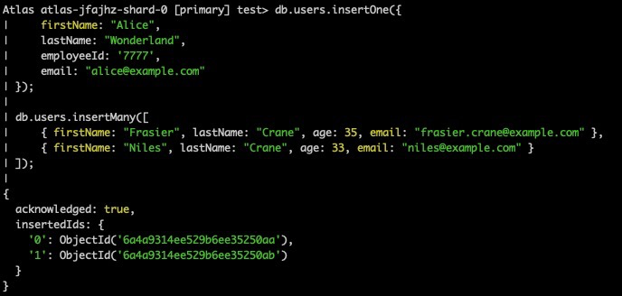

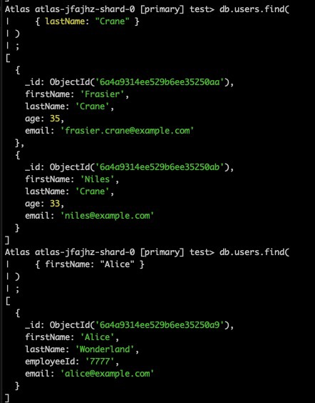
1.b.
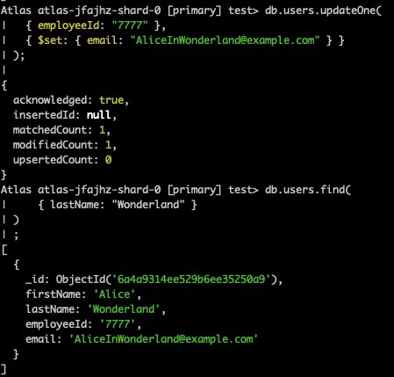

1.c.
