Section 1: Introduction

1.1 Purpose
Identify the team captain, team name, mascot, and provide a short bio of each team member. Identify the goals of the website. Identify the core users of the website.

1.1.1 Team
Team: Jennifer Syder and Jonathan Cantu
Team Captain: Jonathan Cantu
Team Name: Unidentified Formatting Objects (U.F.O.)
Team Mascot: A cute, friendly little UFO
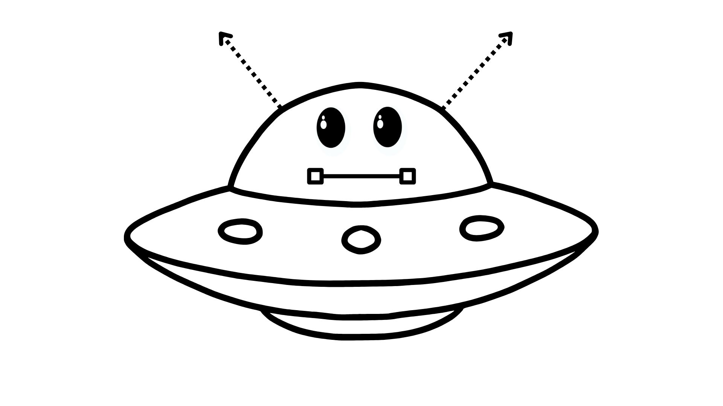
Mascot & Name Meaning:
The team name is a play on web development terminology, and the cute UFO mascot represents our goal to "abduct" the outdated, manual process of shopping for used books and elevate it to an out-of-this-world digital user experience.
Team Bios:
Jonathan C.: Jonathan is a developer who excels in back-end logic, database management, and Python. He enjoys diving into complex technical tasks and ensuring the core functionality of the application runs flawlessly behind the scenes.
Jennifer Snyder: Jennifer is a web developer currently taking summer courses to expand her full-stack skills. When she isn't organizing team projects or coding, she enjoys staying active and getting outside to go rollerblading.

1.1.2 Goals of the Website/Application
The primary goal of this application is to establish a simple, local, computer-based solution for WhatABook customers. It aims to digitally expand the store's presence by allowing users to easily browse in-store inventory, view books by specific authors or genres, and maintain a personal wish list of items they want to purchase.

1.1.3 Core Users of the Website
The core users of this application are middle-aged WhatABook customers who possess minimal computer experience. Because of this, the interface must prioritize extreme simplicity, accessibility, and straightforward navigation over complex features.

1.2 Personas
Create at least three (3) detailed personas to represent the core users of the website.

Persona 1: Dolly (Age 56)
- Emoji/Icon: 👩‍💼
- Demographics: 56 years old, mother of two, grandmother of one. Works full-time at a call center.
- Hobbies: Huge Elvis fan.
- Computer Skill Level: Minimal to moderate. Can navigate basic interfaces but gets anxious about making mistakes.
- Design-Impacting Characteristics: Semi-busy schedule. Tends to overthink software layout and prefers writing physical notes on how to use apps.
- App Needs: Needs text to be explicit and predictable, with a safety net of clear instructions.
- Most Used Feature: Centralized Help Center for reading and transcribing user instructions.
- Least Used Feature: In-depth book details/author background listings (avoids cognitive overload).
- Additional Elements: Call center background means she appreciates good phone support, loves printing out recipes, and coordinating family events.

Persona 2: Howard "Howie" (Age 67)
- Emoji/Icon: 👴⚓
- Demographics: 67 years old, retired sailor, father of four, grandfather of seven.
- Hobbies: Tinkering with and working on cars, sailing culture.
- Computer Skill Level: Low. Frequently requires assistance from family members to troubleshoot apps or navigate new websites.
- Design-Impacting Characteristics: Has all the time in the world but struggles with poor eyesight and mild OCD tendencies regarding organization and alignment.
- App Needs: Strong ADA compliance, adjustable large text options, ultra-simplistic layout with large buttons.
- Most Used Feature: Show a Listing of Books by Genre (to easily find car and sailing books) and View Wishlist to save them.
- Least Used Feature: Search for Book by bookId (too tedious and frustrating for his eyesight).
- Additional Elements: Prefers physical paperback books, hates small touchscreens, relies heavily on keyboard shortcuts when possible.

Persona 3: Marge (Age 38)
- Emoji/Icon: 🧘‍♀️🐸
- Demographics: 38 years old, busy yoga instructor and aspiring author. Mother of three kids.
- Hobbies: Studying nature, frogs, and crabs for her book niches.
- Computer Skill Level: Moderate. "Knows some stuff" and adapts quickly to modern mobile and desktop layouts.
- Design-Impacting Characteristics: Constantly multitasking and extremely "busy busy." Has low tolerance for slow or overly complicated workflows.
- App Needs: A fast, visual experience that lets her curate ideas on the fly and submit feedback easily.
- Most Used Feature: Add Books to a Wishlist (using it like a Pinterest board for writing inspiration).
- Least Used Feature: The Help Center (she prefers to figure things out dynamically and has no time to read guides).
- Additional Elements: Writes her drafts in markdown/cloud docs, uses social media for book promotion inspiration, frequently listens to audiobooks while teaching yoga.

1.3 User Stories
Create five user stories per persona using standard story writing format (there should be a
total of fifteen (15) user stories).

Dolly's User Stories
Persona Role | User Story (As a... I need... so that...) | Documented Assumptions | Size Estimation (Fibonacci)
Dolly (Nervous User) | As a user with minimal computer experience, I need a centralized Help Center, so that I can physically write step-by-step instructions on how to navigate the app. | Assumes WhatABook will include a static, easy-to-find Help or FAQ page in the main navigation. | 3
Dolly (Elvis Fan) | As a music fan, I need to view a list of books by genre, so that I can easily browse biographies without having to type out complex search terms. | Assumes the database will have genres mapped out (e.g., "Biography" or "Music") that can be selected via a button or dropdown. | 5
Dolly (Grandmother) | As a grandmother, I need to search for a book by its title, so that I can quickly check if WhatABook carries a specific book my grandchild requested. | Assumes she knows the exact title of the book she is looking for and can spell it correctly in the search bar. | 5
Dolly (Methodical Shopper) | As a methodical shopper, I need to add books to a wish list, so that I can save them and decide if I want to purchase them later. | Assumes the wish list is persistent and saves her selections even if she closes the application. | 8
Dolly (Call Center Worker) | As a busy full-time worker, I need to view my wish list, so that I can quickly access the books I saved previously without having to search for them all over again. | Assumes navigating to the wish list requires only a single, clearly labeled click from the main menu. | 5

Howie's User Stories
Persona Role | User Story (As a... I need... so that...) | Documented Assumptions | Size Estimation (Fibonacci)
Howie (Retired Sailor/Hobbyist) | As a retired sailor, I need to view a listing of books by genre, so that I can easily find books about maritime history and auto repair without having to type. | Assumes the database includes specific non-fiction genres, and that genres are selectable via a clean list or dropdown. | 5
Howie (Organized Reader) | As a user with OCD tendencies, I need to view my wish list in a clean, organized format, so that I can keep track of my favorite books without feeling visually overwhelmed. | Assumes the application formats the wish list output neatly and consistently. | 5
Howie (Car Tinkerer) | As a hobbyist with plenty of free time, I need to add books to my wish list, so that I can slowly collect reference manuals for my car restoration projects. | Assumes the application allows users to save an unlimited or large number of books to their wish list. | 8
Howie (Leisurely Browser) | As a retiree looking to pass the time, I need to browse the entire in-store book listing, so that I can discover new topics I might not have thought to search for. | Assumes the main catalog view cleanly displays all available WhatABook inventory. | 3
Howie (Loyal Reader) | As an older user who follows specific classic writers, I need to view a listing of books by author, so that I can see everything WhatABook has by my favorite authors. | Assumes the database accurately links and groups all books written by the same author. | 5

Marge's User Stories
Persona Role | User Story (As a... I need... so that...) | Documented Assumptions | Size Estimation (Fibonacci)
Marge (Aspiring Author) | As an aspiring author, I need to add books to my wish list, so that I can curate an inspirational "mood board" of books about nature, frogs, and crabs. | Assumes the wish list can function as a saved, ongoing collection of reference materials. | 8
Marge (Busy Multitasker) | As a multitasking professional, I need to view my wish list, so that I can easily recall the inspirational books I saved when I finally have a moment to sit down and write. | Assumes the wish list is securely tied to her specific customerId and saves reliably across different sessions. | 5
Marge (Yoga Instructor) | As a busy yoga instructor, I need to view a listing of books by author, so that I can quickly find works by my favorite mindfulness experts between classes. | Assumes author names are clearly formatted and easy to quickly scan on a mobile device or screen. | 5
Marge (Busy Mother) | As a mother of three, I need to search for a book by title, so that I can quickly find the exact bedtime story my kids asked for without wasting time. | Assumes the title search functionality is fast, accurate, and returns immediate results. | 5
Marge (Niche Researcher) | As a nature writer, I need to view a listing of books by genre, so that I can research what other books have been published in my specific niche. | Assumes the genres in the WhatABook catalog are descriptive enough to help her conduct market research. | 5

1.4 Work Estimation
Feature | Supported stories | Task | Work hours | Task points
Help Center | 1 | Identify commands and workflows needing instructions | 0.5 | 1
Help Center | 1 | Write clear step-by-step help content | 1 | 1
Help Center | 1 | Add a Help option to the Python menu | 1 | 1
Help Center | 1 | Format instructions for console readability | 1 | 1
Help Center | 1 | Test navigation and revise unclear instructions | 1 | 1
Browse all books | 1 | Add a catalog option to the main menu | 0.5 | 1
Browse all books | 1 | Query all books from MongoDB | 1 | 1
Browse all books | 1 | Sort books consistently by title or author | 0.5 | 1
Browse all books | 1 | Format the full catalog for console display | 1.5 | 2
Browse all books | 1 | Test the complete inventory output | 1 | 1
View books by genre | 3 | Review and validate genre values in the collection | 1 | 1
View books by genre | 3 | Add a numbered genre-selection menu | 1 | 2
View books by genre | 3 | Write the MongoDB genre query | 1.5 | 2
View books by genre | 3 | Sort and format matching books | 1 | 1
View books by genre | 3 | Test valid, invalid, and empty results | 1.5 | 2
View books by author | 2 | Add an author-search menu option | 0.5 | 1
View books by author | 2 | Capture and normalize the author name | 1 | 2
View books by author | 2 | Write a case-insensitive author query | 1.5 | 2
View books by author | 2 | Sort and format matching books | 1 | 1
View books by author | 2 | Test exact, partial, and missing authors | 1.5 | 2
Search by title | 2 | Add a title-search menu option | 0.5 | 1
Search by title | 2 | Capture and sanitize the title input | 1 | 2
Search by title | 2 | Write a case-insensitive title query | 1.5 | 2
Search by title | 2 | Format matching books for display | 1 | 1
Search by title | 2 | Test exact, partial, invalid, and missing titles | 1.5 | 2
Add to wishlist | 3 | Prompt for customer ID and book ID | 1 | 2
Add to wishlist | 3 | Verify that the customer exists | 1 | 2
Add to wishlist | 3 | Verify that the book exists | 1 | 2
Add to wishlist | 3 | Check for duplicate wishlist entries | 1 | 2
Add to wishlist | 3 | Insert and confirm the wishlist item | 1.5 | 3
Add to wishlist | 3 | Test successful, invalid, and repeated additions | 2 | 3
View wishlist | 3 | Capture and validate the customer ID | 1 | 1
View wishlist | 3 | Retrieve wishlist records for the customer | 1 | 2
View wishlist | 3 | Join wishlist records with book information | 2 | 3
View wishlist | 3 | Sort and format the complete wishlist | 1.5 | 2
View wishlist | 3 | Test valid, invalid, empty, and long wishlists | 1.5 | 2
Application integration | All 15 | Create the main Python console menu | 1.5 | 3
Application integration | All 15 | Configure the MongoDB connection | 1 | 2
Application integration | All 15 | Connect menu choices to feature functions | 2 | 3
Application integration | All 15 | Add reusable input validation and error handling | 2 | 3
Application integration | All 15 | Perform end-to-end application testing | 3 | 5

Section 2: Process Design

2.1 Sitemap
This menu structure supports the personas’ needs while keeping navigation simple and predictable. Dolly benefits from the centralized Help Center, Howie can browse books and view an organized wishlist, and Marge can quickly search for books and save them for later. Each completed operation returns the customer to the main menu unless the customer chooses to exit.
WhatABook Console Application
│
├── 1. View All Books
│ └── Display the complete used-book inventory
│
├── 2. Search for Books
│ ├── Search by Title
│ ├── Search by Author
│ └── Browse by Genre
│
├── 3. Wishlist Management
│ ├── View Customer Wishlist
│ └── Add Book to Wishlist
│
├── 4. Help Center
│ ├── Application Instructions
│ ├── Menu Explanations
│ └── Input Examples
│
└── 5. Exit Application

Prototypes
Main Menu

========================================
WHATABOOK
Used Science Fiction & Fantasy Books
========================================

1. View All Books
2. Search for Books
3. View My Wishlist
4. Add a Book to My Wishlist
5. Help Center
6. Exit

Enter a menu option:

Search Menu

----------------------------------------
SEARCH BOOKS
----------------------------------------

1. Search by Title
2. Search by Author
3. Browse by Genre
4. Return to Main Menu

Enter a menu option:

Book Search Results

----------------------------------------
SEARCH RESULTS
----------------------------------------

Book ID: B1024
Title: The Sword of Shannara
Author: Terry Brooks
Genre: Fantasy
Condition: Very Good
Price: $24.95
First Edition: Yes
Signed: No

1. Add Book to Wishlist
2. Perform Another Search
3. Return to Main Menu

Customer Wishlist

----------------------------------------
CUSTOMER WISHLIST
----------------------------------------

Customer: Dolly Williams
Customer ID: C1001

1. The Hobbit
Author: J.R.R. Tolkien
Price: $18.95

2. Interview with the Vampire
Author: Anne Rice
Price: $14.95

3. The Black Unicorn
Author: Terry Brooks
Price: $11.95

Total Wishlist Items: 3

Press Enter to return to the main menu.

Help Center

----------------------------------------
HELP CENTER
----------------------------------------

VIEW ALL BOOKS
Displays the complete bookstore inventory.

SEARCH FOR BOOKS
Search by title, author, or genre.

VIEW MY WISHLIST
Enter your customer ID to display saved books.

ADD TO WISHLIST
Enter your customer ID and the desired book ID.

Press Enter to return to the main menu.

Consistency and predictability: Every screen uses the same heading style, numbered menu format, spacing, and return-to-menu behavior. This reduces confusion and helps users with limited computer experience understand what will happen after each selection.

Clear feedback and error prevention: The application confirms successful actions and provides specific messages for invalid customer IDs, book IDs, menu choices, and duplicate wishlist entries. For example:

Book successfully added to your wishlist.
OR
That book is already in your wishlist.

Readability and accessibility: The console design uses plain language, short instructions, large visual separators, and uncluttered output. These choices support Howie’s poor eyesight and preference for organized displays while also helping Dolly avoid feeling overwhelmed.

ORD

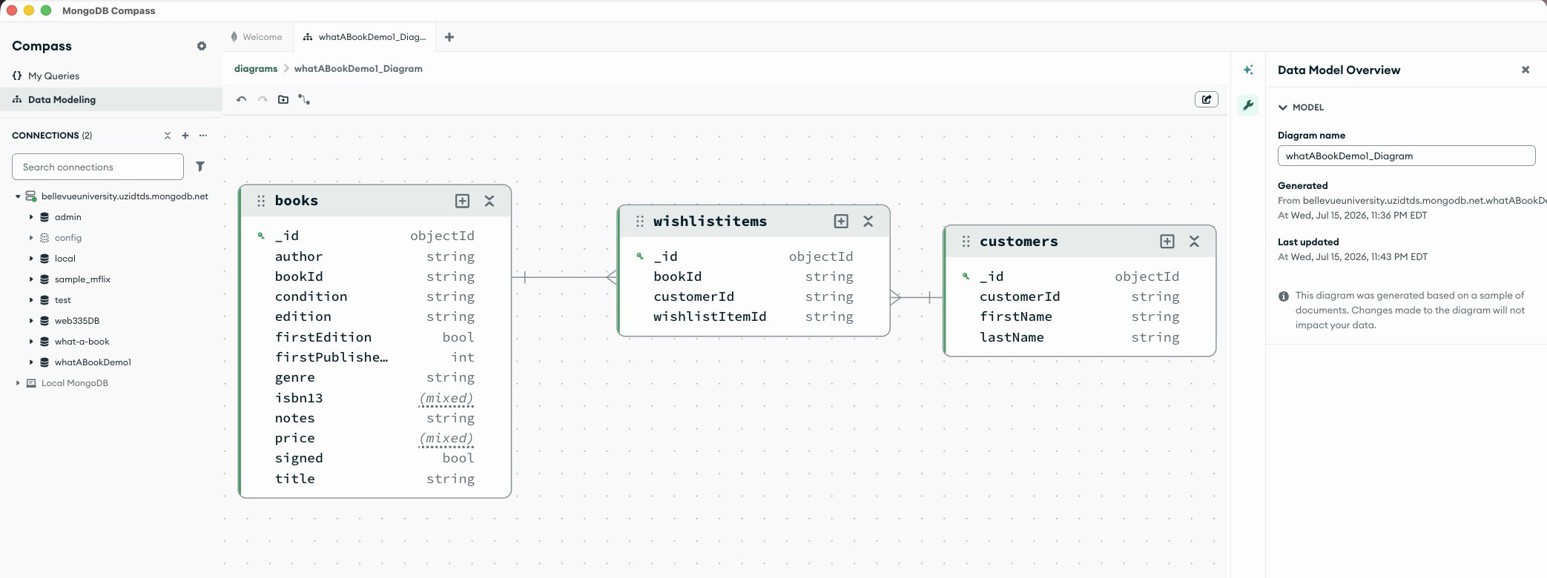

NoSQL Data Structure
Books Collection:
[
{
"bookId": "b1001",
"title": "The Hobbit",
"author": "J.R.R. Tolkien",
"genre": "Fantasy",
"isbn13": "9780547928227",
"firstPublishedYear": 1937,
"edition": "Mariner Books paperback edition",
"condition": "Very Good",
"price": 12.95,
"signed": false,
"firstEdition": false,
"notes": "A classic adventure set in Middle-earth."
},
{
"bookId": "b1009",
"title": "The Sword of Shannara",
"author": "Terry Brooks",
"genre": "Fantasy",
"isbn13": null,
"firstPublishedYear": 1977,
"edition": "1997 Easton Press Masterpieces of Fantasy signed collector's edition",
"condition": "Fine",
"price": 495.0,
"signed": true,
"firstEdition": false,
"notes": "Leather-bound with gold-gilded page edges and a Certificate of Authenticity signed by Terry Brooks and dated May 8, 1999. Collector's edition may not carry a standard ISBN."
}
]

Customer Collection

[
{
"customerId": "c1001",
"firstName": "Jonathan",
"lastName": "Cantu"
},
{
"customerId": "c1002",
"firstName": "Jennifer",
"lastName": "Snyder"
},
{
"customerId": "c1003",
"firstName": "Dolly",
"lastName": "Presley"
},
{
"customerId": "c1004",
"firstName": "Howard",
"lastName": "Mariner"
},
{
"customerId": "c1005",
"firstName": "Marge",
"lastName": "Meadow"
}
]

Wishlistitems Collection

[
{
"wishlistItemId": "w1001",
"customerId": "c1001",
"bookId": "b1001"
},
{
"wishlistItemId": "w1002",
"customerId": "c1002",
"bookId": "b1002"
},
{
"wishlistItemId": "w1003",
"customerId": "c1003",
"bookId": "b1003"
},
{
"wishlistItemId": "w1004",
"customerId": "c1004",
"bookId": "b1004"
}
]

Retrospective

Team Challenges

What would you do differently?

