Assignment 9.2 - Deploying Your API on Render

Welcome to "Assignment 9.2 - Deploying Your API on Render." For this week's assignment you will be learning how to deploy your API.

Required Action:

Using what you learned from this week's reading assignment, complete "Hands-On 8.1: Deploying Your API on Render" from the "Pragmatic RESTful APIs with NodeJS and Express" textbook.

Do not forget to stage, commit, and push your work to GitHub.

Submission Instructions:

- Due Date: Day 7 of the week by 11:59 PM (CST/CDT).
- Screenshots of your computer's folder structure and your GitHub repo folder structure, following the guidelines outlined above. Add the images to a single Word document and name the file {yourlastname}-{assignment-number}.
- Link to your web-420 GitHub repo.
- Link to your Render deployment website.

SOLUTION:
Here's my git repo:
https://github.com/joncantu-nh/in-n-out-books

Here's the renderer URL:
https://in-n-out-books-1gs9.onrender.com/

Project Folder Screenshot:
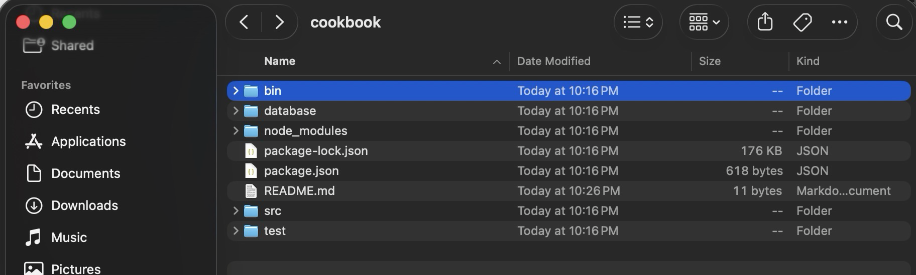
Here's my local folder structure:
Jonathans-MacBook-Pro-M5:Projects jonathan$ tree -L 4 in-n-out-books/
in-n-out-books/
├── bin
│ └── www
├── database
│ ├── books.js
│ ├── collection.js
│ └── users.js
├── package-lock.json
├── package.json
├── public
│ ├── images
│ ├── index.html
│ ├── javascripts
│ └── stylesheets
│ └── style.css
├── README.md
├── routes
│ ├── auth.js
│ ├── books.js
│ ├── index.js
│ └── users.js
├── src
│ └── app.js
└── test
├── app.spec.js
└── setup.js

10 directories, 16 files
Jonathans-MacBook-Pro-M5:Projects jonathan$ ls -al in-n-out-books/
total 416
drwxr-xr-x 15 jonathan staff 480 Aug 1 22:28 .
drwxr-xr-x 34 jonathan staff 1088 Aug 1 22:17 ..
-rw-r--r--@ 1 jonathan staff 8196 Aug 1 22:17 .DS_Store
-rw-r--r-- 1 jonathan staff 275 Aug 1 22:17 .editorconfig
drwxr-xr-x 12 jonathan staff 384 Aug 1 22:28 .git
-rw-r--r-- 1 jonathan staff 160 Aug 1 22:17 .gitignore
drwxr-xr-x 3 jonathan staff 96 Aug 1 22:17 bin
drwxr-xr-x 5 jonathan staff 160 Aug 1 22:17 database
-rw-r--r-- 1 jonathan staff 183521 Aug 1 22:17 package-lock.json
-rw-r--r--@ 1 jonathan staff 768 Aug 1 22:17 package.json
drwxr-xr-x 7 jonathan staff 224 Aug 1 22:17 public
-rw-r--r-- 1 jonathan staff 17 Aug 1 22:28 README.md
drwxr-xr-x 6 jonathan staff 192 Aug 1 22:17 routes
drwxr-xr-x 3 jonathan staff 96 Aug 1 22:17 src
drwxr-xr-x 4 jonathan staff 128 Aug 1 22:17 test

