Assignment 4.2 – Developing a JSON Web Service
Jonathan Cantu
June 28, 2026

Directory Structure:
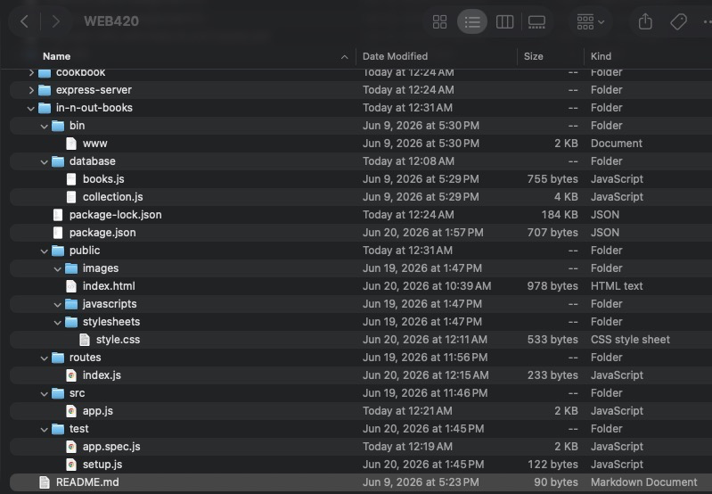

Repo Structure:

