Assignment 6.2 – Developing a JSON Web Service (PUT)
Jonathan Cantu
July 12, 2026

Directory Structure:
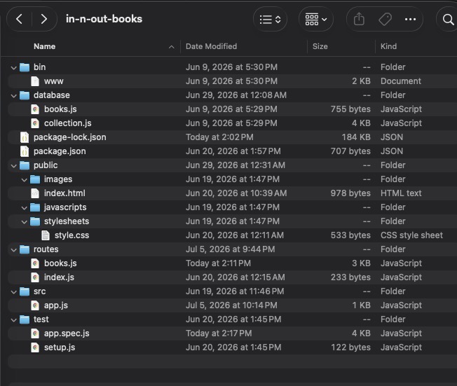

Repo Structure:

