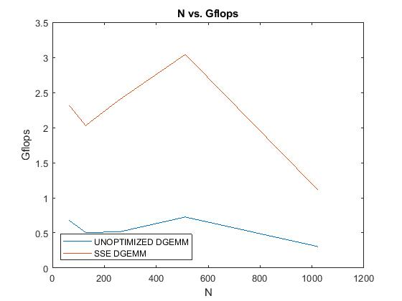

The SSE_DGEMM is faster because if it is a smaller execution rate than the Gflops will in turn become larger and create a graph like above where you see SSE_DGEMM surpasses UNOPTIMIZED_DGEMM in Gflops Value.