ZipGrade Score Report

# AP Comp Science Unit 8 Test

Date Created: Apr 26 2018 10:20 AM  
Date Exported: May 02 2018 02:14 PM

Classes:   
 - 2nd

# Summary Statistics

Number of Scores: 10  
Points Possible: 40

Mean (raw/percent): 29.1 / 72.75%  
Standard Deviation (raw/percent): 8.24 / 20.6%

Max (raw/percent): 37.0 / 92.5%  
Q3 (raw/percent): 34.0 / 85.0%  
Median (raw/percent): 83.75 / 83.75%  
Q1 (raw/percent): 20.0 / 50.0%  
Min (raw/percent): 14.0 / 35.0%

# Grade Distribution

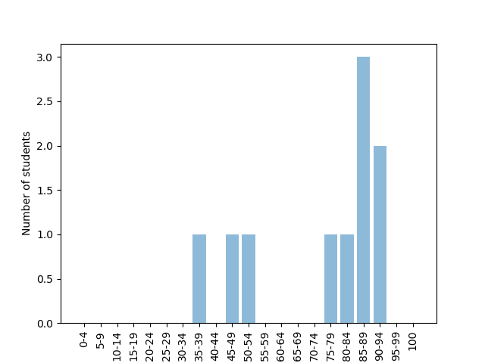

# Difficulty Analysis

## Key version: A

Most difficult Questions (at least 12.0% missed)  
 q=23, n=8, %=16.0  
 q=22, n=7, %=14.0  
 q=39, n=7, %=14.0  
 q=25, n=6, %=12.0  
 q=40, n=6, %=12.0

Easiest Questions (no more than 0.0% missed)  
 q=1, n=0, %=0.0  
 q=3, n=0, %=0.0  
 q=6, n=0, %=0.0  
 q=9, n=0, %=0.0

# Class scores for 2nd

|  |  |  |  |
| --- | --- | --- | --- |
| Name | Raw | Possible | Percent |
| Babbage, Charles | 34 | 40 | 85% |
| Berners-Lee, Tim | 19 | 40 | 47.5% |
| Boole, George | 20 | 40 | 50% |
| Brin, Sergey | 33 | 40 | 82.5% |
| Ellison, Larry | 14 | 40 | 35% |
| Gates, Bill | 34 | 40 | 85% |
| Gosling, James | 30 | 40 | 75% |
| Hopper, Grace | 36 | 40 | 90% |
| Torvalds, Linus | 34 | 40 | 85% |
| Van Rossum, Guido | 37 | 40 | 92.5% |

# Individual student reports for 2nd

**Babbage, Charles**ID: 97867  
Test: AP Comp Science Unit 8 Test  
Key: A  
Class: 2nd  
Raw: 34/40  
Percent: 85%  
Response Summary: (Correct)  
 1. C 2. A 3. B 4. C 5. C  
 6. E 7. D 8. C 9. B 10. B  
 11. B 12. C 13. B 14. E 15. A  
 16. D 17. C 18. B 19. B 20. E  
 21. D 22. C (B) 23. A (B) 24. A (D) 25. D  
 26. A 27. D 28. E 29. E 30. C  
 31. C 32. C 33. C (E) 34. D (B) 35. E  
 36. C 37. D 38. A 39. E (D) 40. C

**Berners-Lee, Tim**ID: 58718  
Test: AP Comp Science Unit 8 Test  
Key: A  
Class: 2nd  
Raw: 19/40  
Percent: 47.5%  
Response Summary: (Correct)  
 1. C 2. A 3. B 4. C 5. B (C)  
 6. E 7. B (D) 8. C 9. B 10. B  
 11. B 12. B (C) 13. A (B) 14. B (E) 15. D (A)  
 16. A (D) 17. C 18. A (B) 19. A (B) 20. C (E)  
 21. D 22. C (B) 23. D (B) 24. D 25. A (D)  
 26. C (A) 27. D 28. D (E) 29. B (E) 30. D (C)  
 31. B (C) 32. B (C) 33. E 34. E (B) 35. E  
 36. C 37. D 38. A 39. D 40. A (C)

**Boole, George**ID: 10101  
Test: AP Comp Science Unit 8 Test  
Key: A  
Class: 2nd  
Raw: 20/40  
Percent: 50%  
Response Summary: (Correct)  
 1. C 2. A 3. B 4. B (C) 5. C  
 6. E 7. D 8. C 9. B 10. C (B)  
 11. A (B) 12. C 13. B 14. D (E) 15. D (A)  
 16. B (D) 17. C 18. B 19. A (B) 20. E  
 21. B (D) 22. A (B) 23. D (B) 24. C (D) 25. E (D)  
 26. A 27. C (D) 28. E 29. D (E) 30. C  
 31. A (C) 32. C 33. E 34. B 35. C (E)  
 36. C 37. A (D) 38. D (A) 39. B (D) 40. A (C)

**Brin, Sergey**ID: 12326  
Test: AP Comp Science Unit 8 Test  
Key: A  
Class: 2nd  
Raw: 33/40  
Percent: 82.5%  
Response Summary: (Correct)  
 1. C 2. A 3. B 4. C 5. C  
 6. E 7. D 8. C 9. B 10. E (B)  
 11. B 12. C 13. B 14. E 15. A  
 16. D 17. B (C) 18. A (B) 19. B 20. E  
 21. D 22. B 23. A (B) 24. D 25. B (D)  
 26. A 27. D 28. E 29. E 30. C  
 31. C 32. C 33. E 34. B 35. C (E)  
 36. C 37. D 38. A 39. C (D) 40. C

**Ellison, Larry**ID: 53643  
Test: AP Comp Science Unit 8 Test  
Key: A  
Class: 2nd  
Raw: 14/40  
Percent: 35%  
Response Summary: (Correct)  
 1. C 2. D (A) 3. B 4. C 5. C  
 6. E 7. D 8. B (C) 9. B 10. B  
 11. D (B) 12. E (C) 13. A (B) 14. C (E) 15. E (A)  
 16. B (D) 17. C 18. E (B) 19. B 20. A (E)  
 21. D 22. E (B) 23. B 24. C (D) 25. B (D)  
 26. D (A) 27. D 28. A (E) 29. A (E) 30. D (C)  
 31. B (C) 32. C 33. B (E) 34. A (B) 35. A (E)  
 36. E (C) 37. B (D) 38. C (A) 39. C (D) 40. A (C)

**Gates, Bill**ID: 34782  
Test: AP Comp Science Unit 8 Test  
Key: A  
Class: 2nd  
Raw: 34/40  
Percent: 85%  
Response Summary: (Correct)  
 1. C 2. A 3. B 4. C 5. C  
 6. E 7. D 8. C 9. B 10. B  
 11. B 12. C 13. B 14. D (E) 15. A  
 16. D 17. C 18. B 19. B 20. E  
 21. D 22. C (B) 23. D (B) 24. D 25. D  
 26. A 27. D 28. E 29. E 30. C  
 31. B (C) 32. C 33. E 34. E (B) 35. E  
 36. C 37. D 38. A 39. D 40. A (C)

**Gosling, James**ID: 23472  
Test: AP Comp Science Unit 8 Test  
Key: A  
Class: 2nd  
Raw: 30/40  
Percent: 75%  
Response Summary: (Correct)  
 1. C 2. A 3. B 4. C 5. C  
 6. E 7. D 8. C 9. B 10. C (B)  
 11. B 12. B (C) 13. B 14. E 15. A  
 16. D 17. C 18. B 19. D (B) 20. E  
 21. D 22. (B) 23. C (B) 24. D 25. E (D)  
 26. A 27. D 28. D (E) 29. E 30. C  
 31. C 32. C 33. E 34. B 35. E  
 36. C 37. D 38. B (A) 39. E (D) 40. E (C)

**Hopper, Grace**ID: 19233  
Test: AP Comp Science Unit 8 Test  
Key: A  
Class: 2nd  
Raw: 36/40  
Percent: 90%  
Response Summary: (Correct)  
 1. C 2. A 3. B 4. C 5. C  
 6. E 7. D 8. C 9. B 10. B  
 11. B 12. C 13. B 14. E 15. A  
 16. D 17. C 18. B 19. D (B) 20. E  
 21. D 22. D (B) 23. B 24. D 25. D  
 26. B (A) 27. D 28. E 29. E 30. C  
 31. C 32. C 33. E 34. B 35. E  
 36. C 37. D 38. A 39. E (D) 40. C

**Torvalds, Linus**ID: 23806  
Test: AP Comp Science Unit 8 Test  
Key: A  
Class: 2nd  
Raw: 34/40  
Percent: 85%  
Response Summary: (Correct)  
 1. C 2. A 3. B 4. C 5. C  
 6. E 7. D 8. C 9. B 10. D (B)  
 11. A (B) 12. C 13. B 14. E 15. B (A)  
 16. D 17. C 18. B 19. B 20. E  
 21. D 22. B 23. D (B) 24. D 25. B (D)  
 26. A 27. D 28. E 29. E 30. C  
 31. C 32. C 33. E 34. B 35. E  
 36. C 37. D 38. A 39. D 40. A (C)

**Van Rossum, Guido**ID: 95620  
Test: AP Comp Science Unit 8 Test  
Key: A  
Class: 2nd  
Raw: 37/40  
Percent: 92.5%  
Response Summary: (Correct)  
 1. C 2. A 3. B 4. C 5. C  
 6. E 7. D 8. C 9. B 10. B  
 11. B 12. C 13. B 14. E 15. E (A)  
 16. D 17. C 18. B 19. B 20. E  
 21. D 22. B 23. A (B) 24. D 25. D  
 26. A 27. D 28. E 29. E 30. C  
 31. C 32. C 33. E 34. B 35. E  
 36. C 37. D 38. A 39. E (D) 40. C