**Election Analysis Audit:**

1. **Overview of Election Audit:**

In this Project, we needed to help Tom with gathering election results based on the given csv file. We are given ballot_id, which is a unique identifier for each voter, which county they are from, and which candidate they voted for in the election. The objective is to determine the total number of votes, this is important to determine the percentage of votes per candidate, number and percentage of votes per county, and number and percentage of votes for each candidate, find the county with the most votes and lastly find the winner of the election with the number and percentage of votes.

1. **Election-Audit Results:**
   * The total number of votes in the congressional election is 369,711. This was derived with the code snippet

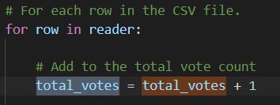

First we declared the total_votes to 0, this will allow us to start the count. Next when we iterate through the full csv file we will continuously add 1 as a tally to each the variable total votes. After iterating through the full csv file we will get the total votes.

Output:

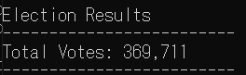

To determine data for each county, such as the number of votes and percentage per county, it is needed to

Determine all the unique counties

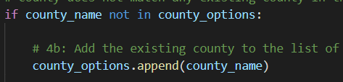

This say to add county to our list if it is not already there and start the count at 0.

If it is determined the is not unique, iterate through the csv tallying 1. dict county_votes have to different values stored, the county name with the county votes. This will determine the county total votes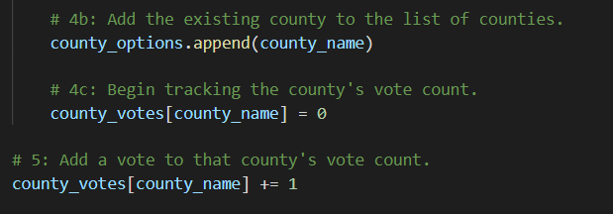

Lastly now that we have the number we need, being the total votes and all the county specific votes all that is needed to be done is the arithmetic equation to determine the percentage of votes.

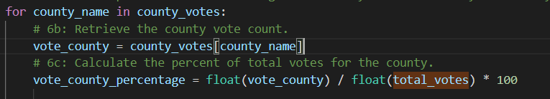

* + To determine the largest county we use a sorting algorithm to find the largest county. This will go through the list, compare the first 2 totals and which ever total is larger is compared to the next county total until the end. Once gone through the whole list, the largest will be stored in the winning count

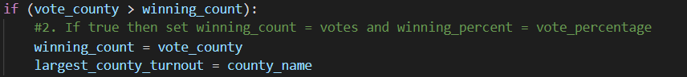

* To determine the number and percentage of votes for each candidate, the same strategy would be used for getting the county total and county percentage. Start tally and 0. Determine uniqiue candidates, iterate through the csv file and tally the votes based on the outcome.
  + The winner election Diana DeGette, with 272,892 votes and 73.8% of all the votes. To gather this information, the same strategy is used for finding the largest country, except instead of finding the largest county we find the largest candidate.

1. **Election-Audit Summary:**

On this script we determined three main things, Total number of votes, total votes for each county and candidates and percentage for each vote’s candidate. This script can be used for automating the tallying of the election voting instead of manually counting the votes. This script can be used for other precincts where their votes need to be tallied for each county. This is because no value is hard coded for either the candidate or the county. If we have a well formatted csv with the right headers, then the data will be able to be pulled the same way and automatically insert the county and the candidate’s name. This script can be used for governor’s election and modified to be for presidential elections. It would need to be modified for the electoral college for each state and would need to hard code the electoral college for each state. Or instead have a csv for each state and just tally the votes after. Another way this could be used in a different election is using the total number of votes casted and using that as the best way to determine where to hold rallies and campaign a little harder in those areas.