**PyBer_Analysis**

**Overview of Analysis**

The goal of this analysis is to compare and contrast of the total weekly fares for each type of community, rural or suburban or urban, over time. To properly analyze this we extract ride count, average fare per ride, and average number of drivers. We compare this on a multiple line graph to show the difference over he difference month to see if there are any correlations.

**Results**

[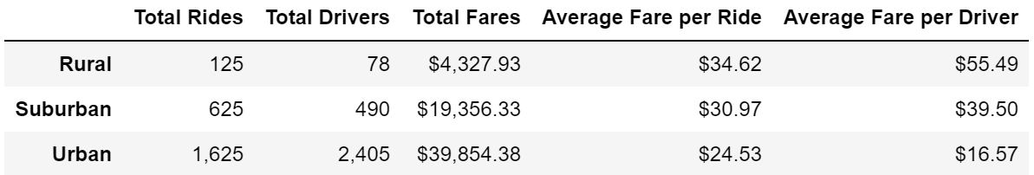](https://github.com/caseychen3605/PyBer_Analysis/blob/main/Analysis/Summary_DataFrame.PNG)

After this analysis it indicates that overall there is a correlation while comparing the different communities with rural versus suburban versus urban. Urban communities tend to be the most populated while rural is the least populated. The urban and most populated communities have the most total rides at 1625, consequentially highest total fares at 39000 dollars, total drivers, 2405. The Rural have the least total rides, 125 there fore lowest total fares at 4000 dollars and total drivers at 78. And the middle suburban has total rides 625, 19000$ total fares, and total drivers 490. However it has an inverse correlation for the size of community to the average fare per ride and average fare per driver. The biggest communities, urban, have the highest average fare per ride and per driver and the smallest, rural, has the largest average fare per rider and per driver.

April. [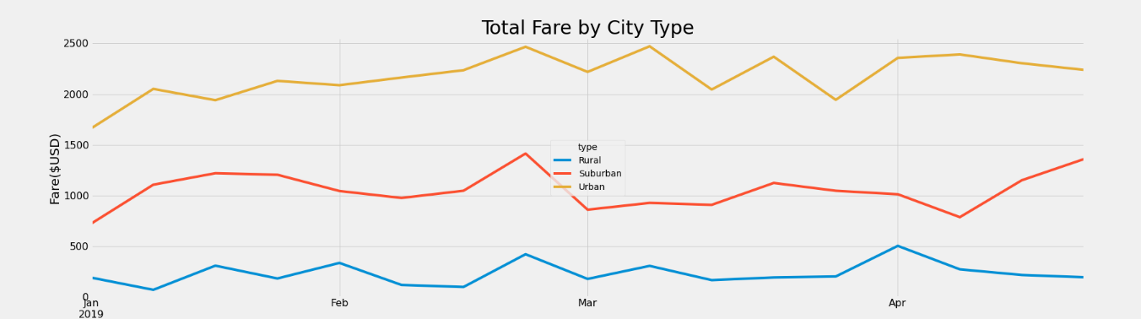](https://github.com/caseychen3605/PyBer_Analysis/blob/main/Analysis/Fig8.png)

**Summary**

In summary three business recommendations would be:

1. See caused the few spikes in the chart, such as the on in late February and the one at the start on April. If you could see any events such as holidays or local sporting events maybe caused the spike. To see if there were any holidays that triggers the spike in rides to see if there are a specific type of location that the destinations were going to, such as churches or bars or parks. To track if something local analyze to see if there is any specific location that have a destination significantly more than others.
2. Another way to recommendation for the business is to check if there large rides or if there is just more frequency of rides. The if there are less rides but longer rides that cause it to be more expensive and cause the total fares to spike but a promotion during that time frame could be five dollars off versus a percentage off because a flat dollar off would save the business money on a large ride, for example 5 dollars off would be better than 10 percent on any trip over 50 dollars, 10 percent off 75 dollars is 7.50 off worse deal for the business than 5 dollars off but 10 percent off 25 dollars is only 2.50 dollars off but a worse deal for the company than 5 dollars. But if there was a time where the rides were short, and the fare was smaller than it is better to take the percentage off versus the flat 5 dollars off.
3. The last thing to recommend is to check is there is a proper demand in the rural areas. There are least total rides and total drivers in the rural areas however the ratio is the highest from total rides and total drivers so per driver they give 1.6 but in the urban is it the opposite. The ratio is .6. I would recommend to see if to reallocate some of the resources from urban to rural areas if more is needed.