1. **Overview of the school district analysis:**

The purpose of this analysis was to extract data from the csv file and help maria analyze math, math passing percentage, and reading passing percentage and overall passing percentage(if they passed both math and reading). To analyze it even further analyze, isolate each different type of data score based on spending per student, size of the school, school type ( district or charter).

1. **Results:**





Removing the 9th grade student in this case did not impact the data set much. The first is dataFrame is before removing the ninth graders from Thomas Hgh School, the Second is after the ninth graders from Thomas High School was removed. The data set it large enough it would barely impact the data of the High School. The Average reading, Math and Overall was not affected enough for it to impact the data more that .1%.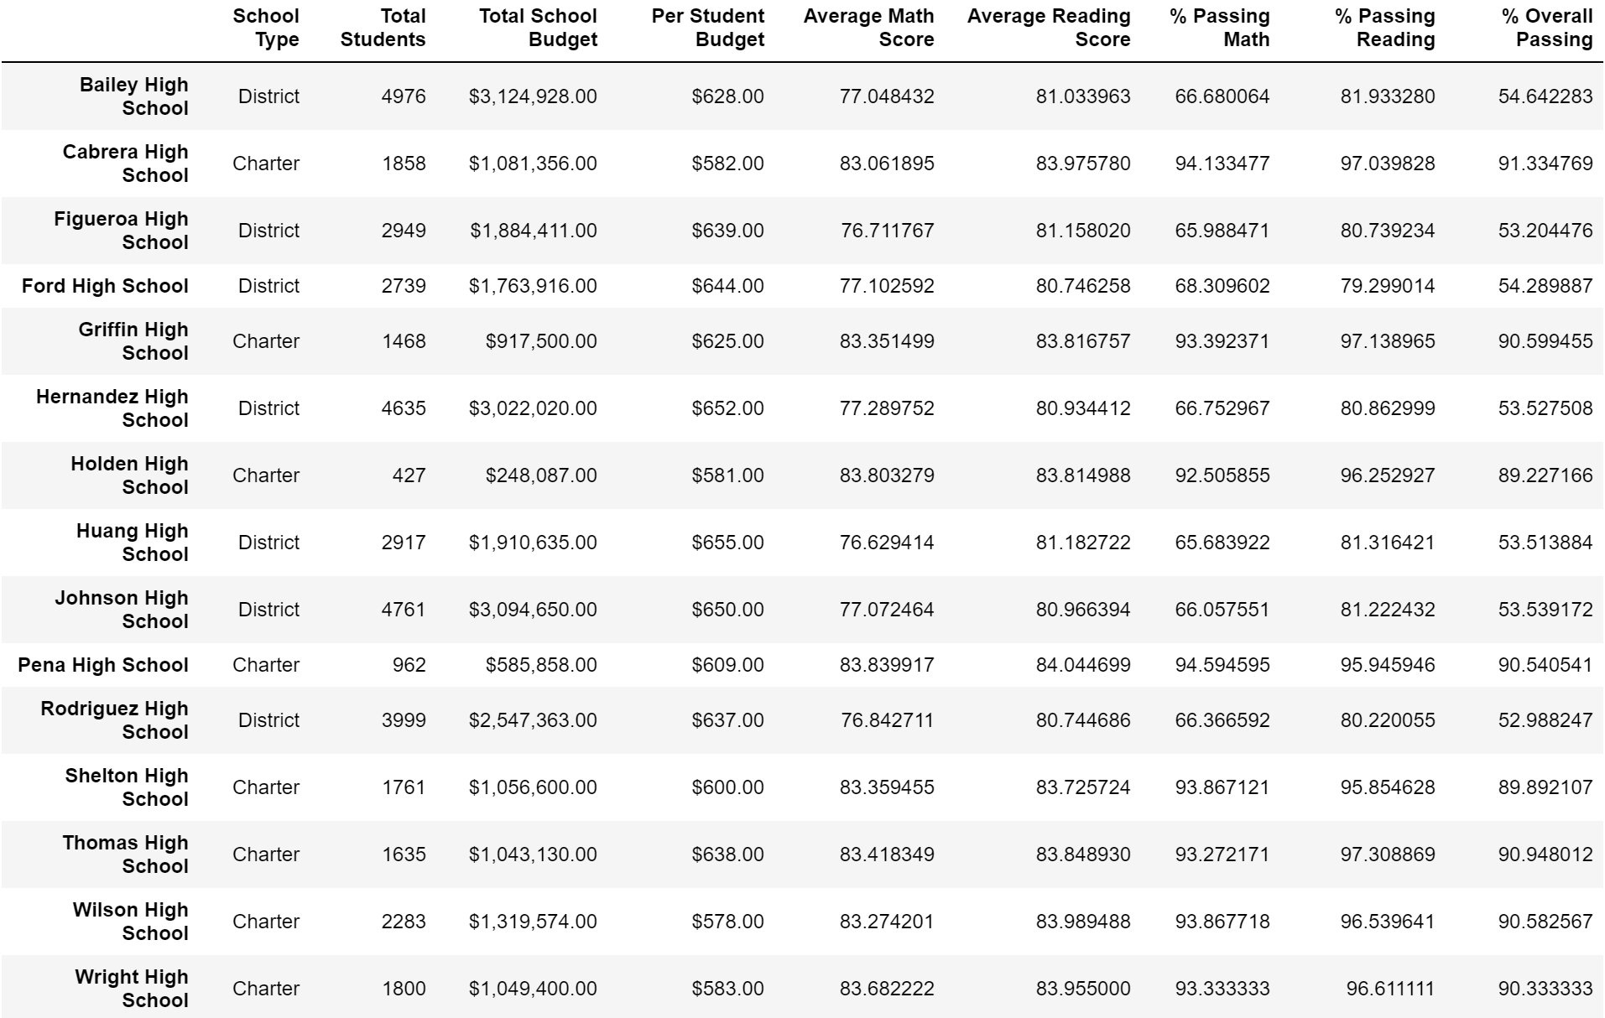

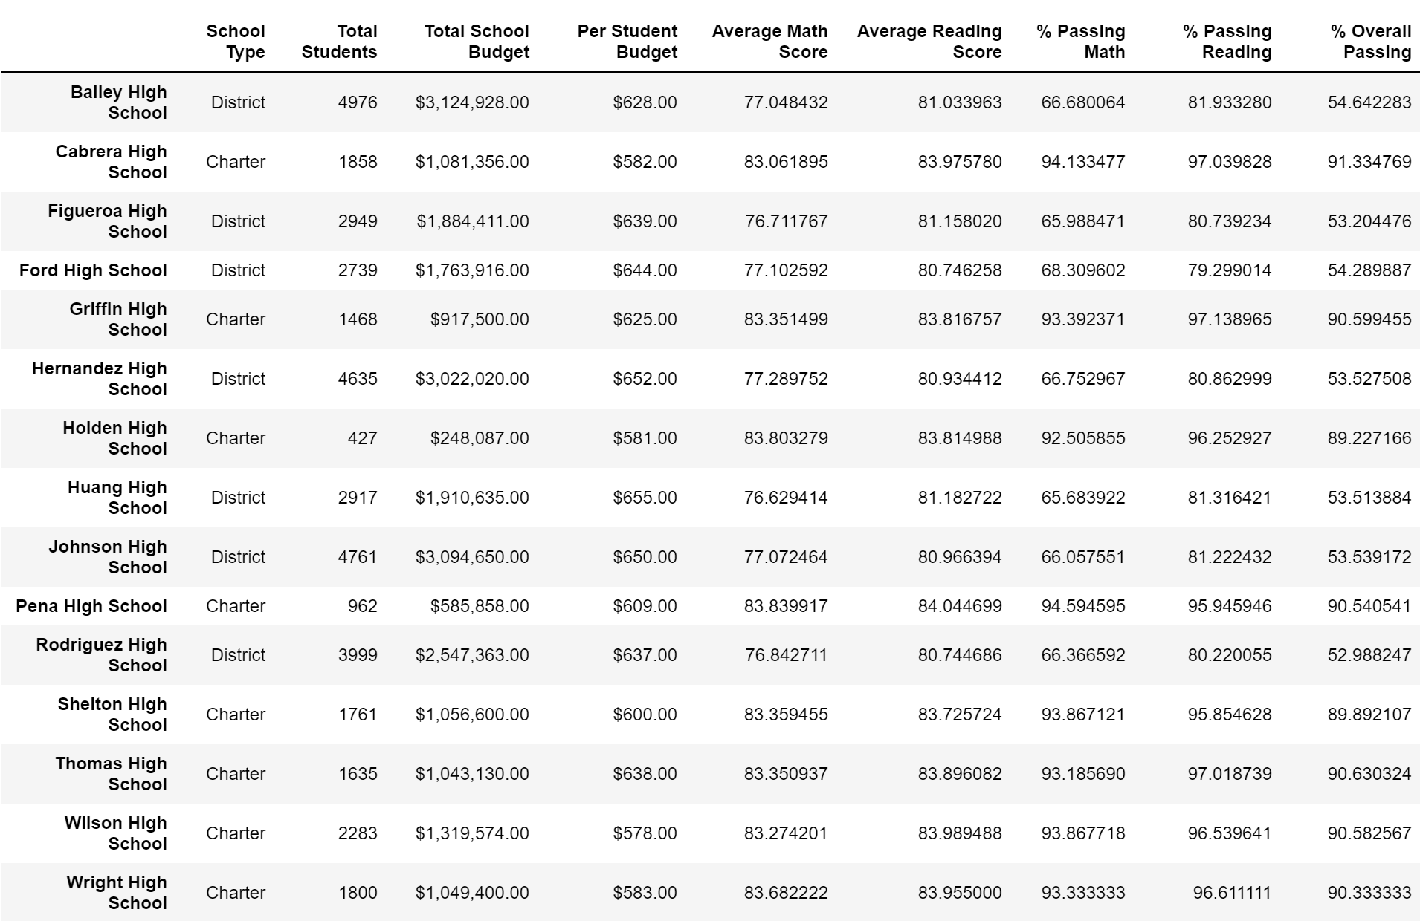

1. **Summary:**

The 4 major changes that occurred are:

The number of total of students. When we Nan that would drop the student count because we essentially removed them from the table.

Because the scored of the students were nullified the were average score of math, reading and overall score would change. However they did not change much. Two reasons why they did not change was because it was there was not enough students to greatly impact the dataset or because the score was close to the average so removing them would not alter the average. In this case it was both