**Overview of Project**

**Purpose**

The purpose of this project was to refactor the code used in previous modules that pulled stock data from 2017 and 2018, and with this data use it to help Steve’s parents determine if the stocks were profitable. the code was refactored to increase the efficiency of the of the code which we track by the duration of the execution

The data given was a ticker value, the date the stock was issued, the opening, closing and adjusted closing price, the highest and lowest price, and the volume of the stock from 2017 as well as 2018. To evaluate for properly instead of day by day, it was needed to store each ticker data into an array and evaluate each ticker.

**Analysis**

In the original code we had a nested for loop. In that code snipped it was a necessary part in order to execute the code logically with the proper output. However, with the nested for loop it causes time to evaluate to grow exponentially based on the input size of the data, big O notation  O(n^2)*O*(*n*2). The data set was not huge therefore not super noticeable meets the eye unless timed. In the new refactored code the big O notation was O(n) and would grow linearly based on the input data size versus exponentially like the previous. Because of this the refactored code proves to be faster and more efficient.

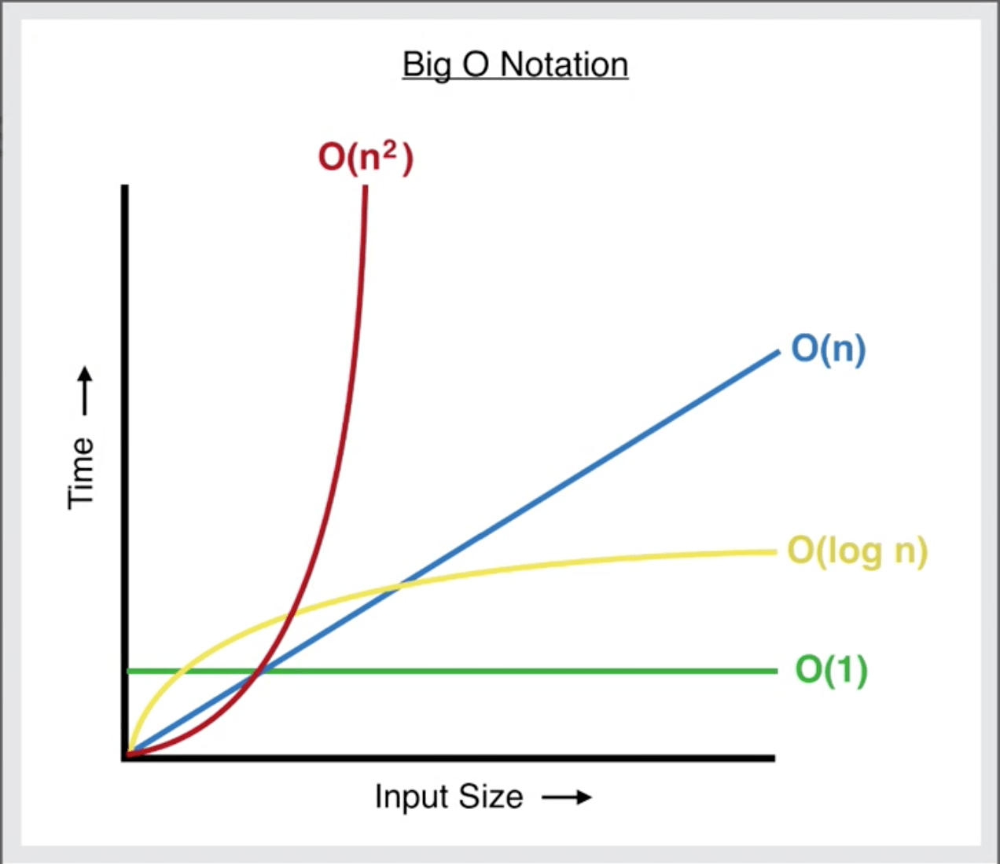

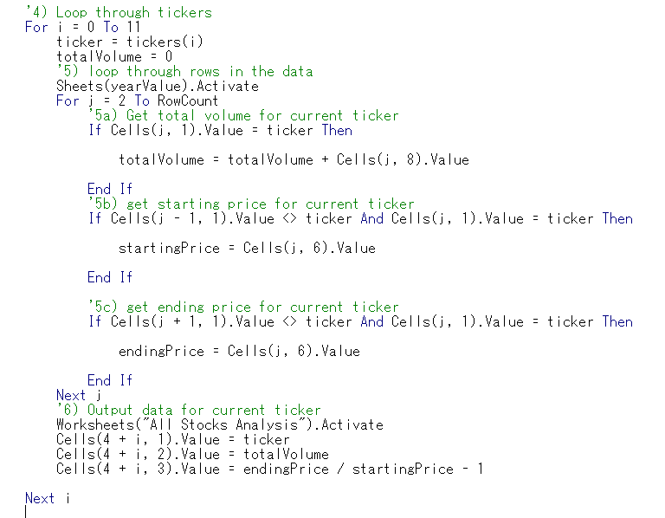while iterating through all the rows in this example in AllStockAnalysis of the nested for loop that cause the O(n2) causing it to be slower that the refactored code

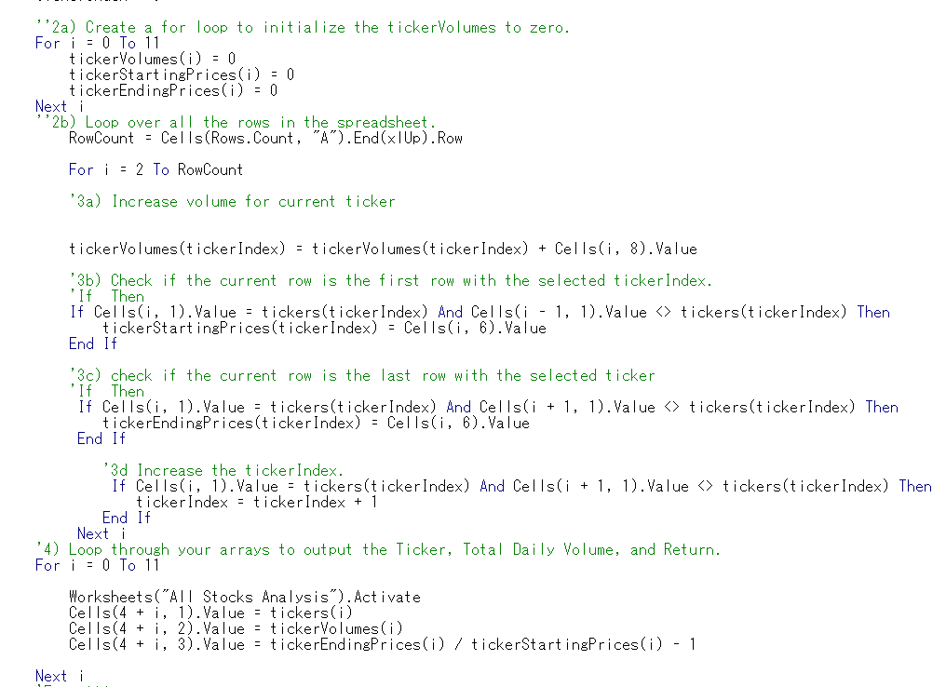in each of the for loops there is no nested for loops.

**Summary**

**Pros and Cons of Refactoring Code**

Refactoring helps make our code cleaner and more organized. A few advantages of a cleaner code. A cleaner code will make it easier to read and debug if needed. Another advantage is it is quicker, if there was a larger dataset it would increase the runtime exponentially if not refactored. One disadvantage to is there is more lines of code to when it is not refactored.

**The Advantages of Refactoring Stock Analysis**

The biggest benefit that occurred as a result of the refactoring was an decrease in macro run time. The original analysis took approximately one second to run, whereas our new analysis only took about a four of the time (approximately 0.25 seconds) to run. Attached below are the screenshots that indicate the run time for our new analysis.