Overview of the analysis: Explain the purpose of this analysis.

import data from sqlalchemy then compare the different tempertures of junevs december

Results: Provide a bulleted list with three major points from the two analysis deliverables. Use images as support where needed.

in conclusion june is a lot hotter than december

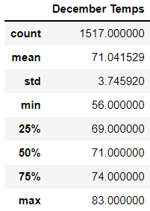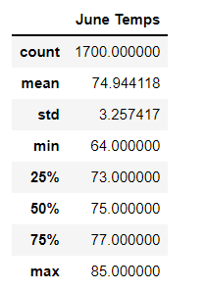

Summary: Provide a high-level summary of the results and two additional queries that you would perform to gather more weather data for June and December.

By comparing the statistic summary of the two months, we can conclude that temperature patterns remain steady throughout the whole year. However, there are two more queries that we need to include to get a better understanding of the weather on Oahu. Although temperatures may remain about the same throughout the year, precipitation may not and would also have a significant impact of the business's sustainability. Doing a statistically summary of the precipitation patterns during the months of June and December will give us a better picture of the overall weather pattern.

Another query that can be created to help us further our analysis is comparing the most active stations to the weather patterns. This can help us narrow down the best location by giving us the most popular station combined with the most stable weather patterns.