Idle Power Generator Simulator
Backend Formula & Design Reference
Living document — v0.5
Platform: Unity, C#, Android

Contents

1. Core Design Philosophy
This game is an incremental idle simulator about running a power station and, eventually, a planetary grid. It targets two audiences simultaneously:
- Players with no engineering background, who learn real concepts gradually through play.
- Players who already understand power systems and want a numerically grounded simulation.
The game accommodates both by exposing complexity slowly — one new mechanic per era — while running a full physically-grounded simulation underneath at all times.

1.1 Guiding principles
- One concept per era. Each era introduces exactly one new mechanic. Mastery is sequential.
- Real units. W → kW → MW → GW → TW → PW → EW. Players learn SI prefixes through play.
- The maths is always running. What changes between eras is the exposed surface, not the underlying simulation.
- Failure is real but telegraphed. Cascades to blackout are possible; the warning signs are always visible.
- Offline rewards engagement, not absence. Offline progression is generous but capped; active play is meaningfully better.
- UI ages with the player. Aesthetic, typography, and metaphor shift era-by-era.

2. Era Progression & Wattage Targets
Each era spans roughly 1.5–3 orders of magnitude of output. The full game spans ~16 orders of magnitude, from a hand-cranked bulb (1 W) to a Kardashev Type I civilization (10^16 W).

2.1 Era output targets
Era | Start output | End output | Real-world analogue | Player time
1 — Workshop | 1 W | ~1 kW | One bulb to a household | 30 min – 2 hr
2 — Demonstration | 1 kW | ~100 kW | A theatre to a city block | 2 – 8 hr
3 — War of Currents | 100 kW | ~10 MW | A district to a small town | 8 – 24 hr
4 — Grid Awakens | 10 MW | ~1 GW | A town to a small city | 1 – 3 days
5 — Interconnected | 1 GW | ~50 GW | A city to a region | 3 – 10 days
6 — Nuclear | 50 GW | ~1 TW | A region to a country | 1 – 3 weeks
7 — Market | 1 TW | ~20 TW | A country to a continent | 2 – 6 weeks
8 — Renewables | 20 TW | ~200 TW | Above current world total | 4 – 10 weeks
9 — Smart Grid | 200 TW | ~10 PW | Hypothetical electrified world | 2 – 4 months
10 — AI Age | 10 PW | ~1 EW | Toward Type I civilization | 4 – 8 months
11 — Global / Fusion | 1 EW | ~10 EW+ | Kardashev I and beyond | Indefinite

2.2 The single new concept per era
- Era 1: Effort makes power. Tap → number up.
- Era 2: Demand isn't constant. Scheduled contracts vary by time of day.
- Era 3: Distance has a cost. Transmission losses (I²R), AC vs DC.
- Era 4: The grid has a heartbeat. Frequency wobbles when load changes — the swing equation arrives.
- Era 5: Power isn't just power. Reactive power and power factor.
- Era 6: Big machines are slow. Baseload vs peaking, ramp rates, maintenance.
- Era 7: Price moves. Half-hourly spot market, arbitrage, ancillary services.
- Era 8: Sun and wind don't take orders. Intermittency, inertia scarcity, storage.
- Era 9: Demand is a resource. Demand-side response, V2G, microgrids.
- Era 10: The machine sees patterns you don't. AI dispatchers as upgradeable units.
- Era 11: Planetary balance. Time-zone arbitrage, fusion, climate-coupled load.

3. Demand Modelling
Demand is decomposed into independent components, each tunable for difficulty and era. The master equation:
D(t) = D_base · (1 + S_year(t)) · S_week(t) · S_day(t) + Σ E_i(t) + N(t) + G(t)

3.1 Base demand
D_base scales linearly with city size (population). Era 1 starts at 1 W. By Era 11, D_base is at planetary scale.

3.2 Annual seasonality (Fourier, two harmonics)
S_year(t) = A1·cos(2π·t/T_year) + A2·cos(4π·t/T_year + φ)
- A1 controls overall annual variation amplitude.
- A2 with phase φ produces the twin peaks of summer cooling and winter heating.
- Site-specific values: tropical climates have A1 ≈ 0.05; UK-like climates have A1 ≈ 0.15.

3.3 Weekly cycle
Simple multiplier table:
Day | Multiplier
Monday – Friday | 1.00
Saturday | 0.85
Sunday | 0.75
Industrial-heavy cities have sharper contrast; residential cities flatter.

3.4 Daily curve
S_day(t) = 1 + α·sin(2π(t − φ_morning)/24) + β·sin(2π(t − φ_evening)/12) + γ·exp(-((t − t_peak)/σ)²)
- Gentle morning ramp, sharp evening peak.
- Gaussian term gives the 5–8pm spike that dominates real grids.
- Asymmetry between morning ramp and evening spike is intentional — evening ramps are where grids fail.

3.5 Stochastic events E_i(t)
Event class | Arrival | Magnitude | Duration
Micro-spikes (TV pickup) | Poisson λ=2–5/day | 2–8% of base | 2–10 min
Industrial transients | Poisson λ=0.5/day | 10–20% of base | 30 min – 4 hr
Weather extremes | Markov chain | 1.5–2.5× cooling/heating | 2–7 days
Black swans | Scripted, telegraphed | Large | Variable
Note: Markov weather state — once in a heatwave, the system tends to stay there. Use a 2-state chain with sticky transitions.

3.6 Noise N(t)
Ornstein–Uhlenbeck mean-reverting process for high-frequency jitter:
dN = -θ · N · dt + σ · dW
- Typical values: θ ≈ 0.5/hour, σ tuned for ~1% RMS.
- Models the natural micro-variation of grid load and punishes operation too close to limits.

3.7 Growth G(t)
Compound annual growth at +0.5% per in-game year baseline. Era-dependent — industrial revolution eras see faster growth (~2% per year); mature grid eras flatten to ~0.3%.

3.8 Forecasting tiers
Tier | Visible horizon | Uncertainty band
0 | Next 15 minutes | ±10%
1 | Next 1 hour | ±5%
2 | Next 6 hours | ±3%
3 | Next 24 hours | ±2%
4 | Next 7 days | Probabilistic; 1 hr deterministic

4. Power Quality & Grid Dynamics

4.1 Frequency — the swing equation
The single most important equation in the simulation:
2H/ω0 · dω/dt = P_mech − P_elec − D · (ω − ω0)
- ω = grid angular frequency; ω0 = 2π·50 (UK) or 2π·60 (US).
- H = system inertia constant, in seconds, weighted by online generators.
- P_mech = total mechanical input (generation).
- P_elec = total electrical load.
- D = damping coefficient (load self-regulation; motors slow when frequency drops).

4.2 Rate of Change of Frequency (RoCoF)
RoCoF = (P_load − P_gen) / (2H)
- A 100 MW mismatch on a 1000 MW system with H=5s gives RoCoF = 1 Hz/s — catastrophic.
- The central late-game tension: renewables have no inertia. As wind/solar share grows, H drops, and small disturbances become grid-collapse events.
- Mitigations: batteries with synthetic inertia, grid-forming inverters, synchronous condensers.

4.3 Frequency response tiers
Response | Timescale | Mechanism | Source
Inertial | 0 – 2 s | Kinetic energy release | Spinning mass
Primary | 2 – 30 s | Governor droop | All synced generators
Secondary | 30 s – 10 min | Automatic Generation Control | Designated units
Tertiary | 10 min – 1 hr | Operator/market dispatch | Manual / market

4.4 Under-frequency cascade (brutal mode)
Trigger | Consequence
f < 49.5 Hz | Stage 1 UFLS — 5% load shed. Trust hit.
f < 49.2 Hz | Stage 2 UFLS — additional 10% shed.
f < 48.8 Hz | Stage 3 UFLS — additional 15% shed. Crisis state.
f < 48.0 Hz | Generators auto-trip. Cascade. BLACKOUT.
f > 51.5 Hz | Over-frequency renewable trip. Risk of ricochet collapse.

4.5 Voltage and reactive power
Active power flows from where frequency is higher; reactive power flows from where voltage is higher. This separation gives two coupled but distinct control loops.
V_drop ≈ (P·R + Q·X) / V
- In transmission, X >> R, so reactive power Q dominates voltage.
- Reactive sources: synchronous generator excitation, capacitor banks, synchronous condensers, STATCOMs.
Power factor PF = P / |S| = cos(φ). Target > 0.95. Below this, regulators fine and equipment over-stresses.

4.6 Harmonics (late game)
THD = √(Σ V_h²) / V_1
Becomes a player concern when inverter-based generation exceeds ~30% of mix. Above 5% THD: customer equipment damage, fines. Mitigation: active filters, grid-forming inverters.

5. Era 1–2 Balance Reference

5.1 Era 1 — Workshop
Single currency: stored charge measured in joules (W·s), displayed as ⚡. Production = capability AND spending. No separate money.

5.1.1 Tap mechanics
- Crank Tap Value (CTV) starts at 1 W per tap.
- No tap rate cap or stamina — design assumes idle dominates by minute 5.
- Sustained tap rate target: 3–5 Hz comfortably; faster is fine but not required.

5.1.2 Era 1 upgrade tree
Upgrade | Cost (J) | Effect | Line
Better Grip | 5 | +1 W/tap (1→2) | Crank
Brass Handle | 25 | +2 W/tap (2→4) | Crank
Geared Crank | 150 | +6 W/tap (4→10) | Crank
Two-handed Crank | 800 | ×2 multiplier on all crank | Crank
Wooden Flywheel | 20 | 0.5 W passive | Flywheel
Heavier Flywheel | 100 | 1.5 W passive | Flywheel
Iron Rim | 500 | ×2 passive multiplier | Flywheel
Bearings | 2,000 | ×2 passive multiplier | Flywheel
Read Faraday | 1,000 | Unlocks Dynamo | Discovery
Build Dynamo | 3,000 | 8 W passive | Discovery
Walk Outside | 10,000 | Unlocks Water Wheel | Discovery
Water Wheel | 30,000 | 40 W passive | Discovery

5.1.3 Era 1 pacing milestones
Wall-clock | Cumulative output | Key purchase
0:00 | 1 J | First tap
0:30 | 30 J | Better Grip
1:00 | 100 J | Wooden Flywheel — idle income unlocked
7:00 | 1,000 J | Faraday's Notes
15:00 | 4,000 J | Dynamo — first wow moment
45:00 | 40,000 J | Water Wheel — output ~80 W
~1:30 | ~500 kJ | Era 2 unlock at 1 kW sustained

5.1.4 Era 2 — Demonstration
Two currencies: joules (for equipment) and pennies (from contracts, for upgrades). Soft prestige resource: reputation.

5.1.5 Era 2 generators
Generator | Capex (d) | Output | Notes
Hand crank | 0 | 1–10 W/tap | Manual
Apprentice on dynamo | 50 | 50 W | Wage 1 d/hr
Water wheel | 500 | 200 W | Seasonally varying
Steam engine (small) | 2,000 | 800 W | Coal: 1 d/hr
Steam engine (large) | 10,000 | 4,000 W | Coal: 4 d/hr

5.1.6 Era 2 contract economics
Contract pay = duration_hours × required_watts × era_rate
- Era 2 base rate: ≈ 0.001 d / (W·s).
- Prestige contracts pay 1.3–1.6× base rate, with reputation bonus on completion.
- Failed contracts (output below 50% of required): −2 reputation, pro-rated pay.

6. Numerical Foundations

6.1 Cost growth ratios
- One-time upgrades: cost of next tier = previous × g, with g = 5 typical for early game.
- Stackable buildings: g = 1.15 (classic Cookie Clicker constant) per additional unit.
- The mix of step-jumps and smooth growth produces the right pacing feel.

6.2 Output growth target
- Each tier of upgrade should ≈ double effective output.
- Time-to-next-upgrade should sit at 1–3 minutes for the first hour, stretching to 5–15 minutes as the game opens up.
- Under 30 seconds = anxious. Over 30 minutes = boring.

6.3 The power-law spine
dP/dt ≈ k · P^α with α slightly less than 1
All eras follow this shape. α controls how growth tapers; k controls absolute speed. Tuning per era is just picking α and k to fit the target wattage range and time budget.

6.4 Numerical precision
- Use double everywhere in the sim for power, energy, money up to the GW range.
- Use decimal for money displayed to the player (avoids rounding artefacts in UI).
- Beyond ~1e15 W (PW range), switch to a BigNumber library (BreakInfinity.cs recommended — it's what Antimatter Dimensions uses).

6.5 Display formatting
- 3 significant figures, largest applicable SI prefix.
- 1,247,000 W → "1.25 MW", not "1247 kW".
- Animate prefix transitions (W → kW, etc.) as a small dopamine reward.
- Late game: SI prefix → scientific notation → BigNumber engineering notation.

7. Offline Progression
The single most important engineering challenge in this game. The simulation has hours-long timescales but rich short-timescale dynamics that cannot be naïvely fast-forwarded.

7.1 Tiered fidelity model

7.1.1 Short absence (< 5 minutes)
Full-fidelity catch-up. Tick the normal sim at 10× speed until current. No abstraction.

7.1.2 Medium absence (5 minutes – 6 hours)
Mesoscopic. 1Hz dynamic tick replaced by 1-minute aggregated tick. Dispatch solved as static optimisation (instant ramps). No sub-threshold stochastic faults. Major events (heatwaves, contract deadlines, scheduled maintenance) resolve correctly.

7.1.3 Long absence (> 6 hours)
Macroscopic. Compute integrals algebraically over the absence:
- Energy produced = ∫ dispatch(t) dt
- Revenue = ∫ price(t) · generation(t) dt
- Fuel = generation × heat_rate × time
- Degradation = run-hours added
- Contract performance = average dispatch / average demand
Stochastic events are not simulated; a single dice roll per event class decides whether anything dramatic happened. If yes, flag for player review on reopen — never resolve a fault while the player is asleep.

7.2 Offline efficiency curve
offline_rate = online_rate × base × time_decay × era_factor
base = 0.7
time_decay = exp(-t / τ)
τ depends on era
Era band | τ (hours)
Era 1–3 | 24
Era 4–6 | 12
Era 7–9 | 6
Era 10–11 | 3
- First hours offline approach 70% of online rate.
- Late hours decay sharply — rewards checking back in.
- era_factor goes from 1.0 (Era 1) down to 0.4 (Era 11). Late game rewards active decisions.

7.3 Save data structure

7.3.1 Continuous state
- Grid frequency, voltage profile.
- Per-generator: online state, current output, fuel level, hours since maintenance, age, wear.
- Per-storage unit: state of charge, cycle count, capacity degradation.
- Per-interconnect: flow direction, magnitude.

7.3.2 Discrete state
- Money, reputation, era progress, era-specific milestones.
- Owned upgrades (bit field).
- Active contracts and their performance trackers.
- Research progress.
- Active modifiers (insurance, regulatory phase, weather state).
- Random seed for reproducibility.

7.3.3 Logged history
- Last N events (faults, contracts, milestones) — circular buffer, ~100 entries.
- Daily aggregates for last 30 days.
- Lifetime totals (cumulative MWh, revenue, emissions).

7.4 Versioning
Every save has version: N. Each version bump ships with a migration function. Day-one discipline — never break players two years in.

7.5 Cheat resistance
- Monotonic time anchor: write Unix time on save; on load, if device time < last save time, assume tampering and award zero offline.
- Optional server time check for leaderboards.
- Don't over-engineer — this is single-player.

7.6 Welcome-back UX
- Loading: "Catching up on X hours, Y minutes…" (<500ms target).
- Summary card with animated counters and any events that occurred.
- Surface any decisions awaiting player attention.
- Drop into live game.

7.7 Era-aware flavour
Same mechanic, different narrative wrapper:
- Era 1: "Your apprentice cranked while you were away."
- Era 6: "AGC handled load following. Two minor faults auto-cleared."
- Era 10: "The dispatch AI optimised 14,000 sub-decisions. One opportunity flagged for your review."

8. Unity / C# Architecture Notes

8.1 Tick rates
- Sim tick: 1 Hz for grid dynamics (frequency, voltage). Critical during disturbances.
- UI tick: 60 Hz, decoupled from sim.
- Offline catch-up: configurable speed-up, capped by abstraction level.

8.2 Recommended patterns
- Event bus / pub-sub for fault, trip, dispatch, contract events — decouples sim from UI.
- ScriptableObjects for generator definitions, upgrade definitions, era configs.
- Separate Simulation, Economy, and Presentation assemblies.
- Deterministic RNG with stored seed; one RNG instance per concern (weather, faults, market) to avoid coupling.

8.3 Numerical libraries
- System.Decimal for money display.
- double for power, energy, time.
- BreakInfinity.cs for late-game large numbers (open source, used by Antimatter Dimensions).

8.4 Save format
- JSON or MessagePack with version field.
- Migrations stored in version-ordered list; load chain runs all migrations from save version to current.
- Compress with gzip if file size matters (>1MB typical late game).

8.5 Mobile considerations
- App suspend → autosave immediately.
- Resume → recompute offline progression before showing UI.
- Battery: cap UI refresh to 30 Hz when on battery, 60 Hz when plugged in.
- Touch targets: minimum 44dp.
- Test on low-end Android — the simulation must run on a £150 device.

9. Upgrade Taxonomy & Costing Principles
All player purchases fall into one of five categories. Each uses a different currency and serves a different decision flavour. Getting this taxonomy right prevents late-game economy collapse.

9.1 The five categories
Category | Currency | Cost shape | Decision flavour
Infrastructure | Cash | Stackable / capacity-scaled | Capex vs revenue
Efficiency / Tech | Cash (+ research gate) | Tiered one-time (g≈5) | Scale vs improve
Research | Research points | One-time tree | Long-term strategy
Reputation | Reputation (gated) | Threshold-based | Behavioural compass
Meta-progression | Engineering XP | Doubling tiers | Build optimisation

9.2 Infrastructure costs cash — always
Anything physical that exists in the game world is paid for in cash. Generators, lines, substations, storage, control rooms, fuel depots. No exceptions after Era 1.
Era 1 exception: in the pre-cash period, joules serve as both capability and currency. The last beats of Era 1 introduce shillings as the player gains their first customer, teaching the cash-for-infrastructure rule before Era 2 makes it dominant.

9.3 Cost scaling curves
Three coexisting shapes:

9.3.1 Stackable (more of the same)
cost(n) = base × 1.15^n
Classic idle-game shape. 20th unit costs ~16× the first.

9.3.2 Capacity-scaled (one bigger thing)
cost(P) = base × (P / P_ref)^0.7
Engineering 0.7 rule. Rewards consolidation; tapering economies of scale.

9.3.3 Tech tier (next generation)
cost(tier) = base × 8^tier
Each tier is ~order-of-magnitude more expensive but delivers ~3× capability. Per-unit-output improves; absolute jump is daunting.

9.4 Maintenance & degradation
annual_maintenance = capex × (m_base + m_age × age_years)
m_base ≈ 0.03 (3% of capex/yr new)
m_age ≈ 0.005 (+0.5%/yr of age)
Skipping maintenance saves cash but increases failure probability via Weibull distribution on time-since-service.

9.5 Decommissioning
- Coal: ~15% of capex, 2 in-game years.
- Nuclear: 25–40% of capex over decades.
- Renewables: low cost (~5–10% of capex), 1 year typical.
- Decommissioning is asymmetric and slow — rewards forward planning.

9.6 The headroom rule
At any moment, the player should be able to afford 2–3 meaningful purchases but desire 5–6. This produces the constant low-grade tension that drives idle game retention.

9.7 Infrastructure capex anchors by era
Era | First-gen capex | Mid-era capex | Capstone capex
1 | 20 J (flywheel) | 3,000 J (dynamo) | 30,000 J (water wheel)
2 | 50 d (apprentice) | 2,000 d (small steam) | 10,000 d (large steam)
3 | £200 (turbine proto) | £8,000 (early coal) | £40,000 (city coal)
4 | £15k (coal unit) | £200k (multi-unit) | £2M (regional)
5 | £8M (large coal) | £80M (hydro) | £400M (first nuclear)
6 | £200M (CCGT) | £1.5B (modern nuclear) | £4B (mega-plant)
7 | £80M (peaking gas) | £2B (interconnector) | £15B (offshore wind)
8 | £500M (utility solar) | £5B (BESS network) | £40B (HVDC link)
9 | £2B (smart retrofit) | £20B (microgrid net) | £100B (continental smart-grid)
10 | £20B (AI cluster) | £200B (planetary forecast) | £1T (quantum optimisation)
11 | £10T (fusion demo) | £100T (fusion fleet) | £1Q+ (Dyson-adjacent)

9.8 Opex display
- Display all ongoing costs as £/year (familiar to players).
- Tick internally as £/sec or per-tick.
- Fuel, maintenance, staffing, decommissioning reserve all separate line items in the financial summary.

9.9 Worked example — Era 6 nuclear plant decision
To build a new PWR, the player navigates five currencies in sequence:
- Research gate: PWR Gen III unlock (12,000 RP).
- Reputation gate: ≥150 reputation for license.
- Infrastructure cost: £4.2B capex, 6 in-game years construction.
- Efficiency layer: optional retrofits (cooling efficiency, load-following).
- Meta context: prestige unlocks may modify nuclear capacity factor.
Each step pulls a different decision lever. The choice is rich rather than purely budgetary.

10. Black Start Minigame
A blackout is the dramatic climax mechanic. When frequency cascade trips all generators, the player enters a guided multi-phase minigame to rebuild from zero. The poetic core: the player literally returns to the hand-crank of Era 1.

10.1 Design objectives
- Recognised consequence — the cascade reflects decisions, not RNG.
- Time pressure — real-time clock; outage minutes always count against trust.
- Mastery activation — every system the player has learned is used at once.
- Catharsis on recovery — restoration is one of the great game satisfactions.
- Bearable on failure — losing a black start is bad but not run-ending.

10.2 The cascade warning sequence
Window | Visual | Player options
T-90 to T-60 | Amber alarms | Recoverable; quick dispatch may save it.
T-60 to T-30 | Red alarms | Limited tools; shed load, fire reserves, import.
T-30 to T-0 | Death spiral | Generators tripping; little control left.
T-0 | Total black | Two-second silence, then minigame begins.
Warning window length is itself scaled by Operator Training Preparedness — see Section 11.

10.3 The five-phase minigame

10.3.1 Phase 0 — Triage (10 seconds)
Automatic. Shows the player which black-start-capable assets survived. Counter ticking from blackout T+0.

10.3.2 Phase 1 — Cranking power (60–180 seconds)
Direct Era 1 callback. The player selects and starts a black-start unit:
Unit type | Output | Spool time | Interaction
Diesel genset | 5–40 MW | Instant | Tap crank icon 8–12 times (Era 1 mechanic)
Hydro (manual) | 50–200 MW | 60 s | Drag-and-hold gate opening slider
OCGT battery-start | 100–300 MW | 30 s | Hold to spool; release at target idle speed
Auto-crank exists but takes 30% longer than manual — preserves the tactile beat.

10.3.3 Phase 2 — Establishing the island (3–8 min)
Player picks which substations to energise. Each load has a profile shown as a visible bar chart:
- Hospitals: small constant load, high trust value.
- Residential: moderate load, gentle inrush.
- Industrial: huge running load AND 3× inrush spike for several seconds.
- Critical infrastructure (water, comms): missing these triggers secondary cascades.
Picking too-large a load -> frequency collapse on the island -> generator trip -> back to Phase 1. Core puzzle: load prioritisation under capacity constraints, with moral weight (who gets power first).

10.3.4 Phase 3 — Bringing up the second generator (5–15 min)
CCGT auxiliary start sequence with sequential steps:
- Auxiliaries powered (5 min after island formation).
- Lube oil circulation (3 min).
- Steam turbine pre-warming (10 min hot start, 45 min cold).
- Sync attempt ready.
Per-step failure chance ~5% in brutal mode, ~1% well-prepared. On failure: Retry (60s penalty), Bypass with OXP (faster, small damage risk), or Abandon (lose unit).

10.3.5 Phase 4 — Synchronisation (10–60 seconds, dexterity)
Synchroscope minigame. Player matches incoming generator to island on three axes:
- Frequency match (within 0.1 Hz).
- Phase match (synchroscope at 12 o'clock).
- Voltage match (within 5%).
Tap CLOSE BREAKER when all three are aligned. Out-of-phase = mechanical slam (5-min recovery in forgiving, permanent damage in brutal). The Era 4 sync minigame returns under pressure.

10.3.6 Phase 5 — Cascade restoration (20–90 min game time)
Player expands the island: energise industrial customers, re-energise transmission lines, sync more generators, reconnect to neighbouring grids. Minigame ends at 95% pre-blackout load served.

10.3.7 Phase 6 — Post-mortem
Report card with total outage, customer-minutes, trust hit, permanent damage, costs. Followed by honest contributing-factors analysis — what specifically went wrong. Teaching moment, not punishment.

10.4 The practice drill
A paid feature: schedule a planned black-start drill at low-demand hours. Trust is not affected (customers notified). OXP is earned based on performance. Lets the player practice safely and incentivises a meaningful OXP branch.

10.5 Offline blackout handling
If a blackout would occur offline, snapshot the moment. On player reconnect, offer to play the minigame retroactively from that saved state. 24-hour window before auto-resolve (mild trust hit + fuel cost). Respects player agency without forcing a missed opportunity.

10.6 Cinematic touches
- Two-second silent black at blackout moment.
- Sound design carries the recovery story — single mechanical chug, then low hum, then ambient grid hum.
- On-screen city map lights up region-by-region as restoration progresses.
- In-game hour compresses to ~1 real minute during minigame; never rushed by simulation clock.
- Post-mortem lingers — restored grid in background, time to absorb what happened.

11. Preparedness Dashboard & Neglect-Driven Difficulty
Black-start difficulty is a function of the player's ongoing choices, not a separate setting. A diligent operator faces a fair black start; a neglectful operator faces the nightmare. The Preparedness Dashboard exposes this as a permanent UI element from Era 4 onwards.

11.1 The six preparedness scores
Score | Range | Driven by
Maintenance Preparedness (MP) | 0–100 | Avg days-since-service weighted by capacity
Fuel Reserve Preparedness (FRP) | 0–100 | Stockpile days vs target days of cover
Redundancy Preparedness (RP) | 0–100 | Count and diversity of black-start units
Operator Training Preparedness (OTP) | 0–100 | OXP invested in black-start; drill recency
Inertia Health (IH) | 0–100 | Spinning mass / total generation ratio
Critical Infrastructure Mapping (CIM) | 0–100 | Era 5 upgrade — identifies & prioritises critical loads

11.2 How preparedness maps to minigame difficulty
Minigame parameter | Driven by | Effect range
Sequence step failure rate | MP, FRP | 0.5% (good) to 12% (neglected) per step
Sync window forgiveness | OTP | Wide green zone to razor-thin
Inrush damage severity | MP, IH | Trip-only to permanent damage
Number of black-start units | RP | Direct mapping to phase 0 options
Secondary cascading failures | CIM, FRP | None (good) to many (neglected)
Permanent damage risk | OTP, MP | None to severe
Pre-blackout warning time | OTP | 90 s (trained) to 30 s (rookie)
Time pressure (outage clock) is constant and unaffected by preparedness. That is the baseline of fairness.

11.3 Difficulty floor and ceiling
- Floor: even perfect 100/100 preparedness has at least one minor sequence failure per recovery, narrow-enough sync window, and a non-trivial trust hit. Otherwise black starts become boring.
- Ceiling: even 0/100 across the board must remain playable. Hard, not impossible.

11.4 Design implications
The Preparedness Dashboard becomes a primary optimisation target. The game shifts from purely maximising revenue to balancing revenue against resilience — a more interesting strategic space, and one that maps to how real utilities actually operate.

12. Prestige Economy & Legacy Formulas
Three nested prestige loops at different timescales. Each produces a different currency with different scaling, supporting progression from hours-long sessions to thousands-of-hours campaigns.

12.1 The three loops at a glance
Loop | Timescale | Resets | Earns
1 — Decommission & Rebuild | Hours | Current infrastructure, current site | Engineering XP
2 — New Site | Days | Infrastructure, contracts, current site | Site Mastery Points (SMP)
3 — Historical Replay | Weeks | Nearly everything except achievements | Engineering Legacy (EL)

12.2 Loop 1 — Engineering XP
XP_earned = floor(K_xp * log10(lifetime_MWh / 1000) * achievement_mult * preparedness_bonus)
- K_xp scales by era: 5 in Era 2 to 200 by Era 11.
- Logarithmic in MWh keeps gains feeling linear in effort.
- Achievement multipliers: new milestone x1.2, survived black start x1.5, all contracts hit x1.3, no permanent damage x1.2. Multiplied together.
- Preparedness bonus: 0.8 + (avg_score / 100) * 0.4 — diligence rewarded with prestige progress.
Spend curve:
cost(stack level n) = base_cost * 1.5^n
Sample upgrades: quick-start cash, inherited contracts, preserved reputation, research head-start, era skip tokens.
Note: XP tree resets at Loop 2 prestige (except nodes marked "permanent"). Forces re-earning tactical upgrades, lets a permanent core build over many sites.

12.3 Loop 2 — Site Mastery Points
SMP_earned = floor(sqrt(lifetime_MWh_on_site / 10^9) * site_difficulty_multiplier)
- Square root: SMP grows slower than XP — deeper currency.
- Site difficulty multipliers: Alpha (temperate) x1.0, Beta (cold) x1.2, Gamma (tropical) x1.2, Epsilon (desert) x1.5, etc.
Spends include per-site permanent bonuses (climate adaptation, local fuel sourcing, workforce training) and global unlocks (new site types, parallel site management, site interconnects).

12.3.1 Sample sites and their character
Site | Climate / character | Strategic emphasis | Multiplier
Alpha | Temperate generic | Baseline learning site | x1.0
Beta | Cold-dominant | Fuel logistics, heating peaks | x1.2
Gamma | Tropical, hurricanes | Cooling peaks, event resilience | x1.2
Delta | Mountain, hydro-rich | Transmission challenges | x1.1
Epsilon | Desert, water-scarce | Extreme solar, no cooling water | x1.5
Zeta | Industrial heartland | Brutal load curves, high revenue | x1.3
Eta | Archipelago | No big interconnects, microgrids | x1.4

12.4 Loop 3 — Engineering Legacy
EL_earned per Historical Replay = floor(log2(1 + total_lifetime_MWh / 10^15))
- Log base 2 is intentional — Legacy must grow slowly even as wattage compounds.
- First replay ~5 EL; tenth replay ~12 EL despite 10,000x more production.
Spend curve:
cost(EL upgrade level n) = base * 2.5^n
g=2.5 is gentle by incremental standards — Legacy is the carrot. A patient player can always push one more level.

12.4.1 Sample EL upgrades
- Born Engineer: +1 W/tap permanently (1 EL).
- Faraday's Mantle: research costs -10% permanently, stack to -80% (5 EL base).
- Strong Foundations: start runs with one tier of free infrastructure (15 EL).
- Time Compression: offline tau doubled permanently, stack to x8 (25 EL base).
- Polymath: all currencies +5% production, stack to +100% (10 EL base).

12.5 Alternate History unlocks
Each alternate history is a meaningful campaign with modified rules — effectively a new game mode unlocked with EL.
- What if Tesla won? AC-only path; wireless power transmission unlocks at Era 5.
- What if nuclear was cheap? Nuclear capex -80%, but emissions regulated earlier.
- What if fusion came in 1980? Skip renewable transition entirely.
- What if storage was solved early? Batteries 10x cheaper from Era 4.
- Steampunk: Tech tree never advances past Era 3 — race against history.
- Climate emergency: Hard carbon cap tightens every era; force transition or fail.
Cost range: 50–200 EL per branch. Each is 20–60 hours of meaningfully different play.

12.6 The prestige recommendation moment
ShouldRecommendDecommission = XP_gain_if_prestige_now > XP_gain_per_hour * 4
UI shows a soft glow on the prestige button when this is true. Similar formulas for Loop 2 (when site SMP-per-hour halves) and Loop 3 (3+ days in Era 11 without major progress).

12.7 Calibration rule
Across all three loops:
"A prestige that takes T hours of play to set up should produce permanent buffs equivalent to ~0.3T hours of progression."
- 5-hour Decommission gives buffs worth ~1.5 hours.
- 50-hour Site cycle gives buffs worth ~15 hours.
- 200-hour campaign gives buffs worth ~60 hours.
30% interest rate is the well-tested zone (Antimatter Dimensions sits around 25–35%).

12.8 The fundamental shape
Prestige currencies should compound exponentially in number, but utility per unit should compound less than exponentially. The three loops produce currencies that feel respectively plentiful, precious, and sacred.

13. Research System
Research is the slowest, deepest, most strategic currency. It rewards patience and long-term thinking. Two principles shape every design decision:
- Research is knowledge, not equipment. RP buys the ability to build something better; cash buys the thing itself. The separation makes research feel like a parallel optimisation rather than a slower cash sink.
- Research is permanent across most prestiges. Loop 1 (Decommission) and Loop 2 (New Site) keep research entirely. Only Loop 3 (Historical Replay) resets it, and EL upgrades carry research-speed bonuses forward. Research is the long memory of the player's career.

13.1 RP generation — three sources

13.1.1 Operational learning (passive)
RP_per_MWh = K_op * era_factor * diversity_bonus
- K_op ~= 0.001 RP/MWh in Era 4, scaling with era.
- era_factor: Era 4 = 1.0; Era 11 = 50. Grows with era but slower than wattage, so research stays meaningful in late game.
- diversity_bonus: 1.0 (one generator type) to 1.5 (5+ different types). Encourages varied fleet, which also aids resilience.

13.1.2 R&D facilities (active investment)
Dedicated cash-funded buildings that produce RP continuously:
Facility | Era | Capex | RP/hour
Apprentice's workshop | 3 | £500 | 5
Engineering office | 4 | £20K | 50
R&D laboratory | 5 | £500K | 500
National research institute | 6 | £20M | 5,000
Corporate R&D division | 7 | £200M | 50,000
AI-augmented research lab | 10 | £20B | 5,000,000
Each facility focuses on a branch of the tech tree. Active investment beats passive accumulation — the "tech rush" archetype.

13.1.3 Discoveries and events (one-shot)
Rare, story-driven RP windfalls:
- Scientific breakthroughs make headlines (small RP bonus).
- Competitor failures studied (free RP in safety branch).
- Foreign utility data-sharing (mid-game diplomatic event).
- Employee patents (RP + small cash royalty).
- Black-start survival grants operational research bonus on related branches.

13.2 The six research branches
Separate trees per branch, with cross-branch dependencies at key nodes. Each branch focuses on one area; the deepest, most powerful techs sit at intersections.
Branch | Scope
Generation | Turbines, generators, fuels, plant types
Transmission & Distribution | Lines, transformers, HVDC, smart grid
Storage | Batteries, pumped hydro, hydrogen, flywheels
Controls & Automation | Governors, SCADA, AGC, AI dispatch
Safety & Reliability | Maintenance, protection systems, black-start tech
Environment & Efficiency | Emissions, heat recovery, lifecycle

13.3 Cross-branch nodes
The most exciting unlocks sit at intersections of two or three branches. Examples:
- Combined Cycle Gas Turbine: Generation (Gas Turbine Theory) + Environment (Heat Recovery).
- Battery storage with grid-forming inverters: Storage + Controls + Transmission.
- Deepest endgame techs typically sit at three-way intersections.
Visually marked with hexagonal node shapes (vs round-rect for single-branch nodes).

13.4 Branch shape
Each branch is roughly 3 nodes wide and 8–12 nodes deep. One tier per era of advancement. Players see the structure of the next two tiers in detail; deeper tiers show as locked silhouettes — sense of vast depth without overwhelming.

13.5 RP cost scaling
cost(tier T in branch) = base_branch_cost * g^T
base_branch_cost ~= 50 RP (era-appropriate)
g ~= 3
- Tier 1 = 50 RP, Tier 2 = 150 RP, ... Tier 8 = ~100,000 RP.
- Cross-branch nodes multiply cost by 2.5.
- Endgame nodes (Tier 10-12) routinely cost millions of RP.

13.6 Strategic archetypes
- No-facility operator. Slow operational learning only. Tech lags by 1–2 eras. Viable but conservative.
- Pace-keeper. One facility per era; tech keeps up with era progression. Default balanced approach.
- Tech rush. Multiple facilities; research drives equipment unlocks. Research 1–2 eras ahead, but heavy cash drain.

13.7 UI design rules
- One branch at a time as the primary view (mobile-friendly). Tabs at top to switch branches.
- Node states: researched (solid, full colour), available (highlighted), visible-locked (dimmed), hidden (silhouette only).
- Era band on the left as temporal anchor.
- Cross-branch nodes: hexagonal shape + small label indicating target branch.
- Selected-node panel below shows cost, effect, and ETA based on current RP/hour.
- Branch tabs carry small badges when a new node has become available in that branch.

13.8 Future enhancements (deferred)
- Research queue / planning mode — let the player chain multiple researches for offline auto-progress.
- Zoomed-out research map view (whole tech tree, navigable hex grid).
- Branch-specialisation bonuses (deep investment in one branch grants compounding gains).

14. Preparedness Dashboard Tutorial Sequence
The dashboard introduces six scores gradually, each tied to a moment where the underlying mechanic becomes player-relevant. Throwing all six at the player at once would be overwhelming and undercut the "one new concept per era" principle.

14.1 The introduction pattern
Each introduction follows a 5-step shape that becomes a template for introducing any new system:
- A specific in-game event happens that is caused by low preparedness in this area.
- A narrative reveal frames the new concept in plain English.
- The dashboard visibly grows to include the new score.
- The player is offered an immediate way to raise the new score (usually by spending currency).
- The score animates upward as they act, anchoring cause-and-effect.
Pedagogy: experience -> reflection -> naming -> instrumentation. Failure first, vocabulary second, metric third.

14.2 The six introductions in order

14.2.1 MP (Maintenance Preparedness) — early Era 4
- Trigger: Player's first generator failure from over-running its service interval (~Era 4).
- Teachable moment: CCGT trips offline; output drops; player scrambles to cover.
- First interaction: "Schedule service for all overdue units (£X)" button. Pressing it visibly raises MP from low to high.

14.2.2 FRP (Fuel Reserve Preparedness) — mid Era 4
- Trigger: Cold snap or demand spike depletes coal stockpile mid-event; plant trips.
- Teachable moment: "COAL-3 OFFLINE — FUEL EXHAUSTED" during evening peak.
- First interaction: Fuel Manager panel opens; player drags stockpile target sliders per fuel type. Sees FRP climb. Learns it has an ongoing cost.

14.2.3 RP (Redundancy Preparedness) — Era 5, first brownout
- Trigger: Serious frequency event causing partial blackout; UFLS triggers but full cascade is avoided.
- Teachable moment: Recovery hampered by limited restart options. Post-event analysis flags single point of failure.
- First interaction: Asset Review panel highlights candidate units that could be upgraded with black-start capability. Each upgrade costs cash but raises RP measurably.

14.2.4 CIM (Critical Infrastructure Mapping) — Era 5
- Trigger: Research-driven, not failure-driven. Activates when player completes "Critical Load Identification" in Safety branch.
- Teachable moment: Engineering team has mapped critical loads — narrative reveal only.
- First interaction: Guided minigame: city map appears, player drags unclassified loads into Critical / Important / Standard categories. CIM jumps to 100.
Set-and-forget after initial classification; only re-prompts if new infrastructure appears (e.g., a new hospital district).

14.2.5 OTP (Operator Training Preparedness) — Era 6
- Trigger: Player's first OXP spend on a black-start-related procedure (e.g., Sync Procedures Training).
- Teachable moment: Operators have completed procedures training — narrative reveal.
- First interaction: "Schedule Drill (£15K)" button appears. Player schedules drill for next quiet night; plays tutorial-grade easy version; earns OXP; OTP jumps. Demystifies black start before the real one happens.

14.2.6 IH (Inertia Health) — Era 8, renewable threshold
- Trigger: Player's renewable generation share crosses 30%, followed by a frequency event with dramatically elevated RoCoF.
- Teachable moment: RoCoF is 3x the value seen on similar disturbances pre-renewables. Post-event analysis attributes to lost inertia.
- First interaction: Synthetic Inertia panel: options to build batteries with grid-forming inverters, synchronous condensers, or retire renewables. Each shifts IH.
This is the Era 8 aha moment given numerical form. The hidden cost of renewables becomes visible.

14.3 The visual rollout
The dashboard itself grows visually as scores are added. Era 4: small two-row panel in corner. Era 8: full six-row display with mini-charts for trends. The physical growth of the UI mirrors the player's growing responsibilities — part of the era-shifting principle.
Each new score should pulse with a highlight ring for a few in-game hours after introduction, then fade to permanent ambient status.

14.4 Risks to watch
- Score blindness: Late-game players may stop checking the dashboard. Counter: surface specific scores in moment-relevant contexts (when firing up a generator that's overdue, show its MP contribution).
- Goodharting: Players optimise the metric, not underlying health. Counter: scores should be honest reflections of state, not synthetic proxies.
- Punishment without recovery: Players who fall behind need visible paths back. Counter: scores show actionable guidance ("to raise MP from 40 to 70, schedule maintenance on units X, Y, Z").
- Concept overload: Player triggers two introductions in same session. Counter: queue introductions with at least 1 in-game day delay between them.

14.5 Skippability
Veteran replay players (Loop 3 prestige) should not sit through six tutorial moments. Reveal text and first-interaction panels offer "I know this" links that collapse to one-line confirmations. The introduction still happens (dashboard adds the score) but is not slowed by reading. First-playthrough defaults to full guidance; subsequent runs default to compact.

15. Black Start Triage Screen — Visual Design Notes
The first screen of the black-start minigame, shown after the two-second silent black. Its job: communicate available assets with maximum urgency and clarity. Aesthetic: emergency lighting just kicked on.

15.1 Layout priority (vertical reading order)
- Header: outage timer (already ticking — typically T+12 seconds on arrival).
- Situation summary: one plain-language sentence about what happened.
- Ready units: tappable cards, healthiest first.
- Marginal units: amber border, problems visible.
- Unavailable units: dimmed, with reason ("needs island", "SCRAM safe state").
- Preparedness summary: honest 6-score snapshot at moment of cascade.
- Call to action: "select black-start unit".
Player should be able to decide from the top half of the screen alone if needed.

15.2 Visual grammar
- Palette: amber emergency tones + deep black + single ominous red for outage timer. Era-agnostic enough to work in any era.
- Outage timer: largest, reddest element. Monospaced font. Ticks from T+0.
- Unit cards: green = ready, amber = marginal, dimmed brown = unavailable. Status badge at top-right of each.
- Micro-stats per unit (fuel, batteries, last service days) colour-coded individually.
- Preparedness panel uses the same colour grammar as the main dashboard (red/amber/green per score).

15.3 Information philosophy
- Unavailable units shown deliberately, with reason — communicates the scale of what's been lost.
- Preparedness summary at the bottom shows the player exactly why this is happening — the opening salvo of the post-mortem.
- No Cancel / Pause / Settings buttons. Once in black start, the player is committed.
- Simulation pauses if the player backgrounds the app; the in-game button to escape simply isn't there.

15.4 Era-specific styling (future work)
- Era 4 black start: brass-and-bakelite aesthetic; analog gauges; physical-feel switches.
- Era 6: institutional cream and green CRTs; the classic 70s control room look.
- Era 10: monastic minimalism; whitespace; conversational AI prompts.
- Information density and colour grammar stay constant — only the surface aesthetic changes.

15.5 Typography rules across the minigame
- Monospaced font for system-generated data (unit IDs, timer, technical readouts).
- Proportional sans-serif for prose (situation summaries, button labels).
- The visual distinction between "machine output" and "human prose" is preserved throughout.

16. Open Questions (Living List)
Items to resolve in future design sessions:
- Era 4 synchronisation minigame — design and difficulty curve (referenced by black start Phase 4).
- Era 3 AC/DC branch — exact divergent mechanics.
- Market trading mechanics for Era 7 (price model, contract types).
- Renewable forecasting maths for Era 8 (wind/solar models).
- AI agent design for Era 10 — what is upgradeable, what is configurable.
- Achievement and lifetime stat structure.
- Soundtrack/audio direction per era.
- Localisation strategy (units, language, currency symbols).
- Reputation thresholds for each contract / partner tier.
- Site Beta–Eta detailed demand models.
- Alternate History branches — full mechanical specifications.
- Research-queue / planning UI design.
- Cross-branch dependency map as a navigation aid.
- Era 10 zoomed-out research map view.
- Score recovery guidance UX — how the dashboard surfaces "how to fix" instructions.

17. Changelog
v0.1 — Initial draft. Era progression, demand modelling, power quality, Era 1–2 balance, numerical foundations, offline progression, architecture notes.
v0.2 — Upgrade taxonomy. Added five-category upgrade taxonomy, cost scaling curves, era-by-era capex anchors, maintenance/decommissioning formulas.
v0.3 — Black start, preparedness, prestige. Added full black-start minigame design (six phases), Preparedness Dashboard with neglect-driven difficulty system, and three-loop prestige economy with Engineering XP / Site Mastery Points / Engineering Legacy formulas.
v0.4 — Research, dashboard tutorial, triage UI. Added full research system (RP sources, six branches, cross-branch nodes, cost scaling, archetypes, UI rules), six-stage dashboard tutorial sequence with introduction pattern, and black-start triage screen visual design notes.
v0.5 — Era mockup gallery. Added Appendix A: full set of static screenshot mockups for all eleven eras, showing the aesthetic arc from candlelit workshop to planetary grid. Era 8 mockup incorporates the mature six-score Preparedness Dashboard.

Appendix A — Era Mockup Gallery
A reference set of static UI mockups, one per era. These are not final designs — they encode the aesthetic intent, information hierarchy, and emotional tone for each era. Use them as a north star when building real UI in Unity.
The aesthetic arc is itself the storytelling. Placing Era 1 and Era 11 side by side communicates the entire dramatic journey of the game without a single label. Each intermediate era forms a plausible aesthetic descendant of the one before.
Across all eras, the colour grammar stays consistent: green means healthy, amber means caution, red means alarm, gold means achievement. Specific shades evolve with each era's aesthetic — Era 1's gold is candlelit yellow; Era 11's is cooler honey-amber — but the meaning is constant. A player who has played for 200 hours can glance at any era's screen and immediately understand state.

Era 1 — The Workshop
London, 14th March 1821 · 1 W to 1 kW
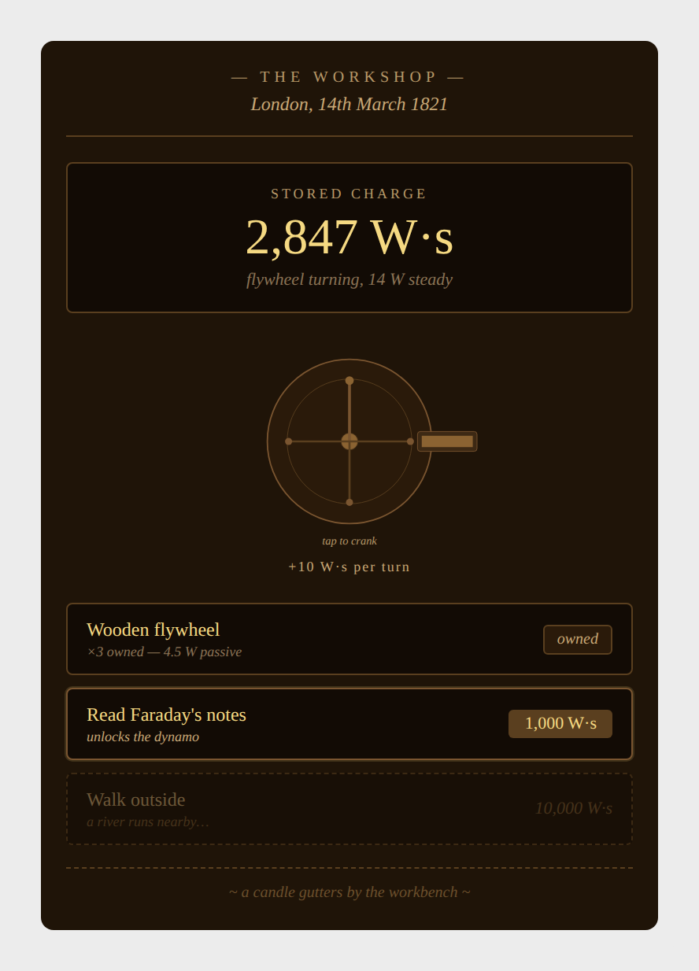
Candlelit workshop. Brass crank as the central interaction. Sepia palette, Georgia serif, Bodoni numerals. The "stored charge" reading is the dominant element — at this stage capability and currency are the same thing. The locked "Walk outside" upgrade hints at the river that unlocks the water wheel. One concept on screen: effort makes power.

Era 2 — The Demonstration
Tuesday evening, 9th October 1851 · 1 kW to 100 kW
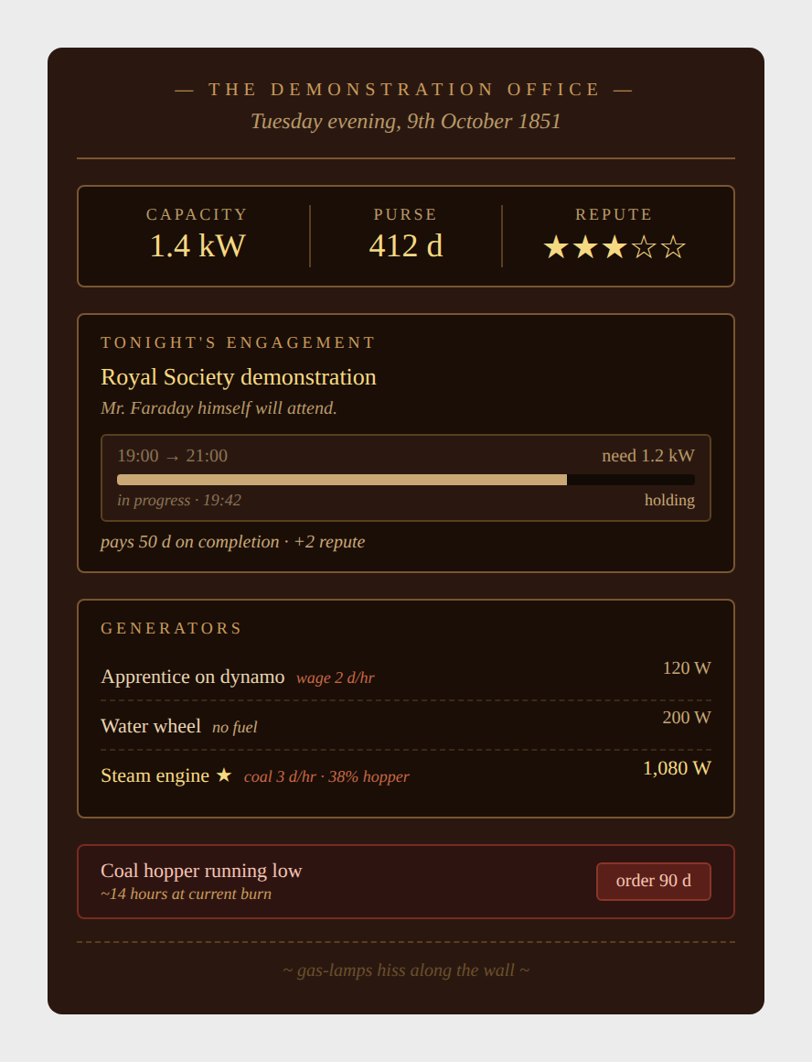
Gas-lit demonstration office. Two currencies (capacity + pennies) plus the new Reputation star track. The contract progress bar is the era's spotlight mechanic — first taste of time-pressure-with-stakes. The coal hopper warning introduces fuel logistics in miniature; the apprentice's wage shown in coral teaches that passive income is no longer free. The weather glass hint plants the seed of forecasting.

Era 3 — The War of Currents
Pearl Street, 7th April 1893 · 100 kW to 10 MW
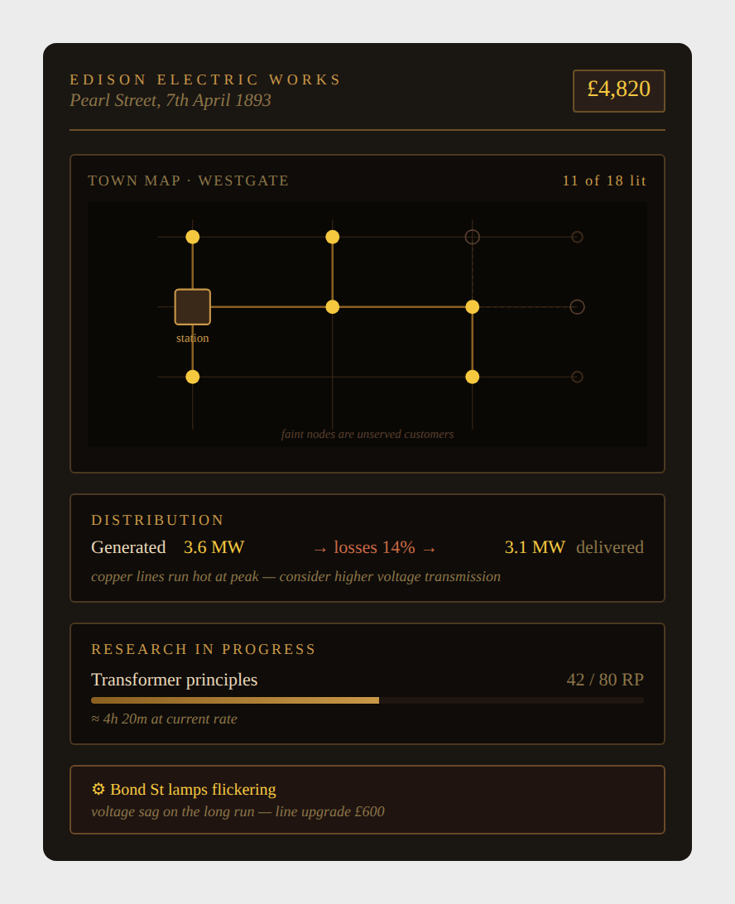
AC-path player after committing in the soft-prestige choice. First town map with glowing customer nodes. Transmission losses now visible as a percentage — the 14% loss between generated and delivered teaches the I²R lesson viscerally. Research as a parallel system makes its debut. Faint nodes show unserved customers — the next expansion target.

Era 4 — The Grid Awakens
Central Electric Station · 14 June 1928 · 10 MW to 1 GW
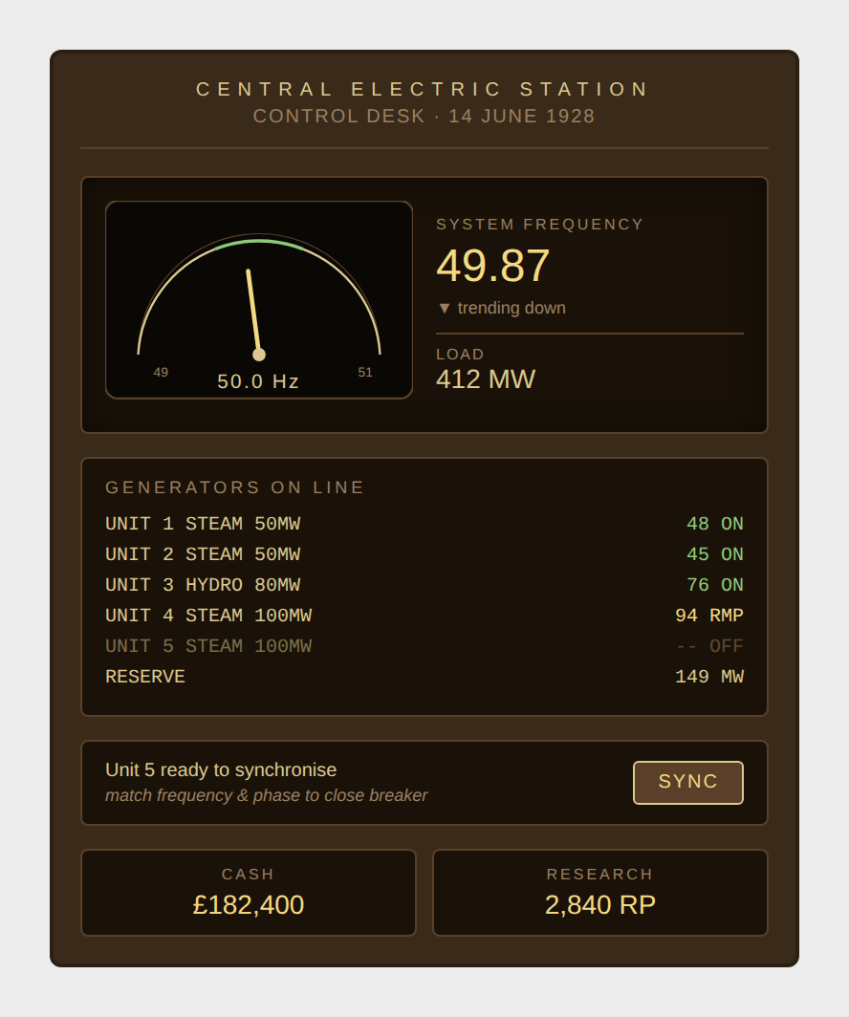
Bakelite-and-brass control desk. The frequency needle is now real — it wobbles. Monospaced unit list mimics a real generator status board. The "SYNC" button is the era's defining minigame moment: a new generator is ready to be brought online, and the player has to match frequency and phase manually. Cash and research now tracked side-by-side.

Era 5 — The Interconnected Grid
Midlands Region · 12 November 1952 · 1 GW to 50 GW
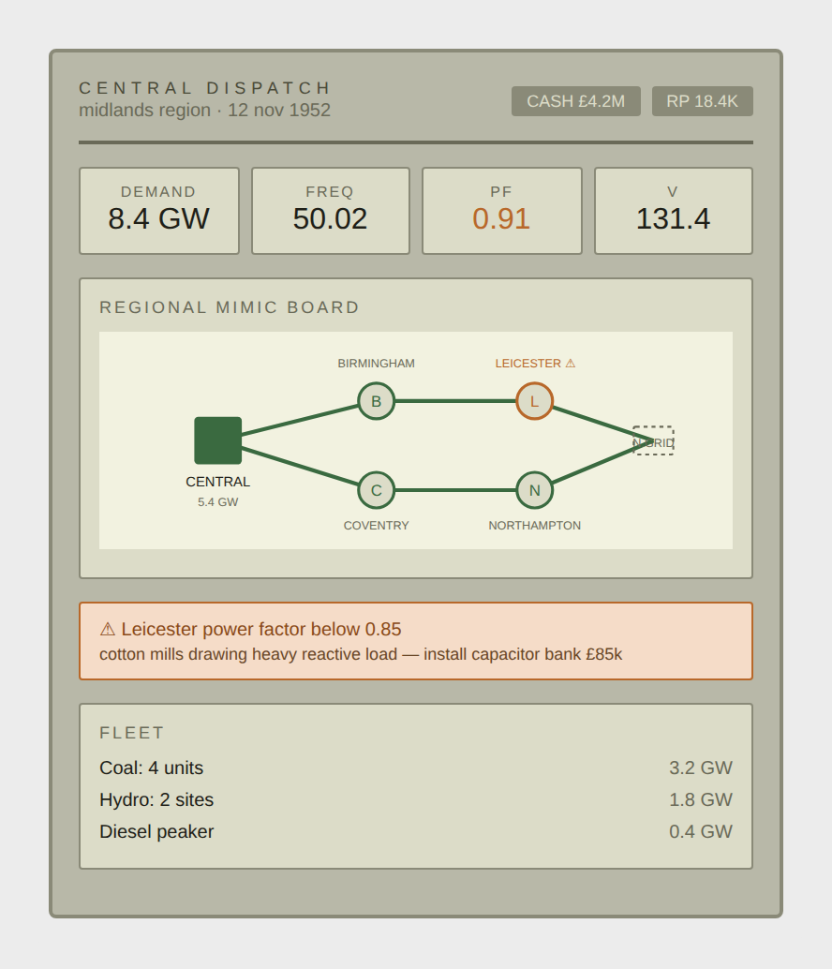
Painted-metal mid-century control room. Power factor and voltage appear as new headline stats. The mimic board shows multiple cities connected through transmission. Leicester's amber ring + power-factor warning teaches reactive power through a localised problem — cotton mills drawing heavy reactive load is a specific, traceable cause. Capacitor bank installation is the affordable fix.

Era 6 — The Nuclear Age
National Grid · 17:42 · 14 November 1978 · 50 GW to 1 TW
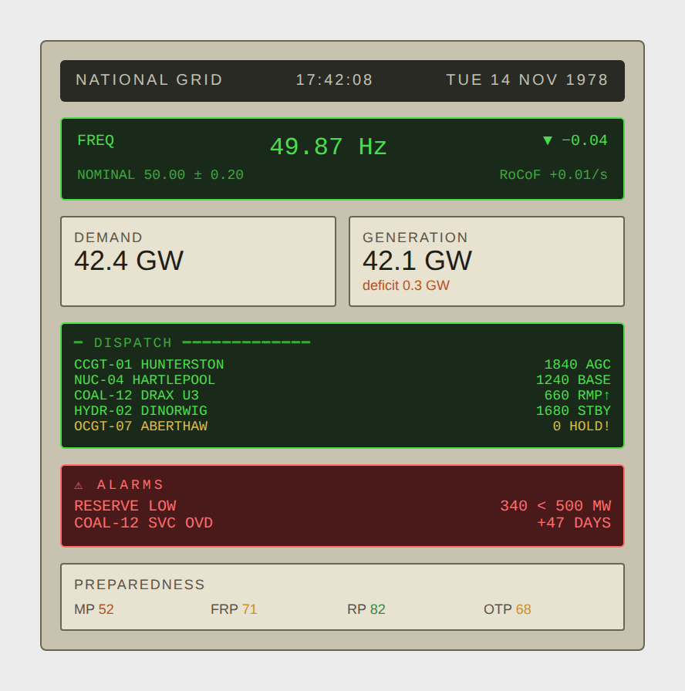
Institutional control room. Green-on-black CRT for system-generated data, cream tiles for human-readable stats. RoCoF now visible; reserve margin shown as a tight ratio. AGC and BASE dispatch modes signal automation. The amber OCGT on HOLD! plus red maintenance alarm illustrate the brutal-mode tension: reserve is below margin, a coal unit is overdue for service, and one peaker is unavailable. The preparedness scores at the bottom hint at the trouble brewing.

Era 7 — The Liberalised Market
TradeStation · 23 September 1998 · 1 TW to 20 TW
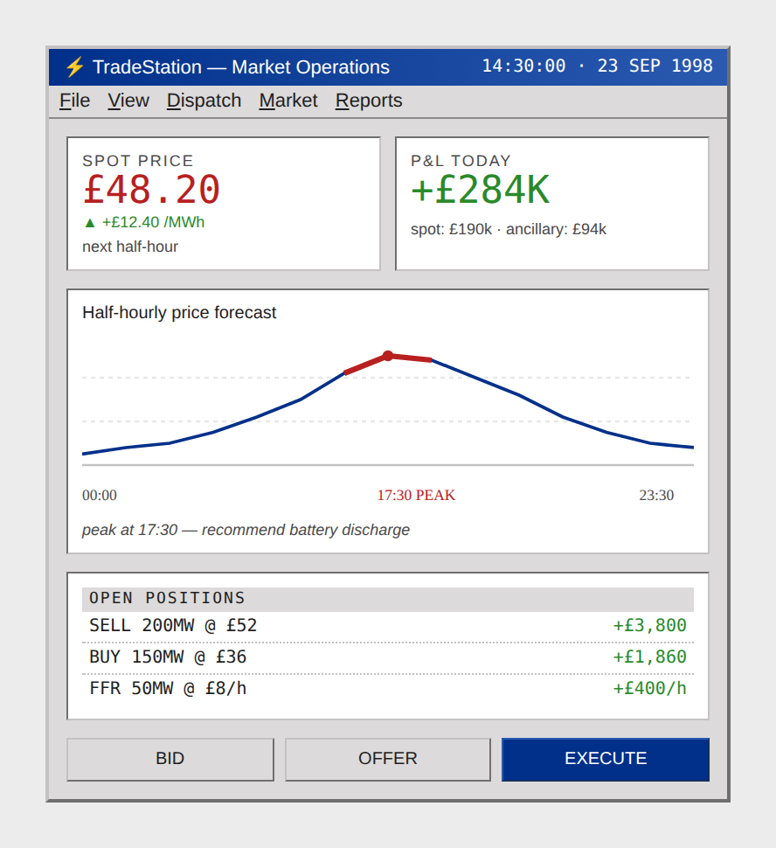
Windows-95-era trading terminal. The dispatch room has retreated to a window in the background; the player's primary screen is now software. Spot price ticker, P&L tracking, half-hourly price forecast chart with the peak highlighted, open positions. Ancillary services revenue (FFR) appears as a distinct income stream. Battery discharge recommendation surfaces directly — the game is teaching arbitrage by suggesting it.

Era 8 — The Renewable Transition
National Control Centre · 14 May 2024 · 20 TW to 200 TW
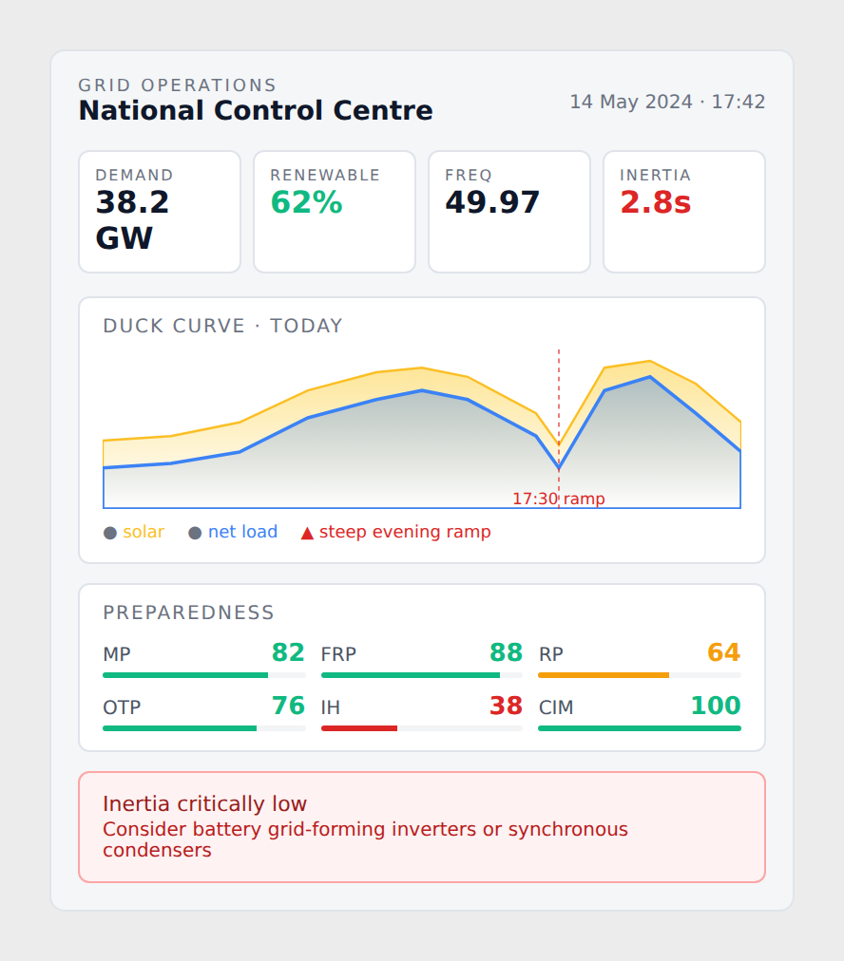
Modern flat design, mobile-first dashboard aesthetic. The full six-score Preparedness Dashboard now visible — five greens, one amber (RP), one critical red (Inertia Health). Duck-curve chart shows the steep evening ramp as the era's new shape-of-problem. The red callout at the bottom names the underlying issue (inertia critically low) and proposes a remedy (grid-forming inverters, synchronous condensers). The mature dashboard is the player's primary strategic anchor at this point.

Era 9 — The Smart Grid
Living Network · UK South · 14 August 2038 · 200 TW to 10 PW
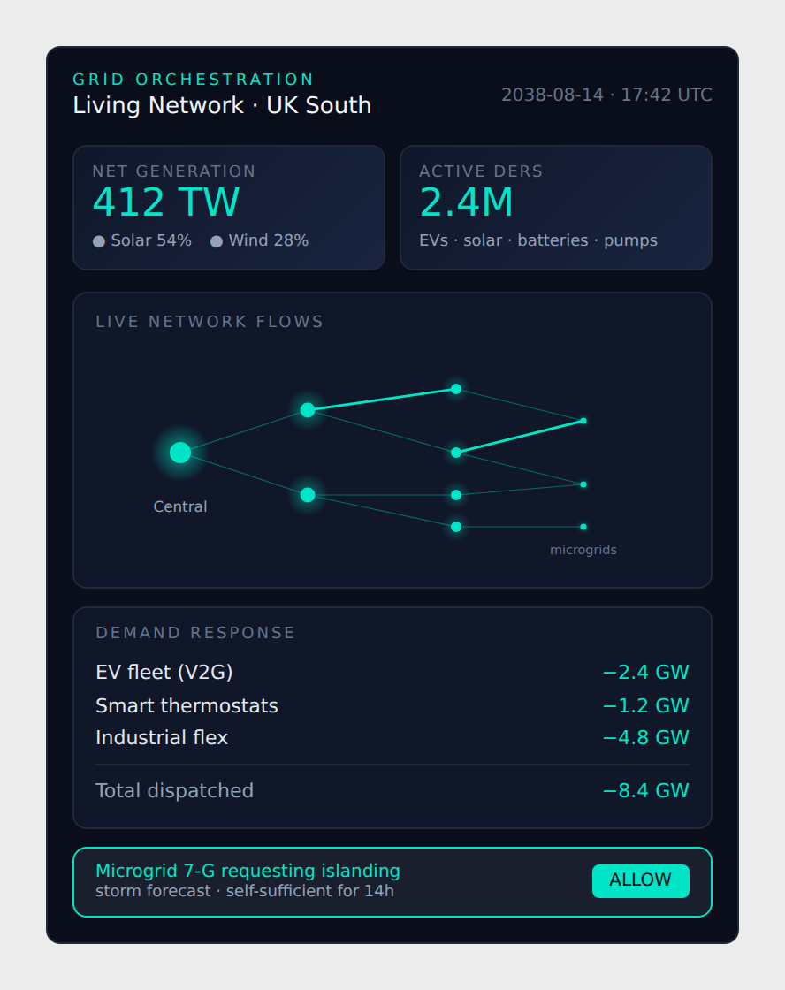
Dark mode, neon accents, glow-haloed network nodes. Distributed energy resources (EVs, prosumers, batteries) are now counted in the millions. Demand-side response is its own dispatch column, with EVs participating via V2G. The microgrid islanding request at the bottom shows a new kind of decision: not "produce more power" but "let part of the grid run autonomously". The mental model has flipped from centralised production to distributed orchestration.

Era 10 — The AI Age
14 May 2052 · 10 PW to 1 EW
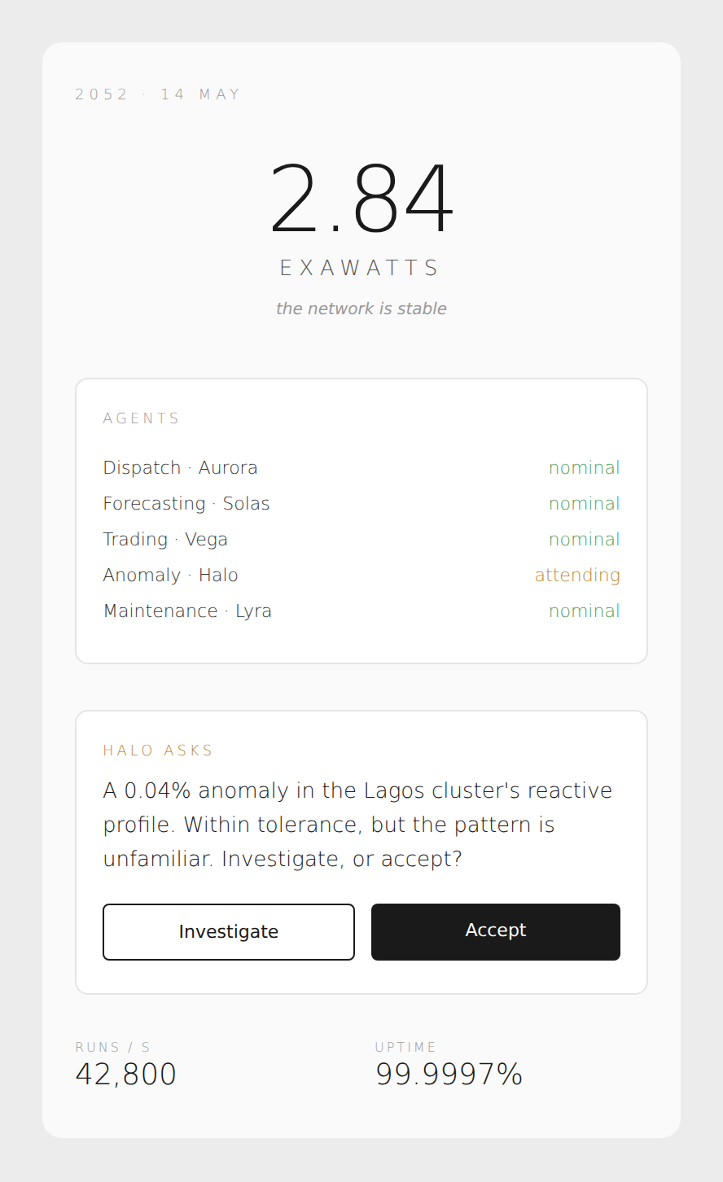
Monastic minimalism. Ultra-light typography, vast whitespace, oversized headline number. The dials are gone — they were always abstractions, and now even the abstractions are abstracted. The agent list shows five AI dispatchers running the grid autonomously; the player's primary interaction is approving or investigating their decisions. The Halo agent's 0.04% anomaly question is the new form of gameplay: the AI flags edge cases for human judgement.

Era 11 — The Global Grid
2080 · synchronous time · 1 EW and beyond
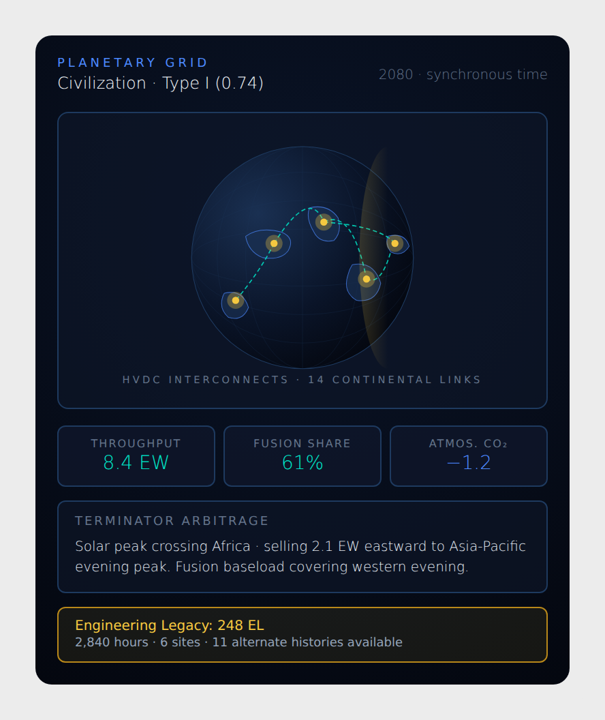
Planetary view. HVDC interconnects glow as green dashed arcs spanning continents. The terminator (day/night boundary) is visible as a soft gold gradient — the game now matters at a civilizational scale. Kardashev scale indicator (Type I, 0.74). Terminator arbitrage is the new optimisation: solar peak rolling around the planet, fusion baseload covering the night side. The Engineering Legacy total at the bottom anchors the player's long-term campaign progress — 248 EL across 2,840 hours.

