Workload Evaluation Report

joiner-xray-log

Report Date:06/29/2018

Overview

|  |  |
| --- | --- |
| Results File(s): | joiner-xray-log |
| Spark Version: | 2.1.1 |
| Cluster Size (number of servers): | local[*] |
| Cluster Location: | AWS EMR |
| Node or Instance Type: |  |
| Workload Description(s): |  |

|  |  |  |  |  |  |  |
| --- | --- | --- | --- | --- | --- | --- |
| Number of Steps | Number of Jobs | Number of Stages | UDFs (Y/N) | Data Format (csv, avro, parquet) | Data Frame/ RDD | Total Run Time (s) |
| 1 | 0 | 4 | No |  | RDD | 5.047 |

**Note:**On Task Summary charts and Task Detail charts there are outlier tasks marked with red color. Task is considered to be an outlier when its run time differs by more than two standard deviations from the mean and at the same time more than 25% from the mean.

Overall Performance Summary

|  |  |  |
| --- | --- | --- |
| Workload | Accelerated? | Time (s) |
| Sampling Stages | No | 5.047 |
| Total App |  | 5.047 |

Workload details on the next pages.

Workload details:

Step0: joiner-xray-log

Execution Time:

|  |  |  |  |  |
| --- | --- | --- | --- | --- |
| Number of Jobs | Number of Stages | UDFs (Y/N) | Data Format (csv, avro, parquet) | Data Frame/ RDD |
| 0 | 4 | No |  | RDD |

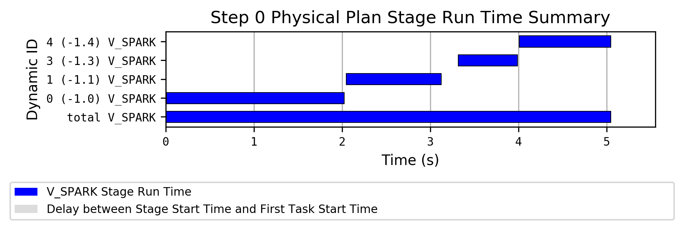

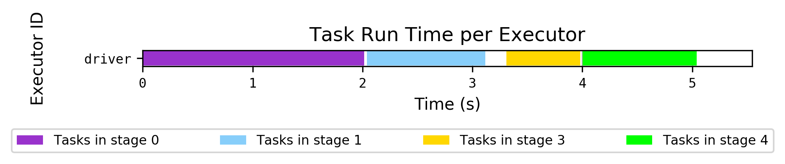

Hostname to Executor ID Mapping:

|  |  |  |
| --- | --- | --- |
| Hostname | IP | Executor ID List |
| localhost |  | driver |

Sampling Stages Details

|  |  |  |  |  |
| --- | --- | --- | --- | --- |
| Stage ID | Operators | Number of Tasks | Number of UDFs | Total Runtime (Task Runtime) (s) |
| 0 | (0) | 200 | 0 | 2.023 (2.015) |
| 1 | (0) | 200 | 0 | 1.077 (1.077) |
| 3 | (0) | 200 | 0 | 0.674 (0.673) |
| 4 | (0) | 102 | 0 | 1.038 (1.037) |

|  |  |  |  |
| --- | --- | --- | --- |
| Stage | Time (s) | Average Task Time (ms) | Task Standard Deviation (ms) |
| 0 | 2.023 | 83 | 143 |
| 1 | 1.077 | 44 | 20 |
| 3 | 0.674 | 27 | 11 |
| 4 | 1.038 | 81 | 32 |
| **TOTAL** | **5.047** |  |  |

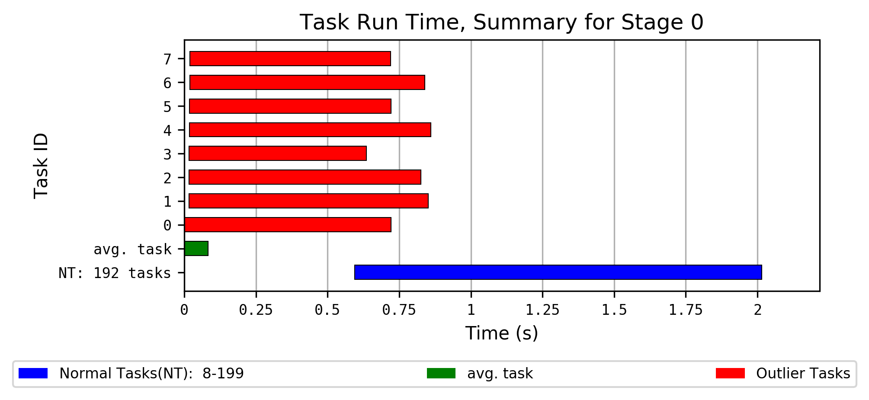

Task Outliers for Stage 0, part 1

| Task ID | Executor ID | Executor Run Time | JVM GC Time | Executor Deserialize CPU Time | Bytes Read | Shuffle Bytes Written | Result Size |
| --- | --- | --- | --- | --- | --- | --- | --- |
| Stage Avg. |  | 42 ms | 4 ms | 3 ms | 37.6 KiB | 103.12 bytes | 1.31 KiB |
| Slow Outliers Avg. |  | 0.3 s | 54 ms | 36 ms | 42.49 KiB | 151.25 bytes | 1.41 KiB |
| 0 | driver | 0.2 s | 13 ms | 18 ms | 23.13 KiB | 0 bytes | 1.24 KiB |
| 1 | driver | 0.5 s | 95 ms | 19 ms | 61.63 KiB | 202 bytes | 1.58 KiB |
| 2 | driver | 0.5 s | 95 ms | 23 ms | 61.46 KiB | 199 bytes | 1.58 KiB |
| 3 | driver | 0.2 s | 13 ms | 20 ms | 23.13 KiB | 0 bytes | 1.24 KiB |
| 4 | driver | 0.5 s | 95 ms | 0.1 s | 62.04 KiB | 402 bytes | 1.58 KiB |
| 5 | driver | 0.2 s | 13 ms | 22 ms | 23.13 KiB | 0 bytes | 1.24 KiB |
| 6 | driver | 0.5 s | 95 ms | 19 ms | 62.23 KiB | 407 bytes | 1.58 KiB |
| 7 | driver | 0.2 s | 13 ms | 32 ms | 23.13 KiB | 0 bytes | 1.24 KiB |

Task Outliers for Stage 0, part 2

| Task ID | Executor ID | Shuffle Write Time | Records Read | Executor CPU Time | Shuffle Records Written | Executor Deserialize Time | Task Run Time |
| --- | --- | --- | --- | --- | --- | --- | --- |
| Stage Avg. |  | 3 ms | 0.51 | 19 ms | 0.51 | 17 ms | 83 ms |
| Slow Outliers Avg. |  | 15 ms | 0.75 | 99 ms | 0.75 | 0.3 s | 0.8 s |
| 0 | driver | 0 ms | 0 | 70 ms | 0 | 0.3 s | 0.7 s |
| 1 | driver | 27 ms | 1 | 0.2 s | 1 | 0.3 s | 0.8 s |
| 2 | driver | 41 ms | 1 | 0.2 s | 1 | 0.3 s | 0.8 s |
| 3 | driver | 0 ms | 0 | 46 ms | 0 | 0.3 s | 0.6 s |
| 4 | driver | 24 ms | 2 | 0.1 s | 2 | 0.3 s | 0.8 s |
| 5 | driver | 0 ms | 0 | 67 ms | 0 | 0.3 s | 0.7 s |
| 6 | driver | 25 ms | 2 | 0.1 s | 2 | 0.3 s | 0.8 s |
| 7 | driver | 0 ms | 0 | 55 ms | 0 | 0.3 s | 0.7 s |

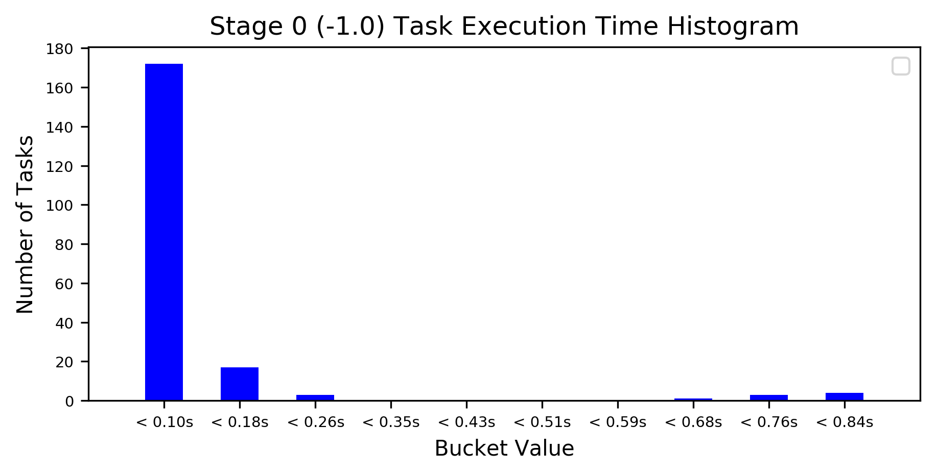

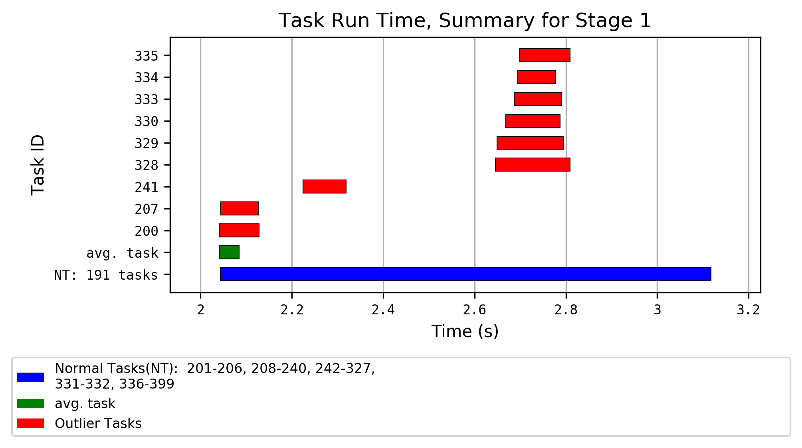

Task Outliers for Stage 1, part 1

| Task ID | Executor ID | Executor Run Time | Total Records Read | Local Bytes Read | Executor Deserialize CPU Time | Result Serialization Time | Result Size |
| --- | --- | --- | --- | --- | --- | --- | --- |
| Stage Avg. |  | 28 ms | 0.51 | 103.12 bytes | 2 ms | 0 ms | 2.38 KiB |
| Slow Outliers Avg. |  | 89 ms | 1.11 | 226.56 bytes | 2 ms | 0 ms | 2.38 KiB |
| 200 | driver | 57 ms | 0 | 0 bytes | 2 ms | 0 ms | 2.36 KiB |
| 207 | driver | 50 ms | 0 | 0 bytes | 2 ms | 0 ms | 2.36 KiB |
| 241 | driver | 52 ms | 0 | 0 bytes | 2 ms | 1 ms | 2.44 KiB |
| 328 | driver | 0.1 s | 3 | 587 bytes | 2 ms | 0 ms | 2.4 KiB |
| 329 | driver | 0.1 s | 1 | 202 bytes | 2 ms | 0 ms | 2.37 KiB |
| 330 | driver | 0.1 s | 2 | 421 bytes | 2 ms | 0 ms | 2.39 KiB |
| 333 | driver | 90 ms | 1 | 199 bytes | 2 ms | 0 ms | 2.37 KiB |
| 334 | driver | 76 ms | 1 | 227 bytes | 2 ms | 0 ms | 2.37 KiB |
| 335 | driver | 91 ms | 2 | 403 bytes | 2 ms | 0 ms | 2.39 KiB |

Task Outliers for Stage 1, part 2

| Task ID | Executor ID | Executor CPU Time | Executor Deserialize Time | Local Blocks Fetched | Task Run Time | Peak Execution Memory |
| --- | --- | --- | --- | --- | --- | --- |
| Stage Avg. |  | 12 ms | 4 ms | 0.51 | 44 ms | 1.3 KiB |
| Slow Outliers Avg. |  | 27 ms | 6 ms | 1.11 | 0.1 s | 3.22 KiB |
| 200 | driver | 17 ms | 4 ms | 0 | 87 ms | 0 bytes |
| 207 | driver | 14 ms | 4 ms | 0 | 83 ms | 0 bytes |
| 241 | driver | 12 ms | 30 ms | 0 | 95 ms | 0 bytes |
| 328 | driver | 40 ms | 2 ms | 3 | 0.2 s | 9.98 KiB |
| 329 | driver | 31 ms | 2 ms | 1 | 0.1 s | 800 bytes |
| 330 | driver | 27 ms | 4 ms | 2 | 0.1 s | 8.38 KiB |
| 333 | driver | 57 ms | 3 ms | 1 | 0.1 s | 800 bytes |
| 334 | driver | 25 ms | 2 ms | 1 | 83 ms | 800 bytes |
| 335 | driver | 23 ms | 2 ms | 2 | 0.1 s | 8.31 KiB |

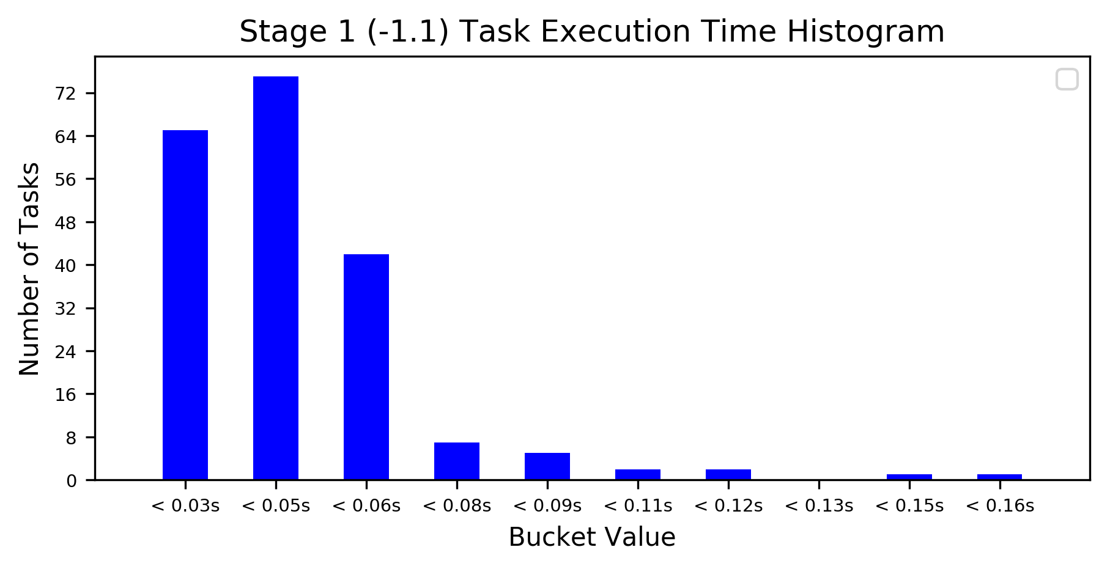

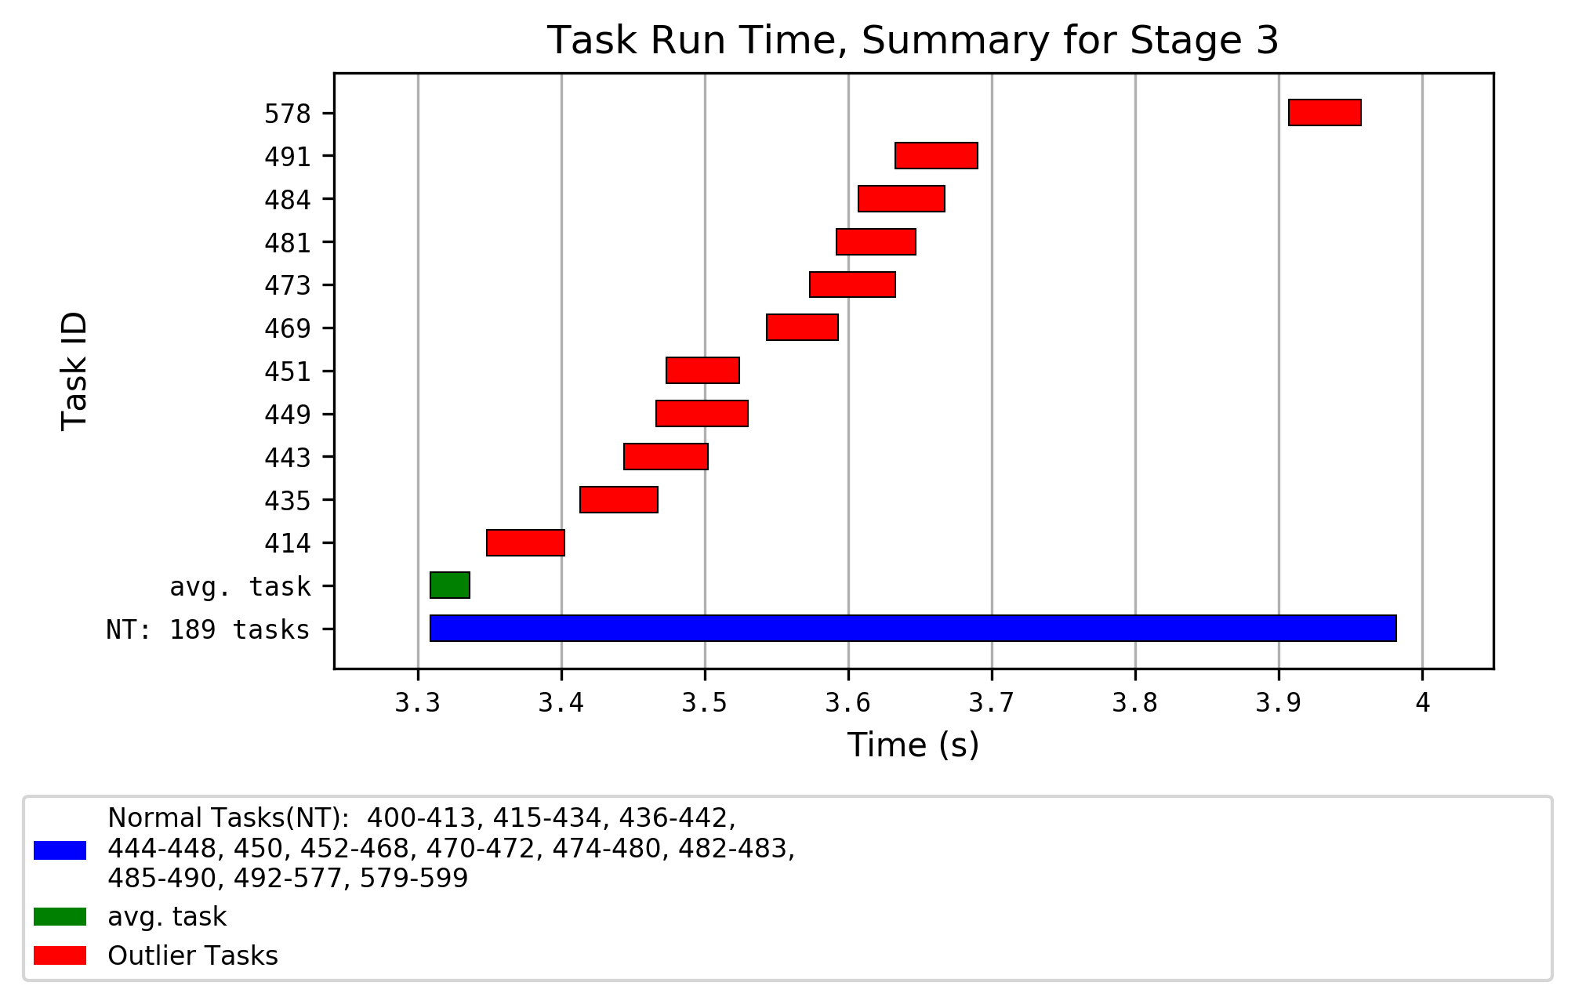

Task Outliers for Stage 3, part 1

| Task ID | Executor ID | Executor Run Time | Executor Deserialize CPU Time | Bytes Read | Result Serialization Time | Shuffle Bytes Written | Result Size |
| --- | --- | --- | --- | --- | --- | --- | --- |
| Stage Avg. |  | 5 ms | 6 ms | 2.77 KiB | 0 ms | 121.02 bytes | 1.18 KiB |
| Slow Outliers Avg. |  | 18 ms | 6 ms | 7.09 KiB | 0 ms | 351 bytes | 1.4 KiB |
| 414 | driver | 27 ms | 6 ms | 6.01 KiB | 0 ms | 246 bytes | 1.41 KiB |
| 435 | driver | 26 ms | 7 ms | 9.56 KiB | 1 ms | 502 bytes | 1.5 KiB |
| 443 | driver | 6 ms | 7 ms | 5.99 KiB | 0 ms | 244 bytes | 1.41 KiB |
| 449 | driver | 20 ms | 6 ms | 9.28 KiB | 1 ms | 468 bytes | 1.5 KiB |
| 451 | driver | 27 ms | 6 ms | 9.95 KiB | 0 ms | 463 bytes | 1.41 KiB |
| 469 | driver | 21 ms | 6 ms | 6.01 KiB | 0 ms | 243 bytes | 1.41 KiB |
| 473 | driver | 21 ms | 6 ms | 7.89 KiB | 0 ms | 485 bytes | 1.41 KiB |
| 481 | driver | 8 ms | 6 ms | 6.01 KiB | 0 ms | 242 bytes | 1.41 KiB |
| 484 | driver | 16 ms | 5 ms | 7.91 KiB | 0 ms | 488 bytes | 1.41 KiB |
| 491 | driver | 29 ms | 6 ms | 9.34 KiB | 0 ms | 480 bytes | 1.41 KiB |
| 578 | driver | 1 ms | 6 ms | 16 bytes | 0 ms | 0 bytes | 1.07 KiB |

Task Outliers for Stage 3, part 2

| Task ID | Executor ID | Shuffle Write Time | Records Read | Executor CPU Time | Shuffle Records Written | Executor Deserialize Time | Task Run Time |
| --- | --- | --- | --- | --- | --- | --- | --- |
| Stage Avg. |  | 1 ms | 0.51 | 3 ms | 0.51 | 11 ms | 27 ms |
| Slow Outliers Avg. |  | 4 ms | 1.45 | 8 ms | 1.45 | 20 ms | 56 ms |
| 414 | driver | 2 ms | 1 | 7 ms | 1 | 19 ms | 54 ms |
| 435 | driver | 3 ms | 2 | 11 ms | 2 | 13 ms | 54 ms |
| 443 | driver | 2 ms | 1 | 6 ms | 1 | 28 ms | 58 ms |
| 449 | driver | 2 ms | 2 | 11 ms | 2 | 19 ms | 64 ms |
| 451 | driver | 8 ms | 2 | 12 ms | 2 | 9 ms | 51 ms |
| 469 | driver | 2 ms | 1 | 6 ms | 1 | 19 ms | 50 ms |
| 473 | driver | 2 ms | 2 | 10 ms | 2 | 12 ms | 60 ms |
| 481 | driver | 2 ms | 1 | 6 ms | 1 | 19 ms | 55 ms |
| 484 | driver | 4 ms | 2 | 10 ms | 2 | 18 ms | 60 ms |
| 491 | driver | 15 ms | 2 | 9 ms | 2 | 22 ms | 57 ms |
| 578 | driver | 0 ms | 0 | 1 ms | 0 | 42 ms | 50 ms |

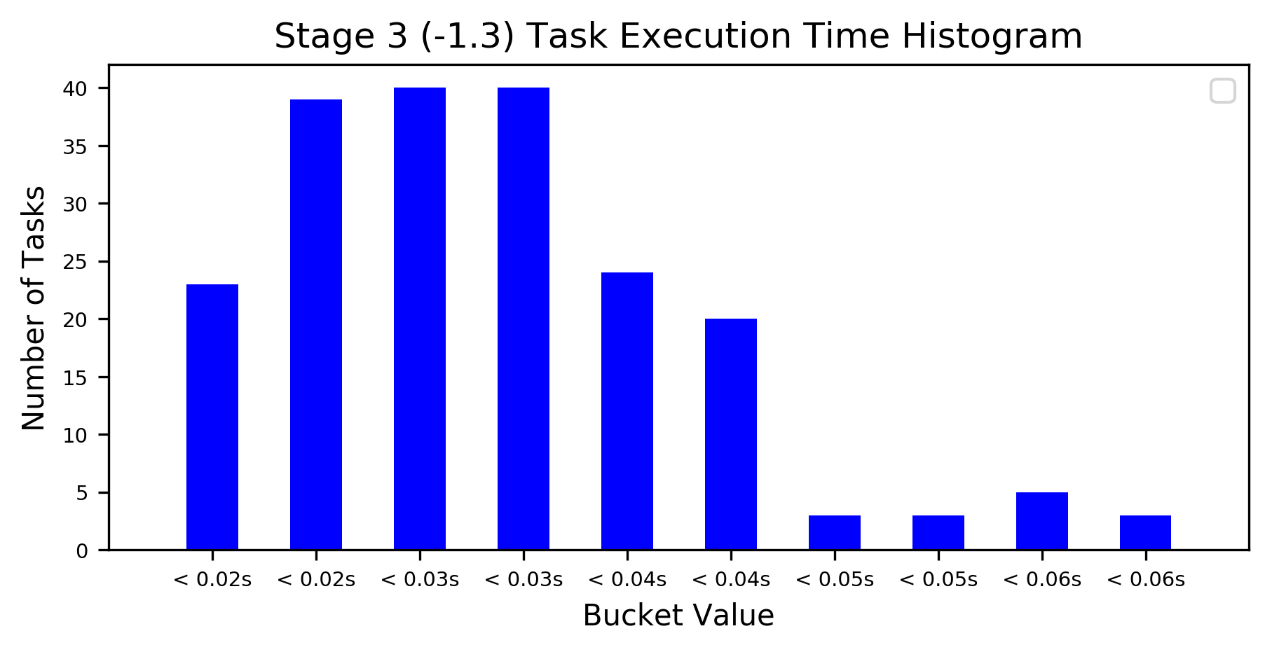

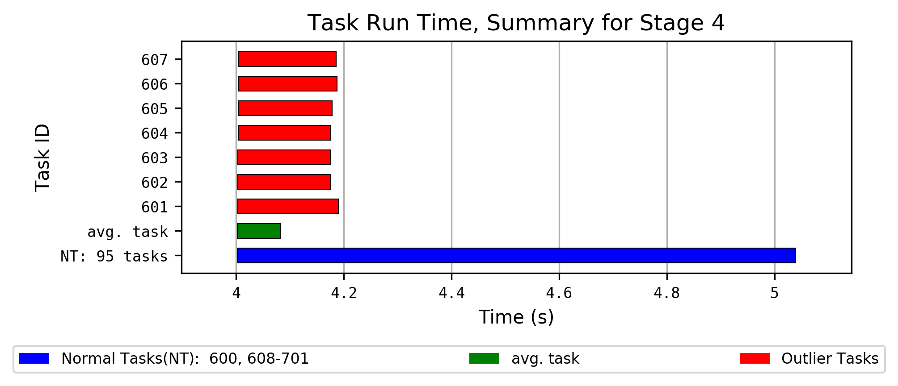

Task Outliers for Stage 4

| Task ID | Executor ID | Executor Run Time | Local Bytes Read | Executor Deserialize CPU Time | Bytes Written | Executor CPU Time | Executor Deserialize Time | Task Run Time | Peak Execution Memory |
| --- | --- | --- | --- | --- | --- | --- | --- | --- | --- |
| Stage Avg. |  | 56 ms | 237.29 bytes | 12 ms | 130.99 bytes | 18 ms | 17 ms | 81 ms | 8.48 KiB |
| Slow Outliers Avg. |  | 0.1 s | 242.86 bytes | 20 ms | 137.57 bytes | 35 ms | 32 ms | 0.2 s | 8.63 KiB |
| 601 | driver | 0.1 s | 243 bytes | 20 ms | 157 bytes | 39 ms | 31 ms | 0.2 s | 8.71 KiB |
| 602 | driver | 0.1 s | 239 bytes | 20 ms | 128 bytes | 33 ms | 33 ms | 0.2 s | 8.6 KiB |
| 603 | driver | 0.1 s | 242 bytes | 18 ms | 130 bytes | 37 ms | 31 ms | 0.2 s | 8.59 KiB |
| 604 | driver | 0.1 s | 230 bytes | 22 ms | 129 bytes | 37 ms | 31 ms | 0.2 s | 8.47 KiB |
| 605 | driver | 0.1 s | 245 bytes | 22 ms | 134 bytes | 36 ms | 28 ms | 0.2 s | 8.66 KiB |
| 606 | driver | 0.1 s | 240 bytes | 17 ms | 136 bytes | 28 ms | 32 ms | 0.2 s | 8.63 KiB |
| 607 | driver | 0.1 s | 261 bytes | 18 ms | 149 bytes | 35 ms | 36 ms | 0.2 s | 8.74 KiB |

