Workload Evaluation Report

realign-xray-log

Report Date:06/29/2018

Overview

|  |  |
| --- | --- |
| Results File(s): | realign-xray-log |
| Spark Version: | 2.1.1 |
| Cluster Size (number of servers): | local[*] |
| Cluster Location: | AWS EMR |
| Node or Instance Type: |  |
| Workload Description(s): |  |

|  |  |  |  |  |  |  |
| --- | --- | --- | --- | --- | --- | --- |
| Number of Steps | Number of Jobs | Number of Stages | UDFs (Y/N) | Data Format (csv, avro, parquet) | Data Frame/ RDD | Total Run Time (s) |
| 1 | 0 | 7 | No |  | RDD | 96.467 |

**Note:**On Task Summary charts and Task Detail charts there are outlier tasks marked with red color. Task is considered to be an outlier when its run time differs by more than two standard deviations from the mean and at the same time more than 25% from the mean.

Overall Performance Summary

|  |  |  |
| --- | --- | --- |
| Workload | Accelerated? | Time (s) |
| Sampling Stages | No | 96.467 |
| Total App |  | 96.467 |

Workload details on the next pages.

Workload details:

Step0: realign-xray-log

Execution Time:

|  |  |  |  |  |
| --- | --- | --- | --- | --- |
| Number of Jobs | Number of Stages | UDFs (Y/N) | Data Format (csv, avro, parquet) | Data Frame/ RDD |
| 0 | 7 | No |  | RDD |

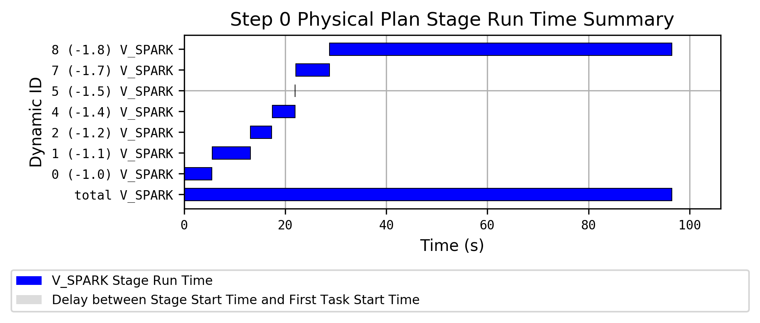

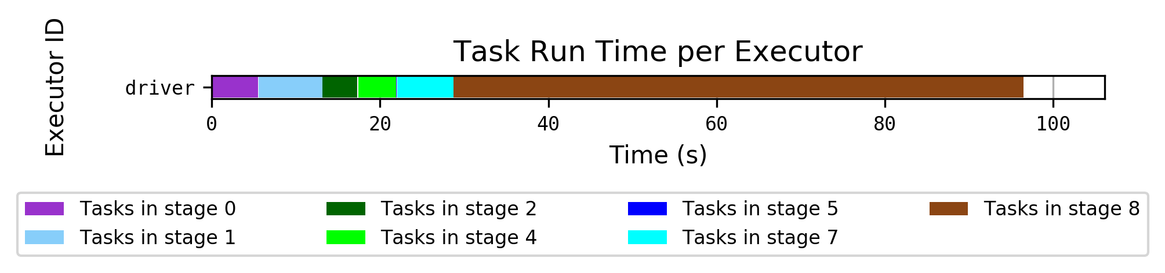

Hostname to Executor ID Mapping:

|  |  |  |
| --- | --- | --- |
| Hostname | IP | Executor ID List |
| localhost |  | driver |

Sampling Stages Details

|  |  |  |  |  |
| --- | --- | --- | --- | --- |
| Stage ID | Operators | Number of Tasks | Number of UDFs | Total Runtime (Task Runtime) (s) |
| 0 | (0) | 3 | 0 | 5.469 (5.46) |
| 1 | (0) | 3 | 0 | 7.549 (7.549) |
| 2 | (0) | 3 | 0 | 4.179 (4.177) |
| 4 | (0) | 3 | 0 | 4.495 (4.494) |
| 5 | (0) | 3 | 0 | 0.039 (0.039) |
| 7 | (0) | 3 | 0 | 6.665 (6.665) |
| 8 | (0) | 3 | 0 | 67.727 (67.727) |

|  |  |  |  |
| --- | --- | --- | --- |
| Stage | Time (s) | Average Task Time (s) | Task Standard Deviation (s) |
| 0 | 5.469 | 5.166 | 0.24 |
| 1 | 7.549 | 7.154 | 0.333 |
| 2 | 4.179 | 4.169 | 0.007 |
| 4 | 4.495 | 4.477 | 0.011 |
| 5 | 0.039 | 0.037 | 0.002 |
| 7 | 6.665 | 6.643 | 0.027 |
| 8 | 67.727 | 67.369 | 0.436 |
| **TOTAL** | **96.467** |  |  |

