COP 2805C-31294

Summer

Jonathan Disla

Assignment 01

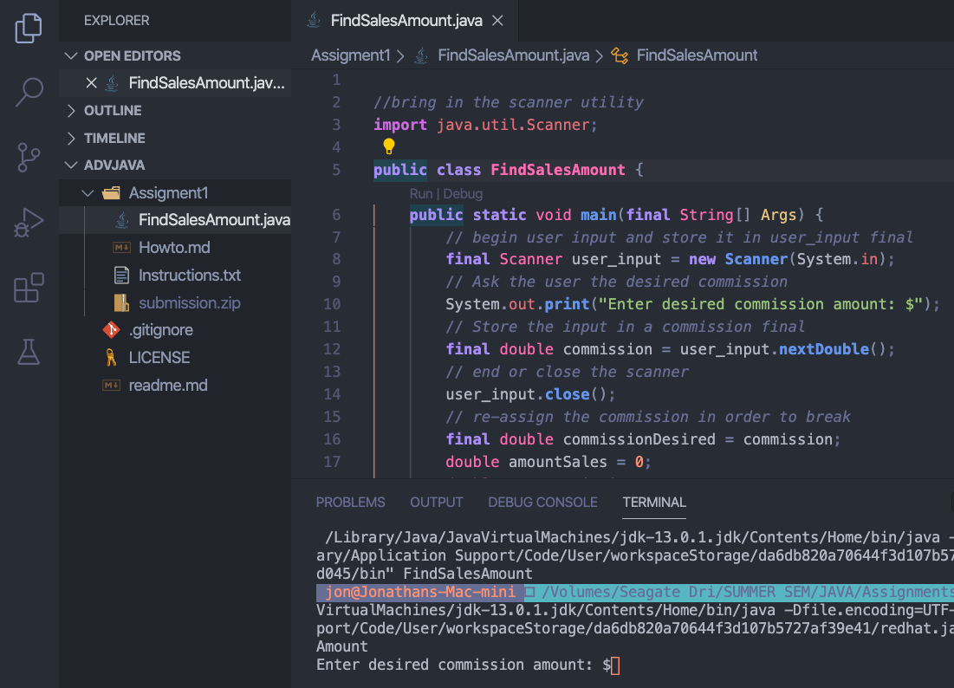

The program first ask for “Enter desired commission amount: $

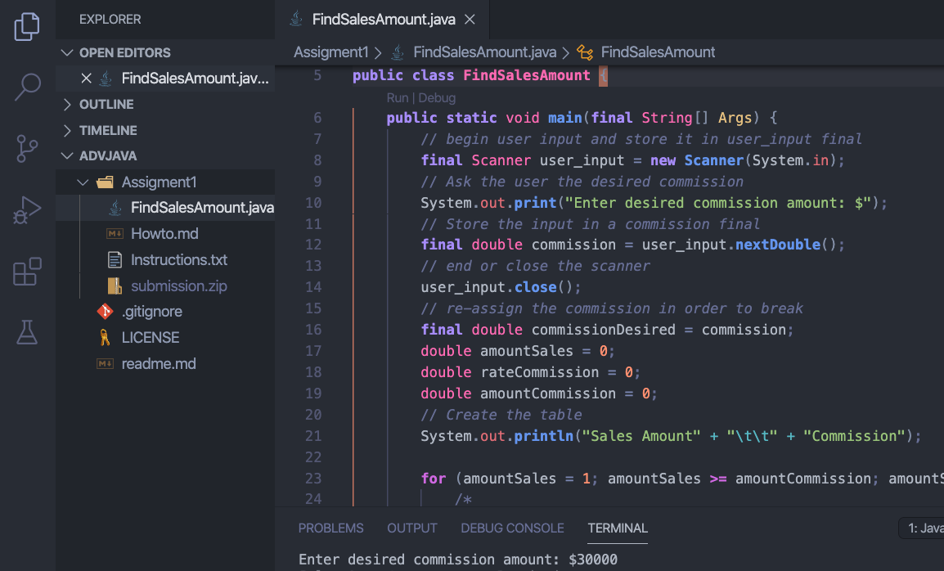

Enter the amount of $30,000 for the desired commission.

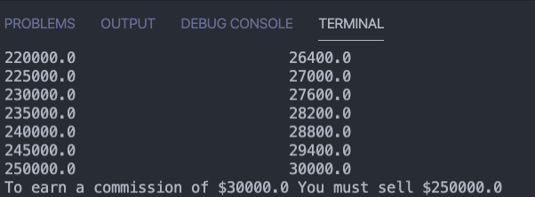

In order to earn a commission of 30000 you must sell $250,000

You are welcome to try other amounts to check for consistency.

//*bring in the scanner utility*

**import** java.util.Scanner;

**public** **class** **FindSalesAmount** {

**public** **static** void **main**(**final** String[] Args) {

// *begin user input and store it in user_input final*

**final** Scanner user_input = **new** **Scanner**(System**.**in);

// *Ask the user the desired commission*

System**.**out**.print**("Enter desired commission amount: $");

// *Store the input in a commission final*

**final** double commission = user_input**.nextDouble**();

// *end or close the scanner*

user_input**.close**();

// *re-assign the commission in order to break*

**final** double commissionDesired = commission;

double amountSales = 0;

double rateCommission = 0;

double amountCommission = 0;

// *Create the table*

System**.**out**.println**("Sales Amount" + "\t\t" + "Commission");

**for** (amountSales = 1; amountSales **>=** amountCommission; amountSales++) {

/*

*\* if the amountSales is less than or equal to 5000 The rate of commission is*

*\* 0.08*

*/

**if** (amountSales **<=** 5000) {

rateCommission = 0.08;

}

/*

*\* if the amountSales is greater than or equal to 5001 The rate of commission is*

*\* 0.10*

*/

**if** (amountSales **>=** 5001 **&&** amountSales **<=** 10000) {

rateCommission = 0.10;

}

/*

*\* if the amountSales is greater than or equal to 10000 The rate of commission*

*\* is 0.012*

*/

**if** (amountSales **>=** 10000) {

rateCommission = 0.12;

}

// *add and assign 4999 to the sales amount*

amountSales += 4999;

// *calculate the commission by multiplying the sales by the commission rate*

amountCommission = amountSales * rateCommission;

System**.**out**.println**(amountSales + "\t\t\t" + amountCommission);

// *check if the commission amount is greater than or equal to the desired*

// *commission and if so, stop the for loop*

**if** (amountCommission **>=** commissionDesired) {

**break**;

}

}

System**.**out**.println**("To earn a commission of $" + commissionDesired + " You must sell $" + amountSales);

}

}