Jonathan Disla

Assignment 1.4

Web 335

Prof. Krasso

ORD

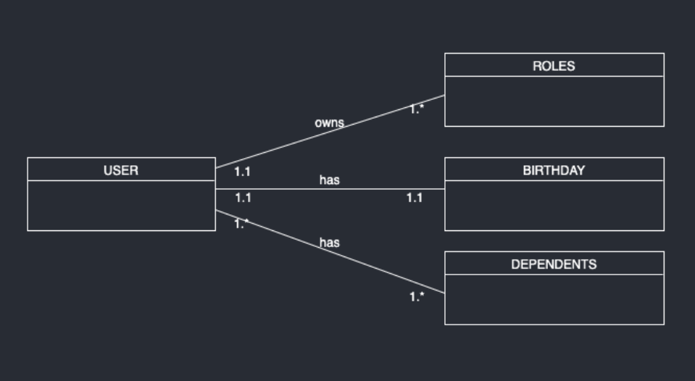

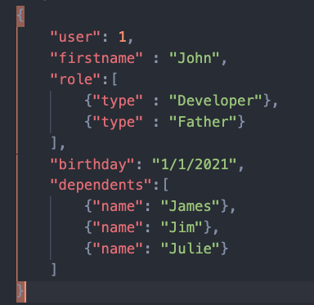NoSQL Data Structure