Jonathan Disla

Assignment 2.3

Web 335

Prof. Krasso

ORD

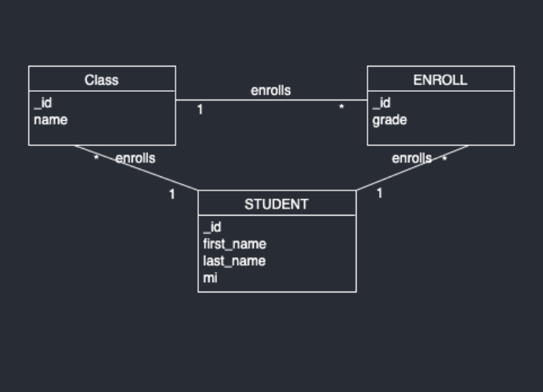

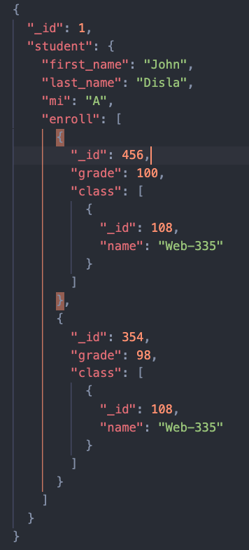NoSQL