Jonathan Disla

Assignment 3.3

Web 335

Prof. Krasso

ORD

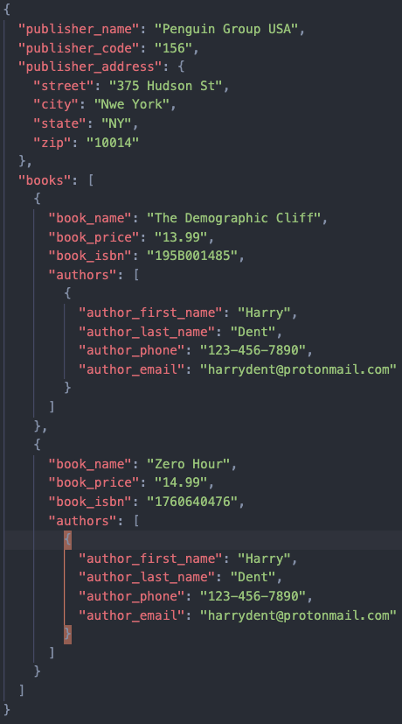NoSQL Data Structure