Jonathan Disla

Assignment 4.2

Web 335

Prof. Krasso

MongoDB Installation

Installation

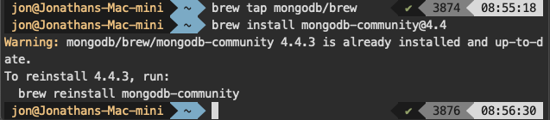

Connection

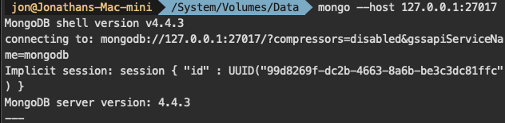

MongoDB Compass

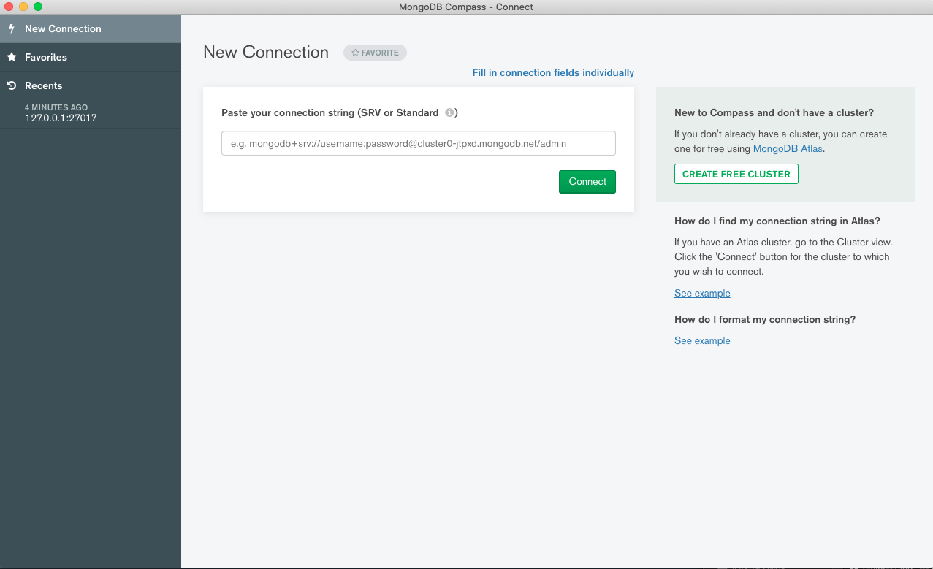

MongoDB Instance

