Jonathan Disla

Assignment 4.3

Web 335

Prof. Krasso

MongoDB Connection

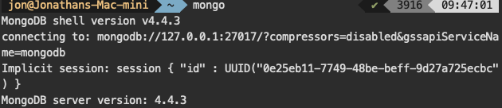

helloWorld function

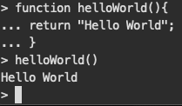

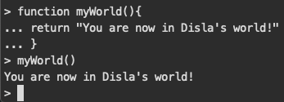myWorld function