Jonathan Disla

Assignment 5.3

Web 335

Prof. Krasso

Exhibit A

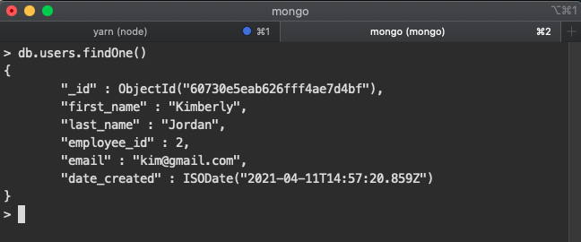

Exhibit B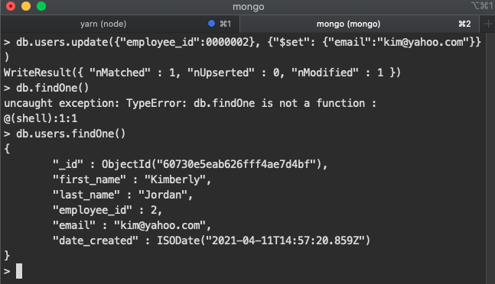 & C