Jonathan Disla

Assignment 5.2

Web 335

Prof. Krasso

Exhibit A

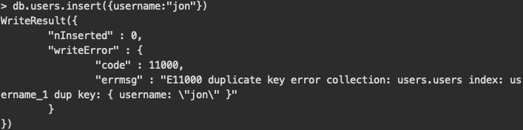

Exhibit B

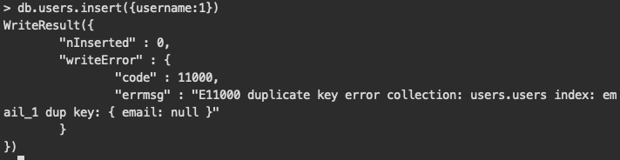Exhibit 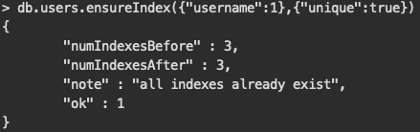C