Jonathan Disla

Assignment 3.2

Web 420

Prof. Krasso

JAVA Version

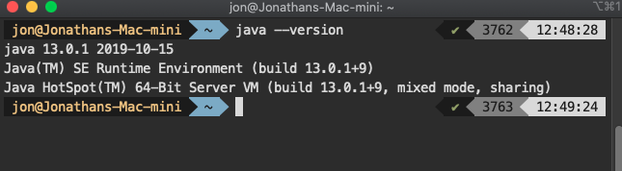S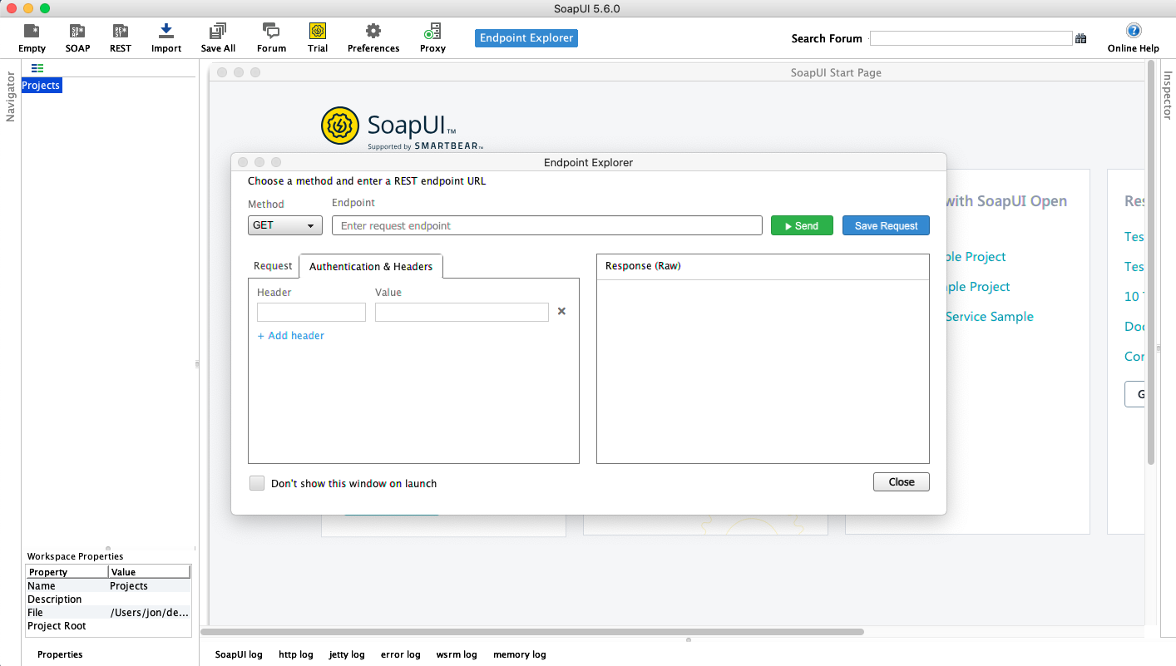OAP UI