Jonathan Disla

Assignment 3.4

4/3/2021

Web 420

Prof. Krasso

Left Pane Request

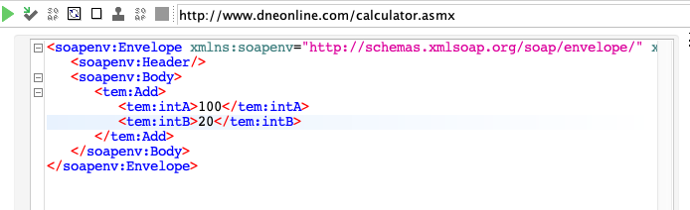

R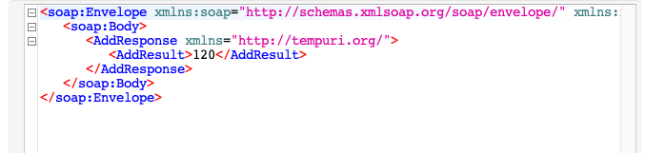ight Pane Result