Jonathan Disla

Assignment 4.4

Web 420

Prof. Krasso

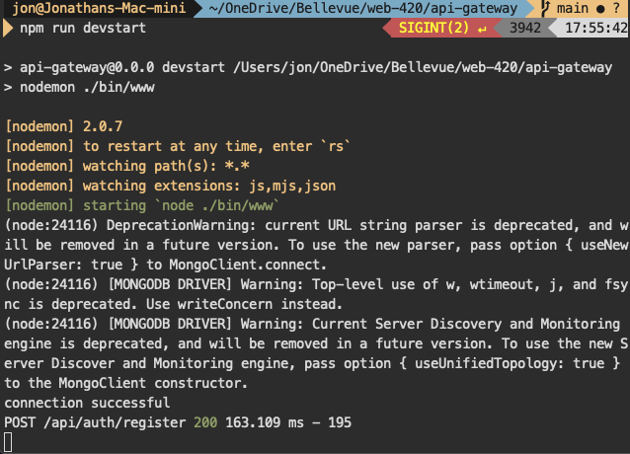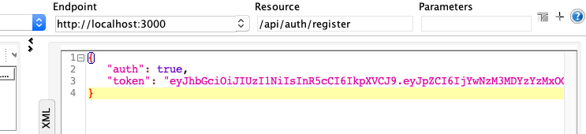

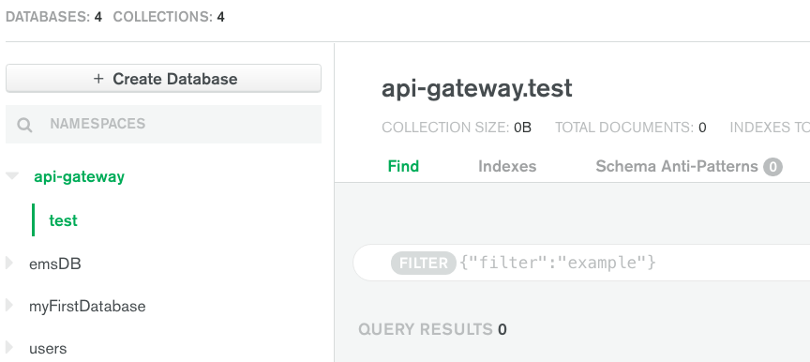

14. Sign in to mLab, open the api-gateway database, and take a screenshot of the added entry

* Nothing listed on MongoDB Atlas (rather than Mlab) as SOAP UI was POSTing to localhost:3000/api/auth/register which is local.