Jonathan Disla

Assignment 5.2

Web 420

Prof. Krasso

Exhibit A

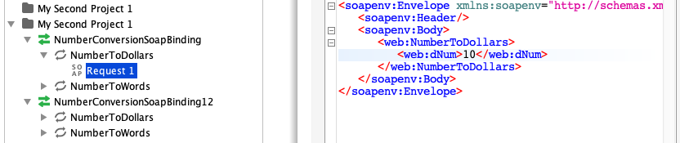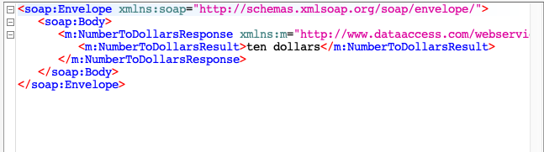Exhibit B