Jonathan Disla

Assignment 5.3

Web 420

Prof. Krasso

Exhibit A



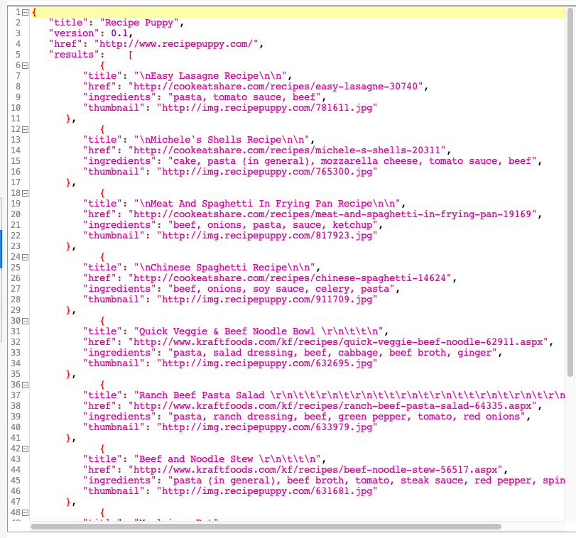Exhibit B