Jonathan Disla

Assignment 5.4

Web 420

Prof. Krasso

Professor this did not work. I hope I can get some partial credit as there is not way to contact anyone for help. Googling and some classmates helped me get to this point however.

Issue: Able to post new users but unable to GET the user by the x-access-token. Illustrated below:

POST request creates the new user



GET request to see the user



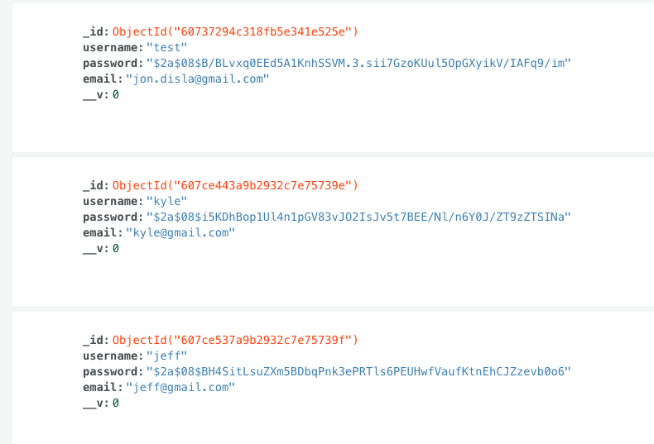Picture of records created

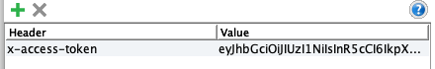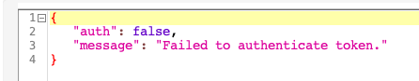SOAP UI token and response