Jonathan Disla

Assignment 6.3

Web 420

Prof. Krasso

Exibit A

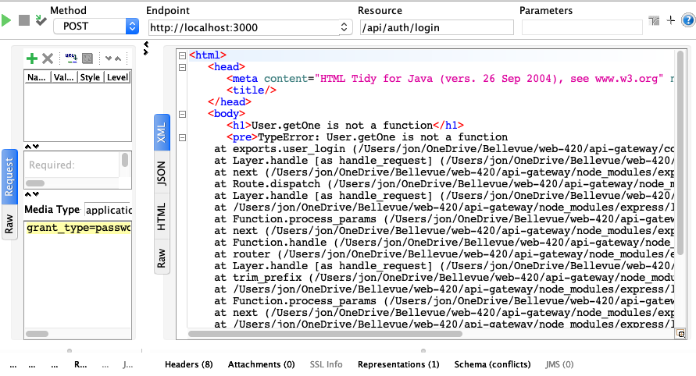

Exibit B

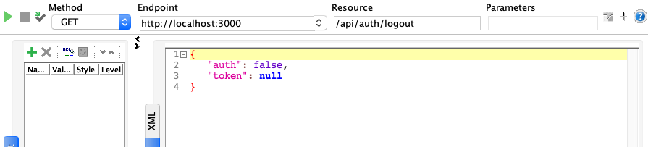

Exibit C



Exibit D



Exhibit E