Nodeflix

Web 420

Team Hufflepuff

Assignment 7.2

**BIOS**

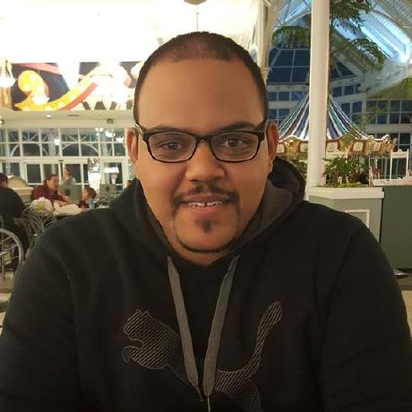

Jonathan Disla

Team Captain

Jonathan Disla is a web developer out of Orlando Florida. He started developing at an early age as a hobby, left the field, and recently started his journey back to development. Jonathan has attended a coding boot camp and is now in pursuit of a bachelor's degree in web development from Bellevue University. When Jonathan is not programming, he is spending time with his wife and little daughter who bring happiness to his life. He also has a passion for music which he has used to create children's songs for private parties as a contractor. His sound engineering roots also facilitate the process of editing and mixing music. In his working life, Jonathan works in information technology where he notices the struggles that older generations have with continuous emerging technology. He led an effort in creating a flow-based system of questions and answers that technologically challenged individuals can use to learn new technology.

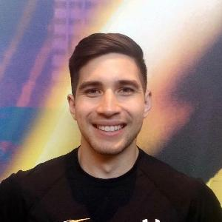

Mark Watson

Software Developer

Mark is a Software Developer who currently studies at Bellevue University in their Web Development program. He has worked with frontend technologies such as HTML, CSS and JavaScript as well as libraries like Bootstrap, React, Semantic UI and jQuery. He also has experience with the backend languages – Node and Python, frameworks like Express, and databases such as MySQL and MongoDB. Mark’s goal as a developer is to get better every day and he would like to, one day, be a contributor to projects that make a positive difference in the world. He enjoys learning new things and work that challenges him to stretch his skills in more directions. Mark is currently based in Las Vegas, NV with his fiancé, Kristen. He has a 2-year-old daughter, Willow and another child on its way, due in July 2021! Mark is a former collegiate athlete, playing soccer in the NCAA. His hobbies include reading, playing sports, coaching, exercising, traveling, outdoor activities and rooting for the Portland Trail Blazers.

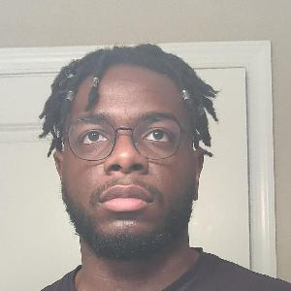

Larry Ohaka

Designer / Developer

My name is Larry Ohaka and I am 25 years old. Born and raised in Maryland, I grew up drawing just about anything that caught my attention. I loved watching cartoons and ever since the age of 6 I've been developing in other areas of art such as painting and sculpting. Later on in life I gained interest in design after my first graphic design class in high school. So far in my academic career I have attended Bowie State University for 2 years, then graduated from University of Maryland, Baltimore County (UMBC) in 2017 with a BA in Visual Arts. I decided to transfer to the UMBC for the visual arts program so I can have a better understanding of the graphic design field, but now that I’ve gone through those courses in design I found another interest, coding. After graduating and after finding a job in graphic design I started to delve in learning HTML & CSS. It was a struggle at first but I taught myself the fundamentals and gave myself projects to work on to strengthen this skill. Building on this interest in coding I decided to enroll for a degree in web development in order to add other languages to my skill set (Javascript, Python, and maybe Ruby) so I could merge my two interests (design & developing) in hopes to tread into the field of full stack developing.

**Goals of this website**

1. Allow users to stream tv series, movies, and documentaries
2. Create a profile that allows user to create "favorited" list
3. Allow a shuffle option
4. Create search function to search for show/movie/documentary

**Core users**

* Users will be avid show binge watchers (age range:10-30)
* Users capable of subscribing monthly/annually

**Personas**

 **Persona:** Williams Family **Ages:** 30, 10, 7 **Gender:**Male/Female

**Distinguishing Characteristic:** The Williams Family are avid

family rated shows binge watchers between the targeted ages.

**Important Feature:** Allows the mom to create a family profile.

**Unimportant Feature:** Not interested in documentary films

**Needs to Meet:** They must have a favored list to because the kids are impatient when they want to watch a show.

**Favorite Brands:** Disney, Nickelodeon

**Hobbies:** Legos, Coloring, Soccer

**Occupation:** Teacher (mom)

**Computer Skill Level**: 8/10

**Persona:** Paul and Gertrude **Ages:** 40s **Gender:** Male/Female

**Distinguishing Characteristic:** Enjoy documentaries about political and historic events.

**Important Feature:** Would like to be able to shuffle and get randomized suggestions to watch and a DVR function.

**Unimportant Feature:** Not interested in pre-recorded sporting

**Needs to Meet:** Must be able to record with DVR and get suggestions for movies and shows.

**Favorite Brands:** JC Penny, Goldman Sachs, Berkshire Hathaway

**Hobbies:** Traveling, Collecting, Photography

**Occupation:** Paul (History Teacher), Gertrude (Lawyer)

**Computer Skill Level:** 5/10

 **Persona:** Mike and Shawn **Age:** 23 & 27 **Gender:** Male

**Distinguishing Characteristic:** Like to bet on sport games and are part of a fantasy football league live in the same home.

**Important Feature:** Need to be able to pre-record events and must be able to stream two different devices at the same time

**Unimportant Feature:** They have their own live tv subscription so don’t need premium channels.

**Needs to Meet:** Pre-recorded sporting and two active streaming connections

**Favorite Brands:** Nike, NFL, UFC

**Hobbies:** Car detailing, Video games, Motorcycles

**Occupation:** High rise construction workers

**Computer Skill Level:** 9/10

**Persona:** Grandparents **Ages:** 60s **Gender:** Male/Female

**Distinguishing Characteristic:** They enjoy watching old flicks from the time they were young. They would like a large library.

**Important Feature:** Streaming old tv shows and an easy to navigate interface.

**Unimportant Feature:** Don’t care about watching commercials

**Needs to Meet:** Unlimited TV shows and user friendly interface.

**Favorite Brands:** Pinch a Penny, Black and Decker, Marshalls

**Hobbies:** Knitting, Gardening

**Occupation:** Retired

**Computer Skill Level: 1**/10

**Persona:** Tech Firm **Ages:** 30s **Gender:** Male/Female

**Distinguishing Characteristic:** They like to have employees be able to stream their favorite movies while under brakes. Would need a large library with unlimited movies.

**Important Feature:** Want a commercial free experience and a lot of connections at the same time.

**Unimportant Feature:** Favored list not necessary as it is a shared account.

**Needs to Meet:** Commercial free

**Favorite Brands:** Apple, Windows, Google

**Hobbies:** Many different interests

**Occupation:** Developers

**Computer Skill Level:** 10/10

**User Requirements**

* As a family, we want to have a favored list so that we can choose programs to watch quickly.
* As a history teacher, I wand to get show suggestions so that I can find new shows that I may not know about.
* As roommates we want to have two simultaneous streaming connections so that we can watch games in our separate rooms.
* As grandparents, we want to watch unlimited TV shows so that we can catch up on our old TV episodes.
* As a tech firm, we want to have no commercials so that employees have time to watch content instead of commercials.

**Designer/Developer Requirements**

* As a developer, I want access to fast servers so that users don’t have buffering and intermittency.
* As a developer, I want a scalable database of titles so that I can add new titles.
* As a developer, I want to integrate google or facebook sign in so that it is easier to sign users in.
* As a developer, I want to use React or Angular so that the interface can be modern and faster.
* As a developer, I want to use a movie and shows API so that the app can have summaries and movie ratings.