Jonathan Disla

Assignment 7.1

Web 420

Prof. Krasso

**SVG**

**Purpose:** SVG is an image format...includes a hypermedia control that lets different parts of an image link to different resources (Richardson & Amundsen, 202). SVG stands for *scalable vector graphics,* and it is a file format that allows you to display vector images on your website. This means that you can scale an SVG image up and down as needed without losing any quality, making it a great choice for responsive web design (tbh). When used in a container, the SVG element is used as the outermost element of SVG documents, but it can also be used to embed an SVG fragment inside an SVG or HTML document. Scalable vector graphics can be used to scale geometric shapes, icons, technical drawings, fonts, icons, and logos without quality loss. These images do not show the aliasing effect typical of raster graphics, in which individual pixels appear (Ionos).

**Protocol Semantics:** the same as Xlink

**Application Semantics:** vector graphics

**Medium:** XML

**Defined:** Mozilla MDN ([**https://developer.mozilla.org/en-US/docs/Web/SVG**](https://developer.mozilla.org/en-US/docs/Web/SVG))

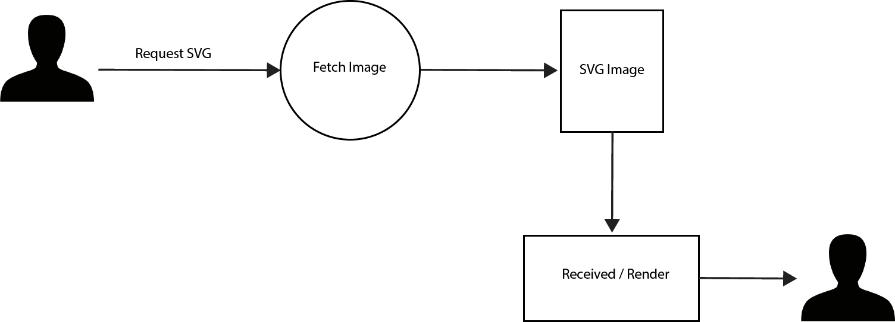**SVG Flow Diagram**

**OpenSearch**

**Purpose:** OpenSearch is a standard for representing search forms. It can be used standalone, or incorporated into another API using the search link relation (Richardson & Amundsen, 201). According to MDN, the OpenSearch format lets a website describe a search engine for itself, so that a browser or other client application can use that search engine (MDN). The specific template for OpenSearch contains fields such as ShortName, Description, InputEncoding, Image, URL, Param and moz:searchForm.

**Protocol Semantics:** searching using GET

**Application Semantics:** search queries

**Medium:** XML

**Defined:** Mozilla MDN (<https://developer.mozilla.org/en-US/docs/Web/OpenSearch>)

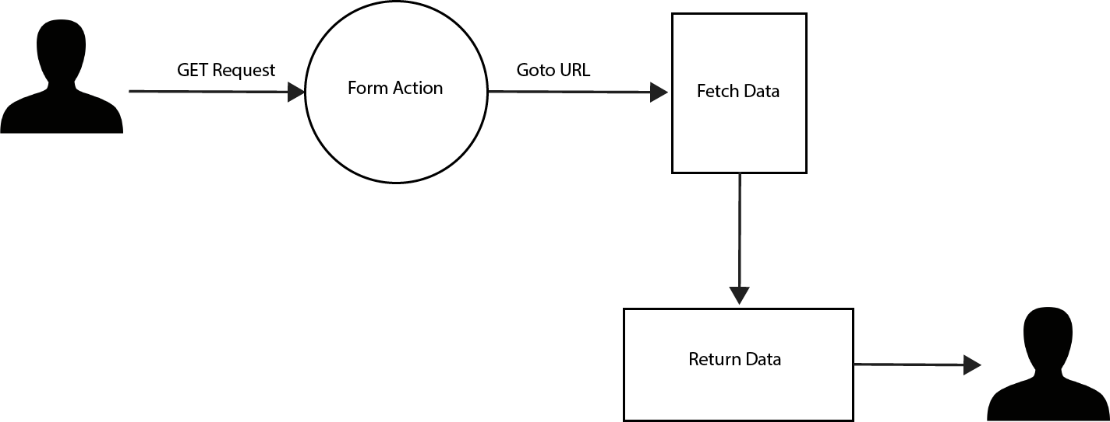**OpenSearch Flow Diagram**

Reference List

Digital Guide Ionos. “SVG format: how to embed graphic files into your website”. Ionos, 23 August 2017.

<https://www.ionos.com/digitalguide/websites/website-creation/svg-format-how-to-> [embed-svg-vector-graphics/](https://www.ionos.com/digitalguide/websites/website-creation/svg-format-how-to-embed-svg-vector-graphics/)

# MDN Web Docs. “SVG: Scalable Vector Graphics”. Mozilla, Accessed 29 April 2021.

https://developer.mozilla.org/en-US/docs/Web/SVG

# TBH Creative. “Benefits of using SVG (scalable vector graphics)”. TBH, 15 June 2017.

<https://blog.tbhcreative.com/2017/06/benefits-of-using-svg.html>

Richardson L. & Amundsen M. “RESTful web apis”. - Sebastopol, CA: O’Reilly Media.