Jonathan Disla

Assignment 8.4

Web 420

Prof. Krasso

After adding the provided code, the program no longer runs. After some research it looks like there is a service worker issue which is my best guess. This is the server result I am getting:

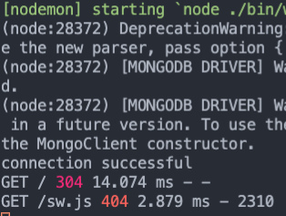

I may find a solution to this still however right now this is where the program is at; unable to run any routes at the moment.