SCREENSHOTS
Placement Skill-Gap Hub — Build Evidence
Hackathon  HACKORBIT 2K26 | Team  Codeavengers | Track  Track A — DataDrishti
01 Power BI Desktop · 02 Web Dashboard (Live Site) · 03 GitHub Repository · 04 Vercel Deployment

01
Power BI Desktop
The actual analytics implementation — DAX, data model, native slicers

• Placement Command Center
• Skill Demand vs. Readiness
• Action Center — Priority Matrix & Recommendation Engine

POWER BI DESKTOP
Placement Command Center
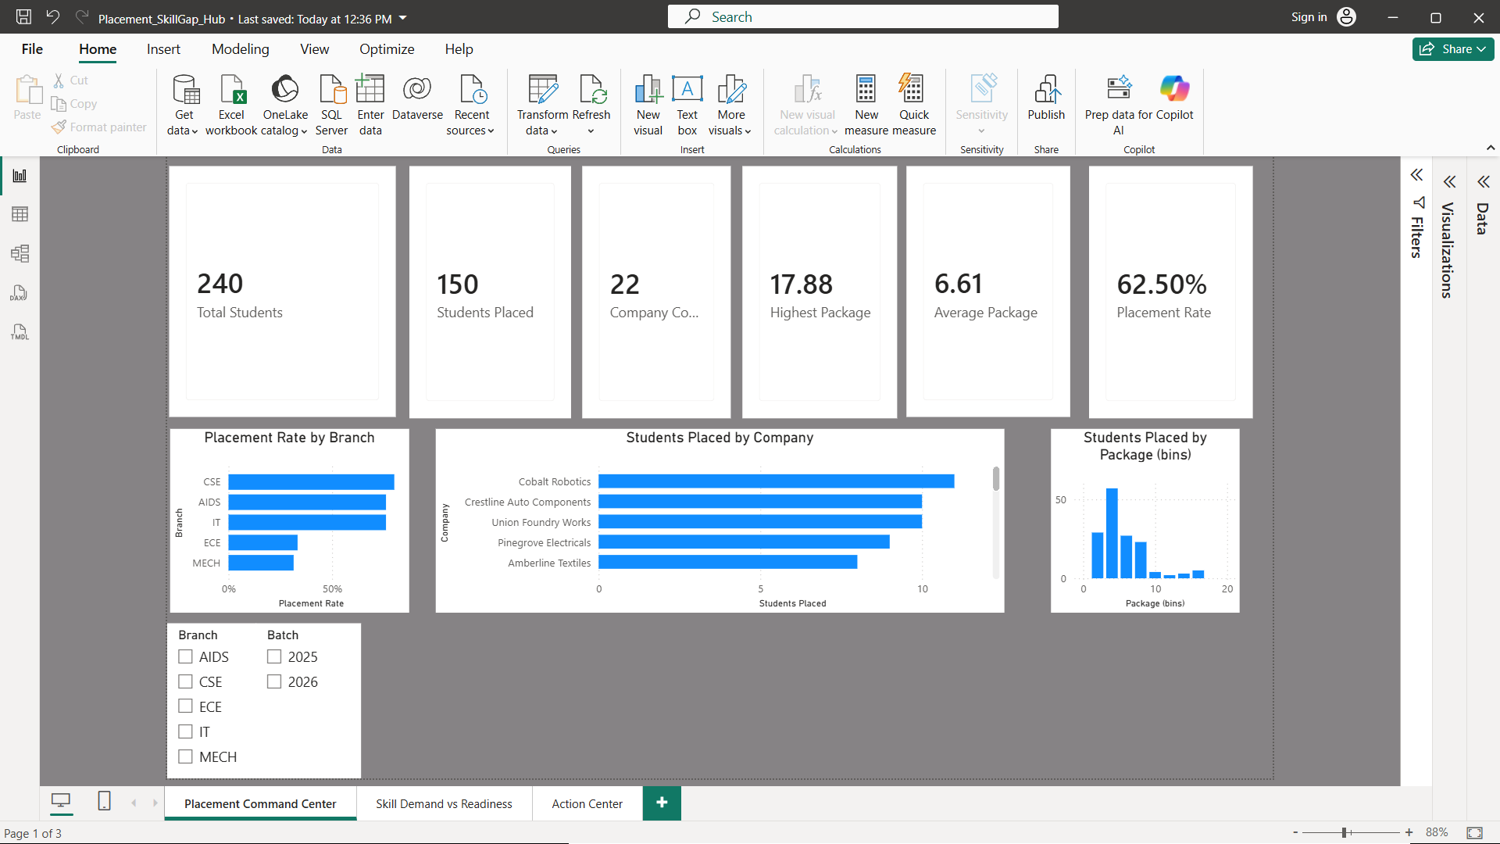

POWER BI DESKTOP
Skill Demand vs. Readiness
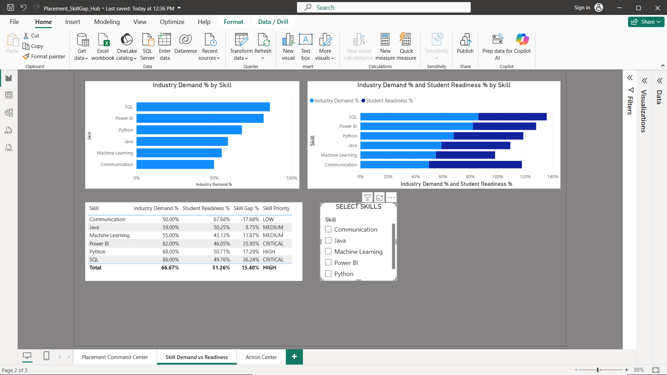

POWER BI DESKTOP
Action Center — Priority Matrix & Recommendation Engine
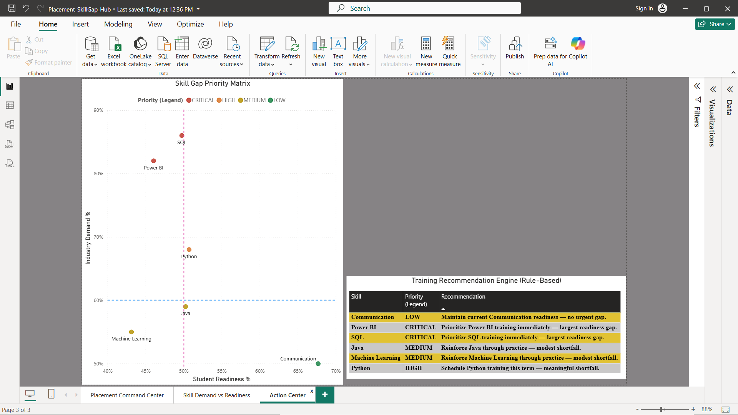

02
Web Dashboard
The live companion site — zero dependencies, same data and logic as Power BI

• Placement Command Center
• Skill Demand vs. Readiness
• Action Center — Priority Matrix & Recommendation Engine

WEB DASHBOARD — LIVE SITE
Placement Command Center
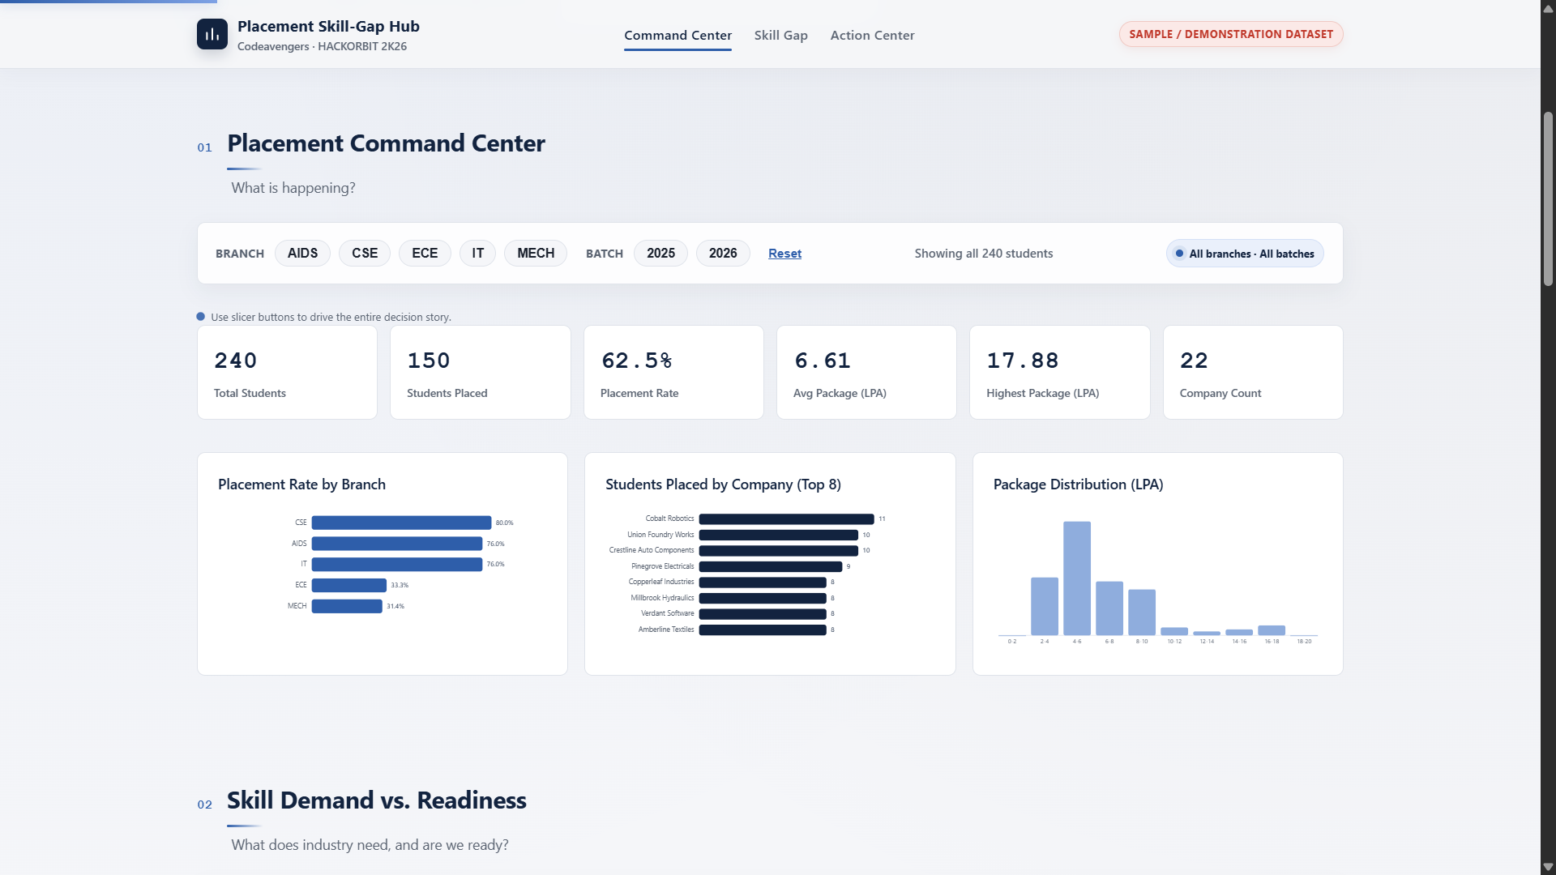

WEB DASHBOARD — LIVE SITE
Skill Demand vs. Readiness
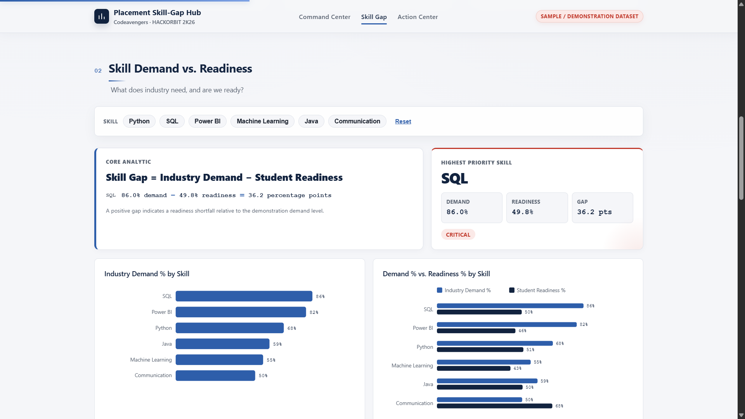

WEB DASHBOARD — LIVE SITE
Action Center — Priority Matrix & Recommendation Engine
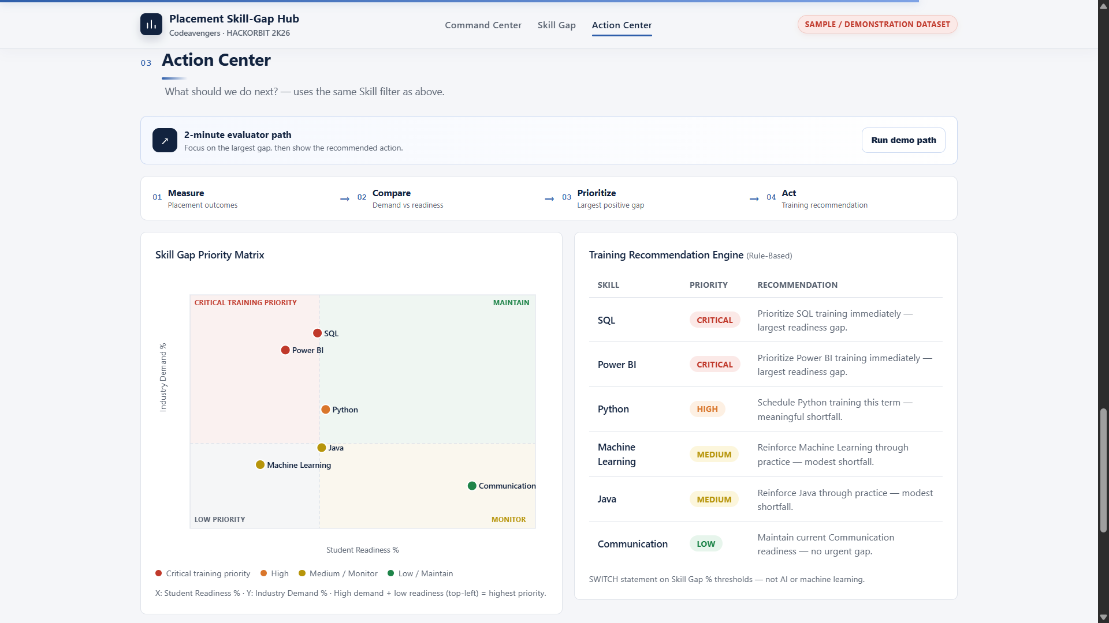

03
GitHub Repository
Full source: strategy docs, dataset, generator scripts, Power BI file, and web dashboard

• codeavengers-placement-skill-gap

GITHUB
Repository — codeavengers-placement-skill-gap
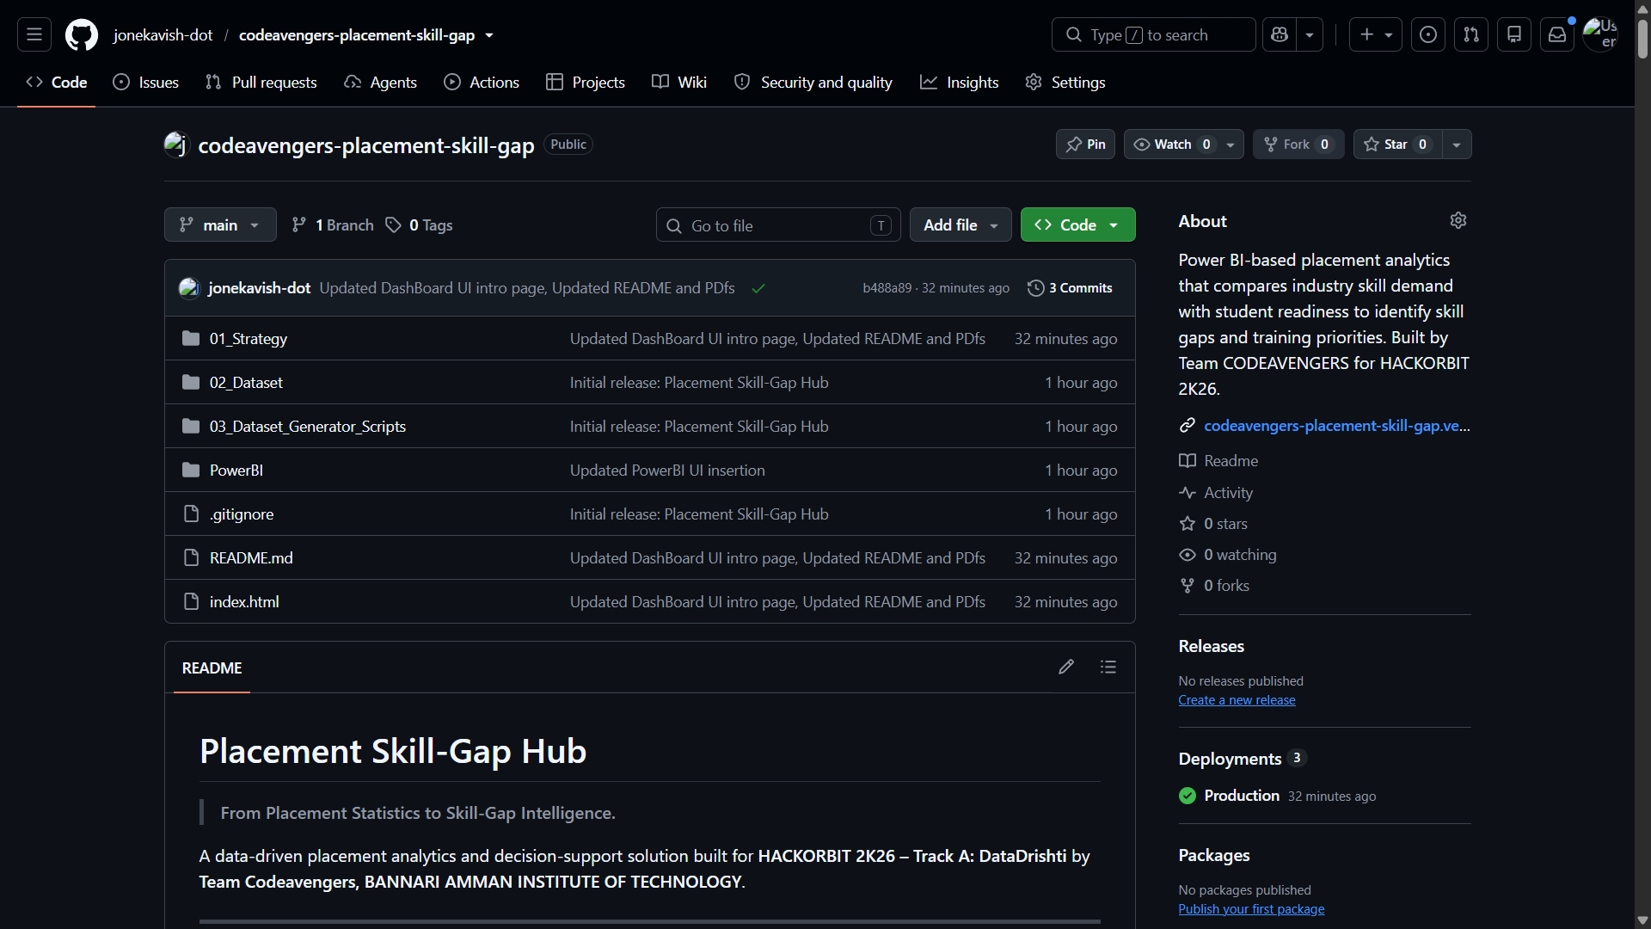

04
Vercel Deployment
The web dashboard, live and publicly reachable — no install required to view

• codeavengers-placement-skill-gap.vercel.app

VERCEL
Production Deployment
