DEV SPRINT’26
DEVOPS HACKATHON 2026
SOFTWARE REQUIREMENTS SPECIFICATION
AND PROJECT SUBMISSION REPORT
Submission field | Team to complete
Team Name | CODEAVENGERS
Domain / Category | Category 5: DevSecOps and Security Automation
Problem Statement Number and Title | Problem 22: Secret Leak Detection in Git Repositories
Team Leader and Register Number | Kavish S R – 7376251CS249
Team Members and Register Numbers | GOWSHIK GUNAL R - 7376251CS191  PRANESH K V – 7376252AD273
Submission Date | 14 October 2026

1. Team Details
Field | Details
Team Name | CODEAVENGERS
Domain / Category | Category 5: DevSecOps and Security Automation
Problem Statement | Problem 22: Secret Leak Detection in Git Repositories
Team Leader | Kavish S R - 7376251CS249 (Team Leader, DevOps)
Team Member 1 | GOWSHIK GUNAL R - 7376251CS191 (Backend)
Team Member 2 | PRANESH K V – 7376252AD273 (Frontend and documentation)

2. Problem Statement and Abstract
2.1 Official Problem Statement
Problem 22: Secret Leak Detection in Git Repositories (Category 5: DevSecOps and Security Automation; Difficulty: Beginner-Intermediate).
Develop a secret-detection workflow that identifies dummy credentials accidentally introduced into source code and prevents the affected change from passing the configured security checks.
Minimum Requirements: Create a sample Git repository. Configure a secret scanner. Include safe dummy secret examples. Integrate scanning into a pre-commit hook or CI workflow. Report the affected file and detected issue. Demonstrate detection of a dummy credential.
Expected Deliverables: Sample repository. Secret-scanning configuration. Pre-commit hook or CI workflow. Detection report. README explaining safe secret handling and remediation.
Final Demonstration: Attempt to commit a dummy API key and demonstrate that the scanner detects or rejects the change.
Suggested tools: Gitleaks, Git hooks, GitHub Actions.
2.2 Abstract
A credential pasted into source code and committed is effectively public: Git keeps every historical version, so deleting the line later does not remove the secret. SecretShield addresses this by placing three independent gates between a developer and the shared repository. Gate 1 is a pre-commit hook that scans staged files on the developer's machine and cancels the commit when a credential is found. Gate 2 is a GitHub Actions workflow that re-scans every push, so a hook bypassed with --no-verify still fails the pipeline. Gate 3 is a FastAPI service deployed on AWS EC2 behind Nginx that receives a redacted report from CI, stores it in SQLite and presents it on a public dashboard, alongside a Scan now page where any visitor can paste text and see it checked immediately.
Detection combines Gitleaks with a purpose-built Python engine of nine rules across three severities; Critical and High findings block, Low findings warn. False positives are suppressed by an entropy threshold, documented-placeholder detection, a path allowlist and a line-level marker. Every finding is masked at detection and re-masked at the API, so no report, log or page ever holds a full credential. The system is verified by 50 automated tests, including one asserting that the repository passes its own scanner.
3. Software Requirements Specification (SRS)
3.1 Purpose
SecretShield prevents credentials from entering a Git repository, and reports any that are attempted, without ever disclosing the credential itself. This document specifies what the system must do, how it is built and deployed, and how each requirement is verified, so that the team and the reviewers share one agreed definition of done.
3.2 Scope
Must-have (all complete): a sample Git repository containing clearly labelled dummy credentials; a configured secret scanner (Gitleaks plus a built-in engine) with a custom rule set and a fake-key allowlist; a pre-commit hook that cancels a commit on a Critical or High finding; a GitHub Actions workflow that fails the pipeline on the same condition; a detection report naming the affected file, line, rule, severity and a masked value; token-authenticated upload of that report to a live service; a public dashboard of scan history; and a README covering safe secret handling and remediation.
Optional (complete): per-finding remediation guidance; three-level severity gating; a public Scan now page for ad-hoc text; and commit message and SHA shown per scan.
Out of scope: user accounts and roles, multi-repository management, automatic key rotation, scanning of container images or binary files, and automatic history rewriting.
3.3 Intended Users
Developer - commits code; is blocked by the hook and shown how to fix the leak.
Reviewer or judge - opens the public dashboard, inspects scan reports and tests the Scan now page without needing any credentials.
Maintainer (the project team) - configures scanner rules, deploys the service and holds the ingest token.
CI pipeline - an automated consumer that scans each push and uploads a redacted report.
3.4 Overall Product Description
A developer works normally. On git commit, the pre-commit hook runs the scanner over the staged files; if a Critical or High secret is found, the commit is cancelled and the terminal shows the file, line number, rule, severity, a masked value and the remediation steps. If the developer bypasses the hook with --no-verify, the push reaches GitHub, where the Actions workflow runs the same scanner across the working tree and fails the build. The workflow then POSTs a redacted JSON report to the SecretShield service using a token held as a GitHub Actions secret. Nginx proxies the request to the FastAPI application, which validates the token, re-masks every value defensively and stores the scan in SQLite. Anyone can then open the dashboard to see the scan history with pass or fail status and the masked findings, or use the Scan now page to check pasted text, which is scanned in memory and never stored.
3.5 Functional Requirements
ID | Requirement | Priority | Verification method
FR-01 | Scan staged files on commit and cancel the commit when a Critical or High secret is found | Must | T-2: scripted demo blocks a dummy AWS key; test_detects_aws_access_key
FR-02 | Report the affected file, line number, rule, severity and a masked value | Must | T-2: hook output inspected; asserted in test_scanner.py
FR-03 | Re-scan every push in CI and fail the pipeline on a Critical or High finding | Must | T-3: pushed with --no-verify; GitHub Actions run went red
FR-04 | Never emit a full secret in any report, log or page | Must | T-5: test_no_finding_contains_the_raw_secret; manual log inspection
FR-05 | Suppress false positives on documented placeholders and fixture paths | Must | T-4: test_documented_placeholders_are_ignored; AWS example key not flagged
FR-06 | Accept a redacted report only with a valid ingest token | Must | T-6: test_report_without_a_token_is_rejected returns HTTP 401
FR-07 | Show scan history with pass/fail, commit message and SHA on a public dashboard | Must | T-7: dashboard inspected after each CI run
FR-08 | Attach remediation steps to every finding | Should | test_every_finding_carries_fix_steps
FR-09 | Gate on severity: Critical and High block, Low warns | Should | test_low_severity_only_warns
FR-10 | Scan pasted text on demand without storing it | Should | T-8: test_scan_now_detects_a_dummy_key; test_scan_now_does_not_store_anything
3.6 Non-Functional Requirements
ID | Requirement | How it is addressed
NFR-01 | Usability | A blocked developer is shown the file, line, severity, a masked value and the exact fix, in plain language, at the moment the commit is refused. The dashboard needs no login or credentials for a reviewer to read it.
NFR-02 | Reliability | If the live service is unreachable or rejects a report, the uploader warns and exits 0, so the gate's verdict is unaffected. Containers use restart: unless-stopped and a 30-second health check. If Gitleaks is absent the built-in engine runs alone; if Python is absent the hook skips rather than blocking all work.
NFR-03 | Performance | A staged-file scan completes in roughly one second; the CI job completes in about 15 seconds; the dashboard and Scan now responses are effectively immediate. Files over 2 MB and binaries are skipped.
NFR-04 | Security | Values are masked at detection and re-masked at the API, so a modified client cannot cause a raw secret to be stored; a test asserts this. The ingest endpoint requires a token compared with hmac.compare_digest. The token lives in GitHub Actions secrets and a 600-permission .env, never in Git. Containers run as an unprivileged user. Nginx rate-limits the public scan endpoint and sets security headers. SSH is restricted by security group.
NFR-05 | Maintainability / reproducibility | Rules live in one configuration file, so adding a rule needs no code change. The whole stack starts with a single command. 50 automated tests cover detection, redaction, authentication, deduplication and schema migration, and one test asserts the repository passes its own scanner.
NFR-06 | External accessibility | Deployed on AWS EC2 with an Elastic IP at http://16.112.247.69/, reachable by anyone without credentials. Verified from a mobile connection outside the build network, and independently by GitHub's runners posting reports to it.

3.7 Assumptions and Constraints
Assumptions: team members have Python 3.10 or newer and Git installed; GitHub Actions is enabled on the repository; the AWS account and EC2 instance are prepared before the event, as the event rules require.
Supported configurations: developer machines on Windows (via Git Bash), Linux or macOS; server on Ubuntu 24.04 with Docker Compose.
Constraints: three team members; build window of roughly three hours plus a 40-minute deployment slot; deployment must be an externally accessible Linux server rather than a ready-made static host; only documented dummy credentials are used anywhere in the repository.
Known limitations: detection is pattern and entropy based, so a credential in an unusual format can be missed, which is why the gates are layered rather than trusted individually; the service detects and reports but does not rotate keys or rewrite Git history; the deployed demo runs over plain HTTP.
4. System Design
4.1 Architecture Diagram
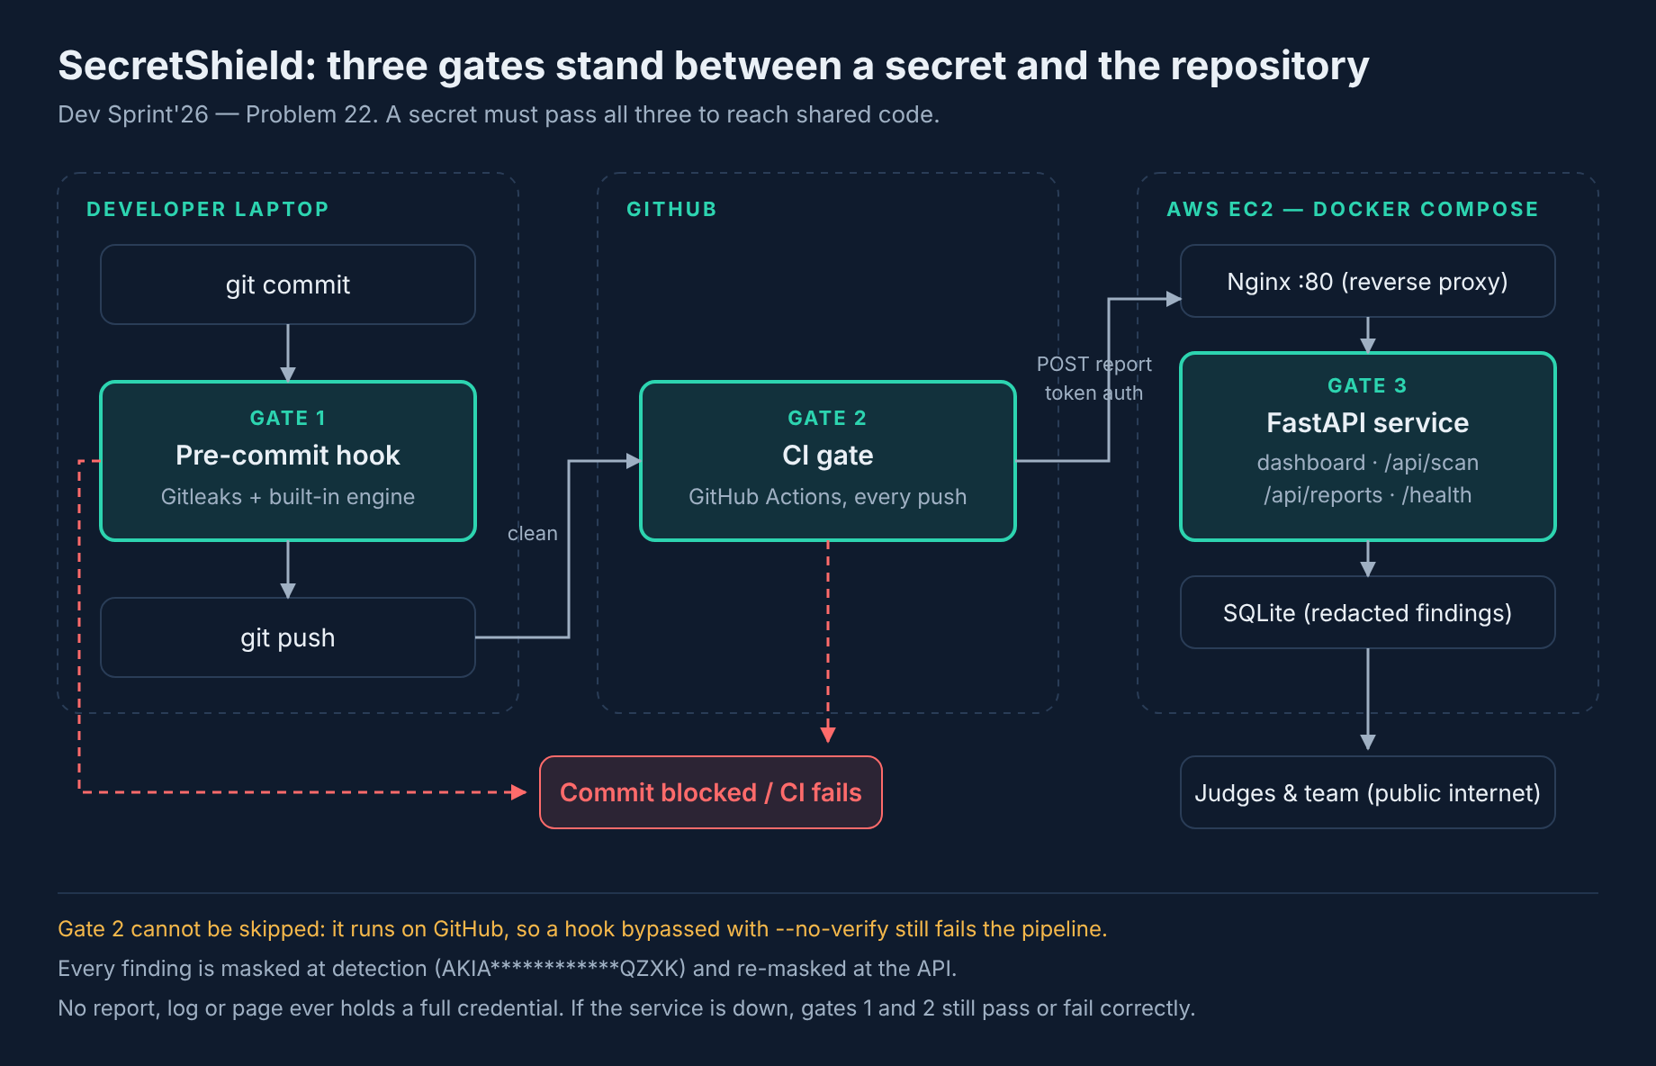
4.2 Component Description
Component | Responsibility | Technology
Frontend / interface | Dashboard of scan history with masked findings, plus a public Scan now page for ad-hoc text | HTML, CSS, vanilla JavaScript
Backend / core logic | Scanning engine, severity gating, redaction, report ingest API with token authentication | Python 3.11, FastAPI, Gitleaks
Data store / external service | Stores one row per scan and one row per redacted finding; no column can hold a raw secret | SQLite on a named Docker volume
Automation / deployment | Pre-commit hook, CI scanning and gating, image build, deployment and reverse proxy | Git hooks, GitHub Actions, Docker Compose, Nginx, AWS EC2
4.3 Workflow / Algorithm
- Step 1 - Trigger: a developer runs git commit, or a push or pull request reaches GitHub.
- Step 2 - Collect and filter: the scanner lists the staged files (hook) or all tracked files (CI), then discards binaries, files over 2 MB and allowlisted paths such as fixtures/ and tests/.
- Step 3 - Detect: Gitleaks runs with the project's .gitleaks.toml and --redact, and the built-in engine applies nine regular-expression rules. A candidate is discarded if it matches a documented placeholder, if its Shannon entropy falls below 3.0 for generic key rules, or if its line carries the marker secretshield:allow. Findings from both engines are merged and de-duplicated so one secret is reported once.
- Step 4 - Decide and report: every matched value is masked (AKIA************QZXK). The scan is FAIL if any finding is Critical or High, otherwise PASS. The hook exits 1 on FAIL, cancelling the commit; CI fails the job and uploads the redacted JSON report to the live service, which stores it and shows it on the dashboard.
- Step 5 - Failure handling: if the live service is unreachable or rejects the report, the uploader warns and exits 0, so the gate's own pass or fail verdict is never altered by a reporting problem. If Gitleaks is not installed, the built-in engine runs alone and a note is printed. If Python is missing, the hook skips with a message rather than blocking all work. Requests to the ingest endpoint without a valid token are rejected with HTTP 401 and logged.
4.4 Data Flow or API Details
Endpoints: POST /api/reports (token required, stores a redacted report); GET /api/reports (scan history for the dashboard); POST /api/scan (scans pasted text, stores nothing, returns Cache-Control: no-store); GET /health (liveness, used by the container health check); GET / (dashboard).
Report fields per finding: file, line, rule, severity, redacted_value, remediation. Per scan: repo, commit, branch, message, status, timestamp.
Data files: .gitleaks.toml (rules and allowlist), report.json (CI output, also kept as a build artifact), secretshield.db (SQLite; tables scans and findings, neither of which has a column capable of holding a raw secret).
Operational commands: python3 scripts/secretshield_scan.py --staged (hook), --all --json report.json (CI), --paths <path> --force (demo).

5. Technology Stack and Implementation
Layer / Area | Technology used | Purpose
Frontend / interface | HTML, CSS, vanilla JavaScript | Dashboard and Scan now page; no framework, so nothing to build
Backend / core logic | Python 3.11, FastAPI, Uvicorn, Gitleaks 8.18.4 | Secret detection (Gitleaks plus a custom nine-rule engine), REST API, severity gating and redaction
Database / storage | SQLite | Scan history and redacted findings
Testing | pytest (50 tests) | Detection, allowlisting, redaction, token enforcement, schema migration, self-scan
Version control | Git + GitHub | Source-code management
Packaging / containerization | Docker and Docker Compose | Reproducible two-service stack: application and Nginx
CI/CD and automation | GitHub Actions | Scans every push, fails on a Critical or High finding, uploads the redacted report
Hosting / deployment | AWS EC2 t3.micro, Ubuntu 24.04, ap-south-1, with an Elastic IP | External access at http://16.112.247.69/
5.1 Implemented Features
Feature | Implementation summary | Status
Gate 1: pre-commit hook | Scans staged files and cancels the commit on a Critical or High finding, showing file, line, rule, masked value and remediation | Complete
Gate 2: CI gate | GitHub Actions re-scans every push and fails the build, catching hooks bypassed with --no-verify | Complete
Error / failure handling | Service-down, missing-Gitleaks, missing-Python, invalid-token and unmasked-input cases all handled without altering the gate verdict | Complete
Gate 3: live dashboard and Scan now | Token-authenticated report ingest, public scan history with masked findings, and in-memory scanning of pasted text | Complete

6. DevOps Workflow
6.1 Version Control
Repository: https://github.com/jonekavish-dot/secretshield (branch main).
All application code, scanner configuration, the pre-commit hook, the CI workflow, the Dockerfile, the Compose file, the Nginx configuration, tests and documentation are tracked in this single repository. Secrets are not: .env is listed in .gitignore and only .env.example, which contains variable names and no values, is committed. The service's ingest token reaches CI through GitHub Actions secrets. A .gitattributes file pins shell scripts and the hook to LF endings so they remain executable when cloned on Windows and deployed to Linux. Commit history shows incremental work, including fixes for CI test collection and for duplicate findings on the dashboard.
6.2 Build and Run Instructions
Action | Command / instruction
Install dependencies | pip install -r requirements-dev.txt
Run tests | python -m pytest -q (expected: 50 passed)
Build / package | sudo docker compose build
Start application | sudo docker compose up -d (local: uvicorn app.main:app)
Health check / verification | curl http://16.112.247.69/health -> {"status":"ok"}

6.3 Automation and Deployment
CI/CD: a GitHub Actions workflow runs on every push and pull request. Job 1 installs Gitleaks, scans the working tree, writes a job summary table, uploads report.json as a build artifact, posts the redacted report to the live service and fails the build if a Critical or High secret is present. Job 2 runs the 50-test suite.
Containers: a two-service Docker Compose stack. The web image is built from python:3.11-slim, installs Gitleaks, runs as an unprivileged user (shield, UID 1001) and carries a HEALTHCHECK against /health. Nginx terminates port 80, proxies to the application, applies security headers and rate-limits the public /api/scan endpoint. Both services use restart: unless-stopped, so they return automatically after a reboot. Named volumes hold the database and logs, so they survive an image rebuild.
Configuration: all runtime configuration is environment variables, supplied from a .env file created at deployment time with permissions 600.
Deployment: scripts/deploy-aws.sh installs Docker, generates the ingest token, builds the images, starts the stack and polls the health endpoint until the service responds.
Logging and monitoring: the application writes to stdout and a log file on a named volume, recording every scan and every rejected request; container health is polled every 30 seconds; Nginx keeps access and error logs.
Security automation: the project gates itself with its own scanner, and a test asserts that the repository passes its own scan, so the tool cannot regress into shipping a secret of its own.
6.4 DevOps Evidence
- [x] Git repository / commit history
- [x] Successful build or CI workflow
- [x] Automated test result
- [x] Container or service status, if applicable
- [x] Deployment log or verification
- [x] Health check, monitoring, security scan, or recovery evidence, if applicable
6.5 Deployment Details
Field | Details
Deployment platform / server | AWS EC2 t3.micro, Ubuntu 24.04 LTS, Mumbai (ap-south-1), with an associated Elastic IP
Live application or operational endpoint | http://16.112.247.69/ (health: http://16.112.247.69/health)
Deployment method | Docker Compose (application + Nginx) provisioned by scripts/deploy-aws.sh, which installs Docker, generates the ingest token, builds the images and polls the health endpoint
Deployment status | Working
External access verified | Yes - opened from a mobile connection outside the build network, and verified by GitHub Actions successfully posting reports to it from GitHub's runners
Known access limitations | Served over plain HTTP; no domain name or TLS certificate. SSH is restricted at the security-group level.

7. Output Screenshots and Evidence
Attach genuine screenshots from the actual implementation. Caption each image with what it proves. Use sections relevant to the chosen problem, but include core functionality and deployment evidence.

Screenshot 1 — Main Interface / Entry Point
Evidence to capture: Show the running application, CLI, dashboard, or operational entry point.
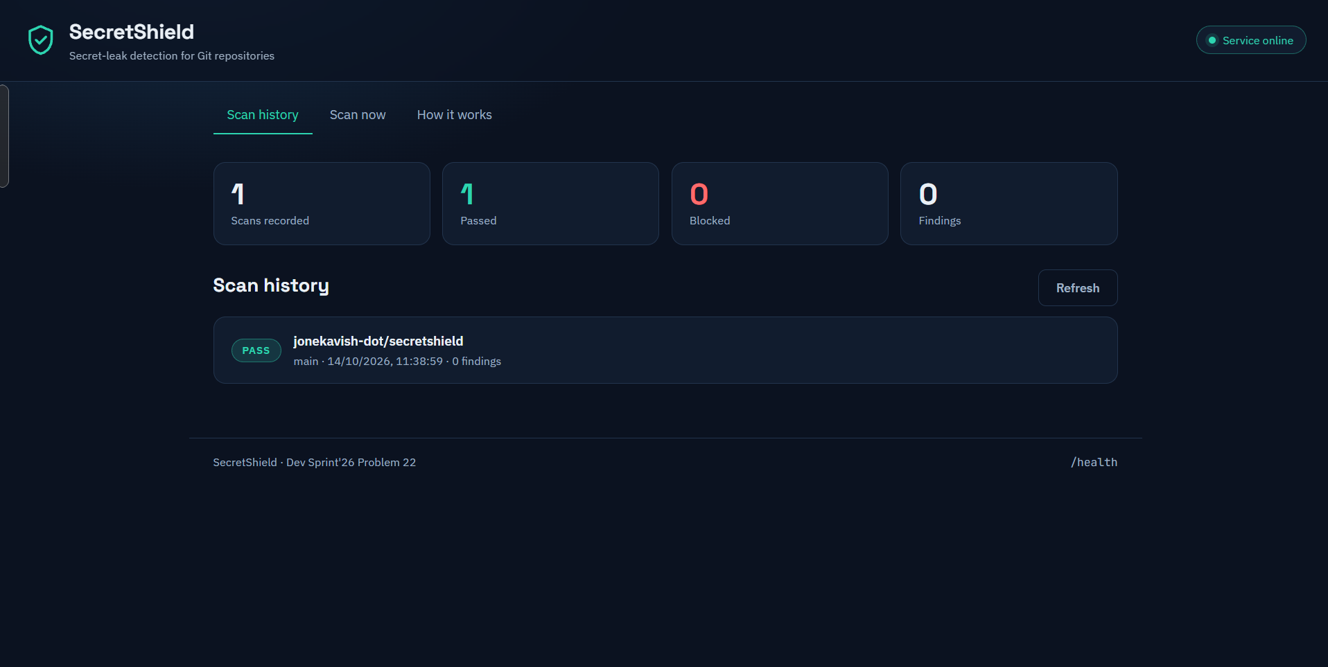
Figure 1 - The SecretShield dashboard served from the live EC2 deployment. Proves the operational entry point is running: service status online, scan counters, and the scan history populated by a real CI run.
Screenshot 2 — Core Functionality
Evidence to capture: Show the primary feature required by the selected problem statement.
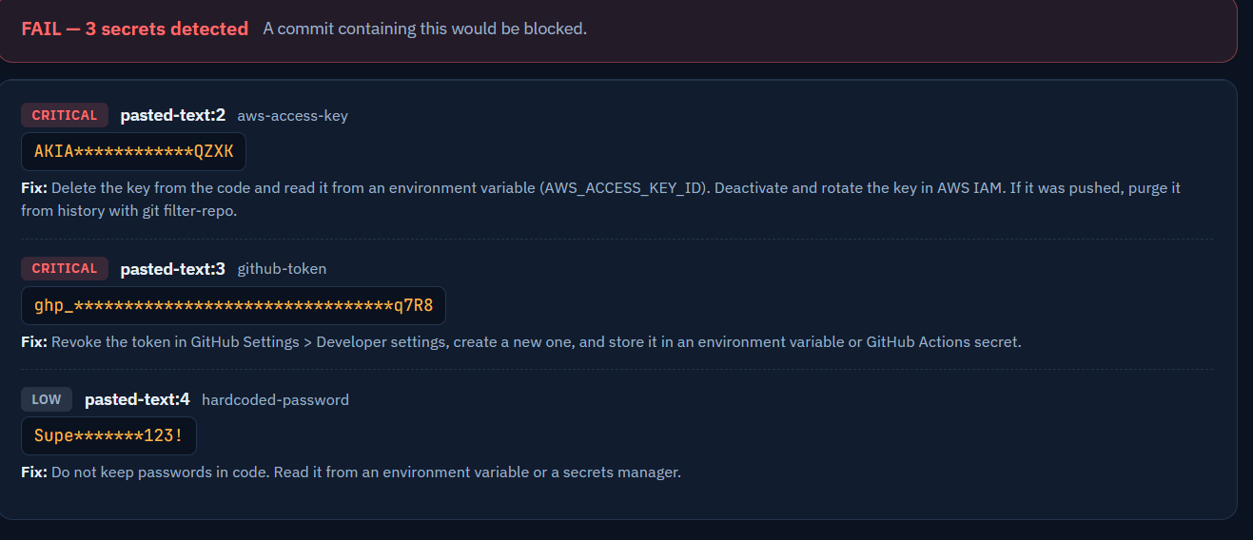
Figure 2 - Core functionality: three dummy credentials detected in pasted text. Proves detection of a dummy credential (FR-01, FR-10), severity classification (two Critical, one Low), masked values (FR-04) and per-finding remediation (FR-08). No full credential appears anywhere.

Screenshot 3 — Test or Validation Result
Evidence to capture: Show a meaningful test, expected output, or pass/fail result.
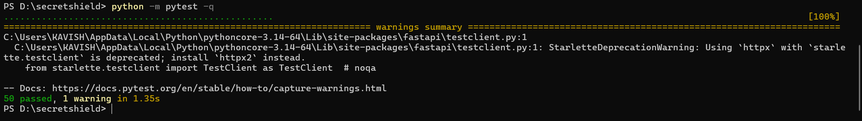
Figure 3 - The full automated suite passing: 50 tests covering detection, allowlisting, redaction, token enforcement, finding de-duplication, schema migration, and the test that asserts the repository passes its own scanner.
Screenshot 4 — Failure Handling / Automation
Evidence to capture: Show a failure, recovery, security check, pipeline, or automation result if relevant.
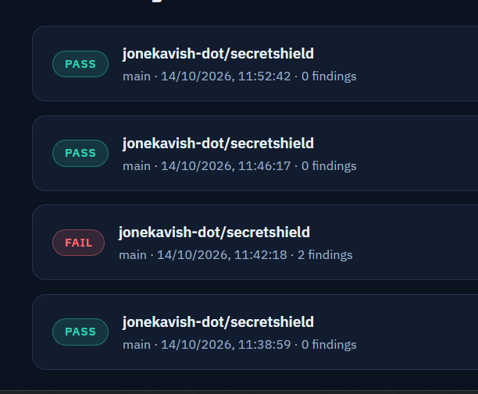
Figure 4 - Scan history showing a FAIL recorded between passing runs. The failing scan is the dummy AWS key pushed with --no-verify: the local hook was bypassed, the CI gate caught it, failed the build and reported it here (FR-03). The surrounding PASS rows are the same repository after the key was replaced with an environment variable.

Screenshot 5 — Live Deployment
Evidence to capture: Show the externally accessible application or operational endpoint.
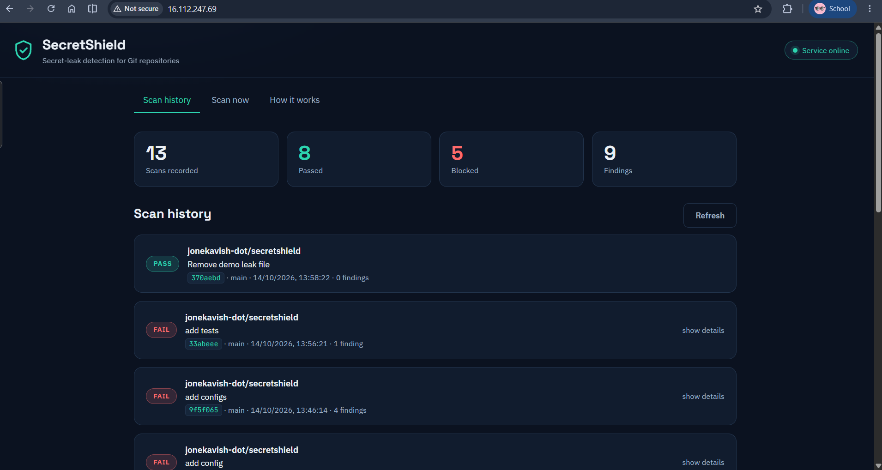
Figure 5 - The application at its public address (visible in the browser address bar), reached from outside the build network. 13 scans recorded, 8 passed and 5 blocked, each row carrying its commit message and short SHA. This is the live deployment judges can open themselves.
Screenshot 6 — DevOps Evidence
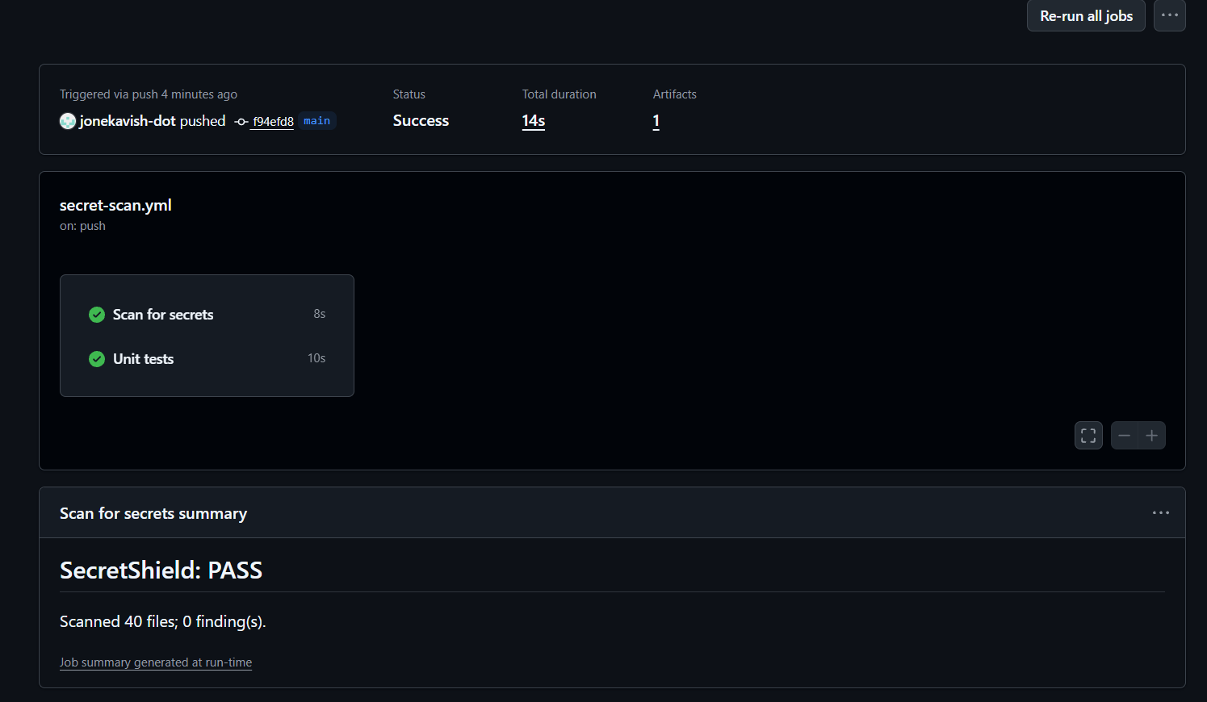
Evidence to capture: Show relevant CI/CD, build, container, logs, monitoring, or deployment evidence.
Figure 6 - A GitHub Actions run with both jobs green: 'Scan for secrets' (the CI gate) and 'Unit tests'. The job summary reports SecretShield: PASS across 40 scanned files, and the run produced the report artifact that was posted to the live service.
8. Results and Discussion
All nine must-have requirements and all three optional requirements are implemented and demonstrated end to end on live infrastructure. A dummy AWS key committed locally is blocked by the pre-commit hook with the file, line, rule, severity, masked value and remediation shown. The same key pushed with --no-verify fails the GitHub Actions run, and the redacted report appears on the public dashboard within seconds. Replacing the key with an environment variable returns the pipeline to green. The Scan now page detects pasted credentials immediately without storing them.
Evidence: 50 automated tests pass; CI runs are green on clean commits and red on a planted secret; the dashboard at http://16.112.247.69/ is reachable from outside the build network, verified from a mobile connection.
Two defects were found and fixed during development, both by our own tooling or testing. The repository initially failed its own scan because sample keys were embedded in the dashboard UI and the demo script; those values were moved into the allowlisted fixtures directory and a regression test now guards it. The dashboard also silently dropped the commit identifier because the frontend read a field name the API does not return; this was corrected and the commit message added alongside it.
Remaining gaps: the deployment serves plain HTTP, and detection remains pattern-and-entropy based rather than semantic.
9. Conclusion and Future Enhancements
9.1 Conclusion
SecretShield delivers the required minimum viable solution and demonstrates it on an externally accessible deployment. A dummy credential is stopped at the developer's machine, stopped again in CI if the local check is bypassed, and recorded on a live dashboard with its value masked and remediation attached. The layering is the point: no single control has to be perfect, because a secret must defeat all three to reach shared code. The project also holds itself to the standard it enforces, passing its own scanner on every commit.
9.2 Limitations
Detection relies on known credential shapes and entropy, so a secret in an unusual or encoded format can pass undetected; the layered gates mitigate but do not eliminate this.
The system detects and reports; it does not rotate credentials or rewrite Git history, though it tells the user how to do both.
The deployment serves plain HTTP, so reports travel unencrypted; this is acceptable for masked data over a short-lived demo but would not be for production.
The hook can be bypassed locally with --no-verify by design; only the CI gate is mandatory.
GitHub push protection independently blocks the dummy AWS keys in the fixtures directory, which required an explicit test-use allowance on the repository.
SQLite and a single container suit one team and one repository; they would not suit an organisation-wide rollout.
9.3 Future Enhancements
Serve the dashboard over HTTPS with a certificate and a domain name.
Support multiple repositories with per-repository tokens and filtering on the dashboard.
Scan full Git history on a schedule, not only the current working tree, to surface credentials committed before adoption.
Verify whether a detected credential is still live by calling the provider's introspection endpoint, and raise severity accordingly.
Replace SQLite with PostgreSQL and add authentication for maintainer actions.
Post findings back to the pull request as a review comment so developers see them without leaving GitHub.
Add a baseline file so an existing repository can adopt the tool without failing on pre-existing findings.

Repository | https://github.com/jonekavish-dot/secretshield
Live deployment | http://16.112.247.69/

