Workshop 2 Notes

- Intro
- Poll of class:
- How many people are here for the first time?
- How many people have KiCAD installed?
- How many people have Eagle installed?
- Brief explanation of workshop series (*only if there are new people)
- Structure of today's workshop
- Invitation for everyone to speak up for any questions, comments, or corrections
- Overview of PCB layout
- Scalable yet (amateur accessible) manufacturing
- Lots of variation (PCB, FPC, rigid-flex, SMT, Thru-hole,design for extreme environments)j
- PCB fabrication techniques:
- Etching
- Milling
- Laser
- Component assembly techniques:
- Pick-and-place
- Tweezers and paste
- Soldering iron
- Press fit
- Automated inspection and testing (JEDEC)
- Different applications:
- Low power / mobile
- High power
- High voltage
- High precision
- Extreme environments
- Design:
- History: Printing industry, cordwood, World War II anti-aircraft electronics
- Layers: Copper, Solder mask, Paste, silkscreen
- Board stack-up, power and ground planes
- Mechanical integration
- Component placement considerations
- What are the conditions at the inputs and outputs of the
- What are the highest frequencies and rise time?
- How many power supplies, what are their specifications?
- What areas are analog, digital, or RF?
- Grouping components by type
- Signal integrity
- Thermal considerations
- Demonstration in software

Return Current Considerations
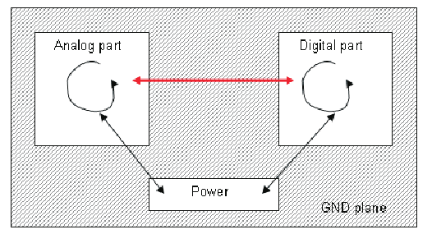Return path loop area

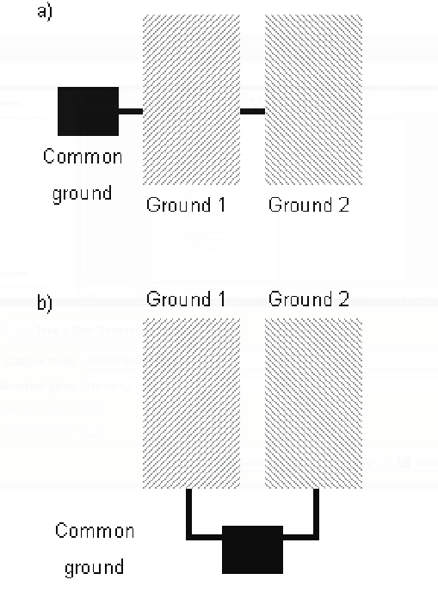Ground routing
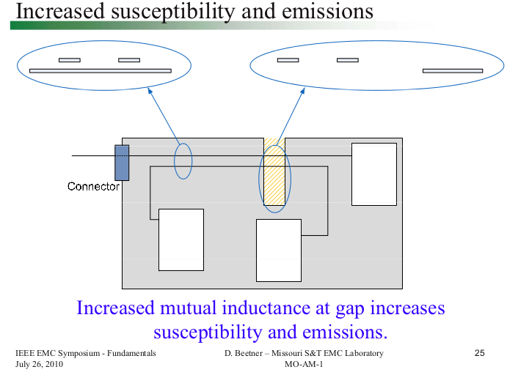
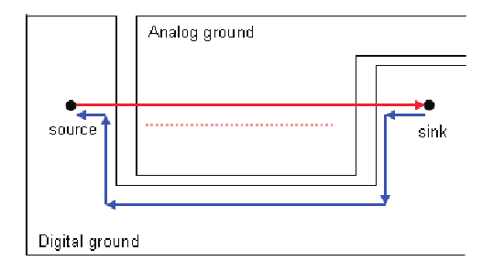
Good placement of different zones
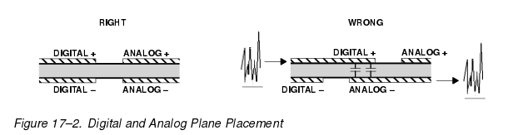
Signal Routing

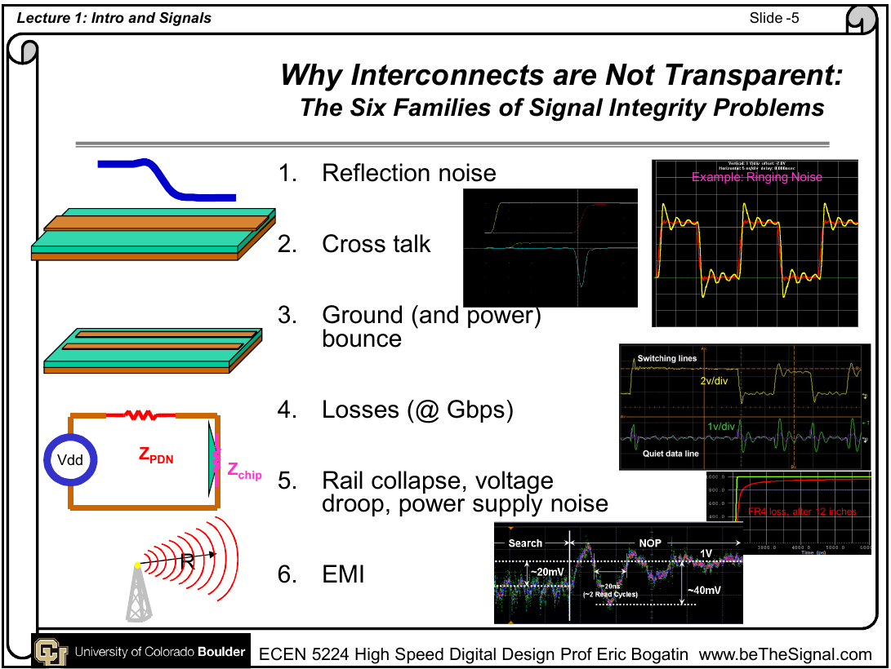

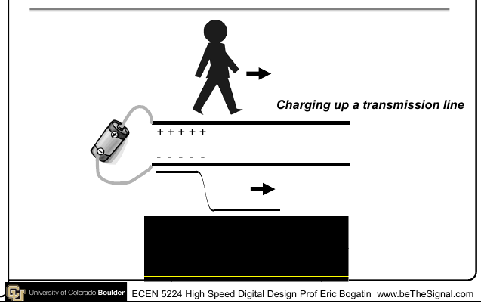
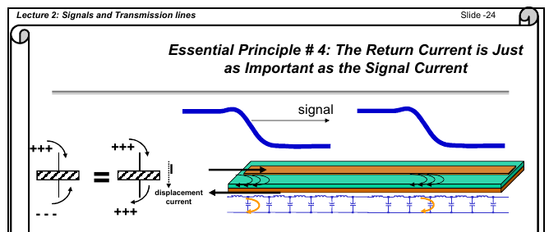
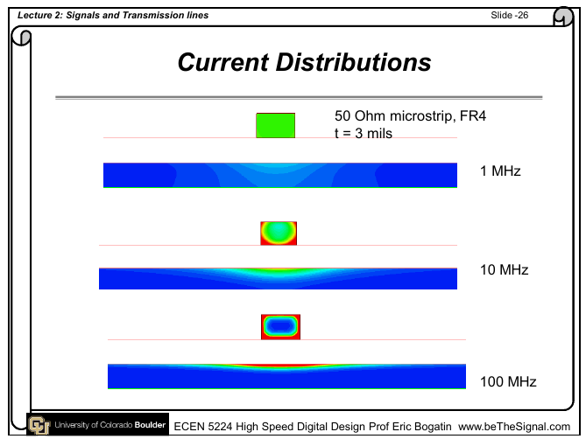
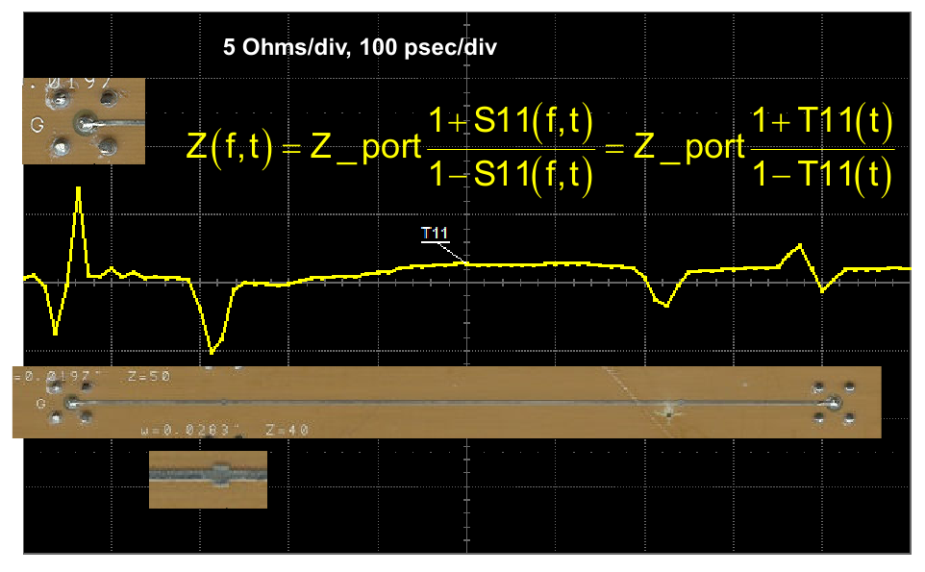
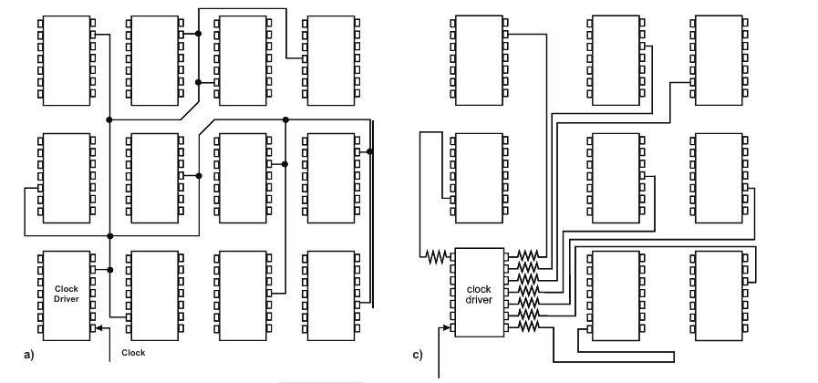
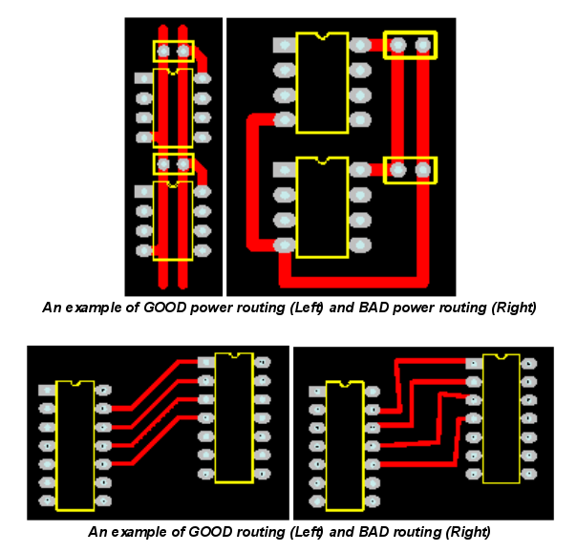
Noise and EMI

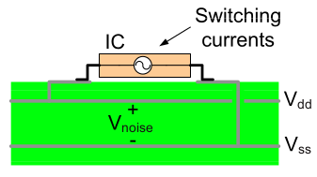
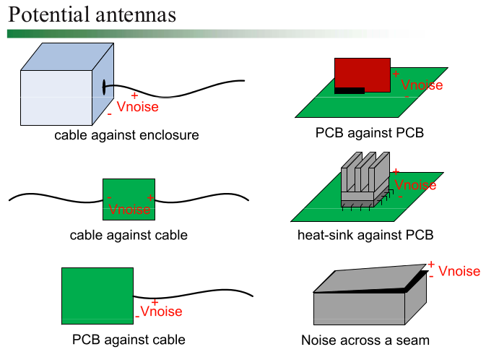
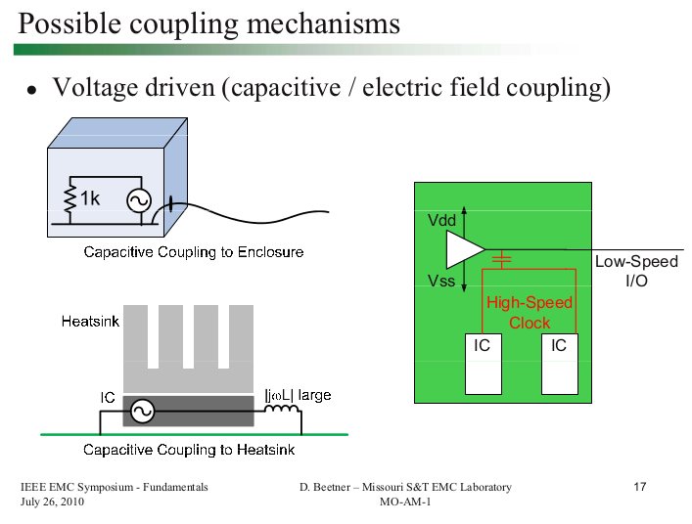
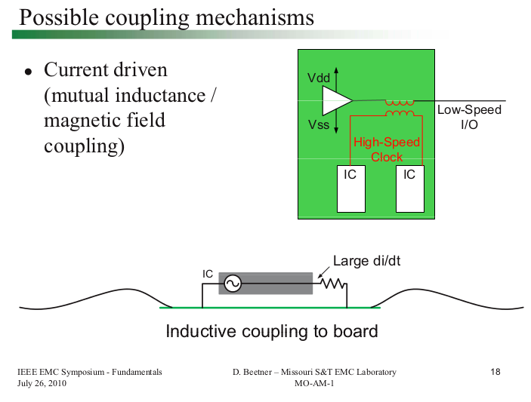
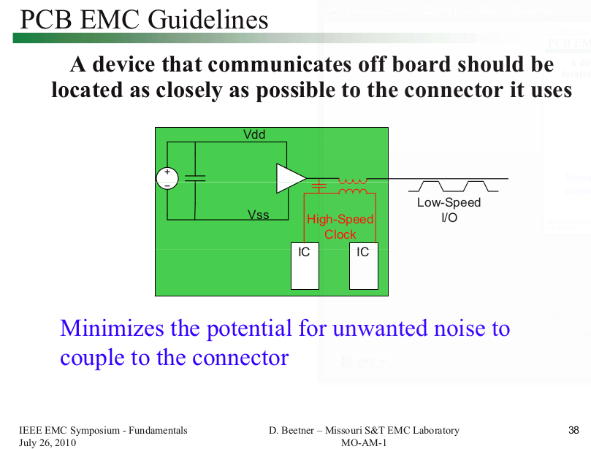
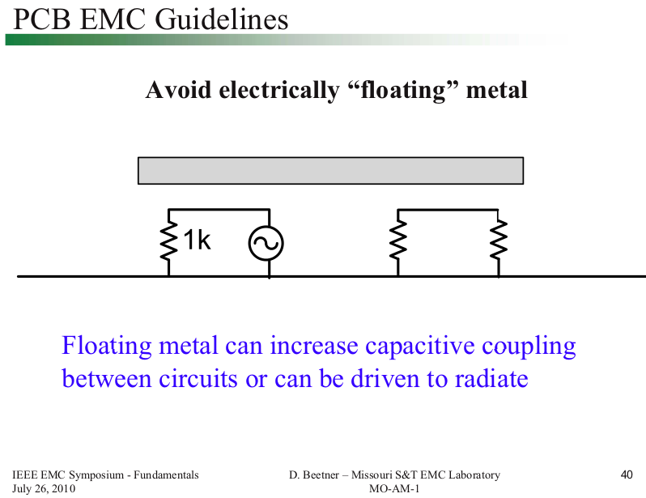
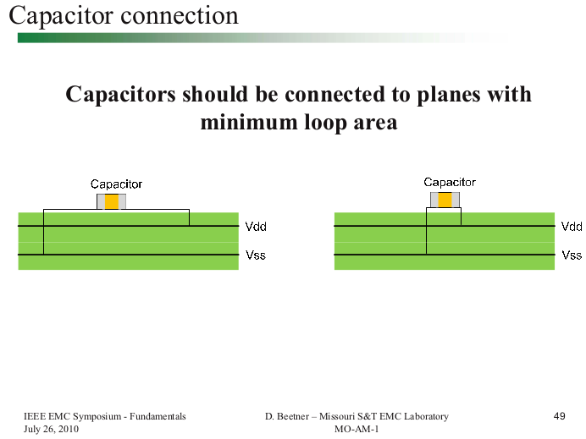
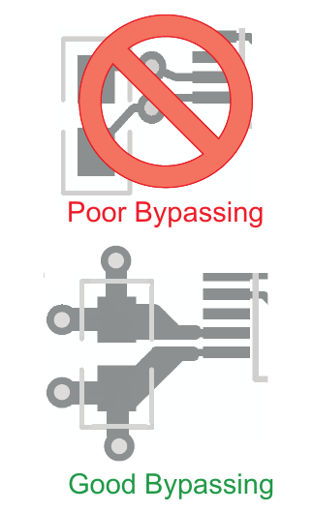
Thermal Considerations
