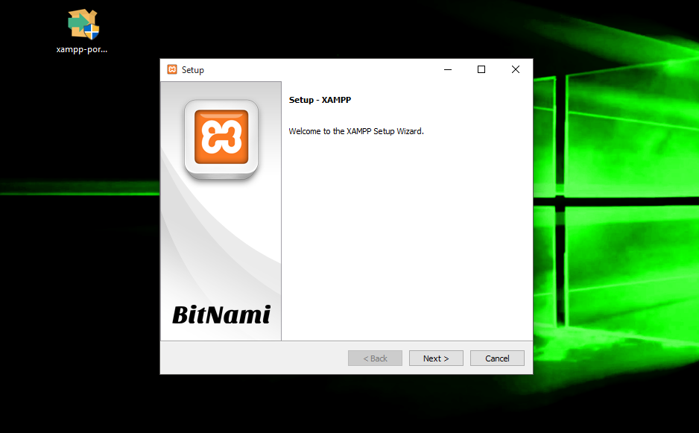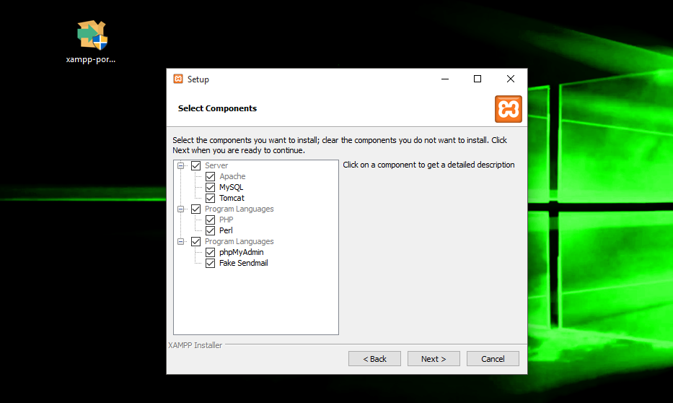**1.) Installation**

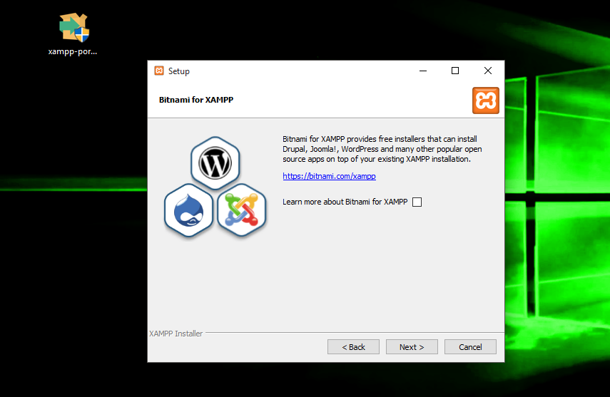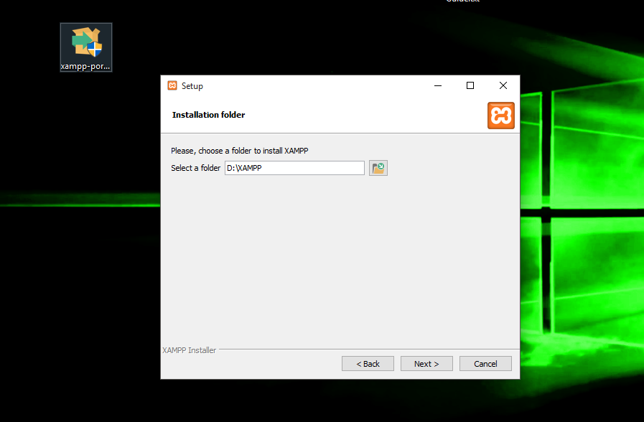

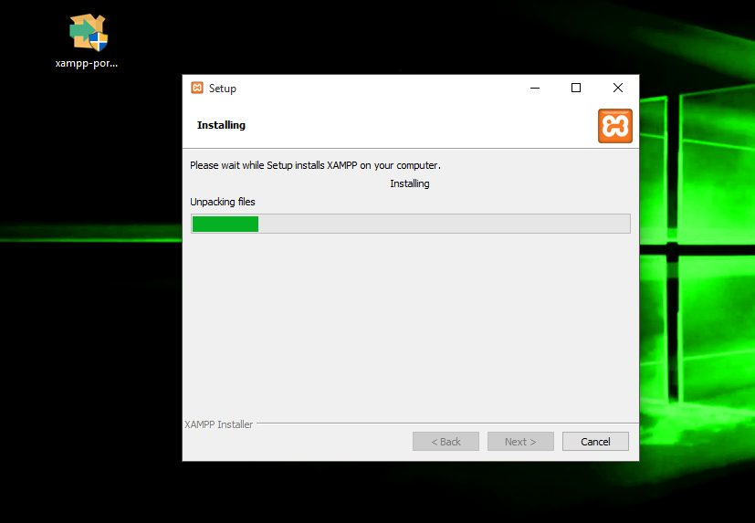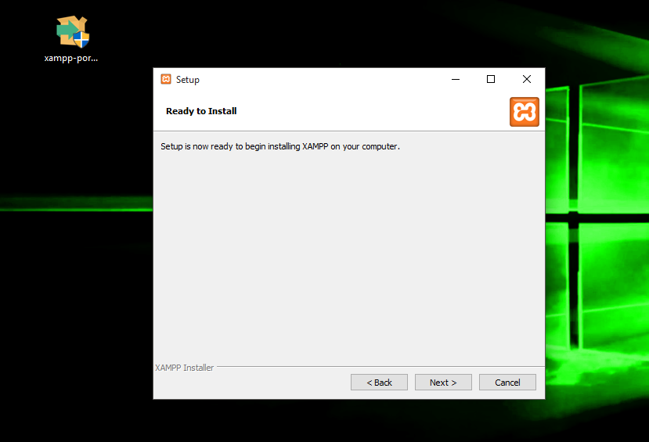

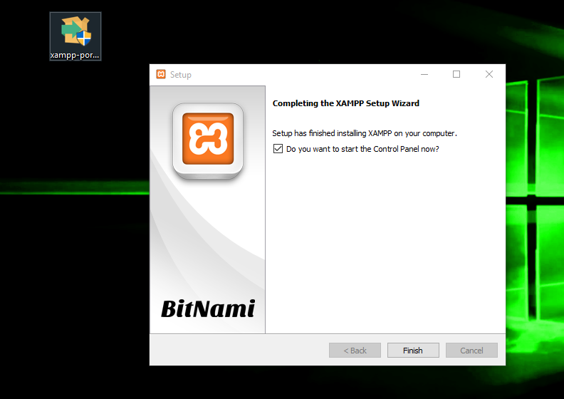

**2.) SQL Statements**

* **Creating and Using Database**

**>** Create Database studrecdb;

**>** use studrecdb;

* **Creating Different Tables**
  + **STUDENT**

**>** Create Table STUDENT (SNO char (10) NOT NULL, Surname varchar (20) NULL, FirstName varchar (20) NULL, Town varchar (20) NULL, Province varchar (20) NULL, Primary Key (SNO));

* **TEACHER**

> Create Table TEACHER (TeacherID varchar (5) NOT NULL, TeacherName varchar (30) NULL, Primary Key (Teacher));

* + **SUBJECT**

**>** Create Table SUBJECT (SubCode varchar (7) NOT NULL, SubName varchar (30) NULL, Semester tinyint NULL, TeacherID varchar (5) NULL, Primary Key (SubCode), Foreign Key (TeacherID) references TEACHER (TeacherID));

* + **CLASS**

**>** Create Table CLASS (SubCode varchar (7) NULL, SNO char (10) NULL, Foreign Key (SubCode) references SUBJECT (SubCode), Foreign Key (SNO) references STUDENT (SNO));

* **Inserting Data to Tables**
  + **STUDENT**

> INSERT INTO STUDENT (SNO, Surname, FirstName, Town, Province) VALUES (’15-1-02181’, ‘Tapang’, ‘Jonel Dominic’, ‘Duero’, ‘Bohol’), (’16-1-15222’, ‘Salamanca’, ‘Christian Gal’, ‘Duero’, ‘Bohol’), (’15-1-05221’, ‘Rojas’, ‘Michael James’, ‘Albuera’, ‘Leyte’), (’15-1-02221’, ‘Montañez’, ‘Neptali’, ‘Baybay’, ‘Leyte’), (’15-1-00051’, ‘Lipardo’, ‘Vince’, ‘Mahaplag’, ‘Leyte’), (’14-1-12111’, ‘Vitualla’, ‘John Paul’, ‘Baybay’, ‘Leyte’);

* + **TEACHER**

> INSERT INTO TEACHER (TeacherID, TeacherName) VALUES (‘99999’, ‘Elizabeth T. Mamasig’), (‘44444’, ‘Winston M. Tabada’);

* + **SUBJECT**

> INSERT INTO SUBJECT (SubCode, SubName, Semester, TeacherID) VALUES (‘CS113’, ‘File Processing & Database Sys’, 1, ‘99999’), (‘CS135’, ‘Visual Programming (C#)’, 1, ‘44444’);

* + **CLASS**

> INSERT INTO CLASS (SubCode, SNO) VALUES (‘CS113’, ‘15-1-02181’), (‘CS113’, ’15-1-52123’), (‘CS113’, ’15-2-12310’), (‘CS113’, ’16-1-00106’), (‘CS135’, ‘15-1-02181’), (‘CS135’, ’15-1-52123’), (‘CS135’, ’15-2-12310’), (‘CS135’, ’16-1-00106’);

What is the syntax of the query statement that will answer for each of the questions below?

1. Which subjects run in semester 1?

> SELECT SubCode, SubName from SUBJECT where Semester = 1;

1. List all the Student Number, Surname and First Name of students enrolled in CS113.

> SELECT SNO, Surname, Firstname from STUDENT, SUBJECT where SubCode = ‘CS113’;

1. List all the Student Number, Surname and First Name of students who live in the province of Leyte.

**>** SELECT SNO, Surname, FirstName from STUDENT where Province = ‘Leyte’;