Stat 136 – Experimental Design

Exercise No. 5: LSD and Factorial Experiments

Name: Jonel Dominic E. Tapang Course & Year: BSCS – 3

1.

a.

|  |  |  |  |  |  |  |
| --- | --- | --- | --- | --- | --- | --- |
|  | Df | Sum Sq | Mean Sq | F value | Pr(>F) |  |
| Operator | 3 | 51.5 | 17.167 | 9.810 | 0.00993 | ** |
| Order | 3 | 18.5 | 6.167 | 3.524 | 0.08852 | . |
| Method | 3 | 72.5 | 24.167 | 13.810 | 0.00421 | ** |
| Residuals | 6 | 10.5 | 1.750 |  |  |  |

//Significant codes: 0 ‘***’ 0.001 ‘**’ 0.01 ‘*’ 0.05 ‘.’ 0...1 ‘ ’ 1

Answer: Yes, there is Significant Treatment effect

F-Ratio: 13.810

p-value: 0.00421

b.

Turkey’s HSD Test Statistic Value: 3.238134

Critical Value: 4.895599

|  |  |  |
| --- | --- | --- |
| Treatment | Means | Group |
| Method C | 13.25 | a |
| Method D | 11 | ab |
| Method B | 9.25 | bc |
| Method A | 7.5 | C |

c.

$$RE\left(\frac{LSD}{CRD}\right)=\frac{MSR+MSC+\left(t-1\right)MSE}{\left(t+1\right)MSE}x100$$

$$RE\left(\frac{LSD}{CRD}\right)=\frac{6.167+17.167 +\left(4-1\right)1.750 }{\left(4+1\right)1.750 }x100$$

$$RE\left(\frac{LSD}{CRD}\right)=\frac{28.584}{8.75 }x100$$

$$RE\left(\frac{LSD}{CRD}\right)=11.4286$$

2.

a.

|  |  |  |  |  |  |  |
| --- | --- | --- | --- | --- | --- | --- |
|  | Df | Sum Sq | Mean Sq | F value | Pr(>F) |  |
| Day | 4 | 12.24 | 3.06 | 0.979 | 0.455014 |  |
| Batch | 4 | 15.44 | 3.86 | 1.235 | 0.347618 |  |
| Ingredients | 4 | 141.44 | 35.36 | 11.309 | 0.000488 | *** |
| Residuals | 12 | 37.52 | 3.13 |  |  |  |

//Significant codes: 0 ‘***’ 0.001 ‘**’ 0.01 ‘*’ 0.05 ‘.’ 0.1 ‘ ’ 1

Answer: Yes, there is Significant Treatment effect

F-Ratio: 11.309

p-value: 0.000488

b.

Turkey’s LSD Test Statistic Value: 2.436636

Critical Value: 2.178813

|  |  |  |
| --- | --- | --- |
| Treatment | Means | Group |
| Day 5 | 6.8 | a |
| Day 1 | 6.6 | a |
| Day 2 | 5.6 | a |
| Day 3 | 5.4 | a |
| Day 4 | 5 | a |

c.

$$RE\left(\frac{LSD}{CRD}\right)=\frac{MSR+MSC+\left(t-1\right)MSE}{\left(t+1\right)MSE}x100$$

$$RE\left(\frac{LSD}{CRD}\right)=\frac{3.86 +3.06 +\left(5-1\right)3.13 }{\left(5+1\right)1.750 }x100$$

$$RE\left(\frac{LSD}{CRD}\right)=\frac{19.44}{10.5 }x100$$

$$RE\left(\frac{LSD}{CRD}\right)=185.1429$$

3.

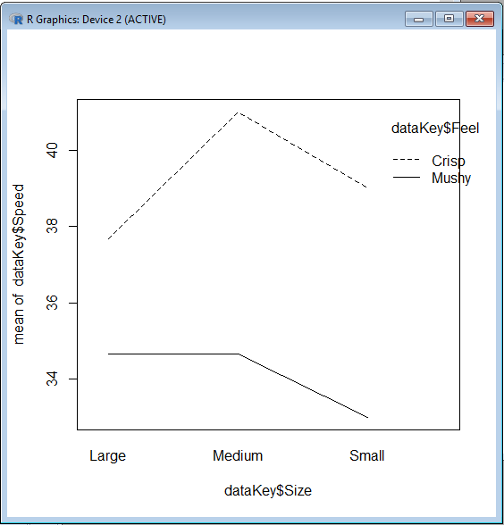a.

b.

|  |  |  |  |  |  |  |
| --- | --- | --- | --- | --- | --- | --- |
|  | Df | Sum Sq | Mean Sq | F value | Pr(>F) |  |
| Size | 2 | 12.33 | 6.17 | 1.762 | 0.213 |  |
| Feel | 1 | 117.56 | 117.56 | 33.587 | 8.53e-05 |  |
| Size:Feel | 2 | 10.11 | 5.06 | 1.444 | 0.274 | *** |
| Residuals | 12 | 42.00 | 3.50 |  |  |  |

//Significant codes: 0 ‘***’ 0.001 ‘**’ 0.01 ‘*’ 0.05 ‘.’ 0.1 ‘ ’ 1

Answer: No, there’s no significant interaction between key size and keyboard feel on typing speed

F-Ratio: 1.444

p-value: 0.274

c. i.

Answer: No, there’s no significant effect of the key size on typing speed

F-Ratio: 1.762

p-value: 0.213

ii.

Answer: Yes, there’s significant effect of the keyboard feel on typing speed

F-Ratio: 33.587

p-value: 8.53e-05

4.

a.

|  |  |  |  |  |  |  |
| --- | --- | --- | --- | --- | --- | --- |
|  | Df | Sum Sq | Mean Sq | F value | Pr(>F) |  |
| CycleTime | 2 | 426.3 | 213.17 | 61.887 | 2.24e-12 | *** |
| Temperature | 1 | 44.5 | 44.46 | 12.909 | 0.00097 | *** |
| Operators | 2 | 279.0 | 139.50 | 40.500 | 6.11e-10 | *** |
| CycleTime:Temperature | 2 | 68.9 | 34.46 | 10.005 | 0.00035 | *** |
| CycleTime:Operators | 4 | 349.7 | 87.42 | 25.379 | 4.76e-10 | *** |
| Temperature:Operators | 2 | 8.0 | 4.02 | 1.167 | 0.32290 |  |
| CycleTime:Temperature:Operators | 4 | 38.4 | 9.60 | 2.788 | 0.04087 | * |
| Residuals | 36 | 124.0 | 3.44 |  |  |  |

//Significant codes: 0 ‘***’ 0.001 ‘**’ 0.01 ‘*’ 0.05 ‘.’ 0.1 ‘ ’ 1

Answer: Yes, there’s significant interaction between cycle time, temperature, and operator.

F-Ratio: 2.788

p-value; 0.04087

b.

CycleTime:Temperature

Answer: Significant

F-Ratio: 10.005

p-value: 0.00035

CycleTime:Operators

Answer: Significant

F-Ratio: 25.379

p-value: 4.76e-10

Temperature:Operators

Answer: Not Significant

F-Ratio: 1.167

p-value: 0.32290

c.

CycleTime

Answer: Significant

F-Ratio: 61.887

p-value: 2.24e-12

Temperature

Answer: Significant

F-Ratio: 12.909

p-value: 0.00097

Operators

Answer: Significant

F-Ratio: 40.500

p-value: 6.11e-10

d. At 5% level of significance.Based on the analysis of the given data, I can conclude that the three factors has an individual main effect at. There first order interaction also has a significant effect except the interaction between temperature and operator. Finally for the interaction between the 3 factors, it has a significant effect on dyeing the said cloth.