CS 138 – Software Engineering

Exercise 5 : Determination of Critical Path in Schedule Development

Name: Jonel Dominic E. Tapang Course & Year: BSCS -3

**1.)**

|  |  |  |  |  |  |  |  |  |
| --- | --- | --- | --- | --- | --- | --- | --- | --- |
| Acitivity Calculation | | | | | | | | |
| Task | Duration | Preceding | Subsequence | ESDays | EFDays | LSDays | LFDays | Float |
| T1 | 10 |  | T2 | 1 | 10 | 1 | 10 | 0 |
| T2 | 15 | T1 | T3 | 11 | 25 | 11 | 25 | 0 |
| T3 | 10 | T2 | T6,T7,T13 | 26 | 35 | 26 | 35 | 0 |
| T4 | 20 |  | T6,T13 | 1 | 20 | 26 | 45 | 25 |
| T5 | 10 |  | T10 | 1 | 10 | 66 | 75 | 65 |
| T6 | 15 | T3,T4 | T9 | 36 | 50 | 46 | 60 | 10 |
| T7 | 20 | T3 | T8 | 36 | 55 | 36 | 55 | 0 |
| T8 | 35 | T7 | T14 | 56 | 90 | 56 | 90 | 0 |
| T9 | 15 | T6 | T10,T11,T14 | 51 | 65 | 61 | 75 | 10 |
| T10 | 5 | T5,T9 | T12 | 66 | 70 | 76 | 80 | 10 |
| T11 | 10 | T9 | - | 66 | 75 | 121 | 130 | 55 |
| T12 | 20 | T10 | T15 | 71 | 90 | 81 | 100 | 10 |
| T13 | 35 | T3,T4 | - | 36 | 70 | 96 | 130 | 60 |
| T14 | 10 | T8,T9 | T15 | 91 | 100 | 91 | 100 | 0 |
| T15 | 20 | T12,T14 | T16 | 101 | 120 | 101 | 120 | 0 |
| T16 | 10 | T15 | - | 121 | 130 | 121 | 130 | 0 |

|  |  |  |  |  |  |  |  |  |  |  |  |  |  |  |  |  |  |  |  |  |  |  |  |  |  |  |
| --- | --- | --- | --- | --- | --- | --- | --- | --- | --- | --- | --- | --- | --- | --- | --- | --- | --- | --- | --- | --- | --- | --- | --- | --- | --- | --- |
| Gantt Chart | | | | | | | | | | | | | | | | | | | | | | | | | | |
| TASK | Days | | | | | | | | | | | | | | | | | | | | | | | | | |
| 1-5 | 6-10 | 11-15 | 16-20 | 21-25 | 26-30 | 31-35 | 36-40 | 41-45 | 46-50 | 51-55 | 56-60 | 61-65 | 66-70 | 71-75 | 76-80 | 81-85 | 86-90 | 91-95 | 96-100 | 101-105 | 106-110 | 111-115 | 116-120 | 121-125 | 126-130 |
| T1 |  |  |  |  |  |  |  |  |  |  |  |  |  |  |  |  |  |  |  |  |  |  |  |  |  |  |
| T2 |  |  |  |  |  |  |  |  |  |  |  |  |  |  |  |  |  |  |  |  |  |  |  |  |  |  |
| T3 |  |  |  |  |  |  |  |  |  |  |  |  |  |  |  |  |  |  |  |  |  |  |  |  |  |  |
| T4 |  |  |  |  |  |  |  |  |  |  |  |  |  |  |  |  |  |  |  |  |  |  |  |  |  |  |
| T5 |  |  |  |  |  |  |  |  |  |  |  |  |  |  |  |  |  |  |  |  |  |  |  |  |  |  |
| T6 |  |  |  |  |  |  |  |  |  |  |  |  |  |  |  |  |  |  |  |  |  |  |  |  |  |  |
| T7 |  |  |  |  |  |  |  |  |  |  |  |  |  |  |  |  |  |  |  |  |  |  |  |  |  |  |
| T8 |  |  |  |  |  |  |  |  |  |  |  |  |  |  |  |  |  |  |  |  |  |  |  |  |  |  |
| T9 |  |  |  |  |  |  |  |  |  |  |  |  |  |  |  |  |  |  |  |  |  |  |  |  |  |  |
| T10 |  |  |  |  |  |  |  |  |  |  |  |  |  |  |  |  |  |  |  |  |  |  |  |  |  |  |
| T11 |  |  |  |  |  |  |  |  |  |  |  |  |  |  |  |  |  |  |  |  |  |  |  |  |  |  |
| T12 |  |  |  |  |  |  |  |  |  |  |  |  |  |  |  |  |  |  |  |  |  |  |  |  |  |  |
| T13 |  |  |  |  |  |  |  |  |  |  |  |  |  |  |  |  |  |  |  |  |  |  |  |  |  |  |
| T14 |  |  |  |  |  |  |  |  |  |  |  |  |  |  |  |  |  |  |  |  |  |  |  |  |  |  |
| T15 |  |  |  |  |  |  |  |  |  |  |  |  |  |  |  |  |  |  |  |  |  |  |  |  |  |  |
| T16 |  |  |  |  |  |  |  |  |  |  |  |  |  |  |  |  |  |  |  |  |  |  |  |  |  |  |

*Critical Path 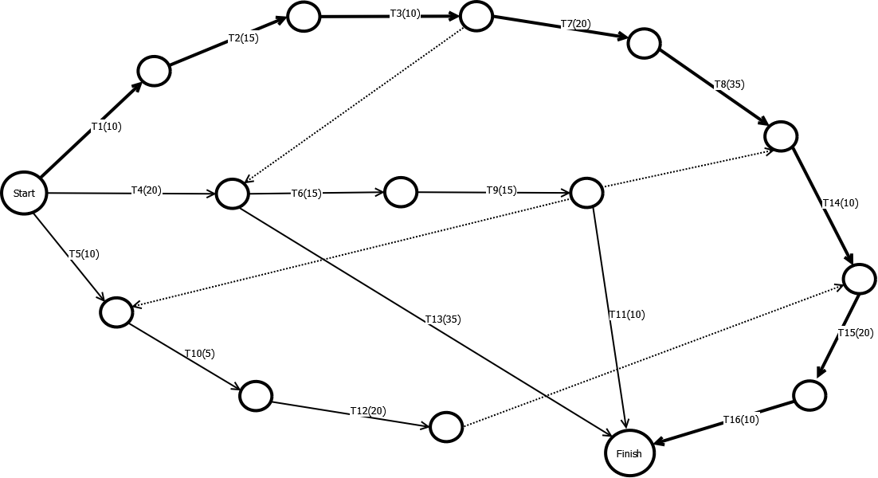**Arrow Diagram**

|  |  |  |  |  |  |  |  |  |  |  |  |  |  |  |  |  |
| --- | --- | --- | --- | --- | --- | --- | --- | --- | --- | --- | --- | --- | --- | --- | --- | --- |
| Acitivity Calculation | | | | | | | | | | | | | | | | |
| Task | Preceding | Subsequence | Subcontractor X | | | | | | | Subcontractor Y | | | | | | |
| Duration | ESDays | EFDays | LSDays | LFDays | Float | Cost | Duration | ESDays | EFDays | LSDays | LFDays | Float | Cost |
| A | - | C | 18 | 1 | 18 | 5 | 22 | 4 | 14 | 16 | 1 | 16 | 4 | 19 | 3 | 15 |
| B | - | D,E | 10 | 1 | 10 | 1 | 10 | 0 | 10 | 8 | 1 | 8 | 1 | 8 | 0 | 13 |
| C | A | F | 5 | 19 | 23 | 23 | 27 | 4 | 8 | 4 | 17 | 20 | 20 | 23 | 3 | 10 |
| D | B | F | 6 | 11 | 16 | 22 | 27 | 11 | 8 | 5 | 9 | 13 | 19 | 23 | 3 | 10 |
| E | B | G | 9 | 11 | 19 | 11 | 19 | 0 | 10 | 8 | 9 | 16 | 9 | 16 | 0 | 13 |
| F | C,D | H | 4 | 24 | 27 | 28 | 31 | 4 | 6 | 3 | 21 | 23 | 24 | 26 | 3 | 9 |
| G | E | H | 12 | 20 | 31 | 20 | 31 | 0 | 11 | 10 | 17 | 26 | 17 | 26 | 0 | 12 |
| H | F,G | - | 10 | 32 | 41 | 32 | 41 | 0 | 10 | 9 | 27 | 35 | 27 | 35 | 0 | 12 |
|  | | |  | | | | Total Cost | | 77 |  | | | | Total Cost | | 94 |
| No. of days needed to complete | | | | | | 41 | No. of days needed to complete | | | | | | 35 |
| Average Cost(Total Cost / No. of Days) | | | | | | 1.878 | Average Cost(Total Cost / No. of Days) | | | | | | 2.685 |

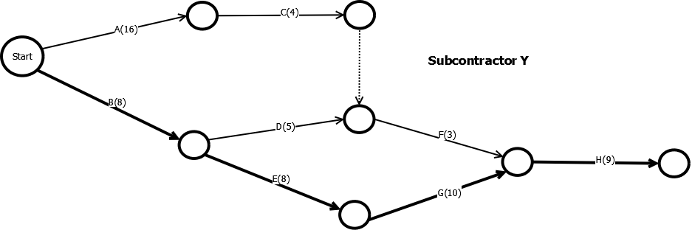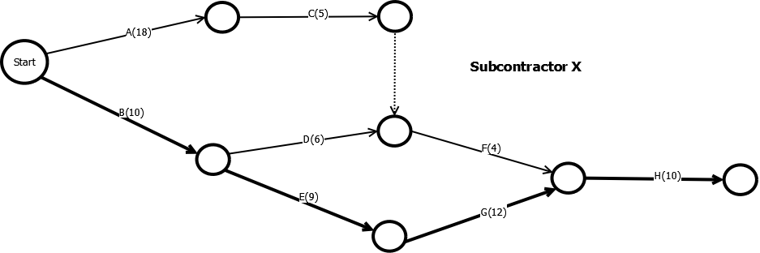 **2.)**

|  |  |
| --- | --- |
| **Subcontractor X** | |
| **Total Cost** | 77 |
| **No. Of Days** | 41 |

|  |  |
| --- | --- |
| **Subcontractor Y** | |
| **Total Cost** | 94 |
| **No. Of Days** | 35 |

**2.1.**

**2.2.**

**-** Based on the given set of data, Sucontractor X can finish the project with lesser cost compared to Subcontractor Y. Wwhen the issue is about the No. Of day to complete the given tasks, Subcontractor Y can finish earlier compared with Subcontractor X. In conclusion, in terms of effiency, Subcontractor X is more effecient than Subcontractor Y, because Subcontractor X cost lesser amount per day than Subcontractor Y.

|  |  |  |  |  |  |  |
| --- | --- | --- | --- | --- | --- | --- |
| Acitivity Calculation | | | | | | |
| Task | Preceding | Subcontractor | Duration | Start Date | Finish Date | Cost |
| A | - | X | 18 | 1 | 18 | 14 |
| B | - | Y | 8 | 1 | 8 | 13 |
| C | A | X | 5 | 19 | 23 | 8 |
| D | B | X | 6 | 9 | 14 | 8 |
| E | B | Y | 8 | 9 | 16 | 13 |
| F | C,D | Y | 3 | 24 | 26 | 9 |
| G | E | Y | 10 | 17 | 26 | 12 |
| H | F,G | Y | 9 | 27 | 35 | 12 |
| Total Cost : | | | | | | 89 |

**2.3.**

* Task A,C, and D will be assigned to Subcontractor X and the rest will be for Subcontractor Y. The total cost will 89